**Fig 1. Representations of a) NSR, b) AF, and c) PAC signals in the ECG dataset, along with d) NSR, e) AF, and f) PAC signals in the PPG dataset.**

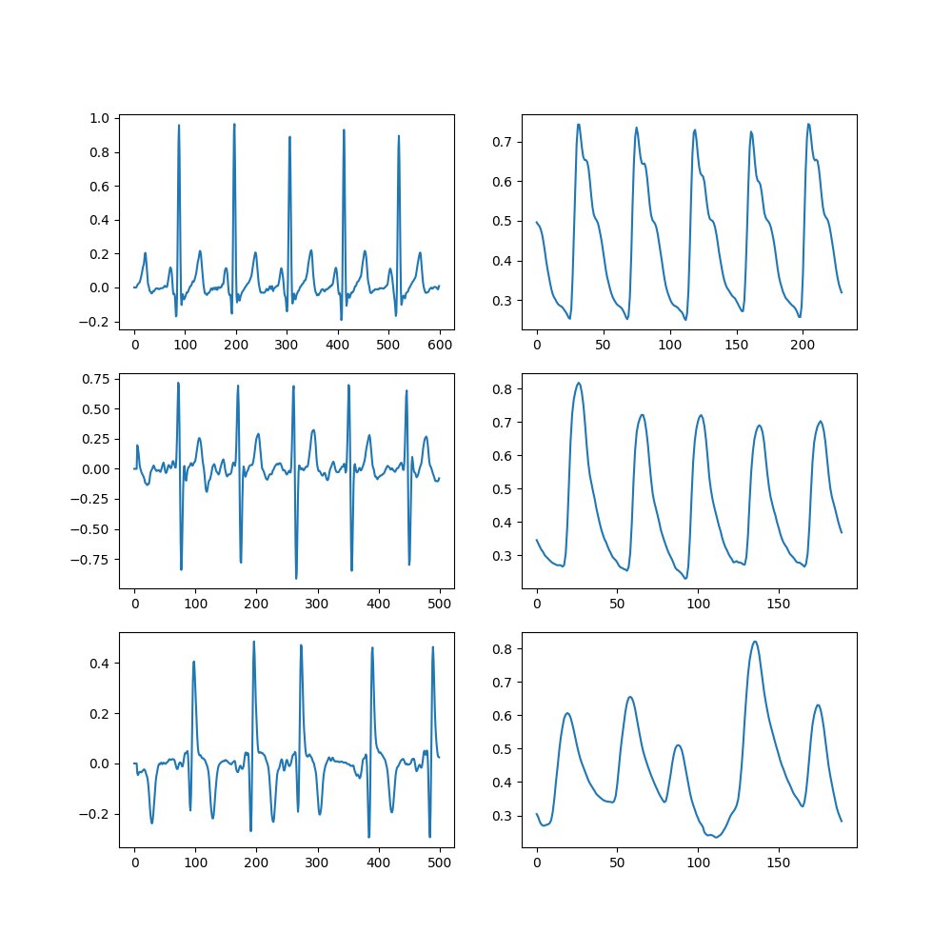

**Amplitude**

**Samples**

**a)**

**b)**

**c)**

**d)**

**e)**

**f)**