<https://github.com/mircea-negrau/University-Lab-FLCD>

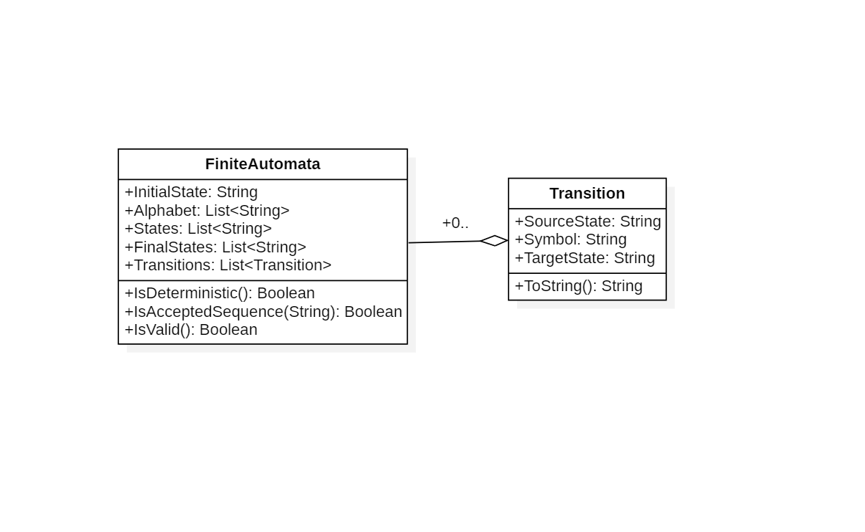

Finite Automata has 5 attributes:   
1. Initial state (string)

2. Alphabet (list of strings)

3. States (list of strings)

4. Final states (list of strings)

5. Transitions (list of transitions)

IsDeterministic():

For each state and for each symbol in the alphabet, we check that the FA has at most one possible transition comprised of the state and the symbol.

If the above is true, the Finite Automata is deterministic.

Otherwise, the Finite Automata is NOT deterministic.

IsAcceptedSequence(string sequence):

The current state is initially the initial state.

For each symbol in the sequence, returns False if:

* if the symbol is NOT in the FA’s alphabet.
* If the FA has no transition with the current state as source state and the given symbol.

After each symbol, the current state becomes the transition’s target state.

If the current state in the end is not found in the final states of the FA, returns False.

IsValid():

The method checks the following step by step:

* If the FA has at least one state,
* If the FA has at least one symbol in alphabet,
* If the FA has at least one final state,
* If the FA has at least one transition,
* If the FA’s states contain the initial state,
* If the FA’s states contain all the states in the final list of states,
* If all transitions of the FA have a source state and a target state found in the list of states and the transition’s symbol is found in the alphabet of the FA.

**Input file BNF:**

<alphabet> = <number> | <alphabet> <number>

<states> = <string> | <string> <states>

<initial state> = <string>

<final states> = <string> | <string> <final states>

<transitions> = <transition> | <transitions> <transition>

<file> = <states> “\n” <alphabet> “\n” <initial state> “\n” <final states> “\n” <transitions>

<char> = a | b | … | z | A | B | … | Z

<string> = <char> | <string> <char>

<digit> = 0 | 1 | ... | 9

<number> = <digit> | <number> <digit>

<transition> = <string> “ “ <number> “ “ <string>