Experiments and conclusions:
1) Comparison of 2 x 1D Kmeans (one for each state signal) versus 2D Kmeans (meaning to fit a 2D grid from trajectories, which suffers from the curse of dimensionality, takes a lot of time and does not work well) => using separate 1D Kmeans for each state is a lot better
2) For state stabilization, x -> 0, the Kmeans tends to converge to a logarithmic quantizer, as for closed-loop trajectories, which are based on exponentials, more or less, it tends to be the best quantizer to “compensate” the exponentials to logarithms;
3) I think the Kmeans can be made more efficient from a number of bits’ point of view
From the MATLAB file experiment_v2_exploit_comparison.m:
- output tracking (Kmeans kind of works the same as logarithmic)
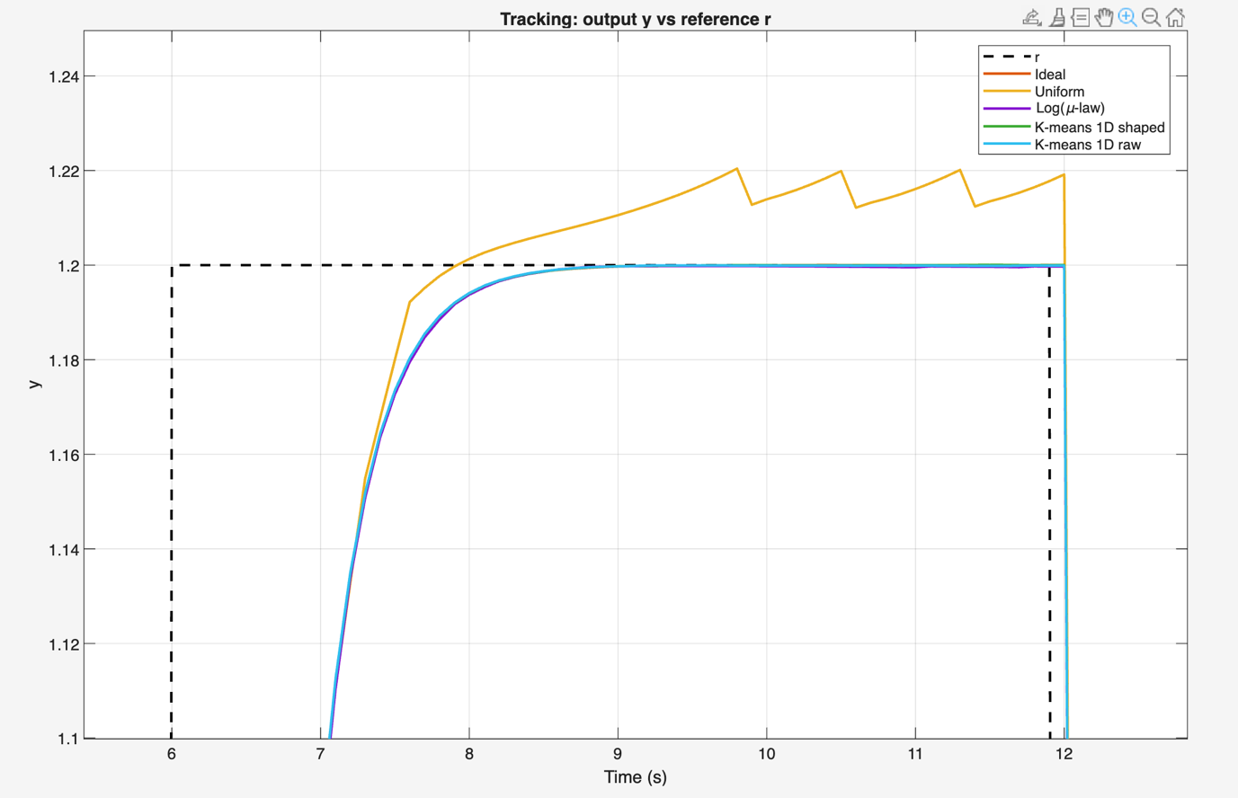

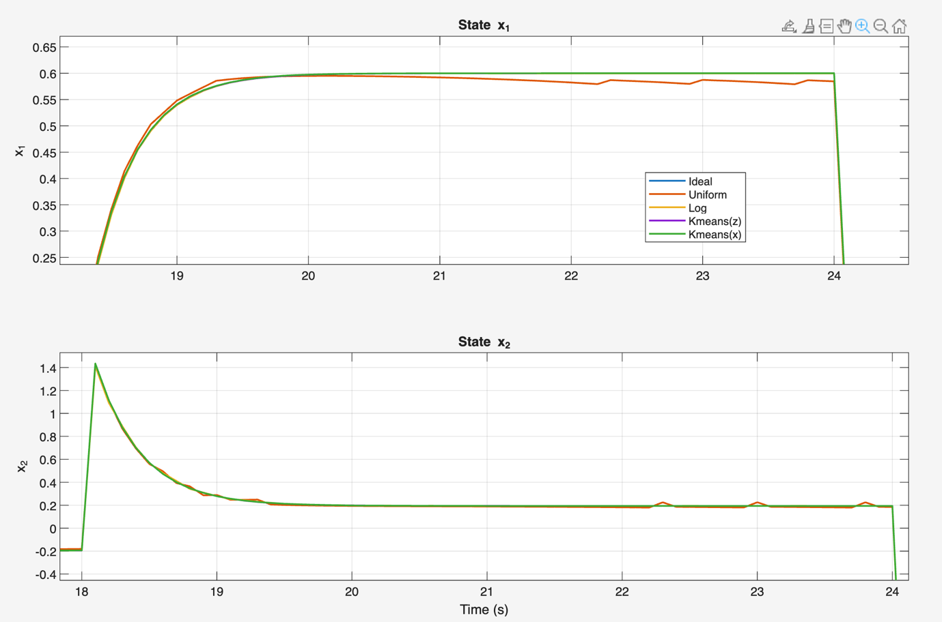
- state signals (Kmeans kind of works the same as logarithmic)

- Voronoi diagram for Kmeans centroids (it sure looks like the Kmeans learns the relevant partitioning of the 2D plane from the system trajectories)
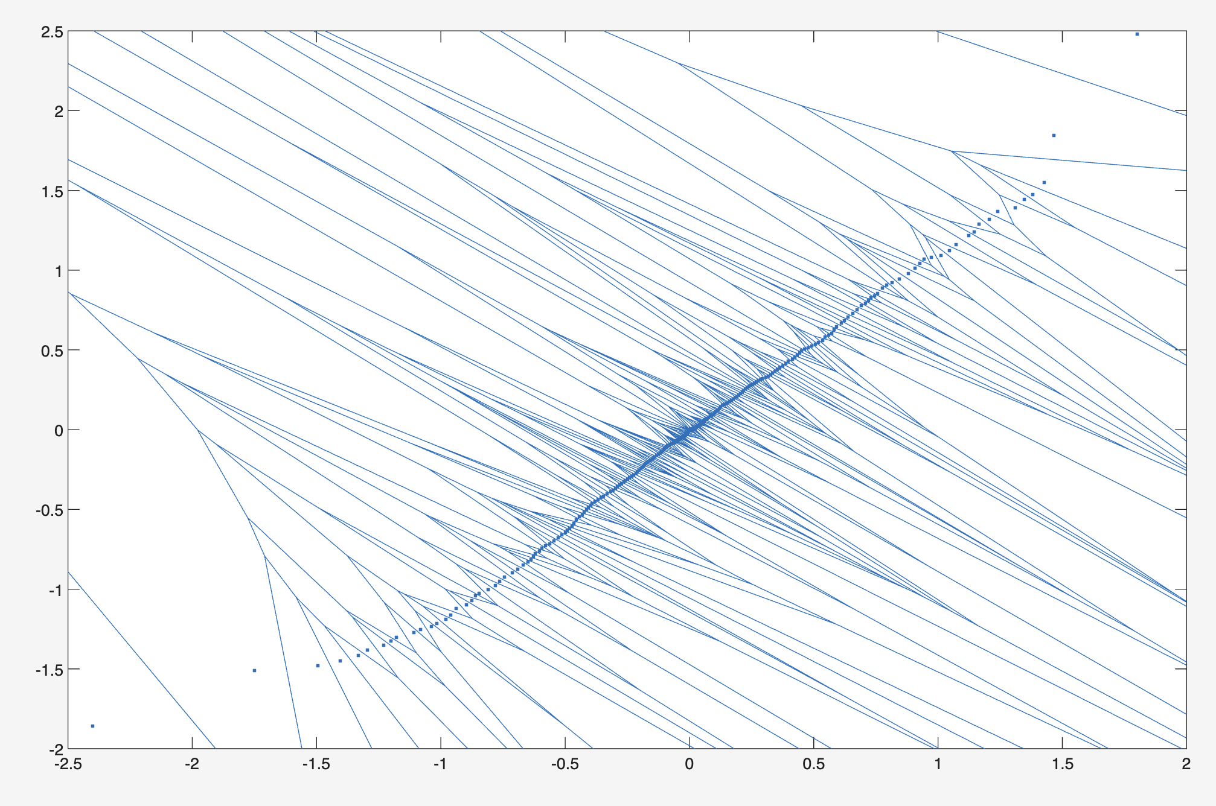

Excess cost of the LQR index for the stabilization to origin problem: J = J_ideal + Delta_J -> Plot of Delta_J distribution of probability using the considered quantizers (MATLAB file experiment_v1_kmeans_1D.m):
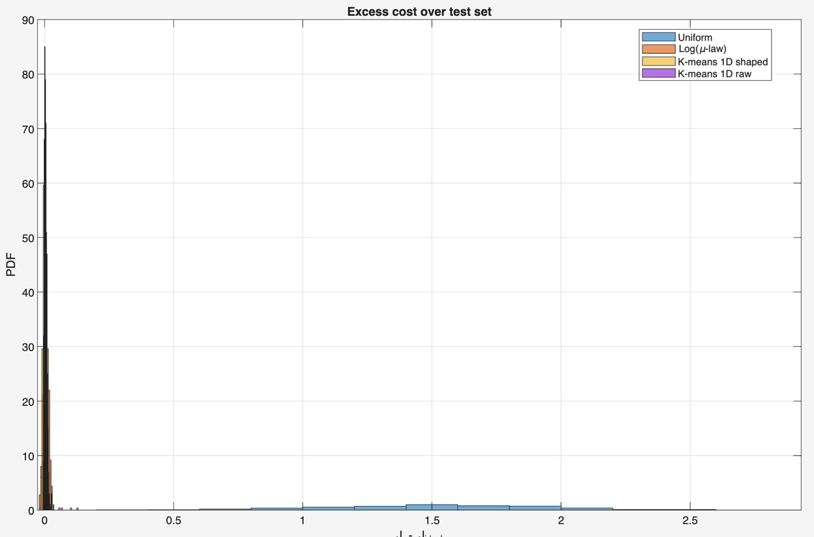
- First plot shows that the uniform is on a different league
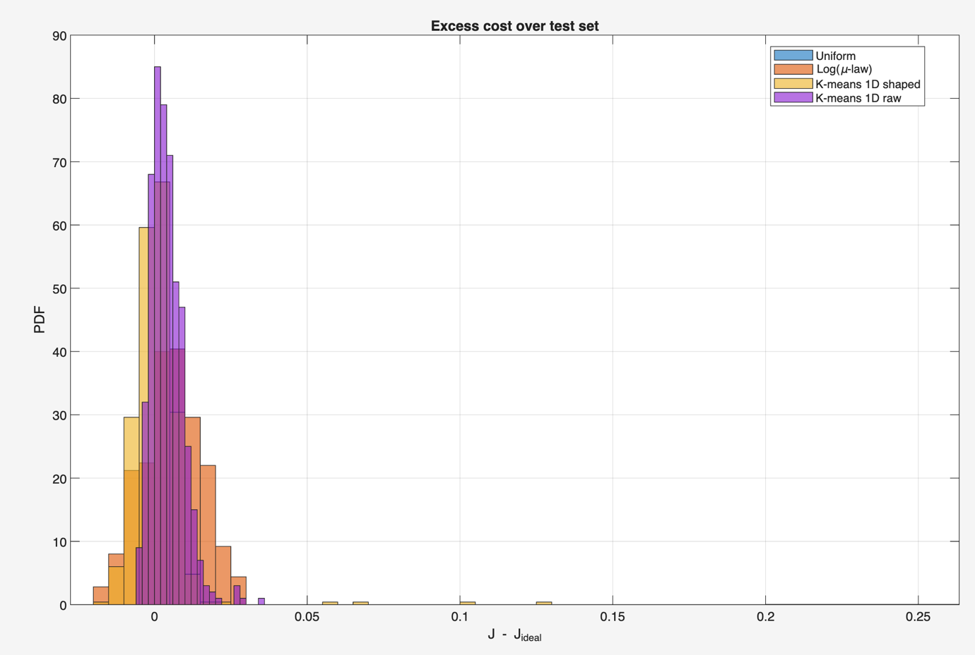
- Second plot shows that they all tend to converge to similar behaviors for this simple problem (Kmeans may be a bit more consistent, let’s say):
4) Behaviour and excess cost of the LQR index for reference tracking (consider three references: -d, 0, +d, to cover the state space as much as possible). Important conclusion: the logarithmic quantizer works “perfectly” for the origin, but does not work at all to the other extremes, as it doesn’t have quantization steps (precision) for x1 and x2 far from the origin. On the other hand, the Kmeans learns to have good precision around all three references.
- MATLAB file exp_v7_scalar_case_kmeans.m:
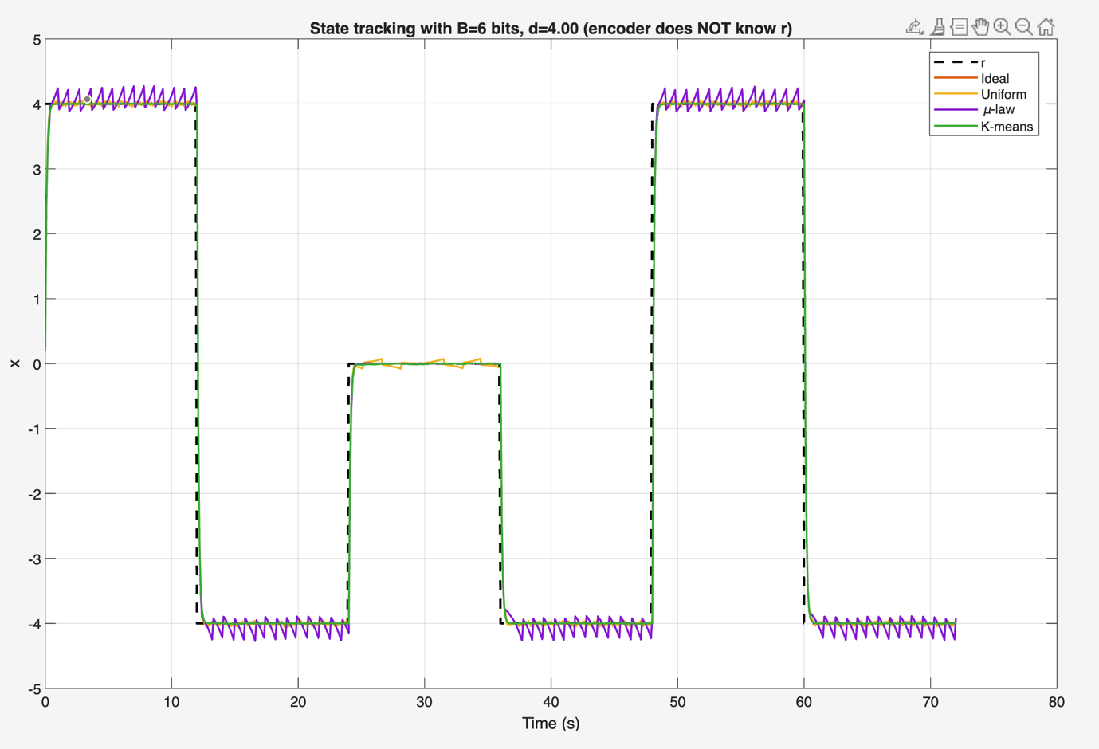
-- good tracking on all three references for Kmeans vs good tracking only around origin for the log quantizer (+same performance everywhere using uniform quantizer)

-- distribution of state signals for the three reference points
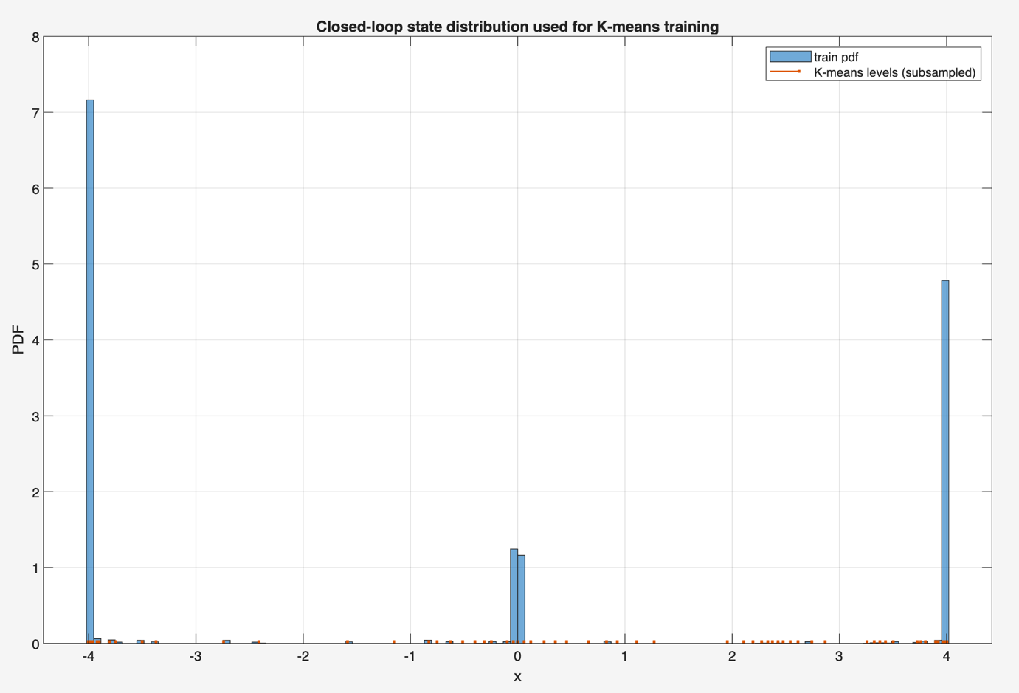

- vast improvement of the performance index J when we take multiple references into account
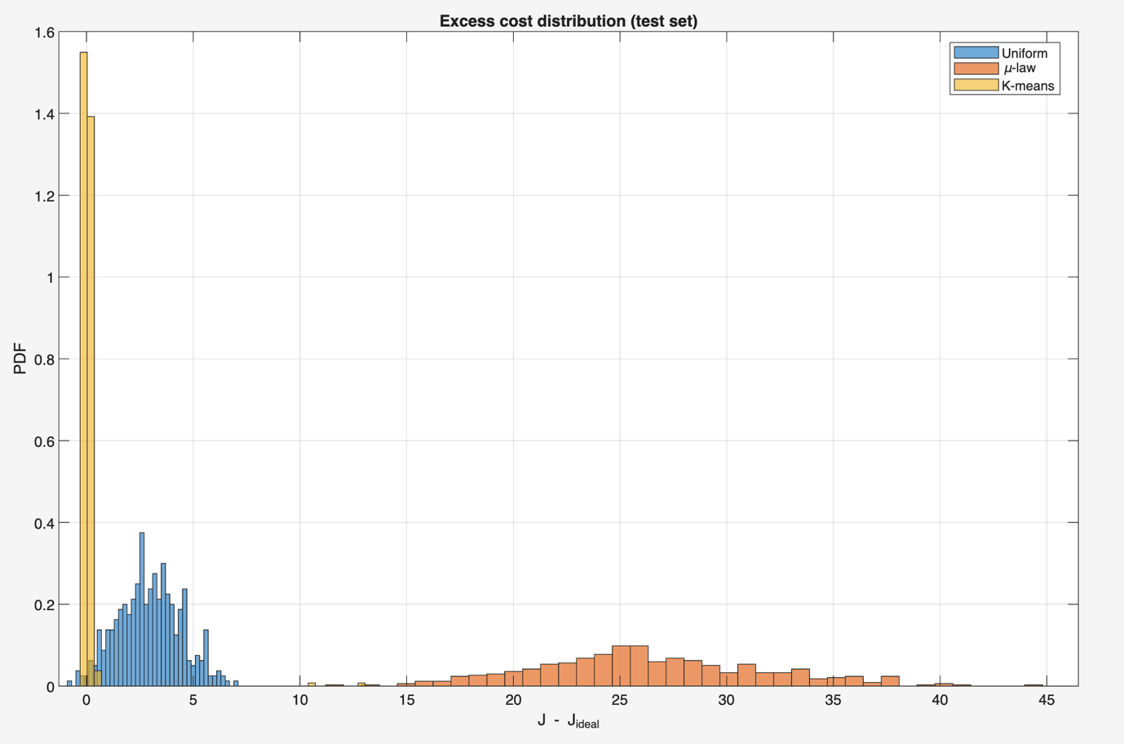
What to exploit next?
- Quantization for problems where the control trajectories are predefined and improve those cases as much as possible; for example, finite horizon LQR, optimal control problems etc., in which we build a quantizer tailored to that problem => Data-driven quantization
- I also tried a nonlinear parameter adaptation algorithm (PAA) type solution, as in System Identification, in which I wanted to “learn” the compensation between the ideal command signal and command signal computed using the quantized state signals, i.e., to compensate the quantizer loss of resolution, but, at first glance, it didn’t work too well. It could be experimented with more trials and different setups, but I don’t know if we could provide some guarantees of it, or a more rigorous methodology.
- ??

