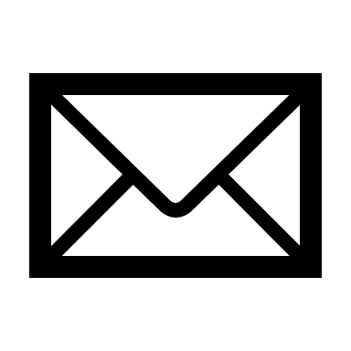

linkedin.com/in/emilyrichards

+1 (646) 555-7890

emily.richards@email.com

New York, NY

**SKILLS**

* English: Fluent
* Spanish: Native
* German: Intermediate

**LANGUAGES**

* Campaign management & performance tracking
* SEO & content strategy
* Google Analytics & data reporting
* Social media marketing
* Email marketing & CRM management
* Team leadership & collaboration

**SOFTWARES**

* Google Analytics
* WordPress
* Canva

Digital marketing professional with over 5 years of experience in designing and executing successful digital strategies. Specialized in campaign management, SEO optimization, and data analytics for leading companies. Creative and results-driven, skilled at transforming data into actionable insights to drive traffic, engagement, and conversions. Proven ability to work in multidisciplinary teams and perform under pressure.

**EMILY RICHARDS**

**SUMMARY**

**WORK EXPERIENCE**

*Michelin*, Chicago, IL

* Created content for the company blog, increasing brand visibility.
* Coordinated internal and external communication campaigns.
* Organized digital events while adhering to allocated budgets.

*Boeing*, Los Angeles, CA

**Content Manager & Digital Campaign Coordinator, 20XX – 20XX**

* Managed projects ensuring deadlines and objectives were met.
* Conducted SEO audits and implemented strategies to enhance visibility.
* Launched marketing campaigns, improving conversion rates by over 15%.

**Digital Marketing Manager**, **20XX – 20XX**

*Wasp Marketing*, New York, NY

* Designed and managed digital campaigns, achieving an average ROI of 5X.
* Implemented SEO strategies, increasing organic traffic significantly.
* Developed digital content strategies to boost engagement across social.

**Marketing & Communications Assistant, 20XX – 20XX**

**Freelance Community Manager, 20XX – 20XX**

*Various Clients (Startups, NGOs)*, San Francisco, CA

* Managed social media accounts for 3 startups, growing their audience.
* Created visual and editorial content across multiple digital platforms.
* Trained teams in communication and management tools.

**EDUCATION**

Courses: UX Design, Visual Communication, Project Management

*Columbia University, New York, NY*

**Master’s in Digital Marketing & E-Commerce, 20XX – 20XX**

Specialization in Digital Content Strategy and Communication

*University of California, Berkeley, CA*

**Bachelor’s in Communication & Media, 20XX – 20XX**

Graduated with Honors

*New York High School, New York, NY*

**High School Diploma in Science (Mathematics Focus), 20XX**

**John Smith**, Sales Director, TotalEnergies

John.smith@email.com, +1 (917) 777-7777

**REFERENCES**

**Pablo Mesa**, Project Manager, Publicis USA

Pablo.mesa@email.com | +1 (646) 888-8888

DIGITAL MARKETING MANAGER

**CONTACT**

©AZURIUS – Modelos-de-curriculum.com

**Dear Job Seeker,**

If you're having difficulty composing your resume, here are some free resources available that can assist you in creating a strong resume that highlights your suitability for the position to potential employers:

* [How to Make a Good Resume](https://www.my-resume-templates.com/how-to-make-a-resume/?utm_source=Word_Doc&utm_medium=Model_CV_Link&utm_campaign=MDC_Downloads)
* [Skills to Put on a Resume](https://www.my-resume-templates.com/skills-to-put-on-a-resume/?utm_source=Word_Doc&utm_medium=Model_CV_Link&utm_campaign=MDC_Downloads)
* [Resume Objective Examples](https://www.my-resume-templates.com/resume-objective-examples/?utm_source=Word_Doc&utm_medium=Model_CV_Link&utm_campaign=MDC_Downloads)

Also, discover other free downloadable and ready-to-fill CV templates in Word format:

* [Basic Resume Templates](https://www.my-resume-templates.com/basic-resume-templates/?utm_source=Word_Doc&utm_medium=Model_CV_Link&utm_campaign=MDC_Downloads)
* [Modern Resume Templates](https://www.my-resume-templates.com/modern-resume-samples/?utm_source=Word_Doc&utm_medium=Model_CV_Link&utm_campaign=MDC_Downloads)
* [Creative Resume Templates](https://www.my-resume-templates.com/creative-cv-templates/?utm_source=Word_Doc&utm_medium=Model_CV_Link&utm_campaign=MDC_Downloads)
* [Professional Resume Templates](https://www.my-resume-templates.com/career-resume-templates/?utm_source=Word_Doc&utm_medium=Model_CV_Link&utm_campaign=MDC_Downloads)
* [Europass CV](https://www.my-resume-templates.com/europass-cv/?utm_source=Word_Doc&utm_medium=Model_CV_Link&utm_campaign=MDC_Downloads)

Best regards,

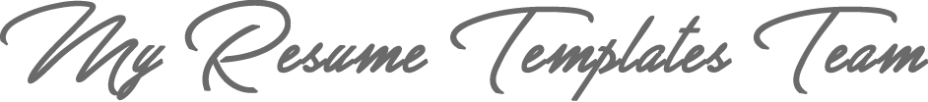

[www.my-resume-templates.com](https://www.modelos-de-curriculum.com/?utm_source=Word_Doc&utm_medium=Model_CV_Link&utm_campaign=MDC_Downloads)

**COPYRIGHT - PLEASE READ THIS MESSAGE**

©These examples of free resume templates are the property of Azurius S.L. You may   
download and modify them without any problem if they are for personal use.

Do not forget to remove this copyright notice before modifying and printing your CV.

You cannot resell these examples or their derivatives. You cannot make them available on other websites without our consent. For any related questions, please write to us at contact@my-resume-templates.com

Discover more resume templates at [www.my-resume-templates.com](https://www.my-resume-templates.com/)