**Отчет по тачке**

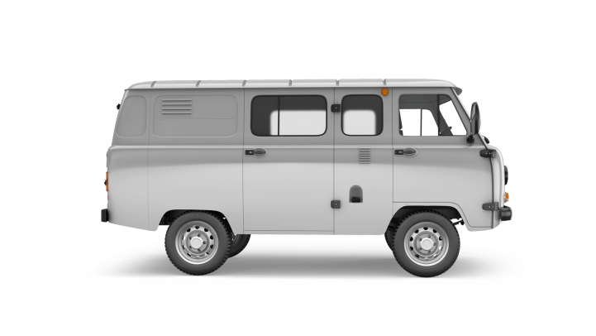

|  |  |  |  |
| --- | --- | --- | --- |
| Mark | Model | Fuel consumption | Price |
| UAZ | Buhanka | 15,5 l/100 km | 9899,98 USD |