Mireille Abd El Sayed                                             Thursday, September 15th, 2022

40215738

**Website 1:** [**https://coastalworld.com/**](https://coastalworld.com/)

Design: The design is very nice and cute, it had me smiling the whole time. However, I felt like it was more of an actual game then a banking website.

Usability: If you are a teen or young adult using this site, I would say that it is very user friendly because it is exactly like any game that you could’ve played when you were younger, such as *Club Penguin*. However, I don’t see my grandparents or even parents using this site or understanding how it works.

Content: During the 30 mins that I spent on this website, I realized that even though it was a community banking site, not much information was being communicated.

Creativity: This website was super creative, it felt like I was playing a game.

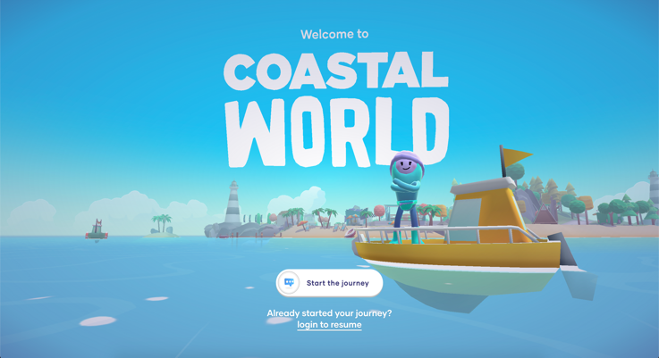

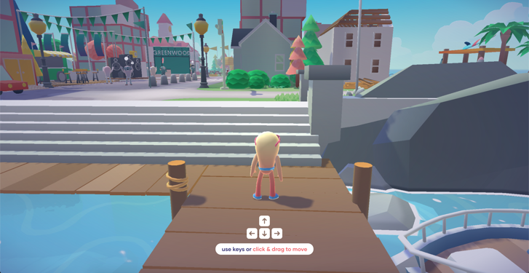

**Website 2:** [**https://hennessy-house-of-moves.hello-jury.com/**](https://hennessy-house-of-moves.hello-jury.com/)

Design: This website looks amazing! It looks like an actual house/museum for the NBA X Hennessy collaboration. Things are presented clearly and makes you appreciate everything.

Usability: This site was very user friendly. Before beginning, little pop-ups would appear and would explain how you could navigate through the site.

Content: The content was all very interesting, from little recipes for NBA x Hennessy inspired drinks, to a museum of some jerseys and even a performance.

Creativity: The aspect of navigating through a space might not be very innovative, however, it was very well executed and had a very clean design.

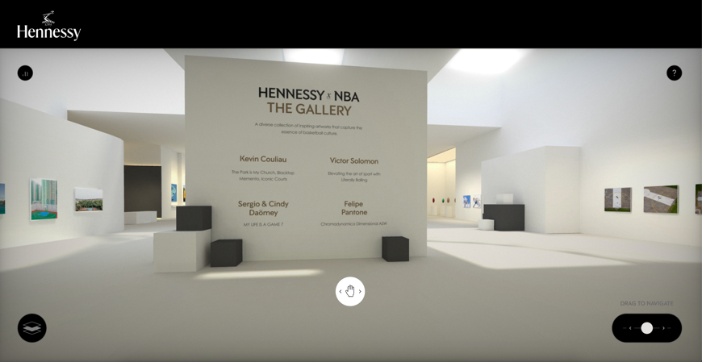

**Website 3:** [**https://mac-pam.netlify.app/**](https://mac-pam.netlify.app/)

Design: The design looks fun and inviting, you clearly get what the site is about, burgers.

Usability: The site had a very nice user experience. Everything was well indicated on the site. When you clicked on the Uber, it would direct you directly to the UberEATS site.

Content: The content was all present, from the address to the phone number, email, prices of each article, and even the story on how the store started.

Creativity: For a restaurant, I feel like this is an innovative way to introduce yourself and display your menu.

