Reference : - https://www.youtube.com/watch?v=GXFw8SV-51g

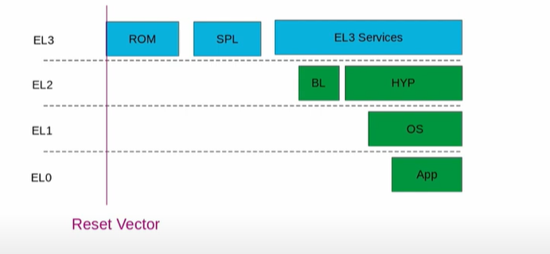

First it starts with EL3 i.e. the highest exception level.

ROM code is vendor implementation, and it is fused into SOC.

SPL – Second stage Bootloader

Then EL3 services run.

The EL3 services then finally starts full strength bootloader. It will then handover to kernel and will provide hypervisor facilities if enabled and put itself into exception level 1.

Finally, kernel started up and user space is available, we will run our application.

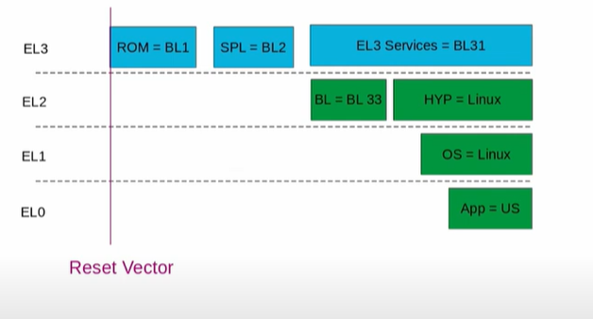

ROM code is also named as BL1. SPL is named as BL2.

EL3 services running in EL3 is named as BL31 i.e. 3rd stage but the first part, which is going to run permanently in EL3, while the kernel is also running parallaley in the system.

Full strength bootloader(BL) running in EL2 is also named as BL33. Finally the control is handed over Hypervisor (in the form of Linux kernel) or Linux kernel in EL1.

Finally, the application runs. APP=US for User space

**First stage BL1 ROM Code: -**

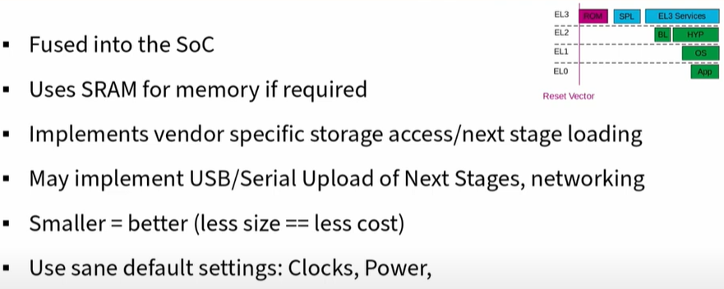

**Second stage (BL2): TF-A/U-Boot SPL/Barebox PBL**

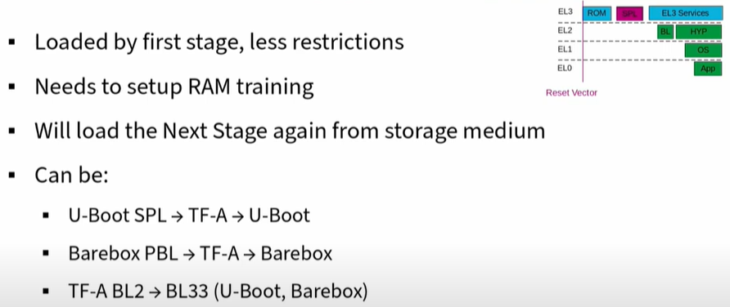

Boot flow can be: U-Boot SPL -> ARM Trusted Firmware -> U-Boot boot loader

17:26