B2 hardware schematic screenshot: -

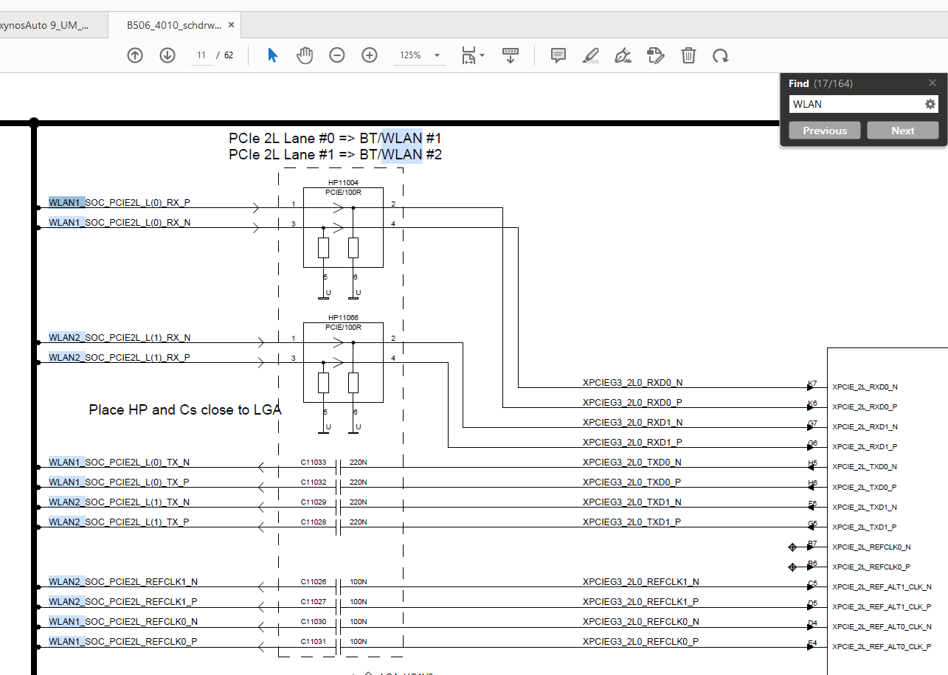

TRM of V920 SOC: -

Hi..I looked into V920 TRM document what we are having. We could see that PCIe pins of SOC with WLAN1 and WLAN2 chips are as below.

PCIe pins for WLAN1: -

XPCIE_2L_RXD0_N

XPCIE_2L_RXD0_P

XPCIE_2L_TXD0_N

XPCIE_2L_TXD0_P

XPCIE_2L_REF_ALT0_CLK_N

XPCIE_2L_REF_ALT0_CLK_P

XPCIE_PERSTN2

XPCIE_CLKREQ2

PCIe pins for WLAN2: -

XPCIE_2L_RXD1_N

XPCIE_2L_RXD1_P

XPCIE_2L_TXD1_N

XPCIE_2L_TXD1_P

XPCIE_2L_REF_ALT1_CLK_N

XPCIE_2L_REF_ALT1_CLK_P

XPCIE_PERSTN3

XPCIE_CLKREQ3

I could see Ball-Map description is there only in Page - 154 of TRM.

While looking into "PCI Express: Register Description" chapter of TRM, section : 28.5.3 PCIe_GEN3 2 Lane Link.

I could see Base addresses as below -

PCIe_GEN3_2L0 Link Base address : 0x1300_0000

PCIe_GEN3_2L1 Link Base address : 0x1500_0000

But when I see target or .dtsi file then Base addresses observed is as below: -

For WALN1: PCIe port - pcie_2: pcie@161C0000

For WALN2: PCIe port - pcie_3: pcie@161C1000

So, with available information/document, we are unable to map PCIe pins with PCIe port and its base addresses.