# PCIe enumeration in-stability issue in IDCEvo: -

Contents

PCIe enumeration in-stability issue in IDCEvo: - 1

1. Block Diagram showing Power-On-GPIO and Reset signals : - 2

2. Power-On-GPIO becoming high after PERST# is releasing, which is not correct: - 2

3. Power sequence time diagram as per PCIe specification: - 3

4. Correction in power-up sequence with our patch: - 4

5. Result: - 4

## Block Diagram showing Power-On-GPIO and Reset signals : -

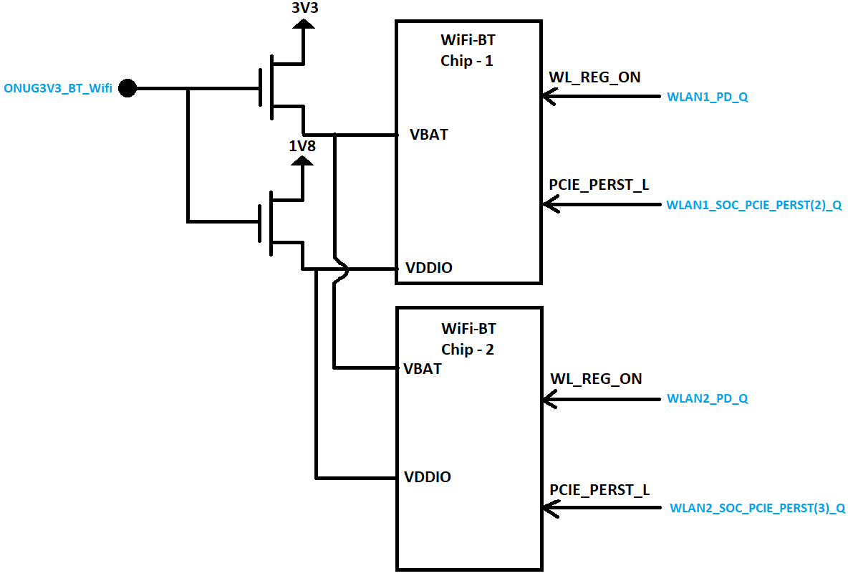

Figure – 1

## Power-On-GPIO becoming high after PERST# is releasing, which is not correct: -

Figure – 2

Legend:

Yellow: ONUG3V3_BT_Wifi

Cyan: WLAN1_SOC_PCIE_PERST(2)_Q

Violet: WLAN1_SOC_PCIE_CLKREQ(2)_Q

Blue: WLAN1_SOC_PCIE2L_REFCLK0_P

The above waveform is not following PCIe compliance. Power to PCIe-Endpoint should become stable before release of PERST# signal.

Fix: - This we are correcting with a patch to Android-kernel repo, by asserting “ONUG3V3_BT_Wifi” signal in probe function of Exynos PCIe controller driver using “Pinctrl” select state.

## Power sequence time diagram as per PCIe specification: -

As per PCIe specification “PCI Express® Card Electromechanical Specification Revision 3.0 July 21, 2013”, page No – 30, the initial power up sequence should be as below.

Figure - 3

Same we can see in WiFi chip (Cypress: CYW8x570 ) data sheet, page no - 86, Power to the chip should be stable before release of PERST# signal. It is shown below.

Figure – 4

## Correction in power-up sequence with our patch: -

## 

Figure – 5

Legend:

Yellow: ONUG3V3_BT_Wifi

Green: WLAN1_SOC_PCIE_PERST(2)_Q

Blue: WLAN1_SOC_PCIE_CLKREQ(2)_Q

Violet: WLAN1_SOC_PCIE2L_REFCLK0_P

## Result: -

1. Power to Wifi chip is enabled about 11.54 seconds before release of PERST# signal.
2. PCIE_CLKREQ signal goes to LOW about 6.26s after Power to WiFi chip is stable.

It follows PCIe Electromechanical specification and WiFi chip data sheet.