**GPIO number identification in Exynos-Auto-9 soc: -**

1. **Method – 1: -**

**#** mount -t debugfs none /sys/kernel/debug

# cat /sys/kernel/debug/gpio

In BMW IDCevo pinmux excel sheet, if any pin is let us say “gpp3_2”, then as per above screenshot we can see that GPIO group “gpp3” is having GPIO numbers ranging from 137 to 144. So, pin gpp3_2 is mapped to GPIO number – 139.

1. **Method 2: -**

# cd /sys/kernel/debug/pinctrl

# ls

O/p –

10830000.pinctrl-samsung-pinctrl 16de0000.pinctrl-samsung-pinctrl

10c30000.pinctrl-samsung-pinctrl 1a460000.pinctrl-samsung-pinctrl

11850000.pinctrl-samsung-pinctrl 1a470000.pinctrl-samsung-pinctrl

16040000.pinctrl-samsung-pinctrl pinctrl-devices

16450000.pinctrl-samsung-pinctrl pinctrl-handles

16c30000.pinctrl-samsung-pinctrl pinctrl-maps

Using exynos .dtsi file - exynosautov920.dtsi, we know from schematic and pinmux table that our pin of interset is with which GPIO group – PERIC0. From the .dtsi file or from TRM we can see that base address of PERIC0 is 0x10830000.

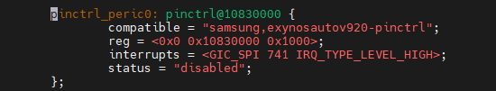

Now on target we will run command as below.

# cat /sys/kernel/debug/pinctrl/10830000.pinctrl-samsung-pinctrl/pinmux-pins

O/p – [See next page]

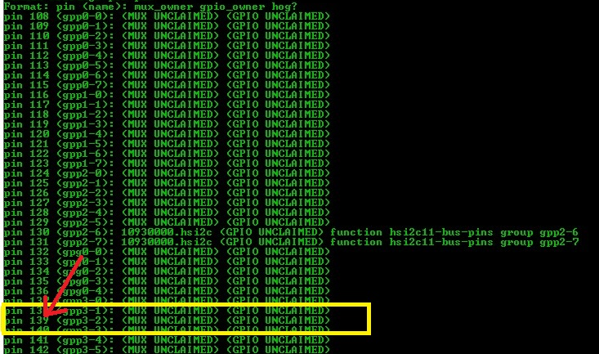

1. **Other useful command [to be tested its usage]**

# cat /sys/kernel/debug/pinctrl/10830000.pinctrl-samsung-pinctrl/pins

**Note: -**

File: - include/dt-bindings/pinctrl/samsung.h

#define EXYNOS_PIN_FUNC_INPUT 0

#define EXYNOS_PIN_FUNC_OUTPUT 1

#define EXYNOS_PIN_FUNC_2 2

1. **GPIO Pin muxing:**

To find GPIO pin configuration refer – GPIO chapter in TRM - ExynosAuto V920_User Manual_Part1_ALL_REV 1.00, Pg – 317.

For example, for GPIO – GPH0[4], follow page – 317, as shown below.

