PNP HD Tuner part number - PN3034HT

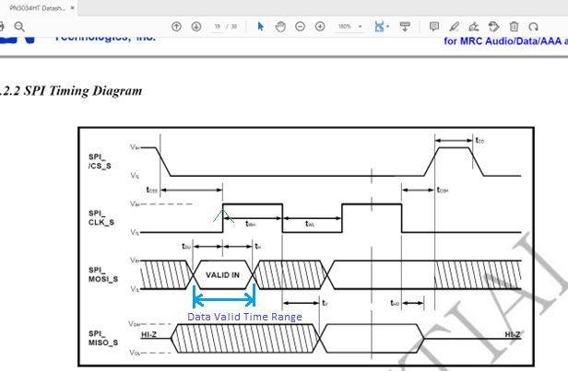

Figure - 1

From above figure in case of HD tuner data is sampled at rising edge because data is only valid tSU (setup time) before occurring the rising edge and it is valid for tH (hold time) after rising edge.

Before and after the (tRISING_EDGE + tH ) and (tRISING_EDGE - tSU), data is not valid and it may change or latched, it is shown as slant parallel lines in above figure.

Thus it confirms that HD tuner operates in SPI Mode – 0, if CPOL = 0.