**Test 1: -**

Hardware Sample – B413, High

Test setup – No code change

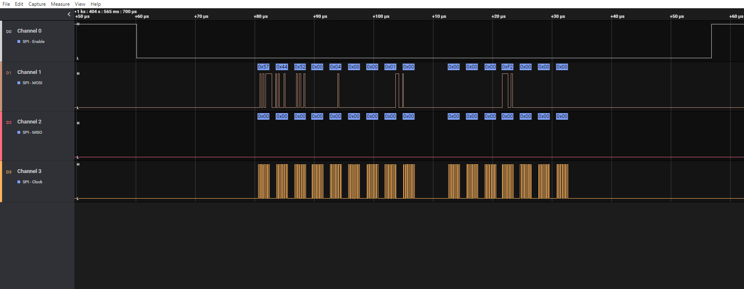

Figure 1– SPI Get version command or MOSI

Figure 2 – Tuner Reply or MISO

Status – Data Read OK

**Test 2: -**

Hardware Sample – B413, High

Test setup - FORCE bit disabled using “dynamic_spi_node” driver. In PNP driver, in function dab_read(), following code was added to toggle GPIO.

dab_read()

{

while(1){

dab_cs_assert(dabspi->cs_gpio);

udelay(100);

dab_cs_deassert(dabspi->cs_gpio);

udelay(100);

}

}

Result: -

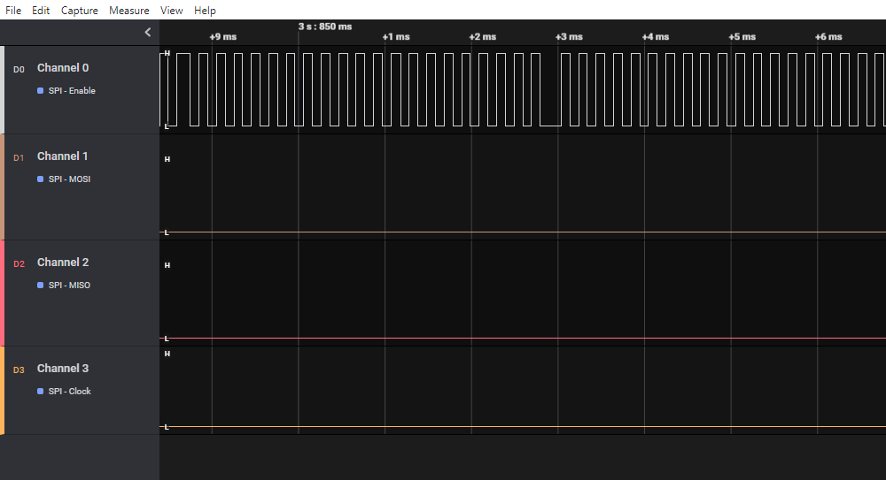

Conclusion 1: - This confirms that SPI_CS is toggling due to explicit GPIO toggling in PnP driver.

**Test 3: -**

Hardware Sample – B413, High

Test setup – FORCE bit masked using “dynamic_spi_node” driver

Test method: -

After loading the PnP driver, when test app was ran then below waveform came and test app was blocked at first read () call in main () function.

Then SPI_CS became permanently high.

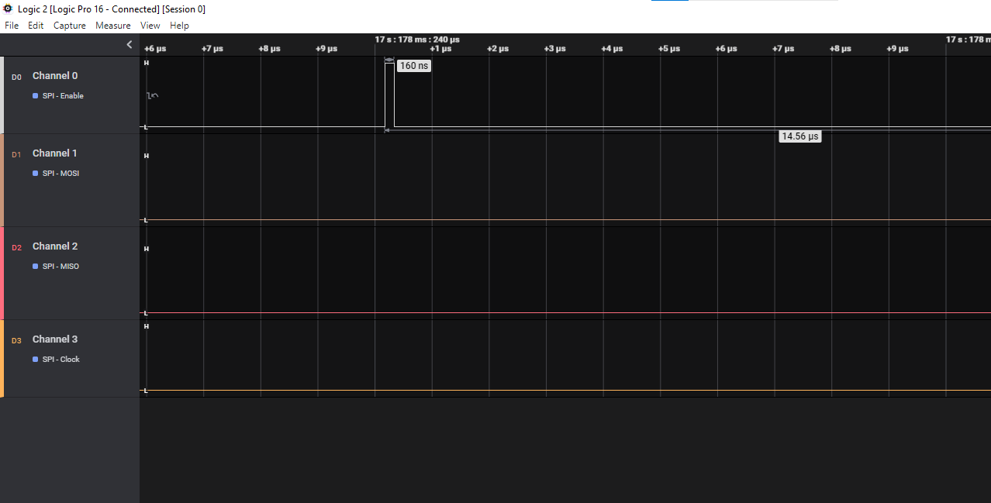

Figure – Expanded view

The question is when FORCE bit is masked, who togged CS as above.

At this stage, number of interrupt counts are only 4, as shown in figure below.

By taking kernel log, it is clear that it is failing at function spi_xchange() of PNP driver in interrupt routine in response to interrupt pulse coming from tuner.



**Source code in PNP driver –**

static irqreturn_t send_spi_data(int irq, void *data)

{

dab_cs_assert(dabspi->cs_gpio);

dabspi->txlen = 12;

res = spi_xchange(dabspi->spi, NULL, dabspi->rx_buf, dabspi->txlen);

if (res) {

dev_err(&dabspi->spi->dev, "PNP_Dabplugin: xchange failed[%d]\n", res);

goto ret;

}

res = dab_fill_kfifo(dabspi);

if (res)

dev_err(&dabspi->spi->dev, "PNP_Dabplugin: Error %s\n", __func__);

ret:

dab_cs_deassert(dabspi->cs_gpio);

return IRQ_HANDLED;

}

**Code flow: -**

spi_xchange() - - > spi_sync () - - > __spi_pump_messages( ) - - > spi_transfer_one_message - - >

omap2_mcspi_transfer_one() - - > omap2_mcspi_work_one() - - > omap2_mcspi_txrx_pio()

**Kernel Log: -**

*[ 0] [ 164.014929] [<80011ac1>] (show_stack) from [<801be8df>] (dump_stack+0x87/0xac)*

*[ 0] [ 164.014946] [<801be8df>] (dump_stack) from [<802a02ed>] (__spi_pump_messages+0x2f9/0x54c)*

*[ 0] [ 164.014960] [<802a02ed>] (__spi_pump_messages) from [<802a0721>] (__spi_sync+0x1d1/0x1d8)*

*[ 0] [ 164.014980] [<802a0721>] (__spi_sync) from [<7f81c13b>] (spi_xchange+0x52/0x6c [pnp_dabplugin])*

*[ 0] [ 164.014999] [<7f81c13b>] (spi_xchange [pnp_dabplugin]) from [<7f81c371>] (send_spi_data+0x34/0x80 [pnp_dabplugin])*

*[ 0] [ 164.015017] [<7f81c371>] (send_spi_data [pnp_dabplugin]) from [<80066485>] (irq_thread_fn+0x15/0x38)*

*[ 0] [ 164.015031] [<80066485>] (irq_thread_fn) from [<800666d3>] (irq_thread+0xfb/0x18c)*

*[ 0] [ 164.015044] [<800666d3>] (irq_thread) from [<8003e297>] (kthread+0xaf/0xc4)*

*[ 0] [ 164.015058] [<8003e297>] (kthread) from [<8000eb8d>] (ret_from_fork+0x11/0x24)*

*[ 0] [ 164.015067] MIR: In function - __spi_pump_messages, line no - 1164*

*[ 0] [ 164.015074] HARMAN: Force bit is masked*

*[ 0] [ 165.024700] pnp_dabplugin spi2.0: RXS timed out*

*[ 0] [ 165.024721] pnp_dabplugin spi2.0: SPI transfer failed: -5*

*[ 0] [ 165.024733] HARMAN: Force bit is masked*

*[ 0] [ 165.024750] spi_master spi2: failed to transfer one message from queue*

*[ 0] [ 165.024763] pnp_dabplugin spi2.0: PNP_Dabplugin: xchange failed[-5]*

*[ 0] [ 165.733989] CPU: 0 PID: 1686 Comm: irq/243-pnp_dab Not tainted 4.4.14 #Rel_Elina_J6_IUKRAM_21465B-21-gf1f4b3213295*

*[ 0] [ 165.734007] Hardware name: Generic DRA72X (Flattened Device Tree)*

*[ 0] [ 165.734038] [<80014501>] (unwind_backtrace) from [<80011ac1>] (show_stack+0x11/0x14)*

*[ 0] [ 165.734058] [<80011ac1>] (show_stack) from [<801be8df>] (dump_stack+0x87/0xac)*

*[ 0] [ 165.734078] [<801be8df>] (dump_stack) from [<802a02ed>] (__spi_pump_messages+0x2f9/0x54c)*

*[ 0] [ 165.734093] [<802a02ed>] (__spi_pump_messages) from [<802a0721>] (__spi_sync+0x1d1/0x1d8)*

*[ 0] [ 165.734116] [<802a0721>] (__spi_sync) from [<7f81c13b>] (spi_xchange+0x52/0x6c [pnp_dabplugin])*

*[ 0] [ 165.734135] [<7f81c13b>] (spi_xchange [pnp_dabplugin]) from [<7f81c371>] (send_spi_data+0x34/0x80 [pnp_dabplugin])*

*[ 0] [ 165.734156] [<7f81c371>] (send_spi_data [pnp_dabplugin]) from [<80066485>] (irq_thread_fn+0x15/0x38)*

*[ 0] [ 165.734171] [<80066485>] (irq_thread_fn) from [<800666d3>] (irq_thread+0xfb/0x18c)*

*[ 0] [ 165.734184] [<800666d3>] (irq_thread) from [<8003e297>] (kthread+0xaf/0xc4)*

*[ 0] [ 165.734200] [<8003e297>] (kthread) from [<8000eb8d>] (ret_from_fork+0x11/0x24)*

*[ 0] [ 165.734209] MIR: In function - __spi_pump_messages, line no - 1164*

*[ 0] [ 165.734218] HARMAN: Force bit is masked*

*[ 0] [ 166.734688] pnp_dabplugin spi2.0: RXS timed out*

*[ 0] [ 166.734702] pnp_dabplugin spi2.0: SPI transfer failed: -5*

*[ 0] [ 166.734709] HARMAN: Force bit is masked*

*[ 0] [ 166.734738] spi_master spi2: failed to transfer one message from queue*

*[ 0] [ 166.734748] pnp_dabplugin spi2.0: PNP_Dabplugin: xchange failed[-5]*

*[ 0] [ 166.734769] CPU: 0 PID: 1686 Comm: irq/243-pnp_dab Not tainted 4.4.14 #Rel_Elina_J6_IUKRAM_21465B-21-gf1f4b3213295*

*[ 0] [ 166.734777] Hardware name: Generic DRA72X (Flattened Device Tree)*

*[ 0] [ 166.734792] [<80014501>] (unwind_backtrace) from [<80011ac1>] (show_stack+0x11/0x14)*

*[ 0] [ 166.734807] [<80011ac1>] (show_stack) from [<801be8df>] (dump_stack+0x87/0xac)*

*[ 0] [ 166.734820] [<801be8df>] (dump_stack) from [<802a02ed>] (__spi_pump_messages+0x2f9/0x54c)*

*[ 0] [ 166.734832] [<802a02ed>] (__spi_pump_messages) from [<802a0721>] (__spi_sync+0x1d1/0x1d8)*

*[ 0] [ 166.734846] [<802a0721>] (__spi_sync) from [<7f81c13b>] (spi_xchange+0x52/0x6c [pnp_dabplugin])*

*[ 0] [ 166.734863] [<7f81c13b>] (spi_xchange [pnp_dabplugin]) from [<7f81c371>] (send_spi_data+0x34/0x80 [pnp_dabplugin])*

*[ 0] [ 166.734880] [<7f81c371>] (send_spi_data [pnp_dabplugin]) from [<80066485>] (irq_thread_fn+0x15/0x38)*

*[ 0] [ 166.734893] [<80066485>] (irq_thread_fn) from [<800666d3>] (irq_thread+0xfb/0x18c)*

*[ 0] [ 166.734904] [<800666d3>] (irq_thread) from [<8003e297>] (kthread+0xaf/0xc4)*

*[ 0] [ 166.734916] [<8003e297>] (kthread) from [<8000eb8d>] (ret_from_fork+0x11/0x24)*

*[ 0] [ 166.734925] MIR: In function - __spi_pump_messages, line no - 1164*

*[ 0] [ 166.734932] HARMAN: Force bit is masked*

*[ 0] [ 167.744690] pnp_dabplugin spi2.0: RXS timed out*

*[ 0] [ 167.744710] pnp_dabplugin spi2.0: SPI transfer failed: -5*

*[ 0] [ 167.744721] HARMAN: Force bit is masked*

*[ 0] [ 167.744736] spi_master spi2: failed to transfer one message from queue*

*[ 0] [ 167.744748] pnp_dabplugin spi2.0: PNP_Dabplugin: xchange failed[-5]*

*[ 0] [ 167.836026] pnp_dabplugin spi2.0: PNP_Dabplugin: No Data available in Kfifo, going to wait*

*[ 0] [ 183.047580] pnp_dabplugin spi2.0: PNP_Dabplugin: Read was interrupted [-512]*

From above log, it is found that the below function is failing on masking FORCE bit.

ret = master->transfer_one_message(master, master->cur_msg);

static int spi_master_initialize_queue(struct spi_master *master)

{

…..

if (!master->transfer_one_message)

master->transfer_one_message = spi_transfer_one_message;

………

}

static int spi_transfer_one_message(struct spi_master *master, struct spi_message *msg)

{

spi_set_cs(msg->spi, true);

ret = master->transfer_one(master, msg->spi, xfer);

if (ret < 0) {

dev_err(&msg->spi->dev, "SPI transfer failed: %d\n", ret);

goto out;

}

}

Error - SPI transfer failed due to master->transfer_one( )

**File – drivers/spi/spi-omap2-mcspi.c**

static int omap2_mcspi_probe(struct platform_device *pdev)

{

……….

master->transfer_one = omap2_mcspi_transfer_one;

……….

}

Hence, finally omap2_mcspi_transfer_one() is failing due to spi_sync() call from IRQ routine of Pnp driver. The function omap2_mcspi_transfer_one() in turn calls the function omap2_mcspi_work_one().

Then it calls omap2_mcspi_txrx_pio().

**Actual failure: -**

spi_xchange() - - > spi_sync () - - > __spi_pump_messages( ) - - > spi_transfer_one_message - - >

omap2_mcspi_transfer_one() - - > omap2_mcspi_work_one() - - > omap2_mcspi_txrx_pio()

*omap2_mcspi_txrx_pio() {*

*if (mcspi_wait_for_reg_bit(chstat_reg, OMAP2_MCSPI_CHSTAT_RXS) < 0) {*

*dev_err(&spi->dev, "RXS timed out\n");*

*goto out;*

*}*

*}*

static int mcspi_wait_for_reg_bit(void __iomem *reg, unsigned long bit)

{

unsigned long timeout;

timeout = jiffies + msecs_to_jiffies(1000);

while (!(readl_relaxed(reg) & bit)) {

……

}

This error comes when data is not received with 1 second time out.

Hardware register - MCSPI_CH0STAT, AM335X TRM Pg – 4942.

Observation: - Immediately after Tuner reset, it gives two pulses. But we can see from below figure is that SPI_CLK does not generate. It is the reason it is failing due to “RXS” timeout of 1000ms.

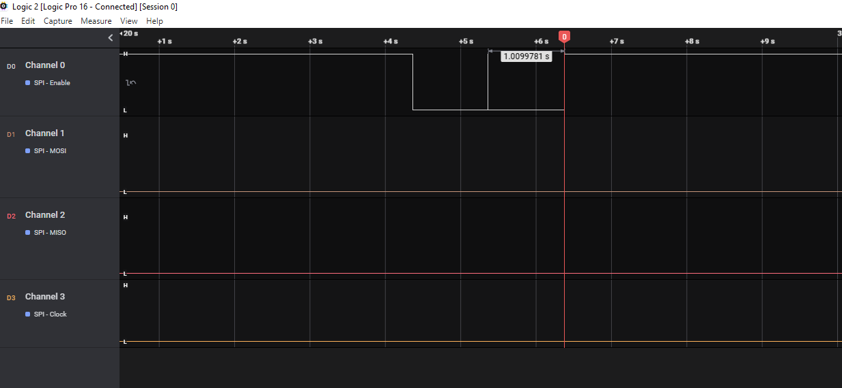

**Test 4: -**

Behavior after Reset.

Test setup: -

FORCE bit masked. Test app programmed to generate Reset.

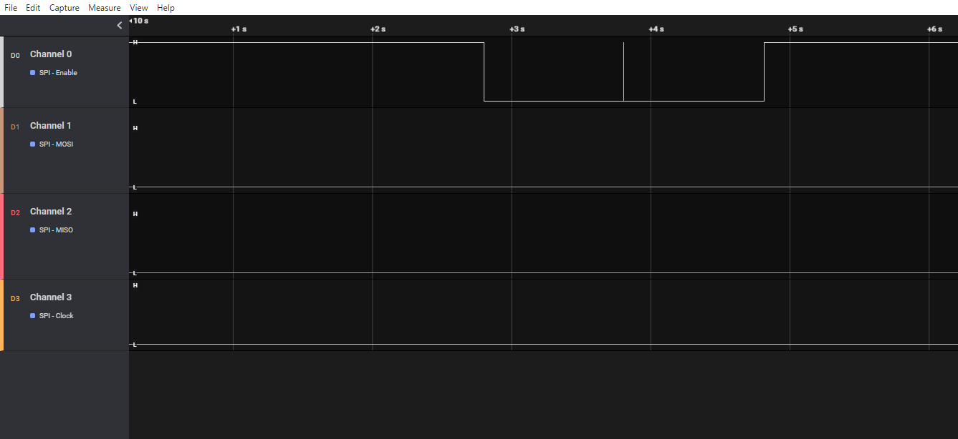

**Test 5: -**

Behavior just after Power ON Reset.

Test setup: -

FORCE bit unmasked. GPIO toggling in PNP driver is commented.

Test app programmed to generate Reset.

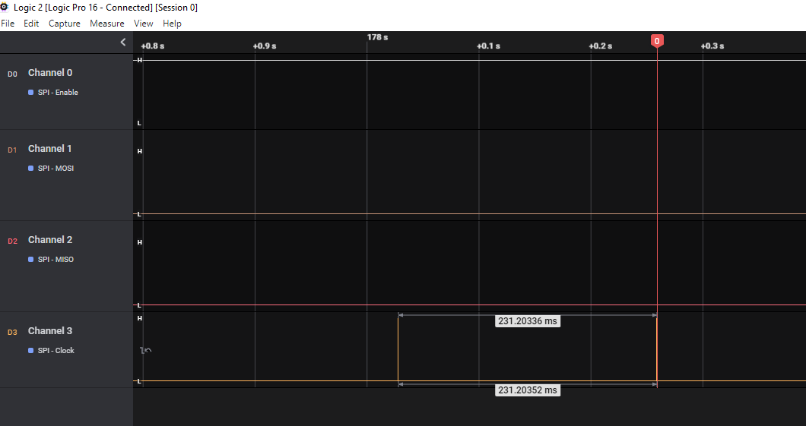

**Test 6: -**

Behavior just after Power ON Reset.

Test setup: -

FORCE bit unmasked. GPIO toggling in PNP driver is enabled back.

Test app programmed to generate Reset.

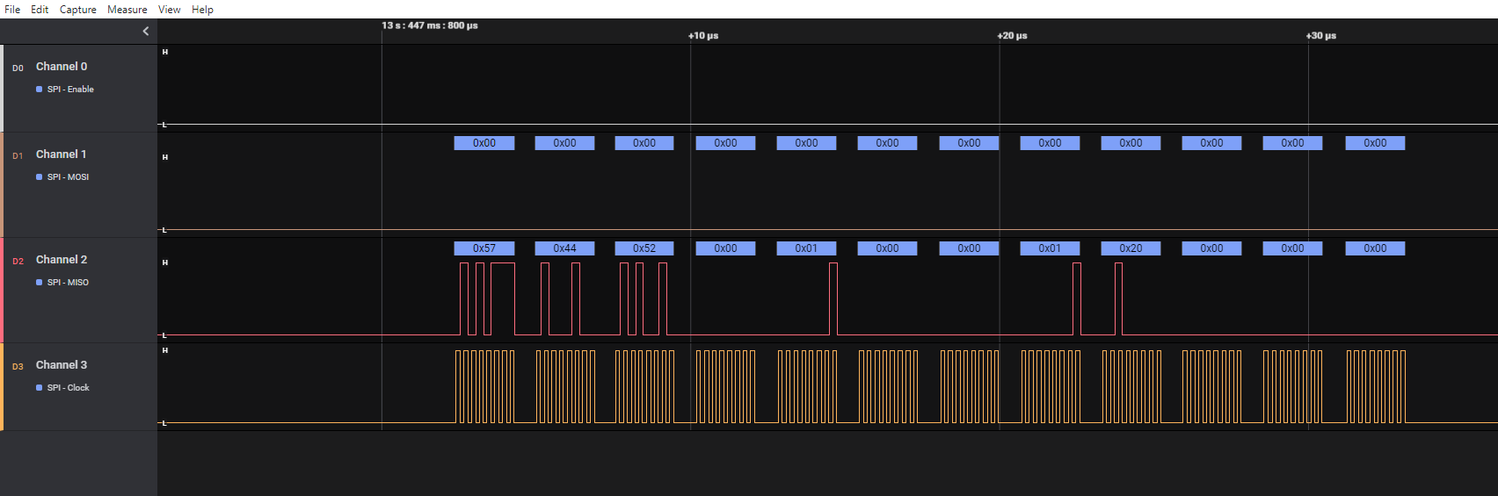

Conclusion: -

As SPI_CS is set using Pin Muxing as GPIO4_9 using DTS, so CS is toggling because of PNP driver

only. But when we mask FORCE bit then SPI_CLK is not generated from OMAP SPI Master.

So, for SPI_CS to work FORCE bit should be enabled, if GPIO is used for toggling the SPI_CS.

As per kernel version – 4.19 below code was found for spi_set_cs().

File – drivers/spi/spi.c

static void spi_set_cs(struct spi_device *spi, bool enable)

{

if (spi->mode & SPI_CS_HIGH)

enable = !enable;

if (gpio_is_valid(spi->cs_gpio)) {

gpio_set_value(spi->cs_gpio, !enable);

/* Some SPI masters need both GPIO CS & slave_select */

if ((spi->controller->flags & SPI_MASTER_GPIO_SS) &&

spi->controller->set_cs)

spi->controller->set_cs(spi, !enable);

} else if (spi->controller->set_cs) {

spi->controller->set_cs(spi, !enable);

}

}

File – drivers/spi/spi-omap2-mcspi.c

static int omap2_mcspi_work_one(struct omap2_mcspi *mcspi,

struct spi_device *spi, struct spi_transfer *t)

{

……

if (gpio_is_valid(spi->cs_gpio))

omap2_mcspi_set_cs(spi, spi->mode & SPI_CS_HIGH);

}

From above function it is clear that even if we use DTS property “cs-gpio = < &gpio4 9 >, the omap FORCE bit is getting changed accordingly for CS to toggle.

In our case, PNP driver is toggling GPIO but as we are not using DTS property cs-gpio, so SPI core’s function spi_set_cs() is choosing omap2_mcspi_set_cs() to toggle FORCE bit.

**Note: -**

GPIO CS pin muxing for SPI for PNP DAB tuner.

For B413 IUK Ram High variant hardware the dts file is “arch/arm/boot/dts/

j6eco_inkram_high_generic. dtsi”. In this “dab-cs-pinmux” is defined as below.

*dabplugin {*

*dab-cs-gpio = <115>;*

*dab-irq-gpio = <230>;*

*dab-cs-pinmux = <0x4A0035C8 0x0006000E>;*

*dab-pm-disable;*

*};*

From page number - 71 of DRA74x data sheet:

Ball No – D11 is “vout1_clk” by default and it can be multiplexed to behave as “spi3_cs0”

in Mux-Mode = 8 and it can behave as “gpio4_9” in Mux-Mode = 14.

From page number – 4429 of DRA74x TRM:

Control module core base address for “CTRL_CORE_PAD_VOUT1_CLK” be 0x4A00 35C8.

As per “Pad Configuration Register” in page – 4376, the ball D11 is set to behave as “GPIO4_9”

and receiver is enabled to work in bidirectional mode.

