**SPI Driver Basics: -**

1. **SPI Modes: -**

CPOL = 0 - > Idle state of SPI_CLK is low

CPHA = 0 - > Data latched in falling edge

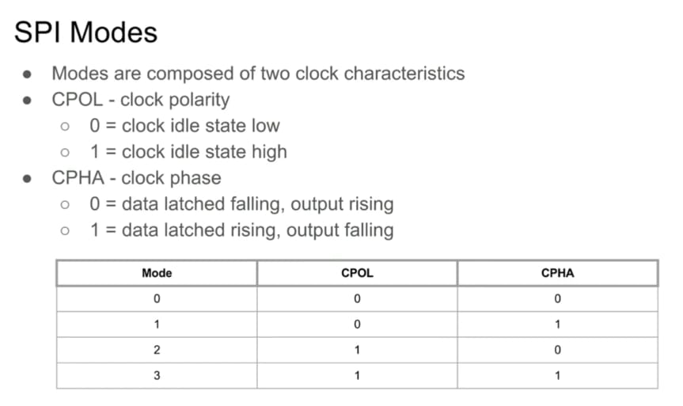

Figure - 1

1. **Types of SPI: -**

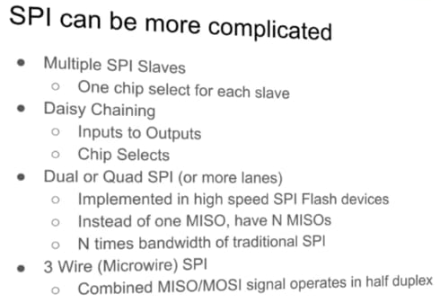

Figure – 2

1. **Linux SPI Driver: -**

There are two types of SPI driver –

1. SPI controller driver
2. SPI protocol driver

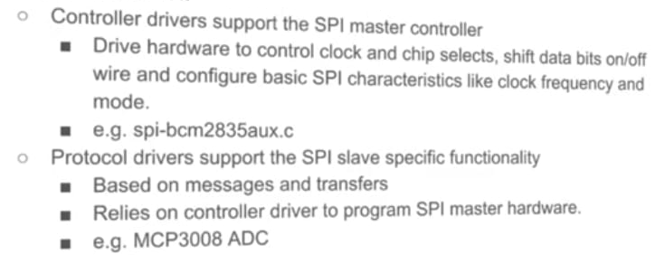

Figure – 3

1. **Linux SPI communication: -**

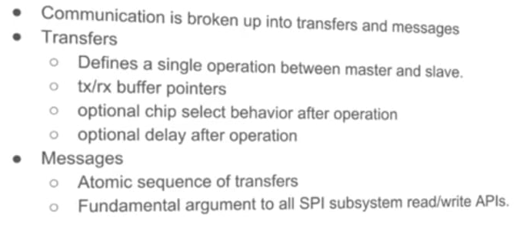

Figure – 4

struct spi_message is basically argument to all SPI sub system read/write APIs.

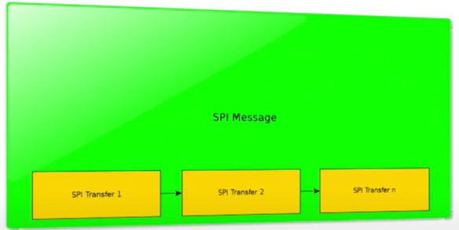

Figure – 5

1. **Adding a SPI device to a system: -**

Figure - 6

1. **SPI device DT binding: -**

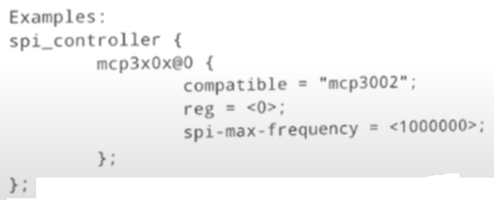

Figure – 7

1. **Adding SPI device using board file: -**

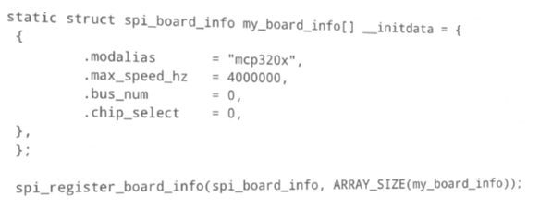

Figure - 8

1. **SPI protocol driver: -**

Follows standard driver model.

Figure – 9

1. **SPI sub system kernel APIs: -**

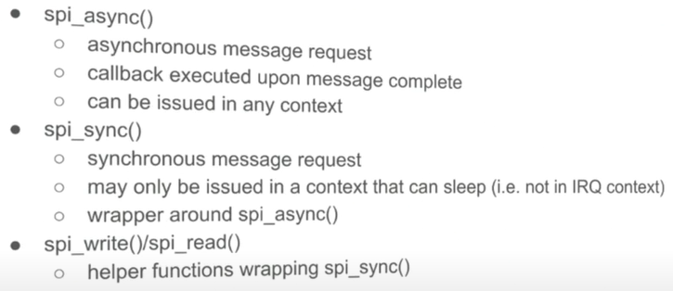

Figure - 10

Figure – 11

1. **SPI controller driver: -**

Figure – 12

transfer_one model allows us to let the core support GPIO chip select.

1. **User space driver - spidev: -**

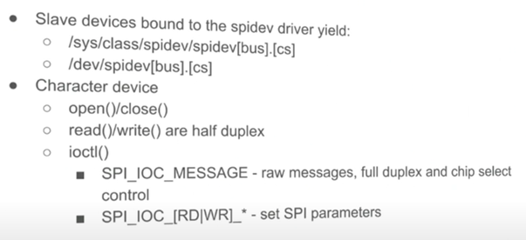

Figure – 13

SPI is inherently a full duplex bus.

1. **“spi_transfer” cs_change flag: -**

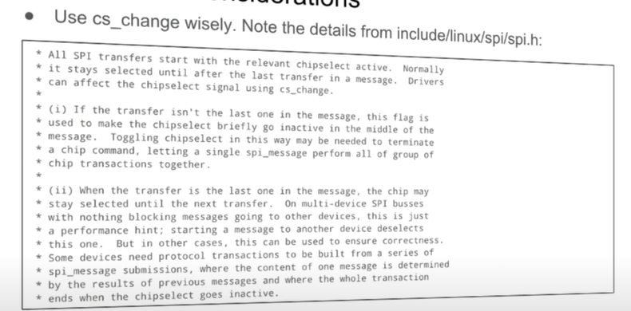

1. **Performance considerations: -**

1. **Performance tools: -**

