**SPI Driver Basics: -**

1. **SPI Modes: -**

CPOL = 0 - > Idle state of SPI_CLK is low

CPHA = 0 - > Data latched or shifted out on falling edge

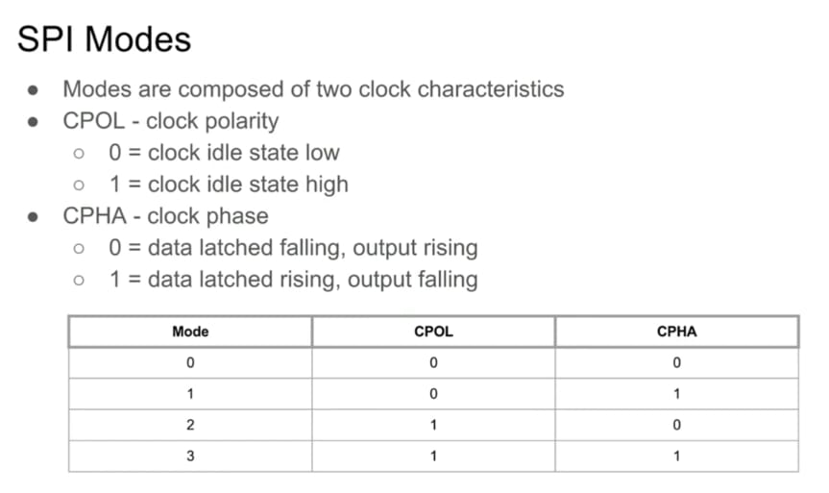

Figure – 1

**SPI Mode = 0: -**

In SPI Mode = 0, CPOL = 0 and CPHA = 0. So, idle state of clock is zero and since CPHA = 0, so data is latched or shifted out on falling edge and data is sampled or captured on rising edge of clock. It is shown in figure – 2 below.



Figure – 2: SPI_MODE = 0

From figure – 2, it is clear that in SPI Mode = 0, data are latched or shifted out on falling edge and data are sampled or captured on clock’s rising edge.

**SPI Mode = 1: -**

In SPI Mode = 1, CPOL = 0 and CPHA = 1. So, idle state of clock is zero and since CPHA = 1, so data is latched or shifted out on rising edge and data is sampled or captured on falling edge of clock. It is shown in figure – 3 below.



Figure – 3: SPI_MODE = 1

If CPHA = 1, then data changes or latches at rising edge for both MOSI and MISO signal.

1. **Types of SPI: -**

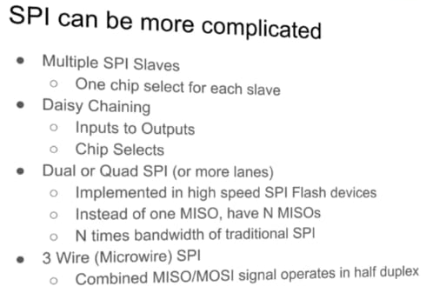

Figure – 2

1. **Linux SPI Driver: -**

There are two types of SPI driver –

1. SPI controller driver
2. SPI protocol driver

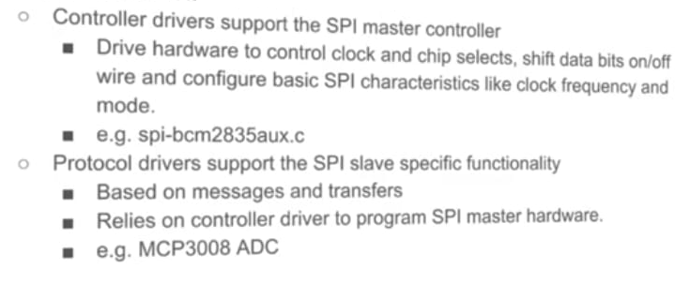

Figure – 3

1. **Linux SPI communication: -**

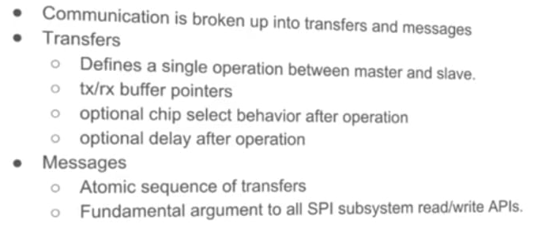

Figure – 4

struct spi_message is basically argument to all SPI subsystem read/write APIs.

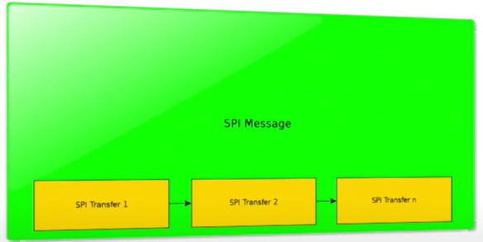

Figure – 5

1. **Adding a SPI device to a system: -**

Figure - 6

1. **SPI device DT binding: -**

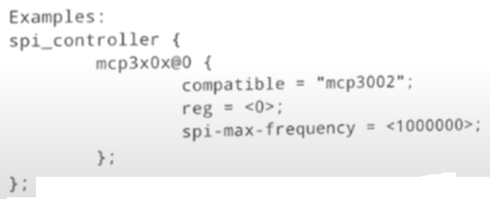

Figure – 7

1. **Adding SPI device using board file: -**

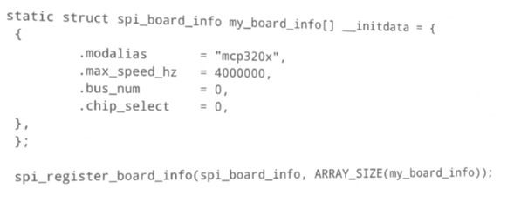

Figure - 8

1. **SPI protocol driver: -**

Follows standard driver model.

Figure – 9

1. **SPI sub system kernel APIs: -**

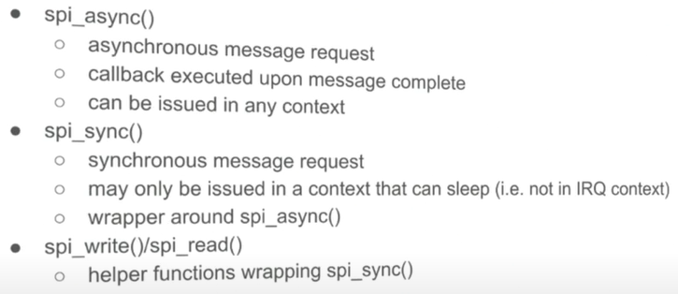

Figure - 10

Figure – 11

1. **SPI controller driver: -**

Figure – 12

transfer_one model allows us to let the core support GPIO chip select.

1. **User space driver - spidev: -**

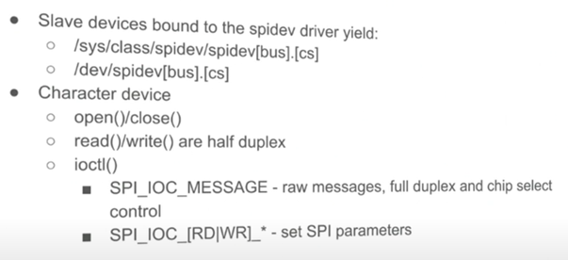

Figure – 13

SPI is inherently a full duplex bus.

1. **“spi_transfer” cs_change flag: -**

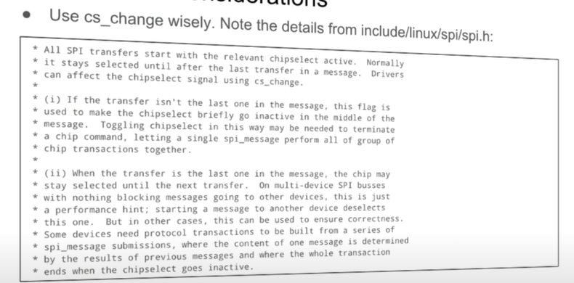

1. **Performance considerations: -**

1. **Performance tools: -**

1. **SPI core API: -**

Source code – drivers/spi/spi.c

1. spi_transfer_one_message(): -

This is a standard implementation of transfer_one_message() for drivers which implement a transfer_one() operation.

It does following things: -

* It takes struct spi_message as argument. As we know that spi_message is having multiple spi_transfer.

This function iterates through various “struct spi_transfer” in “struct spi_message” and then it invokes lower-level function of controller for transfer to take place.

static int spi_transfer_one_message(struct spi_controller *ctlr,

struct spi_message *msg)

{

list_for_each_entry(xfer, &msg->transfers, transfer_list) {

…..

ret = ctlr->transfer_one(ctlr, msg->spi, xfer);

…..

= = > wait for a timeout for transfer completion

}

* This function also introduces some delay after each transfer, by using following piece of code.

struct spi_transfer *xfer;

f (xfer->delay_usecs) {

u16 us = xfer->delay_usecs;

if (us <= 10)

udelay(us);

else

usleep_range(us, us + DIV_ROUND_UP(us, 10));

}

* This function is also responsible for setting CS line as per user choice as below.

if (xfer->cs_change) {

if (list_is_last(&xfer->transfer_list,

&msg->transfers)) {

keep_cs = true;

} else {

spi_set_cs(msg->spi, false);

udelay(10);

spi_set_cs(msg->spi, true);

}

}

If spi_transfer - > cs_change is chosen 1 then CS changes as below: -

If spi_transfer is not last, then CS line is made high only for 10 µs then it is made low again.

Similarly if spi_transfer is last in the list, then it will maintain CS line low only, if SPI_CS is set as active low.