Contents

# Virtualisation Basics

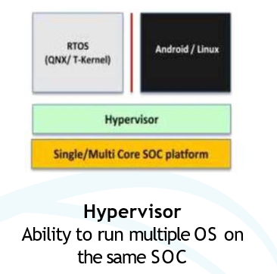

* IDCEvo uses para-virtualisation. Node -0 is Host and Android is guest.

# IDCEvo uses Type-1 hypervisor: -

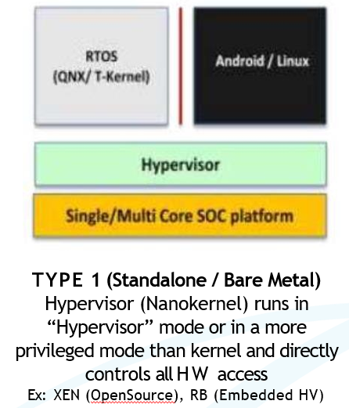

* Type 1 & Type 1.5 Hypervisor can be expected to provide the **right performance** – e.g., no significant degradation of boot time, interrupt latency, scheduling / task switching latency, etc. because it operates as a thin nano or micro-kernel layer directly on top of the HW just exposing hardware resources to Guest OSes.