HOW TO CLAIM ADVANCE FROM MEMBER UNIFIED PORTAL

To claim advance from PF portal, the member ID should be available in EPFO database and the employer should have registered the digital signatures of his authorized signatories with EPFO on the portal.
Pls click on the below link
https://unifiedportal-mem.epfindia.gov.in/memberinterface
Below screen would appear, pls enter your UAN & password / activate your UAN
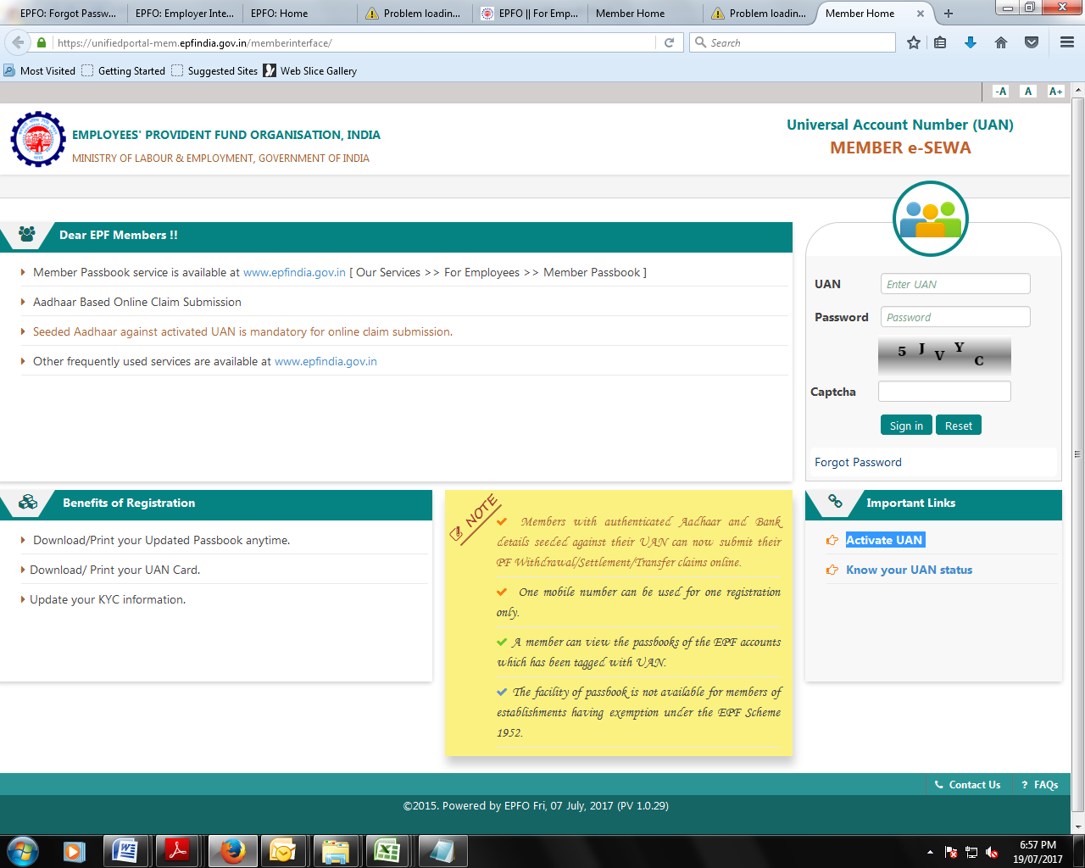

Process flow after UAN activation for Advance claim
Home screen of member is as follows:-
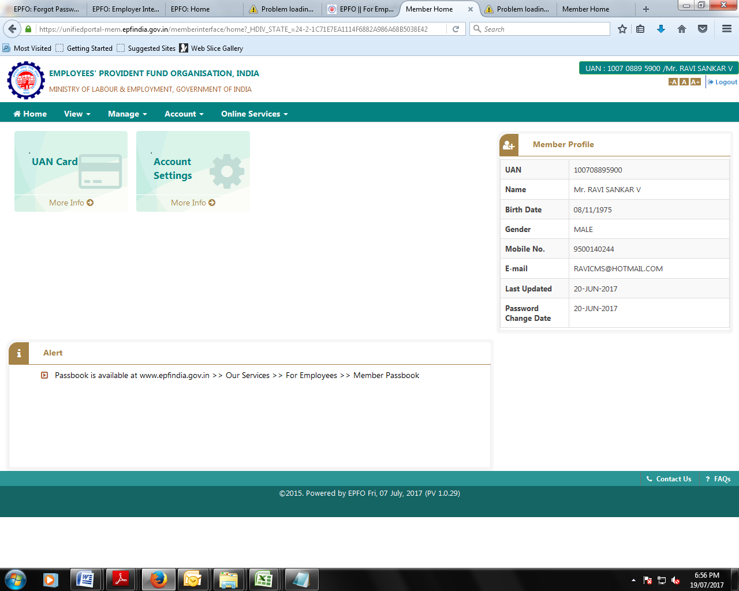

Select Home-> Online services-> Claim (31,19 & 10 C) in the below screen

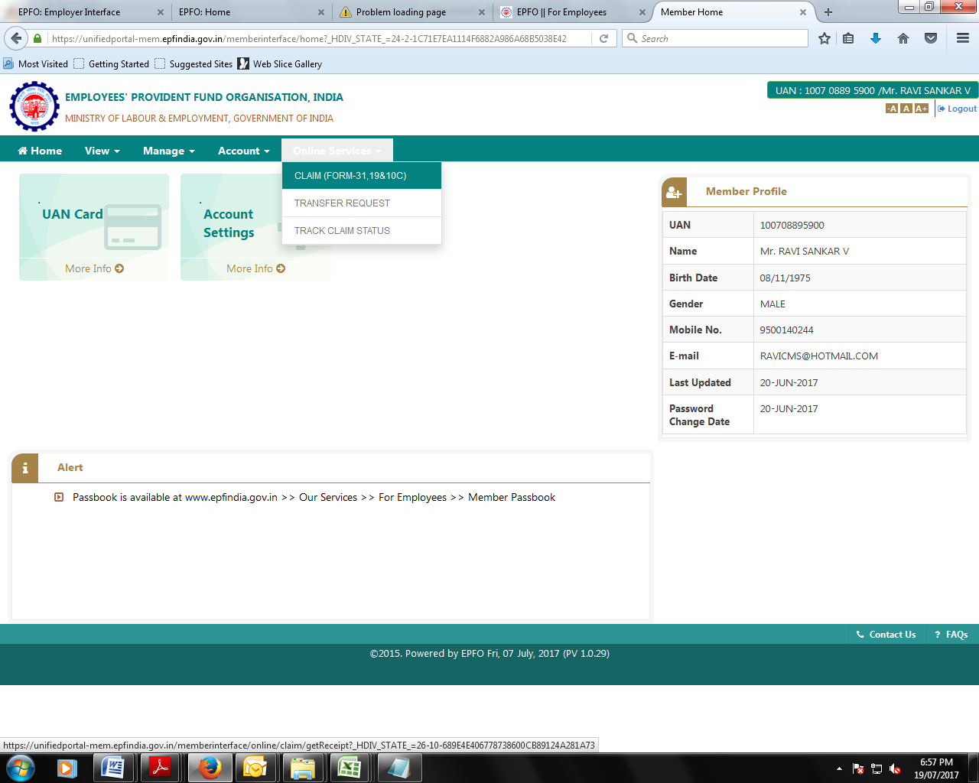

- Click “Proceed for Online Claim” in the below screen
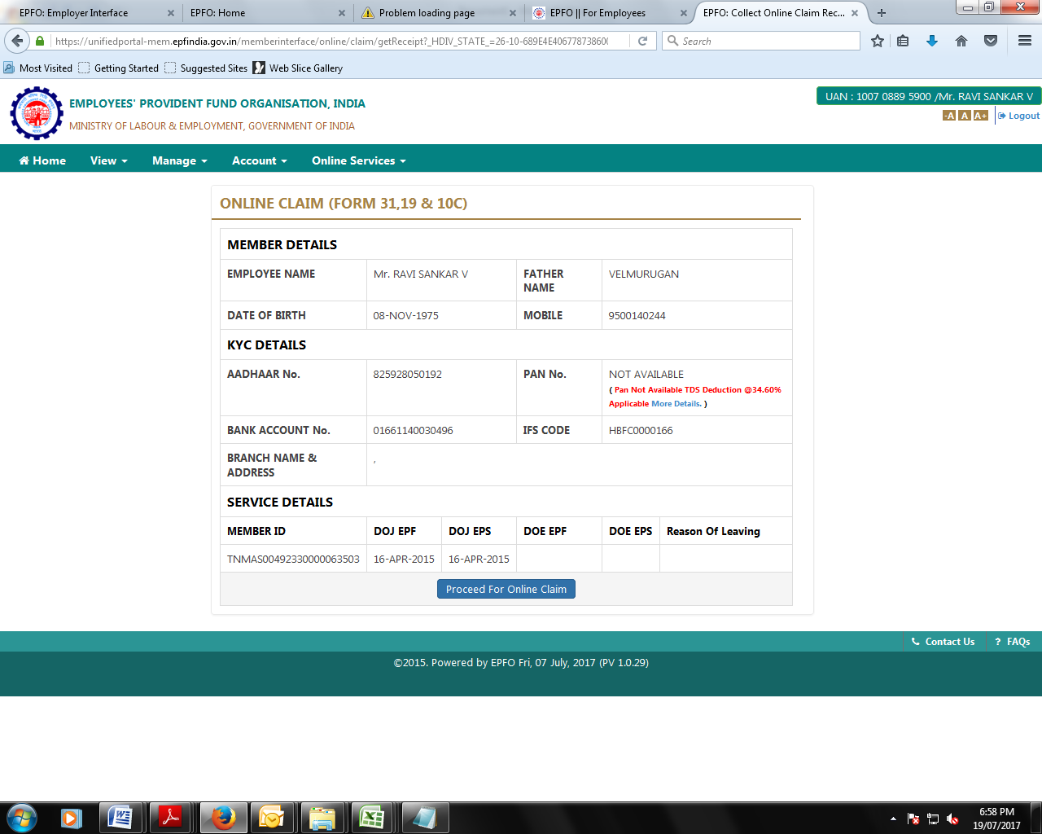

Select drop down in I want to apply for “Select Claim option “ PF Advance ( Form 31) in the below screen

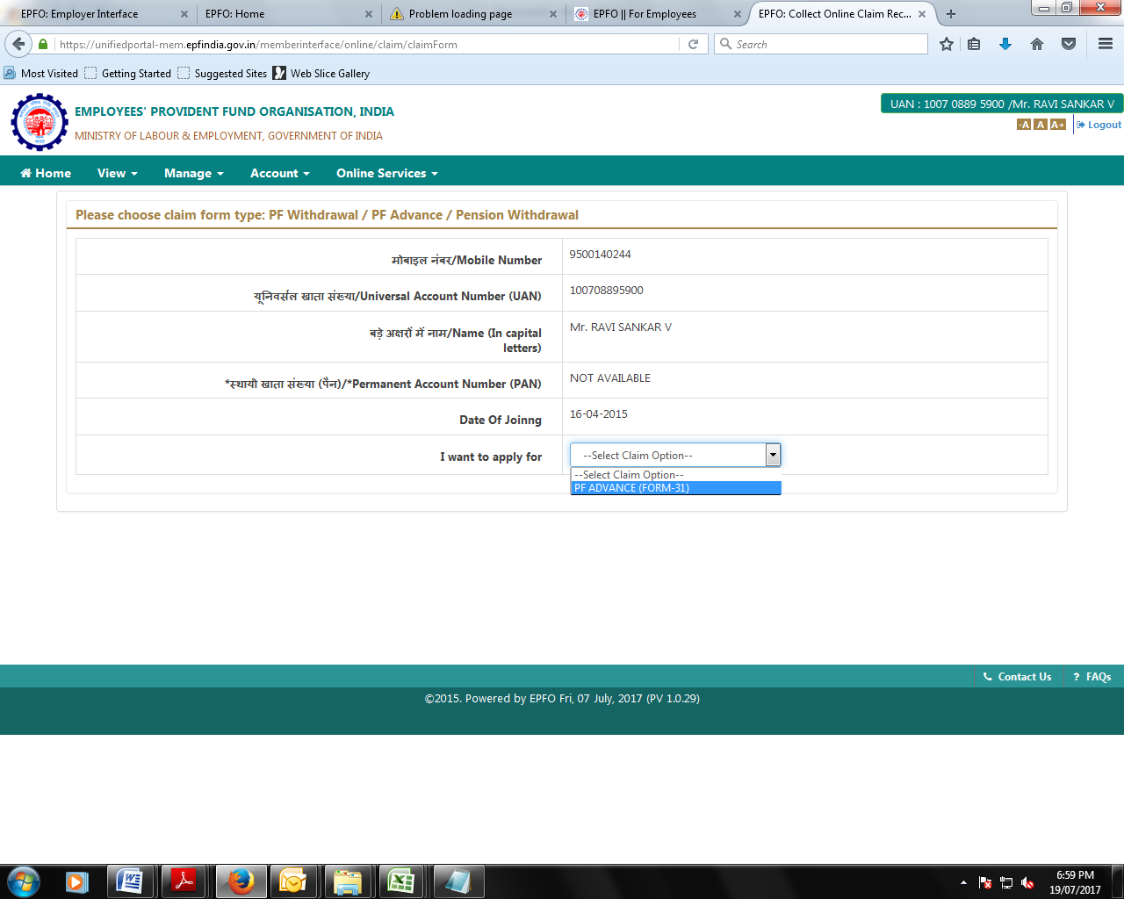

Step: 4
Select Purpose for which advance is required from option listed below based on the your requirement of advance

- Non Receipt of Wages (> 2 months)
- Illness
- Natural Calamities
- Power Cut
- Purchase of Handicap equipment
- Construction of House( Total service not less than 60months)
- Marriage ( Total service not less than 84months)
- Higher Education(( Total service not less than 84months)
- 99% withdrawal before retirement( Age must be more than 41)

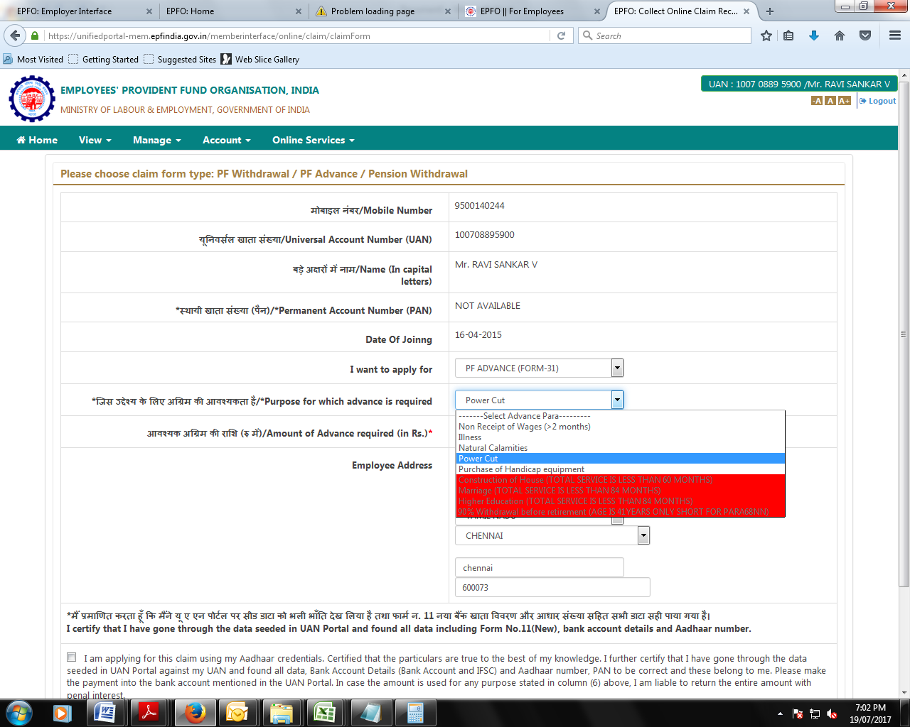

Step :5

Pls provide below listed details in the beneath screen

- Enter Amount of Advance required (in Rs.)
- Enter Employee Address
- Select Check box in the bottom of the window
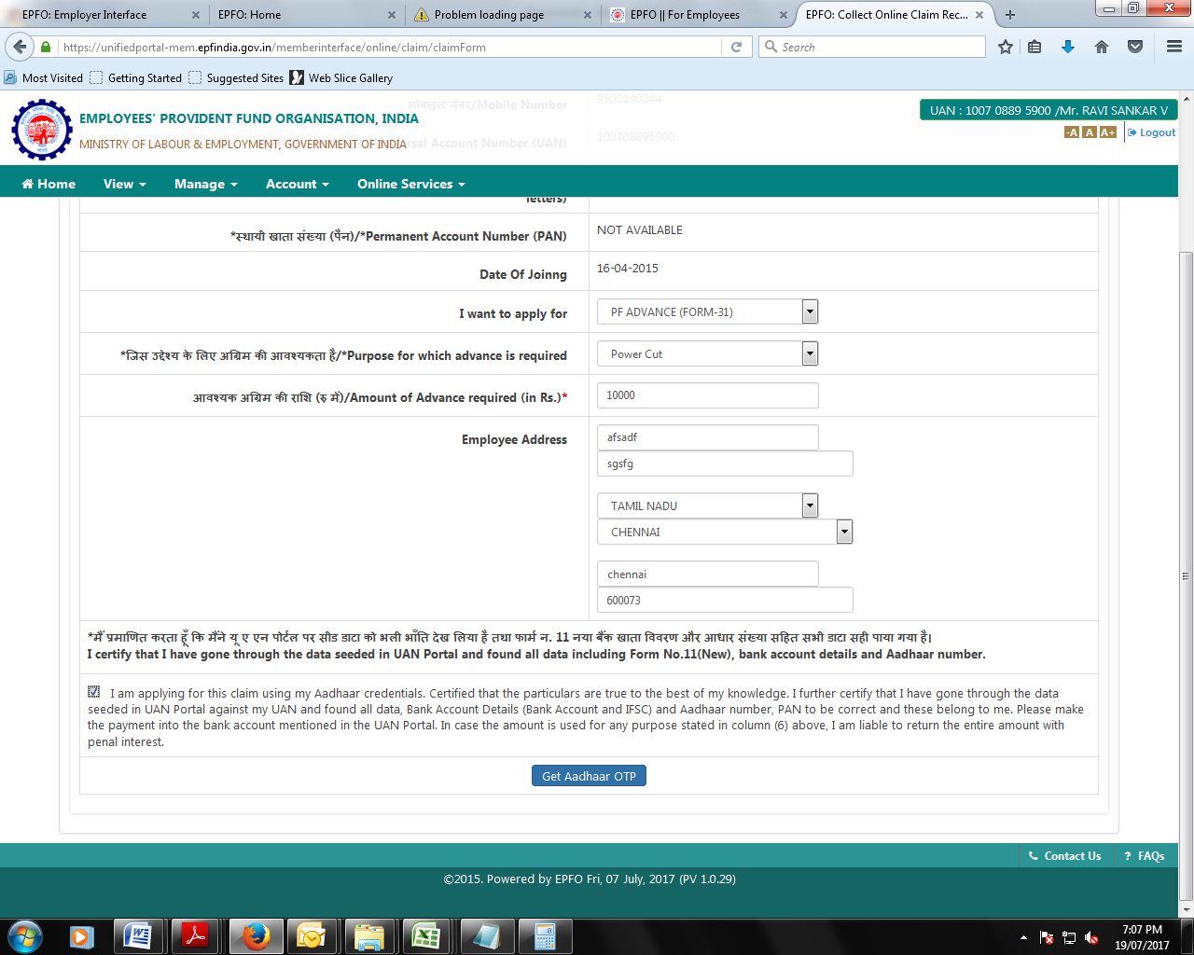

Step: 6

Click Aadhar OTP and enter OTP received on your registered mobile number
Click ” Validate OTP and Submit Claim Form”
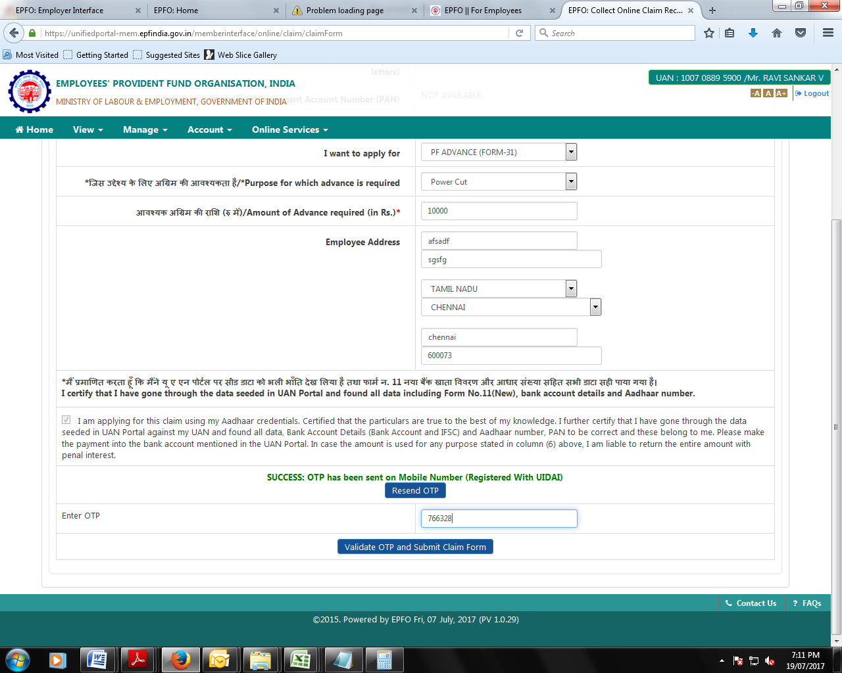

Once cliam submitted through the above process employee can check the Advcne claim status though below link in the employee unified portal

To Check your advance claim status Online Service -> Claim status ( Pls look at the selection down down in the below screen)

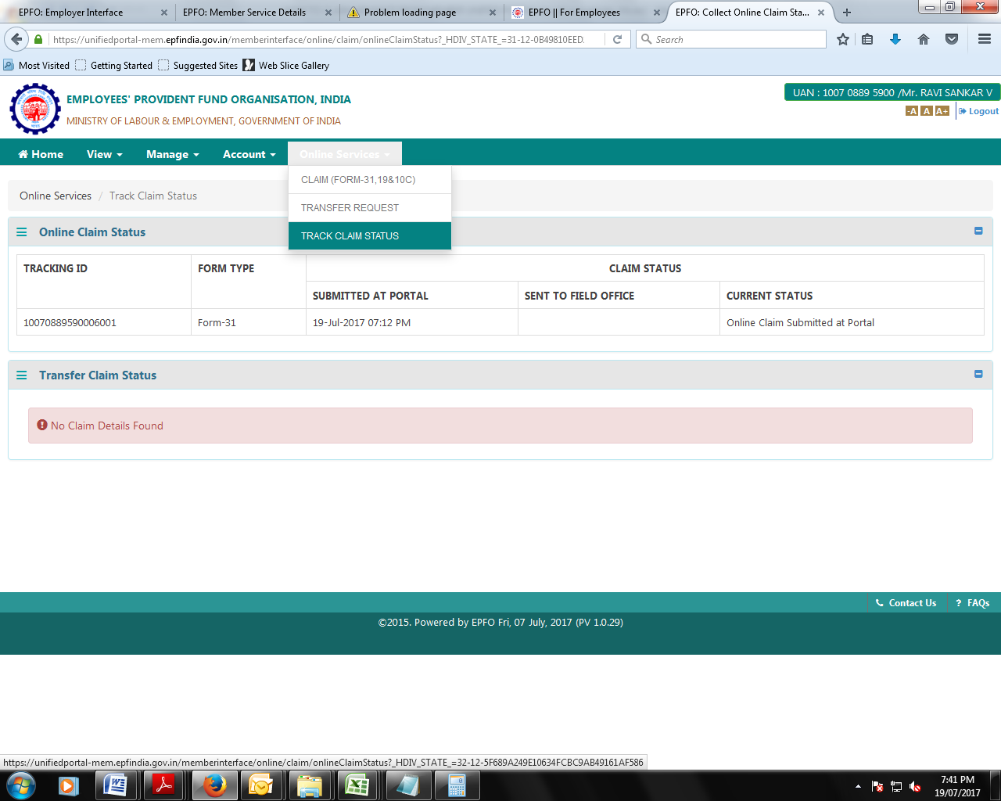

ONLINE TRANSFER PROCESS FLOW IN MEMBER UNIFIED PORTAL
To file a transfer claim online, the member ID should be available in EPFO database and the employer should have registered the digital signatures of his authorized signatories with EPFO on the portal
Transfer will be working only for employee who have already uploaded their KYC in their portal, else first they can upload their KYC and same should approved by the employer through their Digital signature.
Once KYC got updated employee can carry out transfer
Before initiating the transfer process, employee should be ready with the following datas
- PF number & UAN with his/her previous Company
- His DOJ & DOE with previous company
Home-> Online services-> Transfer Request

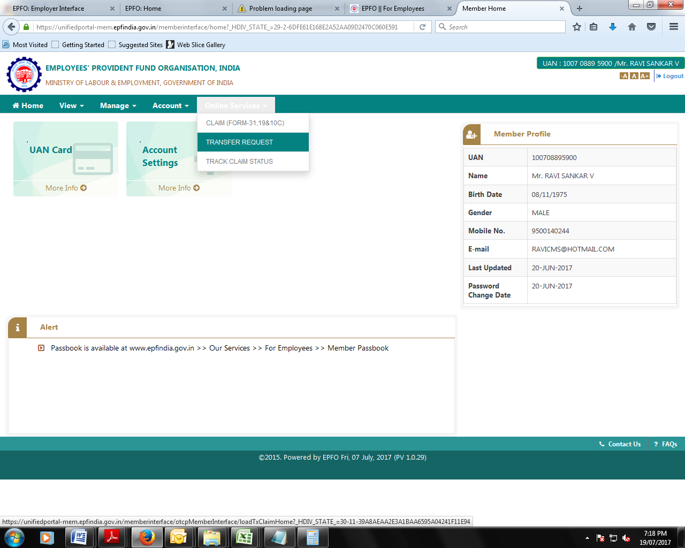

Step: 1

Pls read out the instruction before heading for transfer as follows
Online transfer requests are accepted only when:-
- KYC details are seeded against the UAN.
- Only one transfer request against the previous member ID can be accepted.
- If previous / present (Exempted) trust bank account and IFS code are available.
- Please ensure that the personal information shown below is correct before proceeding with claim submission.
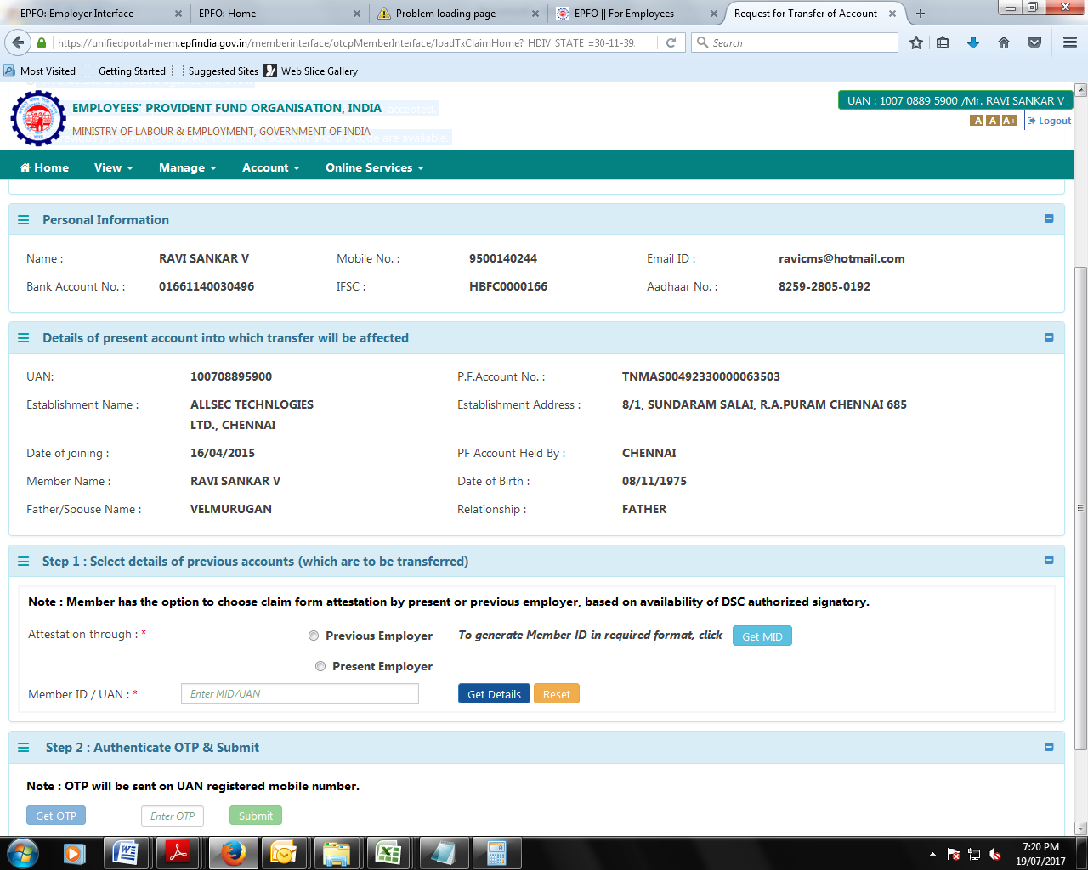

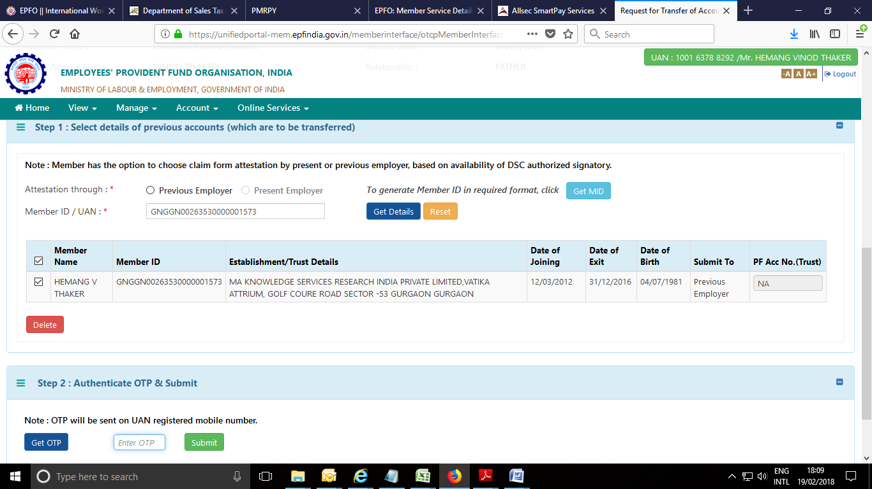

Step: 6
- Select details of previous account
- Provide attestation rights to present Establishment / previous Establishment
- Enter UAN
Step: 7
Click “Get OTP” and enter the OTP received on your registered mobile number
Finally click on “Submit”
Save the transfer acknowledgement for future reference

HOW TO CHECK TRANSFER STATUS
Once Transfer is submitted same will be rerouted to previous & present establishment for attestation
Also you can view your transfer status in the below path
Member portal -> Home Page ->Online Services-> Track Claim Status

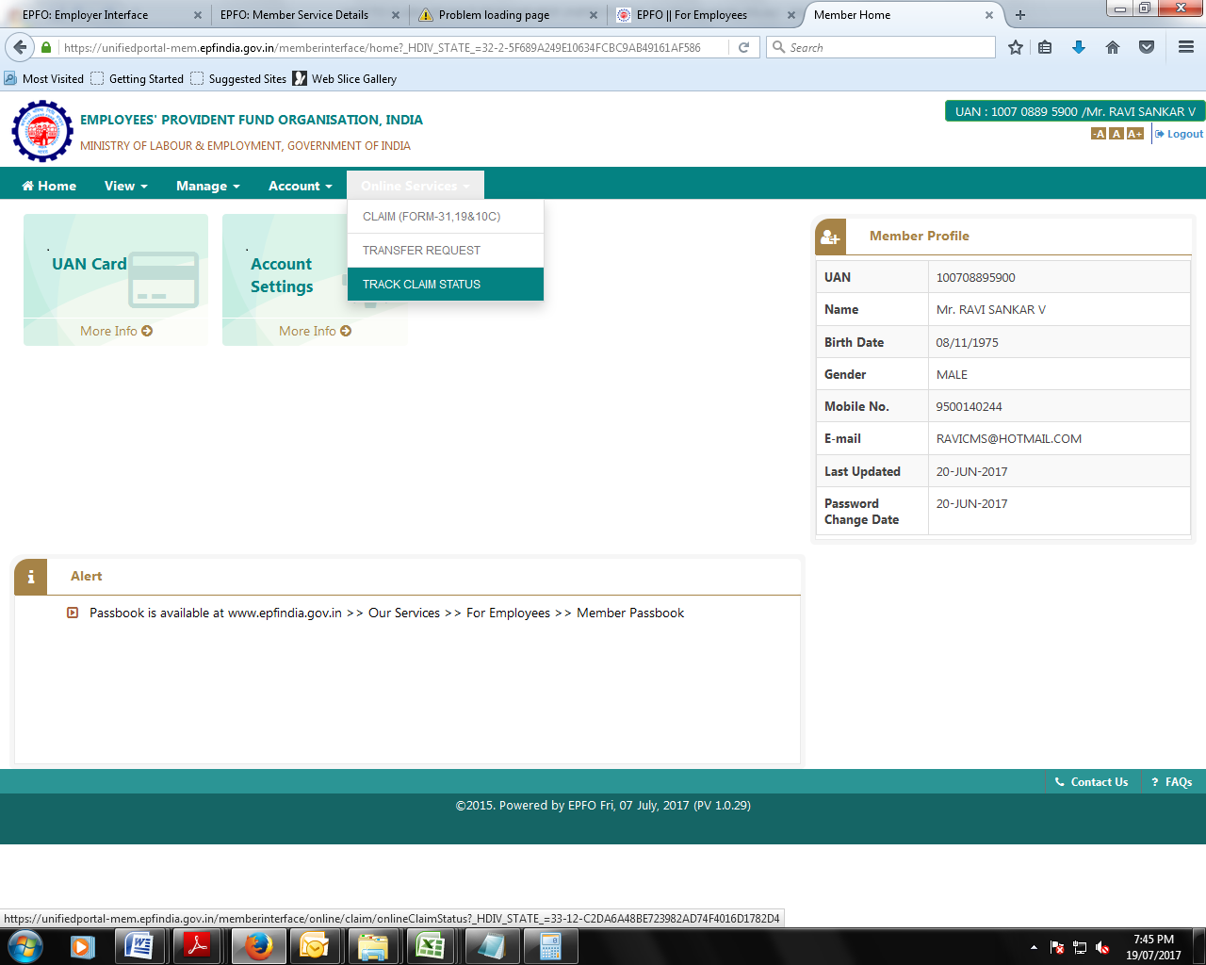

You can view your transfer claim status on the below window.
