1. Physical IRQs may be assigned any vector in the range 32-238. However, Linux uses vector 128 to implement system calls.

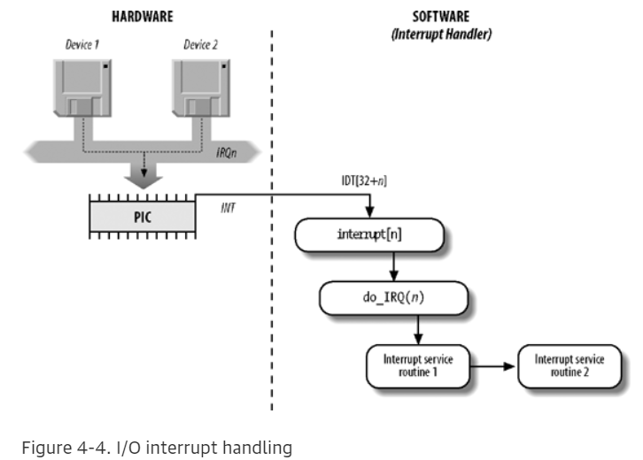

1. IRQ Data Structure: -

The kernel must discover which I/O device corresponds to the IRQ number before enabling interrupts. Otherwise, for example, how could the kernel handle a signal from a SCSI disk without knowing which vector corresponds to the device? The correspondence is established while initializing each device driver.

Each interrupt is described by an interrupt descriptor structure irq_desc. The interrupt is referenced by an ’unsigned int’ numeric value which selects the corresponding interrupt decription structure in the descriptor structures array. The descriptor structure contains status information and pointers to the interrupt flow method and the interrupt chip structure which are assigned to this interrupt.

