Contents
1. Typical MAC to PHY application circuit: - 2
2. Ethernet Hw connection block diagram: - 3
3. Different types of MAC interfaces: - 4
4. Hardware connection of Ethernet PHY on SKAM62 board: - 6
5. Ethernet connection in TIDA-010010 board: - 7
6. DP83867 Ethernet PHY Linux driver: - 7

Typical MAC to PHY application circuit: -

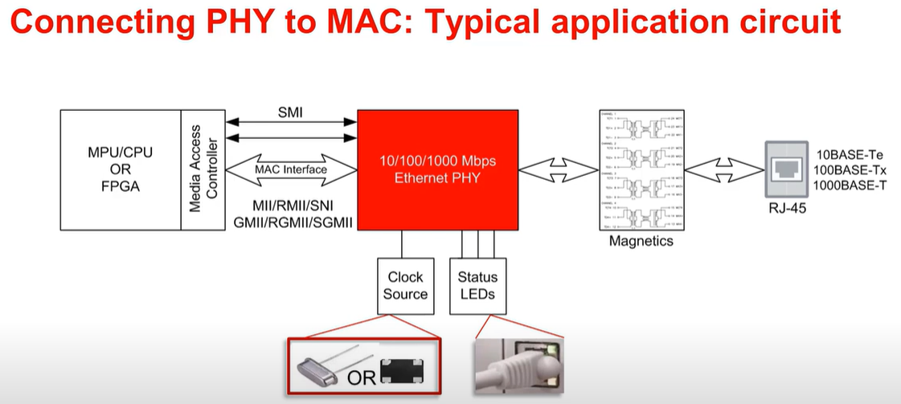

Ethernet Hw connection block diagram: -

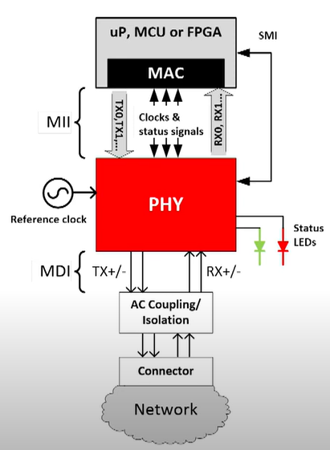

Different types of MAC interfaces: -

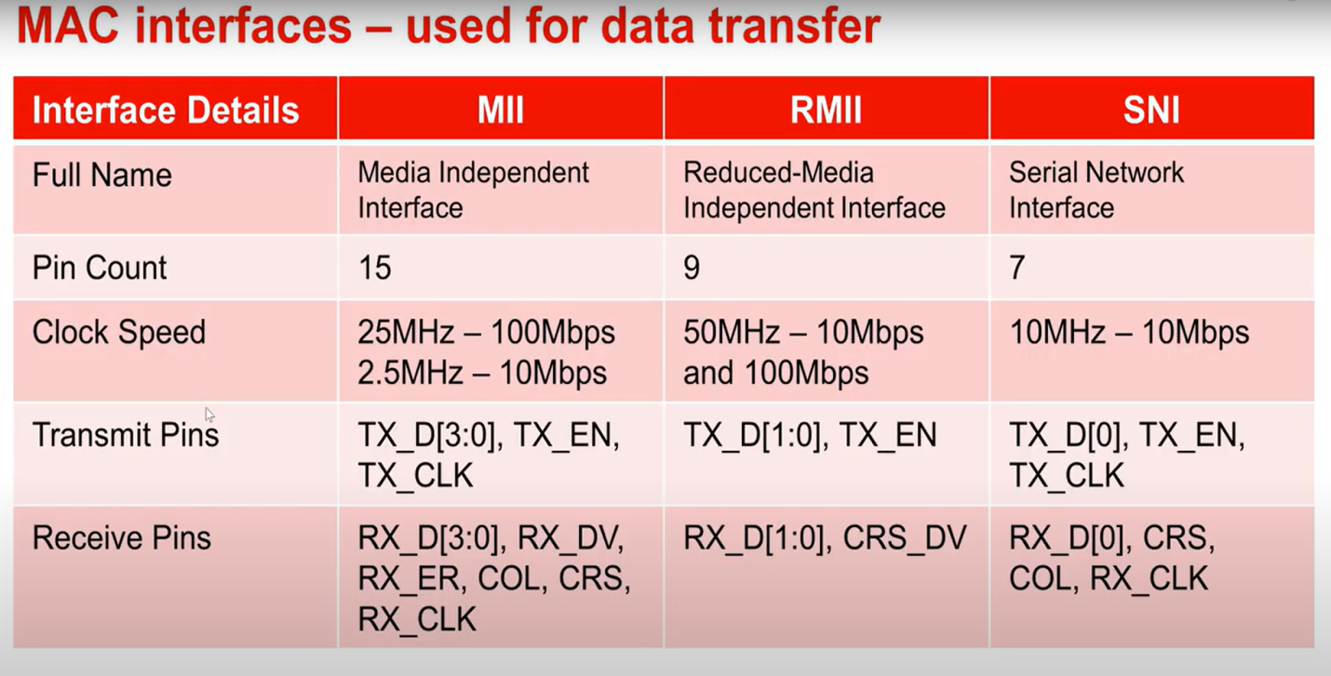

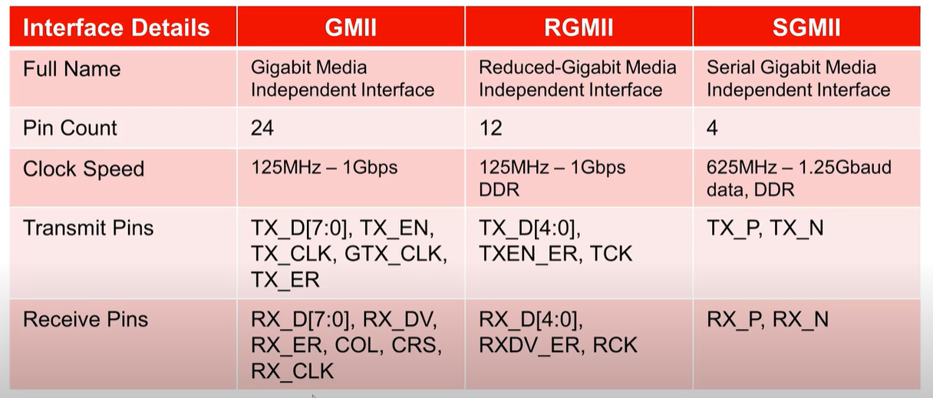

Hardware connection of Ethernet PHY on SKAM62 board: -

Ethernet connection in TIDA-010010 board: -

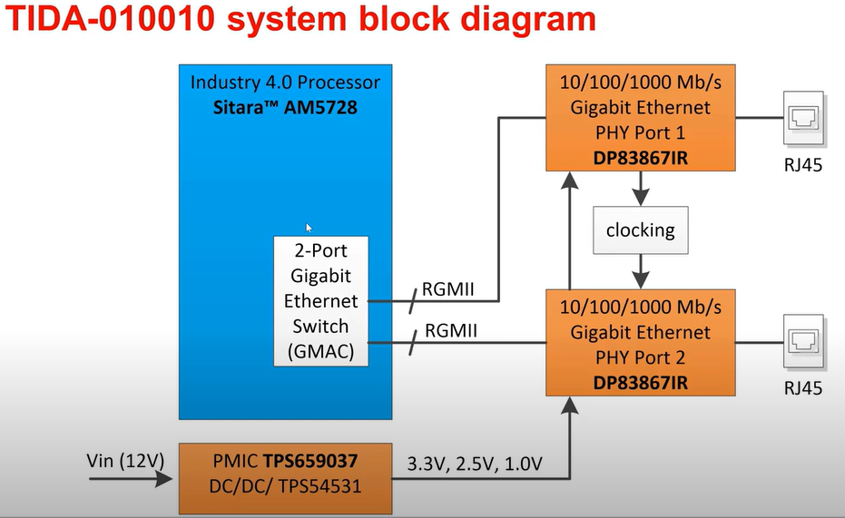

DP83867 Ethernet PHY Linux driver: -
https://elixir.bootlin.com/linux/latest/source/drivers/net/phy/dp83867.c

