# Decoding configuration space of a PCI device

Command:

# lspci -xx

WLAN1: -

----------

0000:01:00.0 Class 0280: Device 12be:bd31 (rev 01)

00: be 12 31 bd 00 00 10 00 01 00 80 02 00 00 00 00

10: 04 00 80 60 00 00 00 00 04 00 00 60 00 00 00 00

20: 00 00 00 00 00 00 00 00 00 00 00 00 be 12 31 bd

30: 00 00 00 00 48 00 00 00 00 00 00 00 00 01 00 00

40: 00 00 00 00 00 00 00 00 01 58 03 06 08 41 00 00

50: 00 00 00 00 00 00 00 00 05 68 8a 00 00 00 00 00

60: 00 00 00 00 00 00 00 00 09 a0 38 00 46 01 00 80

70: 00 00 10 18 00 00 00 00 00 00 00 00 00 00 00 00

80: 00 00 00 18 00 00 00 00 80 80 00 00 00 00 00 00

90: 00 00 00 00 00 01 00 00 00 00 00 00 00 00 00 00

a0: 11 ac 3f 00 00 80 00 00 00 88 00 00 10 00 02 00

b0: 82 8f 00 10 10 2c 10 00 12 dc 46 00 40 00 12 10

c0: 00 00 00 00 00 00 00 00 00 00 00 00 00 00 00 00

d0: 1f 08 08 00 00 04 00 00 06 00 00 00 01 00 00 00

e0: 00 00 00 00 00 00 00 00 00 00 00 00 00 00 00 00

f0: 00 00 00 00 00 00 00 00 00 00 00 00 00 00 00 00

Decoding: -

---------------

Note - lspci data is stored in Little endian.

Vendor ID - 0x12be

Product ID - 0xbd31

Status register (Offset 0x06) - 0x0010 (Bit-3 set to 1, indicates that device has a pointer to the capabilities list ).

Capability pointer (offset 0x34) - 0x00000048

Next capability (offset 0x48) - 0x06035801 ( Capability ID - 0x01, Next Capability pointer - 0x58)

Next capability (offset 0x58) - 0x008a6805 ( Capability ID - 0x05, Next Capability pointer - 0x68)

So, MSI Capability register value - 0x008a6805

MSI Message Control field - 0x008a (As Bit-0 is 0, so MSI is disable,

Bit-23 is 1, so 64bit addressing capable)

MSI Message address - 0x00000000

0001:01:00.0 Class 0280: Device 12be:bd31 (rev 01)

00: be 12 31 bd 00 00 10 00 01 00 80 02 00 00 00 00

10: 04 00 80 70 00 00 00 00 04 00 00 70 00 00 00 00

20: 00 00 00 00 00 00 00 00 00 00 00 00 be 12 31 bd

30: 00 00 00 00 48 00 00 00 00 00 00 00 00 01 00 00

40: 00 00 00 00 00 00 00 00 01 58 03 06 08 41 00 00

50: 00 00 00 00 00 00 00 00 05 68 8a 00 00 00 00 00

60: 00 00 00 00 00 00 00 00 09 a0 38 00 46 01 00 80

70: 00 00 10 18 00 00 00 00 00 00 00 00 00 00 00 00

80: 00 00 00 18 00 00 00 00 80 80 00 00 00 00 00 00

90: 00 00 00 00 00 01 00 00 00 00 00 00 00 00 00 00

a0: 11 ac 3f 00 00 80 00 00 00 88 00 00 10 00 02 00

b0: 82 8f 00 10 10 2c 10 00 12 dc 46 00 40 00 12 10

c0: 00 00 00 00 00 00 00 00 00 00 00 00 00 00 00 00

d0: 1f 08 08 00 00 04 00 00 06 00 00 00 01 00 00 00

e0: 00 00 00 00 00 00 00 00 00 00 00 00 00 00 00 00

f0: 00 00 00 00 00 00 00 00 00 00 00 00 00 00 00 00

Capability pointer (offset 0x34) - 0x00000048

Next capability (offset 0x48) - 0x06035801 ( Capability ID - 0x01, Next Capability pointer - 0x58)

Next capability (offset 0x58) - 0x008a6805 ( Capability ID - 0x05, Next Capability pointer - 0x68)

Note – Power Managemnet Capability ID – 0x01

MSI Capability ID – 0x05

MSIX Capability ID – 0x05

Note - After WLAN-1 driver is loaded, MSI interrupt address is assigned, as shown below.

0000:01:00.0 Class 0280: Device 12be:bd31 (rev 01)

00: be 12 31 bd 06 04 10 08 01 00 80 02 00 00 00 00

10: 04 00 80 60 00 00 00 00 04 00 00 60 00 00 00 00

20: 00 00 00 00 00 00 00 00 00 00 00 00 be 12 31 bd

30: 00 00 00 00 48 00 00 00 00 00 00 00 8d 01 00 00

40: 00 00 00 00 00 00 00 00 01 58 03 06 08 41 00 00

50: 00 00 00 00 00 00 00 00 05 68 8b 00 00 00 00 b6

60: 00 00 00 00 01 00 00 00 09 a0 38 00 46 01 00 80

70: 00 30 10 18 00 00 00 00 00 00 00 00 00 00 00 00

80: 00 30 00 18 00 00 00 00 80 80 00 00 00 00 00 00

90: 04 00 00 00 00 01 00 00 00 00 00 00 00 00 00 00

a0: 11 ac 3f 00 00 80 00 00 00 88 00 00 10 00 02 00

b0: 82 8f 00 10 10 2c 11 00 12 dc 46 00 40 01 12 10

c0: 00 00 00 00 00 00 00 00 00 00 00 00 00 00 00 00

d0: 1f 08 08 00 00 04 00 00 06 00 00 00 01 00 00 00

e0: 00 00 00 00 00 00 00 00 00 00 00 00 00 00 00 00

f0: 00 00 00 00 00 00 00 00 00 00 00 00 00 00 00 00

We can see 0xb6 is added.

## Decoding Capability list

First, check that the device has a pointer to the capabilities list (status register bit 4 set to 1). Then, traverse the capabilities list. The low 8 bits of a capability register are the ID - 0x5 for MSI. The next 8 bits are the offset (in [PCI Configuration Space](https://wiki.osdev.org/PCI#Configuration_Space)) of the next capability.

First capability pointer of 1 byte is at offset 0x34. From this onwards, all capabilities are of 4 bytes each. The least significant byte gives “Capability ID” and next byte to LSB gives pointer to next capability regitser in configuration space.

The MSI capability is as follows:

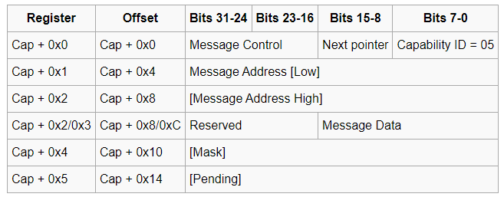

## FCA_R1 bridge device config space decoding: -

00:13.0 Class 0604: Device 8086:5ad8 (rev fd)

PCI Configuration header (PCI-to-PCI-Bridge, Header type - 0x01)

00: 86 80 d8 5a 07 04 10 00 fd 00 04 06 00 00 81 00

10: 00 00 00 00 00 00 00 00 00 01 01 00 30 30 00 20

20: 20 b3 30 b3 81 b3 91 b3 00 00 00 00 00 00 00 00

30: 00 00 00 00 40 00 00 00 00 00 00 00 16 00 00 00

40: 10 80 42 01 01 80 00 00 0f 00 10 00 12 00 71 03

50: c0 00 12 70 60 b2 14 00 28 10 40 00 08 00 00 00

60: 00 00 00 00 37 08 08 00 00 04 00 00 06 00 00 00

70: 02 00 00 00 00 00 00 00 00 00 00 00 00 00 00 00

80: 05 90 01 00 0c f0 e0 fe 92 41 00 00 00 00 00 00

90: 0d a0 00 00 00 00 00 00 00 00 00 00 00 00 00 00

a0: 01 00 03 c8 00 00 00 00 00 00 00 00 00 00 00 00

b0: 00 00 00 00 00 00 00 00 00 00 00 00 00 00 00 00

c0: 00 00 00 00 00 00 00 00 00 00 00 00 00 00 00 00

d0: 77 00 00 00 42 1a 00 00 09 00 10 01 00 00 00 00

e0: 00 00 e3 00 00 00 00 00 06 00 01 00 00 00 00 00

f0: 50 01 00 00 00 04 00 0c 1c 0f 00 01 04 00 00 00

Capability pointer tracing: -

===============================

0x34 -> 0x40

0x40 -> 0x01 42 80 10 (Capability ID - 0x10) PCI Xpress

0x80 -> 0x00 01 90 05 (Capability ID - 0x05) MSI Capability

0x90 -> 0x00 00 a0 0d (Capability ID - 0x0d) PCI Bridge Subsystem Vendor ID

0xa0 -> 0xc8 03 00 01 (Capability ID - 0x01) Power Management Capability

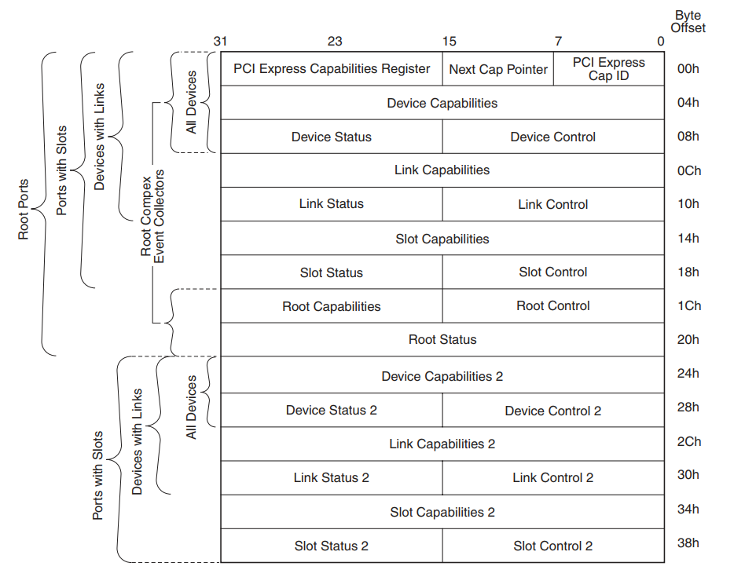

0x40 + 0-> PCI Express Cap ID

Offset: 0x04 -> (PCI Express Device Capabilities Register)

00 00 80 01 [01 -> Max Payload size – 256 bytes]

Offset: 0x08 -> PCI Express Device Control and Status Register

Offset: 0x0C -> Link Capabilities Register

Offset: 0x10-> Link Control and Status Register

Offset: 0x14 -> Slot Capabilities Register

Address: 0x54 -> 0x00 14 b2 60 => Hot Plug Capable and Hot Plug Surprise

Physical Slot No = 2

Bit[6] = 1 -> Hot Plug Capable

Bit[5] = 1 -> Hot Plug Surprise

Bit[31:19] = Physical Slot No

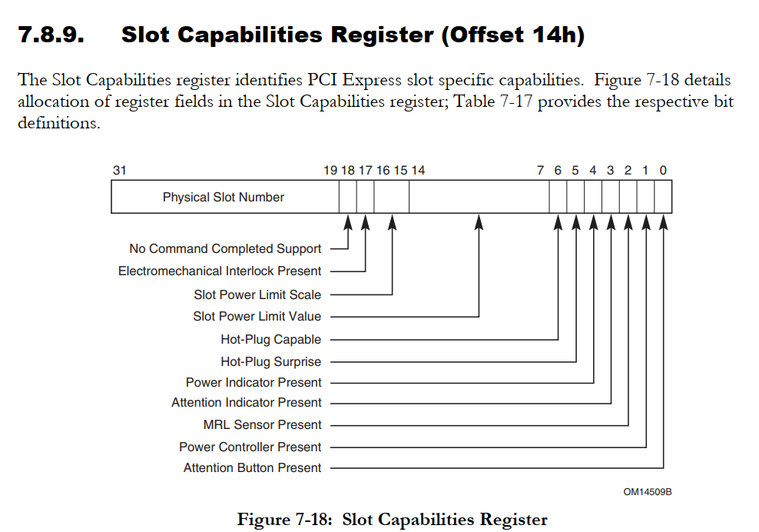

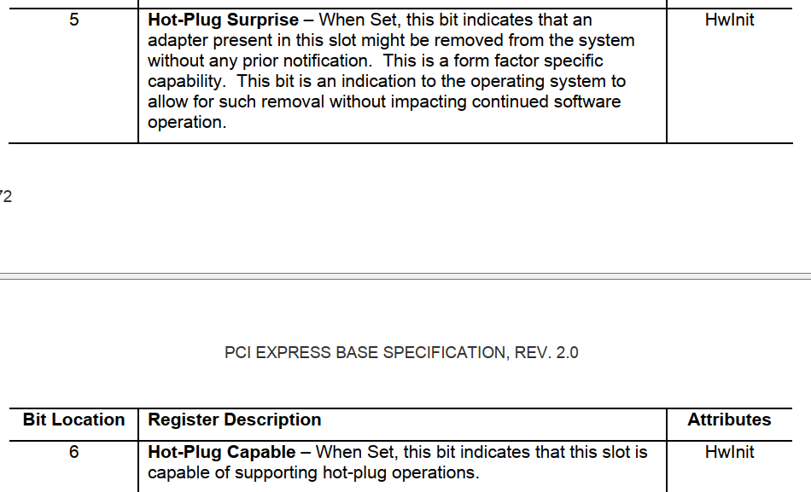

0x18 -> Slot Control and Status Register

0x1C -> Root Control and Capabilities Register

0x20 -> Root Status Register

**Note : - Changing MSI REGISTERS**

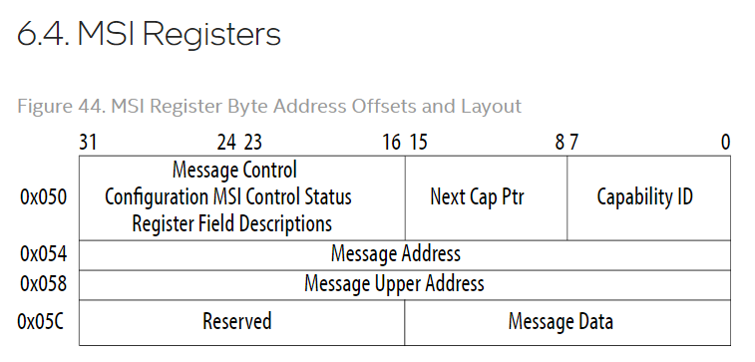

Follow this URL for MSI registers in detail –

<https://www.intel.com/content/www/us/en/docs/programmable/683686/20-4/msi-registers.html>

# ./setpci -s 00:13.0 VENDOR_ID.W

8086

fca_dv2:/data #

fca_dv2:/data # ./setpci -s 00:13.0 VENDOR_ID.W=8087

fca_dv2:/data # ./setpci -s 00:13.0 VENDOR_ID.W

8086

fca_dv2:/data # ./setpci -s 00:13.0 84.W

f00c

fca_dv2:/data # ./setpci -s 00:13.0 84.W=f00d

fca_dv2:/data # ./setpci -s 00:13.0 84.W

f00c

fca_dv2:/data # ./setpci -s 00:13.0 84.W=f00d

fca_dv2:/data #

fca_dv2:/data #

fca_dv2:/data # ./setpci -s 00:13.0 84.W

f00c

fca_dv2:/data # ./setpci -s 00:13.0 04.W

0407

fca_dv2:/data # ./setpci -s 00:13.0 82.W

0001

fca_dv2:/data # ./setpci -s 00:13.0 82.W=0000

fca_dv2:/data # ./setpci -s 00:13.0 82.W

0000

fca_dv2:/data # ./setpci -s 00:13.0 88.l

00004192

fca_dv2:/data # ./setpci -s 00:13.0 88.l=4190

fca_dv2:/data # ./setpci -s 00:13.0 88.l

00004190

fca_dv2:/data #

## Reference: -

https://www.intel.com/content/www/us/en/docs/programmable/683686/20-4/pci-express-capability-structure.html

https://support.xilinx.com/s/article/1148199?language=en_US

https://forums.developer.nvidia.com/t/i-unable-to-access-the-pci-registers-when-my-pci-is-connected-to-jetson-i-am-getting-these-errors/73474/8

http://ccrma.stanford.edu/planetccrma/man/man8/setpci.8.html

https://unix.stackexchange.com/questions/724953/why-setpci-failed