1. Factors in achieving maximum PCIe performance: -

* Link speed and width
* Maximum payload size (for ex – 256, 512, 1024 bytes)
* Large transfer size
* Number of DMA channels (1, 2 or 4)
* Polling vs Interrupt

1. Basic PCI DMA operation: -

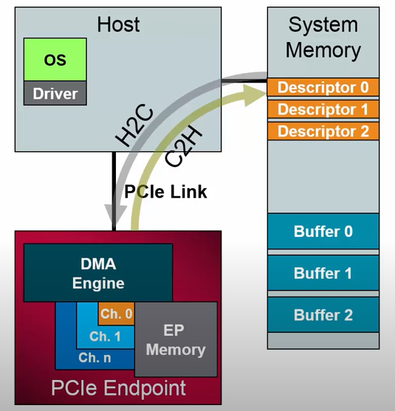

Legend:

H2C : Host to Card

C2H: Card to Host

Descriptors tell DMA engine “where to Put Data To” or “Where to read Data from”.

This gives us idea, how a typical DMA system looks like.

1. Scatter Gather Example: -

Step I. Driver updates

* Sets up desciptors and data
* Writes to DMA engine with address of first descriptor
* Starts DMA engine

Step II. DMA fetches descriptors from memory

* Memory reads
* Adjacent descriptors fetched with single read

Figure – II.a.

Figure – III.b.

Step III. DMA opeartes on descriptors

* Forms PCIe packet (TLP) (Tx) from EP memory
* Writes to associated buffer
* May be more than one TLP descriptor per packet
* Continues to fetch available descriptors

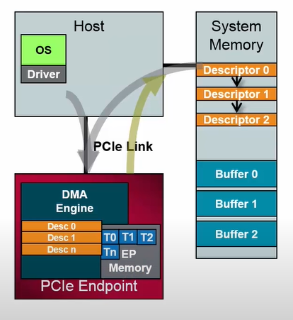

Step IV. DMA processes descriptor with “stop”

* Last descriptor completes transfer
* Interrupt sent to driver
* Descriptors and data released

Step V. Next DMA transfer can begin

* Once the DMA interrupt of previous step is completed, the next DMA transfer can be setup.

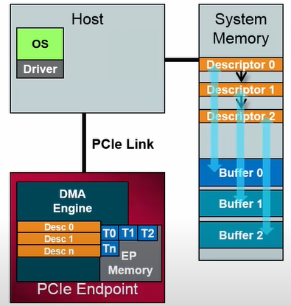

Fig – Descriptors point to buffers