**SPI Driver Basics: -**

1. **SPI Modes: -**

CPOL = 0 - > Idle state of SPI_CLK is low

CPHA = 0 - > Data latched or shifted out on falling edge

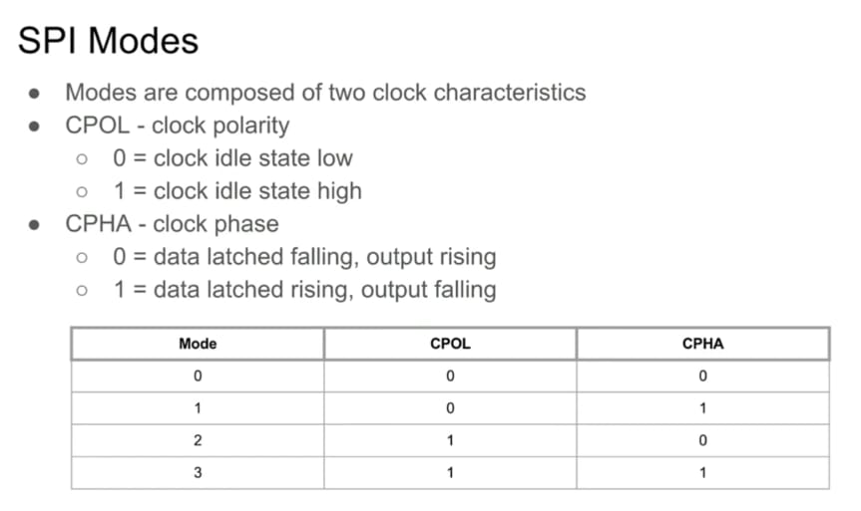

Figure – 1

**SPI Mode = 0: -**

In SPI Mode = 0, CPOL = 0 and CPHA = 0. So, idle state of clock is zero and since CPHA = 0, so data is latched or shifted out on falling edge and data is sampled or captured on rising edge of clock. It is shown in figure – 2 below.



Figure – 2: SPI_MODE = 0

From figure – 2, it is clear that in SPI Mode = 0, data are latched or shifted out on falling edge and data are sampled or captured on clock’s rising edge.

**SPI Mode = 1: -**

In SPI Mode = 1, CPOL = 0 and CPHA = 1. So, idle state of clock is zero and since CPHA = 1, so data is latched or shifted out on rising edge and data is sampled or captured on falling edge of clock. It is shown in figure – 3 below.



Figure – 3: SPI_MODE = 1

1. **Types of SPI: -**

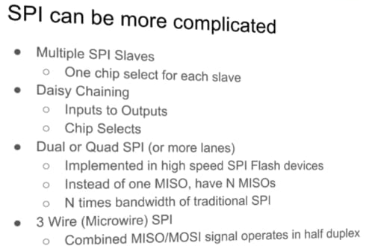

Figure – 2

1. **Linux SPI Driver: -**

There are two types of SPI driver –

1. SPI controller driver
2. SPI protocol driver

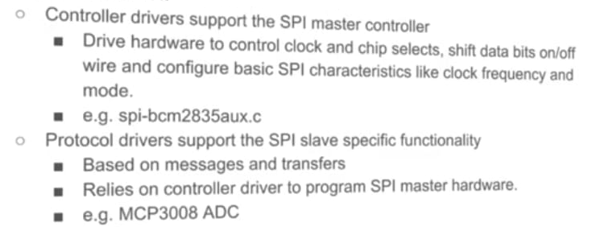

Figure – 3

1. **Linux SPI communication: -**

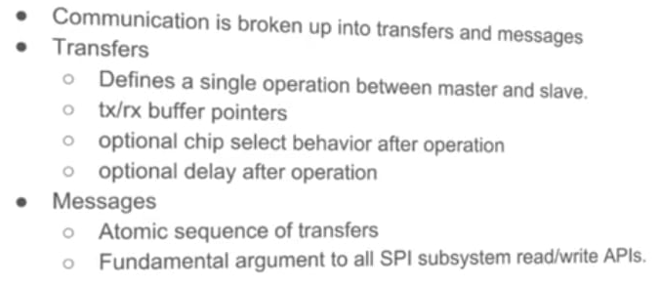

Figure – 4

struct spi_message is basically argument to all SPI subsystem read/write APIs.

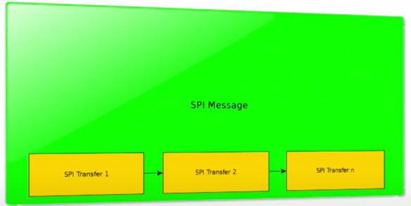

Figure – 5

1. **Adding a SPI device to a system: -**

Figure - 6

1. **SPI device DT binding: -**

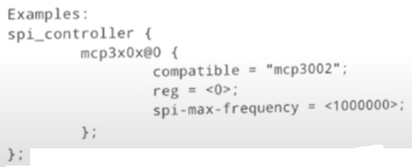

Figure – 7

1. **Adding SPI device using board file: -**

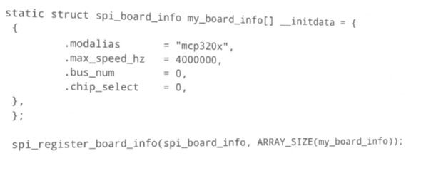

Figure - 8

1. **SPI protocol driver: -**

Follows standard driver model.

Figure – 9

1. **SPI sub system kernel APIs: -**

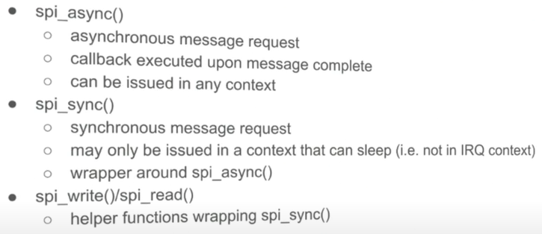

Figure - 10

Figure – 11

1. **SPI controller driver: -**

Figure – 12

transfer_one model allows us to let the core support GPIO chip select.

1. **User space driver - spidev: -**

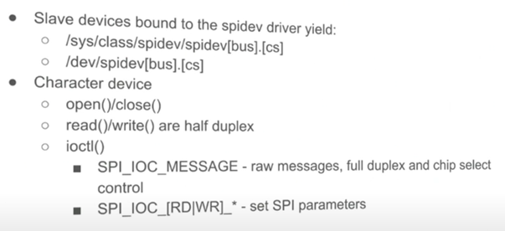

Figure – 13

SPI is inherently a full duplex bus.

1. **“spi_transfer” cs_change flag: -**

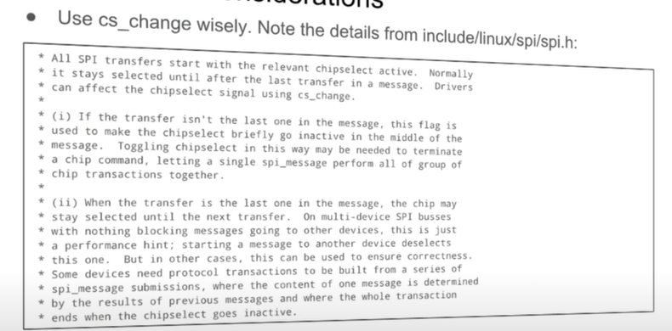

1. **Performance considerations: -**

1. **Performance tools: -**

