**Project Documentation**

**Job Market Data Analytics and Visualization**

1. **Project Overview**

This project analyses a dataset of jobs using Excel AND Power BI to extract insights about companies, job roles, salaries, industries and location. The aim is to apply data cleaning, preprocessing and visualization techniques to build an interactive dashboard that helps understand job market trends, company characteristics and salary distribution.

1. **Tools Used**

* Microsoft Excel – for data cleaning and preprocessing
* Power Query – for advanced data transformation
* Power BI – for creating interactive dashboard and data visualization

1. **Dataset**

* Source: Sample Data (Uncleaned_DS_Jobs.csv)
* Data contains: Job Title, Job Description, Estimated Salary, Job City, Sector, Industry, Founded, No of Employees…etc.,

1. **Steps Followed**

* Data Cleaning in Excel/Power Query
* Removed duplicates, blanks and error values
* Standardized columns
* Replaced missing values
* Split salary estimates to “max salary, min salary, avg salary”
* Created “Company Age” column from Founded year
* Categorized company on the basis of age group into “Established, Mid Age, Start Up”
* Visualization in Power BI
* Built dashboard with cards, bar charts, column charts, filled map, tree map, scatter plot, pie chart and donut charts.
* Inserted Slicers for quick selection
* Added buttons for navigation and clearing slicers
* Added Drill through for interactivity

1. **Key Insights**

* Most job postings are concentrated in states such as DE, WI and NC
* Analyst jobs have higher postings
* Data Scientist roles show higher salary averages compared to analyst roles
* Large sized companies dominate hiring
* Many jobs are offered by well established companies and mid age companies
* Startup companies offer fewer jobs but provide competitive salary
* Technology leads in both no. of jobs and salary

1. **Screenshots**

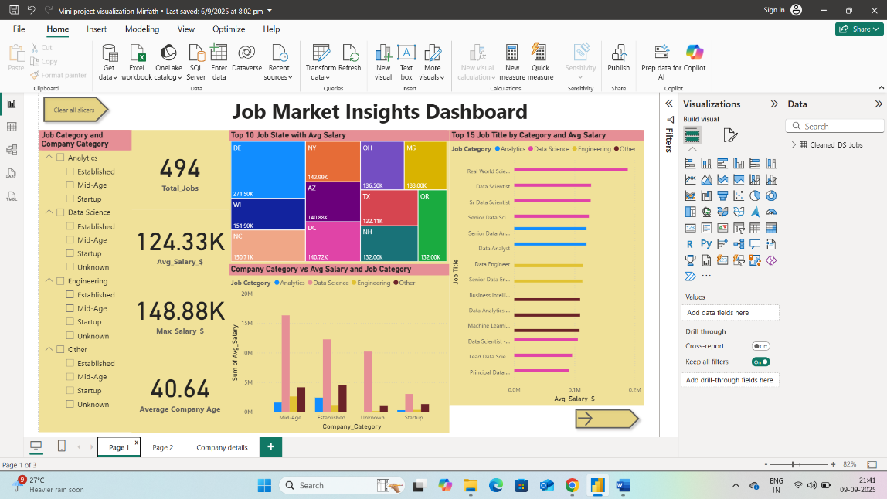

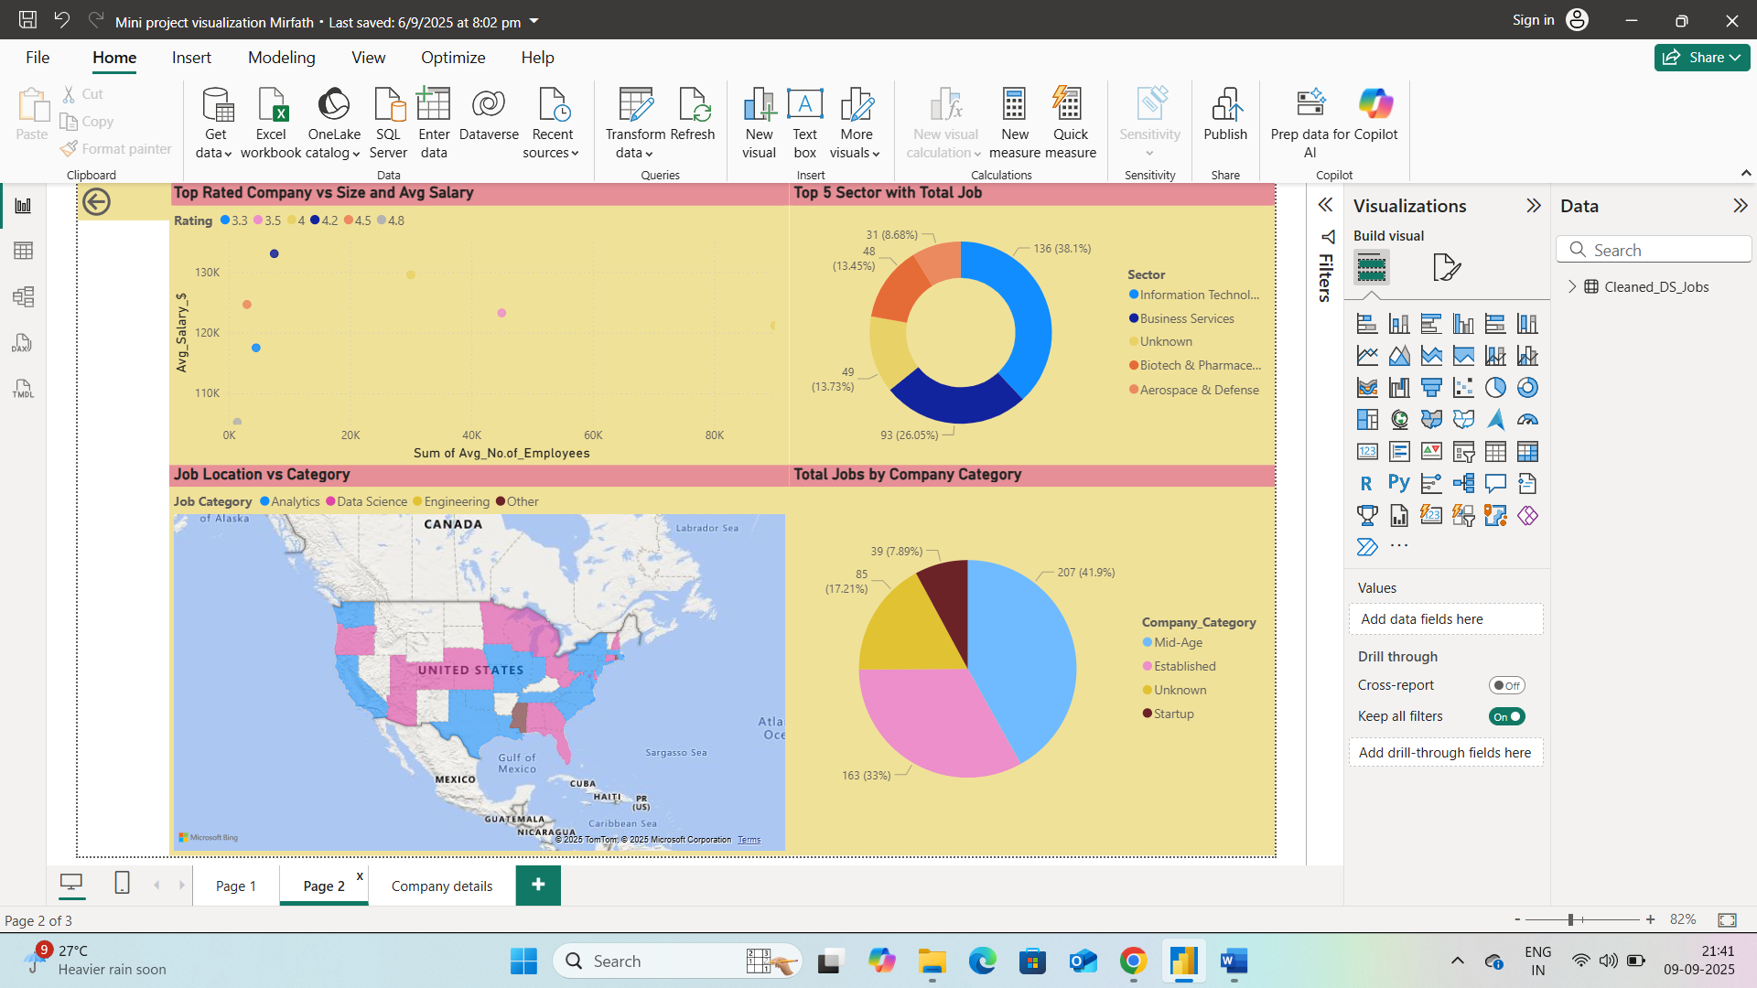

1. **Files Included**

* Uncleaned_DS_Jobs.csv - Raw Dataset
* Mini_Project_Preprocessing_Mirfath.xlsx - Cleaned Dataset
* Mini_Project_Visualization_Mirfath.pbix - Power BI Dashboard
* Mini_Project_Documentation.pdf - Report

1. **How to Use**

* Open Mini_Project_Preprocessing_Mirfath.xlsx to view the cleaned data
* Open Mini_Project_Visualization_Mirfath.pbix in Power BI Desktop to explore the visuals.