**Mirha Zahid Mobile App Projects**

**October 26, 2020 Homework # 7**

|  |  |  |
| --- | --- | --- |
| **Index** |  | **Page Number** |
| Part 1: Tutorials | Volley | 2 |
|  | JSON Parser | 5 |
|  | Google Maps | 7 |
|  | Android location based services | 9 |
|  | Displaying Toast | 10 |
| Part 2: Creating Native App | Description | 11 |
|  | Use Openweather api | 13 |
|  | Showing atleast 10 elements | 15 |
|  | Showing weather and map | 19 |
|  | Displaying map | 22 |
|  | Code | 25 |

Volley tutorial:

Adding implementation in gradle file.

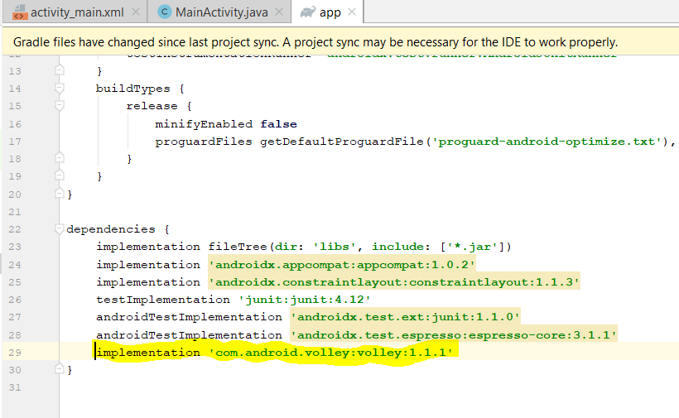

Adding internet permission in android manifest.xml file.

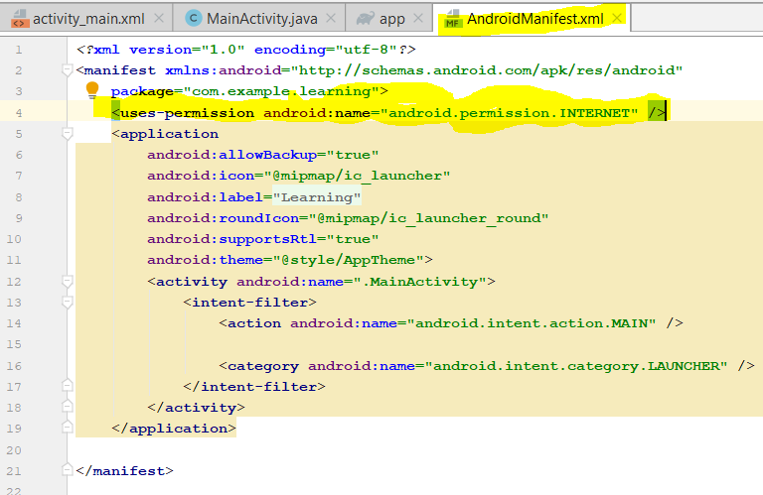

Sending a simple request in MainActivity.java:

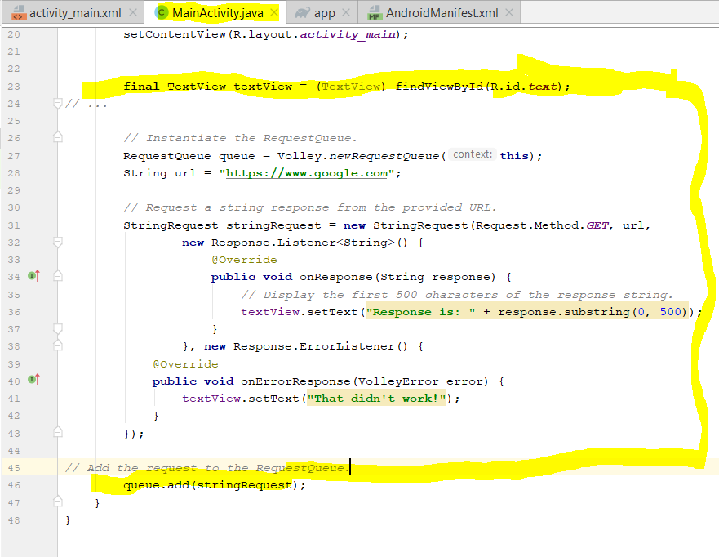

JSON Parser:

Followed the tutorial.

But it didn’t work, and gave the following error.

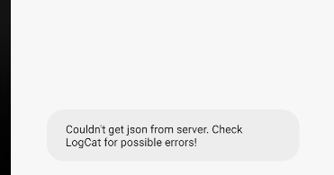

Perform the following steps:

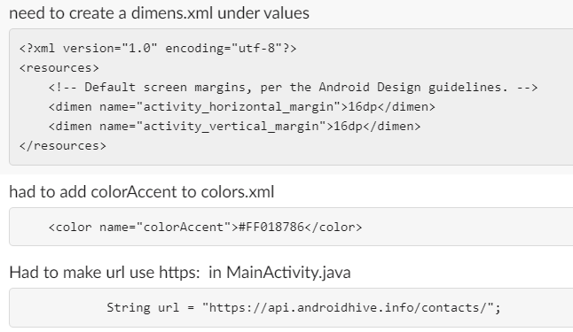

These steps worked and how the following output:

Output :

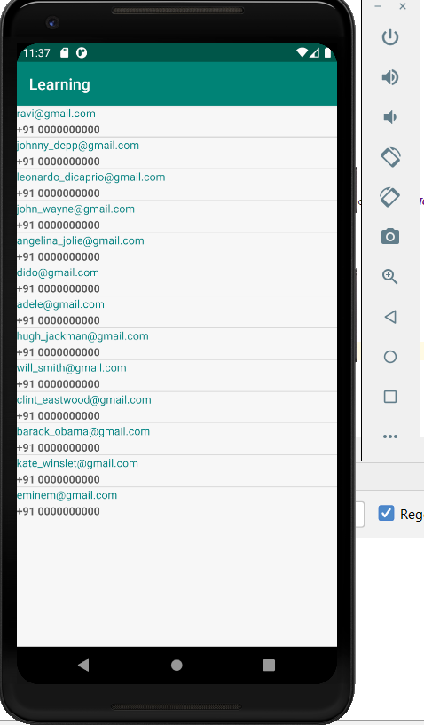

Google Maps:

Followed the tutorial.

Add the following permisions in android manifest.xml:

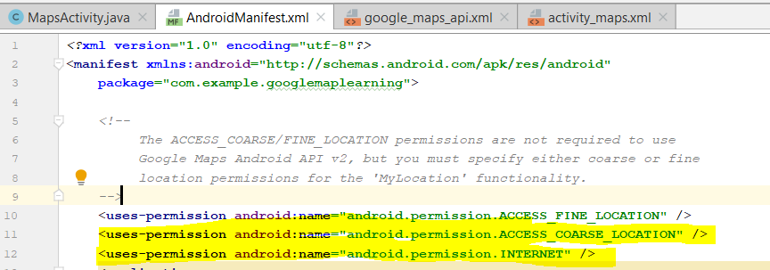

Add a key in the following:

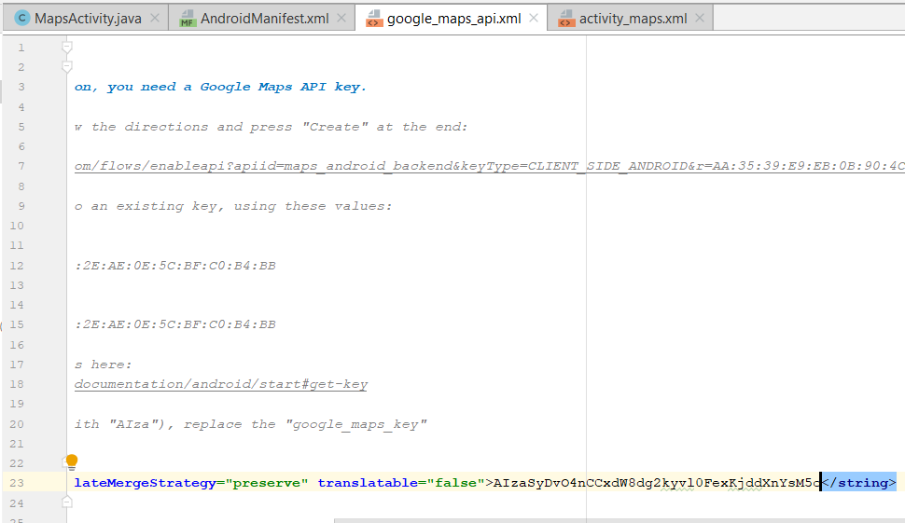

Than copy paste all the code.

The output is as follows:

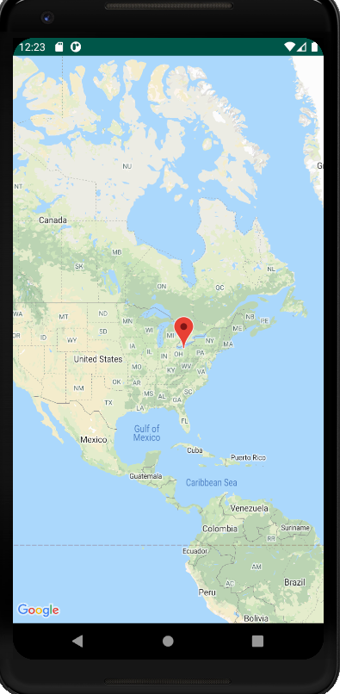

Android Location based services:

Followed the tutorial and get the below output:

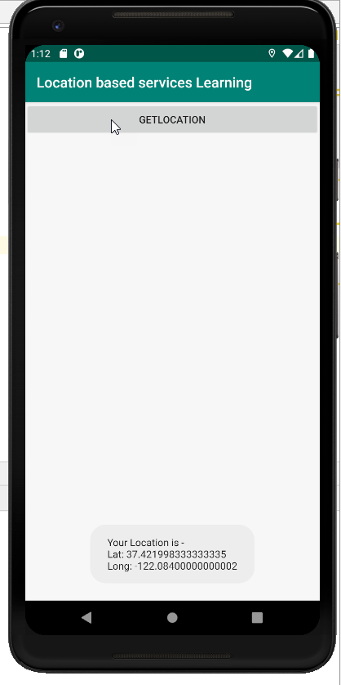

Displaying Toast:

Followed the tutorial and get the below output:

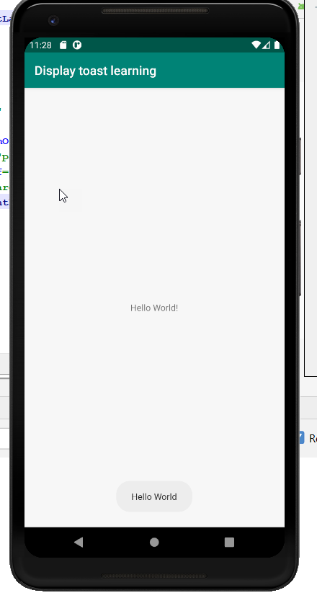

Part 2:

I built an app named as My App.

It has 3 pages.

* Main page
* Weather page
* Map page

Main page is basically a menu page, that gives us an option to select the pages, as you can see below:

I use a cardview for this.

Following is the main page of my app:

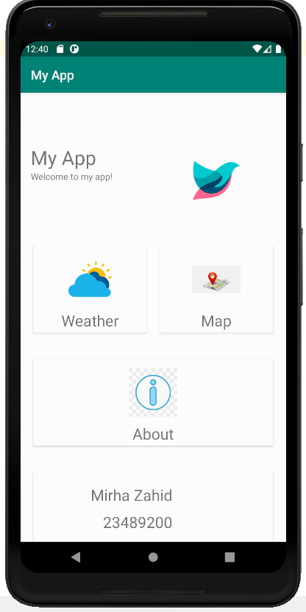

By clicking on the weather card, it navigates us to Weather page:

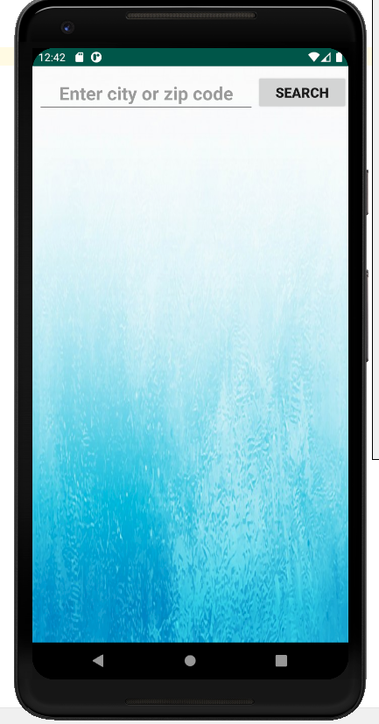

It is asking to enter either city or zip code or geocoords

I use openweather api here. As you can see the a piece of code screenshot below.

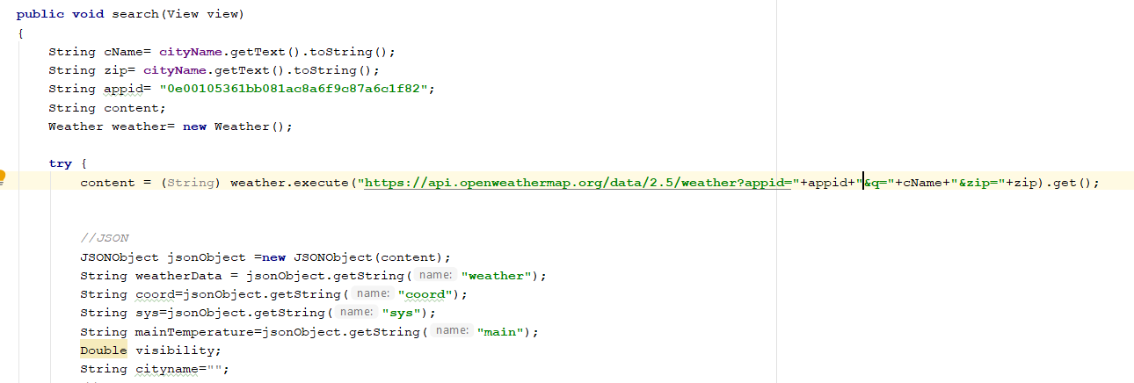

Whenever we search:

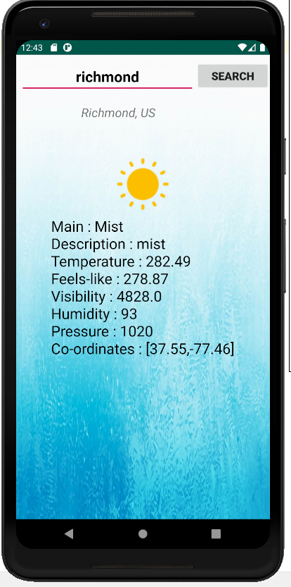

Showing icon on the base of weather:

All other elements

Co-ordinates consists of lat and lon

Showing City name and country code

Search by city

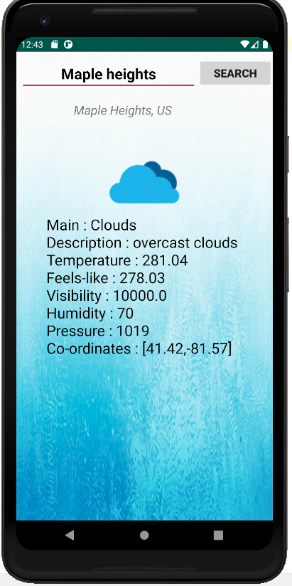

Showing icon on the base of weather:

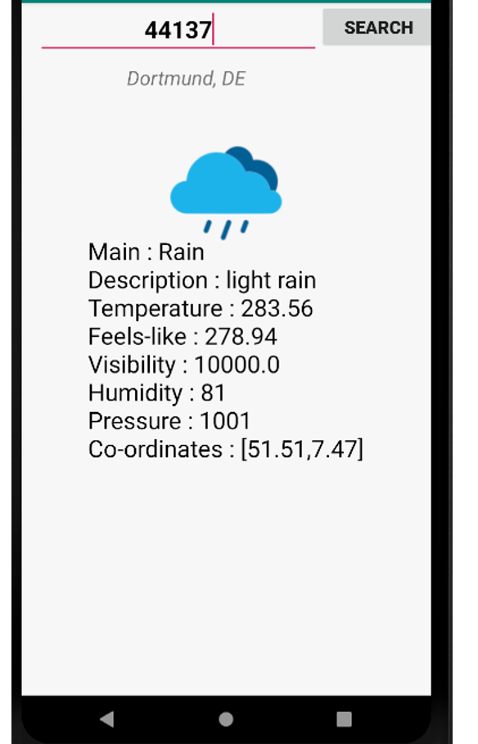

Searching by zip code

Showing icon on the base of weather:

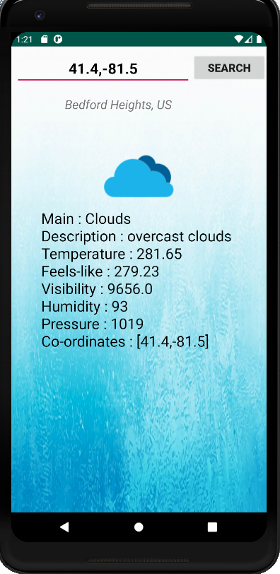

Search with geocoords:

Made a change and displaying map and weather on the same page.

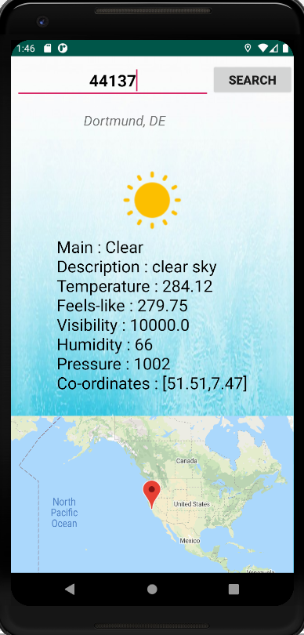

Search with zipcode:

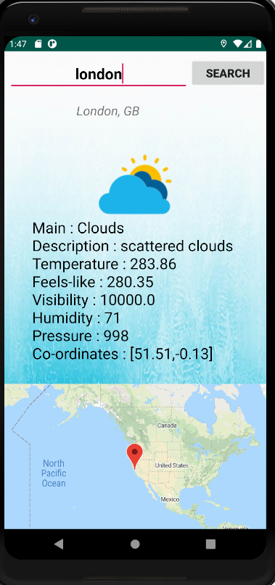

Search with city name:

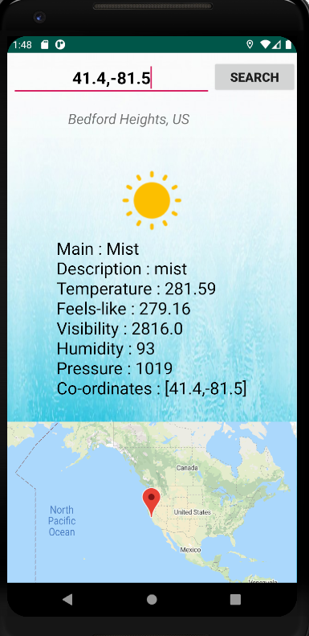

Search with geocoords:

Map Card navigates to the map showing current location:

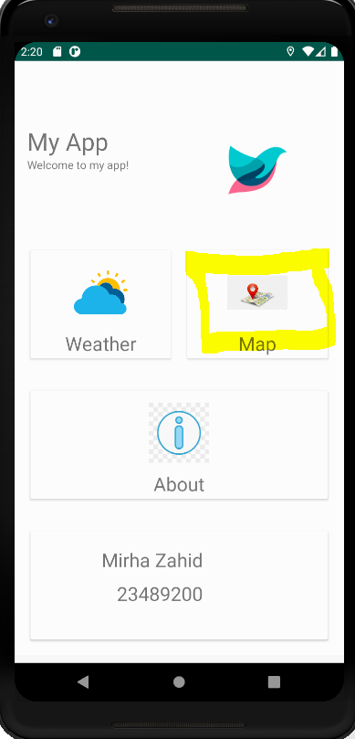

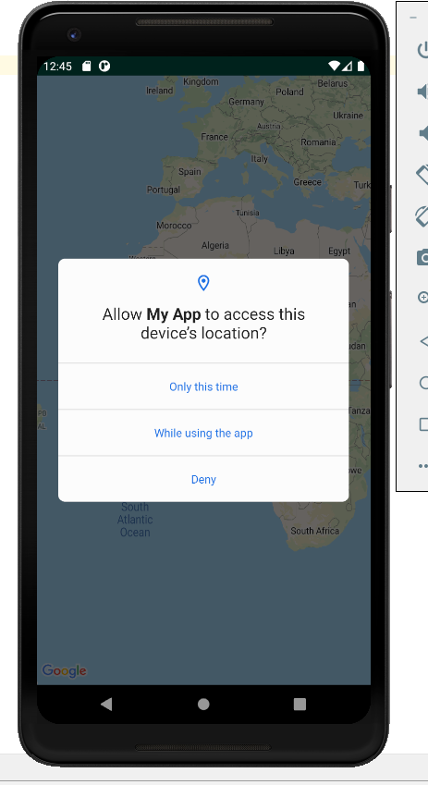

It is asking for permission

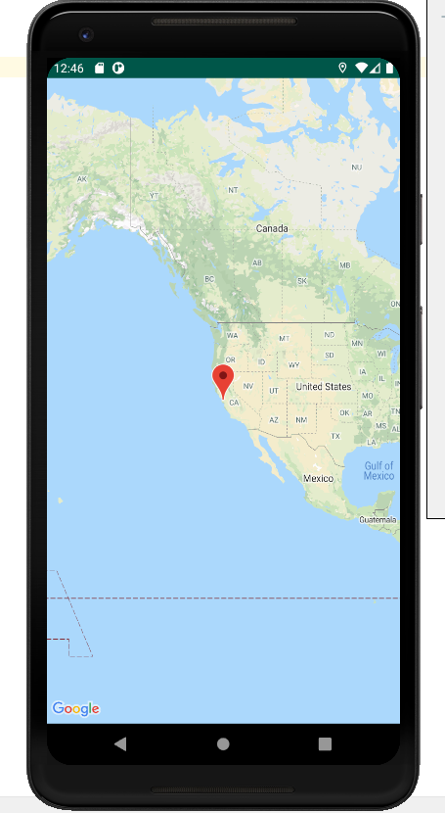

Showing current location

MainActivity.java:

**package** com**.**example**.**rough3**;**

**import** androidx**.**appcompat**.**app**.**AppCompatActivity**;**

**import** android**.**content**.**Intent**;**

**import** android**.**os**.**Bundle**;**

**import** android**.**view**.**View**;**

**import** android**.**widget**.**Button**;**

**import** androidx**.**appcompat**.**app**.**AppCompatActivity**;**

**import** android**.**app**.**Activity**;**

**import** android**.**app**.**DownloadManager**;**

**import** android**.**content**.**Intent**;**

**import** android**.**os**.**AsyncTask**;**

**import** android**.**os**.**Bundle**;**

**import** android**.**os**.**StrictMode**;**

**import** android**.**util**.**Log**;**

**import** android**.**view**.**View**;**

**import** android**.**view**.**inputmethod**.**InputMethodManager**;**

**import** android**.**widget**.**Button**;**

**import** android**.**widget**.**EditText**;**

**import** android**.**widget**.**ImageView**;**

**import** android**.**widget**.**TextView**;**

**import** org**.**json**.**JSONArray**;**

**import** org**.**json**.**JSONException**;**

**import** org**.**json**.**JSONObject**;**

**import** java**.**io**.**IOException**;**

**import** androidx**.**appcompat**.**app**.**AppCompatActivity**;**

**import** androidx**.**cardview**.**widget**.**CardView**;**

**import** android**.**app**.**Activity**;**

**import** android**.**os**.**Bundle**;**

**import** android**.**os**.**StrictMode**;**

**import** android**.**view**.**View**;**

**import** android**.**view**.**inputmethod**.**InputMethodManager**;**

**import** android**.**widget**.**EditText**;**

**import** android**.**widget**.**ImageView**;**

**import** android**.**widget**.**TextView**;**

**import** org**.**json**.**JSONArray**;**

**import** org**.**json**.**JSONException**;**

**import** org**.**json**.**JSONObject**;**

**import** java**.**io**.**IOException**;**

**import** java**.**io**.**InputStream**;**

**import** java**.**io**.**InputStreamReader**;**

**import** java**.**net**.**HttpURLConnection**;**

**import** java**.**net**.**MalformedURLException**;**

**import** java**.**net**.**URL**;**

**import** java**.**util**.**concurrent**.**ExecutionException**;**

**public** **class** MainActivity **extends** AppCompatActivity **{**

Button WeatherPageButton**;**

Button MapPageButton**;**

CardView card_view**,** card_view2**;**

@Override

**protected** **void** onCreate**(**Bundle savedInstanceState**)** **{**

**super.**onCreate**(**savedInstanceState**);**

//setContentView(R.layout.activity_main);

setContentView**(**R**.**layout**.**activity_main**);**

card_view **=** **(**CardView**)** findViewById**(**R**.**id**.**WeatherCard**);** // creating a CardView and assigning a value.

card_view**.**setOnClickListener**(new** View**.**OnClickListener**()** **{**

@Override

**public** **void** onClick**(**View v**)** **{**

openNewActivity**();**

**}**

**});**

card_view2 **=** **(**CardView**)** findViewById**(**R**.**id**.**MapCard**);** // creating a CardView and assigning a value.

card_view2**.**setOnClickListener**(new** View**.**OnClickListener**()** **{**

@Override

**public** **void** onClick**(**View v**)** **{**

openNewActivity2**();**

**}**

**});**

**}**

**public** **void** openNewActivity**(){**

Intent intent **=** **new** Intent**(this,** WeatherPage**.class);**

startActivity**(**intent**);**

**}**

**public** **void** openNewActivity2**(){**

Intent intent **=** **new** Intent**(this,** MapsActivity**.class);**

startActivity**(**intent**);**

**}**

**}**

WeatherPage.java:

**package** com**.**example**.**rough3**;**

**import** androidx**.**appcompat**.**app**.**AppCompatActivity**;**

**import** android**.**os**.**Bundle**;**

**import** android**.**util**.**Log**;**

**import** android**.**view**.**View**;**

**import** android**.**widget**.**Button**;**

**import** android**.**widget**.**TextView**;**

**import** org**.**json**.**JSONArray**;**

**import** org**.**json**.**JSONException**;**

**import** org**.**json**.**JSONObject**;**

**import** java**.**util**.**concurrent**.**ExecutionException**;**

**import** androidx**.**appcompat**.**app**.**AppCompatActivity**;**

**import** android**.**app**.**Activity**;**

**import** android**.**app**.**DownloadManager**;**

**import** android**.**os**.**AsyncTask**;**

**import** android**.**os**.**Bundle**;**

**import** android**.**os**.**StrictMode**;**

**import** android**.**util**.**Log**;**

**import** android**.**view**.**View**;**

**import** android**.**view**.**inputmethod**.**InputMethodManager**;**

**import** android**.**widget**.**Button**;**

**import** android**.**widget**.**EditText**;**

**import** android**.**widget**.**ImageView**;**

**import** android**.**widget**.**TextView**;**

**import** org**.**json**.**JSONArray**;**

**import** org**.**json**.**JSONException**;**

**import** org**.**json**.**JSONObject**;**

**import** java**.**io**.**IOException**;**

**import** androidx**.**appcompat**.**app**.**AppCompatActivity**;**

**import** android**.**app**.**Activity**;**

**import** android**.**os**.**Bundle**;**

**import** android**.**os**.**StrictMode**;**

**import** android**.**view**.**View**;**

**import** android**.**view**.**inputmethod**.**InputMethodManager**;**

**import** android**.**widget**.**EditText**;**

**import** android**.**widget**.**ImageView**;**

**import** android**.**widget**.**TextView**;**

//import com.google.android.material.floatingactionbutton.FloatingActionButton;

//import org.jetbrains.annotations.NotNull;

**import** org**.**json**.**JSONArray**;**

**import** org**.**json**.**JSONException**;**

**import** org**.**json**.**JSONObject**;**

**import** java**.**io**.**IOException**;**

**import** java**.**io**.**InputStream**;**

**import** java**.**io**.**InputStreamReader**;**

**import** java**.**net**.**HttpURLConnection**;**

**import** java**.**net**.**MalformedURLException**;**

**import** java**.**net**.**URL**;**

**import** java**.**util**.**concurrent**.**ExecutionException**;**

**public** **class** WeatherPage **extends** AppCompatActivity **{**

ImageView view_weather**;**

TextView cityName**;**

Button searchButton**;**

TextView result**;**

TextView result2**;**

@Override

**protected** **void** onCreate**(**Bundle savedInstanceState**)** **{**

**super.**onCreate**(**savedInstanceState**);**

setContentView**(**R**.**layout**.**activity_weather_page**);**

cityName**=**findViewById**(**R**.**id**.**cityName**);**

//searchButton=findViewById(R.id.searchButton);

result**=**findViewById**(**R**.**id**.**resut**);**

result2**=**findViewById**(**R**.**id**.**resut2**);**

view_weather**=(**ImageView**)**findViewById**(**R**.**id**.**imageView2**);**

Button searchButton **=** findViewById**(**R**.**id**.**searchButton**);**

searchButton**.**setOnClickListener**(new** View**.**OnClickListener**()**

**{**

**public** **void** onClick **(**View v**){**

// Code here executes on main thread after user presses button

// MainActivity m= new MainActivity();

search**(**v**);**

**}**

**});**

**}**

**public** **void** search**(**View view**)**

**{**

String cName**=** cityName**.**getText**().**toString**();**

String zip**=** cityName**.**getText**().**toString**();**

String appid**=** "0e00105361bb081ac8a6f9c87a6c1f82"**;**

String content**;**

Weather weather**=** **new** Weather**();**

**try** **{**

content **=** **(**String**)** weather**.**execute**(**"https://api.openweathermap.org/data/2.5/weather?appid="**+**appid**+**"&q="**+**cName**+**"&zip="**+**zip**).**get**();**

//JSON

JSONObject jsonObject **=new** JSONObject**(**content**);**

String weatherData **=** jsonObject**.**getString**(**"weather"**);**

String coord**=**jsonObject**.**getString**(**"coord"**);**

String sys**=**jsonObject**.**getString**(**"sys"**);**

String mainTemperature**=**jsonObject**.**getString**(**"main"**);**

Double visibility**;**

String cityname**=**""**;**

//Log.i("weatherData", weatherData);

JSONArray array**=new** JSONArray**(**weatherData**);**

String main **=** ""**;**

String description **=** ""**;**

String icon**=**""**;**

String temperature **=** ""**;**

String humidity **=**""**;**

String pressure**=**""**;**

String feelslike**=**""**;**

String latitude**=**""**;**

String longitude**=**""**;**

String country**=**""**;**

**for(int** i**=**0**;** i**<**array**.**length**();** i**++){**

JSONObject weatherPart **=** array**.**getJSONObject**(**i**);**

main **=** weatherPart**.**getString**(**"main"**);**

description **=** weatherPart**.**getString**(**"description"**);**

icon **=** weatherPart**.**getString**(**"icon"**);**

//temperature= weatherPart.main.getString("temp");

**}**

//Log.d("main: ",main);

JSONObject mainPart**=** **new** JSONObject**(**mainTemperature**);**

temperature **=** mainPart**.**getString**(**"temp"**);**

humidity **=** mainPart**.**getString**(**"humidity"**);**

pressure **=** mainPart**.**getString**(**"pressure"**);**

feelslike**=**mainPart**.**getString**(**"feels_like"**);**

visibility**=**Double**.**parseDouble**(**jsonObject**.**getString**(**"visibility"**));**

cityname**=**jsonObject**.**getString**(**"name"**);**

JSONObject coordPart**=** **new** JSONObject**(**coord**);**

latitude **=** coordPart**.**getString**(**"lat"**);**

longitude **=** coordPart**.**getString**(**"lon"**);**

JSONObject sysPart**=** **new** JSONObject**(**sys**);**

country **=** sysPart**.**getString**(**"country"**);**

String resultText**=** "Main : "**+**main**+**

"\nDescription : "**+**description**+**

"\nTemperature : "**+** temperature**+**

"\nFeels-like : "**+**feelslike**+**

"\nVisibility : "**+**visibility**+**

"\nHumidity : "**+** humidity**+**

"\nPressure : "**+** pressure**+**

"\nCo-ordinates : ["**+** latitude**+**","**+**longitude**+**"]"**;**

String CityResult**=** cityname**+**", "**+**country**;**

result**.**setText**(**resultText**);**

result2**.**setText**(**CityResult**);**

//setImage(view_weather,icon);

//

**switch** **(**icon**){**

**case** "01d"**:** view_weather**.**setImageResource**(**R**.**drawable**.**d01d**);**

**break;**

**case** "01n"**:** view_weather**.**setImageResource**(**R**.**drawable**.**d01d**);**

**break;**

**case** "02d"**:** view_weather**.**setImageResource**(**R**.**drawable**.**d02d**);**

**break;**

**case** "02n"**:** view_weather**.**setImageResource**(**R**.**drawable**.**d02d**);**

**break;**

**case** "03d"**:** view_weather**.**setImageResource**(**R**.**drawable**.**d03d**);**

**break;**

**case** "03n"**:** view_weather**.**setImageResource**(**R**.**drawable**.**d03d**);**

**break;**

**case** "04d"**:** view_weather**.**setImageResource**(**R**.**drawable**.**d04d**);**

**break;**

**case** "04n"**:** view_weather**.**setImageResource**(**R**.**drawable**.**d04d**);**

**break;**

**case** "09d"**:** view_weather**.**setImageResource**(**R**.**drawable**.**d09d**);**

**break;**

**case** "09n"**:** view_weather**.**setImageResource**(**R**.**drawable**.**d09d**);**

**break;**

**case** "10d"**:**view_weather**.**setImageResource**(**R**.**drawable**.**d10d**);**

**break;**

**case** "10n"**:** view_weather**.**setImageResource**(**R**.**drawable**.**d10d**);**

**break;**

**case** "11d"**:** view_weather**.**setImageResource**(**R**.**drawable**.**d11d**);**

**break;**

**case** "11n"**:** view_weather**.**setImageResource**(**R**.**drawable**.**d11d**);**

**break;**

**case** "13d"**:** view_weather**.**setImageResource**(**R**.**drawable**.**d13d**);**

**break;**

**case** "13n"**:** view_weather**.**setImageResource**(**R**.**drawable**.**d13d**);**

**break;**

**default:**

view_weather**.**setImageResource**(**R**.**drawable**.**d01d**);**

**}**

**}** **catch** **(**InterruptedException e**)** **{**

e**.**printStackTrace**();**

**}** **catch** **(**ExecutionException e**)** **{**

e**.**printStackTrace**();**

**}** **catch** **(**JSONException e**)** **{**

e**.**printStackTrace**();**

**}**

**}**

**}**

Weather.java:

**package** com**.**example**.**rough3**;**

**import** android**.**os**.**AsyncTask**;**

**import** java**.**io**.**IOException**;**

**import** java**.**io**.**InputStream**;**

**import** java**.**io**.**InputStreamReader**;**

**import** java**.**net**.**HttpURLConnection**;**

**import** java**.**net**.**MalformedURLException**;**

**import** java**.**net**.**URL**;**

**public** **class** Weather **extends** AsyncTask**<**String**,**Void**,**String**>** **{**

@Override

**protected** String doInBackground**(**String**...** address**)** **{**

**try** **{**

URL url**=new** URL**(**address**[**0**]);**

HttpURLConnection connection**=(**HttpURLConnection**)**url**.**openConnection**();**

connection**.**connect**();**

InputStream is**=**connection**.**getInputStream**();**

InputStreamReader isr**=new** InputStreamReader**(**is**);**

//Retrieve data and return it as String

**int** data **=**isr**.**read**();**

String content **=**""**;**

**char** ch**;**

**while** **(**data**>**0**){**

ch**=(char)**data**;**

content**=** content**+**ch**;**

data**=**isr**.**read**();**

**}**

**return** content**;**

**}** **catch** **(**MalformedURLException e**)** **{**

e**.**printStackTrace**();**

**}** **catch** **(**IOException e**)** **{**

e**.**printStackTrace**();**

**}**

**return** **null;**

**}**

**}**

MapsActivity.java:

**package** com**.**example**.**rough3**;**

**import** androidx**.**core**.**app**.**ActivityCompat**;**

**import** androidx**.**fragment**.**app**.**FragmentActivity**;**

**import** android**.**Manifest**;**

**import** android**.**content**.**Context**;**

**import** android**.**content**.**pm**.**PackageManager**;**

**import** android**.location.**Location**;**

**import** android**.location.**LocationListener**;**

**import** android**.location.**LocationManager**;**

**import** android**.**os**.**Bundle**;**

**import** com**.**google**.**android**.**gms**.**maps**.**CameraUpdateFactory**;**

**import** com**.**google**.**android**.**gms**.**maps**.**GoogleMap**;**

**import** com**.**google**.**android**.**gms**.**maps**.**OnMapReadyCallback**;**

**import** com**.**google**.**android**.**gms**.**maps**.**SupportMapFragment**;**

**import** com**.**google**.**android**.**gms**.**maps**.**model**.**LatLng**;**

**import** com**.**google**.**android**.**gms**.**maps**.**model**.**MarkerOptions**;**

**import** com**.**karumi**.**dexter**.**Dexter**;**

**import** com**.**karumi**.**dexter**.**PermissionToken**;**

**import** com**.**karumi**.**dexter**.**listener**.**PermissionDeniedResponse**;**

**import** com**.**karumi**.**dexter**.**listener**.**PermissionGrantedResponse**;**

**import** com**.**karumi**.**dexter**.**listener**.**PermissionRequest**;**

**import** com**.**karumi**.**dexter**.**listener**.**single**.**PermissionListener**;**

**public** **class** MapsActivity **extends** FragmentActivity **implements** OnMapReadyCallback **{**

LocationManager locationManager**;**

LocationListener locationListener**;**

LatLng userLatLong**;**

**private** GoogleMap mMap**;**

@Override

**protected** **void** onCreate**(**Bundle savedInstanceState**)** **{**

**super.**onCreate**(**savedInstanceState**);**

setContentView**(**R**.**layout**.**activity_maps**);**

// Obtain the SupportMapFragment and get notified when the map is ready to be used.

SupportMapFragment mapFragment **=** **(**SupportMapFragment**)** getSupportFragmentManager**()**

**.**findFragmentById**(**R**.**id**.**map**);**

mapFragment**.**getMapAsync**(this);**

**}**

@Override

**public** **void** onMapReady**(**GoogleMap googleMap**)** **{**

mMap **=** googleMap**;**

locationManager**=(**LocationManager**)** **this.**getSystemService**(**Context**.**LOCATION_SERVICE**);**

locationListener**=new** LocationListener**()** **{**

@Override

**public** **void** onLocationChanged**(**Location **location)** **{**

userLatLong**=new** LatLng**(location.**getLatitude**(),location.**getLongitude**());**

mMap**.**clear**();** //clear old location

mMap**.**addMarker**(new** MarkerOptions**().**position**(**userLatLong**).**title**(**"Your Location"**));**

mMap**.**moveCamera**(**CameraUpdateFactory**.**newLatLng**(**userLatLong**));**

**}**

@Override

**public** **void** onStatusChanged**(**String provider**,** **int** **status,** Bundle extras**)** **{**

**}**

@Override

**public** **void** onProviderEnabled**(**String provider**)** **{**

**}**

@Override

**public** **void** onProviderDisabled**(**String provider**)** **{**

**}**

**};**

// asking for map permission

askLocationPermission**();**

**}**

**private** **void** askLocationPermission**()** **{**

Dexter**.**withActivity**(this).**withPermission**(**Manifest**.**permission**.**ACCESS_FINE_LOCATION**).**withListener**(new** PermissionListener**()** **{**

@Override

**public** **void** onPermissionGranted**(**PermissionGrantedResponse permissionGrantedResponse**)** **{**

**if(**ActivityCompat**.**checkSelfPermission**(**getBaseContext**(),**

Manifest**.**permission**.**ACCESS_FINE_LOCATION**)!=** PackageManager**.**PERMISSION_GRANTED **&&**

ActivityCompat**.**checkSelfPermission**(**getBaseContext**(),**

Manifest**.**permission**.**ACCESS_COARSE_LOCATION**)!=** PackageManager**.**PERMISSION_GRANTED**){**

**return;**

**}**

locationManager**.**requestLocationUpdates**(**LocationManager**.**GPS_PROVIDER**,**0**,**0**,**locationListener**);**

Location lastLocation **=** locationManager**.**getLastKnownLocation**(**LocationManager**.**GPS_PROVIDER**);**

userLatLong**=new** LatLng**(**lastLocation**.**getLatitude**(),**lastLocation**.**getLongitude**());**

mMap**.**clear**();** //clear old location

mMap**.**addMarker**(new** MarkerOptions**().**position**(**userLatLong**).**title**(**"Your Location"**));**

mMap**.**moveCamera**(**CameraUpdateFactory**.**newLatLng**(**userLatLong**));**

**}**

@Override

**public** **void** onPermissionDenied**(**PermissionDeniedResponse permissionDeniedResponse**)** **{**

**}**

@Override

**public** **void** onPermissionRationaleShouldBeShown**(**PermissionRequest permissionRequest**,** PermissionToken permissionToken**)** **{**

permissionToken**.**continuePermissionRequest**();**

**}**

**}).**check**();**

**}**

**}**

Activity_main.xml:

<?xml version=**"1.0"** encoding=**"utf-8"**?>

<ScrollView xmlns:android=**"http://schemas.android.com/apk/res/android"**

xmlns:app=**"http://schemas.android.com/apk/res-auto"**

xmlns:tools=**"http://schemas.android.com/tools"**

android:layout_width=**"match_parent"**

android:layout_height=**"match_parent"**

tools:context=**".rough"**>

<androidx.constraintlayout.widget.ConstraintLayout

android:layout_width=**"match_parent"**

android:layout_height=**"match_parent"**

android:background=**"#FFFFFF"**>

<androidx.appcompat.widget.Toolbar

android:id=**"@+id/toolbar"**

android:layout_width=**"0dp"**

android:layout_height=**"wrap_content"**

android:background=**"#00008577"**

android:minHeight=**"?attr/actionBarSize"**

android:theme=**"?attr/actionBarTheme"**

app:layout_constraintEnd_toEndOf=**"parent"**

app:layout_constraintStart_toStartOf=**"parent"**

app:layout_constraintTop_toTopOf=**"parent"**

/>

<TextView

android:id=**"@+id/textView"**

android:layout_width=**"0dp"**

android:layout_height=**"wrap_content"**

android:layout_marginStart=**"16dp"**

android:layout_marginLeft=**"16dp"**

android:layout_marginTop=**"24dp"**

android:text=**"My App"**

android:textSize=**"30sp"**

app:layout_constraintEnd_toStartOf=**"@+id/imageView"**

app:layout_constraintStart_toStartOf=**"parent"**

app:layout_constraintTop_toBottomOf=**"@+id/toolbar"** />

<TextView

android:id=**"@+id/textView2"**

android:layout_width=**"0dp"**

android:layout_height=**"wrap_content"**

android:layout_marginStart=**"16dp"**

android:layout_marginLeft=**"16dp"**

android:text=**"Welcome to my app!"**

app:layout_constraintEnd_toStartOf=**"@+id/imageView"**

app:layout_constraintStart_toStartOf=**"parent"**

app:layout_constraintTop_toBottomOf=**"@+id/textView"** />

<ImageView

android:id=**"@+id/imageView"**

android:layout_width=**"0dp"**

android:layout_height=**"160dp"**

android:layout_marginEnd=**"16dp"**

android:layout_marginRight=**"16dp"**

app:layout_constraintEnd_toEndOf=**"parent"**

app:layout_constraintStart_toEndOf=**"@+id/textView"**

app:layout_constraintTop_toBottomOf=**"@+id/toolbar"**

app:srcCompat=**"@drawable/logo2"** />

<LinearLayout

android:id=**"@+id/linearLayout"**

android:layout_width=**"0dp"**

android:layout_height=**"175dp"**

android:orientation=**"horizontal"**

android:padding=**"10dp"**

app:layout_constraintEnd_toEndOf=**"parent"**

app:layout_constraintHorizontal_bias=**"0.0"**

app:layout_constraintStart_toStartOf=**"parent"**

app:layout_constraintTop_toBottomOf=**"@+id/imageView"**>

<androidx.cardview.widget.CardView

android:id=**"@+id/WeatherCard"**

android:layout_width=**"0dp"**

android:layout_height=**"match_parent"**

android:layout_margin=**"10dp"**

android:layout_weight=**"1"**>

<RelativeLayout

android:layout_width=**"match_parent"**

android:layout_height=**"match_parent"**>

<TextView

android:id=**"@+id/textView3"**

android:layout_width=**"wrap_content"**

android:layout_height=**"wrap_content"**

android:layout_below=**"@id/bus"**

android:layout_centerHorizontal=**"true"**

android:layout_marginTop=**"10dp"**

android:text=**"Weather"**

android:textSize=**"24sp"**

/>

<ImageView

android:id=**"@+id/bus"**

android:layout_width=**"75dp"**

android:layout_height=**"75dp"**

android:layout_centerHorizontal=**"true"**

android:layout_marginTop=**"15dp"**

app:srcCompat=**"@drawable/wheather"** />

</RelativeLayout>

</androidx.cardview.widget.CardView>

<androidx.cardview.widget.CardView

android:id=**"@+id/MapCard"**

android:layout_width=**"0dp"**

android:layout_height=**"match_parent"**

android:layout_margin=**"10dp"**

android:layout_weight=**"1"**>

<RelativeLayout

android:layout_width=**"match_parent"**

android:layout_height=**"match_parent"**>

<TextView

android:id=**"@+id/textView4"**

android:layout_width=**"wrap_content"**

android:layout_height=**"wrap_content"**

android:layout_below=**"@id/imageView3"**

android:layout_centerHorizontal=**"true"**

android:layout_marginTop=**"10dp"**

android:text=**"Map"**

android:textSize=**"24sp"**

/>

<ImageView

android:id=**"@+id/imageView3"**

android:layout_width=**"75dp"**

android:layout_height=**"75dp"**

android:layout_centerHorizontal=**"true"**

android:layout_marginTop=**"15dp"**

app:srcCompat=**"@drawable/map"** />

</RelativeLayout>

</androidx.cardview.widget.CardView>

</LinearLayout>

<LinearLayout

android:id=**"@+id/linearLayout2"**

android:layout_width=**"0dp"**

android:layout_height=**"175dp"**

android:orientation=**"horizontal"**

android:padding=**"10dp"**

app:layout_constraintEnd_toEndOf=**"parent"**

app:layout_constraintHorizontal_bias=**"0.0"**

app:layout_constraintStart_toStartOf=**"parent"**

app:layout_constraintTop_toBottomOf=**"@+id/linearLayout"**>

<androidx.cardview.widget.CardView

android:layout_width=**"0dp"**

android:layout_height=**"match_parent"**

android:layout_margin=**"10dp"**

android:layout_weight=**"1"**>

<RelativeLayout

android:layout_width=**"match_parent"**

android:layout_height=**"match_parent"**>

<TextView

android:id=**"@+id/textView7"**

android:layout_width=**"wrap_content"**

android:layout_height=**"wrap_content"**

android:layout_below=**"@id/train"**

android:layout_centerHorizontal=**"true"**

android:layout_marginTop=**"10dp"**

android:text=**"About"**

android:textSize=**"24sp"**

/>

<ImageView

android:id=**"@+id/train"**

android:layout_width=**"75dp"**

android:layout_height=**"75dp"**

android:layout_centerHorizontal=**"true"**

android:layout_marginTop=**"15dp"**

app:srcCompat=**"@drawable/about"** />

</RelativeLayout>

</androidx.cardview.widget.CardView>

</LinearLayout>

<LinearLayout

android:layout_width=**"0dp"**

android:layout_height=**"175dp"**

android:orientation=**"horizontal"**

android:padding=**"10dp"**

app:layout_constraintEnd_toEndOf=**"parent"**

app:layout_constraintHorizontal_bias=**"0.0"**

app:layout_constraintStart_toStartOf=**"parent"**

app:layout_constraintTop_toBottomOf=**"@+id/linearLayout2"**>

<androidx.cardview.widget.CardView

android:layout_width=**"0dp"**

android:layout_height=**"match_parent"**

android:layout_margin=**"10dp"**

android:layout_weight=**"1"**>

<RelativeLayout

android:layout_width=**"match_parent"**

android:layout_height=**"match_parent"**>

<TextView

android:id=**"@+id/textView9"**

android:layout_width=**"wrap_content"**

android:layout_height=**"wrap_content"**

android:layout_alignParentEnd=**"true"**

android:layout_alignParentRight=**"true"**

android:layout_marginTop=**"20dp"**

android:layout_marginEnd=**"156dp"**

android:layout_marginRight=**"156dp"**

android:text=**"Mirha Zahid"**

android:textSize=**"24sp"**

/>

<TextView

android:id=**"@+id/textView10"**

android:layout_width=**"wrap_content"**

android:layout_height=**"wrap_content"**

android:layout_below=**"@id/textView9"**

android:layout_alignParentEnd=**"true"**

android:layout_alignParentRight=**"true"**

android:layout_marginTop=**"10dp"**

android:layout_marginEnd=**"156dp"**

android:layout_marginRight=**"156dp"**

android:text=**"23489200"**

android:textSize=**"24sp"**

/>

</RelativeLayout>

</androidx.cardview.widget.CardView>

</LinearLayout>

</androidx.constraintlayout.widget.ConstraintLayout>

</ScrollView>

Activity_weather_page.xml:

<?xml version=**"1.0"** encoding=**"utf-8"**?>

<androidx.constraintlayout.widget.ConstraintLayout xmlns:android=**"http://schemas.android.com/apk/res/android"**

xmlns:app=**"http://schemas.android.com/apk/res-auto"**

xmlns:tools=**"http://schemas.android.com/tools"**

android:layout_width=**"match_parent"**

android:layout_height=**"match_parent"**

android:background=**"@drawable/background"**

tools:context=**".WeatherPage"**>

<EditText

android:id=**"@+id/cityName"**

android:layout_width=**"wrap_content"**

android:layout_height=**"wrap_content"**

android:layout_marginStart=**"8dp"**

android:layout_marginLeft=**"8dp"**

android:layout_marginTop=**"100dp"**

android:layout_marginEnd=**"3dp"**

android:layout_marginRight=**"3dp"**

android:layout_marginBottom=**"45dp"**

android:ems=**"10"**

android:gravity=**"center"**

android:hint=**"Enter city or zip code"**

android:inputType=**"textPersonName"**

android:textColor=**"@android:color/black"**

android:textSize=**"24sp"**

android:textStyle=**"bold"**

app:layout_constraintBottom_toTopOf=**"@+id/searchButton"**

app:layout_constraintEnd_toStartOf=**"@+id/searchButton"**

app:layout_constraintStart_toStartOf=**"parent"**

app:layout_constraintTop_toTopOf=**"parent"**

app:layout_constraintVertical_bias=**"0.484"** />

<Button

android:id=**"@+id/searchButton"**

android:layout_width=**"120dp"**

android:layout_height=**"wrap_content"**

android:layout_marginBottom=**"683dp"**

android:text=**"search"**

android:textSize=**"18sp"**

android:textStyle=**"bold"**

app:layout_constraintBottom_toBottomOf=**"parent"**

app:layout_constraintEnd_toEndOf=**"parent"**

app:layout_constraintLeft_toRightOf=**"@+id/cityName"**

app:layout_constraintTop_toTopOf=**"parent"** />

<TextView

android:padding=**"8dp"**

android:textColor=**"#FF000000"**

android:textSize=**"24sp"**

android:id=**"@+id/resut"**

android:layout_width=**"wrap_content"**

android:layout_height=**"wrap_content"**

android:text=**""**

app:layout_constraintBottom_toBottomOf=**"parent"**

app:layout_constraintEnd_toEndOf=**"parent"**

app:layout_constraintStart_toStartOf=**"parent"**

app:layout_constraintTop_toTopOf=**"parent"** />

<TextView

android:textSize=**"20sp"**

android:textStyle=**"italic"**

android:id=**"@+id/resut2"**

android:layout_width=**"wrap_content"**

android:layout_height=**"wrap_content"**

android:layout_marginTop=**"71dp"**

android:layout_marginBottom=**"199dp"**

android:text=**""**

app:layout_constraintBottom_toTopOf=**"@+id/resut"**

app:layout_constraintEnd_toEndOf=**"parent"**

app:layout_constraintHorizontal_bias=**"0.363"**

app:layout_constraintStart_toStartOf=**"parent"**

app:layout_constraintTop_toBottomOf=**"@+id/cityName"** />

<ImageView

android:id=**"@+id/imageView2"**

android:layout_width=**"wrap_content"**

android:layout_height=**"wrap_content"**

android:layout_marginTop=**"132dp"**

android:layout_marginBottom=**"28dp"**

app:layout_constraintBottom_toTopOf=**"@+id/resut"**

app:layout_constraintEnd_toEndOf=**"parent"**

app:layout_constraintStart_toStartOf=**"parent"**

app:layout_constraintTop_toBottomOf=**"@+id/cityName"**

/>

</androidx.constraintlayout.widget.ConstraintLayout>

Activity_maps.xml:

<?xml version=**"1.0"** encoding=**"utf-8"**?>

<fragment xmlns:android=**"http://schemas.android.com/apk/res/android"**

xmlns:map=**"http://schemas.android.com/apk/res-auto"**

xmlns:tools=**"http://schemas.android.com/tools"**

android:id=**"@+id/map"**

android:name=**"com.google.android.gms.maps.SupportMapFragment"**

android:layout_width=**"match_parent"**

android:layout_height=**"match_parent"**

tools:context=**".MapsActivity"** />