**Explore how GDD calculation depends on the choice of T_base**.

**1.What is base temperature of a buliding and how to choose base temperature.**

Let's consider a regular office building. Dan tries to keep the office building heated to around 20C (about 68F) - after many years on the job he has determined that this is the temperature at which he gets the least number of people complaining that it's too hot or too cold.

On a summer day, when the outside temperature is 20C or below (about 68F), as you can probably guess, Dan switches the cooling off - there's no point in cooling a building when it's already cooler than the temperature you want it.

In fact, Dan has figured out that he can switch the cooling off when the *outside* temperature reaches 17C (62.6F) - a few degrees below the desired inside temperature. The office has a lot of warm people in it and a lot of warm office equipment too - this essentially provides a few degrees of free heating.  In technical terms, this would be described as an average internal heat gain of 3C, or 5.4F.

So, when the outside temperature is above 17C (62.6F), the cooling needs to be on, and when the outside temperature is below 17C (62.6F), Dan can switch the cooling off without incurring any more complaints than usual about it being too hot.

The 17C is the base temperature of Dan’s building. In fact, All buildings have a base temperature - it varies from building to building, but you can think of it as depending on two things

**1. What temperature is the building heated to?  (e.g. Dan's building is heated to 20C or 68F.)**

**2. How much free heating comes from the people and equipment inside the building?  In other words, what's the average internal heat gain?**

 In reality it's more complicated than that - the best base temperature to use can also depend on the thermal properties of the building, the heating schedule, and external influences like solar gains.  But considering the two factors above can help you to get a reasonable first estimate.

#### 2. Turning temperature readings into cooling degree days(CDD)

#### Let's say that we're dealing with a building with a base temperature of around 17C. Consider a single day, July 1st, when the outside air temperature was 18C throughout the entire day. So, throughout the entire day on July 1st, the outside air temperature (18C) was consistently 1 degree above the base temperature of the building (17C), and we can work out the cooling degree days on that day like so

1 degree * 1 day = 1 cooling degree day on July 1st

If, on July 2nd, the outside temperature was 2 degrees above the base temperature, we'd have:

2 degrees * 1 day = 2 cooling degree days on July 2nd

at July 3rd , the outside air temperature was 17C, the same as the base temperature (i.e. 0 degrees above the base temperature).  This gives:

0 degrees * 1 day = 0 cooling degree days on July 3nd

On July 4th it was 15C.  Again, the number of degrees above the base temperature was zero, giving:

0 degrees * 1 day = 0 cooling degree days on July 4th

July 5th had a temperature of 19C from 00:00 to 12:00, and 18C from 12:00 to 24:00.  So for that day we have:

(2 degrees * 0.5 days) + (1 degree * 0.5 days) = 1.5 cooling degree days on July 5th

If we want to get a total degree days for a month, we just need to add the single days together.

**However, in the real world, outside air temperature doesn't remain constant - in fact it changes pretty much all the time. And it's a popular misconception that degree days come with a single base temperature (the base temperature is vary from different condition) Mathematically speaking you'd need an infinite number of temperature readings to calculate degree days properly.**

**Fortunately, "mathematically speaking" doesn't really matter too much in this instance, and half-hourly or hourly temperature readings are plenty good enough to calculate degree days accurately using the method described above.**

**However, reliable half-hourly and hourly temperature readings are rarely readily available, so there are a number of other approximation methods that are used to calculate degree days from more commonly available measurements of outside air temperature.  These methods typically use either the daily maximum and minimum temperatures, or the daily average temperatures.(this is why we use the mean temperature to calculate the GDD).**

growing degree days are calculated in the same way as cooling degree days, but the base temperatures used are based upon the temperatures above which certain plant or insect growth occurs

**2.Ideas on base temperature of GDD**

For GDD, the base temperature is that temperature below which plant growth is zero. However, I think this base temperature does not consider an average internal heat gain (For example, heat caused by plant respiration or heat caused by greenhouse enviroment). For those pants that are largely influenced by the average internal heat gain, should their base temperature not set up the temperature below which plant growth is zero.

**2.1 how to evaluate the base temperature of GDD**

Along with Dan’s building example, if Dan gets the energy consumption data of cooling system and getting the degree-day data, he can visualize these two data (i.e linear regression). The following chart shows different CDD data (i.e cooling degree days) corresponds to different energy consumption data (kwh is units of energy consumption)

1 Month starting CDD kwh

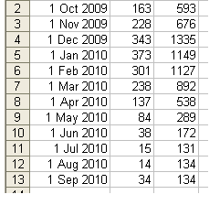

Once Dan made the basic scatter chart, there are a few important extras that he will probably want: a trend line, an equation, and an R2 value (R2 is discussed in the following).

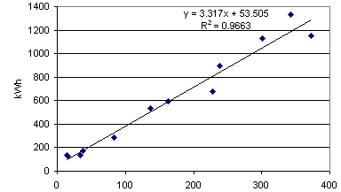

CDD

* The "*y*" corresponds to the kWh
* The "*x*" corresponds to the CDD
* The figure that multiplies the *x* (3.317 in the example chart above) represents the**gradient**of the trend line.
* The constant at the end (53.505 in the example chart above) is the **intercept**. It represents the point at which the trend line crosses the y axis. In theory this should represent the "baseload energy consumption”.

The R2 value is basically a measure of how good the correlation is. The closer the R2 value is to 1, the better the correlation. A good correlation between degree days and energy consumption indicates that the methodology is sound. While calculating the degree days is based on the choice of base temperature, so if our base temperature is more accurate, the value of R2 is more close to 1(i.e. the better the correlation). The following chart shows different base temperature get different results.

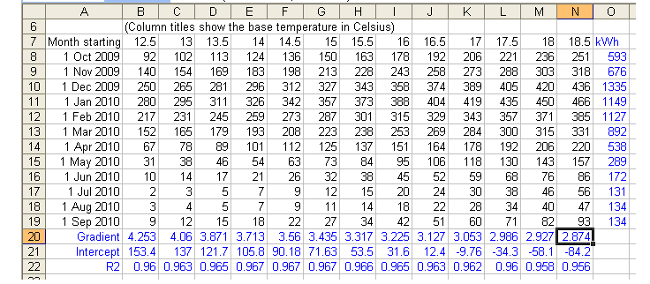

Based on the value of R2, we can evaluate the base temperature. For example, 13C is more accurate than 12C, because 0.963 is greater than 0.96. That means 13C get more accurate degree days so its correlation with energy consumption is more accurate.

The above example is how to evaluate different base temperature from different CDD. However, the principle of CDD and GDD are very similar so the methodology of evaluating base temperature for GDD is the nearly same as CDD. The only difference is that we can take the plant growth length or similar stuff as “energy consumption”.

**Reference**

1.Martin Bromley “Degree Days Understanding heating and Cooling Degree Days” <http://www.degreedays.net/introduction>.

2.“Linear Regression Analysis of Energy Consumption Data”<http://www.degreedays.net/regression-analysis>

3. “Grain and Forage Crops: Growing degree-day calculation

<http://agron-www.agron.iastate.edu/Courses/agron212/Calculations/GDD.htm>

”