Mir Hossain

CS477

HW6

Question 1:

A:

Recursive Formula

placeAds = max( placeAds(i - 6) + revenue(i), placeAds[i - 1] //code used

placeAds[i] = max(placeAds[i - minMiles] + revenue[next], placeAds[i - 1]); //Formula

Explanation:

I used a bottom up approach to solve the problem. First, I checked for a valid location (specified by the requirements). If there is no valid location for at most a mile, then the revenue generated is the final revenue for that point. If a valid location does exist, then we check if the position meets the requirement for the spacing between ads. Then, the revenue will be added to the total revenue within the interval [0 to D] , D being the max distance. When max distance is reaches, the recursive formula would return the max revenue from each valid position.

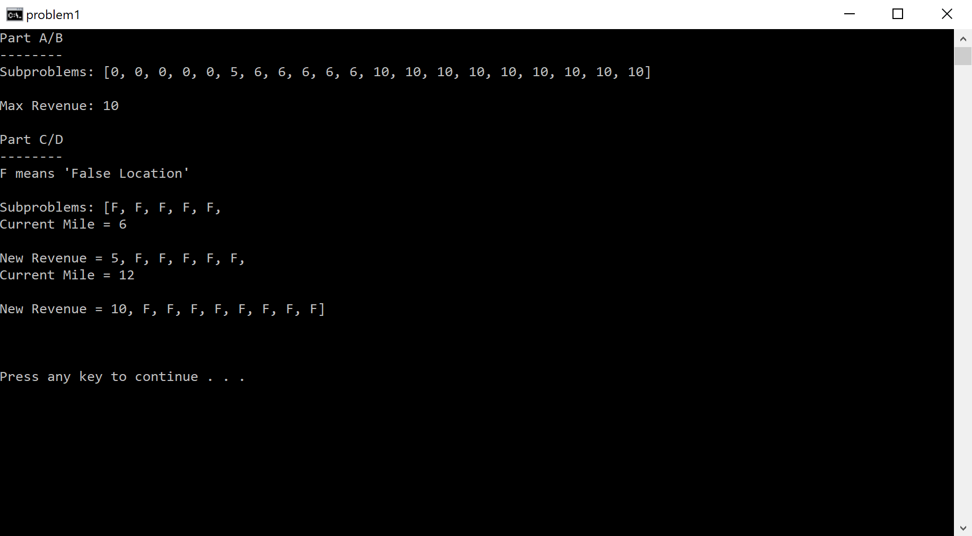

If X and Y are sequences that begin with A then every longest common subsequence will begin with A. Let X = ABCFE and Y = ACBFQ. Both X and Y can also be written as X[A…..i+1] and Y[A……i+1]. Since X[0] = Y[0], then we can add as many letter as we want to both strings and the LCB will always begin with A.

If X and Y are sequences that end with A, then some LCBs will end with A. Since A is the last letter in both sequences, then the LCB will end with an A. The only time the LCB would not end with an A is if more letters were added to the sequences, or if there is a larger LCB somewhere else.