Lecture Notes: Access, Advanced Skills

Importing and Exporting Data
An Access database doesn’t always exist on its own; sometimes, there are data that should be moved to the database (taken from outside sources) or from the database (sent to outside targets.)

External Data
It is very common, especially nowadays, to keep data of a project, company, etc., on several computers. That is, data of one project or one company isn’t wholly located on a single computer but is rather distributed among several devices.
Moreover, data that isn’t stored on the same computer, or even not within the same application, might have a different format.
In other words, if we are interested to make calculations that involve data taken from various sources and formats, we must know how to move data from one app to another and how properly convert the data from one format to another.
Access has tools that let you import data (move data into Access) from any of the following file formats: Oracle, SQL Server and other ODBC compliant databases, Excel, XML, HTML, Word documents and even text files. You won’t need to convert the files manually: Access knows how to do so!

Importing and Exporting Data
Access lets you exchange data in several ways:
- When you link data from an outside source into Access, you don’t copy data from that source into Access, but just display it within the database.
  - This means that, if the data in the original source are modified, the change will be reflected on the data within the Access database.
  - Moreover, if data in the original source are deleted, Access will no longer display these data.
- Importing data means bringing data from an outside source (= format) into the Access database by copying them into the database.
  - Since everything is copied, we are not concerned about the original source, and don’t care if the original source changes or even disappears.
- Exporting data means taking data out from an Access database into some outside target file (or format) by copying them into that external file.

Importing Data
To import data into Access, one can do the following:
- Click the “External Data” tab “Import & Link” group “New Data Source” button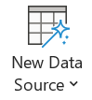,
- Move the mouse over one of the following options (depending on the file you wish to import:)
  - From File: If you wish to import data from either an Excel file, an HTML file, an XML file, or a text file.
  - From Database: If you wish to import data from another database file including Access, SQL Server, Azure, and dBASE.
  - From Online Service: If you wish to import data from a service including Dataverse, SharePoint list, Dynamics 365, Salesforce, or Data Services.
  - From Other Sources, like ODBC databases or Outlook folders.
- Click on the specific type of file whose data you wish to import (e.g., Excel,)
- Follow the instructions on the screen on how to import the data.

Exporting Data
To export data from Access to an external file, one can do the following:
- Click the “External Data” tab “Export” Group, 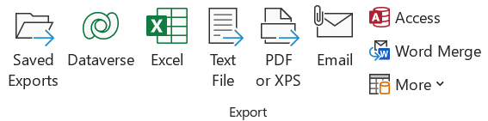
- Click on the file format to which you wish to export the data,
- Follow the instructions on the screen on how to export the data.

Queries
We learned how to add, change, and delete data within a database. Nonetheless, we strive to also get to use our data (letting data ‘accumulate dust’ is not doing any good to a business.) One way to use data is to search them and ask questions about them. We call the procedure of searching for data querying and the questions that we get to ask queries.
For example, you can ask the following interesting questions about a Purchases table that lists purchase ids, purchase dates, id of the customers who purchased, and the total $$$ spent on the purchase:
- What percentage of the purchases occurs on every day of the week? (E.g., 10% of the purchases are on Sundays, 20% on Mondays, etc.)
- On which day of the week do most purchases occur?
- Who are the 10 customers who made the most purchases?
- Who are the 10 customers who spent the most $$$ on purchases?
Using answers to the above questions, we will know what day of the week is the busiest in terms of purchases, and who might be the 10 most loyal (or the most profitable) customers, all of which may help us shift the business towards success and help us build better business plans, loyalty programs, etc.

Creating a Query
Access has an in-built tool called the Query Wizard, which lets you swiftly create a query with only several button clicks.
Here is the procedure for creating a query on some table X:
- Click the “Create” tab “Queries” group “Query Wizard” button 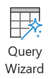,
- Within the dialog box that opened, choose “Simple Query Wizard”, and click OK.
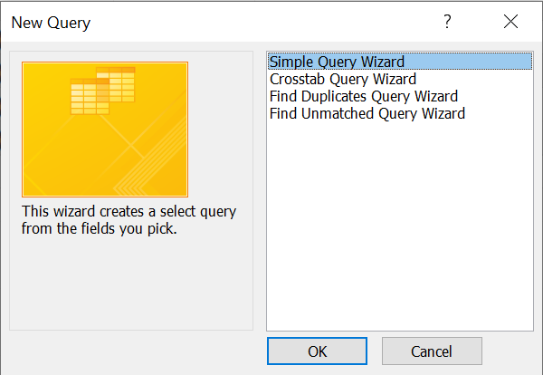
- On the next screen, choose Table X, and choose the columns that you want to appear in the query using the small “>” arrow.
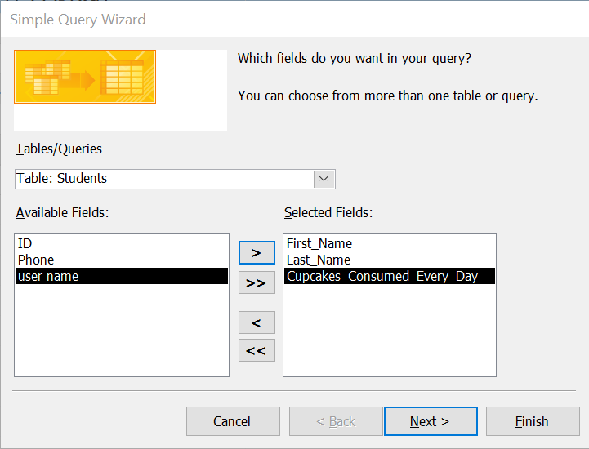
- Click through the next screens of the Wizard:
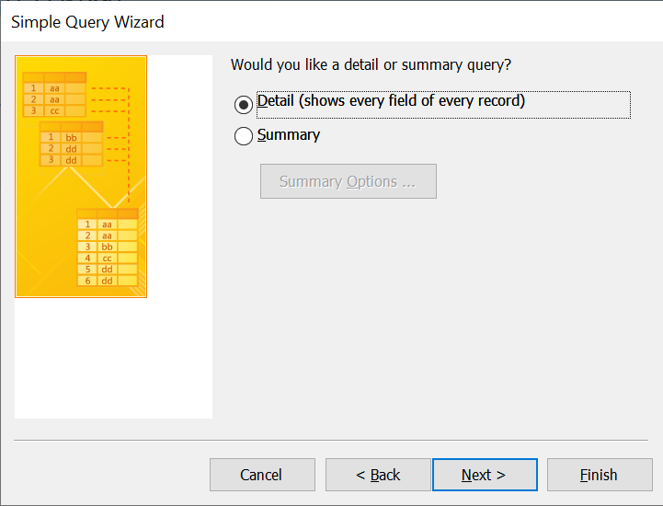
- Assign a name to the query, and click Finish:
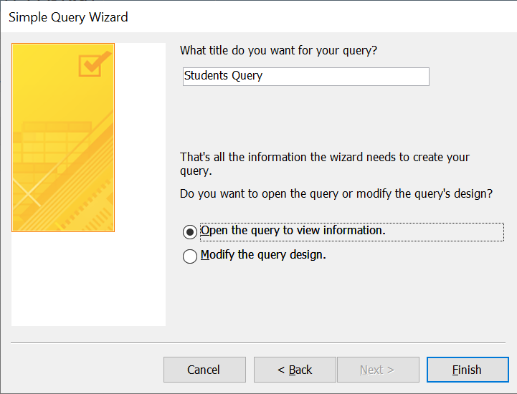
- The result of the query will be displayed in a table-looking structure:
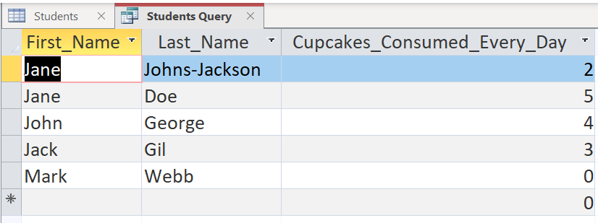
The phrase running a query is the same as saying “displaying the results of a query.”

Criteria in Queries
Sometimes, simply selecting to see some of the columns from a table is not sufficient to answer our questions.
We don’t only want to limit the number of fields we wish to see, but also the number of records, which we usually do by imposing criteria.
Criteria are conditions that we impose on our data. If a record matches the condition, the data from that record is displayed in the query’s result. On the other hand, if a record doesn’t match the condition, it is NOT being displayed.
Example:
The previous simple query resulted in:

However, we can limit our results such that only those students with 3 or more consumed cupcakes per day are displayed. Well, how do we do that?

Design View of Queries
Just as for tables, queries also have a Design View mode.
We need to open the query in Design View to be able to add criteria. To do so, we click on the Home tab View button Design View option.

Typing Criteria
The Design View of a Query looks as follows:
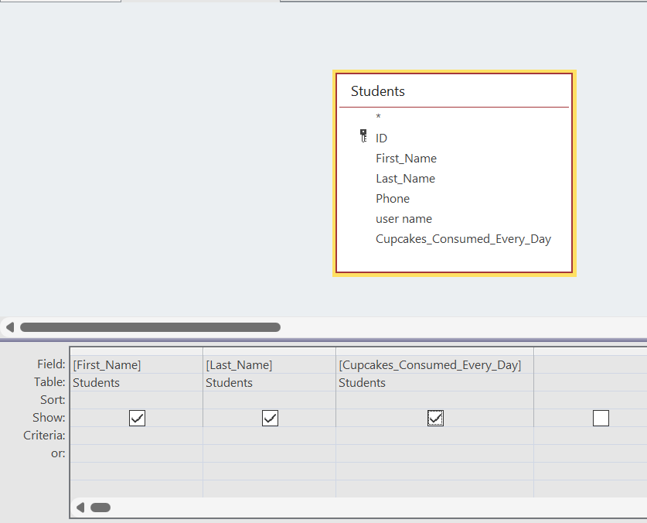
The bottom part of the screen is called the design grid, and it has a row for entering criteria.
Because our goal was to see only those people who eat 3 or more cupcakes, we should:
- Click in the cell that corresponds to the “Criteria” row and the “Cupcakes” column in the design grid,
- Type the following criterion: >=3,
- On the “Query Design” tab, click the “Run” button to run the query .
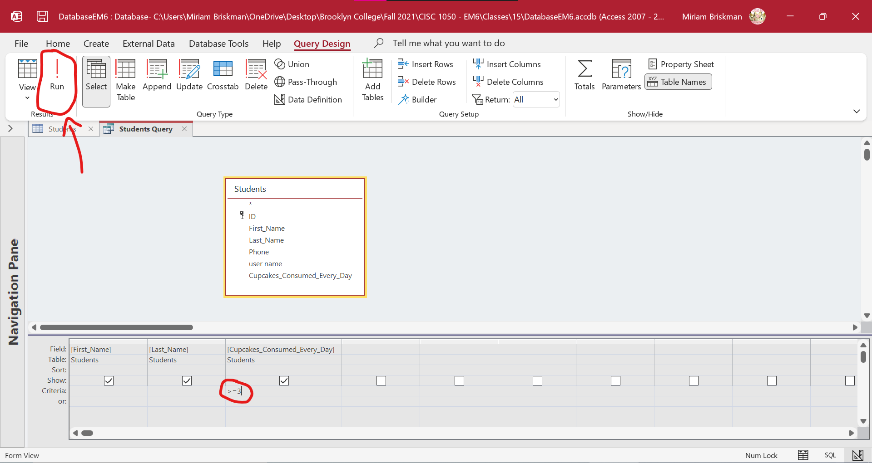
Once we click on the “Run” button, the results of the updated query will be displayed:
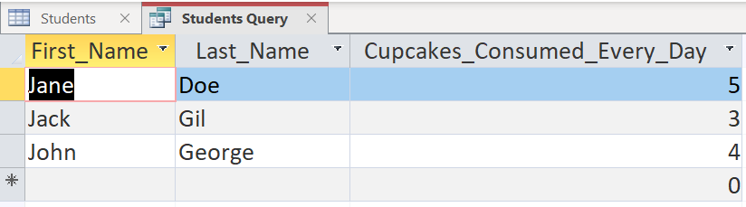
So now we can see the information of only those students who eat 3 or more cupcakes per day.
Notes:
- We can use the following comparison symbols in criteria: =, >, <, <=, >=, NOT (not equal to).
- Because words and even dates can be compared, we can use these same symbols to query words and dates! Consider the following examples:
  - <5/9/2022 is the same as saying “all the dates before May 9, 2022.”
  - NOT "Gil" is the same as saying “every name that is not Gil”.

Using Compound Criteria
Sometimes a single criterion is not enough; we want to our query to be more refined. To achieve this, we specify compound criteria:
- If you have two criteria, the query uses either both or either of them.
- AND uses both criteria (very strict); OR uses either one (less strict.)
- AND and OR work like the AND and OR Excel functions.
Examples:
- >= 20 AND <= 35 Will search for values greater than or equal to 20 and smaller than or equal to 35.
- BETWEEN 1/10/2021 AND 10/25/2021 Will search for dates between 1/10/2021 and 10/25/2021.
  - Same as saying >=1/10/2021 AND <=10/25/2021.
- IN ('CO', 'UT') Will search for owners living in Colorado or Utah.
  - Same as saying ='CO' OR ='UT'.

Forms and Reports
We became familiar with two Access objects so far: a table and a query.
For a more complete set of actions that we can apply to data, we will study two more Access objects: a form and a report, each of which has its own purposes and strengths.

Forms
When you are submitting an online application, logging into an online account, or answering a survey, or are using a tool called form.
A form is a user interface that allows entering, modifying, and viewing information.
In Access, a form will let you enter the data of a new record or modify such data, switch between records, and otherwise interact with the database in a user-friendly and neat way.
The good thing about forms is that they simplify the job of their user. Technicalities such as the order of fields, field properties, etc., are not necessary for the form to work correctly. In fact, the user who interact with the form doesn’t need to be an expert in the structure of the database and the tables therein.

Creating a Form
To create a form:
- Open the table or query on which the form will be based,
- Click the Create tab Forms group Form button.
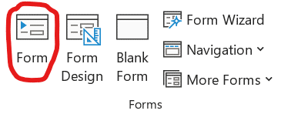
Access will immediately create a form and open it in Layout View:
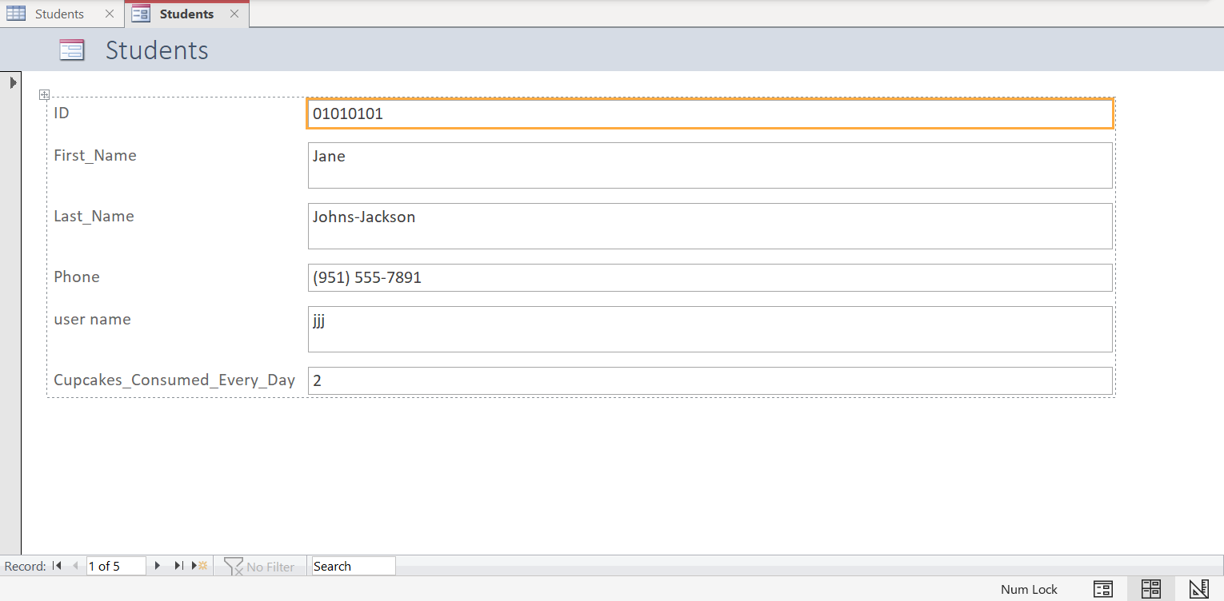
In this view, you can:
- Resize the various text boxes on the form,
- Change the location of (move around) the boxes.
- Add additional boxes or features, such as buttons, labels, links, checkboxes, images, etc.
- Change visual settings, including font, font size, colors, alignment, borders, etc.
When you switch to Form View, the form will let you enter or change records’ data:
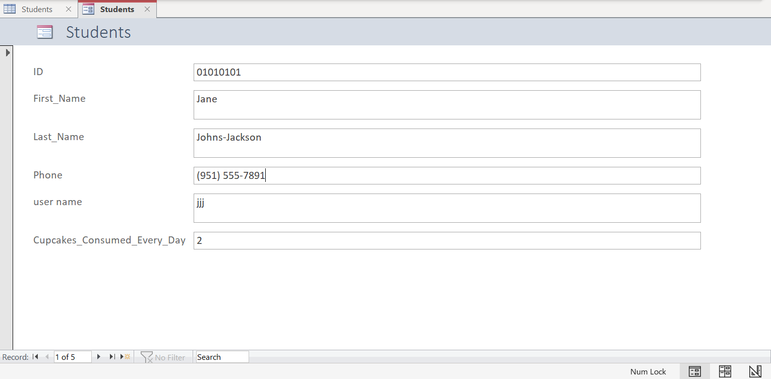
In this view, you change click within boxes, and proceed to entering new data or modifying existing data within the records!
All the changes you make will be reflected within the table or query that is connected to the form, so using a form lets you change the database! Just make sure to save the changes made within the form.
Design View lets you apply more detailed structural changes to the form, including:
- Access to the Header and the Footer sections of the form,
- Ability to add additional form objects, including page breaks, that are not available in Layout View:
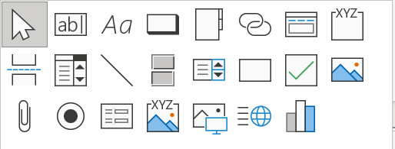
- Ability to add charts into the form 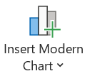,
- Access to setting various form properties via the Property Sheet 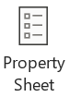.
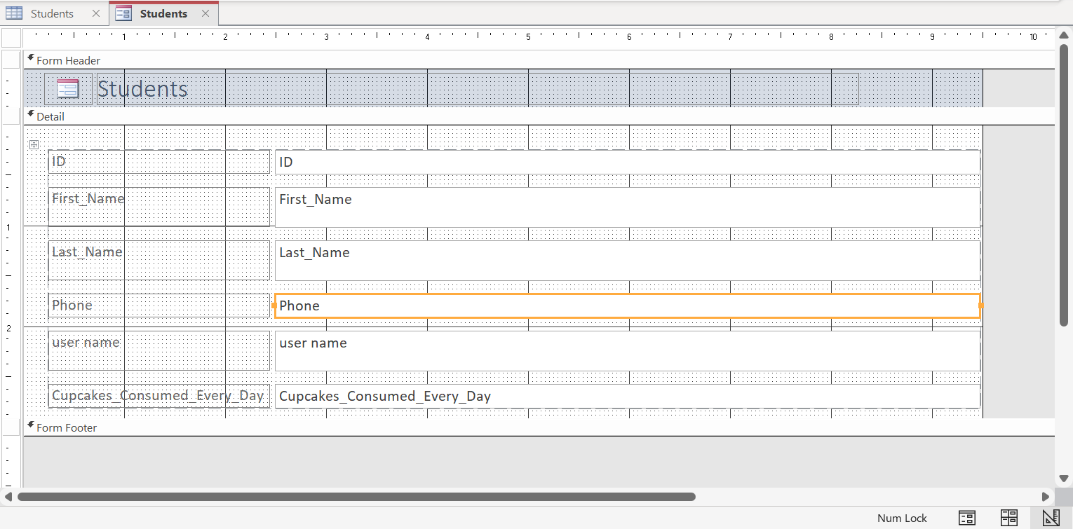
All these functionalities are available within the “Form Design” tab that becomes available when the form opens in Design View:
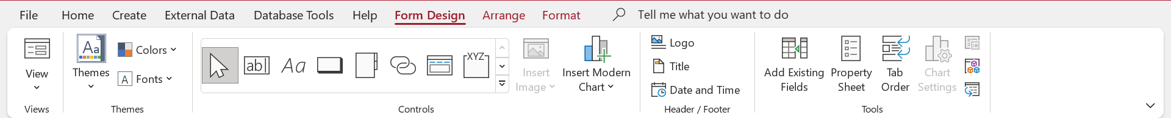
Some great resources on Access forms are described in the following Microsoft webpages: https://support.microsoft.com/en-us/topic/ee51939e-4fff-4304-9086-33d7ca9e4404#ID0EAABAAA=Forms

Reports
Unlike forms, which are mainly used to insert or change data, the purpose of reports is to output data by displaying it on a sheet that is ready for printing.

Creating a Report
To create a new report that is based on either a query or a table:
- Open the table or query for which you want to create a report,
- Open the Create tab “Reports” group “Report Wizard” button,
- In the new window that opens, add:
  - the fields you want to be displayed in the report,
  - the field according to which the report will be grouped (if any), and
  - the order/sorting of data in the report (if any)
- Finally, choose the orientation type (portrait or landscape) and layout type (stepped, block, or outline) of the report, and give the report a name.
- Click the Finish button to complete the creation of the report.
Once these steps are completed, a report like the one in the below image will be generated:
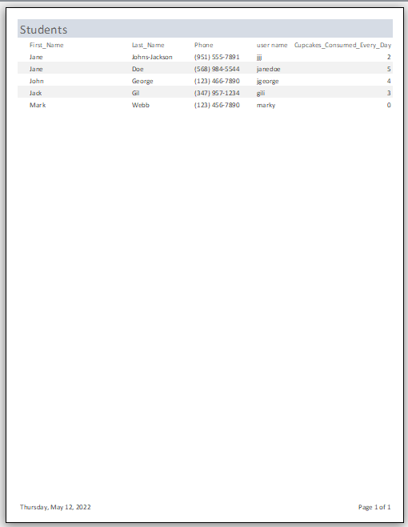
Just as for forms, reports can also be viewed in Layout View, Design View, and Report View, along with a Printout View that allows you to see how the report will look when printed.

Calculated Fields
In the database examples we have been using in class, we created table fields of various types including short text, numbers, currency, yes/no, and more.
One interesting field type is calculated field, which allows you to perform calculations based on other fields in the table.
To add a calculated field:
- Add a new field to the table,
- Select “Calculated Field” or “Calculated” as the data type of that field,
- Select the subtype of the field. It could be either of: Text, Number, Currency, Yes/No, Date/Time.
- In the new “Expression Builder” window that opens, type the formula that Access will use to perform the calculation.
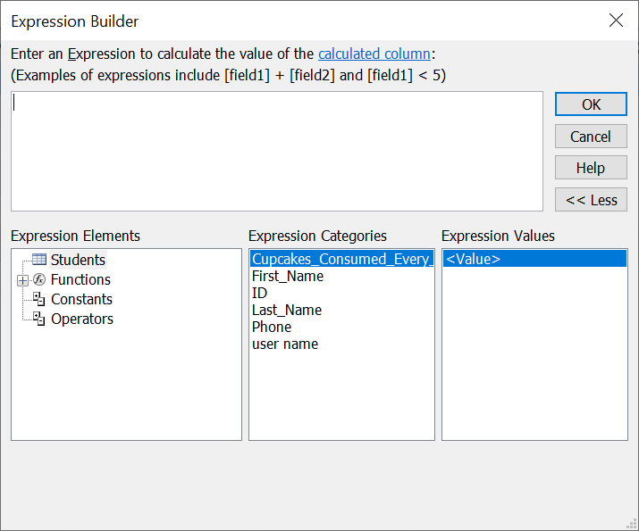
- After typing the formula, click on OK to save the changes and close the window.
- Type the new field’s name.
Example:
To calculate the quantity of eaten cupcakes times 5, we type the formula:
5*[Cupcakes_Consumed_Every_Day]
We put the names of fields in brackets []. This will tell Access to replace this name by the actual quantity within each record. (This is similar to using a cell name, like A1, in Excel.)
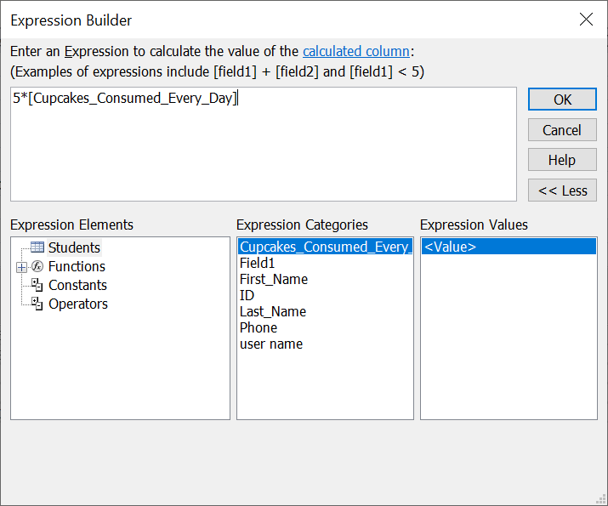
When we return to the Datasheet view of the table, we will see the following data:
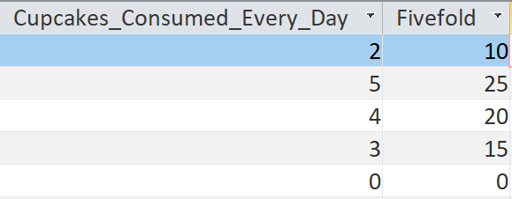
The field “fivefold”, which is the name we gave to the calculated field, successfully displays a x5 quantity of the eaten cupcakes.

Parameter Queries
To make our queries more flexible in terms of criteria, we can let the user of the query indicate the criterion they want to add each time they run a query. This is called a parameter query. This is a nice alternative to typing a particular criterion and changing it each time within the query’s design view.
To create a parameter query, instead of typing a criterion like >2, type the instructions for entering the criterion in brackets [], like:
[Enter the number of cupcakes:]
After adding such a criterion, each time the query is run, the following window will pop up:
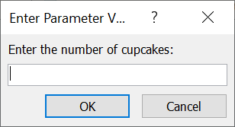
and ask you to type a quantity for cupcakes.
Based on the number that you enter, the query will result in records in which the cupcake quantity is equal to the number you entered.
Examples:
If you enter 5 in the box, the following will be the output of the query:
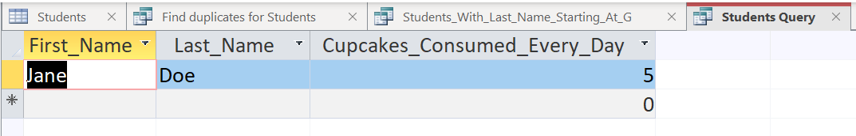
In the next run, if you enter 3, the following will be the output of the query:
