Lecture Notes: Access, Basic Skills

Creating Database Tables

What’s Access?
Access is the database app of the Microsoft Office suite. It lets you build a database, add, delete, and change information, search for information based on some criteria that you give (“make queries”) and allows you to present data that you want in an appealing form.
Let’s see a nice video on Access and on databases! https://www.youtube.com/watch?v=eXiCza050ug

Basic Access Terminology
- A Database management system is a computer software (program) that allows you create a database
- A Relational database is a type of database that consists of a collection of tables, each of which contains information on a specific subject
- A Record is the official name for “row” in a table in Access.
- A Field is the official name for “column” in a table in Access.

Using Access

Launching Access on Your Computer
Just as with other Office apps, you can launch Access by using your computer’s Search Bar to type ‘Access, and then clicking on the icon of the application, which may be one of:
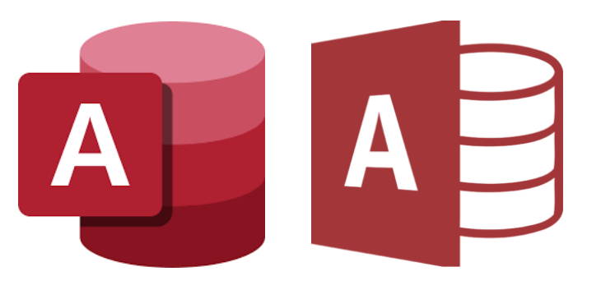
or by finding and clicking this icon elsewhere (in the Start menu, in the Applications folder, or the on Desktop.)

Creating a New Database
Once the Access app opens, it looks like:
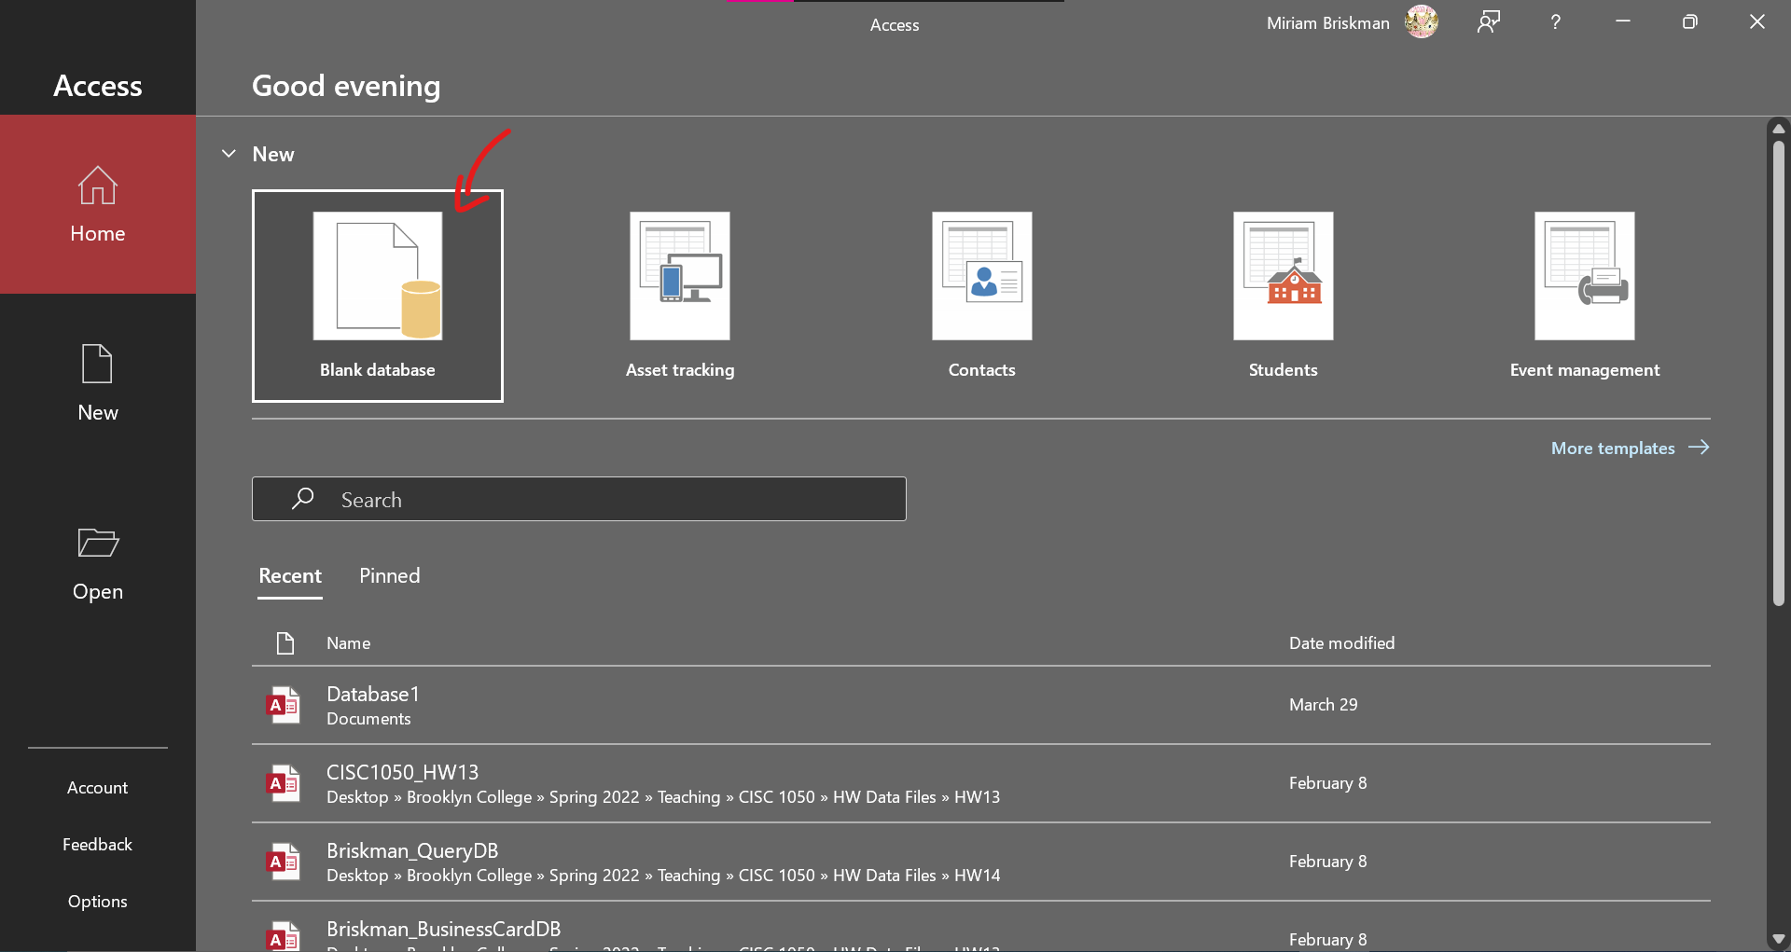
Now, click or double-click the ‘Blank database’ option to create a new, empty Access database file.
For the database to create, you will need to type its name and choose location (folder) on your computer where to save the file by clicking the folder button . Then, click on “Create”:
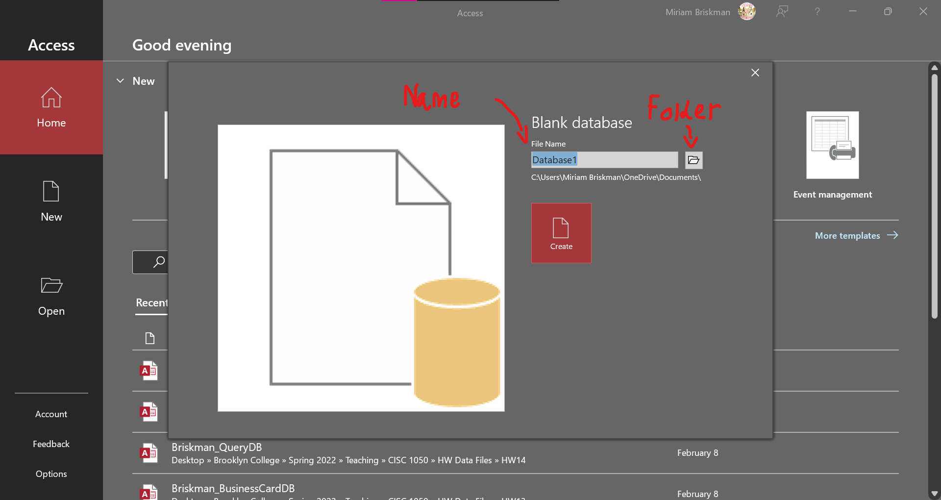
This new database will consist of a single, empty table:
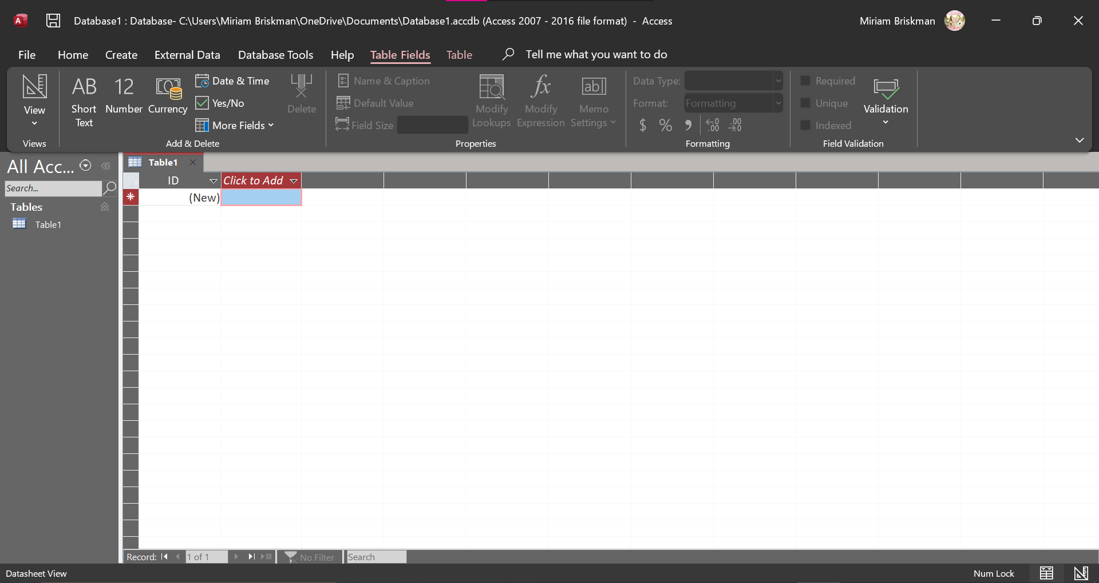

The empty table, called “Table1”, has a single column called by default “ID”. There are currently no data in that table, but you can start adding some by clicking within the cell under the “ID” column.

Understanding Tables
Each Access table stores the info about some type of person, object, or event.
For example, a ‘Customers’ table will store costumer ids, first and last names, addresses, phone numbers, email addresses, and more. A ‘Products’ table will store a product catalog number, product name, description, cost, and more.
Each such trait (id, name, cost, etc.) is represented by a column (= field) in the table. The data of each object is represented by a row (= record) in the table. That is, a row is dedicated to storing the info of each object, person, or event.

Types of Tables
There are three types of tables:
- object tables,
- transaction tables, and
- join tables.
Object tables are tables carrying info about some type of people (customers, employees, contacts) or objects (cars, stores, houses, books, locations.) Transaction tables store info about some type of events (purchases, check-ins, book rentals, class attendance.)
One significant difference between object tables and transaction tables is that transaction tables always have a field for date & time (= timestamp) that describes when the events took place. Object tables don’t necessarily need to have a date & time field, as an object exists for a long duration (e.g., a customer might return to the store in the future.)
A join table is one containing info taken from two tables (usually object tables) in the database. For example, if the database contains a customers table and a table of car types, you could create a join table that tells what cars each customer has. An example would be:
Customer_ID | Car_Type_ID
1 | 234
1 | 543
2 | 234
3 | 129
In this join table, we can see that the customer with ID “1” owns two cars of types 234 and 543. Also, the customer with ID “3” has one car of type 234, and the customer with ID “3” has a car of type 129.

Familiarizing ourselves with Access:
- The Access work area is the area in the middle of the screen where you work on a certain object, such as a table or form:
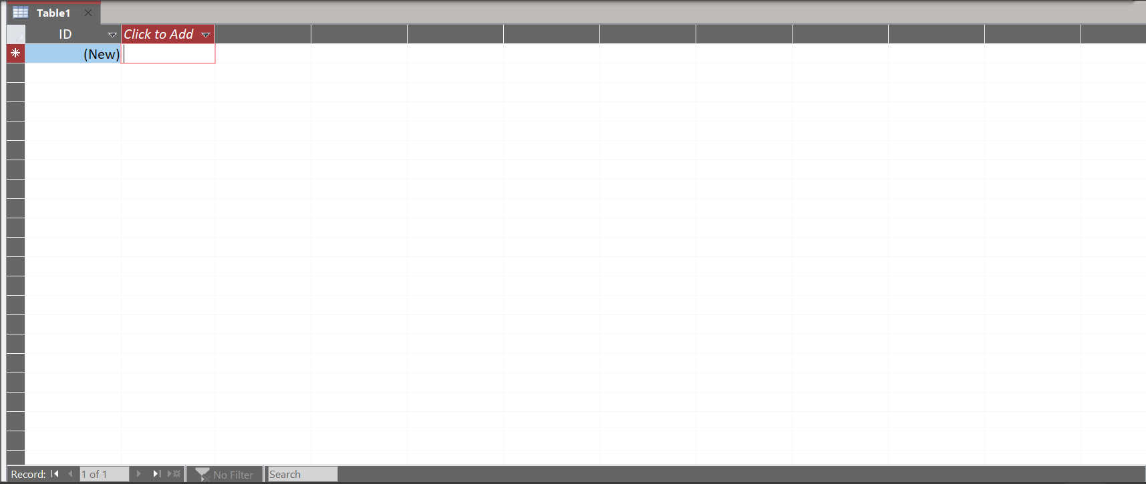
- Object tabs are small areas above the Access work area carrying the names of the objects. Click on one’s object tab to open that object!
- The Navigation Pane is the area to the left of the Access work area; it lists the different objects existing in this Access database.
  - Clicking on the Navigation Pane’s open/close arrow  will close the pane:
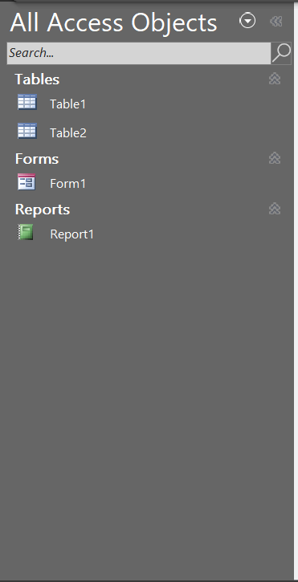
- The Status Bar is the area at the bottom of the screen, ranging from left to right.
It has two buttons:
  - The Datasheet view button  shows the sheet as rows and columns.
  - The Design view button  lets you modify the table’s structure.
- The Ribbon has various tabs: Home, Create, External Data, Database Tools, and Help.
We’ll speak about some of these!

Working with Tables

Saving a Table
To save the empty table “Table1” (which remains unsaved when the database file is created:) Click the Save button on the Quick Access Toolbar Type a new table name Click OK.
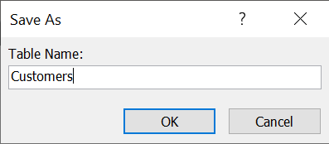

View a Table in Design View
To view the table in Design View:
- Table Tools: Fields tab View arrow Click “Design View.”
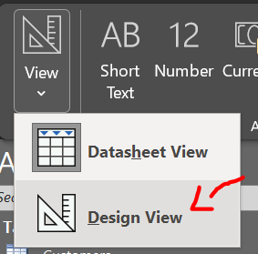
- [Alternative:] Status Bar Click the Design View button.
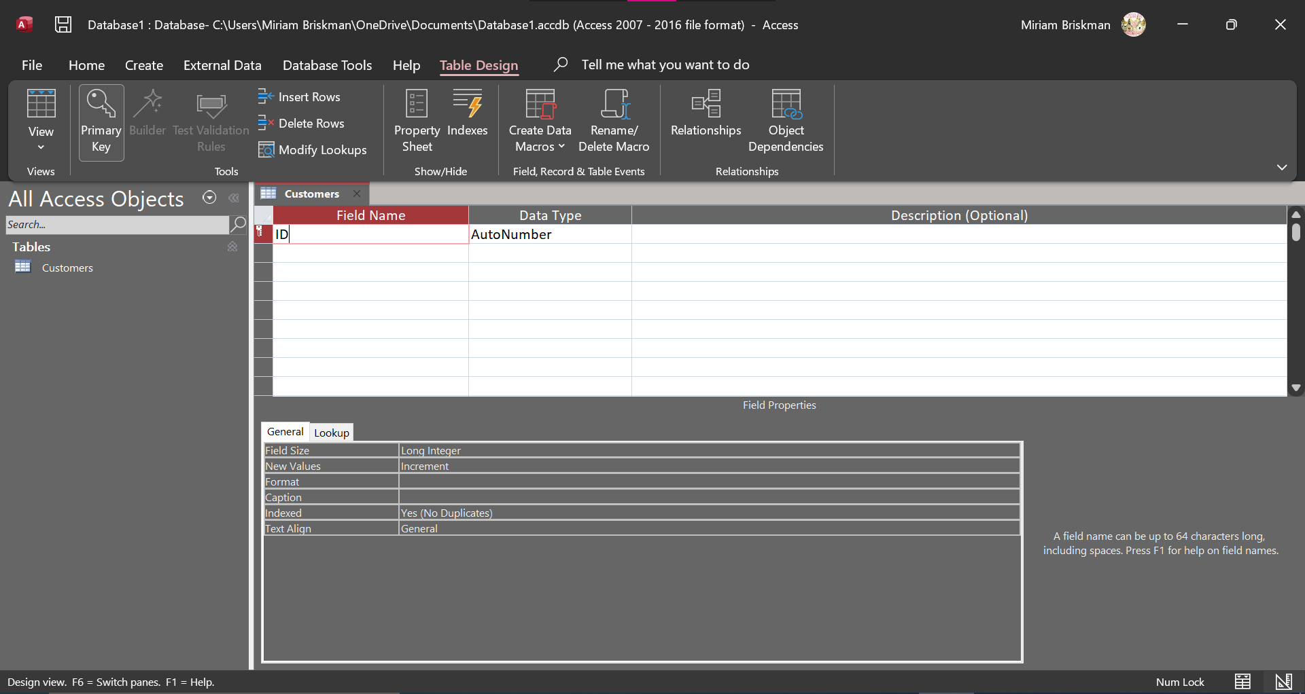
^ The Design View of the table. It lists all the fields (columns) in the table, their data types, and their descriptions. Below these is the Field Properties area that lets you set up field properties.

Adding New Tables
To add new tables into the database, click the Create tab Table button.
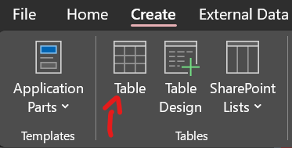

Closing a Table
To close an open table, click the Close button (small x symbol) to the top-right of the table.
If necessary, click “Yes” to save any recent changes made to the table.

Opening a Table
Suppose you created and saved a table called “Customers” in your database and closed it because you finished making changes to it.
To open the table again, do either:
- Double-click the table’s name in the Navigation Pane, or
- Right-click the table’s name in the Navigation Pane Choose the ‘Open’ option.

Fields in Access

Field Properties
Let’s look at the Design View of a table.

The upper part of it lets you view and change the name of each field (column), its data type, and add some description text.
The lower part lets you set some key properties for each field. These include:
Name of Field Property | Purpose
Field Size | Sets the maximum number of characters that can be entered into a text field.
Format | Sets how the data is to be displayed in the table field.
Input Mask | Sets the rules on how data can be entered so that data is entered correctly.
Default Value | Sets the default value that will appear in the table field each time a new record is entered.
Required | Tells whether a value is required to be entered into this table field.
Caption | An alias to the field name that will be displayed instead of the original name.
Indexed | Tells if you want to index the field (internally sort the table by the values of that field.)
Text Align | One of: General, Left, Right, Center, and Distribute.
Each data type will show different field properties that you can modify.

Rules on Naming Fields
You should make the field name:
- Descriptive of what the field contains (e.g., “first_name” instead of “field_1”)
- Concise and not overly long
The following are additional rules that you must abide by while naming fields:
 | Rule | Examples of Illegal Field Name
1 | Cannot exceed 64 characters | Customers_who_are_buying_  in_our_store_at_locations_  in_NY_NJ_PA_NV_FL
2 | Cannot include periods (.), exclamation points (!), accent grave (`), or brackets ([]) | First.Name  City!  `ID  [Date Of Birth]
3 | Cannot include spaces | First Name
4 | Cannot include low-order ASCII characters | See the left-hand table at https://www.asciitable.com/
5 | Cannot start with a blank space | LastName

Data Types
Access distinguishes between distinct types of values: text, numbers, currencies, dates, hyperlinks, attached files, check boxes (yes/no), and more.
Each of the fields in our tables will be of one of these types. A part of the available field types to choose from are:
Data Type | Description
Short text | Alphanumeric characters
Long text | Alphanumeric characters
Number | Numeric values
Large Number | Numeric values
Date/Time | Date and time data
Currency | Monetary data
AutoNumber | Automatic number increments
Yes/No | Logical values: Yes/No, True/False, etc.
OLE Objects | Pictures, graphs, sound, video
Hyperlink | Line to an Internet resource
Attachment | External files
Calculated | Stores calculations based on other fields
Lookup Wizard | Displays data from another table

Primary Key of a Table
Since there might be 1000s of items (records) in a table, some of which may have identical data, we want to have a way to uniquely refer to each record. So, we need to have:
- A Unique identifier is a field (column) containing unique info about each record. Example: IDs, EMPLID, catalog codes.
  - A Primary key is a synonym of Unique Identifier.
Here is an example illustrating why primary keys are crucial:
Suppose Brooklyn College stores student information in its database, which it stores in a table called “Students.” Here is a part of the records in the table:
FirstName | LastName | FiledForGraduation?
Jane | Doe
…
Jane | Doe
There are two Jane Does studying at Brooklyn College, only one of whom filed for graduation. Since the table has no ID that can uniquely distinguish between the two, the college might send notifications on graduation or the commencement ceremony to the wrong Jane Doe. Things can get even worse if the college confuses their academic records or money that the Jane Does need to pay for tuition.

Choosing the Primary Key
When deciding what field to make the primary key of the table, note that such a field must:
- Uniquely identify each record,
- Not be null (have empty cells,)
- Already exist in the table before you create the first record,
- Must remain stable (its properties [e.g., field size] don’t change over time,)
- Be simple and contain as few attributes as possible (to remain general and simple.)

Add the Primary Key
You might wish to leave Access the job of choosing a primary key. In such a case, when you create a table, keep the “ID” field, which is set by Access to auto-generate IDs per each record that you add (you don’t have to type any IDs: access will AutoNumber them for you.)
Alternatively, if you wish to make another field the primary key, open the table in Design View, and then do either:
- Click on the field name of the field you want to turn into the primary key Table Design tab Tools Group Click the ‘Primary Key’ button .
- Right-click over the field name of the field you want to turn into the primary key Choose the ‘Primary Key’ option .

Indexes
An Index is a sorting of a table’s data based on a specific field. The data in its sorted form is stored internally within the database and is used to instantly search for values within that field.
Access stores a copy of the table, and the only difference between the table you see when opening the file and this copy is that the copy has the data sorted by a column.
Example:
Suppose that the “Songs” table in your database stores your favorite song names, the artists’ names, the lengths of the songs in seconds, and the release year of each song.
You realize that, since the table grows by the day (because you add more songs,) it takes longer time to find for songs by the artist’s name.
To make the search faster, you can index the table by the artist’s name (we will learn how to do so in the next section.) Mathematically, instead of taking $n$ seconds to get search results, it will now take Access only up to $\log_{2}{n}$ (the logarithm of $n$) seconds to find the songs, which is ridiculously fast!

Adding Index
To add an index to a field in a table:
- Open the table in Design View,
- On the upper part of the window, click on the field name you want to index,
- In the “Field Properties,” click on the box next to “Indexed” and choose “Yes (No Duplicates).”

To Index or Not to Index?
It is better to avoid adding an index if either of the following is true:
- Your table does not contain too many records (the table is small.)
- You don’t search the table often.
Why is it sometimes good to avoid using indexes? The answer is in the following table:
 | Advantage | Disadvantage
Index Added | Faster searches | File grows larger
Index NOT Added | File remains small | Slower searches
That is, each time you add an index, Access stores a copy of the table, which causes the overall size of the file to grow. For example, if your table has twenty fields, and you decide to index each one of these fields, Access will store twenty (!) copies of the table.
So, as we said, if the table is small (so searching it doesn’t consume too much time) or you don’t search the table often, don’t add indexes.

