Lecture Notes: Access, Intermediate Skills

Table Relationships
Table Relationships is how a database, and Access in particular, organizes data stored in it.
Here are some properties of a high-quality database:
- It contains factual, real-world data.
- It is logical, coherent, and consistent.
- Data is added to the database for a specific, well-defined purpose (e.g., maintaining the data of an organization.)
- Each datum (= a single piece of data) is stored in a field (a.k.a., in a ‘cell’ under the field.)
- The collection of related fields (e.g., EMPLID, first name, last name, etc.) creates a table structure.
Besides just storing data, database management systems allow the manipulation of data: making calculations, re-organizing data, drawing conclusions, creating reports and printouts, etc.

Approaches to Working with Data: Comparison
According to the Database approach, a unified database management system (like Access) stores metadata (= technical data e.g., file size, file structure) about each database file within the ‘system catalog’.
According to the File-System approach, each program that was created to work with data stores metadata about each database file. That is, if we have 1000 programs, we have a total of 1000 copies of the metadata per each data file, one copy per each program.
One advantage of using the database approach becomes evident when the metadata of some database file changes for some reason. If that happens, and the file-system approach is used, it would be necessary to update the information in each of the programs that work with the data. This is a headache because there may be 100s of such programs. On the other hand, if information about a database file needs to be changed, and the database approach is used, then only one change needs to be made: an update in the database management system itself. No headaches!
As such, because, in a database system, we isolate data from the information about the database file, our work of maintaining data becomes easier!

What You See in the Database Is Not What Your Friend Sees
Each database management system recognizes different users. Some of these are reliable (such as the system administrator), and some… are quite not.
To ensure that the data in the database is not maliciously erased or changed, databases define who can do what: who can read information in the database, who can change (‘write’) information, who can delete information, etc. The system administrator or the creator of the database file is usually given the highest ‘privileges’: they can read, change, and delete data.
On the other hand, outside users who are not a part of the company or haven’t created the database are given a limited access. In some cases, they are allowed to view the contents of the database (‘read’) only, but in many other cases, they are denied any access to the database (maybe they are working for the competitors and want to spy on your company!)
The set of data that a particular user is permitted to see & access is called a view.

Many Users Can Use the Database Simultaneously
To make the database accessible as much as possible, database management systems have been constructed such that they allow multiple users at a given moment to use a database file. The situation in which two or more people work on a database file at the same time is called concurrency. Most database management systems today support concurrency.
To ensure that all the changes made by two or more simultaneous users are saved, the database management system must incorporate some concurrency control mechanisms. The reason is that, when two users try to make a change of the same piece of data at the exact same time, only one of the changes will be saved.
Example: 5 is a datum stored in the database. User A decides to change the 5 to 4, while User B, at the exact same time, decides to change the 5 to 6. What number will eventually be stored in the database? Clearly, it will be either 4 or 6. But which one? This depends on who got to make the change last.
Because it is hard to predict which user’s change will be applied (because the changes are done at the very same time,) the database management system must limit such simultaneous activity. That is, if User A started making a change first, we must block the database on User B’s side until User A finishes making their change. Only after User A completes the change, User B will be let to make their change. Such a solution is called mutual exclusion, or mutex.
This way, we will prevent such random, unpredictable changes in a database.

Flat File vs. Normalized Data
The following two terms refer to how data is stored electronically:
Flat File arrangement is the way in which data is stored on a single spreadsheet, without relationship or reference to other spreadsheets.
Normalized File arrangement is the way in which data is stored in several tables (= more than 1 spreadsheet) that can relate to each other.
While adding data, changing data, and making quick calculations in a flat file is easier (like what we did in Excel), you may need to use a normalized approach using a database management system (Access) to ensure simultaneous use of the database file by several users, data protection from intruders, and independence of the data from the application (so that the data could be accessed by another database management system without difficulties.)

Types of Relationships between Database Tables
There are 3 types of relationships between tables in Microsoft Access:
- One-to-One: One record (row) in Table A relates to one record in Table B.
- One-to-Many: (The same as Many-to-One) (The most common relationship!) One record in Table A relates to one or more records in Table B.
- Many-to-Many: One record in Table A relates to one or more records in Table B, and one record in Table B relates to one or more records in Table A.
Below is a general example of the different relationships that can exist between tables in a database. Relationships are expresses as the lines connecting tables.
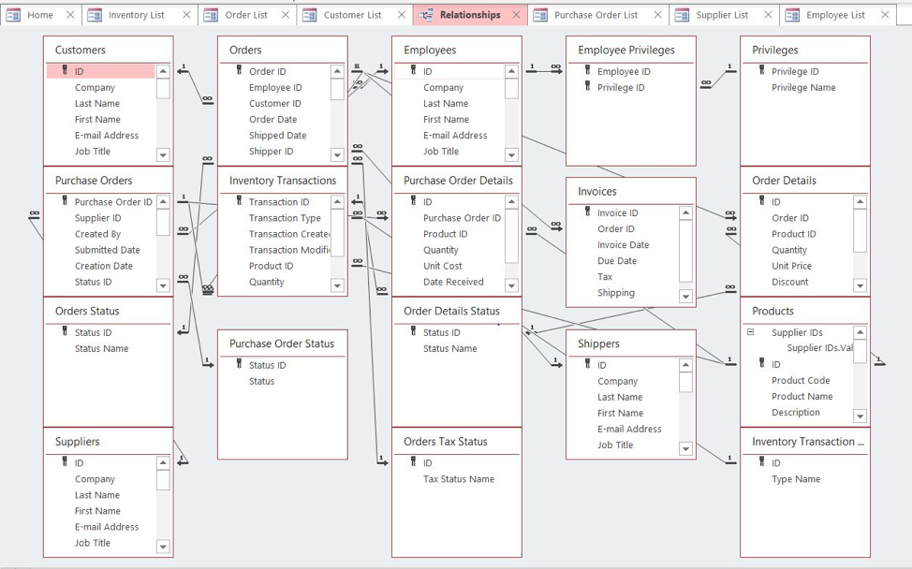
Examples:
- [A college database: One-to-One example] Jane Doe is taking (1) Intro to Computer Applications class and (2) Intro to Accounting this semester. As such, the “Intro to Computer Applications” table below will include 1 row about Jane Doe, and the “Intro to Accounting” table will contain 1 row about the same Jane Doe. Since this is the same Jane Doe, we see that these 2 rows are related. There are no more rows about the same Jane Doe in these table, so this is a one-to-one relationship.
- [A medical office database: One-to-Many example] Dr. Sanches works at the city’s clinic and is scheduled to take care of many patient appointments each week. In the “Doctors” table, there is only 1 row for Dr. Sanches. However, since he has many appointments, there are many rows related in the “Appointments” table to the appointments of Dr. Sanches. Since one doctor has many appointments, we have a One-to-Many relationship.
- [Travelling app database: Many-to- Many example] Each traveler in the database has been at many places around the world. Each travel place in the database has seen tons of travelers. Since each person in the “Travelers” table is related to several world-wide places in the “Destinations” table, and each place in the “Destinations” table is related to many travelers from the “Travelers” table who visited that place, we have a many-to-many relationship.

Note that the Orders table above is an example of a join table, since it contains data taken from 2 other tables in the database!

Working with Tables

Entering Data
Suppose you are working on a table in a database file.
To add new records (= rows) to the table, do either of:
- Open the table in Datasheet view Click within the last row with the * symbol (New).
- Click the Home tab Record group ‘New’ button .
- At the bottom of the datasheet is a thin ribbon with buttons. Click on the “New Record” button .
Once this is done, start typing data within the cells under the table’s fields.
To add more fields, do either of:
- In the datasheet view of the table, click on Click to Add to the right of the rightmost existing field, and
  - Choose the data type of the field.
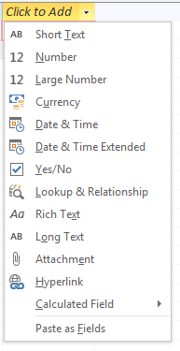
  - Give a name to the field 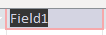.
- In the design view of the table, click within the fields table at the 1st empty row to enter a field name, field type, and description (if wanted.) 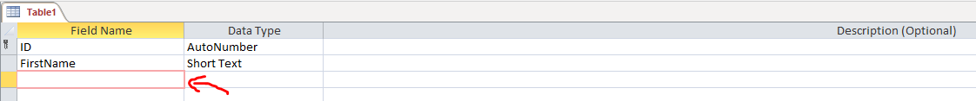

Updating Data
If you find that a certain piece of information is inaccurate, or if new data for an existing record needs to be added:
- In datasheet view, click within the record’s line,
- Click within the cell that corresponds to the trait (field) you need to update,
- Make the update by typing or deleting the cell’s content.
- Repeat the steps 1—3 for each cell that needs to be updated.

Moving within a Datasheet
You can use the mouse or touchpad to click within the cell you want to access.
The following keyboard keys can be used within the worksheet to navigate as well:
Key | Action
ENTER/RETURN or TAB | Move to the cell on the right.
Shift + TAB | Move to the cell on the left.
Arrow Keys (↑↓←→) | Move in the direction of the arrow.

Working with Datasheets

Deleting Records
To delete a single record:
- Right-click over the left square to the left of the record .
- Choose the “Delete Record” option .
To delete multiple contiguous (neighboring) records:
- Click (left-click) over the left square to the left of top record within that group.
- Click and hold the Shift key.
- Click (left-click) over the left square to the left of bottom record within that group.
- Right-click over the selected group of records.
- Choose the “Delete Record” option.
- Release the Shift key.
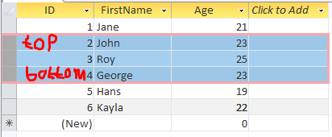

Sorting and Filtering Data
Not only can you add, update, and delete records and fields, but you can also re-order fields and records!

Moving a Field to the Left or Right
If you wish to change the order of fields or to move a field:
- Open the table in datasheet view,
- Left-click on the field name,
- Drag the field to the left or right direction,
- Release the mouse when the field lands at the desired spot.

Changing Font-Related Settings
If you wish to change the font size, font, color, etc.:
- Select the cells whose settings you wish to change,
- Click the Home tab Text Formatting Group Click the button pertaining to the feature you wish to change.
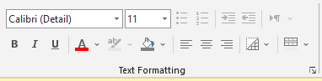

Changing Field Width or Record Height
If a cell is showing data only partially, but you wish the entire content to be visible, do the following:
- Select the records or fields that you wish to expand,
- Click on the Home tab Record Group More arrow ,
- Choose either of the “Row Height” or “Field Width” options,
- In the small window that opens, either type the desired size, or click “Best Fit”.
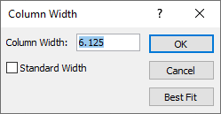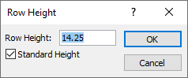

Sorting and Filtering Data
The operation of applying a sort or a filter is very similar to this in Excel.
To sort data in a table by a field:
- Select the field to which you wish to apply sort by clicking on the field name,
- Do either of the following:
  - Click on the Home tab Sort & Filter group Choose either of “Ascending” (A-Z) or Descending (Z-A).
  - Click on the small arrow right next to the field’s name Choose either of “Sort A to Z” or “Sort Z to A”.
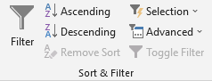

To filter data in a table by a field:
Click on the small arrow right next to the field’s name Uncheck the data that you wish to filter (hide) temporarily from the datasheet’s view.

Aggregating Data
With Access, it is more than easy to show the sum, count, minimum, maximum, average, standard deviation, or variance of the data within some field!
Such a statistic for the data in a field is call an aggregate.
Displaying the aggregate in Access has 3 steps:
- Click the Home tab Records group Σ Totals button 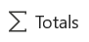,
- At the bottommost record of the table (which is labeled “Total”,) click inside the cell under the field for which you wish to show the statistic,
- Click on the down-arrow that pops-up in that cell, and choose one of Sum, Average, Count, Maximum, Minimum, Standard Deviation, or Variance.
An example of clicking on the “Total” row below the “Cupcakes_Consumed_Every_Day” field to choose one of the available aggregates is shown in the example in the screenshot below:
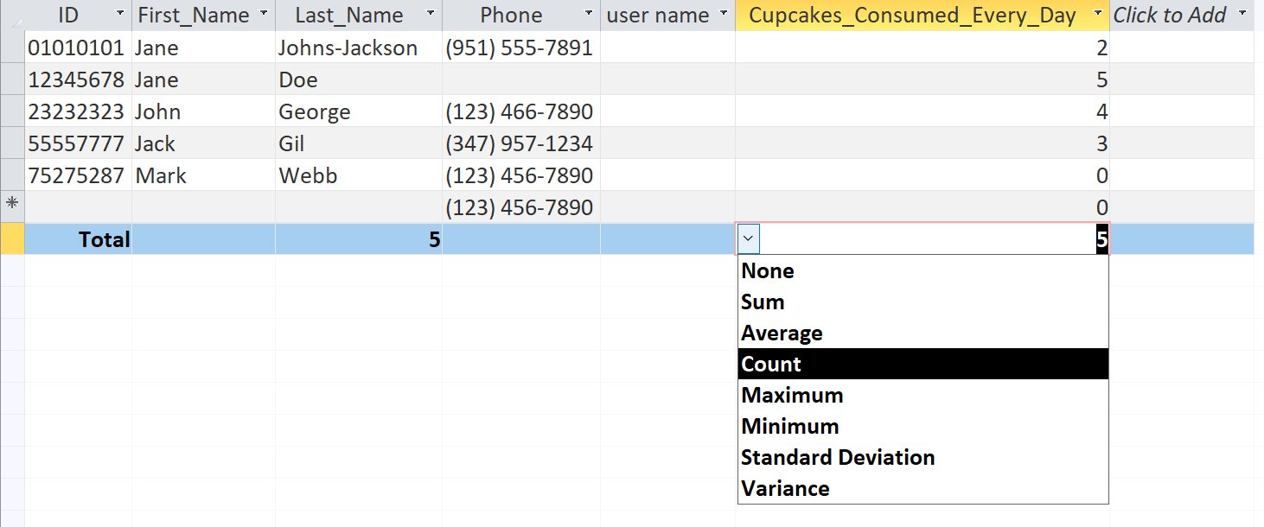
Note that, if the field contains data that is not numerical, the only aggregate that will make sense to apply to the data is Count, because we cannot ‘sum’ names, compute the average of words, etc., as in the example below that attempts to count the number of Last Names:
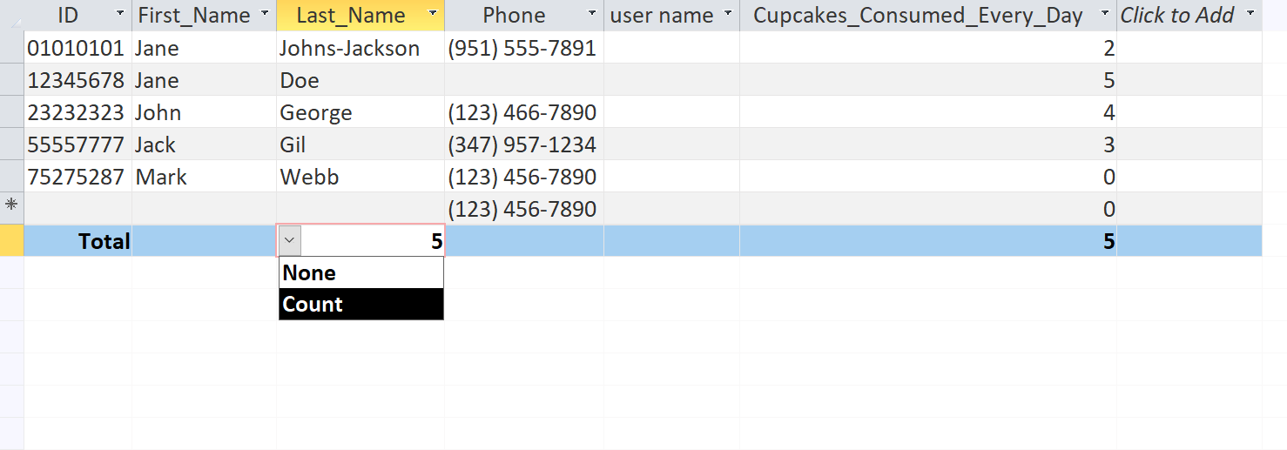
In other words, we only can count how many Last Names there are; we can’t sum them, average, them, etc.

Printing Records
You may choose to print tables or other objects you create in Access by clicking on the File tab Print option.
There, you can choose “Print Preview” to see how your table or other Access object will look when printed to a page. Following is a screenshot of the Print Preview of some table:
