Lecture Notes: Excel, Advanced Skills

Sparkline Charts
When covering the PowerPoint application chapters, we thoroughly discussed SmartArt graphics and Charts, both of which are used to illustrate some data rather than simply dumping it them in a table.
These two tools are also available in the Excel app, and their usage and styling are identical to these of their PowerPoint counterparts.
In addition to these two tools, Excel has another cool type of chart called the Sparkline, which is a mini chart that fits within just a single cell!
Here are three sparkline charts in action on column H:
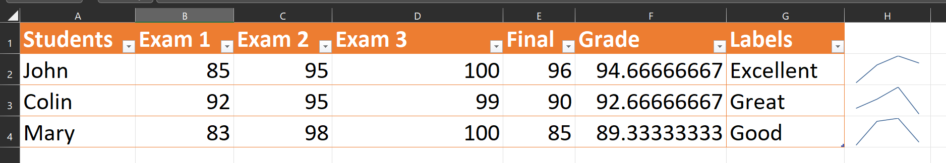
The purpose in using a sparkline chart is to provide a quick illustration of the trends of some data. In the example screenshot above, the 3 sparklines on the right ‘summarize’ the 4 exam grades that the 3 students got: Exams 1-3 and the Final.
We can see, for instance, that Colin got a high grade on the 3rd exam (compared to all other exams,) but the grade he got for the final exam was the lowest among all the grades.

Adding a Sparkline
To add a sparkline into the cell of your choice:
- Click to select the cell,
- Click the Insert tab Sparklines group
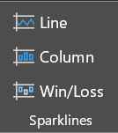
- Click on one of the sparkline choices: Line, Column, or Win/Loss.
The Line option will create a line chart (like the ones in the example above.) The Column option will insert a columns chart into the cell. Finally, the Win/Loss button will add a chart that distinguishes between positive and negative numbers by drawing blue columns if the corresponding number is positive and red columns if it is negative.
In the example about class grades, the only sparkline types that make sense to use are either Line or Column, for all the grades that the students got are non-negative.

Configuring Sparkline Charts
Once you created a sparkline chart on your worksheet, you can modify it in several ways using the Sparkline Design tab:
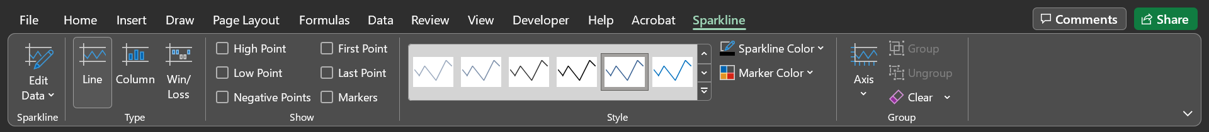
- The Edit Data button will let open the Edit Sparklines dialog box that you used to tell the sparkline what data to use for the chart and where to have the chart displayed.
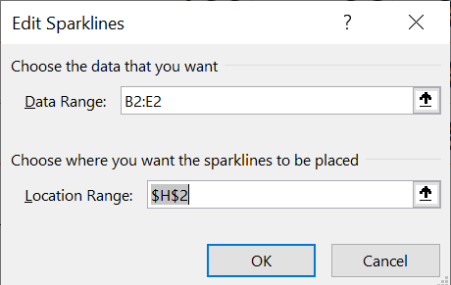
- The Type group will let you switch the structure of the sparkline. For example, if your current sparkline is a Line chart but you’d like it to become a Column chart, you’d click on the Column option, which will change it to a Column chart.
- The Show group allows you to emphasis certain points or columns in your sparkline. For example, if you check the box next to “First Point”, and your sparkline is a Line chart, this will put a red-colored marker (= point, color, or other type of indicator) right on the 1st point of this line:

- Using the Style group, you can choose a different color for the sparkline (including one of the pre-defined colors in the gallery) and change the color of the marker (from red to something else.)
- Finally, the Group sparkline group is where you can re-shape the sparkline by defining the minimum value compared to which data is displayed, and to group 2 or more sparklines together for styling purposes (style changes made to one of the group members will be reflected on the other group members.)

vs.
Minimum point
^ The two sparkline graphics above rely on the same data, but the point at the very bottom of each graphic area is different: the left one’s minimum point is 85, while the right one’s is 0. In other words, these identical charts just use a different perspective.

Conditional Formatting
We learned how to let Excel display 1 of 2 text based on a condition: we used the IF function to let this happen.
But Excel didn’t stop at this feature: Excel also lets you add different formatting to cells depending on a condition (and without using any functions!)
For example, you can choose to highlight in red only those cells with values less than 10:
or highlight these cells that contain the word “Sell” in them:
Applying cell formatting this way will prevent the need to go over each cell and separately apply the exact same formatting, which could take hours if you have many cells. In addition, if the cells value changes in the future, the cell formatting also updates, depending on whether it meets the condition or not.

Adding Conditional Formatting
To add conditional formatting to your cells:
- Select the range or ranges of cells where conditional formatting is to be applied.
- Click on the Home tab Styles group Conditional Formatting arrow. 
- In the menu that opens, select the option that applies to the kind of conditional formatting you’re trying to add:
  - Highlight Cell Rules will let you add formatting to cells that match one of the following conditions: Greater Than (a number), Less Than (a number), Between (two numbers), Equal To (a number or text), Text That Contains (some text), Date Occurring (yesterday, today, tomorrow, 7 days ago, etc.,) and Duplicate Values.
  - Top/Bottom Rules will let you add formatting to cells that match one of the following conditions: Top 10 Items (numerically when comparing the items, not the first ten items on the column,) Top 10%, Bottom 10 Items, Bottom 10%, Above Average, Below Average.
Other conditional formatting options are out of the scope of this class, but they include gradient color fillings, color scales, and pretty icons.

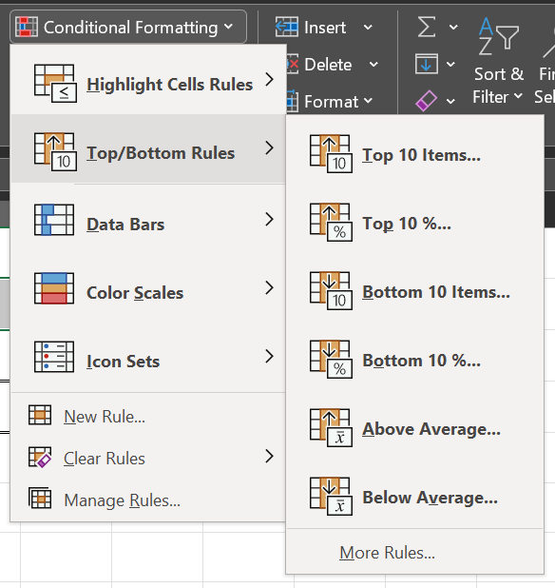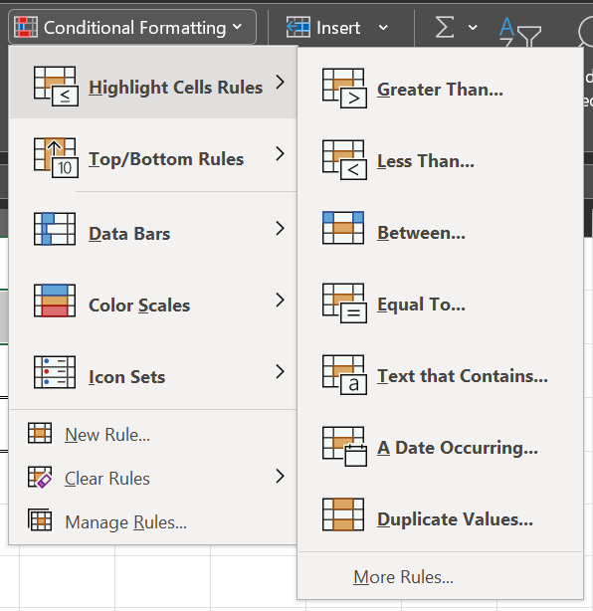
and

You can also use the New Rule option at the bottom of the gallery to enter customized conditional formatting rules and decide what formatting to apply to them (font, font color, font size, background color, etc.)
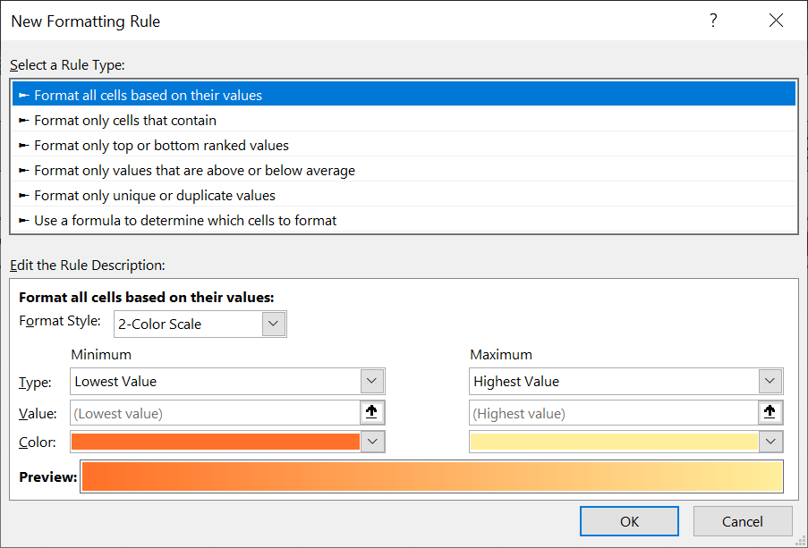
Let’s now have some short exercise on Conditional Formatting! Find it in the conditional_formatting.xlsx workbook in the same folder of these lecture notes.

Pivot Tables
In many cases, tables in Excel contain a great deal of data, which sometimes hinders the detection of patterns in the data.
As a solution to this situation, Excel provides a tool called Pivot Tables, which is an Excel object that creates and formats a table based on existing data in your worksheet and some conditions that you provide to it (without using any formulas!)
To learn more about Pivot Tables, we’ll look now into the PivotTable_Tutorial.xltx Excel template workbook, which provides some nice infographics and exercises.

Macros
Consider the following scenario: you job at the company you’re working in requires that you create formatted worksheets every month. The formatting and the structure of the worksheet doesn’t change from month to month: it remains the same.
So far, you have been spending hours every month to create these extremely similar sheets and have basically re-done the same work again and again.
You can prevent these hours from being spent on this repeated procedure since there is a solution to your situation: macros!
A macro is a recording of your actions upon an Excel workbook that Excel stores within the file. You can record a macro and later ‘play’ it on a similarly structured worksheet to apply the same exact steps that you have been applying while recording the macro. This is an insane time saver.

Getting Started
Before we can start working with macros, we must first make all the related buttons available in Excel.
To do so:
- Click on the File tab More... Options Customize Ribbon and place a checkmark next to Developer. Afterward, click OK to save the change. (See screenshot on the next page.)
- The action in part 1 above will make the Developer tab appear in Excel.
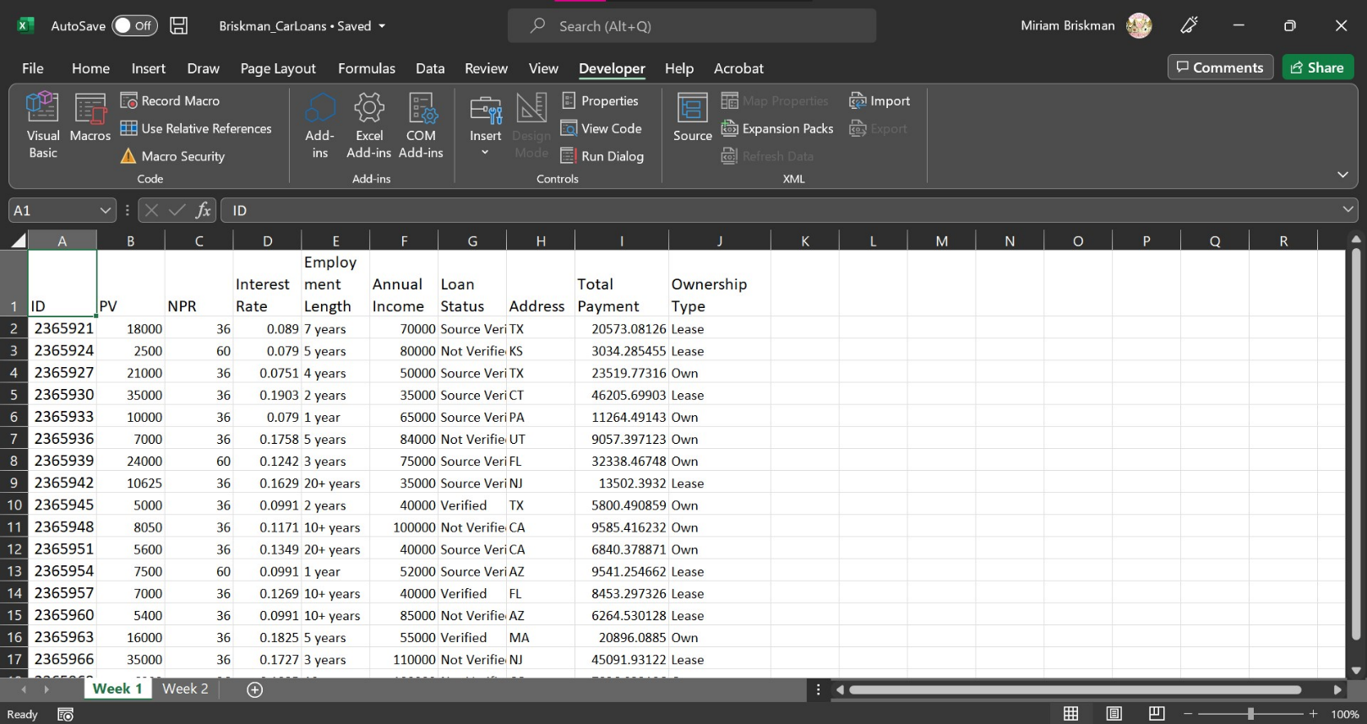
The buttons in the Code group of the Developer tab provide you with all the macro features that you need to use to create awesome macros.

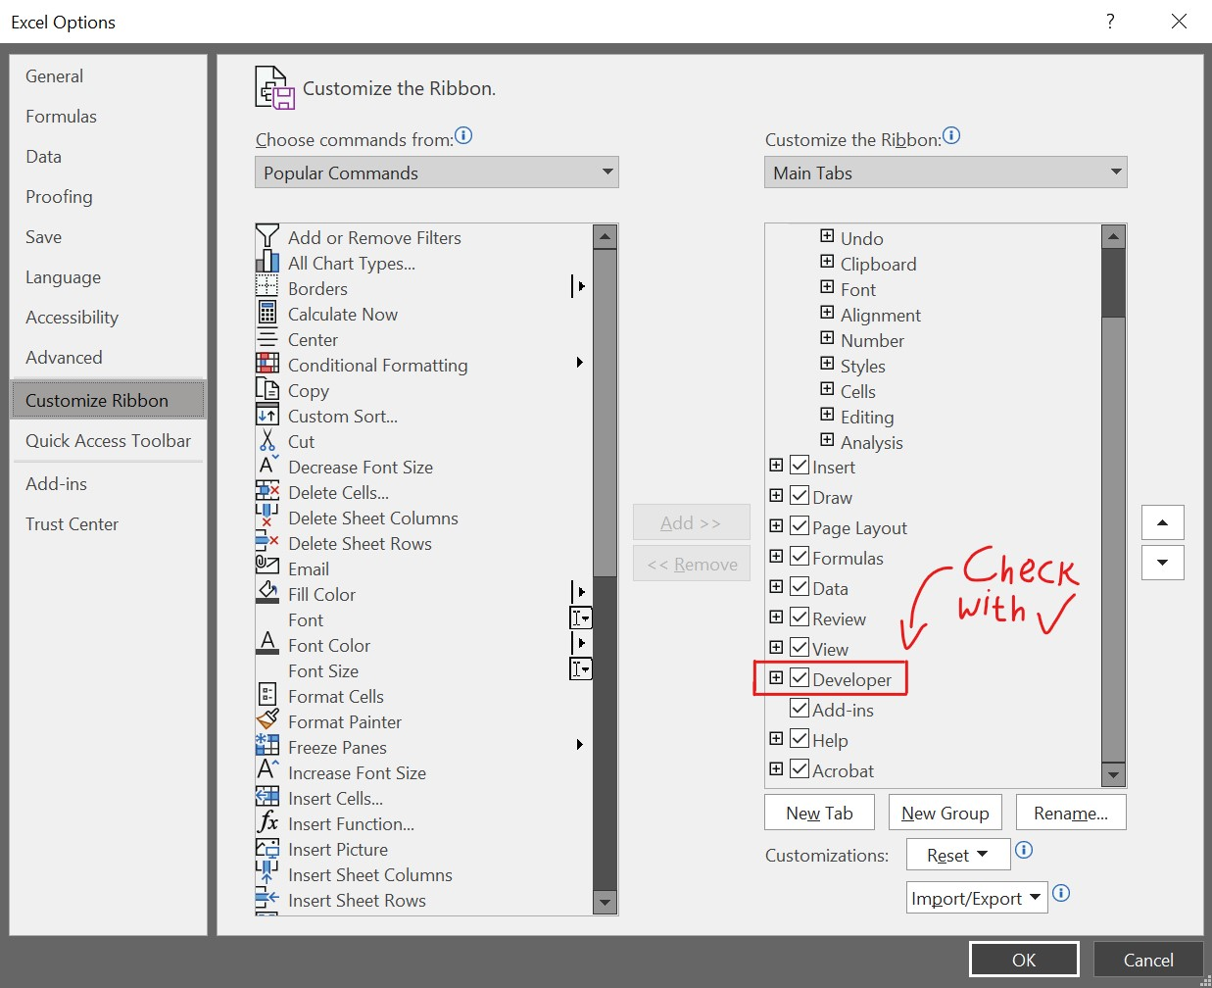
You can also find some of the macro-creation options in the View tab’s Macros group:
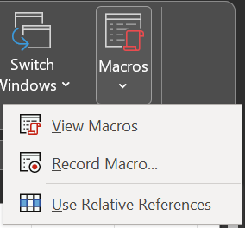

Record a New Macro
To start the recording of a new macro, click on one of the “Record Macro…” options on either the Developer or View tab.
Once you do so, the “Record Macro” dialog box will appear, which will allow you to pick a name for the macro and write a short description of its purpose (since you’ll probably use this macro in the future but may by then forget what it was used for.)
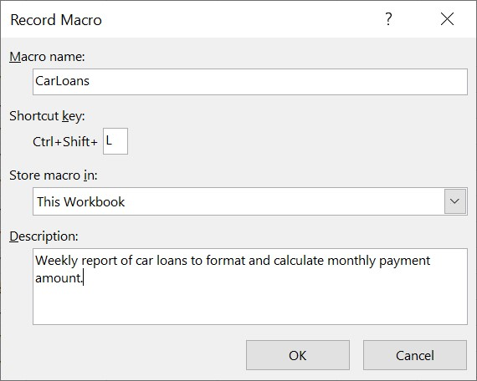
Clicking OK will make the macro start recording. The point of recording a macro is to let Excel capture the activities you do within the workbook. As such, after clicking OK, proceed to formatting cells, adding formulas, adding rows or columns, etc.
The macro won’t record your voice or video: it just records what cells within Excel were clicked, what buttons were clicked, what options were chosen, etc. The time and date are also never recorded.

Stop a Macro’s Recording
Once you’ve finished doing all the activities you wanted the macro to record, you can stop the macro from recording by clicking the Stop Recording button .
The data of the macro will then be temporarily saved within Excel. We say temporarily since you will need to change the Excel file (.xlsx) into an Excel Macro-Enabled file (.xlsm) so that the macro remains within the workbook even after you close it.
If you don’t save the Excel file under the Excel Macro-Enabled file (.xlsm) extension, your macro will be permanently erased from the workbook, and you’ll need to record the macro all over again!

To practice these skills, let’s do the exercise in the Macros_Tutorial.xltx workbook, in which we create and use a new macro!

More Functions!
In this last lecture notes section on Excel, we will get to know and practice some more useful functions. The names and info of these functions are provided in the following table:

Function Name | Purpose | Syntax
VLOOKUP (Vertical Lookup) | Looks for a value in the leftmost column of a table and returns a value in the same row from the column you define.  Example: Find the letter grade corresponding to the score of 85. | =VLOOKUP(  Value to lookup,  Range of cells,  Column Number,  TRUE or FALSE)
HLOOKUP (Horizontal Lookup) | Looks for a value in the topmost row of a table and returns a value in the same column from the row you define.  Example: Find the letter grade corresponding to the score of 85. | =HLOOKUP(  Value to lookup,  Range of cells,  Row number,  TRUE or FALSE)
MATCH | Returns the relative position of a value within a range of cells.  Example: On which row of the column range D5:D10 is the value 150 located? | =MATCH(  Value to lookup,  Range of cells,  1 or 0 or -1)
INDEX | Returns the value in the cell on the Mth row and N^{th} column of some table L1:R2.  Example: What value is on the 3rd row and 2nd column of the table at D5:G12? | =INDEX(  Range of cells,  Row number,  Column Number)
COLUMN | Returns the column number of a cell.  Example: The column number of cell F5 is 6. | =COLUMN(cell)
ROW | Returns the row number of a cell.  Example: The row number of cell F5 is 5. | =ROW(cell)
Nested IF | An IF function inside another IF function.  Example: The result of the function:  =IF(5>6, IF(1>0,"A","B"), IF(8=8,"C","D")) is going to be C. | =IF(5>6, IF(1>0,"A","B"), IF(8=8,"C","D"))
AND | Returns TRUE only if all the conditions are true; otherwise, returns FALSE.  Example: =AND(1>0,2=2) returns TRUE because all of 1>0 and 2=2 are true. | =AND(  Condition 1,  Condition 2,  …)
OR | Returns TRUE if at least one of the conditions is true; else, returns FALSE.  Example: =OR(0>=1,8<9) returns TRUE because at least one condition (8<9) is true. | =OR(  Condition 1,  Condition 2,  …)
IFERROR (If Error) | Returns a value if another value has an error.  Example: =IFERROR(10/0,"Error!") will return ‘Error!’ since we divide by 0. | =IFERROR(  Value to check,  Value to return)
PMT (Payment) | Returns the $$$ you need to pay for a loan.  Only the first 3 parameters are required.  Example: =PMT(3%/12,12,1000) gives minus 84.69, meaning $84.69 must be paid every month to pay the 3% interest, 1-year, $1000 loan. | =PMT(  Annual Interest Rate,  Number of Periods,  Present Value of Loan,  [Future Value],  [0 or 1])
We will now practice the use of all these functions in the fun exercise in the more_functions.xltx workbook!

