Lecture Notes: Excel, Basic Skills

What’s Excel?
Excel is a spreadsheet application that allows data to be organized, summarized, and charted easily. It also allows completing calculations, developing professional-looking reports, publishing organized data to the web, and accessing real-time data from websites.
Let’s look at an example of how powerful the Excel app is! See the start file of the example in Excel Intro Example.xlsx file under Course Documents Lecture Notes Excel Basic.

Basic Excel Terminology
A worksheet is a single grid-like sheet that lets you enter and manipulate data, perform calculations with data, and analyze data.
A workbook is a collection/group of worksheets.
Spreadsheet and sheet are just synonyms of “worksheet”.

Using Excel

Launching Excel on Your Computer
Just as with other Office apps, you can launch Excel by using your computer’s Search Bar to type ‘Excel, and then clicking on the icon of the application, which may be one of:
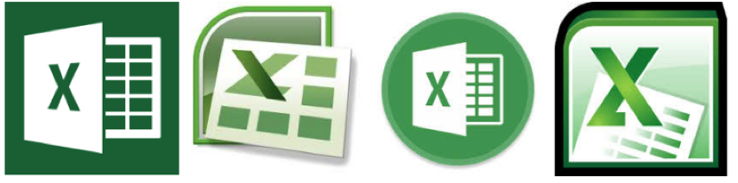
or by finding and clicking this icon elsewhere (in the Start menu, in the Applications folder, or the on Desktop.)

Creating a New Workbook
Once the Excel app opens, it looks like:
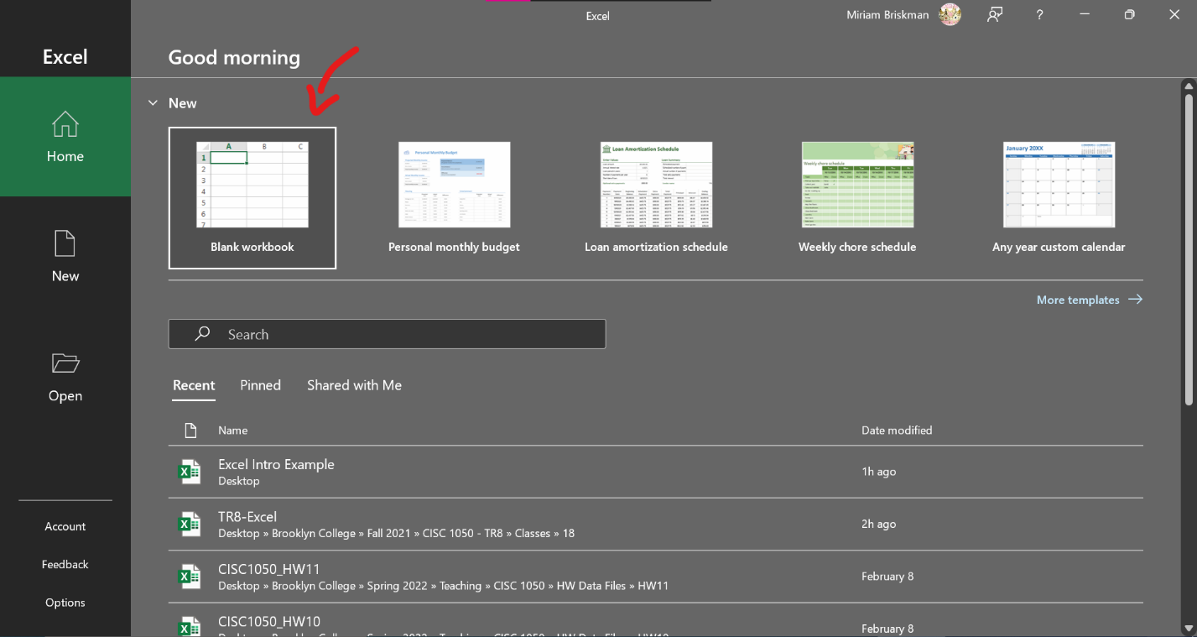
Now, click or double-click the Blank workbook option to create a new, empty Excel workbook. This new workbook will consist of a single worksheet:
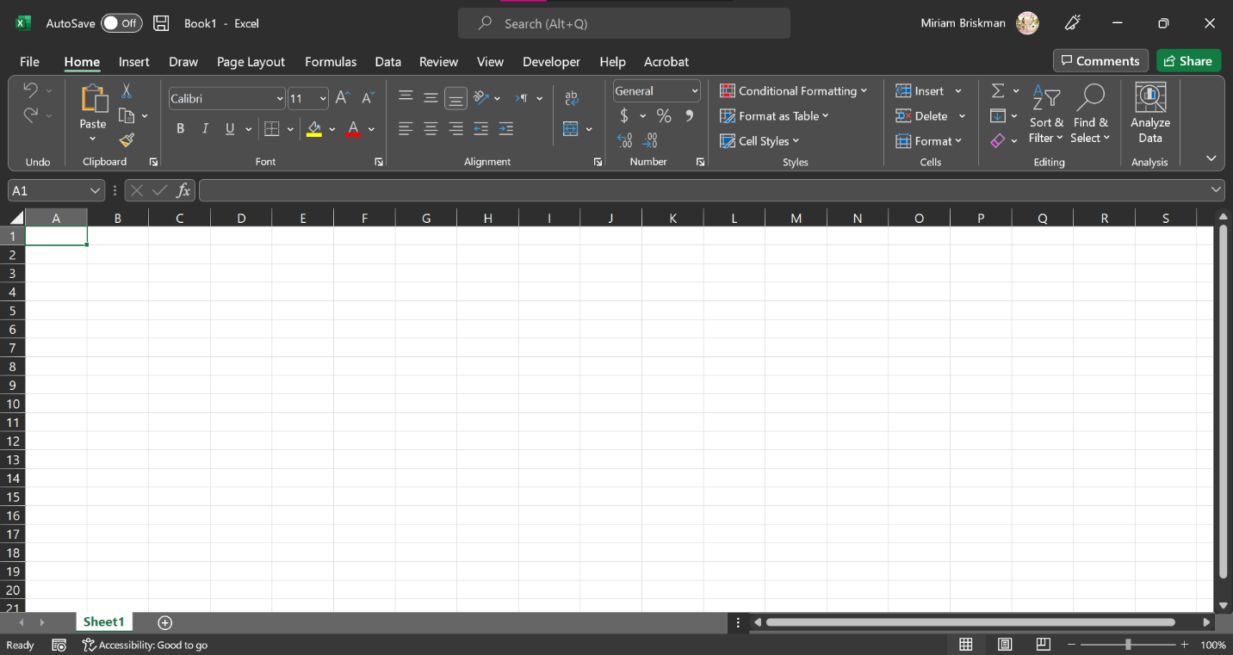

Overview of Excel Controls
Since the window of the Excel application is like those of other Office application (including Word and PowerPoint that we covered,) we will introduce only the features Excel has that Word and PowerPoint don’t:
- A single unit of an Excel workbook, as we mentioned, is a worksheet.
- A blank workbook contains 1 worksheet, called “Sheet1”.
- The Sheet tab is area in the Excel window that shows the worksheets in the book.
- Click the “New Sheet” button: to add more worksheets.
- The Worksheet window is organized into a rectangular grid:
  - Columns are he vertical strips in a worksheet.
  - Rows are he horizontal strips in a worksheet.
  - The heading of each column shows its letter (the 1st column is A.)
  - The heading of each row shows its number (the 1st row is 1.)
  - A Cell is the intersection of a row and a column. For example, cell A1.
  - We always mention the letter first and the number afterwards when referring to a cell (like: K10, the intersection of column K and row 10).
  - Gridlines are the gray lines that separate the cells. They help in seeing and finding cells but can be turned off when not needed.
  - The Active cell is the currently selected cell into which data can be entered.
- When pointing to an Excel cell, the pointer looks like a plus sign .
- The Status Bar has the commands:
  - Normal view button
  - Page Layout button
  - Page Break Preview button
  - Zoom bar and minus (-) and plus (+) buttons
  - The “Sheet tab” is located above the Status Bar.
- Excel has 2 tabs that Word doesn’t have: Formulas and Data.
- The 10 main tabs in Excel are: File, Home, Insert, Draw, Page Layout, Formulas, Data, Review, View, and Help.
- The Formula area is an area above the worksheet grid. It contains the:
  - Formula bar is a text box where you can edit cell data.
  - Name box is a text box showing the name of the active cell. 
- We will discuss these new elements of Excel in this and the following chapters.

Working the Way Around Excel
Selecting a cell:
- Simply click on the cell to select it!
- Or use the arrow keys ← → ↑ ↓ to move to adjacent cells of the currently active cell.
- Alternatively:
  - Click ENTER (RETURN) to move one cell down ↓.
  - Click SHIFT + ENTER to move one cell up ↑.
  - Click TAB to move one cell to the right →.
  - Click SHIFT + TAB to move one cell to the left ←.

How to know which cell is the current active cell?
- The active cell has a heavy green border around it. 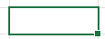
- The Name Box (above cell A1) shows the name of the active cell. 
- The column heading (letter) and the row heading (number) are highlighted in a different gray color. 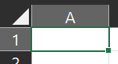

Excel’s definition of ‘Text’: any combination of letters, hyphens (-) or spaces ( ). Text, such as titles or descriptions, should be as concise as possible.
Excel’s definition of a ‘Number’:
- Any combination of 1 2 3 4 5 6 7 8 9 0 + - ( ) , / . $ E e
- E and e are used to express scientific notation, e.g.: $3000=0.3×{10}^{4}=0.3e4$

To add text into an Excel cell, either:
- Select the cell and start typing,
- Double-click the cell and start typing, or
- Select the cell, but type in the Formula Bar,
which is large enough to show long pieces of text.

Basic Formatting and Layout

Table Styles
To apply a table style to data in Excel:
- Using the mouse, select all the cells that you want to belong in your table.
- Click on Home “Format as Table” button. 
- Choose which table style to apply from among the offered styles.
- If your table has headers in it, check the “My table has headers” option.
- After you click OK, your data will turn into a styled table!

Cell Styles
To apply a cell style:
- Select the cell(s) you wish to format.
- Click on Home tab “Cell Styles” button. 
- Choose the appropriate style for your cell.

Cell (Data) Format
Apply a cell data format by either of:
- Home Format “Format Cells”, or
- Home “More” button of the Number group.
Either of these will open the Format Cells dialog box.

For example, when attempting to format the data of a cell containing 1234, the following will be the results:
- $ 1,234.00 is the Accounting format,
- 5/18/1903 is the Date format (because Excel translates the number to that specific date, which is 1234 days after New Year Eve of 1900),
- 123400% is the Percentage format, and
- 1234 is Text format.

Comma Styles
Comma Styles let you add a cell format that contains commas.
Commas could be used to separate groups of digits in your number to make it more readable.
Example: consider 10000000 vs. 10,000,000. Which one is easier to grasp?
To change a cell to a comma format, either:
- Open the “Format Cells” dialog box, and choose where to add commas,
- Home Number group Comma Style button .
- Home Number group Choose Currency in the scroll-down list. This adds both commas and a dollar sign .

Add, Delete, and Move
We can add, delete, and move rows, columns, and cells around in Excel.
To add or delete the data in a row or column:
- Select the row or column by clicking on its heading.
- Then:
  - Right-click over the row or column select “Insert” or “Delete”.
- OR -
  - Click the Home tab Cells group “Insert” or “Delete” buttons.

To move data over from one column or row to another:
- Select the cells whose data you want to move.
- Then:
  - Right-click over the selection choose “Cut”.
- OR -
  - Click Ctrl + X (Cmnd + X on Mac).
- Right-click over the place to paste the cut data choose “Insert Cut Cells”.

Changing Column Width or Row Height
To change column or row width or height do either of the following:
- Suppose you want to expand the width of column A. To do so, place your cursor between column A and column B drag the boundary to the right until column A has sufficiently expanded.
- Click on the gray area at the very top-left corner of the Excel grid (above row 1 and to the left of column A) : it look like a gray right triangle Click the Home tab Click on the ‘Format’ button Click the “AutoFit Column Width” or “AutoFit Row Height”, whichever is needed. This will cause ALL the columns/rows in the Excel worksheet to expand and fully show their contents!
Expanding the column’s width will prevent data in it look like ############.

Working with Several Sheets

Adding New Sheets
We already saw how to recognize what worksheet (or sheet) we are working on.
In many cases, when the Excel file serves to displays various pieces of information, it is a good idea to create separate worksheets within the same file. This is very easy to do!
- Go to Status Bar Click the green plus sign at the left part of the screen to add a new sheet into the file!
- OR -
- Click the Home tab Cell group ‘Insert’ arrow Choose to “Insert Sheet”.

More Operation with Sheet Tabs
Sheets in Excel can be added (as we saw), renamed, hidden, copies, deleted, and even applied a pretty background color! Let’s check out all these abilities!

Ways to Rename a Worksheet
Three ways to rename an Excel worksheet are:
- Double click the sheet tab and type the new name. Click enter to apply the typed changes.
- Right click the sheet tab and select ‘Rename’. Type the new name. Click enter to apply the typed changes.
- Ensure the sheet whose name you wish to change is currently open. On the Home tab, click on ‘Format’ and choose ‘Rename Sheet’. Type the new name. Click enter to apply the typed changes.

