Lecture Notes: Excel, Intermediate Skills

Data Analysis in Excel
This section covers sorting and filtering techniques in Excel, which we briefly saw in the Basic skills chapter of Excel.

Sorting Data
Excel lets you sort (= assign order to) rows of data within a worksheet.
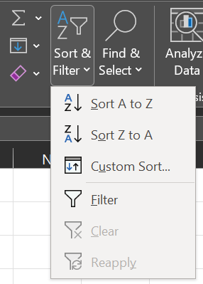
To sort data in a worksheet:
- Select the cells where the data is located,
- Do either of:
  - Click the Home tab Editing group Sort & Filter button
- OR -
  - Click the Data tab Sort & Filter group 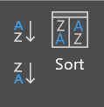
- OR -
  - (If you formatted the data as a table) Click the down arrow next to the column you wish to sort the data by.
- Choose the sorting method you want, depending on what you are to sort:
  - For words or phrases, choose either of:
    - Sort A to Z (From the smallest alphabetical entry to the largest), or 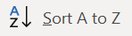
    - Sort Z to A (From the largest alphabetical entry to the smallest.) 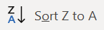
  - For numerical data, choose either of:
    - Sort Smallest to Largest, or 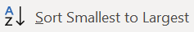
    - Sort Largest to Smallest. 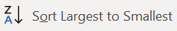
Examples:
Here is some data about cakes on an Excel sheet:
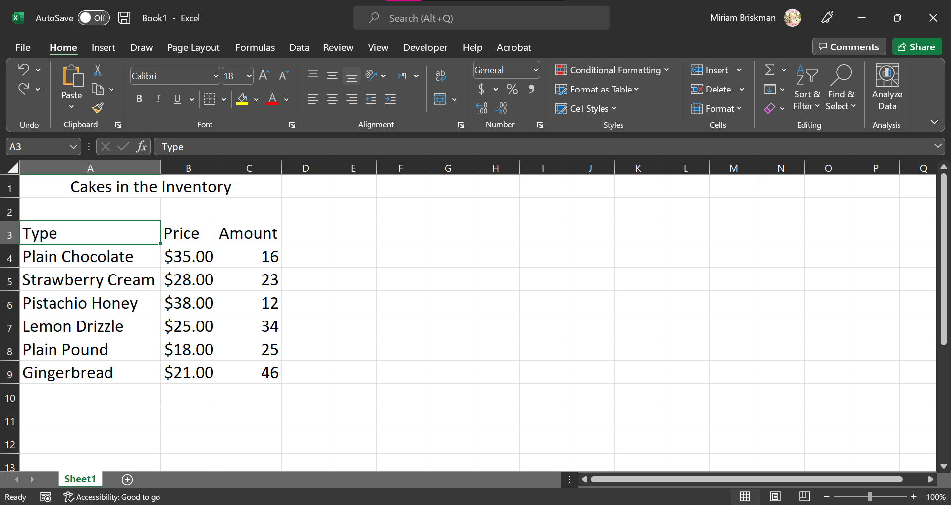
Let’s sort this data by the cake type, from A to Z, using the Home tab’s Sort & Filter button:
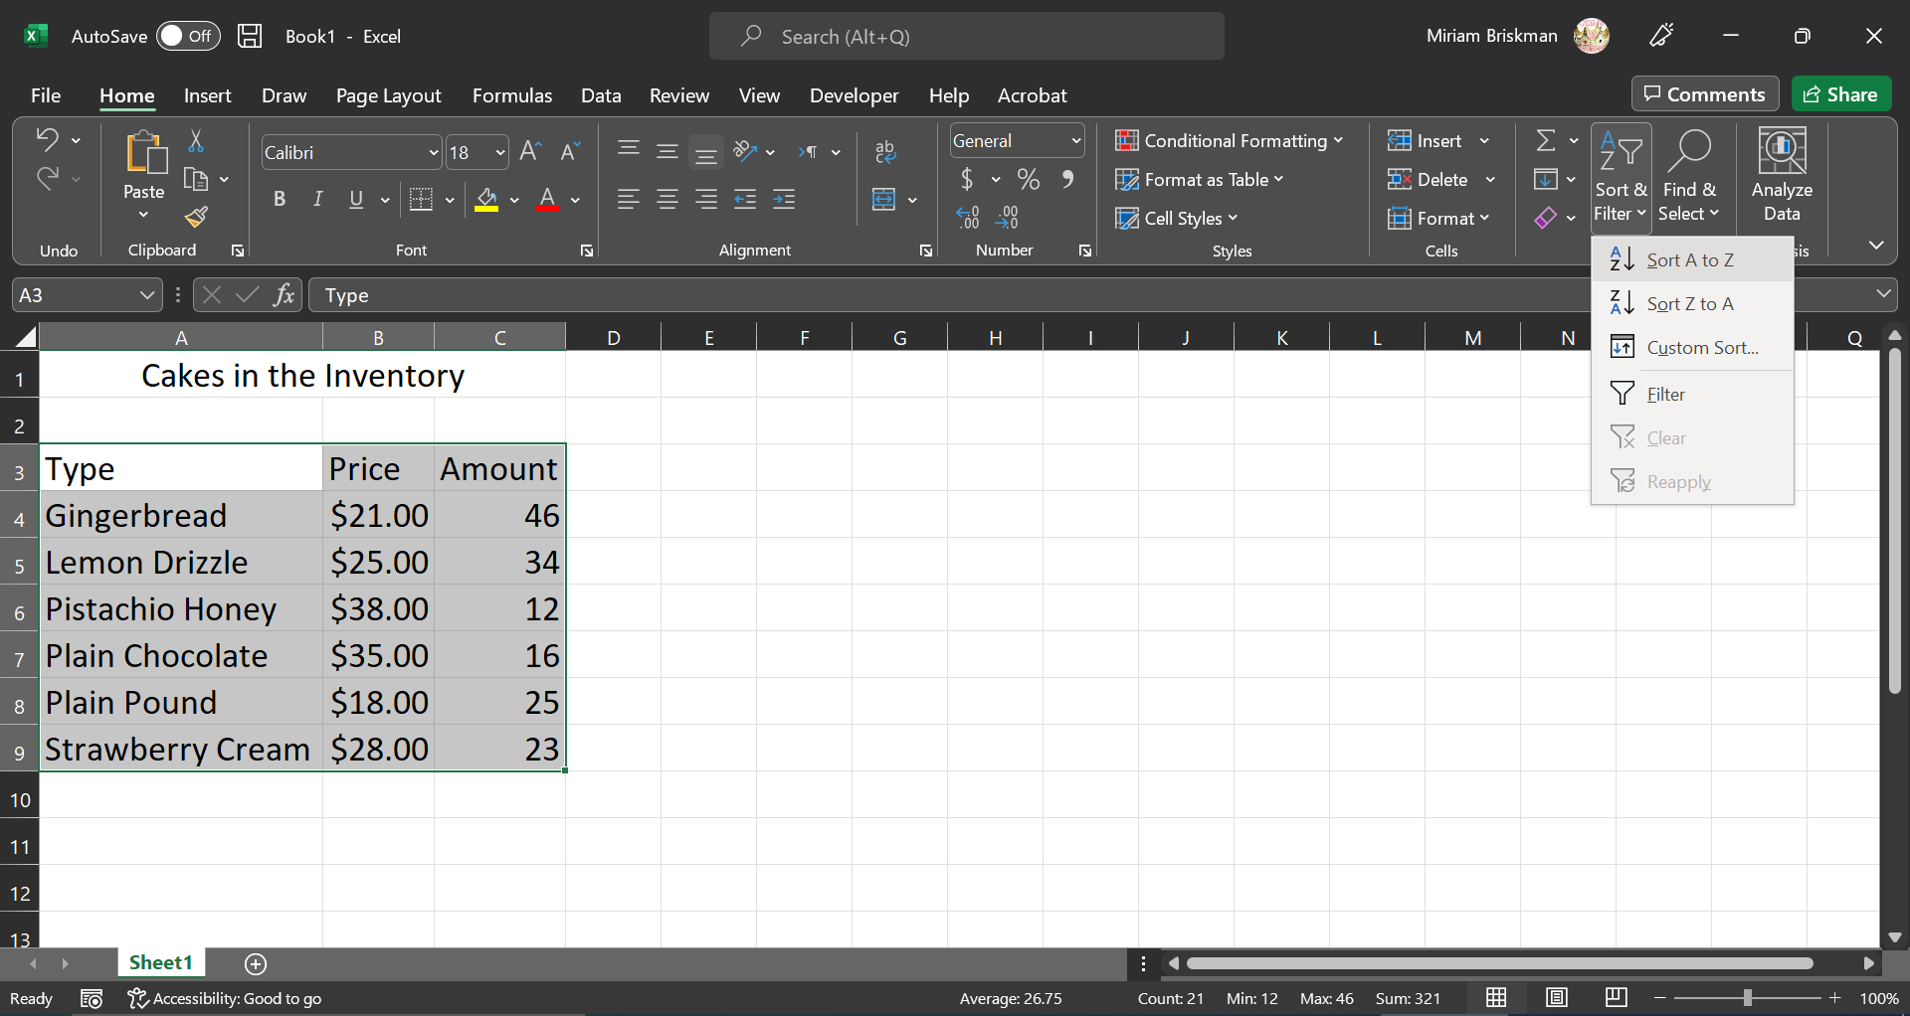
Suppose that we changed our mind and want now to sort the data from Z to A. This time we use the Data tab’s “Sort Z to A” button:
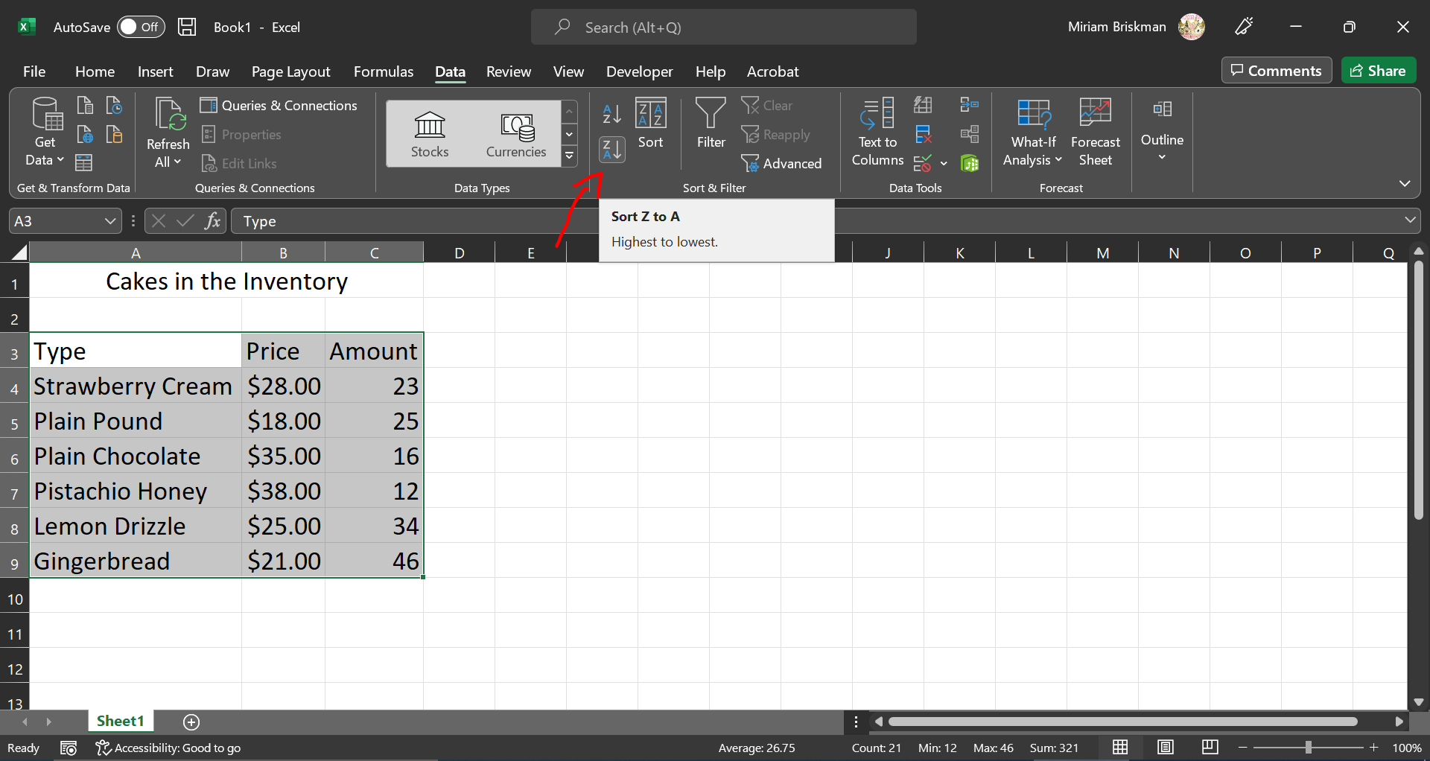
Finally, let’s change the data into an Excel table using the “Format at Table” button on the Home tab, and then use the arrow next to Price to sort the cake data from the smallest to largest cake price:
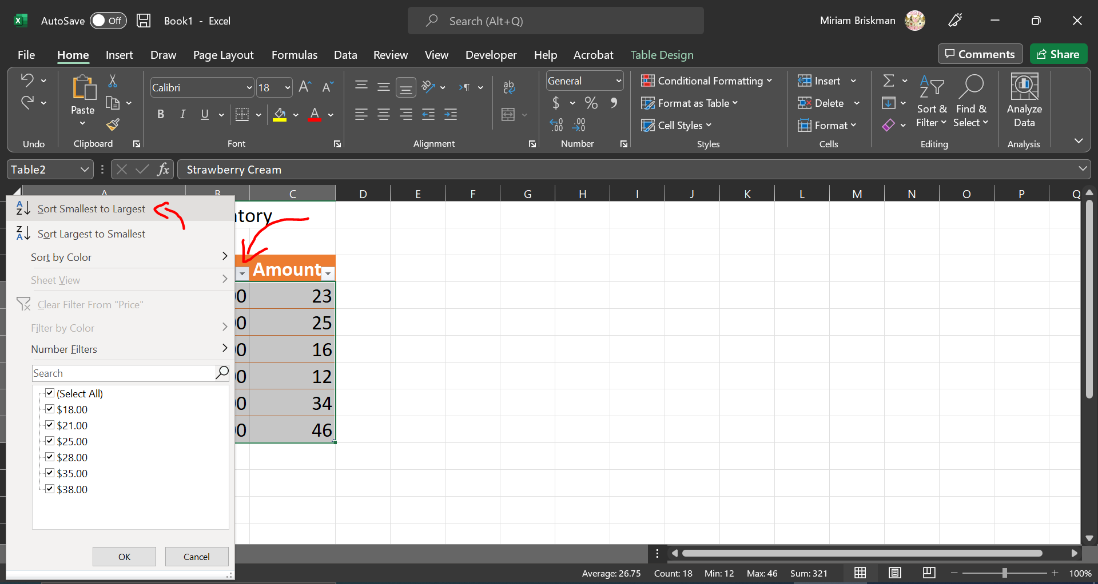
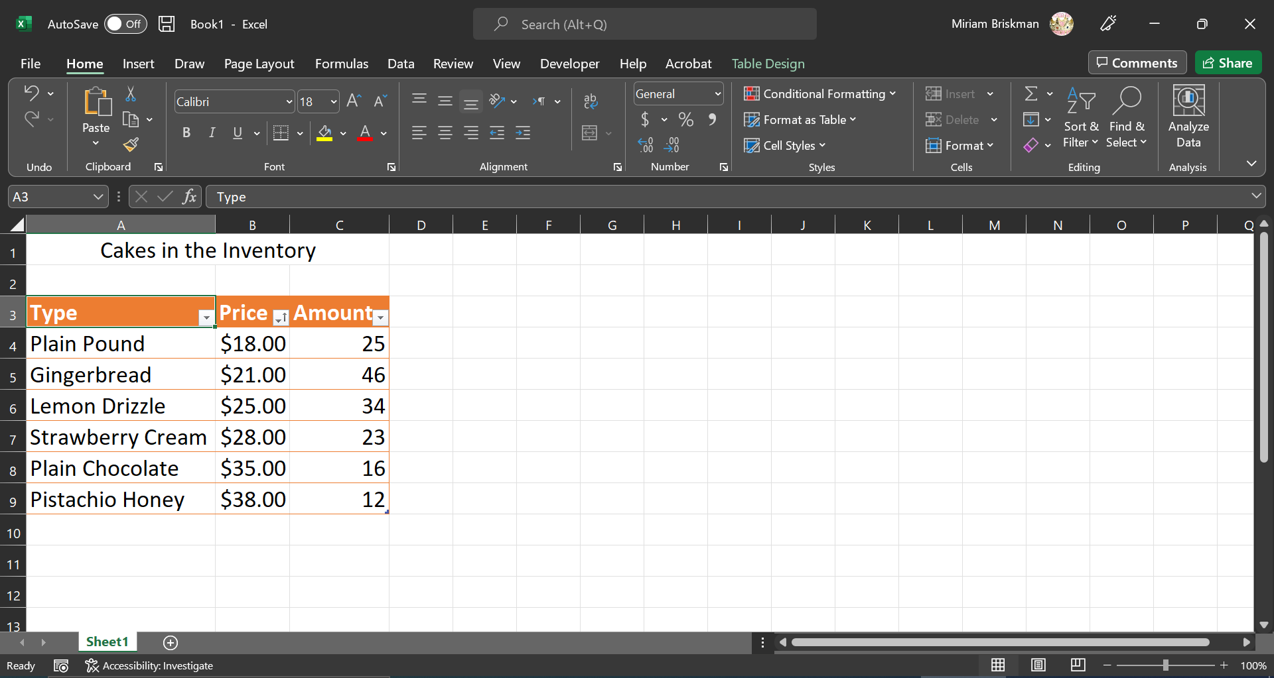

We can also sort special data based on an order that we create.
For example, suppose that we want to categorize our cake by size: Small, Medium, Large, Very Large.
We add the column “Size” to our cake table and indicate the size of each cake type:
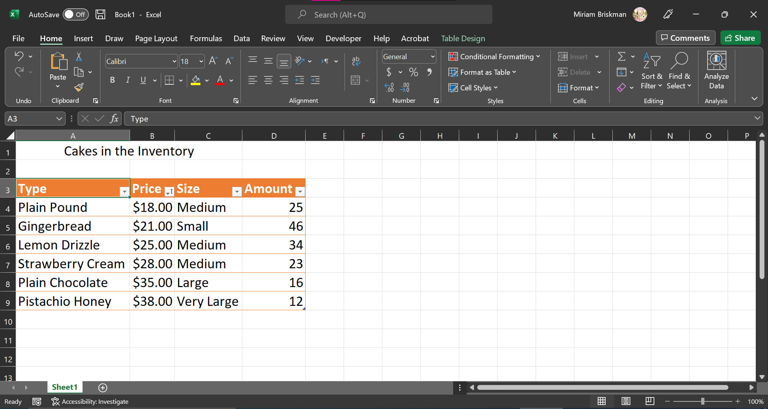
To sort the data in the following order:
- Small
- Medium
- Large
- Very Large
We do the following:
- Select the entire table’s data,
- Click the Home tab Sort & Filter button Customize Sort… button, 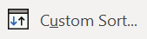
- In the Sort dialog box, click the drop-down list under “Order”, and choose “Custom List…”:
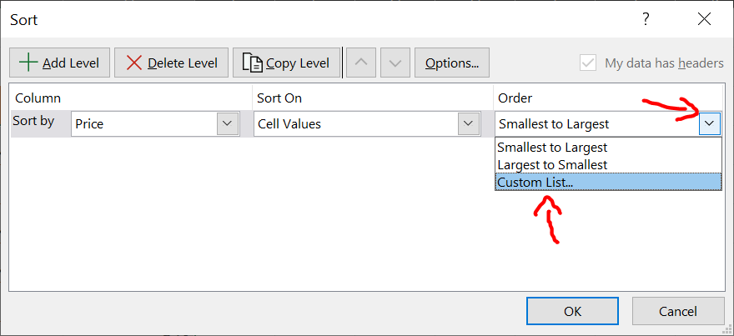
- The Custom Lists dialog box opens, but it doesn’t contain the list we want. Hence, we type our new list items, and then click on “Add” to add the sorting list:
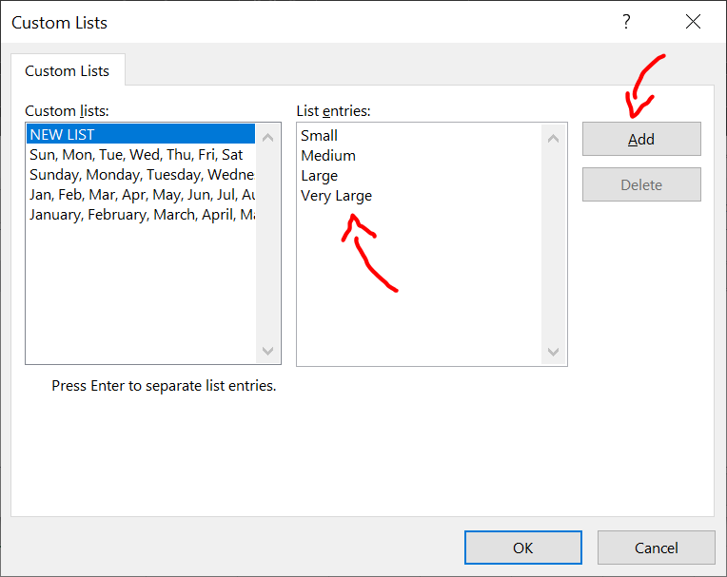
- Then, click OK, and back in the Sort dialog box, select “Size” under the “Sort By” option, and press OK for the sort to take place:
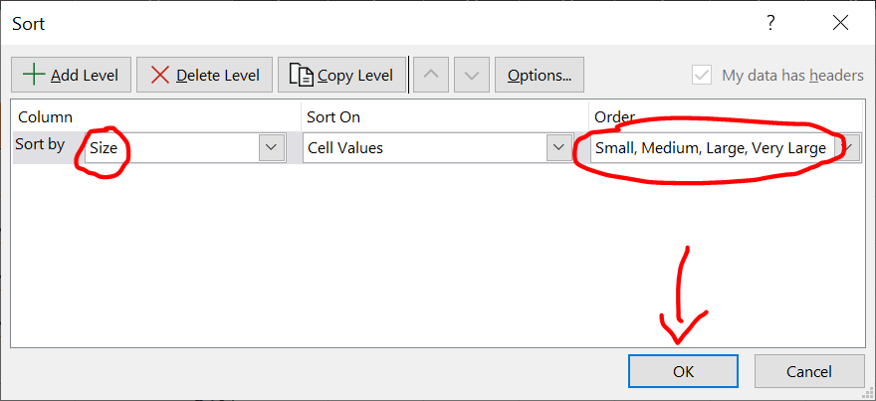

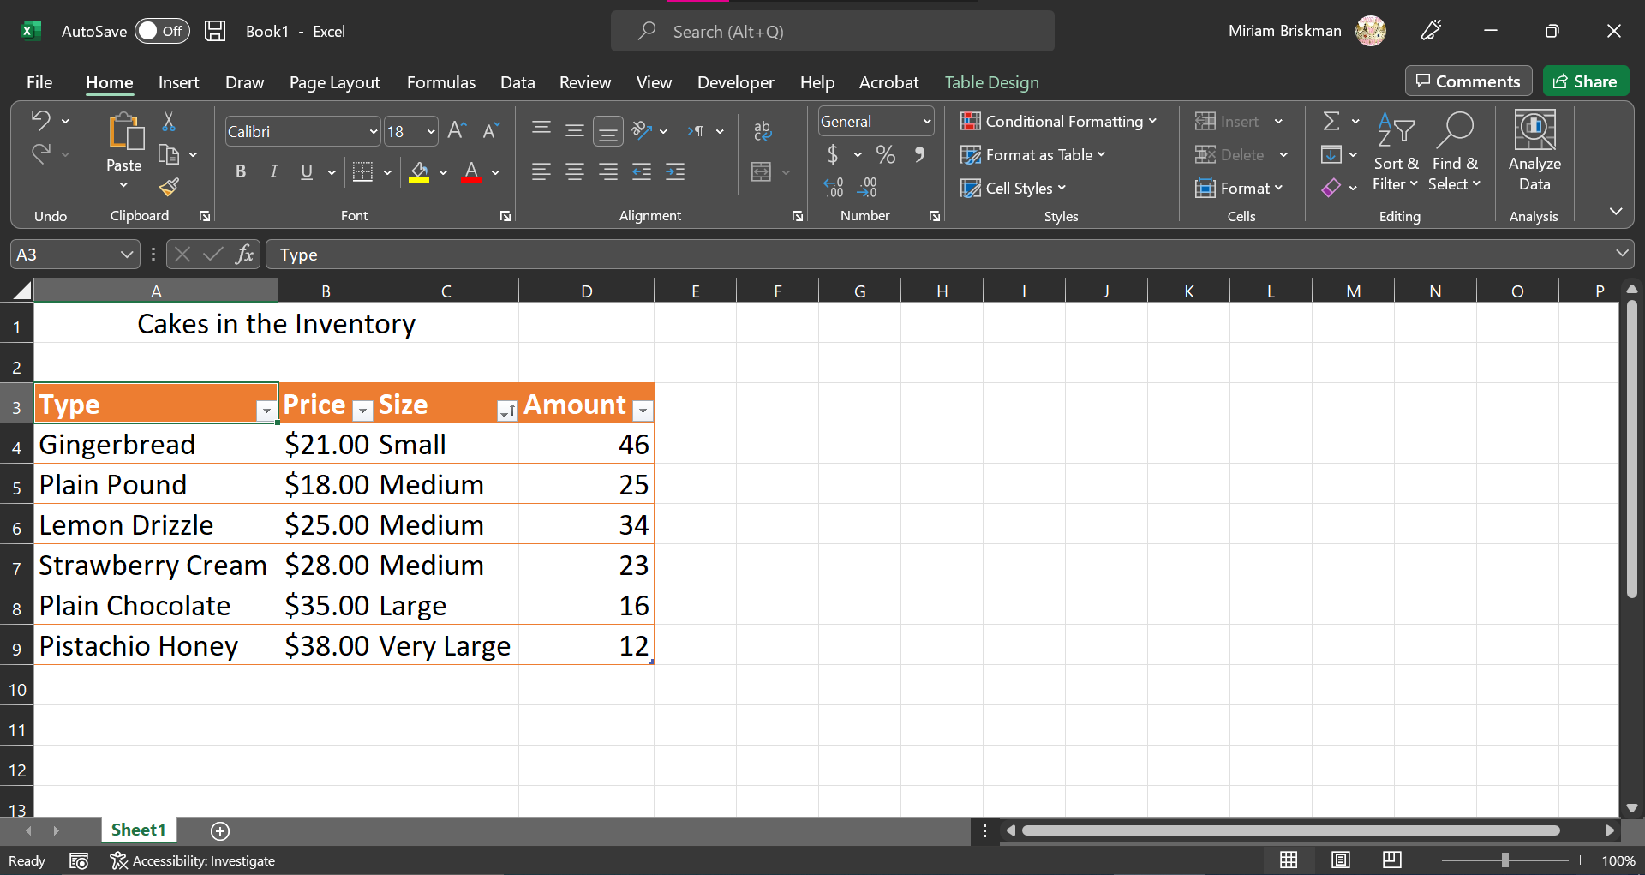

Filtering Data
When you filter data, you decide which data to temporarily show and which data to hide. The data still exists within the worksheet, so hiding it doesn’t delete it.
To filter data that isn’t formatted as a table:
- Select the cells where the data is located.
- Do either of:
  - Click the Home tab Editing group Sort & Filter button
  - 
- OR -
  - Click the Data tab Sort & Filter group
- Click on the Filter button 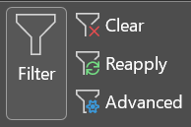. This will cause filter arrows to appear next to data’s headers:
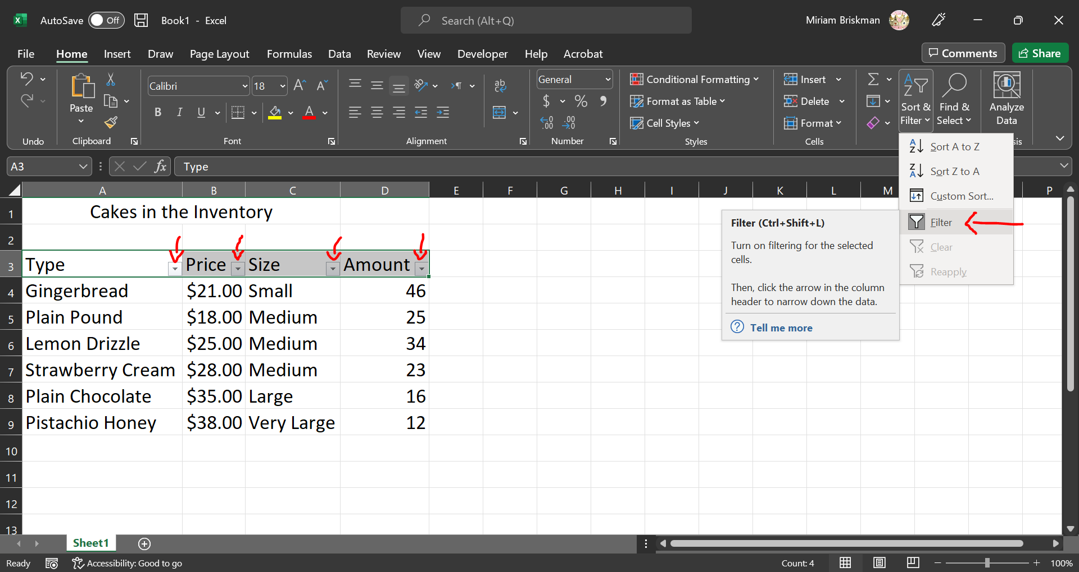
- Click on the down arrow next to the column you wish to filter by.
- Uncheck the values that you to hide (filter) temporarily from the table.
Example:
After adding the clicking the Filter button and adding the down arrows, just as shown in the above screenshots, we choose to filter the table by the cake size. Specifically, we choose to see only Medium-sized cakes:
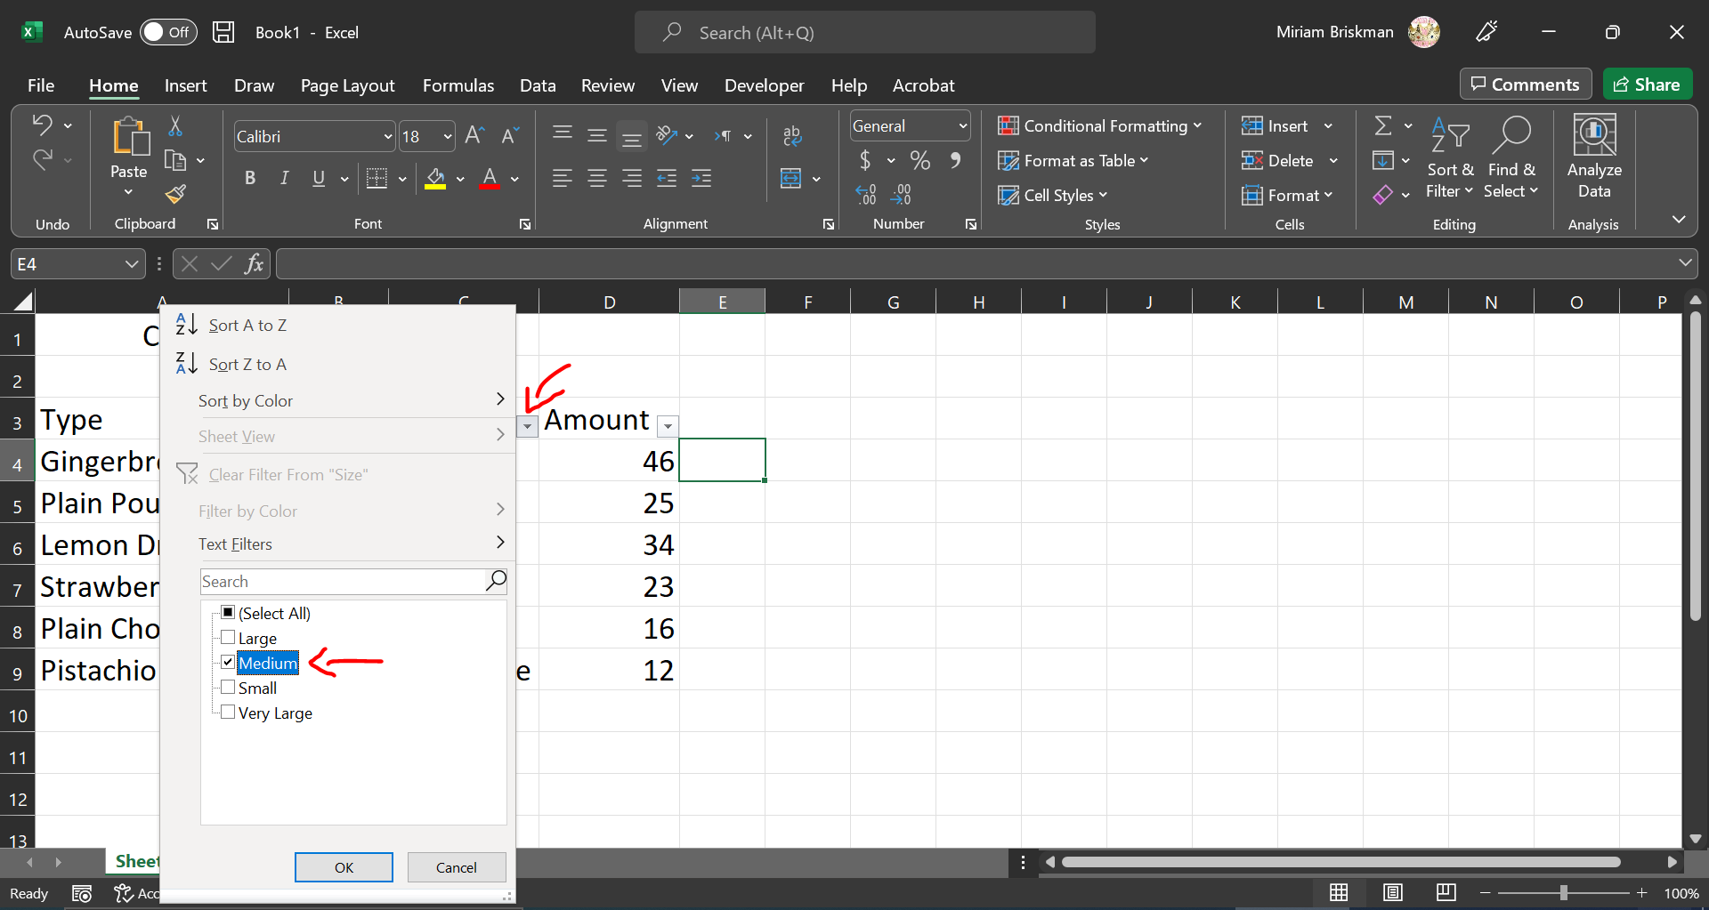

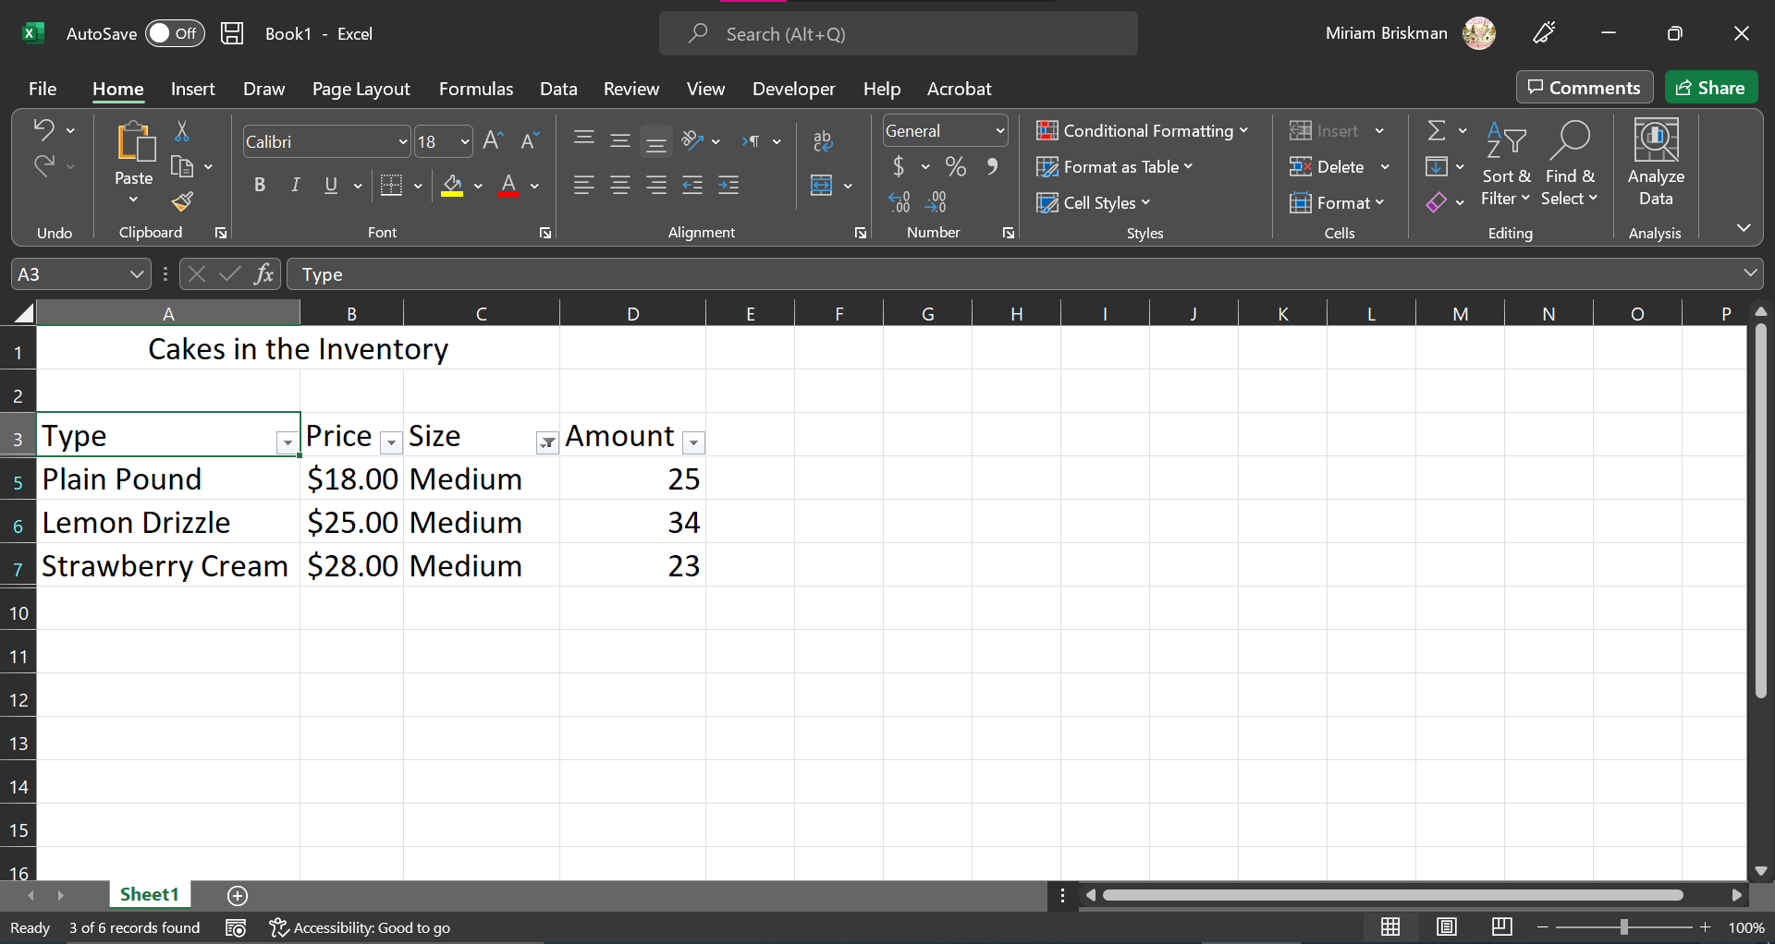

The COUNTIF and IF Functions
In previous classes, we started grasping the power of Excel’s computation.
We saw how to:
- Flash (automatically) Fill data in missing cells of a table,
- Perform a basic math computation: typing =15*2 in a cell will make the cell display 30,
- Show the current date and time by typing =NOW() in a cell.
In part 3 above, the text that we typed, =Now(), is called an Excel function.
Excel has 100s of in-built calculation-performing functions that you can readily add into your worksheet!
In this section, we speak about the power of two Excel functions: COUNTIF and IF. But before that, we need to brush up some concept regarding groups of cells.

Cell Ranges
We learned that each cell has a unique name, such as A1, G13, and AA105.
When talking about two or more adjacent cells, we need to use new notation.
A range of cells is a series of two or more adjacent cells in a column, row, or rectangular group of cells.
We denote a range of cells as L1:R2, where L1 is the upper-leftmost cell in the range, and R2 is the bottom-rightmost cell in that range.
For example:
- A1:B3 = all 6 of A1, A2, A3, B1, B2, B3 (A rectangular group of cells.) 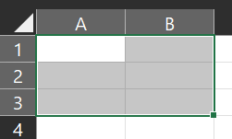
- N8:N11 = N8, N9, N10 and N11 (Four cells on the same column.)
- E2:H2 = E2, F2, G2, and H2 (Four cells on the same row.)

The COUNTIF and IF Functions
Let’s look at the exercises in the Excel file called countif_and_if.xlsx in the same Blackboard folder as these lecture notes are.
This file has two sheets, each of which is dedicated to the COUNTIF and IF functions, respectively.
The COUNTIF function is used to tell how many cells in a certain cell range have a particular value.
For example, we could ask “How many of the cells in range A1:B3 have the content ‘A’?”
Our COUNTIF function in this case would be as follows: =COUNTIF(A1:B3, “A”) and we will simply type this into some cell on our sheet, which is where the result will be displayed.
As you can see from this example, the COUNTIF function accepts two parameters: (1) the cell range where the search should be done, and (2) the item we are trying to count.

The IF function is used to display one of two contents, depending on a condition.
For instance, if cell A1 has a number less than 0 (negative number), we want to display the word “negative”, but if A1 has a number equal to or greater than 0, we want to display the word “nonnegative”.
This IF function will be as follows: =IF(A1 < 0, “negative”, “nonnegative”)
This and any other IF function receive three parameters: (1) the condition that we check, (2) the result that will be displayed if the condition is true, and (3) the result that will be displayed if the condition is false. Since the condition we check can be only one of ‘true’ or ‘false’, exactly one of the two texts, negative or nonnegative will be displayed in the cell where you type this IF function.
Note that:
- Your condition can also have math operators (+, -, *, /, or ^) or use Excel functions. Examples:
  - B6 + 3 > 2*S10
  - ABS(B3) <> 5 [Is the absolute value of the number in B3 different from 5?]
  - SUM(C5:C6) <= SUM(D5:D6) [Is one sum less than or equals to another?]
- You can put any content you want in the two texts, but you must use double quotes around them. However, you could also use cells, like H2, to cause the text in H2 to be displayed.

Automating Data Entry

Flash Fill
Recall that, at the beginning of the Excel, Basic Skills chapter, we investigated the file Excel_Intro_Examples.xlsx.
As we got to know from that lecture, Excel is capable or recognizing various patterns, and thereby help you automatically fill missing information out!
This can be done in one of three ways:
- Start typing data in at least two cells. At some point, Excel will display you a suggested autofill option, which you might accept by clicking ENTER or RETURN:
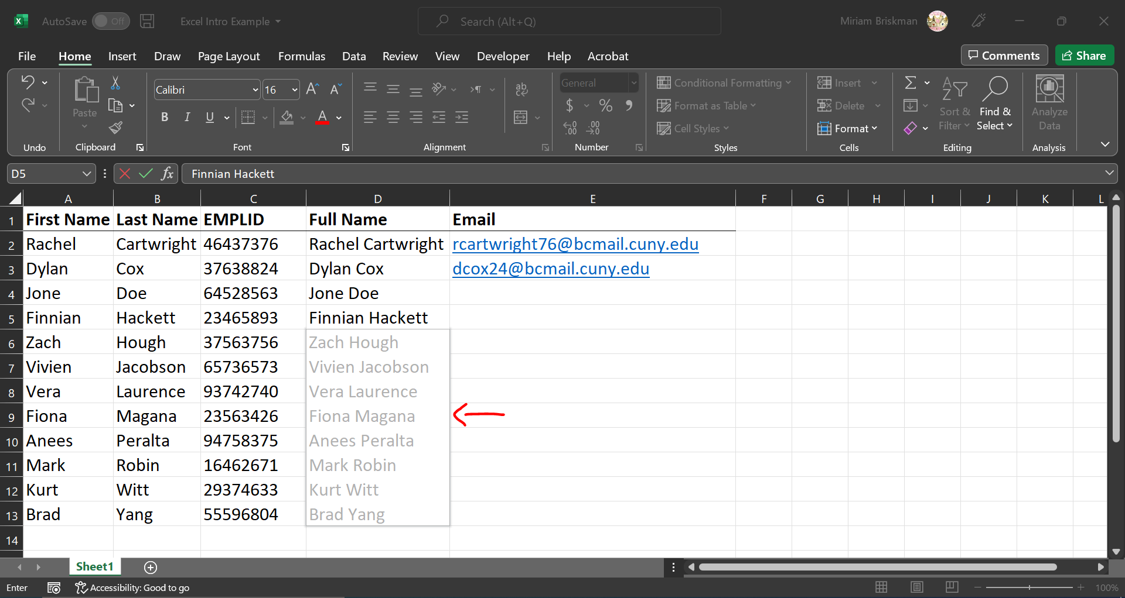
- If that suggestion isn’t displayed automatically, select the 1st empty cell, and then click on the Data tab Data Tools group Flash Fill button :
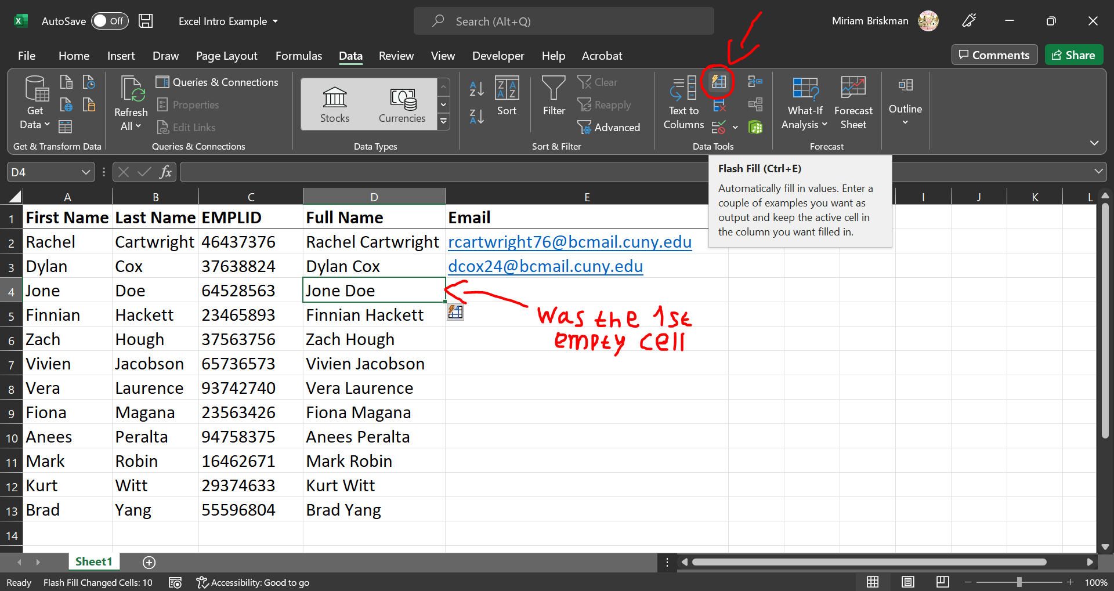
- Select the 1st empty cell, and then click Ctrl + E (works for both Windows and Mac computers.)
This Flash Fill functionality might be turned off for some reason. To turn it back on, go to the File tab options Advanced Editing Options check the “Automatically Flash Fill” box.

Summing Data (using AutoSum and the SUM function)
Suppose you have various numbers in numerous Excel cells, specifically in B2:J2.
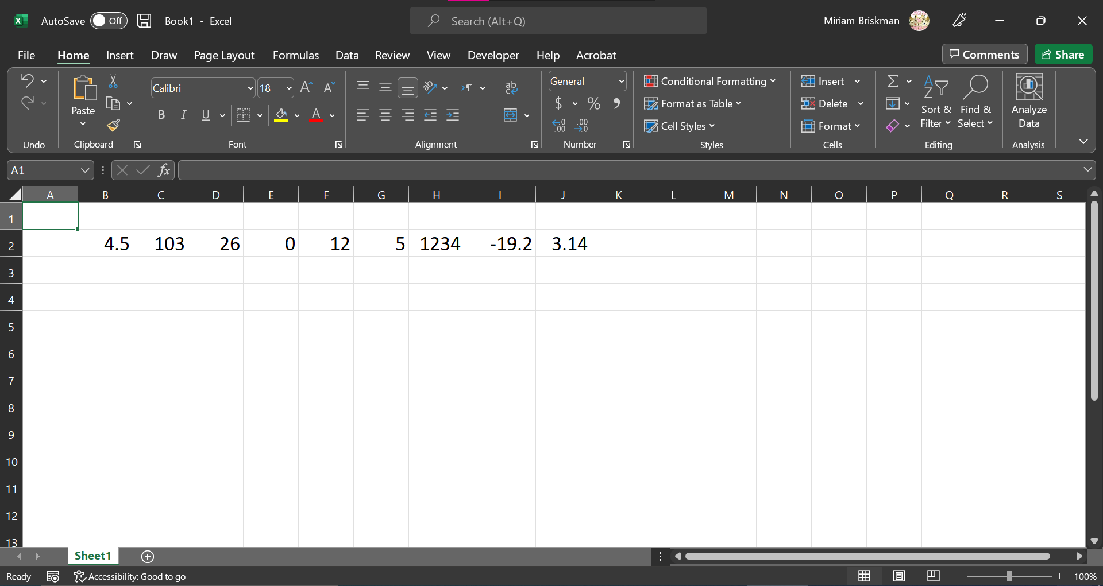
You can compute their total (= find their sum) in, say, cell K2, as follows:
- Select cell K2,
- Do one of the following:
  - Click on the Home tab Editing group Sum button Σ ,
  - Click on the Formulas tab Function Library group Sum button Σ ,
  - Type the function =SUM(B2:J2) either in cells K2 or in the Formula Bar,
  - Click on the Formulas tab Function Library group Math & Trig arrow scroll down and select SUM from the list.
  - Click on the Formulas tab Function Library group Insert Function button fx Type “SUM” in the “Search for a function:” box select “SUM” in the search results click OK.
- Click ENTER/RETURN for result to be displayed in cell K2.
The Σ symbol, which is the Greek uppercase Sigma letter, is often used to denote sums in mathematics, physics, and computer science.
The Sum button mentioned in parts 2a and 2b above is also frequently called AutoSum since it lets you compute the sum of cells nearly automatically (with a click of a single button!)
Some screenshots:
Selecting cell K2, and clicking Home tab’s Sum button:
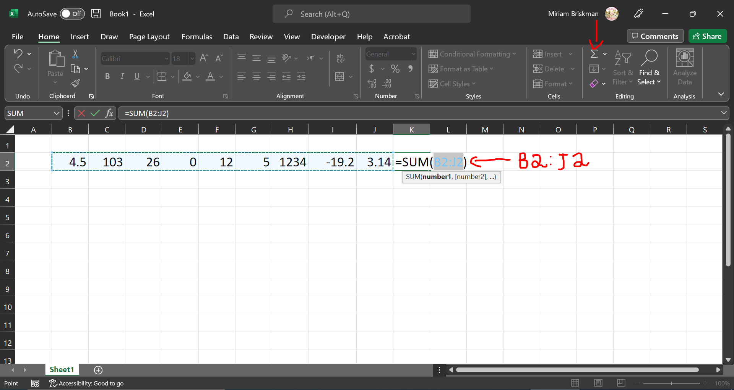
The Formulas tab, with the Sum button circled in red:
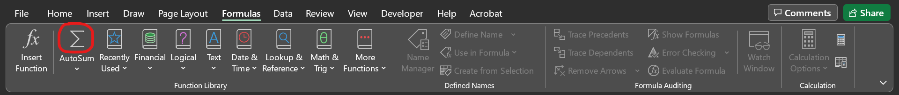
Typing =SUM(B2:J2)in the Formula Bar (with K2 being selected:)
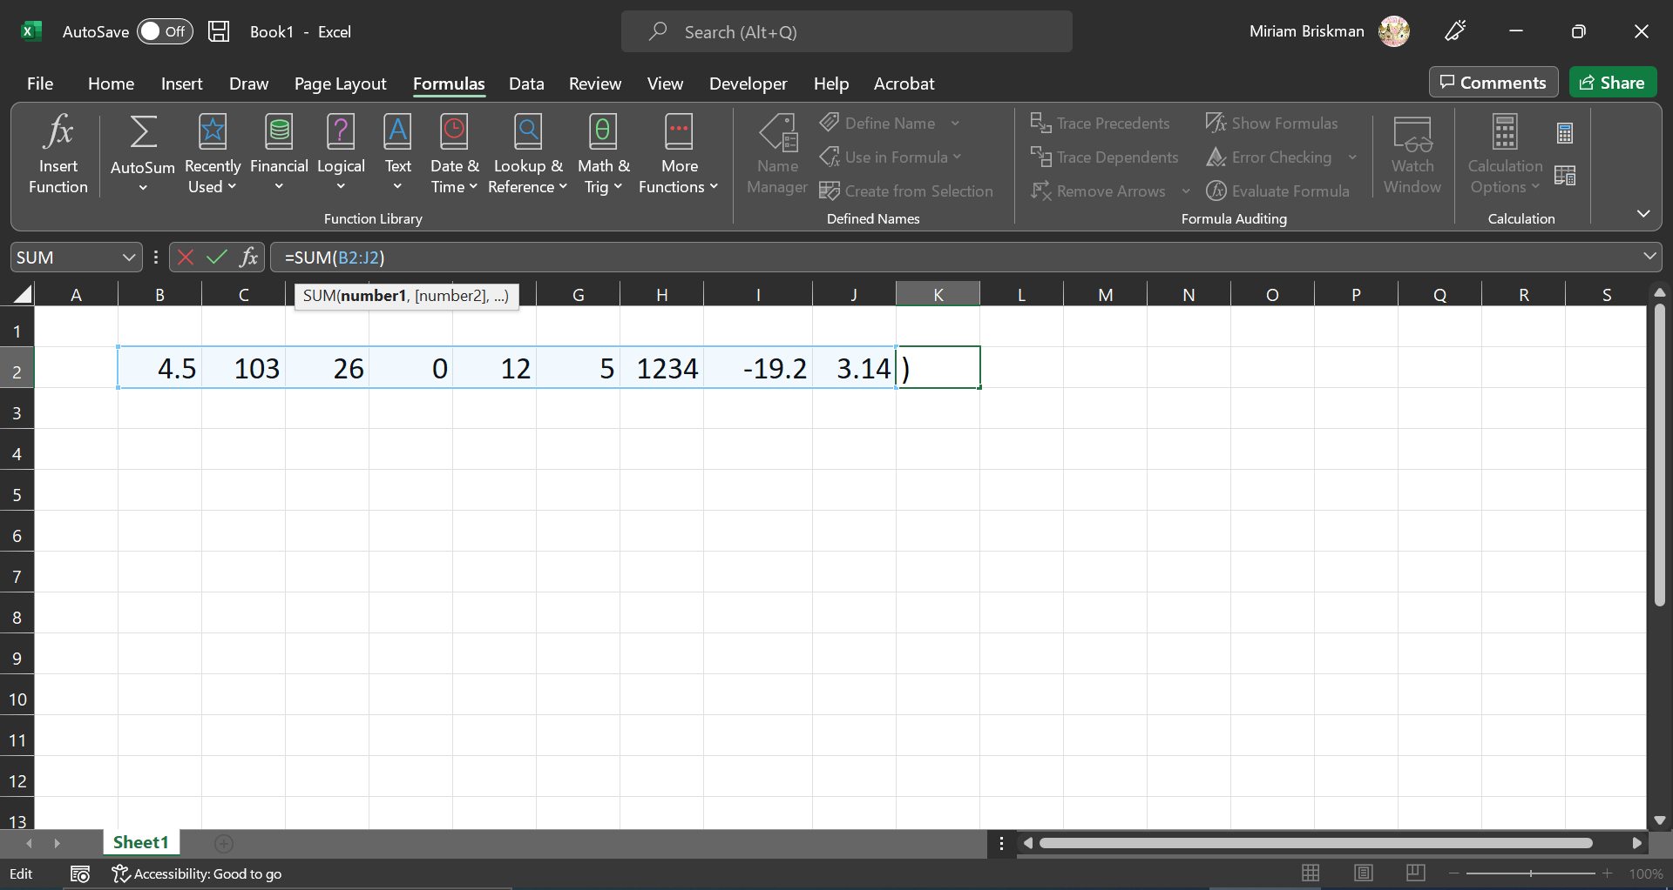
The Insert Function dialog box of the “Insert function” button on the Formulas tab, showing the search results for "SUM":
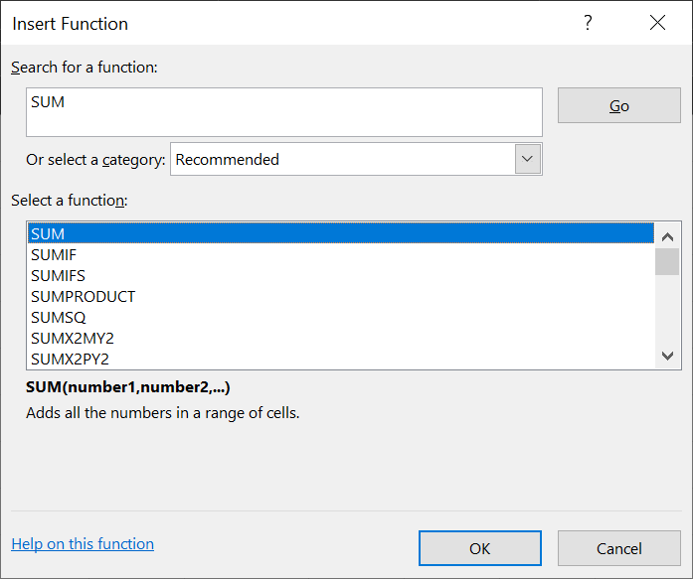
The menu for choosing the SUM function’s parameters (arguments:)
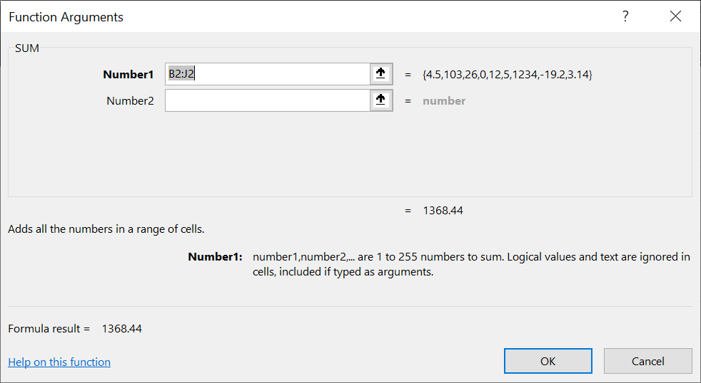
After clicking ENTER/RETURN, the result of the summing will be displayed in cell K2:
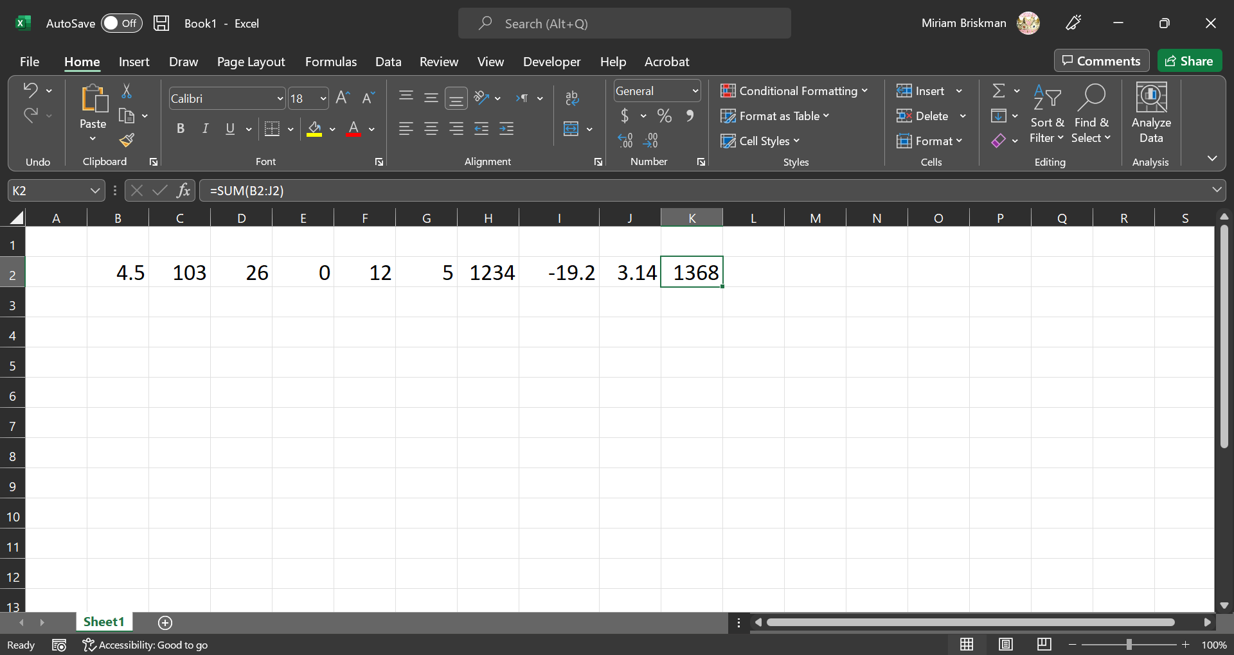

Finally, let’s get familiar with some more cool math-related functions that help us in making some fast and convenient calculations! See the exercises in the math_and_function.xlsx workbook in the same folder as these very lecture notes.

