Lecture Notes: Intro to Computers
Computers were created to make our work easier, faster, and more efficient.
Using a computer, you can accomplish a task that would normally take you a few hours (e.g., writing a letter to 100s of people) in just a few minutes!
Our course will focus on Microsoft’s Office Suite, which is the group of applications targeted at achieving day-to-day academic or business-related tasks such as composing a letter or flyer, creating a presentation, generating & disseminating spreadsheets, and storing & processing data in a database.
However, before covering the Office apps, we should get acquainted with the basic usage of a computer, and this is what we do today! (And perhaps also next class.)
Let’s watch the following 3-min video about the importance of computer literacy (= the knowledge and ability to use computers efficiently): https://www.youtube.com/watch?v=p2k3C-iB88w

Computer Concepts
In this section, we talk about hardware and software, which are components that every computer that you ever use will possess. Also, we explain what kinds of risks exist in ‘excessive’ computer connectivity.

Hardware
Hardware stands for the physical elements (boxes, boards, wires, transistors, etc.) that build up a computer. You know that a computer component is hardware if you can touch it.
Hardware may be located inside a computer (inside its tower or in the body of the laptop) or outside of it (connected to the computer via wires or wirelessly.)
Let’s watch the following 2-min video that shows several examples of components inside a computer: https://www.youtube.com/watch?v=HB4I2CgkcCo.
Question: Can you mention the name of one hardware component from the video?
Examples of hardware that is common to all computers are:
- The motherboard is a board-shaped structure located inside a computer and is its main part: a computer cannot do calculation or remember short-term information without the elements located on it. Components on the motherboard include:
  - The CPU (Central Processing Unit): This is the brain of the computer that performs calculations.
  - The Chipset is set of usually 2 chips: the northbridge and the southbridge. These chips connect the CPU to other components on the motherboard (because after you calculated something, you need to store it or output it to the world!)
  - RAM (Random-Access Memory) is the short-term memory of a computer. This memory has a limited size and is volatile (will be erased when the computer shuts down.) Therefore, you should periodically save your work on a computer!
  - ROM (Read-Only Memory) stores a small program called BIOS that runs when the computer “boots” (turns on or restarts.) ROM is non-volatile, and cannot be deleted, and this is the reason is it a “read-only” part.
  - Buses allow different components to communicate with each other. Buses include wires, optical fibers, and any software that makes them operate.
  - Every computer also has a battery, usually a lithium one, that is used to feed electricity to the computer’s clock (and other date & time configurations.)
- The video also spoke about Storage. This concept embraces permanent data storage that is saved on the computer even after it shuts down. This is the long-term memory of a computer (you don’t have to restart a work: simply retrieve it from storage!)
  - Hard disk drives have higher storage capacity and are cheap.
  - Solid-state drives are faster and use less power.
  - Both hard disk drives and solid-state drives are situated inside the computer. But there also exist removable storage devices! A USB flash drive and an optical disc can be plugged-in (inserted) into a computer and serve as transportable storage.
- Besides making computations, a computer also needs “senses” to get information from the outside, and the mechanics to communicate information to the outside. For this purpose, a computer uses input & output devices:
  - The keyboard, mouse (or touchpad), joystick, camera, and microphone are all input devices since we, as computer users, use these to give the computer information.
  - The monitor, speakers, printer, and Braille embossers are all output devices, because a computer is using all these to pass information to us, the users.

Software
Software is the non-tangible part of a computer. It contains the instructions (also called code) that tells the computer what to do. Software is also commonly called applications or programs. The Microsoft Office suite that we will be using this semester is a collection of software.
Software is divided into 3 general categories:
- The Operating System (OS). It includes all the programs that make a computer function: it turns the computer on or off, distributes resources (like memory and time) among other computer programs, and controls the input and output of information. The Operating System is a type of System Software.
  - Programs included in the Operating System are the Kernel (a core that includes instructions for the basic functionality,) Drivers (each of which provides service for and controls a specific type of device), and the User Interface (a means by which a user can interact with the computer: either graphically by clicking on the screen or textually by typing instructions.)
  - Examples of Operating systems are Windows, Mac OS, Chrome OS, and Linux.
- Utility software is also a type of a system software. Although not essential as the operating system, it helps in analyzing the computer’s behavior, debugging errors, and optimizing its operation. Examples of utility software are text editors, debuggers, antivirus programs, and file management programs (File Explorer, Finder, etc.)
- Application software (or user application software) are all the programs that let users complete daily tasks. This includes creating documents, playing games, listening to music, participating in online meetings, and sending emails.
  - Whether a piece of software is a system software or application software is hard to tell, and there are big debates and even court case decisions on this question.
  - The Office Suite (Word, PowerPoint, Excel, and Access) is Application software.

Security
Security is the ability of the computer to protect itself from outside threats to function properly.
To ensure that the computer is avoiding tasks that are not permitted to be done (for example, an internet user is trying to fetch a company’s secret records,) the following measures might be taken:
- Dividing the users of a computer into those who are “privileged” to request sensitive tasks (e.g., deleting the entire disk) to be done and those who are “non-privileged” for all such tasks.
- Registering computer users and using usernames to authenticate (= identify) them and passwords to verify that this is the actual user.
- Each task type might have a list of users who are allowed to perform the tasks and those who are not. Alternatively, each user might be associated with a list of tasks he or she is permitted to do. This method is called authorization, and each user is either authorized or not authorized to complete a task.
- To prevent external, and perhaps harmful requests from being executed on the computer, hardware or software firewalls are used. They deny traffic of information to the computer via a certain device, and thereby ‘filter’ the incoming requests from that device, keeping the computer safe from intruders.

Privacy
Privacy is your ability to keep information away from people or organizations whom you don’t want to access that information. For example, you allow your primary care provider to view your medical information but don’t want to let your neighbor Jack view it.
There is a tradeoff between (or a challenge in) sharing data and keeping some data private: while there is a strive to share data, some of it might contain information that is private to someone, so there is a need for filtering this shared, outgoing information.
Current privacy concerns include:
- Can third-party companies access the contents of your emails without consent?
- Should people be tagged on Facebook pictures without consent?
- Can organizations with whom you have service (banks, Google, etc.) share your information with third-party companies? (Organizations may get commission for research, advertising, and other activities that the third parties do with your info.)

Operating Systems
There are several ways of recognizing what kind of an operating system you have.
- The logo of a window like 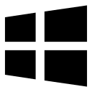 or  tells that you are on a Windows computer. A logo of tells you are using a Mac. The logo also shows up on the screen when you turn the device on.
- Special buttons exist only on Windows computers: Ctrl, Alt, and Windows ( or ) keys and on Mac computers: Command () and Option () keys.
On Windows, you can tell what Windows version you have by either:
- Clicking Windows key + R, typing “winver”, and clicking OK to open a window that shows what the version is.
- Start button > search for “About your PC”.
- Start button > Computer > Properties (works on Windows 7).
- Start button > search for “System Information”.
On Mac, use the following short guide to detect its version: https://support.apple.com/en-us/HT201260
For Chromebooks, use the following short guide: https://support.google.com/chromebook/answer/177889?hl=en
For a Linux computer, use the Stack Exchange answer here: https://unix.stackexchange.com/a/88647

Finding Programs and Files

Start Menu
On Windows, the Start menu contains the following functionalities:
- Accessing the computer’s configurations (via the Control Panel),
- Viewing some frequently used programs,
- Searching for files, programs, or even knowledge (you can search the internet via Windows 10’s Search Bar!)
- Shutting down, hibernating, sleeping, restating the computer, or even switching to other users!

Creating & Organizing Files and Folders
Using Windows’ File Explorer application, one can create new files & folders, view files and their properties, change a file’s (or folder’s) name, move them around, and erase them when needed!
Since folders can be located inside other folders, we get a hierarchical structure that somewhat reminds a tree. This is true about every operating system.
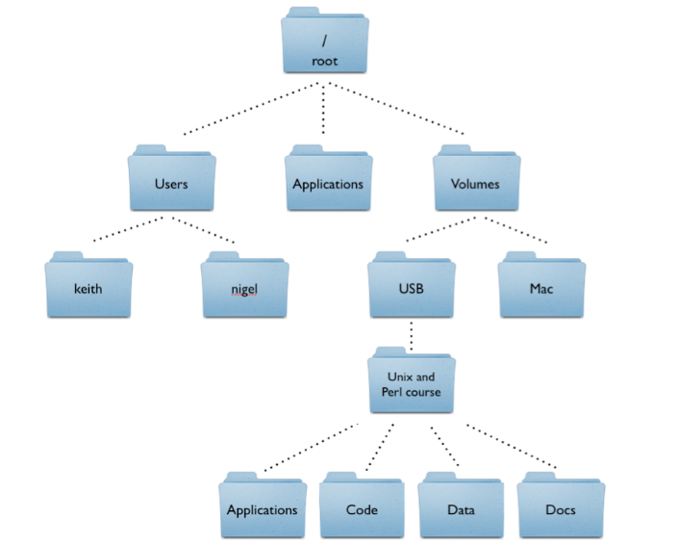
^ How the folders of a Linux or Mac computer are located inside each other.
In the image above, we know at which location a file can be found using a path. An example of a path for the “Applications” folder above is:
/Volumes/USB/Unix and Perl Course/Applications
(The leftmost slash (/) stands for the “root” folder.)
On Windows, the path would look like:
C:\Volumes\USB\Unix and Perl Course\Applications

Deleting a File
In the File Explorer, if you want to delete a file (since it’s probably not needed anymore or contains old information,) right-click on it and select “Delete”.
Immediately after you click “Delete”, you won’t see the file there anymore. However, on Windows, the file is not entirely deleted from the computer: you can find it in the Recycle Bin!
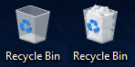
^ An empty and a full-of-garbage Recycle Bins, respectively.
The Recycle Bin is located on your Desktop. Double click the icon of the Recycle Bin to open its folder and see what files you previously deleted.
You can see the properties of the deleted files (names, folders in which they initially were placed, date of deletion, etc.,) restore the file (= return them to their original folders,) or empty the Recycle Bin (= permanently deleting everything currently located in it.)
On Mac, the Trash Can (the counterpart of the Recycle Bin) may look like this:
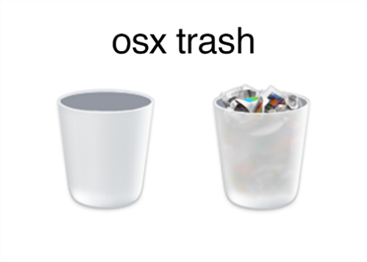 or 
^ Mac’s Trash cans, full or empty.
You will usually find the trash can on your Mac’s Dock (= a row of images of applications or folders at the bottom of the Mac screen.)

Taking Screenshots

Snipping Tool
On Windows, you can use the Snipping Tool to take screenshots of your computer!
The Snipping Tool allows you to:
- Take timed screenshots (up to 5 seconds of delay).
- Take irregularly shaped screenshots.
- Edit taken screenshots (drawing on or highlighting them.)
- Saving, Copying, and Sending (Sharing) screenshots.

Print Screen
You can take a screenshot with a few clicks!
On Windows: Click the Prt Scr button to take a screenshot of the entire screen.
On Mac: Click the Command + Shift + 3 key-shortcut to take a screenshot of the entire screen.
On Chromebook: Click the Shift + Ctrl + Show key-shortcut to take a screenshot of the entire screen.

