Lecture Notes: PowerPoint, Advanced Skills

Theme Colors
In the Lecture Notes for PowerPoint’s Basic Skills, we got familiar with applying a presentation theme and even changing the theme variant (e.g., different colors or textures of the same theme.)
We now look more in-depth into choosing theme colors.

Selecting a Pre-Defined New Color Scheme
Each theme comes with a pre-defined set of colors per different slide objects and text, including main and secondary text/background colors, 6 accent colors (used within SmartArt graphics and charts,) and default colors for hyperlinks. Each such set of colors is called color scheme. Because it unambiguously tells what the color of each piece of text or object should be.
PowerPoint provides about 20 alternative color schemes to choose from for the currently selected theme.
To choose such an existing color scheme, click the Design tab Variants group ‘More’ arrow Colors option Click on one of the color schemes to select it:
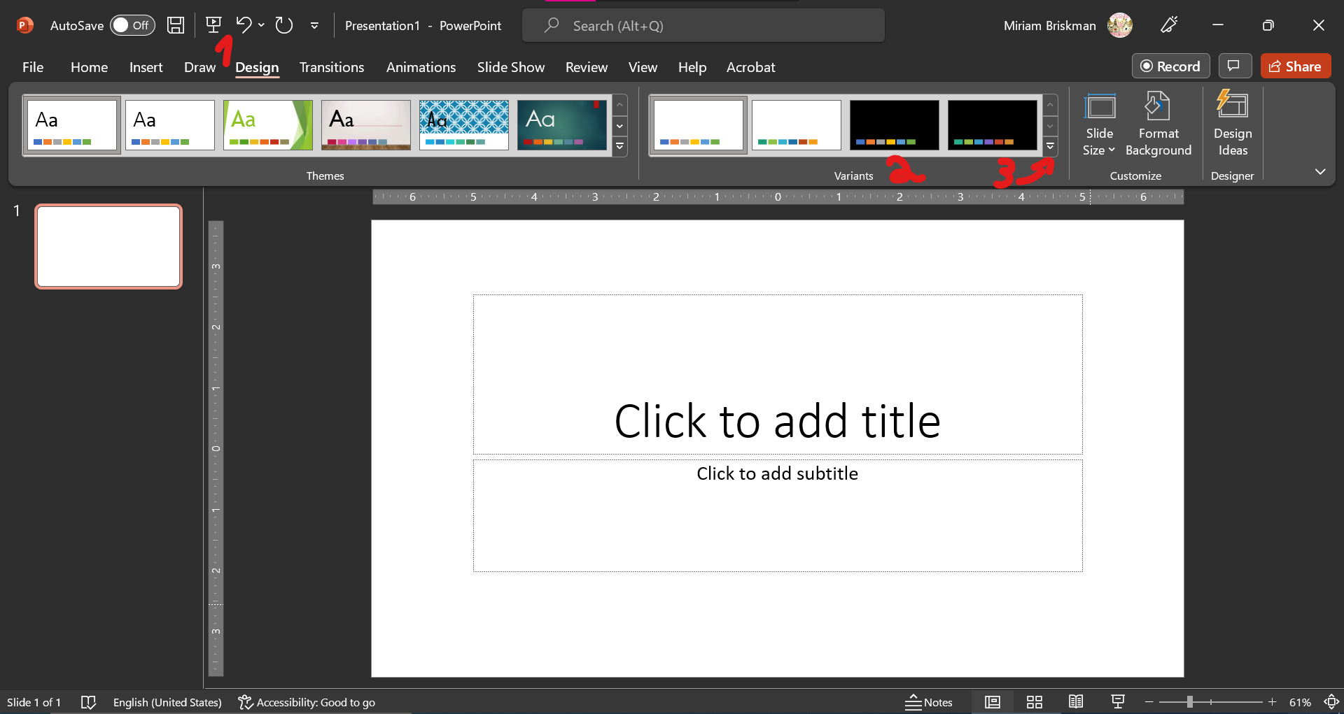
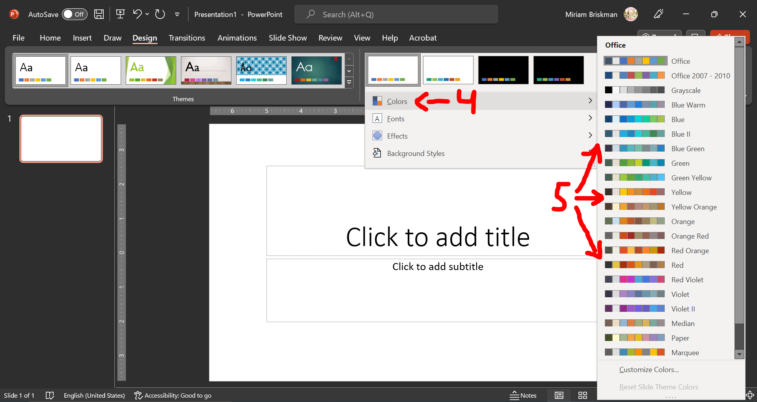
For instance, the blue-colored slides of the ‘Slice’ theme could change to the “Violet II” scheme as shown in the following 2 screenshots:
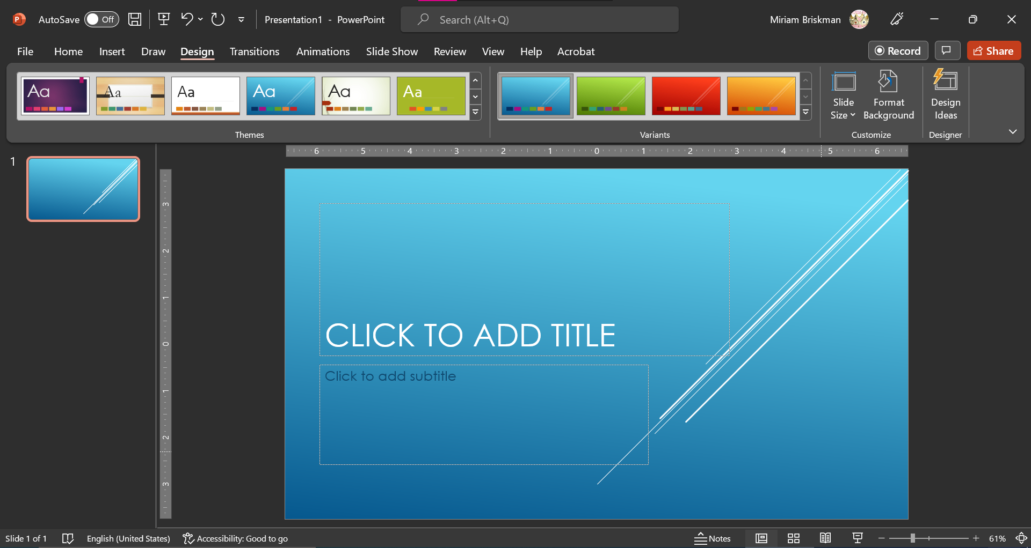
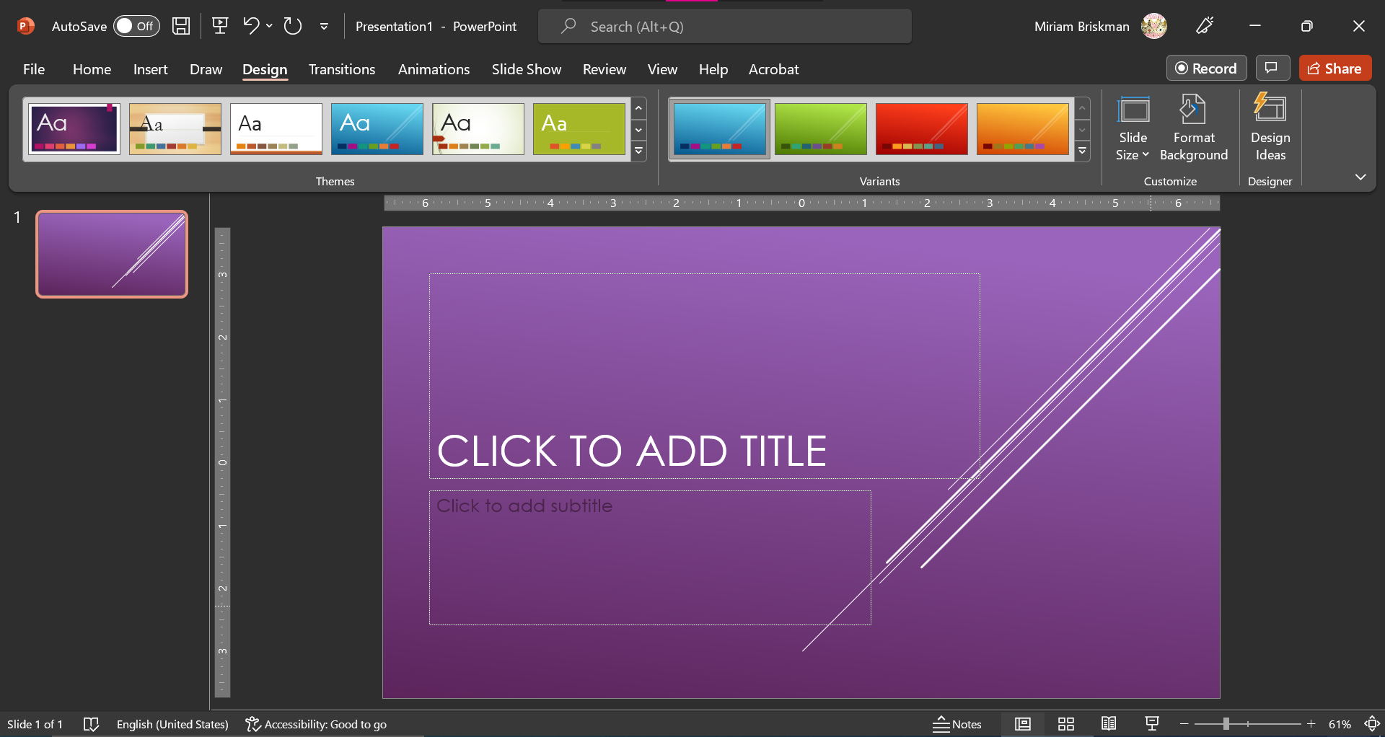

Defining and Using Your Own Color Scheme
PowerPoint lets you create your own color scheme!
To pick up colors for the new scheme, click the Design tab Variants group Colors option “Customize Colors…” option. This will open the “Create New Theme Colors” dialog box:
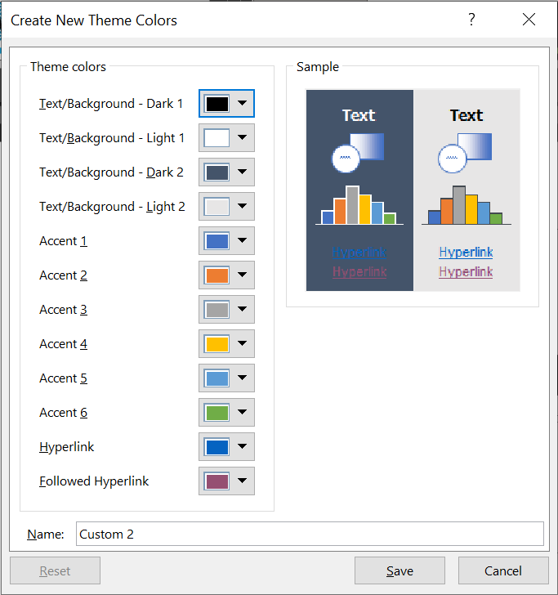
In that window, click on the buttons next to each color category and select the colors you wish. Finally, give a meaningful name to the new scheme inside the “Name:” box, and click Save.
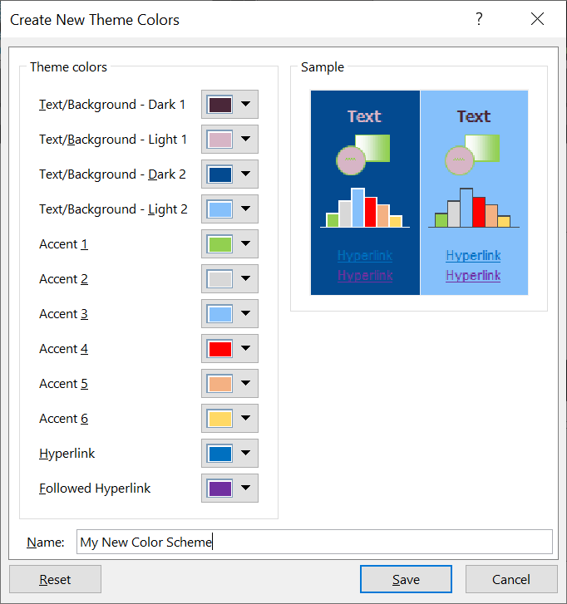
Note that, if you wish to discard your changes so far and start picking colors from scratch, you can click the Reset button, without needing to exit the dialog box.
Once you save the new scheme, you could change the currently used color scheme within the presentation by selecting your scheme in the ‘Colors’ menu:
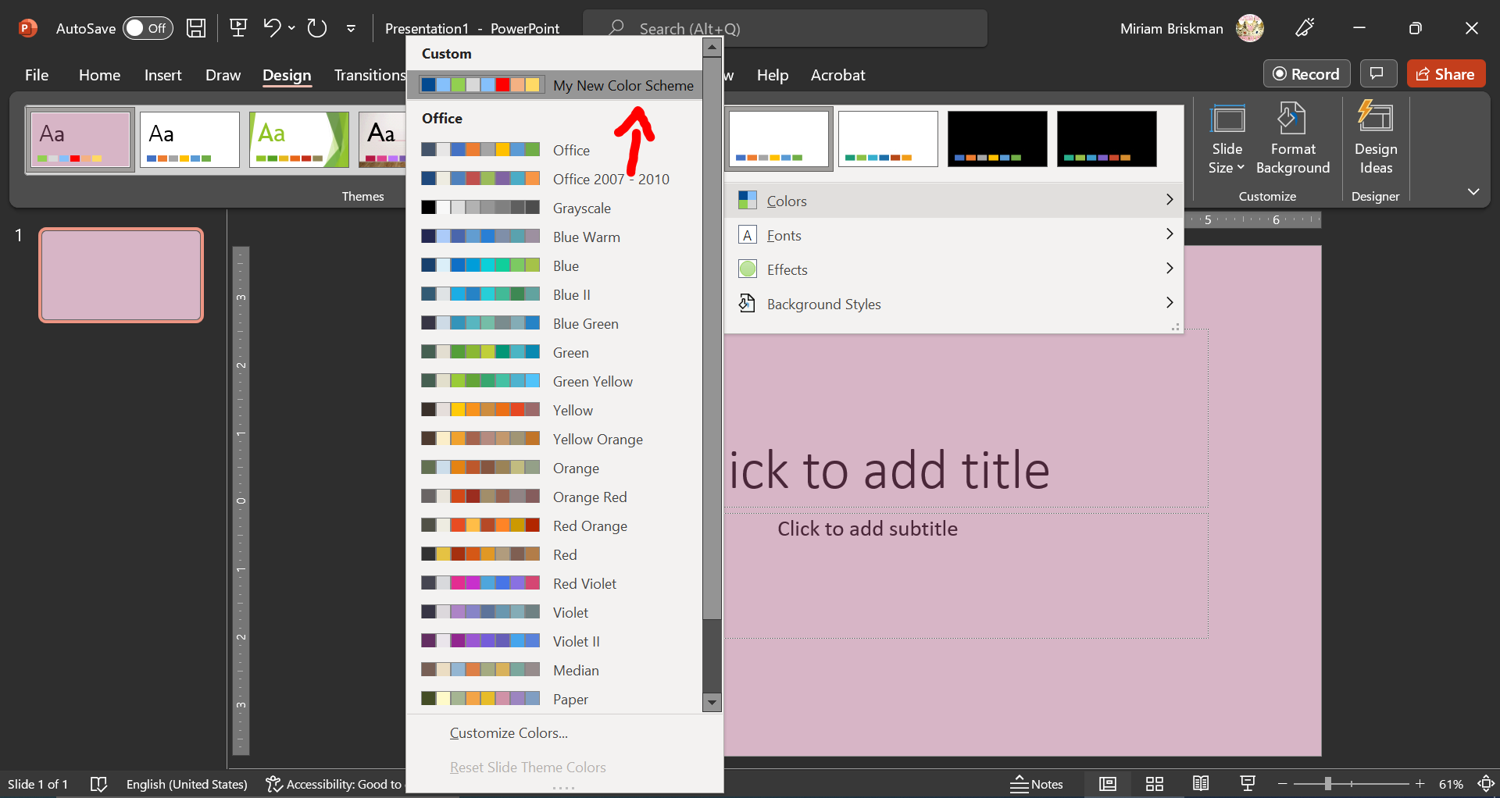

Tables
We already discussed the use of tables in Word, but there’s more to them in PowerPoint!

Ways to Create a Table
A new aspect about tables in PowerPoint is that the number of methods to add a table is greater than in Word. Let’s learn what the 5 methods are:
- Through the Content Placeholder. When you have a slide with a layout containing the Content Placeholder in it (such as “Title and Content”, “Comparison”, “Two Content”, etc.,) you can press the “Insert Table” button in the middle of the placeholder and then select the number of rows and columns in the new table:
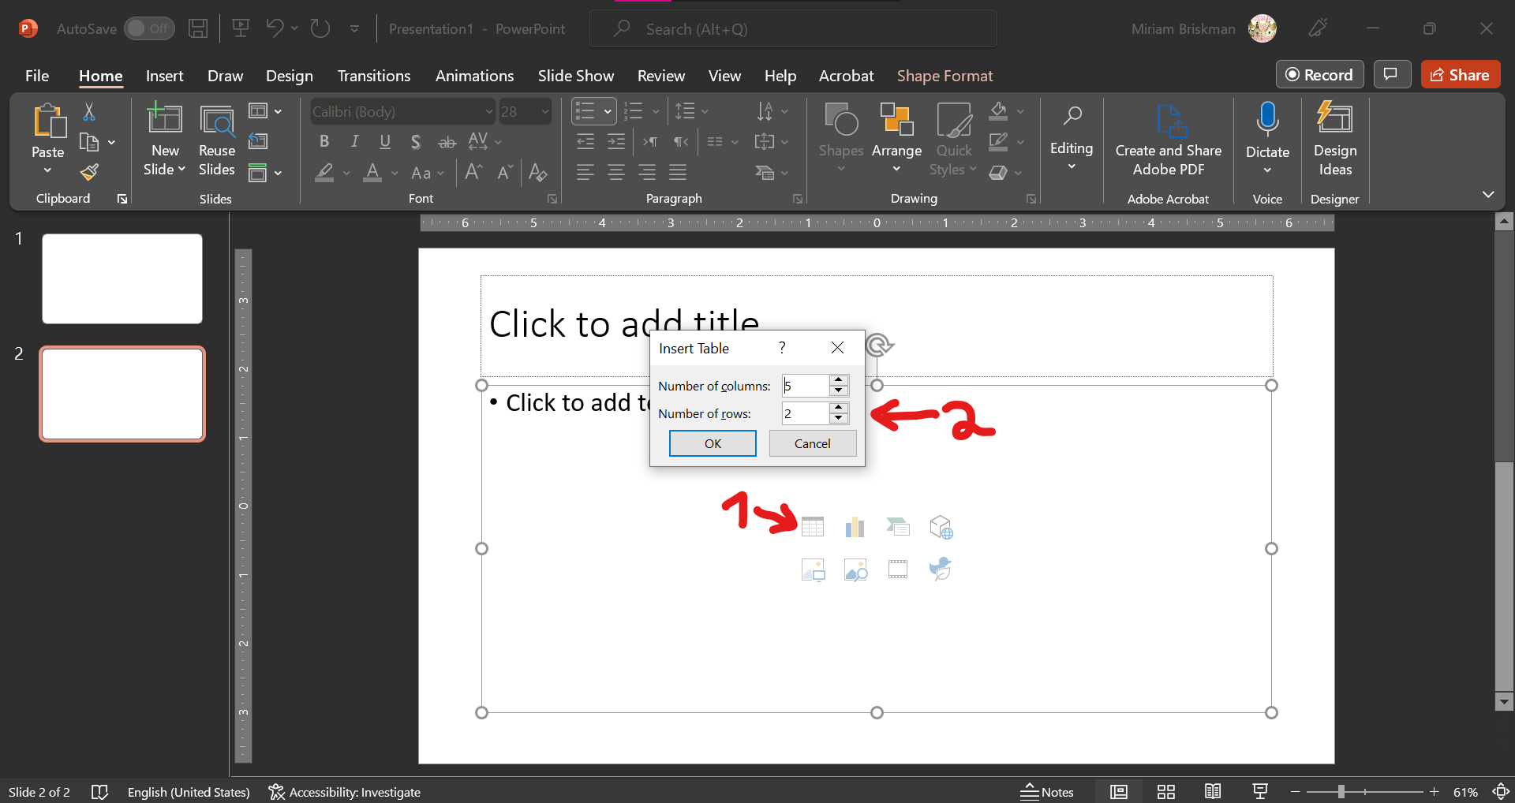
- Through the “Insert Table” option. Click the Insert tab Table button “Insert Table…” option Using the same small dialog box as in Method 1, select the number of rows and columns you want to have in the table:
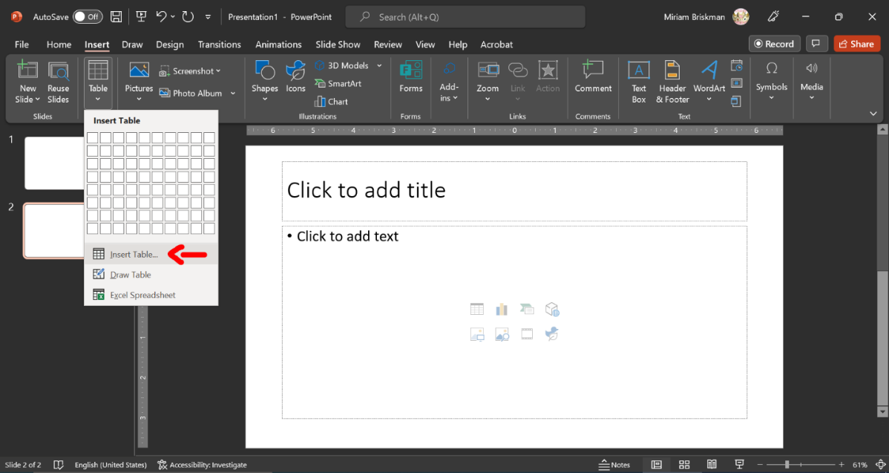
- Through the grid of rows and columns. The grid of rows and columns in the using the Insert tab Table menu allows you to click on the button corresponding to the number of rows and columns you wish to select to have in the table:
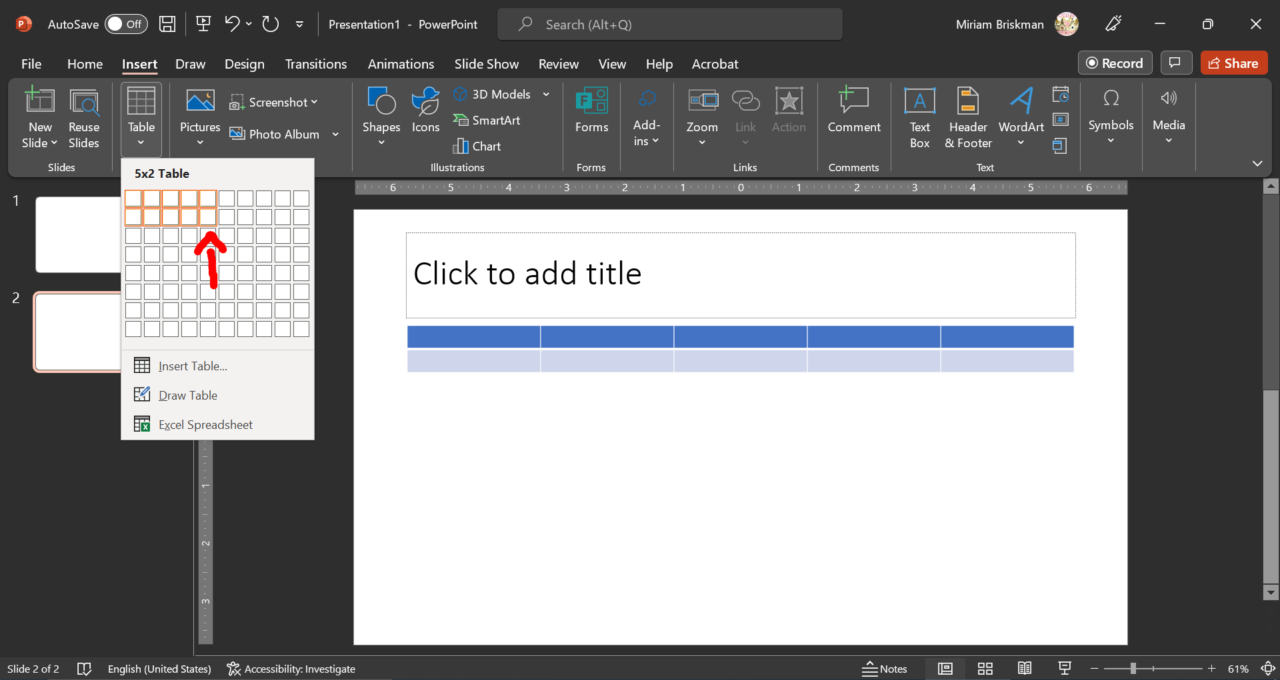
- By Drawing a Table. You can draw a single table cell using the Insert tab Table button “Draw Table” option. You can later add more rows and columns into the table.
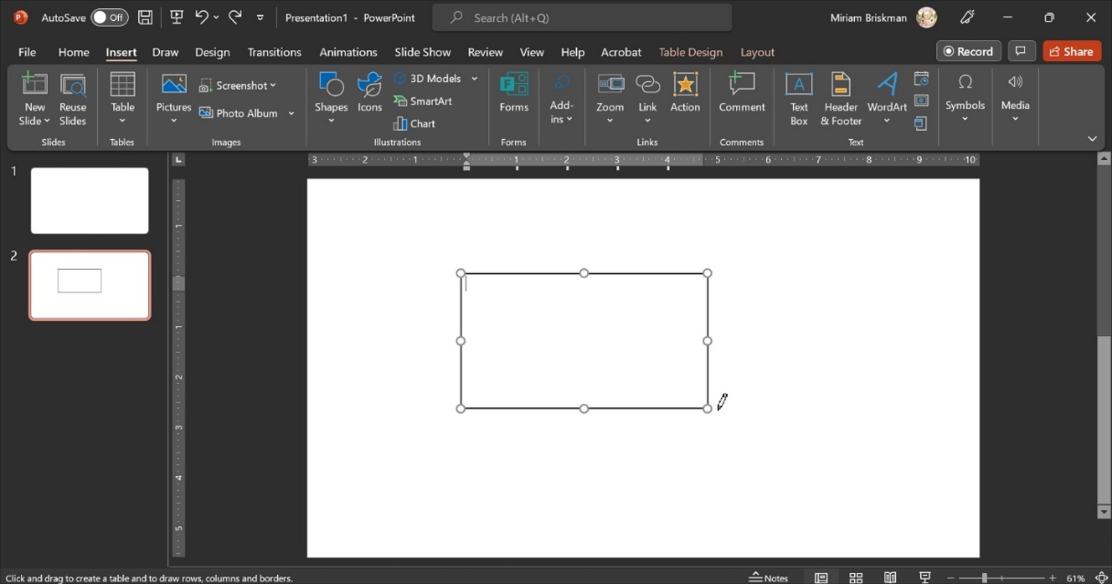
- By using an Excel Spreadsheet. The Insert tab Table button Excel Spreadsheet option allow you to temporarily open the Excel app within PowerPoint and use it to add a new table. The Ribbon of the Excel app also appears while you edit the table, which provides you with all the functionalities of Excel, including letting Excel do some computations for you within the table’s cells (e.g., summing up some numbers.) We will discover the power Excel later this semester.
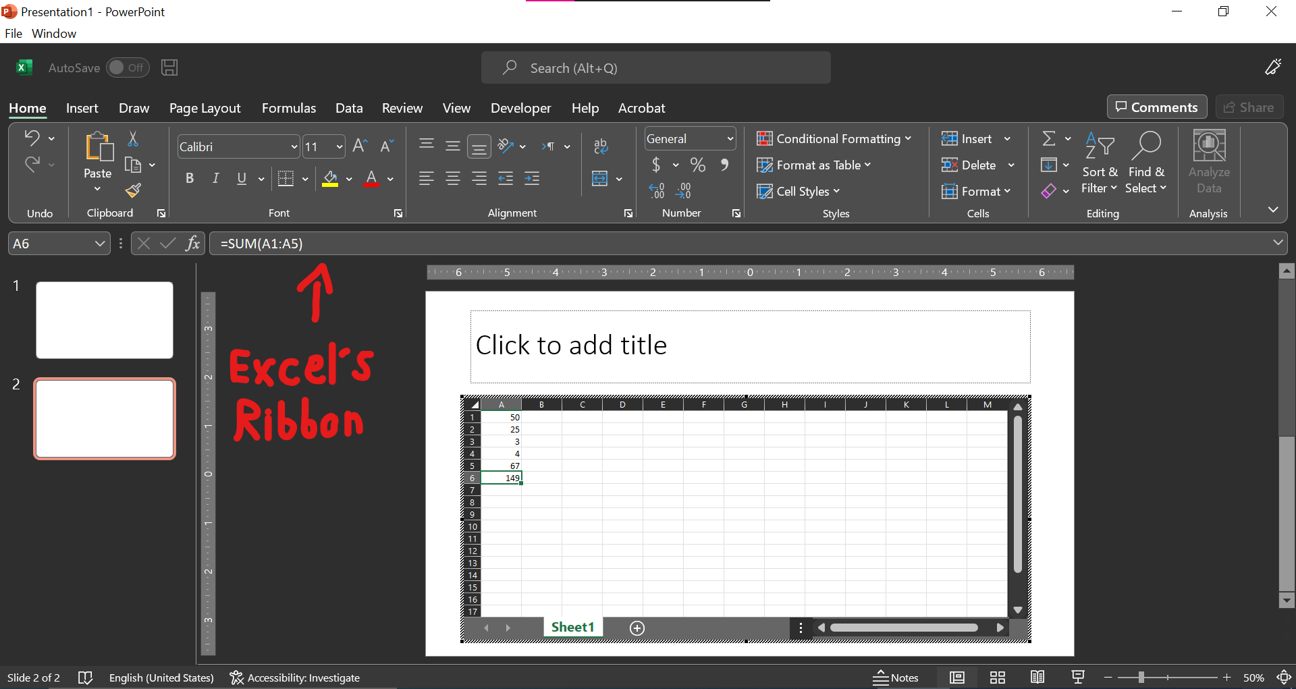
Once you click outside of the table’s area, the table will be created, and Excel’s Ribbon and functionalities will disappear from the screen:
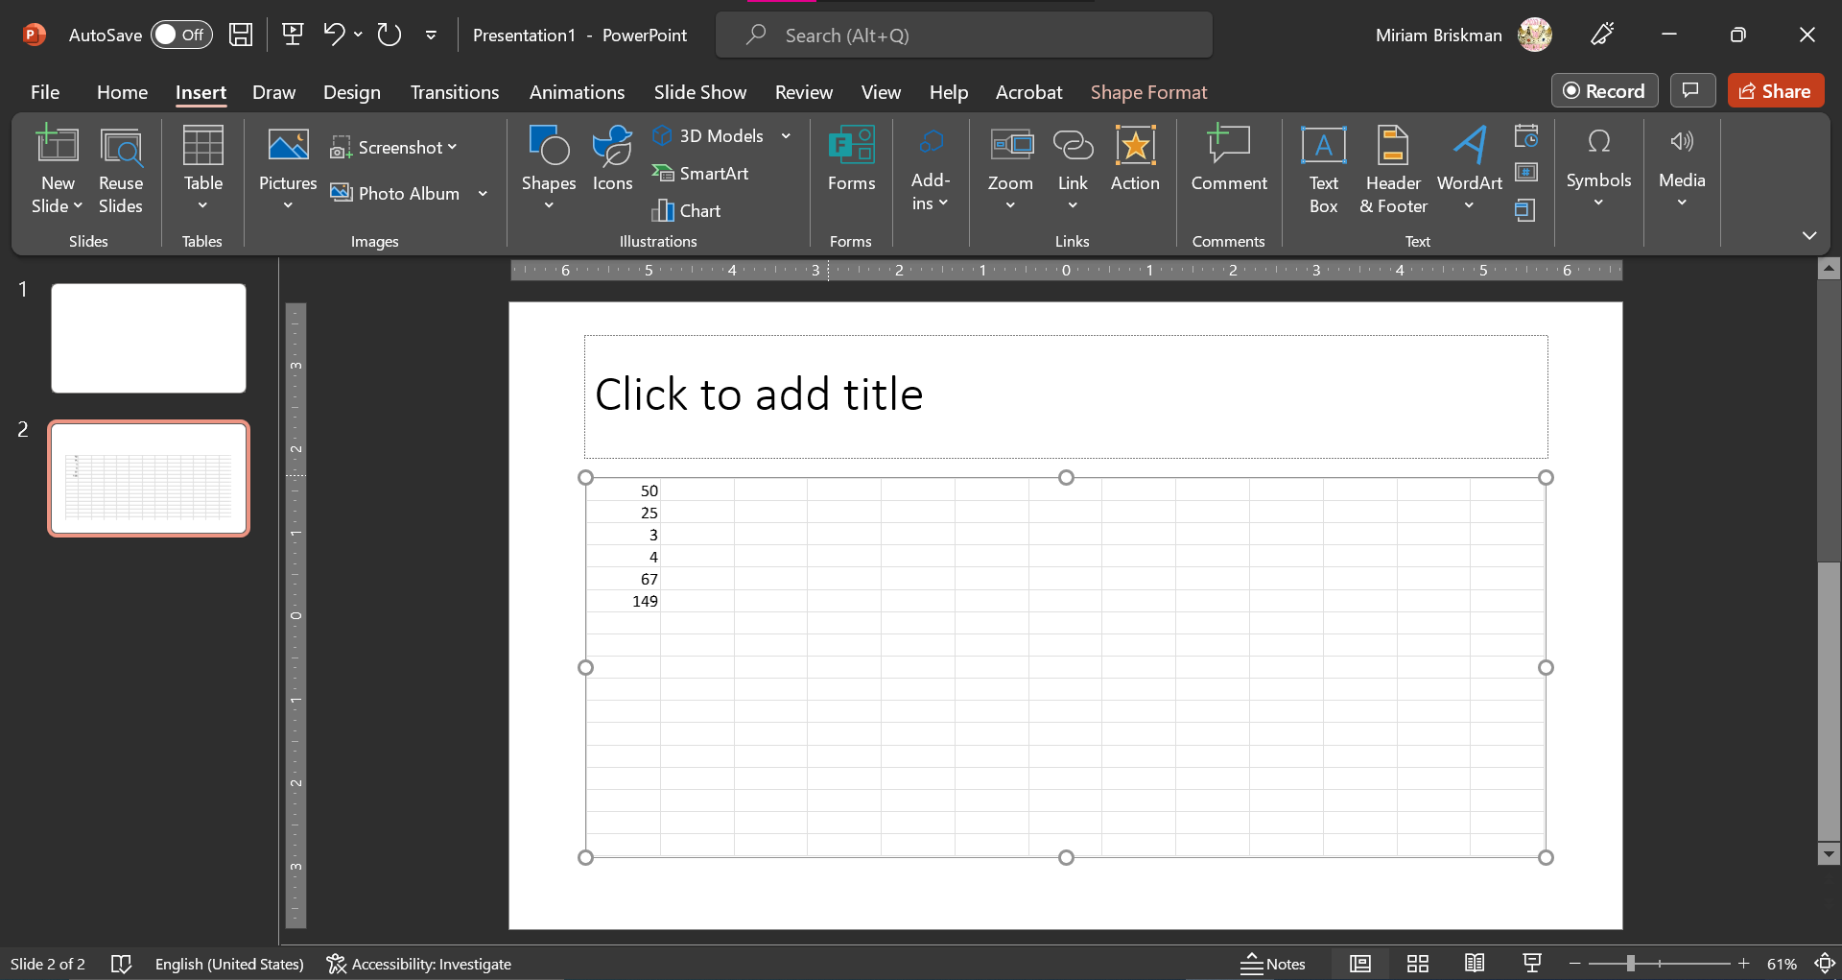
You can double-click the table to re-open it in the Excel editor again when needed.

Formatting Tables
Just as with Word’s tables, you can use PowerPoint’s Table Tools: Design tab that appears when you select a table, to apply any stylistic changes to your table!
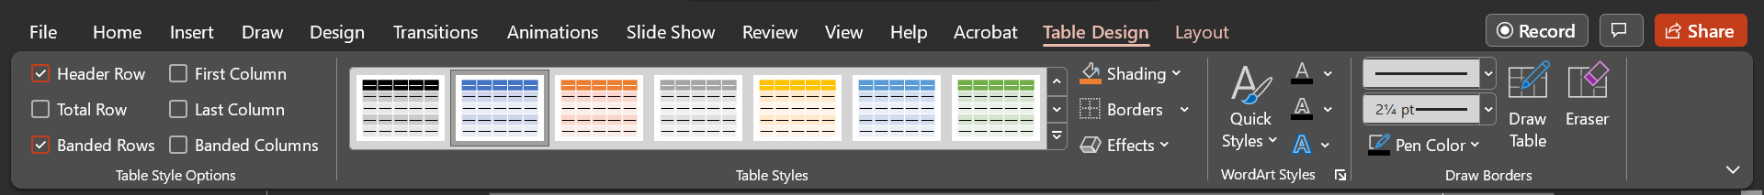
One notable difference between Word’s and PowerPoints Table Design tab is that you can let PowerPoint show some of the most appropriate table styles for you to choose from! To do so, click the “More” button of the Table Styles group, click the small arrow next to “All”, and then select “Best Match for Document”:
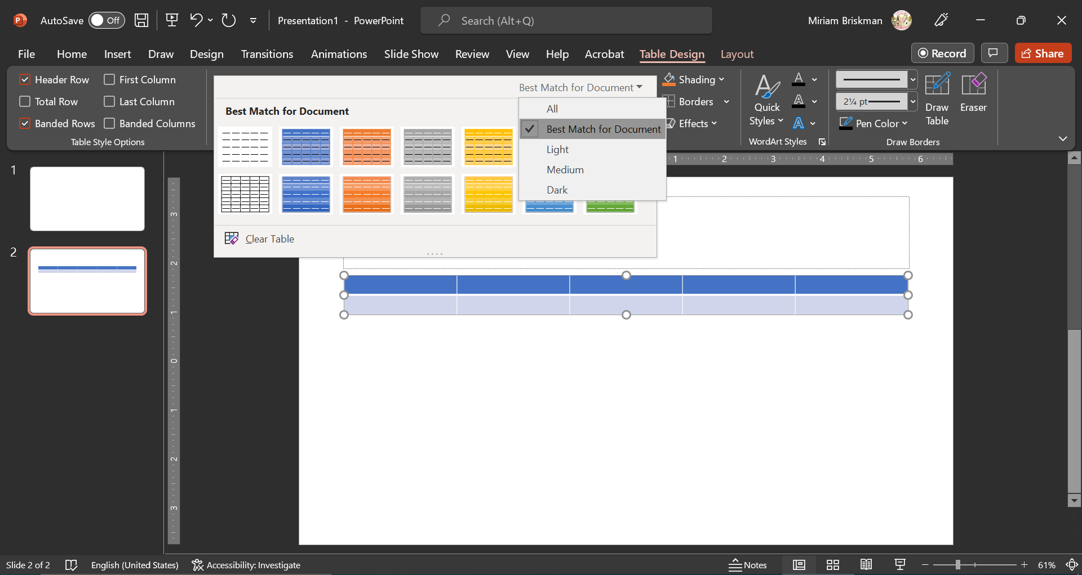

Modify Tables
The Layout tab that shows up when a table is selected lets you change the structural features of the table, including adding or deleting rows or columns, merging a few cells into a single cell, changing the cell’s sizes, deciding where text appears inside the cell, and setting the entire table’s size.
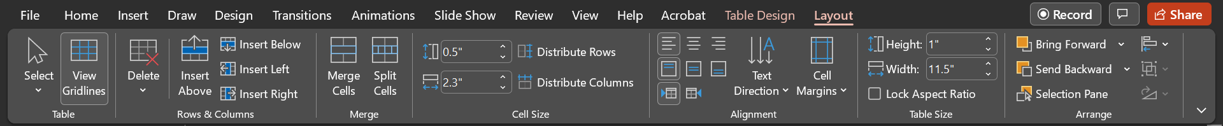
To merge several cells together, first select the cells you wish to merge, and then press the “Merge Cells” button:
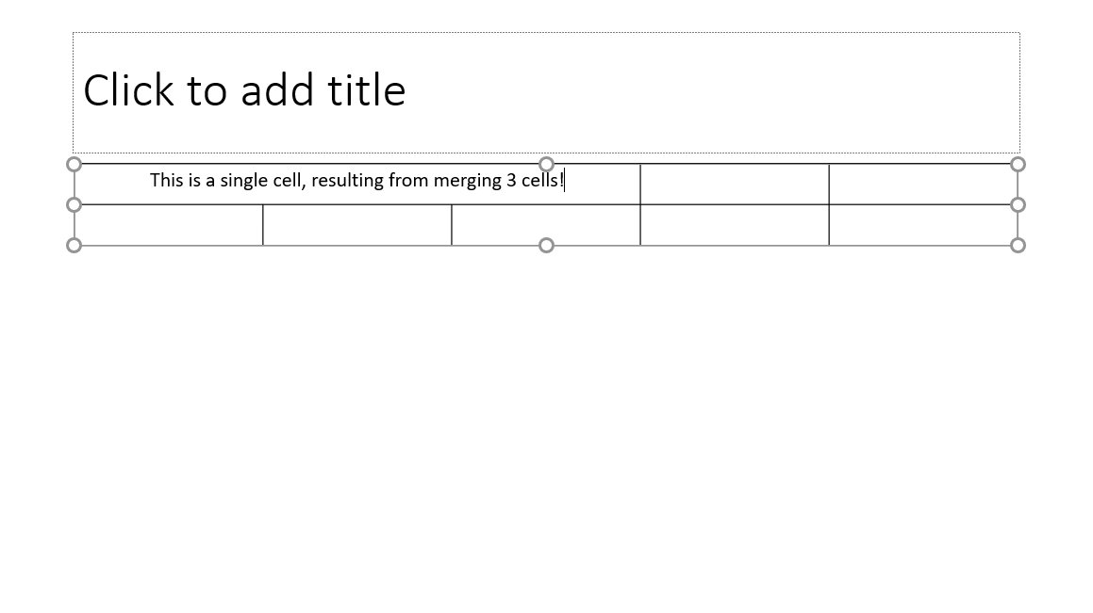

Animations
Transitions let you add ‘action’ between slides. Animations, on the other hand, let you add some action within slides!

Adding an Animation
Animations can be added to text and to objects within the slide, such as text boxes, icons, pictures, shapes, etc.
To start adding an animation, select the object Click the Animations tab click on the “More” button of the Animation group Click on the Animation you wish to add:
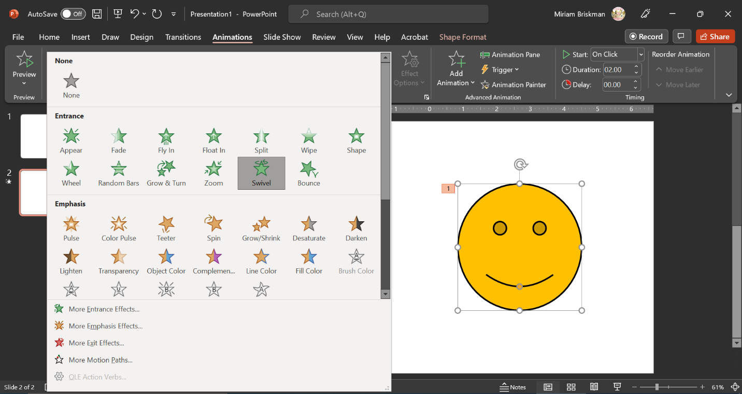

Animation Types
There exist four types of animations: Entrance, Emphasis, Exit, and Motion Paths.
Entrance and Exit animation will make the animated object look like it has just appeared on or gone away from the slide, respectively. Emphasis animations change the object in some way. Finally, Motion Paths allow you to hand-pick and adjust the path in which the object will move.

Other Animation Features
You can Preview (= play) the animations in the current slide by clicking the Preview button. Previewing means watching the animation without starting a Slide Show. 

Some animations also let you change the effect through the Effect Options button. Doing so will change the direction or pattern in which the animation manifests:
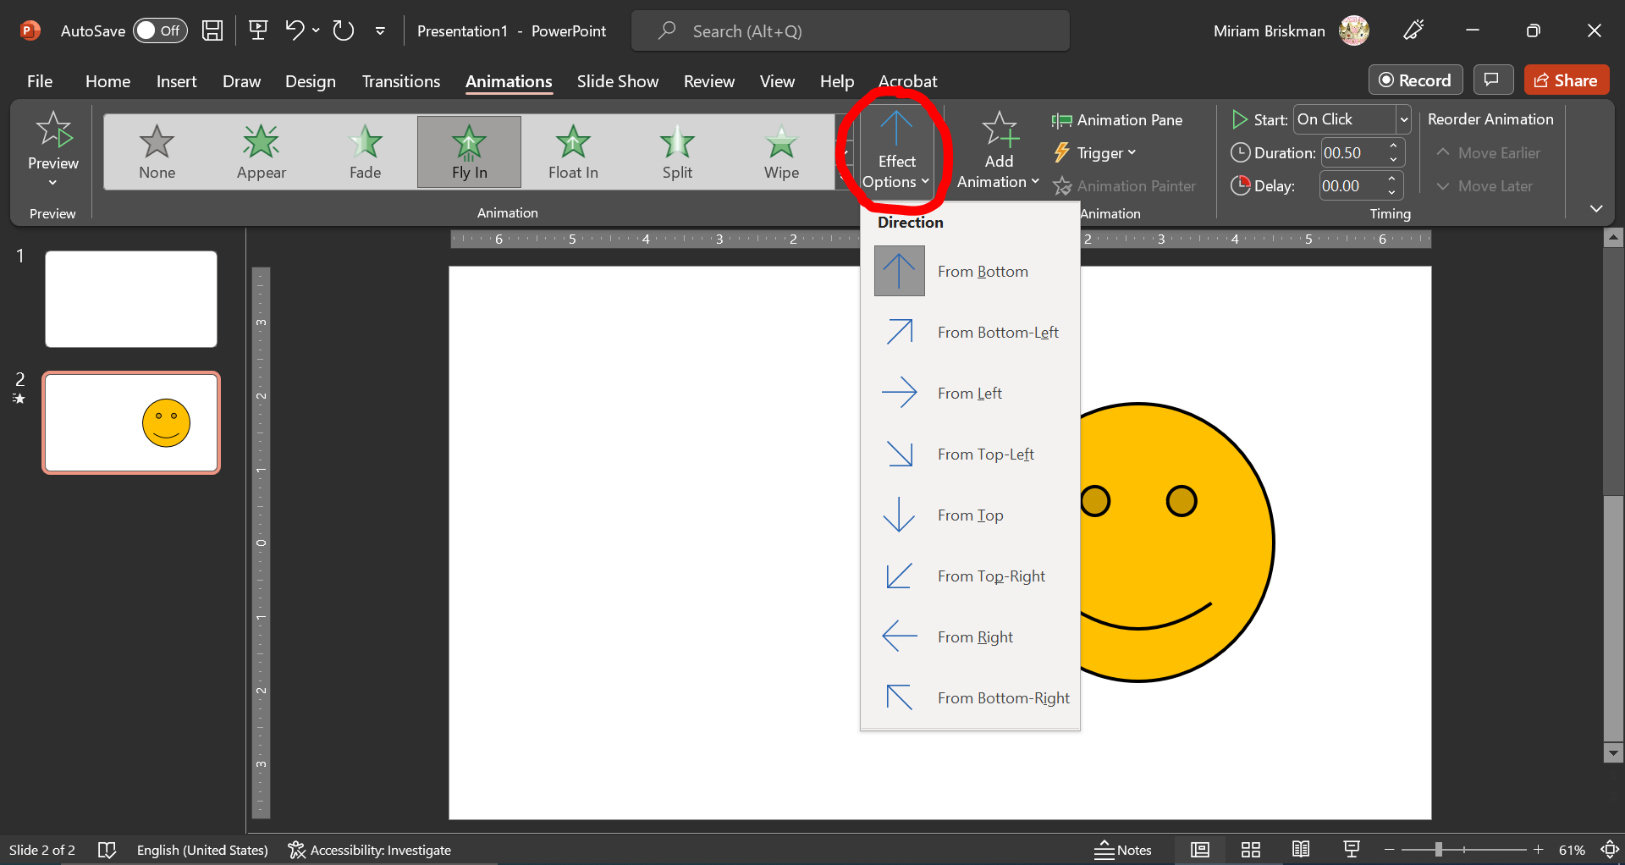

Unlike transitions, animations could be added more than once per each object. For example, we could add one Entrance animation and then one Exit animation to an object. To add additional animations, use the Add Animation button:
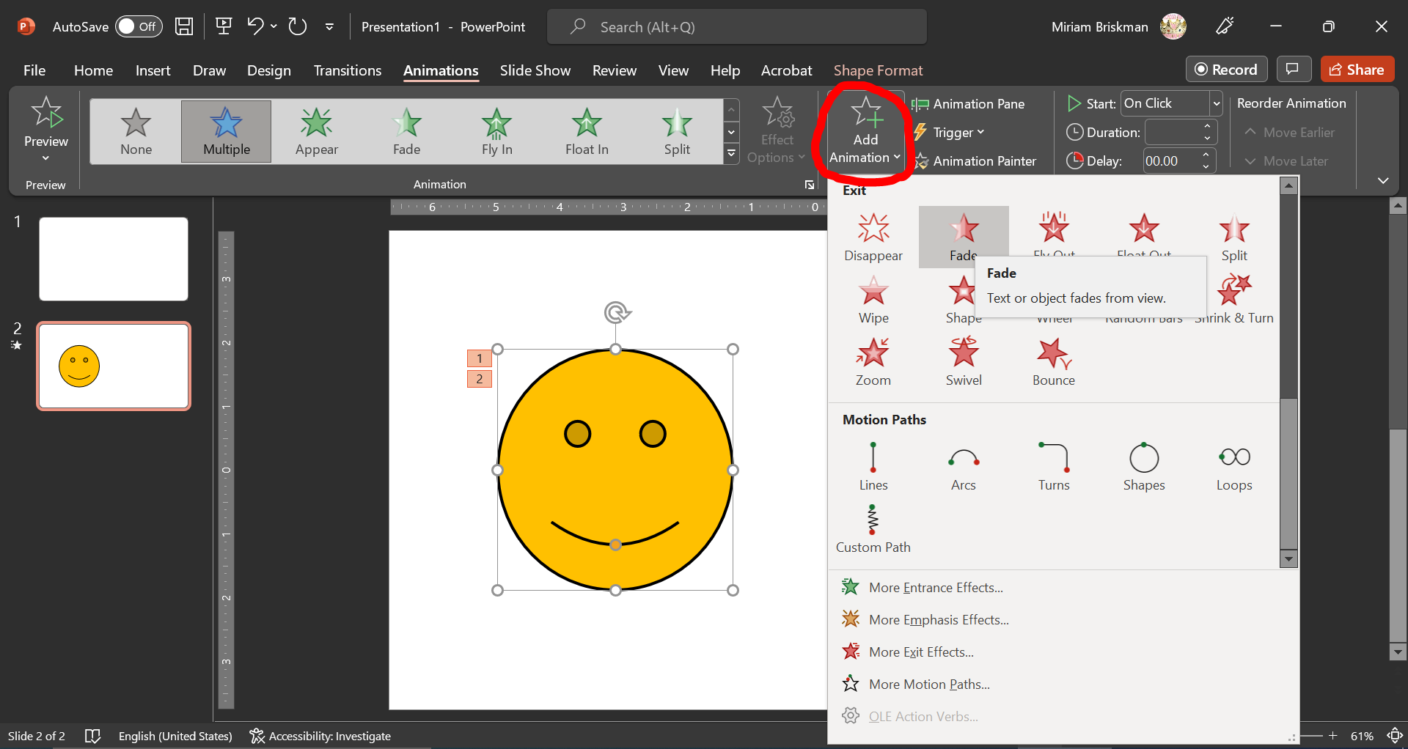

Each time you add an animation to the same object, a small number will appear next to it, indicating the order in which the animations occur. You can see all the animations added so far, change their order, and change other animations features within the Animation Pane:
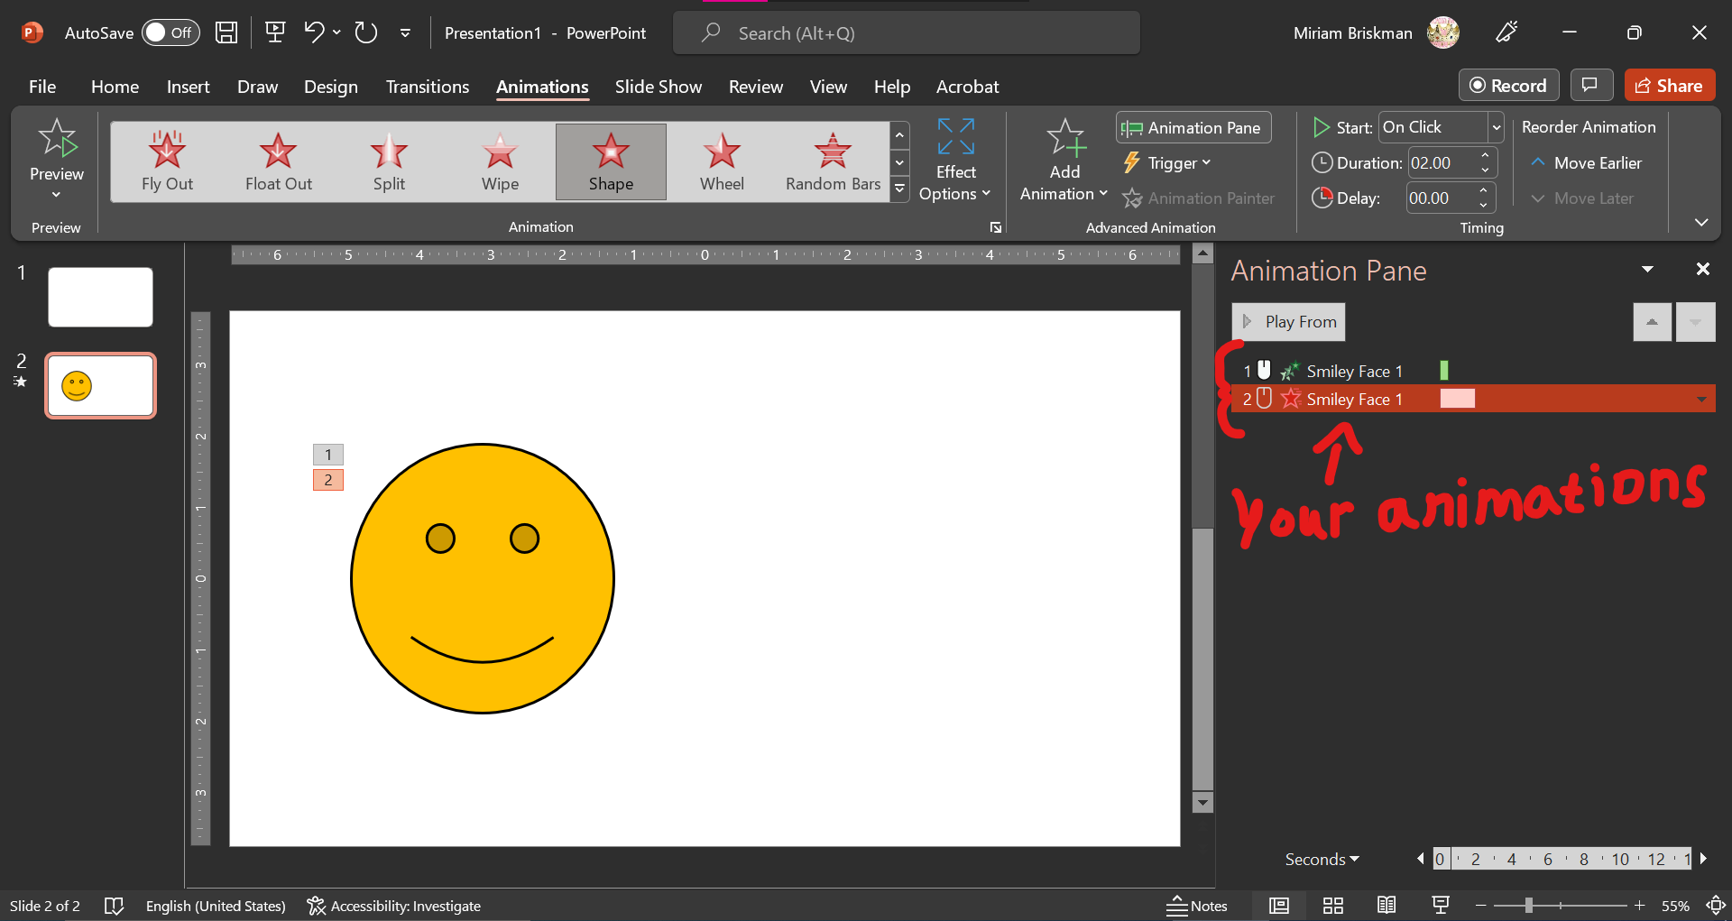

For each animation, you could decide when the animation starts (On click, after the previous animation played, or while the previous animation is playing) using the Start drop down list:
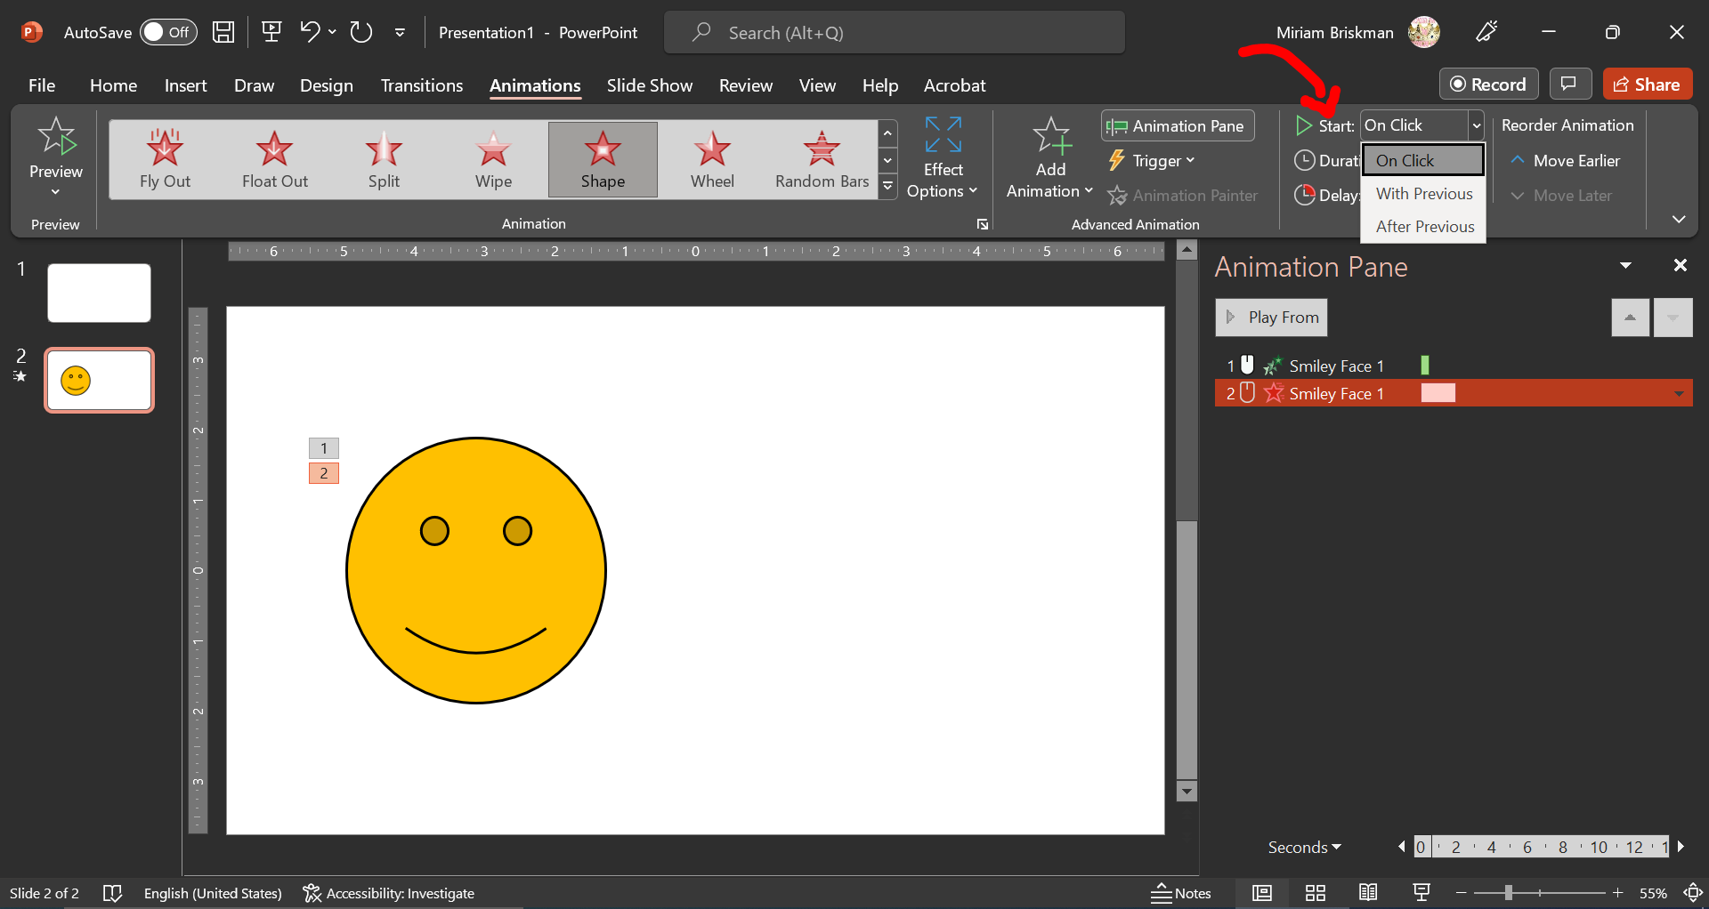

Finally, you may decide how long an animation will play by typing the number of seconds in the Duration box, and decide how much time should pass before the animation starts playing by typing the number of seconds in the Delay box:
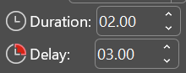
In the example in the screenshot above, the animation will start after 3 seconds of delay and will play for 2 seconds.

Charts
A chart lets you visualize data by organizing it in a certain manner.
PowerPoint offers 17 (!) different types of charts to choose from, with each type emphasizing a different aspect of the data.

Adding a New Chart
There are 2 methods for adding a chart into the current slide:
- Through the Content Placeholder. When you have a slide with a layout containing the Content Placeholder in it, you can press the “Insert Chart” button in the middle of the placeholder.
- Through the Chart button under Insert. You can also click on the Insert tab Illustrations group Chart button.
In any of these 2 ways, the “Insert Chart” dialog box will open:
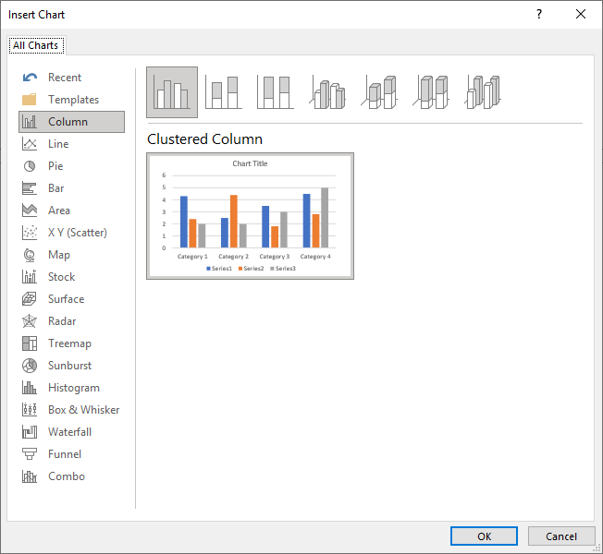
To select a chart, first choose the chart category from the left-hand size of the box (Column, Line, Pie, Bar, etc.) Afterwards, select which style the chart should have by clicking any one of the top illustrations: there are some 2-dimensional and 3-dimensional ones. Then, press OK to add the chart in. 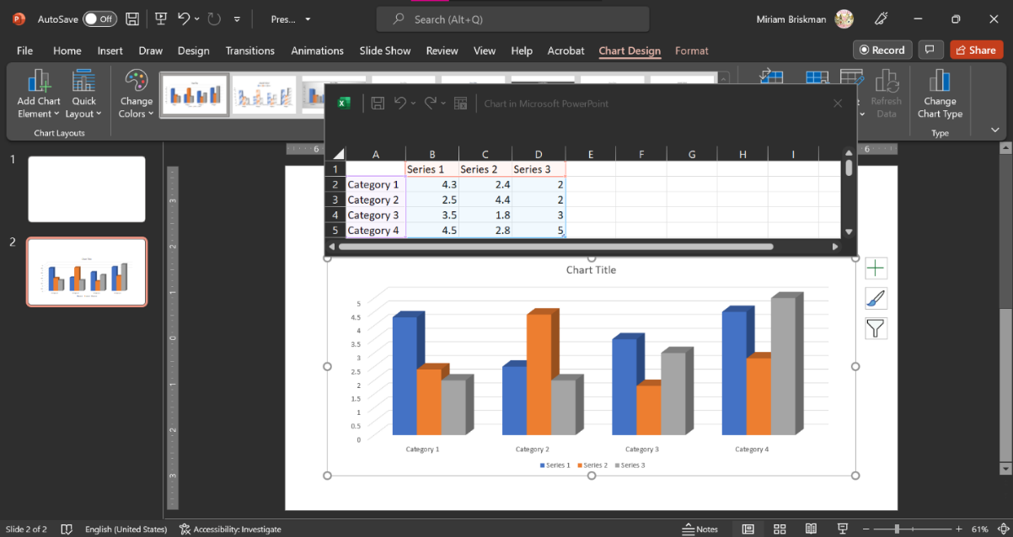
^ Above, we added the “3-D Clustered Column” chart.

Edit Data in a Chart
The added chart contains some dummy data, and your next step is to populate the chart with significant data of your own.
Note that, above the chart, a small window with of an Excel Spreadsheet appeared. This is the place where the dummy data is located. You could click inside the spreadsheet to change the data:
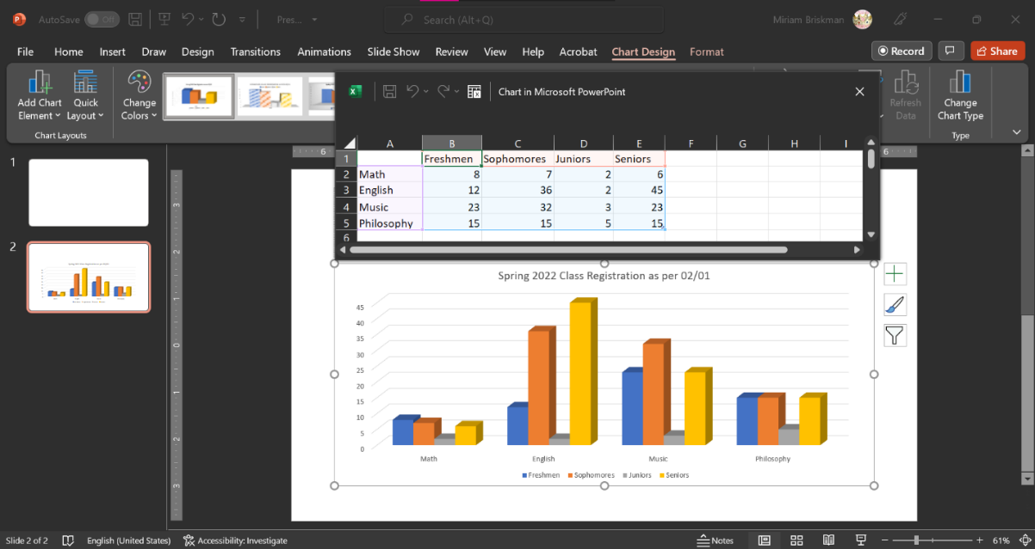
^ The spreadsheet now contains data about student registration for classes at a small college.
As you keep entering data into the chart, the chart automatically updates its columns.
Once the data was added, click the X button on the green-colored spreadsheet to close it.

Note that you can set the title of the chart. Let’s change it to “Spring 2022 Class Registration as per 02/01.”
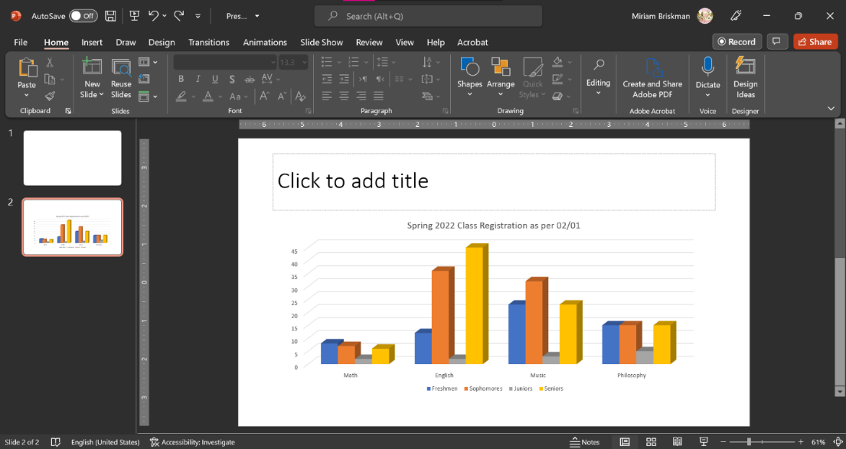

When you click on the chart, you’ll see 3 buttons that pop up on the right: these are chart elements, chart styles, and chart filters. Each of these lets you set quick various chart properties, both stylistic and structural:

For example, when we click the chart filters button (the one that looks like a funnel) and uncheck the boxes next to English, Music, and Philosophy, we will only see the data on registration for Math classes:
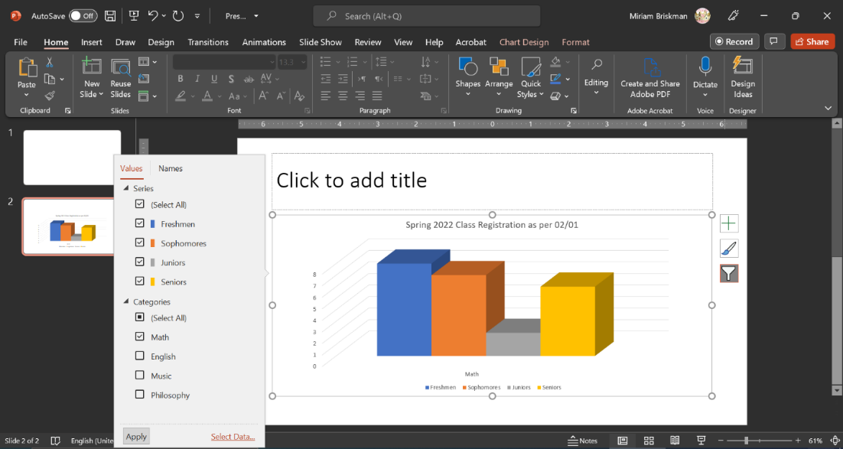
You can also find equivalent options in the Chart Design and Chart Format tabs that appear when a chart is selected.

To correct inaccurate data, or to add data, click the Chart Design tab Data group Edit Data button, which will bring up the Excel spreadsheet that let you change data. 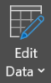

Styling a Chart
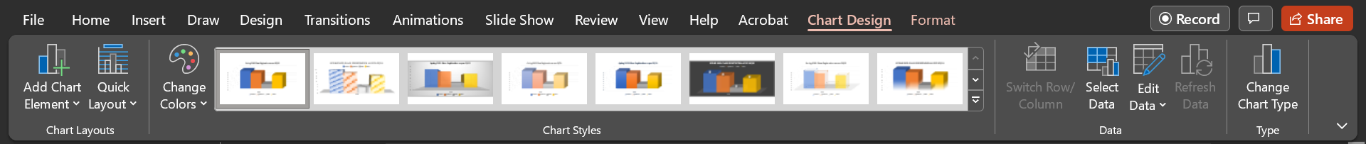
The Chart Design tab contains essential commands to change the style of your chart:
- The Add Chart Elements button 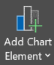 provides you with the choice of what chart elements to add or remove from the chart. Chart elements include Chart Title, Axes, Gridlines, Legend, etc. This is the equivalent button to the right-hand size chart elements button with the green plus logo .
- Next, with the help of the Quick Layout button 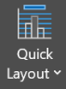, you can modify the layout of the slide, such as the position of the legend and the chart title, etc.
- You can also change the color scheme for the chart with the Change Colors button .
- The Chart Styles gallery contains some alternative chart styles to choose from.
- The Edit Data button, whom we already mentioned, will let you bring up the data in an Excel table for you to be able to make changes to the data.
- When the data are open in the Excel table, you could use the Switch Row/Column button 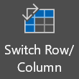 to swap the vertical and horizontal axes of the data. For example, if your table is
 | Morning | Afternoon | Evening
Weekdays | Cereal with Milk | Cheese Sandwich | Yogurt
Weekends | Toast with Veggies | Pasta with Meatballs | Pancake
clicking on the Switch Row/Column button with turn it into
 | Weekdays | Weekends
Morning | Cereal with Milk | Toast with Veggies
Afternoon | Cheese Sandwich | Pasta with Meatballs
Evening | Yogurt | Pancake
and vice versa. This change will then change the organization of this data in the chart.
- The Select Data Source dialog box will appear once clicking the Select Data button 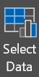. Using it, you can edit the names of exiting rows and columns or delete any unneeded row or column.
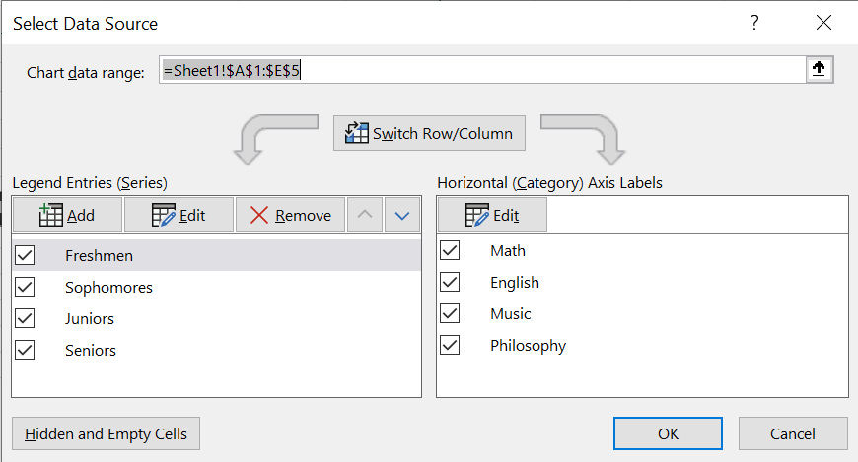
- Finally, the Change Chart Type button 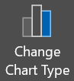 will let you change the type of the chart. For example, if your current chart is a Clustered Column chart, you could change it into a Pie chart using this option.

Formatting a Chart
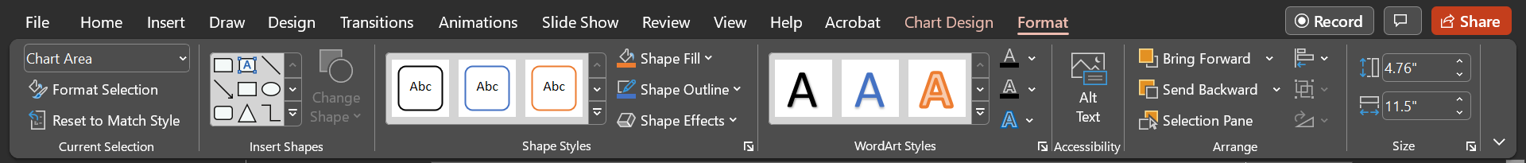
The Format tab that opens when you are working with a chart equips you with the following tools:
- The selection drop-down box in the Current Selection group lets you select (focus on) a part of the chart. “Chart Area” 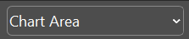 means that the outer border of the chart is clicked.
You could use it instead of clicking a part of the chart using the mouse.
- Depending on which area is currently selected, when clicking on the Format Selection  button, the Format pane (side menu) will show up on the right of the window. This pane lets you set various formatting features for that part of the chart.
- The Reset to Match Style button  discards the changes you made so far to the selected part.
- The Insert Shapes group 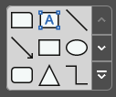 adds a shape of your choice (rectangle, circle, smiley, etc.) into the slide. However, you cannot move the shape outside the outer border of the chart.
- The Shape Styles group and its buttons let you select a pre-defined chart coloring style or set the background color, outline color, or effects (like shadow or bevel) for the selected chart part.
- If the currently selected part has text in it, you could use the button of the WordArt Styles group to set the text’s color or to add some effect to it (outline, shadow, etc.)
- To make your chart easily understandable to screen readers, which are special program that visually-disable people use to read computer files, click the Alt Text button 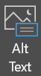 (Alt stands for ‘alternative’.) This lets you type a short textual description to the chart.
- When you need to move the chart in front of of or behind text or other objects on the slide, when you need to align the chart to a certain part of the slide (e.g., the slide’s center or the top-left corner,) you would use the buttons of the Arrange group, just as you would do for other PowerPoint objects.
- When the entire chart is selected, you can change its size (height and width) using the input boxes in the Size group 

