Lecture Notes: Word, Basic Skills

What’s Word?
Word is a full-featured word-processing application that allows you to create professional-looking documents and revise them easily. This includes flyers, research papers, letters, memos, resumes, reports, mailing labels, and newsletters. Word has many features for simplifying the design of documents.
It is very likely you will frequently interact with Microsoft Word throughout your career to create and view business reports.
To get a sense of what Word documents look like:
- Example of Word Templates (pre-prepared documents) can be found by clicking File > Home > More Templates.
- Examples of beautiful documents we can create with Word are at: https://www.smiletemplates.com/free/word-templates/0.html

Using Word

Launching (= Opening/Starting) the Word App on Your Computer
Use one of the following approaches, whichever works:
- Fastest approach: use the “search” bar/box to search for “Word”. In the search results, when you see either of the following icons (= small logos) or similar, either click or double-click on it to open Word: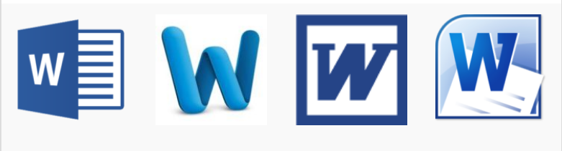
- On a Windows computer (including the CUNY Virtual Desktop,) click the Start button ( or ,) and look for either of the Word icons in the Start menu (= list of files, folders, or app icons.)
- On a Mac computer, look for either of the Word icons in the Applications folder.
- Look for a Word icon on the Desktop folder of the computer.

Opening a New Word Document
After the Word app opens on your computer, click, or double-click the Blank document option to create a new, empty Word document:
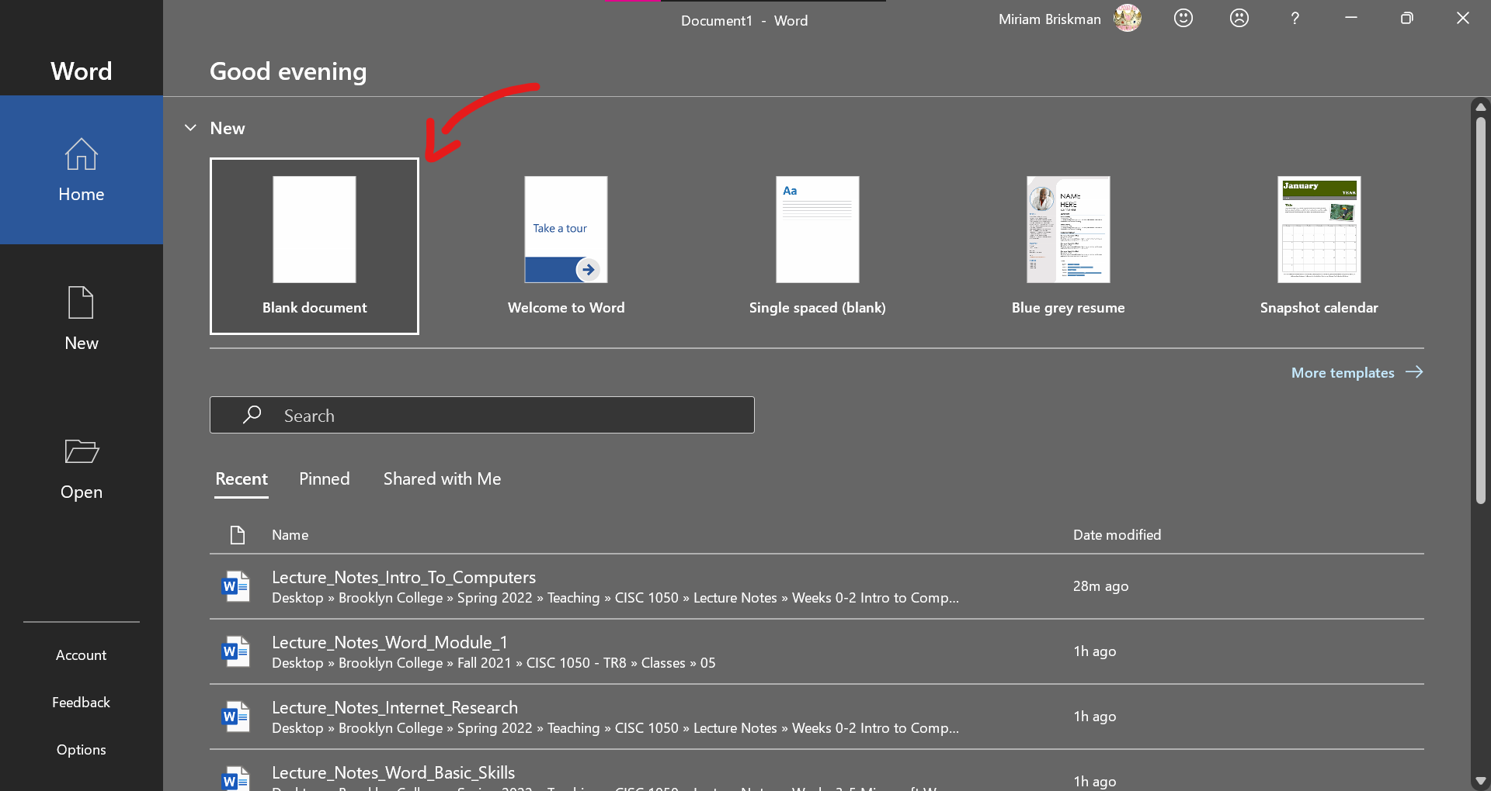
Here’s how the new document will open:
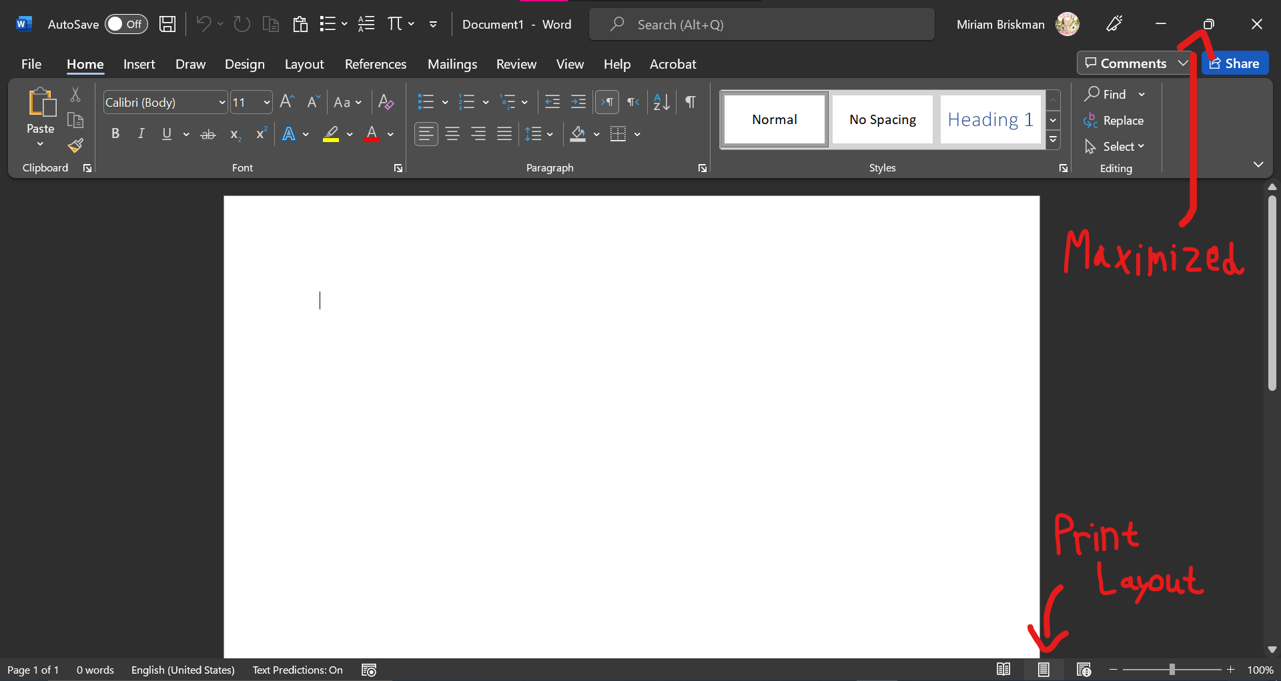
Before proceeding, make sure the window is maximized (= fully expanded on your computer’s screen,) and that the document is shown in Print Layout.

Overview of Word Controls
- Document Window
  - Insertion point, pointer (I-beam)
- Scroll Bar
  - Scroll box, scroll up/down arrows
- Status Bar
  - Current page, total # of words, spelling & grammar button, language, view options (Read Mode, Page Layout, and Web Layout), zoom-in bar and +/- buttons.
- Ribbon – the Control Center of Word
  - Tabs (Home, Insert, Draw, Design, Layout, References, Mailings, Review, View, and Help) groups of commands commands / buttons
  - Active (= currently selected) tab
  - Minimizing or collapsing the Ribbon
  - Special tool (contextual) tabs. Example: The Picture Tools Tab
  - Various items on the Ribbon: buttons, text boxes, and galleries
  - Some allow Live Preview of the design
  - Screen tips when hovering over buttons
  - Comparison: Dialog Box vs. Pane
- Tell Me Box (Word’s Search Box)
- Quick Access Toolbar
  - Always available
  - Can add/ remove commands from it
  - The touch/mouse mode button
- Mini Toolbar and Shortcut Menus
  - Selected text or right-clicking in the document
  - Purpose: to minimize # of clicks or search for commands
- Microsoft Account Area
  - You can see your account info!
Any questions so far?

Saving Word Documents
To save the document for the 1st time:
- Go to File Save As This PC,
- Type the name of the file in the name box,
- Choose the file type to be “Word Document (*.docx)” among the given choices,
- Click the folder icon  or name to choose the folder where to save the file,
- Click 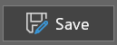 to save the file.
Alternative: Click on the  Save button on the Quick Access Toolbar and do steps 2 – 5 above.
To save an existing document, simply click the  Save button on the Quick Access Toolbar or click Ctrl + S (Mac: Cmnd + S.)

File Extensions
Since the advent of Word in 1983, it has been undergoing many updates. Two Word versions are especially important to note:
- .doc (Word 97–2003 Document)—default Microsoft Word file from Microsoft Word 2003 and older.
- .docx (Word Document)—default Microsoft Word file, works with Microsoft Word 2007 and later. Improved scripts, macros, and other features from the older .doc.
Note: “Word 97”, “Word 2003”, “Word 2007”, “Word 2013”, “Word 2016”, etc., indicate the version of the Word app on your computer.
This semester, we’ll work with .docx Word documents (create, modify, and submit as HW.)

Basic Text Formatting

Principles of Typing Text into a Word Document
- To type a letter/digit/symbol, press the key on your computer’s keyboard that corresponds to that symbol.
- Press the ENTER key (RETURN on Mac) to skip to the next line.
- Word-Wrap: Word continues longs sentences on next line automatically, so you don’t have to click ENTER when the I-beam reaches the right edge of the page.

Moving the I-Beam across the Document
You can move around the document with the keyboard!
- Left, Right, Up, and Down arrow keys
- Home and End keys
- Ctrl shortcuts (Ctrl + Home, Ctrl + Right, etc.)

Selecting and Moving Text Around
To copy, paste, cut, or apply style changes to text, you must first select it. Word lets you select text in several ways:
- To select a single line in the document:
  - Move the pointer to the extreme left of the screen, until it looks like 
  - Click once. On touchpad, tap twice to the left of the line.
- To select a whole paragraph, triple-click over it.
- To select multiple lines:
  - At the top of text, move the pointer to the extreme left of the screen, until it looks like 
  - Click, hold, and drag the pointer down until all text is highlighted.
- To select just several words:
  - Position pointer to the left of the first letter to highlight.
  - Click, hold, and drag to the right until the group of words is highlighted.
After the text was selected, you can move the text by:
- Copying it: Right-click over the selected text and choose “Copy”. Then, paste the copied text at another location inside or outside the document by right-clicking and choosing “Paste”. Alternative: Click Ctrl + C (Mac: Cmnd + C) to copy and Ctrl + V (Mac: Cmnd + V) to paste.
- Cutting it: Right-click over the selected text and choose “Cut”. Then, paste the copied text at another location inside or outside the document by right-clicking and choosing “Paste”. Alternative: Click Ctrl + X (Mac: Cmnd + X) to cut and Ctrl + V (Mac: Cmnd + V) to paste. Note: Cut will copy the text and then delete it from the original place.
- [Alternative to Cutting]: Using your mouse, drag the selected text to the desired new location. This is identical to cutting: it removes the text from the original location, and places it in the new location.

Bold, Italics, Underline, Strikethrough, and Scripts
A few extremely useful text-editing buttons are on the Home tab inside the Font group:
Button Name | Screenshot | Effect on Text | Shortcut
Bold |  | Some Text | Ctrl + B (Mac: Cmnd + B)
Italics |  | Some Text | Ctrl + I (Mac: Cmnd + I)
Underline |  | Some Text | Ctrl + U (Mac: Cmnd + U)
Strikethrough |  | Some Text | Alt H 4 (Mac: Cmnd + Shift + X)
Subscript |  | H₂O (Water molecule) | Ctrl + = (Mac: Cmnd + Shift + =)
Superscript |  | Ca⁺² (Calcium ion) | Ctrl + Shift + + (Mac: Cmnd + Shift + +)

Letter-Casing
The letter-casing (also known as Change Case) button, 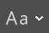, allows you to change a selected text to any of the following available casing types:
Casing Type | Effect on Text | What happened
Sentence Case | Here is some text. | The 1st letter of 1st word in the sentence was capitalized.
Lowercase | here is some text. | All the letters became lowercase.
Uppercase | HERE IS SOME TEXT. | All the letters became uppercase.
Capitalize Each Word | Here Is Some Text. | The 1st letter of each word was capitalized.
Toggle Case | hERE iS sOME tEXT. | Uppercase letters become lowercase, and vice versa.

Font, Font Size, and Font Color
You can find the font settings on the Home tab > Font group:
Format = process of changing the appearance of text and objects.
- Paragraph formatting = changing the way paragraphs look
- Character formatting = changing the way characters (letters or symbols) look
Font = the special shape of text. How the button looks: 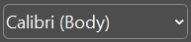
- Consider this, this, this, this, and this.
Font size = the size of the text. How the buttons look: 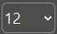, (smaller), (larger font)
- Consider this (9 pts), this (12 pts), and this (18 pts).
- Points (also pts or pt) is the measurement unit of font sizes: about 1/72 inch in height.
Font color = the color in which the text is displayed. How the button looks: 
- Consider this, this, this, this, and this.
Style or Theme = a pre-prepared collection of character and paragraph formatting features.
Example: The font used in these Lecture Notes is Calibri of font size 12 and black color.
To select a particular font, font size, or font color, click on the arrow next to the corresponding button (), and select the option you need.

Font Types
- Serif fonts = contain decorative spikes. Examples: this, this, and this.
- Sans Serif fonts = no such spikes. Examples: this, this, and this.
- Monotone fonts = typesetting machine / robotic look. Examples: this.
Sans Serif fonts are easier to read on screens; serif fonts are easier to read on print text.
Monotone fonts are used in computer programming for simplicity and easier alignment.

Paragraph Formatting
The Paragraph group on the Home tab contains formatting options for paragraphs.
The Align Left button () aligns text to the left edge of the document window:
Lorem ipsum dolor sit amet, consectetur adipiscing elit. Proin vitae molestie metus. Cras rhoncus venenatis mauris ultricies tincidunt. In tristique, erat sit amet laoreet condimentum, est enim auctor enim, eget accumsan arcu sem sed nisi. Vestibulum sit amet vehicula neque. Mauris nec cursus ante, a aliquet lectus. Cras imperdiet vitae lorem eget facilisis. Duis sagittis dignissim suscipit. Praesent non malesuada nulla. Nulla mattis eu leo nec posuere. Sed a purus sit amet odio mollis vehicula in id massa.
The Center button () centers the text on the document window:
Lorem ipsum dolor sit amet, consectetur adipiscing elit. Proin vitae molestie metus. Cras rhoncus venenatis mauris ultricies tincidunt. In tristique, erat sit amet laoreet condimentum, est enim auctor enim, eget accumsan arcu sem sed nisi. Vestibulum sit amet vehicula neque. Mauris nec cursus ante, a aliquet lectus. Cras imperdiet vitae lorem eget facilisis. Duis sagittis dignissim suscipit. Praesent non malesuada nulla. Nulla mattis eu leo nec posuere. Sed a purus sit amet odio mollis vehicula in id massa.
The Align Right button () aligns text to the right edge of the document window:
Lorem ipsum dolor sit amet, consectetur adipiscing elit. Proin vitae molestie metus. Cras rhoncus venenatis mauris ultricies tincidunt. In tristique, erat sit amet laoreet condimentum, est enim auctor enim, eget accumsan arcu sem sed nisi. Vestibulum sit amet vehicula neque. Mauris nec cursus ante, a aliquet lectus. Cras imperdiet vitae lorem eget facilisis. Duis sagittis dignissim suscipit. Praesent non malesuada nulla. Nulla mattis eu leo nec posuere. Sed a purus sit amet odio mollis vehicula in id massa.
The Justify button () distributes the text evenly between the margins of the document:
Lorem ipsum dolor sit amet, consectetur adipiscing elit. Proin vitae molestie metus. Cras rhoncus venenatis mauris ultricies tincidunt. In tristique, erat sit amet laoreet condimentum, est enim auctor enim, eget accumsan arcu sem sed nisi. Vestibulum sit amet vehicula neque. Mauris nec cursus ante, a aliquet lectus. Cras imperdiet vitae lorem eget facilisis. Duis sagittis dignissim suscipit. Praesent non malesuada nulla. Nulla mattis eu leo nec posuere. Sed a purus sit amet odio mollis vehicula in id massa.
The Line and Paragraph Spacing button () sets Line Spacing (Single (1.0), Double (2.0), etc.):
Lorem ipsum dolor sit amet, consectetur adipiscing elit. Proin vitae molestie metus. Cras rhoncus venenatis mauris ultricies tincidunt. In tristique, erat sit amet laoreet condimentum, est enim auctor enim, eget accumsan arcu sem sed nisi. Vestibulum sit amet. (Single 1.0)

Lorem ipsum dolor sit amet, consectetur adipiscing elit. Proin vitae molestie metus. Cras rhoncus venenatis mauris ultricies tincidunt. In tristique, erat sit amet laoreet condimentum, est enim auctor enim, eget accumsan arcu sem sed nisi. Vestibulum sit amet. (Double 2.0)
The Shading button () adds a background color behind the selected paragraph:
Lorem ipsum dolor sit amet, consectetur adipiscing elit. Proin vitae molestie metus. Cras rhoncus venenatis mauris ultricies tincidunt. In tristique, erat sit amet laoreet condimentum, est enim auctor enim, eget accumsan arcu sem sed nisi. Vestibulum sit amet. (Bright orange)
The Paragraph Settings button () allows changing Paragraph Spacing and Indentation by opening the “Paragraph Settings” dialog box.
Lorem ipsum dolor sit amet, consectetur adipiscing elit. (0 pts Before; 0 pts After)
Proin vitae molestie metus. (0 pts Before; 30 pts After)
Cras rhoncus venenatis mauris ultricies tincidunt. (0 pts Before; 8 pts After)
In tristique, erat sit amet laoreet condimentum, est enim auctor enim, eget accumsan arcu sem sed nisi. (0 pts Before; 0 pts After)
To change paragraph spacing, click inside the paragraph, open the dialog box, and look up the “Spacing” section. Then:
- To add spacing above the paragraph, enter the number of points of space to add inside the “Before:” box.
- To add spacing below the paragraph, enter the number of points of space to add inside the “After:” box.
Another way to change paragraph spacing is by using the Layout tab’s Spacing input boxes.
[Note: the difference between line spacing and paragraph spacing is that line spacing creates a space within a paragraph’s lines, while paragraph spacing sets spaces before or after paragraphs. When being asked to change paragraph spacing, don’t confuse it with line spacing.]
The Paragraph Settings dialog box also lets you set indentation in the paragraph. First and look up for the “Indentation” section inside the dialog box. Then:
- To set up First-Line indentation, choose “First line” in the “Special” box, and indicate the size of the indentation in the “By” box.
- To set up Hanging indentation, choose “Hanging” in the “Special” box, and indicate the size of the indentation in the “By” box.
In the following example, we indented the paragraph with First-Line indentation of 0.5 inches:
Lorem ipsum dolor sit amet, consectetur adipiscing elit. Proin vitae molestie metus. Cras rhoncus venenatis mauris ultricies tincidunt. In tristique, erat sit amet laoreet condimentum, est enim auctor enim, eget accumsan arcu sem sed nisi. Vestibulum sit amet. (0.5’’ First-Line Indentation)
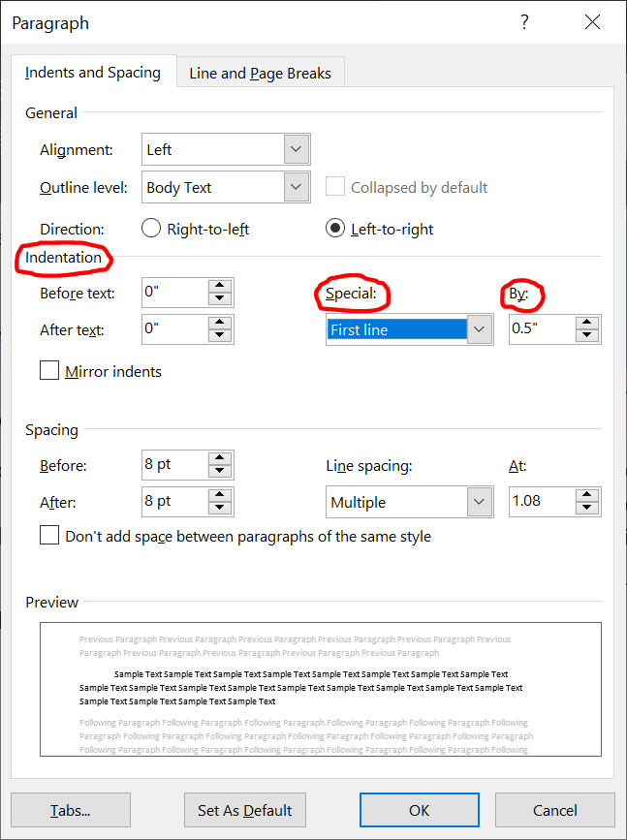
Let’s continue with the review of the Paragraph group on the Home tab.
The Bullets button () changes paragraphs into a bulleted list:
- One
- Two
- Three
The Numbering button () changes paragraphs into a numbered list:
- One
- Two
- Three
The arrows next to the Bullets and Numbering buttons, , allow you to choose the bullet styles (full bullet, hallow bullet, square, harpoon arrow, checkmark, etc.) or numbering styles (Arabic numbers, Greek letters, English letters, etc.)
The Increase Indent and Decrease Indent buttons ( and ) change the levels of list items:
- Color Types (Level 1 paragraph/ list item)
  - Red (Level 2)
    - Rose (Level 3)
    - Cherry
    - Wine
  - Green
    - Olive
    - Forest
    - Jade
- Shirt Types (Level 1)
  - T-shirt (Level 2)
  - Blouse
  - Smoke
  - Sweater

Finding, Replacing, and Proof-Reading Text

Find and Replace
Word lets you search for text in your document (instead of you spending hours finding it in a 1000-page document for example.)
To find text, go to the Home tab > Editing group > Find button .
This will open the Navigation Pane on the left side of the screen:
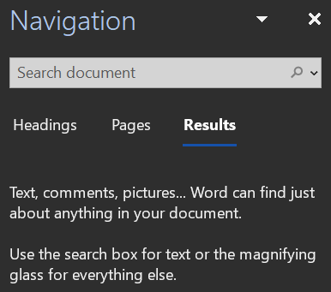
Click in the search box and type the text you are looking for to let Word find all the instances of that text in the document!
You can also replace text with other text. Click Home tab > Editing group > Replace 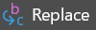button to open the Find and Replace dialog box:
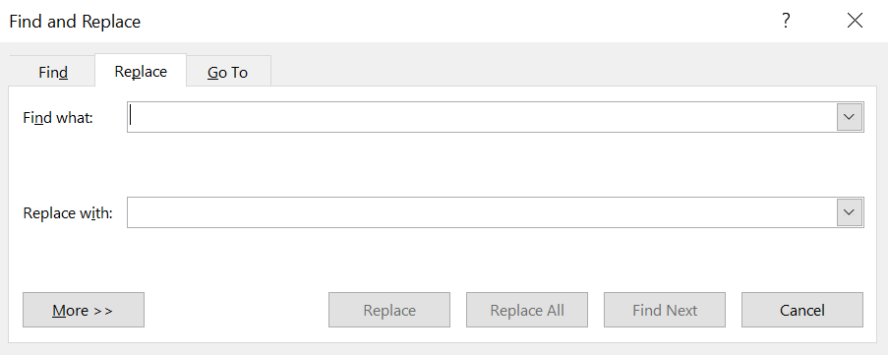
To replace text:
- Type the text you want to replace in the “Find what:” box,
- Type the new text in the “Replace with:” box,
- Click on “Replace” to make a single replacement of the next instance of text that Word finds,
- Alternatively, click “Replace All” to replace all the instances with the new text.
- After you finish all the replacements, click “Cancel” or close the dialog box.

Proof-Reading
Before you send, submit, or post a document, make sure no spelling or grammar errors persist in your document.
Click the Review tab Editor button (it might be called Spelling in some editions of Word,) and perform all the necessary corrections to remove the errors.
Alternatively, if you see a colorful underline under a word or phrase in the document, right-click it, and select the correct spelling/grammar fix.

