Lecture Notes: Word, Intermediate Skills

Page Layout

Tab Stops
When you click the Tab key 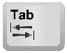 on the keyboard, a relatively large space character called Tab character is inserted into the document.
Example of the Tab character with some background color (it is transparent otherwise:)
A Tab character.
The default width (or size) of this character is 0.5’’ (inches), but we can customize this size by adding tab stops. They allow us to change the location and alignment of text in the document!

A tab stop is a style setting that tells where the I-beam stops after a Tab character was entered, thereby defining the size of the Tab character, and telling where the position of the text that follows the character is.
To add a tab stop:
- Show the Ruler (View tab Check the “Ruler” checkbox):
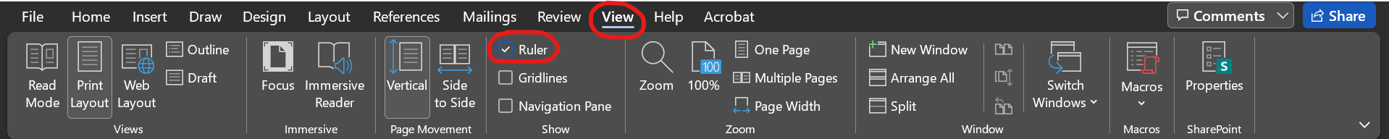
- On the horizontal ruler that appeared right below the Ribbon, choose which tab stop to add by repeatedly clicking on the tab stop type button:
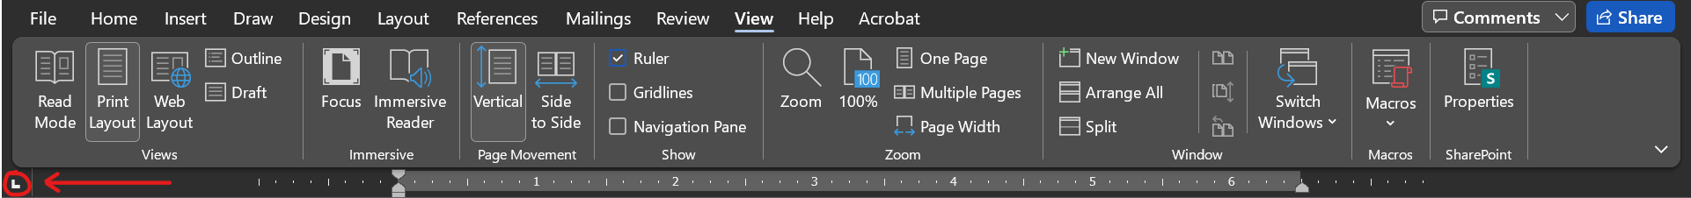
The available tab stops are: Left tab stop , Center tab stop , Right tab stop , Decimal tab stop , and Bar tab stop .
- Finally, click on the Ruler to add the tab stop at the place where you want it to be placed. In the example below, we added a right tab stop at 5.44 inches:
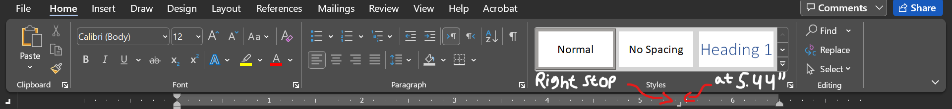
Examples: (Background colors show how far on the Ruler tab stops were added.)

Left tab stops make the Tab character precede the text typed afterwards:
Text followed by a 0.5’’ left tab stop
Text followed by a 1’’ left tab stop
Text followed by a 2’’ left tab stop
Text followed by a 3’’ left tab stop

Right tab stops right-align the text at the end of the Tab character:
Text followed by a 6.5’’ right tab stop
Text followed by a 5’’ right tab stop
Text followed by a 4’’ right tab stop
Text followed by a 3’’ right tab stop

Center tab stops center the text followed by a Tab around the right end of the Tab:
Text followed by a 1.5’’ center tab stop
Text followed by a 2’’ center tab stop
Text followed by a 4’’ center tab stop
Text followed by a 4.5’’ center tab stop
Text followed by a 3’’ center tab stop

Bar tab stops don’t align text but add a vertical bar at the indicated inch. This is done for style:
A bar at 1’’:
A bar at 2’’:
A bar at 5’’:

Decimal tab stops align numbers at decimal points. Examples of decimal tab stops at 5.5’’:
2 x Shirt $ 2.65
1000 + 3.14159265359 1003.14159265359
To remove a tab stop, click, hold, and drag it upwards or downward, and then release the mouse button to make the tab stop disappear.
To move a tab stop over to another place on the Ruler, click hold and drag it to the left or right.
Drag around the right tab stop on this line!
You can add multiple tab stops on the same line! Subsequent clicks of the Tab key will activate them.
Left tab stop at 1’’ Right tab stop at 4.5’’ Bar tab stop at 6’’

In addition to using the Ruler, you can also use the Tabs Dialog Box, which you can open by clicking on Home Tab Paragraph group to open the Paragraph Settings dialog box, and then click on 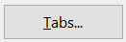 at the bottom-left of the box to open the Tabs Dialog Box.
Alternatively, double-click any tab stop on the Ruler to open the Tabs Dialog Box.
The Tabs Dialog Box allows you to:
- Update the type and inch position of tab stops on the line, and
- Choose which Leader to add. The Leader is the symbol pattern that will replace the transparent tab. Example:
Chapter 1 pp. 12
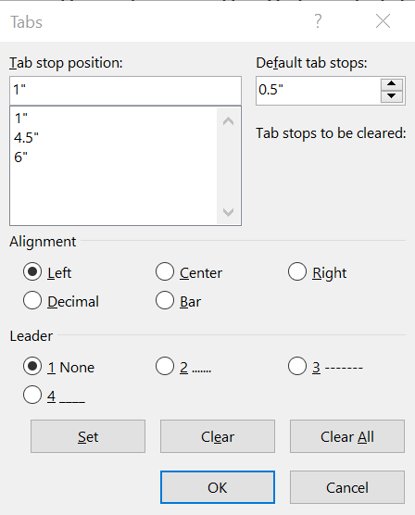

Columns
The text in all the documents we saw so far is organized in one column, but we can change to it 2, 3, or more columns!
To change the number of columns:
- Select the text you wish to divide into column,
- Click the Layout tab Page Setup group Column button, and
- Choose the number of columns.
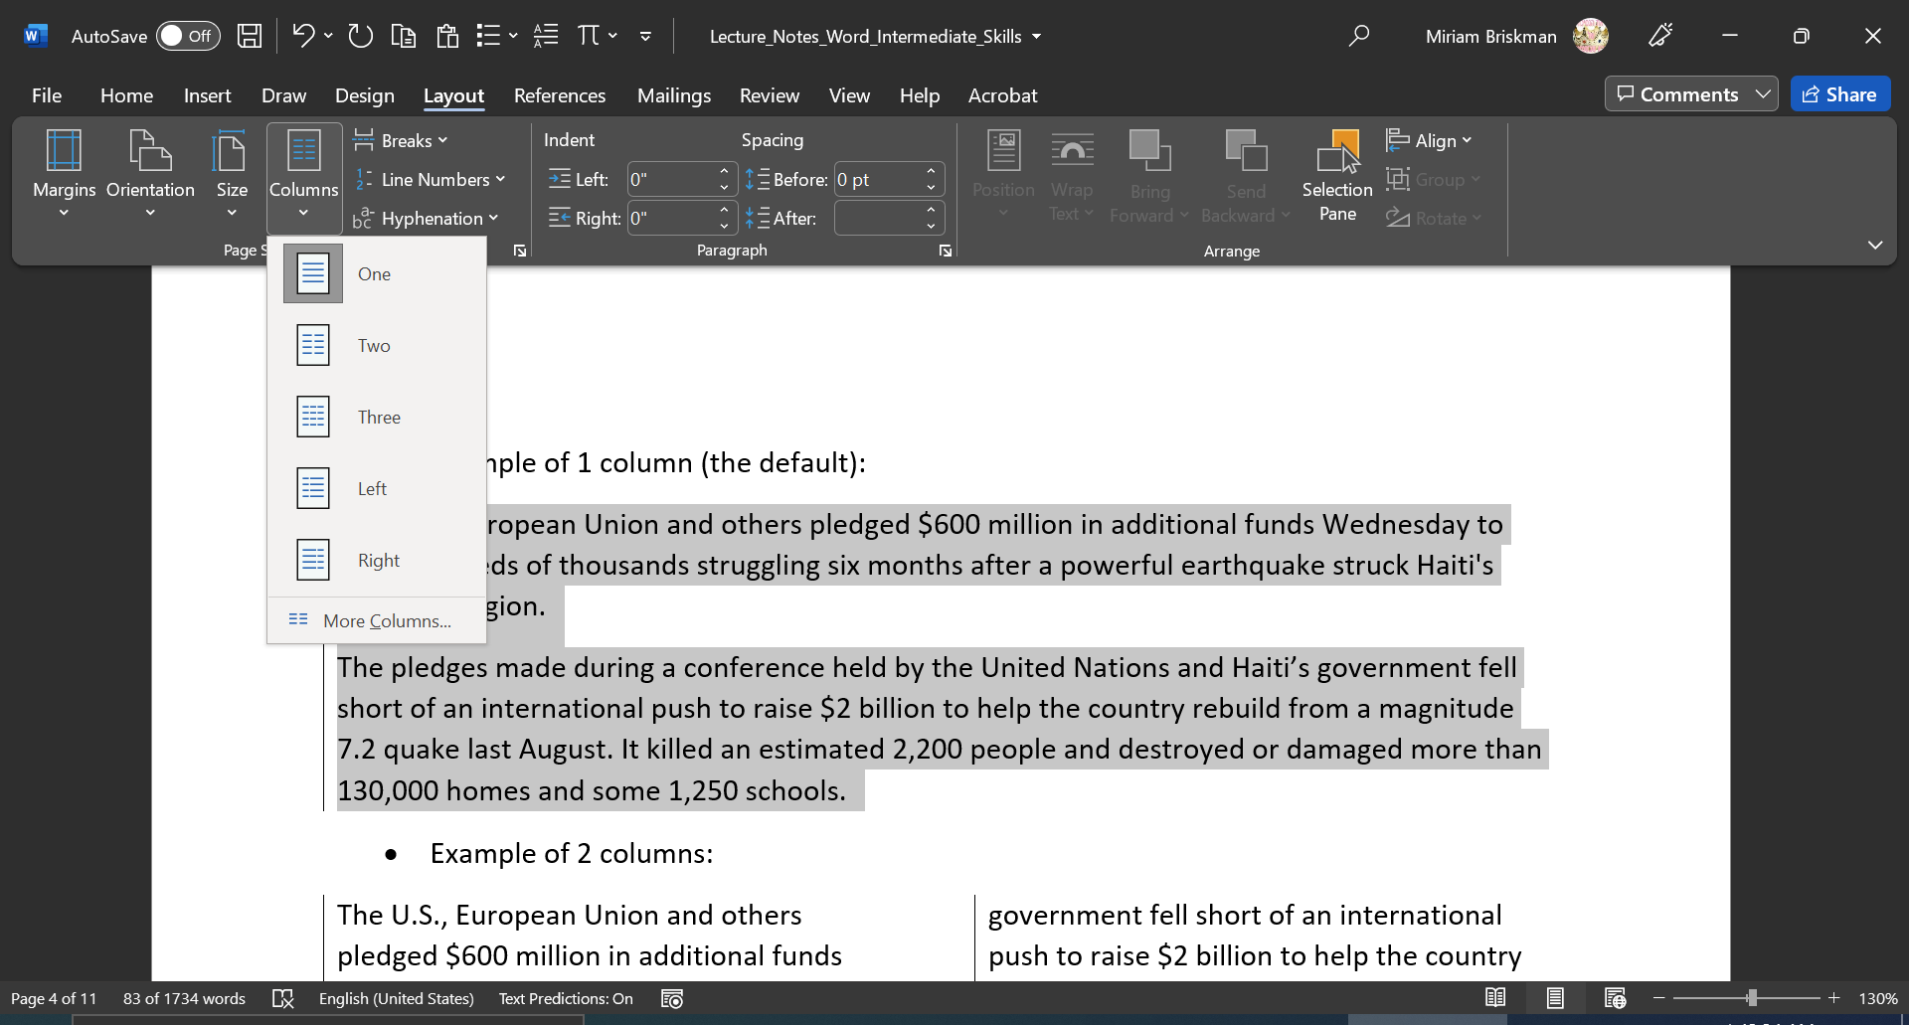
Example of 1 column (the default):
The U.S., European Union and others pledged $600 million in additional funds Wednesday to help hundreds of thousands struggling six months after a powerful earthquake struck Haiti's southern region.
The pledges made during a conference held by the United Nations and Haiti’s government fell short of an international push to raise $2 billion to help the country rebuild from a magnitude 7.2 quake last August. It killed an estimated 2,200 people and destroyed or damaged more than 130,000 homes and some 1,250 schools.
- Example of 2 columns:

The U.S., European Union and others pledged $600 million in additional funds Wednesday to help hundreds of thousands struggling six months after a powerful earthquake struck Haiti's southern region.
The pledges made during a conference held by the United Nations and Haiti’s government fell short of an international push to raise $2 billion to help the country rebuild from a magnitude 7.2 quake last August. It killed an estimated 2,200 people and destroyed or damaged more than 130,000 homes and some 1,250 schools.

- Example of 3 columns:

The U.S., European Union and others pledged $600 million in additional funds Wednesday to help hundreds of thousands struggling six months after a powerful earthquake struck Haiti's southern region.
The pledges made during a conference held by the United Nations and Haiti’s government fell short of an international push to raise $2 billion to help the country rebuild from a magnitude 7.2 quake last August. It killed an estimated 2,200 people and destroyed or damaged more than 130,000 homes and some 1,250 schools.

[The left borders above were added separately for demonstration; they are not added with the change of columns.]
Want some text to shift to the next column? Add a column break by clicking in the text where you want the break to be, and then clicking Layout tab Breaks button Column break.
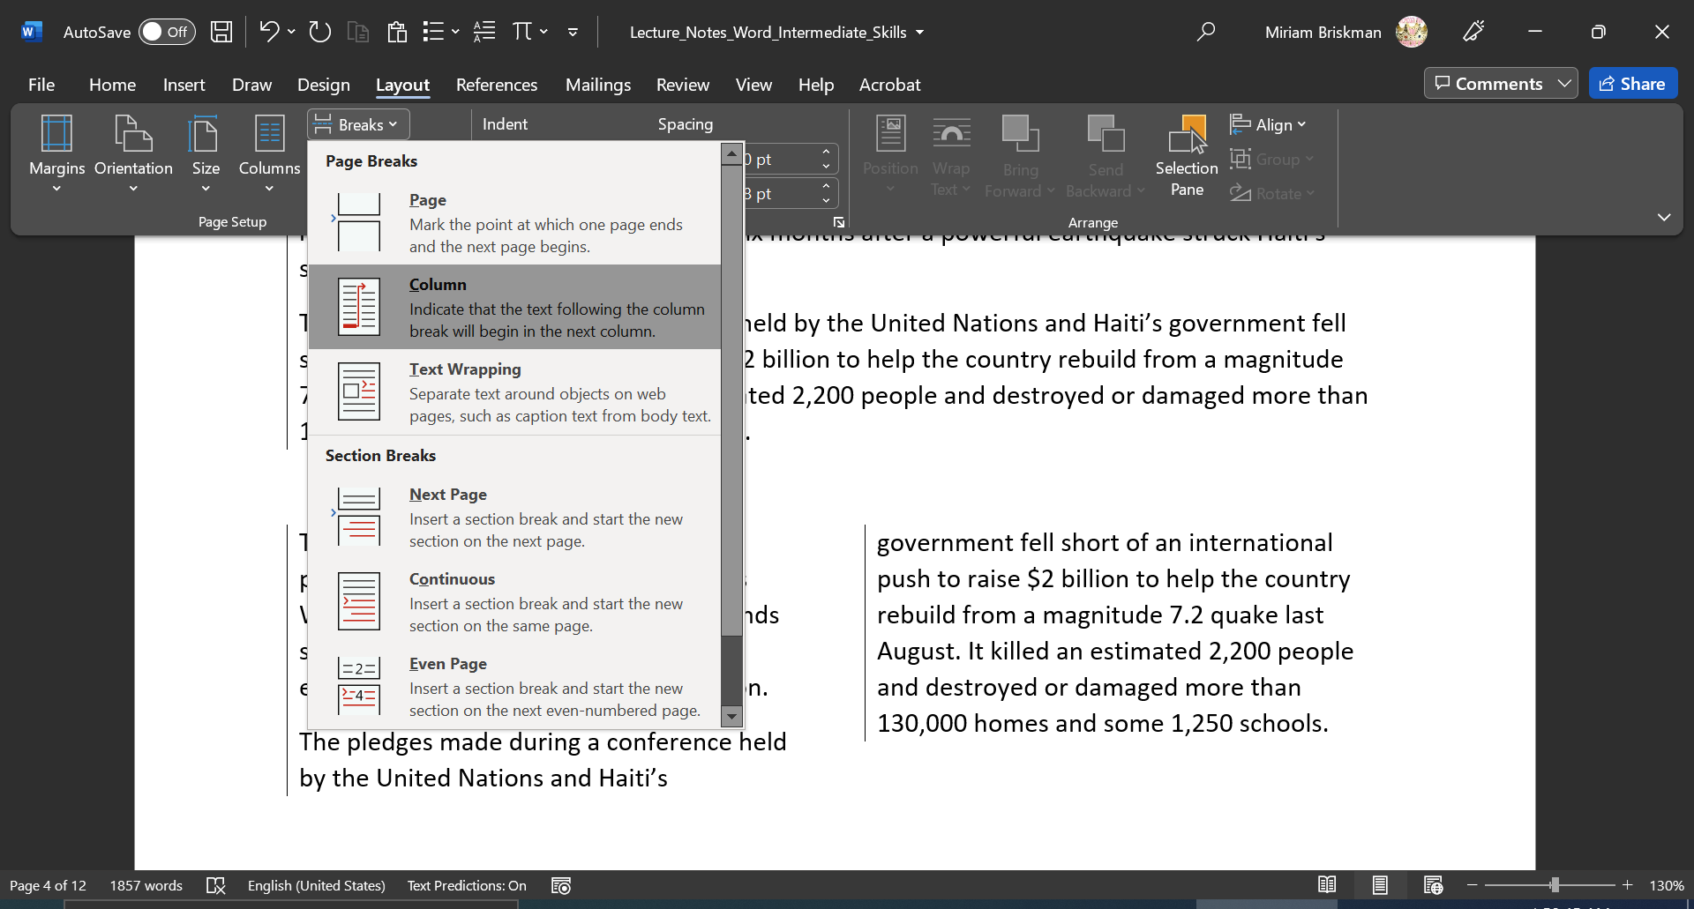
Here is an example of placing a column break:

The U.S., European Union and others pledged $600 million in additional funds Wednesday to help hundreds of thousands struggling six months after [A column break was added right here ]
a powerful earthquake struck Haiti's southern region.
The pledges made during a conference held by the United Nations and Haiti’s government fell short of an international push to raise $2 billion to help the country rebuild from a magnitude 7.2 quake last August. It killed an estimated 2,200 people and destroyed or damaged more than 130,000 homes and some 1,250 schools.

Columns are typically used for shorter pieces of text like dictionary or encyclopedia entries and short stories.

Header, Footer, and Page Numbers
Every page in a Word document has blank areas at the top, bottom, left, and right called margins.
The default margin size across a page (top, bottom, left, and right margins) is 1 inch.
The header of a Word page is located inside the top margin, and the footer is located inside the bottom margin.
One can add text, images, tables, and other elements into both header and footer section. Most added elements will remain fixed (unchanged from page to page.)
To open either the header or footer sections, either double-click it, or click on the Insert tab Header & Footer group Header or Footer button Choose either “Edit Header” or “Blank”.
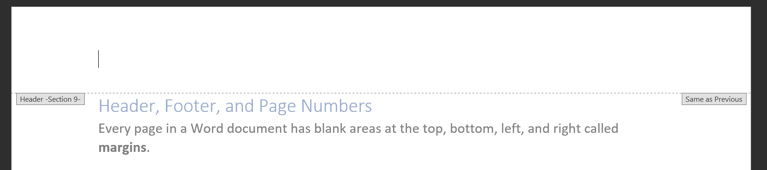
…
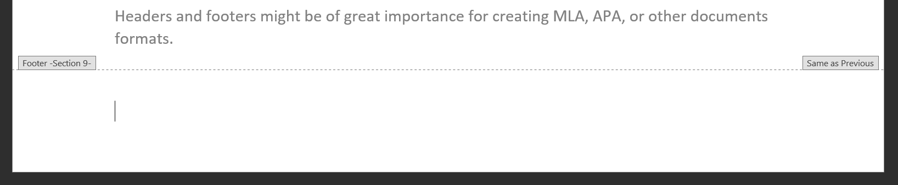
Headers and footers might be of great importance for creating MLA, APA, or other document formats.

You can also add a page number to every page in the document that Word would update automatically on each page.
To add a page number to the header or footer:
- Open the Insert,
- Click on the Page Number button, and
- Choose where to place the page number (Top of Page, Bottom of Page, etc.,)
- Choose one of the styles/positions of the page number by clicking on it.
Example: The MLA document format requires that you write and right-align your last name and the current page number in the header of each page. To do so:
- Open the header section,
- Click on Home tab Align Right button to align all the text to the right edge,
- Type your last name (this will stay fixed across all the document’s pages,)
- Click the Insert tab Page Number Current Position Plain Number (the added page number will vary across the pages to show the current number of each page.)
- Close the header section.
After adding the page number once, there’s no need to update it: Word will update it automatically per each page. E.g., the current page is #7, so the page number will show 7.
In these very lecture notes, you can look into the header to see that we typed “Smith” and added the varying page number:
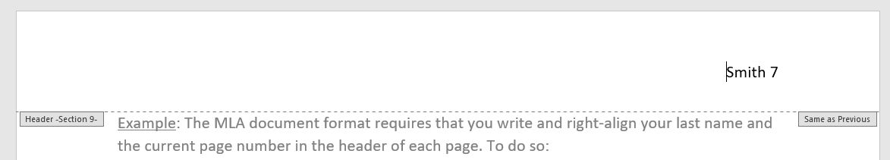

Text Boxes
So far, we have been adding, formatting, and styling text. Word has much more to offer!
A text box, as the name suggest, is a movable box featuring text (and not only.)
Text boxes belong to a group of elements we call objects, which are any non-textual items you can add to Word or other Office apps.
Before we proceed, let’s see a YouTube video about the Insert tab and the various objects that you can add into your Word document using it: https://www.youtube.com/watch?v=VQVR7bmuDo8.
To add a simple, empty text box, click inside the document where you want it to be added, and then click the Insert tab Text Box button Simple Text box:
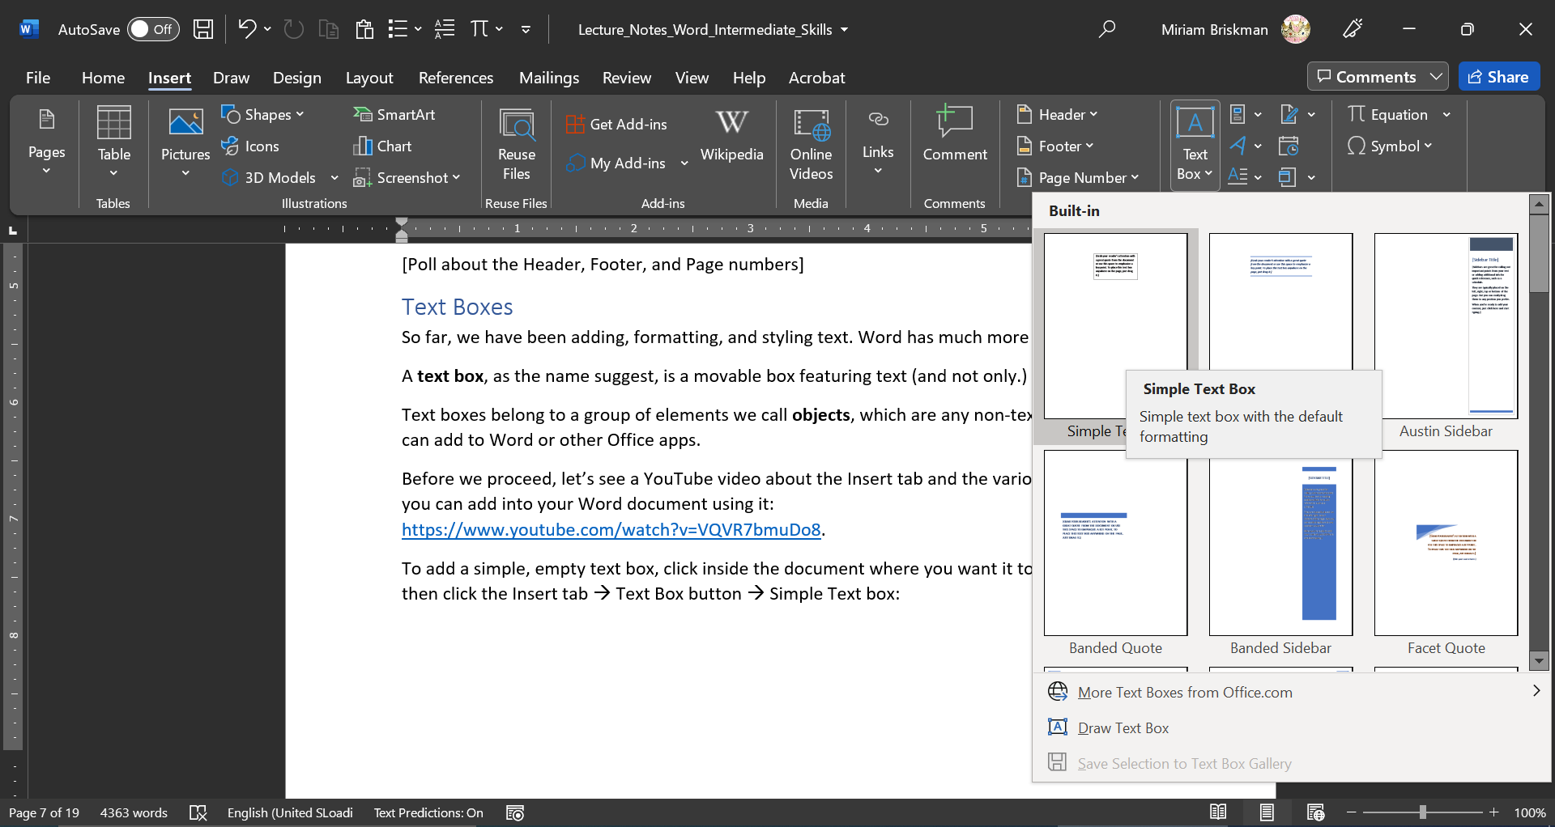
Here is such a simple text box:
[Grab your reader’s attention with a great quote from the document or use this space to emphasize a key point. To place this text box anywhere on the page, just drag it.]
The placeholder text that came inside it can be replaced with text you type, like:
When you click inside the text box or on its borders, you will note that the contextual “Drawing Tools: Shape Format” tab appeared on the Ribbon:
I love pizza!
Or:
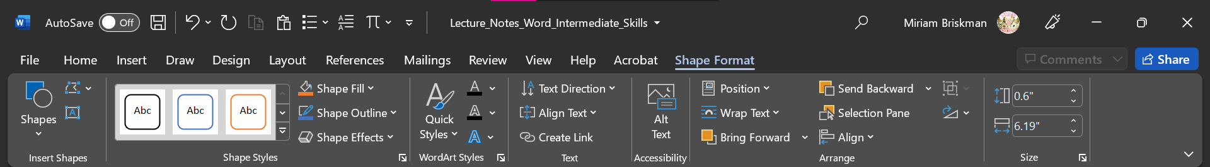
Use the functionalities on this tab to change the style, shape, and position of the text box!

Here is an example of a styled text box:
To make this heart text box, we used the “Shape Format” tab by:
This is a text box!
- Editing the shape of the box to this of a heart,
- Changing the Shape Fill color to red,
- Changing its size to 1.56’’ high and 1.62’’ wide, and
- Aligned the text box to the center of the page.
Some more features
Yet another text box is to the right, which we modified from a simple one by:
- Changing its style to “Intense Effect – Orange, Accent 2”,
- Increasing the size of the text inside to 24 pts (Home tab,)
- Choosing the Text Direction to be “Rotate all text 90°”,
- Aligning the text inside the box to the right direction,
- Centering the text (Home tab,)
- Changing the size of the box to 2 inches high by 3 inches wide,
- Sending the text box backward, behind text (so that text is displayed on its top,) and
- Aligned the box to the right edge of the document.

Some Text Box How-To’s
To move a text box with the mouse over to another place in the document, click on any of the borders of the text box, and drag it to the desired location.
To delete a text box, right-click over its border, and choose “Cut”. Alternatively, click on the border and press the DELETE key.
To rotate a text box (change the angle at which it is displayed,) click on and hold the Rotation arrow , and move the mouse to either left or right to see how the box begins rotating. When the desired rotation is reached, release the mouse button.
Finally, to resize a text box, you can either use the “Height” and “Width” input boxes on the “Shape Format” tab, or drag the sizing handles: 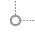, , etc., toward the center of the text box (to reduce its size) or away from the center (to increase its size).

Inserting Shapes
Besides text boxes, you can also insert text-less shapes into the document! This is another kind of a non-textual object.
To insert a shape, click the Insert tab Illustrations group Shapes button Click on the shape you want to insert.
Examples:

The same “Shape Format” tab can be used to style shapes, just as you did with text boxes!

Tables
A table is another type of an object shaped as a rectangular grid of cells. You can populate each cell with text, text boxes, images, charts, symbols & icons, math equations, and even tables! The following table exemplifies this:
This is some text! | A table:  Bla Blu Blup  Foo Bar Boo  Gee Wow Wow | A picture:
An icon: |  | This is a text box!
® | $$a^{2}+b^{2}=c^{2}$$ | π

In the scope of our class, most tables will usually feature text and data.

Table’s Dimensions
A table consists of rows and columns, which make up the cells.
To denote the size of a table, we use the following notation: C x R. The letter C stands for “columns”, while the letter R stands for “rows”.

Examples:
- A 2 x 3 (read as “2 by 3”) table has 2 columns, 3 rows, and therefore 2 x 3 = 6 cells.
- A 6 x 4 table has 6 columns, 4 rows, and therefore 6 x 4 = 24 cells.
- The example table above is 3 x 3, so it has a total of 9 cells.

Insert a New Table
You can insert a new, empty table into a Word document in one of several ways:
- Click the Insert tab Tables group Table button Click anywhere on the rectangular grid to select to enter a table of the desired size.
- Click the Insert tab Tables group Table button “Insert Table…” option Inside the “Insert Table” dialog box, choose the number of rows and columns for the table to contain, and click OK to create that table.
- We’ll view a few more ways when we review the PowerPoint application.

Selection, Insertion and Deletion of a Row/Column
You can select all the cells in a row or column of a table by either of:
- Clicking on the leftmost (or topmost) cell and dragging to the right (or down) to the rightmost (or bottommost) cell you wish to select.
- [In the case of selecting a row] Moving the mouse to the left margin of the document next to the row you wish to select, until the cursor turns into , and then clicking once to select the entire row.
- [In the case of selecting a column] Moving the mouse right above the column you wish to delete so that the cursor turns into , and then clicking once to select the entire column.

Suppose you created a 4 x 5 table:
Column 1 | Column 2 | Column 3 | Column 4
and it turns out you need to insert a column between Column 2 and Column 3. You can do so by either of:
- Right-clicking anywhere inside Column 2 Selecting “Insert” Selecting “Insert Columns to the Right.”
- Right-clicking anywhere inside Column 2 Clicking the “Table Layout” tab “Rows & Columns” group Selecting “Insert Right.”
- Right-clicking anywhere inside Column 3 Selecting “Insert” Selecting “Insert Columns to the Left.”
- Right-clicking anywhere inside Column 3 Clicking the “Table Layout” tab “Rows & Columns” group Selecting “Insert Left.”
A similar action can be done for rows (but you would instead select “Insert Below” or “Insert Above”.)
We then get the following updated table:
Column 1 | Column 2 |  | Column 3 | Column 4
In general, the “Insert” option in the right-click menu of a table has the following options:
- Insert Columns to the Left
- Insert Columns to the Right
- Insert Rows Above
- Insert Rows Below
- Insert Cells…
The “Insert Cells” options lets you insert one cell instead of a whole row or column.
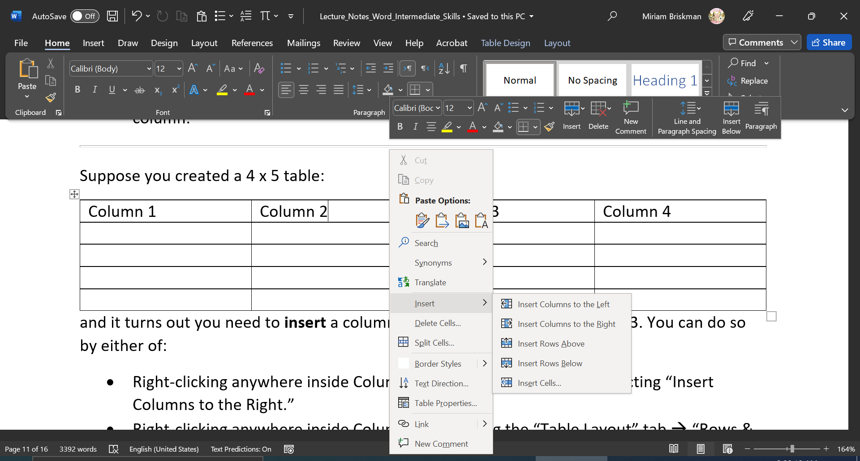

The right-click menu’s Mini Toolbar and the “Table Layout” tab also let you erase (or delete) a column, row, or cells that you don’t need any more in the table. The following options are available in the right-click menu’s Mini Toolbar “Delete” option:
- Delete Cells…
- Delete Columns
- Delete Rows
- Delete Table
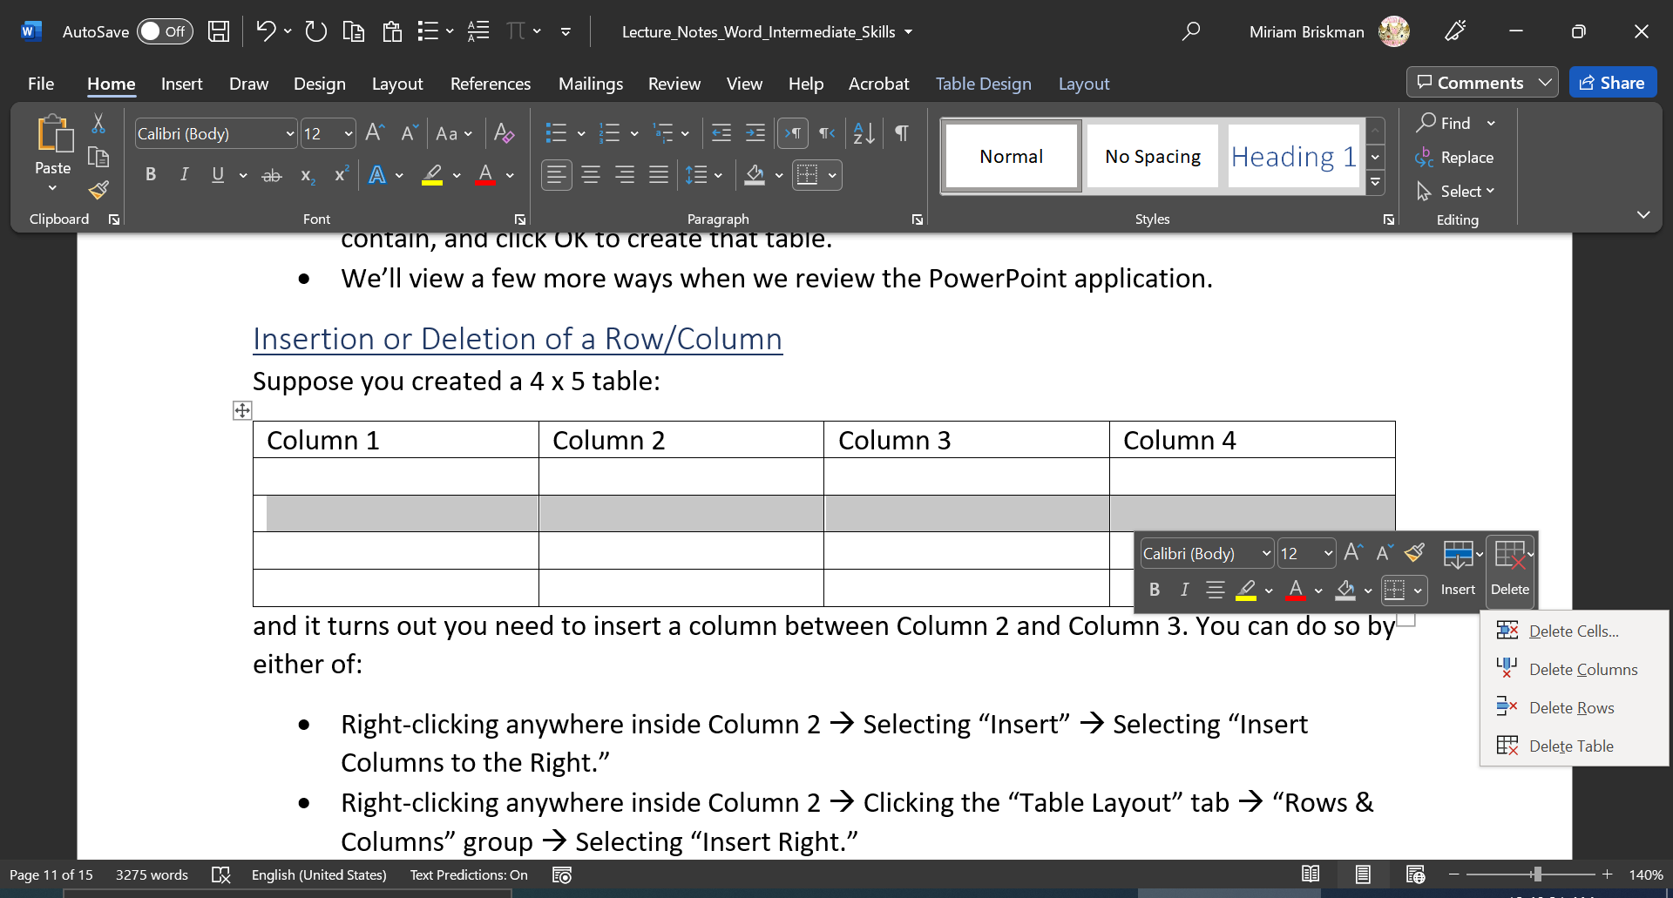

Converting Text to a Table
Suppose you have some data separated by Tab characters, Commas, or some other characters:
Name Date of Birth Street City State Zip Code Phone
Dana 01/01/1992 Fog Brooklyn NY 11112 (616) 658-9545
Ron 01/06/1996 Dog Newark NJ 07102 (973) 746-1619
Let’s turn this into a table! Do the following:
- Select the entire text that should go into the table (including the column headers.)
- Click the Insert tab Tables group Table button Select “Convert Text to Table…”
- In the dialog box that opens, make sure the separator is “Tabs”, and click OK.
Name | Date of Birth | Street | City | State | Zip Code | Phone
Dana | 01/01/1992 | Fog | Brooklyn | NY | 11112 | (616) 658-9545
Ron | 01/06/1996 | Dog | Newark | NJ | 07102 | (973) 746-1619

Formatting Tables
As with simple text and text boxes, you can also change the style of a table as you see right!
Word provides about 50 pre-defined table styles to choose from. These styles will change the colors, borders, background colors, and header styles with just a single click. These formatting changes won’t, of course, modify the content of the table.
To select one such style, click anywhere inside the table Click the “Table Tools: Design Tab” Click the “More” button of the Table Styles group to reveal the entire styles gallery scroll down and then click on the style you’d like to add to the table:
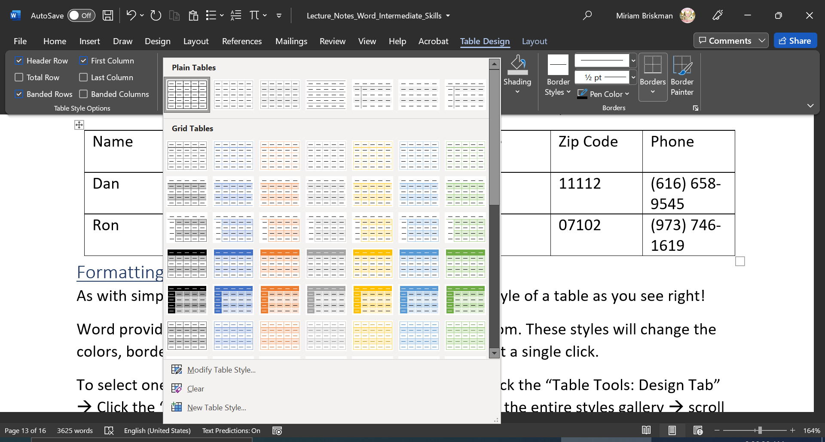
We add the “Grid Table 4 – Accent 1” style to the table from before:
Name | Date of Birth | Street | City | State | Zip Code | Phone
Dana | 01/01/1992 | Fog | Brooklyn | NY | 11112 | (616) 658-9545
Ron | 01/06/1996 | Dog | Newark | NJ | 07102 | (973) 746-1619
This makes the table much more presentable!

You can also change the border settings of individual cells, rows, or columns inside the table.
The “Borders” group under the “Table Tools: Design tab” lets you change:
- The border pattern: solid, dotted, dashed, mixed, double, etc.
- The border width: ¼ pt, ½ pt, 1 pt, 2 pt, etc.
- The side of the border where the change should be made.
- The border colors.
First select the formatting you want, and then either click on the “Borders” button to select which border side you’d like to modify, or click the “Border Painter” button, and draw apply the formatting to the border you want using the mouse.
Here is an example of a 1-cell table with a different border style per each of the 4 sides:

Images
In our graphical-driven society, it is a necessity to use graphical features, like images and graphs, within brochures, reports, etc., to make the document more engaging.

Inserting an Image
You can add images at any place within your document. An image is another type of a Word object.
- First, click inside the document at the place where you wish the image to be added,
- Then, click the Insert tab Illustrations button Pictures button “This Device…” option navigate to the folder where the image you want to add is located, select the image, and insert it.
Word also allows you to insert Online images! To do so, instead of clicking “This Device…”, select “Online Pictures…” and choose to insert whichever image you want.
The screenshot below is a rightful Word image:
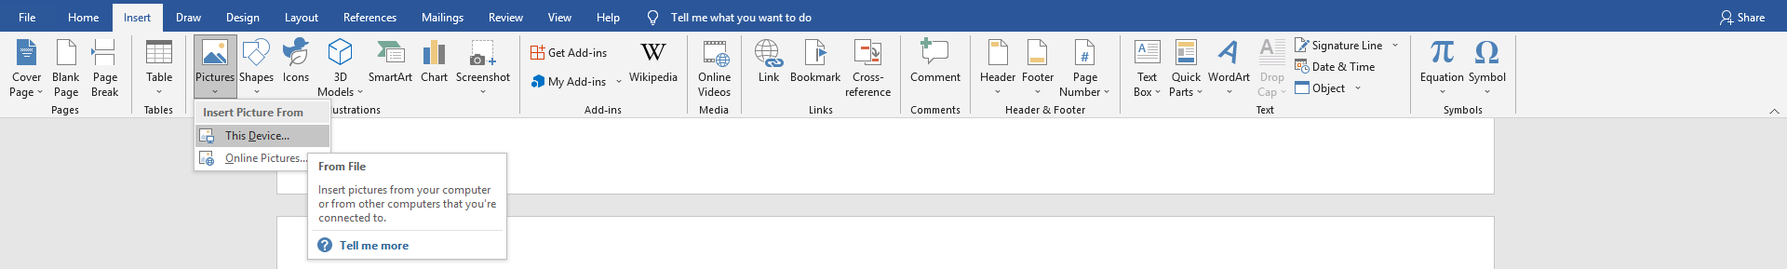
After inserting the image, you can change its size within the document as follows:
- Click anywhere inside the image,
- Click & drag the sizing handles in the direction in which you need to resize the image.
If clicking and holding the Shift key, you can resize the image proportionally (= keeping the same ratio of the height and width of the image) by dragging one of the sizing handles on the corner.

Text Wrap around the Image
In many cases, the images you add will be placed near text. The question is, how will the text around the image be positioned? The text warp feature for images addresses this question.
There are 3 methods for changing the text warp of images:
- When you click on an image, you will note the following small button appearing to its right: . Click on it, and select the new text wrapping setting.
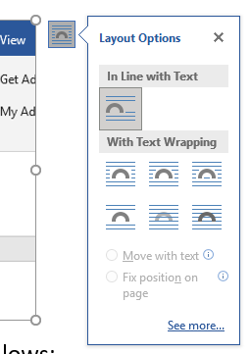
- You can access the same text wrap features using the “Picture Tools: Picture Format” tab by clicking on the “Text Warp” button under the “Arrange” group.
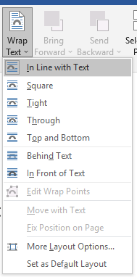
- Finally, on the same tab, you can click the “Position” arrow to choose to place the image at different positions on the page.
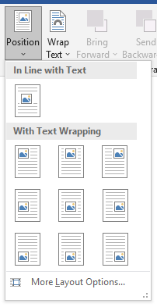
Below are the types of existing text warp types for images in Word:
- Inline text wrap: This is the setting that every image assumes when initially added. In this text wrap, Word behaves as though the image is an inline character, just like any other character in the document.
- Square: Text wraps around the image in a square shape.
- Tight/Through: Text wraps around image, regardless of what shape the image is. This text wrap works best with images that have no background.
- Top and Bottom: Text stops when it hits the top of the image and continues at the bottom of the image; no text is to the left or right of the image.
- Behind text: The image is behind text. In other words, text will cover image.
- In front of text: The image is in front of text. I.e., text behind the image is not visible.

Hyperlinks
In the “Intro to Computers” lecture notes, we explained that a hyperlink (or link) is a piece of text that, if clicked, will either open a webpage, or redirect you to a different location inside this or another document. Hyperlinks use to be, but not always are, blue colored and underlined.
Now we reached the time to discuss how to add, access, change, and remove hyperlinks.

Inserting a Hyperlink
To turn a piece of text in a Word document into a hyperlink:
- Select that piece of text,
- Open the “Insert Link” dialog box window by one of the following 3 options:
  - Click Ctrl + K (Mac: Cmnd + K),
  - Right-click over the selected text choose the “Hyperlink” option, or
  - Click the Insert tab Links button Click the “Insert Link” option,
- Do one of the following:
  - For a link to a webpage, type the webpage’s address in the “Address” input box. 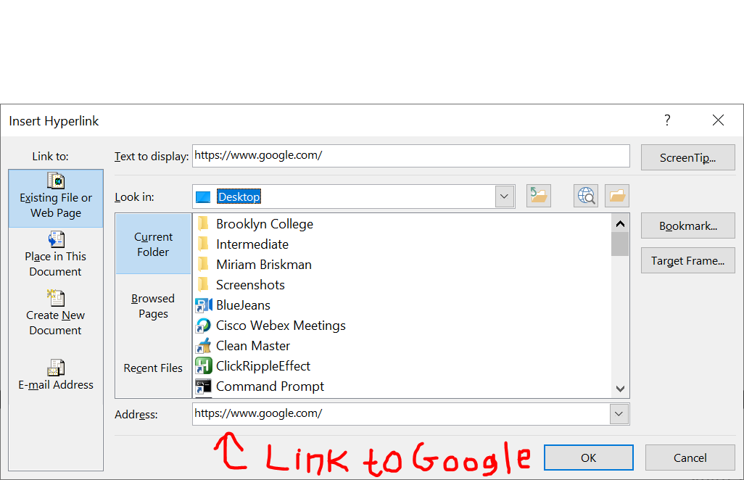
  - For a link to a file on the computer, use the window above the “Address” box to search for the file. Then, click on the file.
  - For a link to a different place inside the same document, click on the “Place in This Document” button and select the section or subsection to which you want the link to redirect.
- Finally, click OK for the link to be added to that text and to close the dialog box.
Example: Using the dialog box as was displayed above, we create this link to Google.

Broken Links
Suppose you decided to create a hyperlink to different file (Word or anything else) located somewhere on your computer.
If that file gets deleted or changes location on the computer, the link will not open it anymore and therefore become a broken link.
For example, this link, which was linked to a nonexistent file called “HelloWorld.docx”, is broken. If you try to open it (by holding Ctrl and clicking the link,) an error message will appear on the screen saying that file cannot be opened.
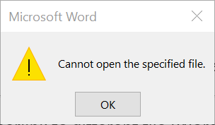

Accessing a Hyperlink
In Word, click Ctrl + the link itself (using the mouse or touchpad) to open the link. [On Mac, simply click or tap the link.] Alternatively, right-click the link and select “Open Hyperlink.”

Changing a Hyperlink’s Style
Note that, after you clicked a hyperlink once, its color turns into purple. This is a way to differentiate between links that have been clicked and those that haven’t while the document is open. Try it out using this link.
Just as with any text, you can change the style of a hyperlink as you please using the text formatting buttons in the Font group on the Home tab.
Alternatively, you can change the default color of any hyperlink you added in this document in the future by clicking the Design tab Colors button “Customize Colors” option. Lastly, change the colors next to “Hyperlink” or “Followed Hyperlink” as desired.
A general recommendation is that you make links distinguishable from the rest of the text to make the document user-friendly and so that the readers of your document easily recognize these as links.

Editing, Copying, and Deleting a Hyperlink
When you right-click a hyperlink in Word, you can choose to:
- Edit Hyperlink. This will open the “Edit Hyperlink” dialog box (which isn’t different from the “Insert Hyperlink” one that you saw earlier) in which you can edit the address or destination of the hyperlink.
- Copy Hyperlink. Once clicked, this option will copy the address to which the hyperlink navigates. Note that the text of the link is not copied. For example, when we copy this link, which opens Google, we copy “https://www.google.com/” to the clipboard, not the text “this link.”
- Remove Hyperlink. If chosen, the hyperlink will be deleted, but the text in the document will remain. For instance, when we choose to delete this link, the words “this link” will remain inside the document.

