FCS 208: Weaving Assignment
For this assignment, you will simulate three different textile weaves using paper. Because you are simulating woven fabric, the warp and weft of these paper project are threads. They should be similar in size.
You will complete this assignment in four parts.
- Create and label each weaving pattern
- Photograph each paper mat and add each image to this document.
- Submit the assignment.
- Archive your work.

Part A. Create and label each weaving pattern
- Obtain at least 6 sheets of 8-1/2 x 11" paper (or larger). You will need at least 2 different colors of paper (3 each). You may use a third color if you wish.
- Follow the simple instructions for making a woven paper mat to understand the basics for preparing your paper. Please measure and use a straight edge to create your lines.
  - NOTE: If you have a paper shredder that cuts strips, you can certainly use that to save time cutting, but you will need to adjust the width of the slots to be similar in size.
- Weave the paper to create an example of two types of weave:
  - Plain
  - Twill or Satin
- For the third example, choose your own weave to recreate. Suggestions:
  - Twill or Satin (the one you didn't choose in step 3)
  - Herringbone
  - Basket weave
  - Chevron
- Write the type of weave you created on the top of each paper mat.

Part B. Photograph the pattern pieces and add to this document
- Scan or photograph each paper mat.
- Save your images to the device where you downloaded this document.
- Insert your images into the designated spaces below. To do this:
  - Click on the picture icon found in the center of the blue box. This will bring up the option to browse your device and insert the desired image.
  - Adjust the size of each image so you are able to fit your image next to the sample image. You may adjust the size by clicking on the image then dragging any corner.

Insert the "plain" weaving
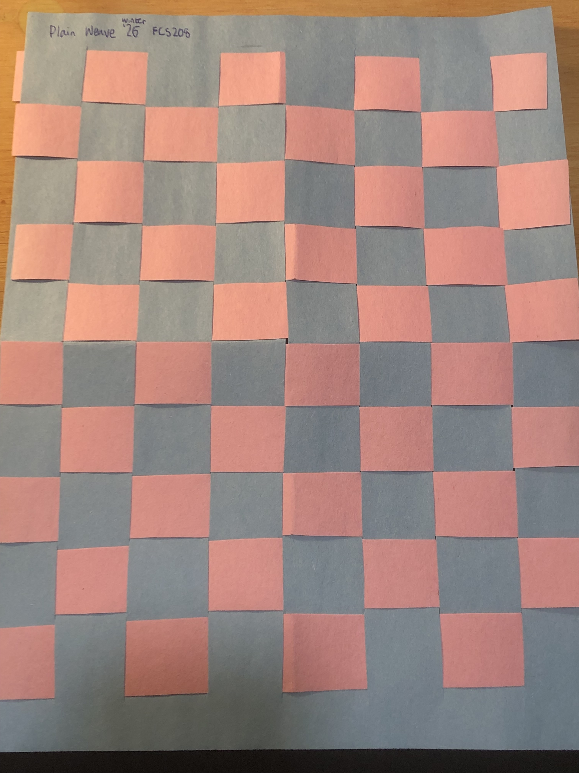

Insert the "satin" or "twill" weaving Twill Weave
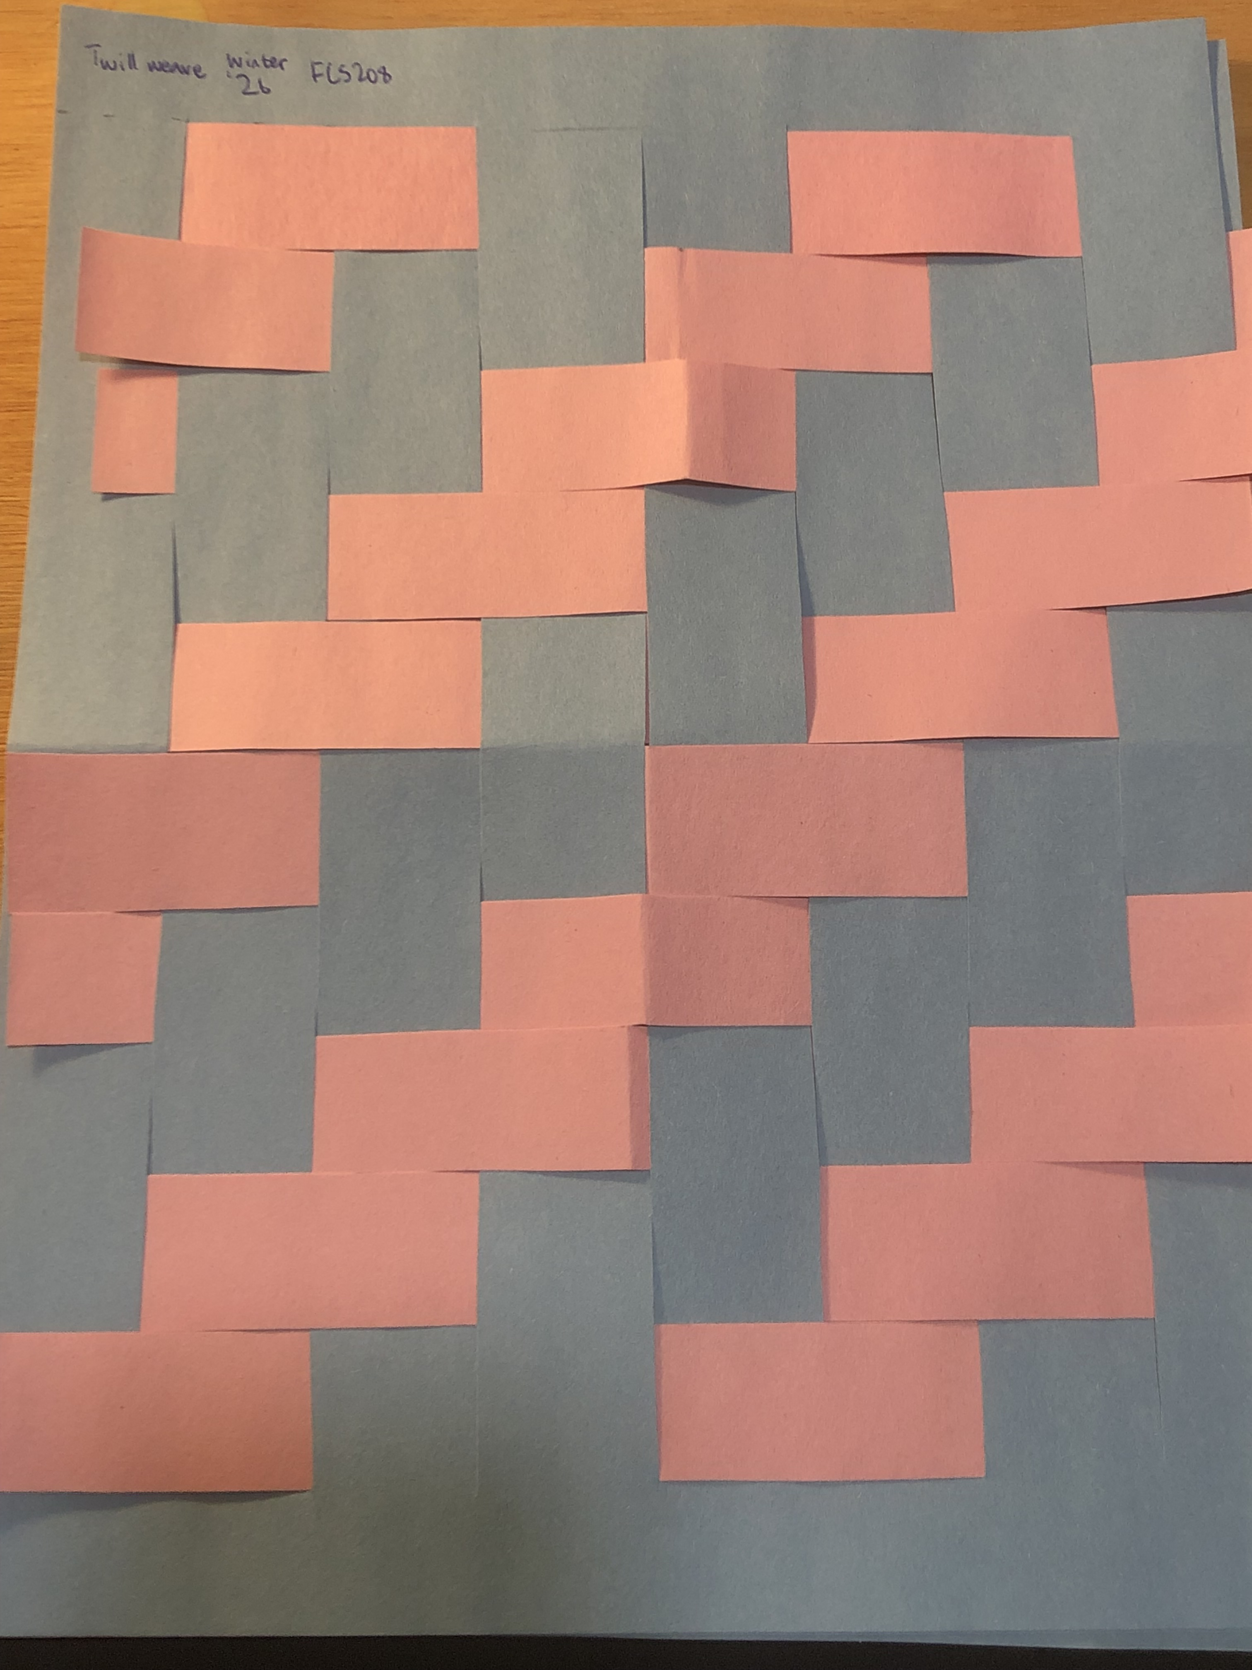

Insert the weaving of your choice. Satin Weave
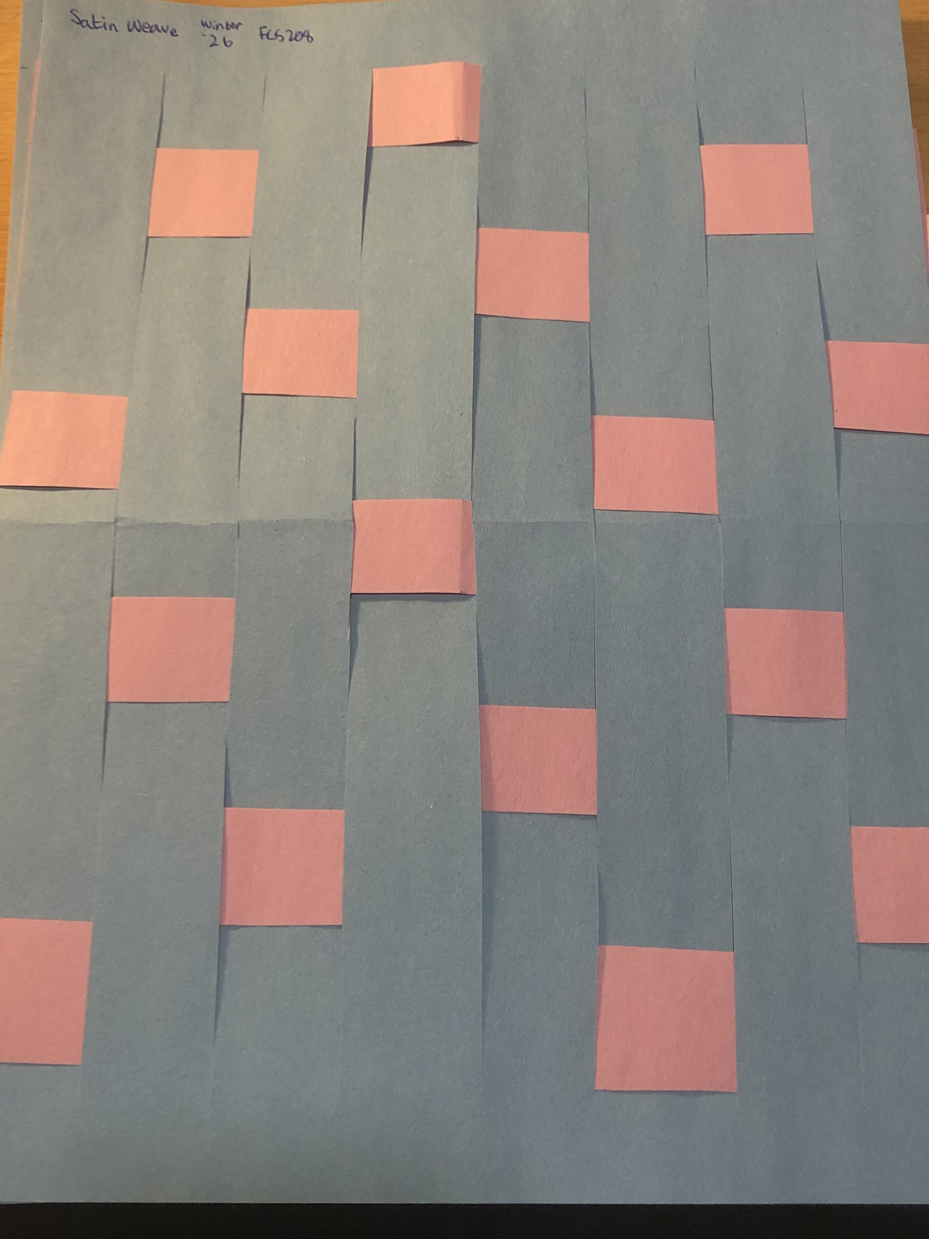

Part C. Submit the Assignment
After you added all the images, submit your work. Before submitting, save this assignment as a PDF.

The steps below describe how to do this.

- With your Microsoft Word document open, click the File tab (top left of the screen).
- Save your Word document.
- Click the File tab again.
- If you have the option to choose Save as PDF, select that option and continue to follow the instructions (you will skip step 7 below). If you don’t have that option, choose Save As.
- Select the location where you want the file saved.
- Enter your desired file name. Recommended: Use the actual assignment name so you can readily find the file in the future. Include your name. Use hyphens or underscores to separate words. Example: If your name is Mary Smith, you might use the following to name the file: W03-Weaving-Smith
- Change the file type by clicking the dropdown menu in the Save as type dropdown. Select PDF from the menu.
- Select Save.

Return to I-Learn and submit the PDF to your instructor.

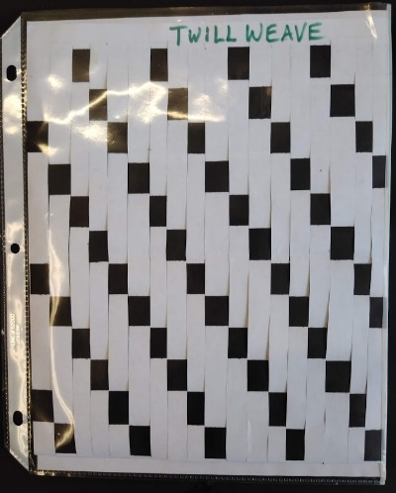
Part D. Archive your work
Carefully protect your work.
- Mount each finished weaving to a piece of cardstock or thick paper.
OR
- Slide your weaving into a plastic protector page.

Save in your career kit.

Congratulations! This assignment is a significant part of your Textile Resource Guide.

