DISTRIBUTED SYSTEMS

MIDTERM EXAM REPORT
Student Name: Myriam Rahal
Student ID: 202111991
Course: Distributed Systems
Academic Year: 2026–2027

1. Introduction
This report presents the development environment, configuration, implementation, and testing activities carried out for the Distributed Systems midterm examination.
The purpose of this project is to apply the fundamental concepts of distributed systems through practical implementation. These concepts include communication between services, message passing, event streaming, containerization, orchestration, and system monitoring.
The project uses modern development tools and technologies to support the deployment and observation of distributed applications. Each implementation phase is documented with explanations, relevant commands, test results, and screenshots demonstrating the progress and successful execution of the tasks.

2. Development Environment and Tools
The following tools and technologies are used to prepare the development environment and support the implementation of the distributed system:
- Python: Used as the primary programming language.
- PyCharm: Used to write, organize, and execute Python code.
- Python Virtual Environment: Used to isolate project dependencies.
- Git: Used for version control and tracking changes.
- GitHub: Used to host and manage the project repository.
- Docker Desktop: Used to run applications and supporting services in containers.
- Kubernetes: Used to manage and orchestrate containerized applications.
- Apache Kafka: Used for distributed event streaming and communication.
- RabbitMQ: Used for asynchronous messaging and message queues.
- Prometheus: Used to collect and query monitoring metrics.
- Grafana: Used to visualize metrics through dashboards.
The tools are configured according to the requirements of the project and are tested before being used in the implementation.

3. Development Environment Setup

3.1 Python and Virtual Environment
Python was prepared as the main programming environment. A virtual environment was configured to isolate the project's dependencies and avoid conflicts with packages installed globally.
Screenshot 1: Python and Virtual Environment Setup
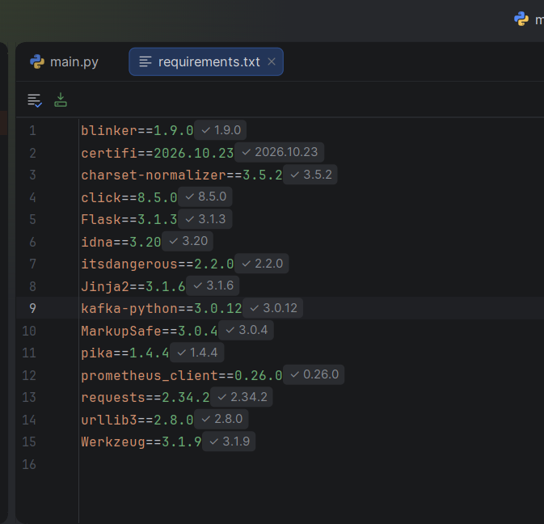

3.2 Git and GitHub Configuration
Git was initialized to track project files and manage version history. A remote GitHub repository was configured to store the project's source files and documentation.
Screenshot 2: Git Repository Configuration
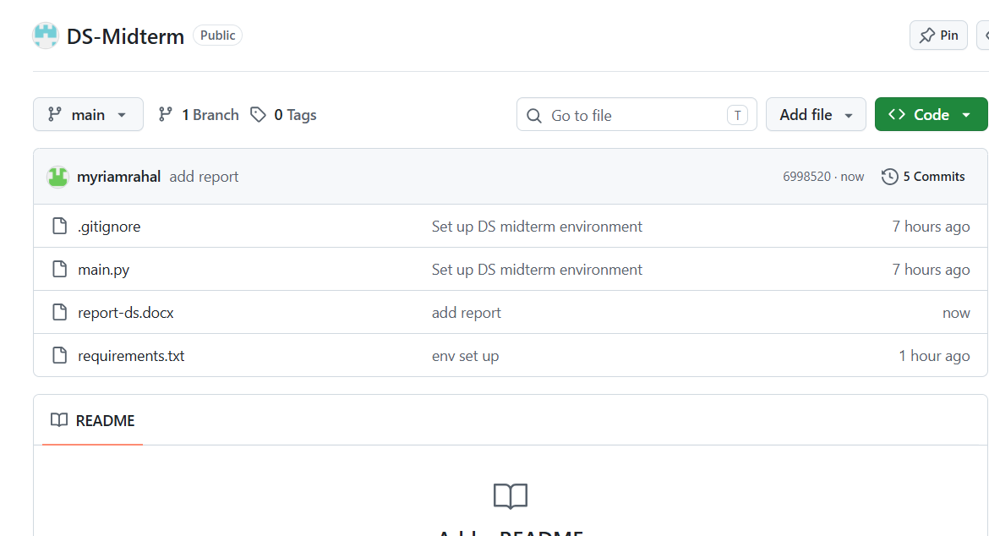

3.3 Docker Configuration
Docker Desktop was configured to run containerized services required for the distributed system. The container images and running containers were checked to verify the environment.
Screenshot 3: Docker Configuration and Running Containers
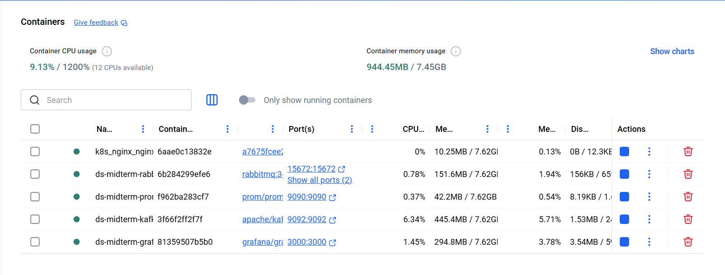

3.4 Kubernetes Configuration
Kubernetes was enabled through Docker Desktop. The Kubernetes context and cluster nodes were checked using kubectl to verify that the cluster was accessible.
Screenshot 4: Kubernetes Cluster Verification
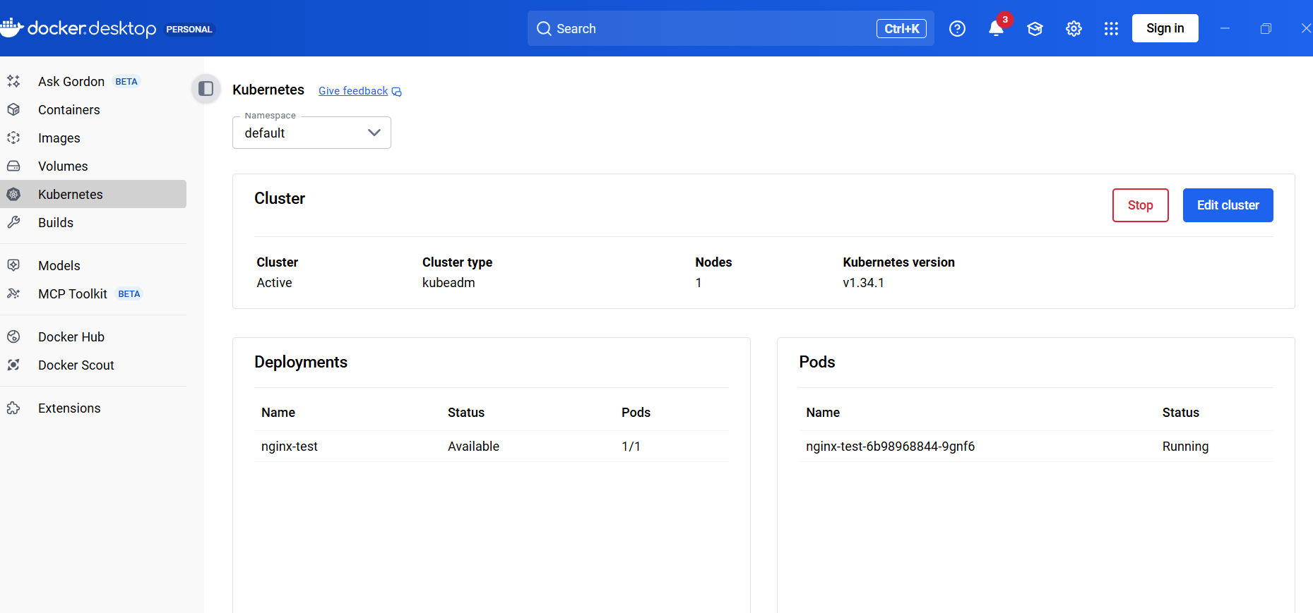

4. Messaging and Distributed Communication

4.1 RabbitMQ
RabbitMQ was prepared as a message broker to support asynchronous communication between distributed components. It allows producers to publish messages to queues and consumers to process those messages independently.
Screenshot 5: RabbitMQ Container and Management Interface
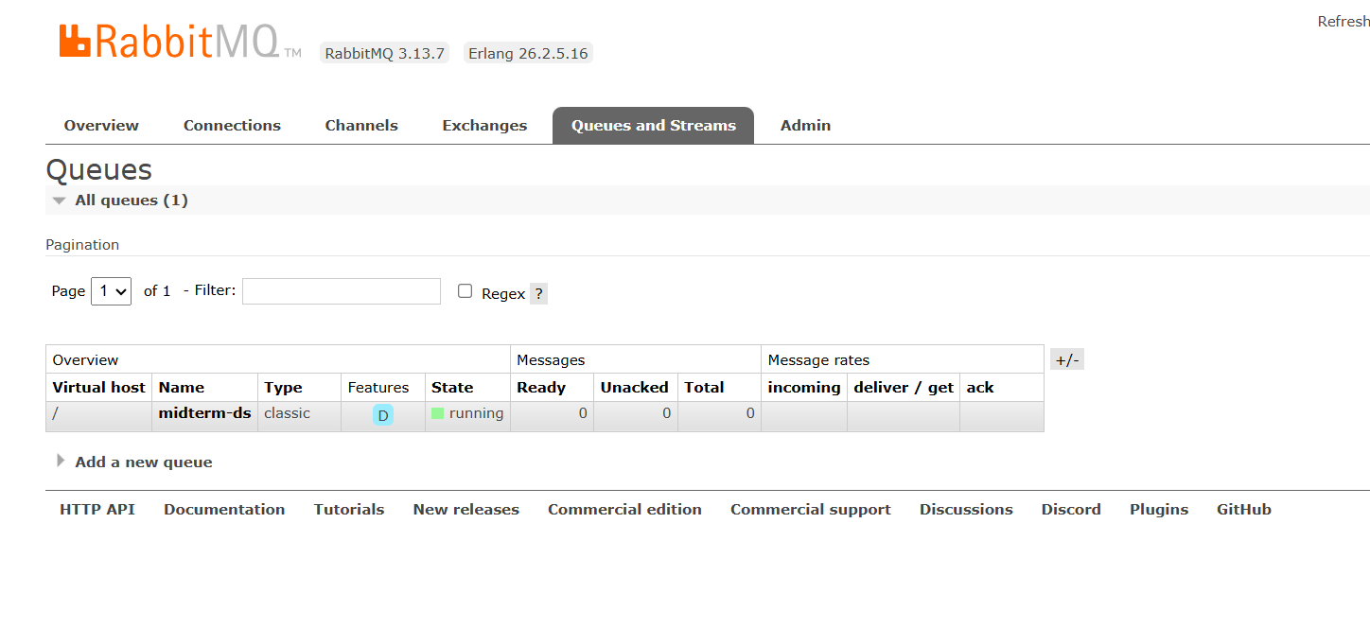

4.2 Apache Kafka
Apache Kafka was configured to support event streaming. A test topic was created, and a message was published and consumed to verify communication through the Kafka broker.

5. Monitoring and Visualization

5.1 Prometheus
Prometheus was configured as the monitoring component. It collects time-series metrics from monitored targets and provides a query interface for examining system health.
The up metric can be used to determine whether a monitored target is being successfully scraped. A value of 1 indicates success, while a value of 0 indicates that the target is not being successfully scraped.
Screenshot 7: Prometheus Interface and Query Results

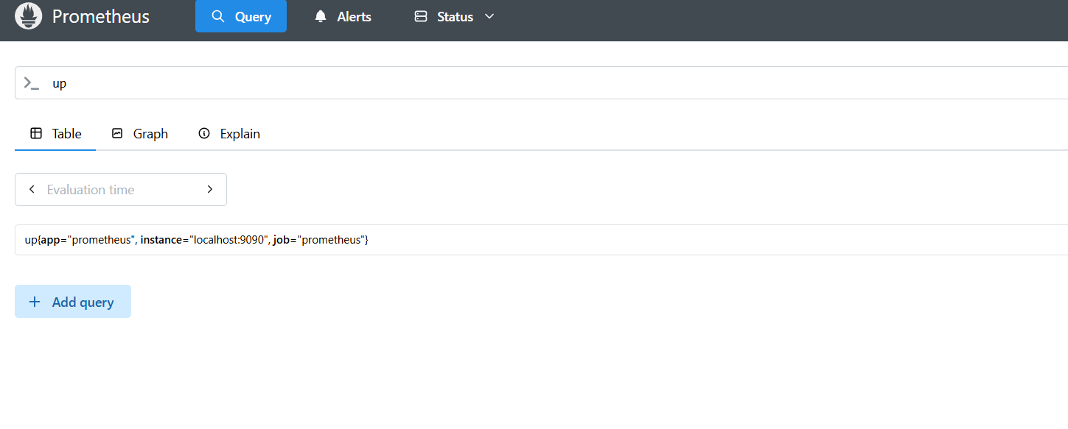5.2 Grafana Dashboard
Grafana was configured to use Prometheus as a data source. A dashboard was started to visualize monitoring metrics and provide an overview of system health.
A panel titled Prometheus Health was created using the up query to display the status of monitored targets.
Screenshot 8: Grafana Prometheus Health Panel
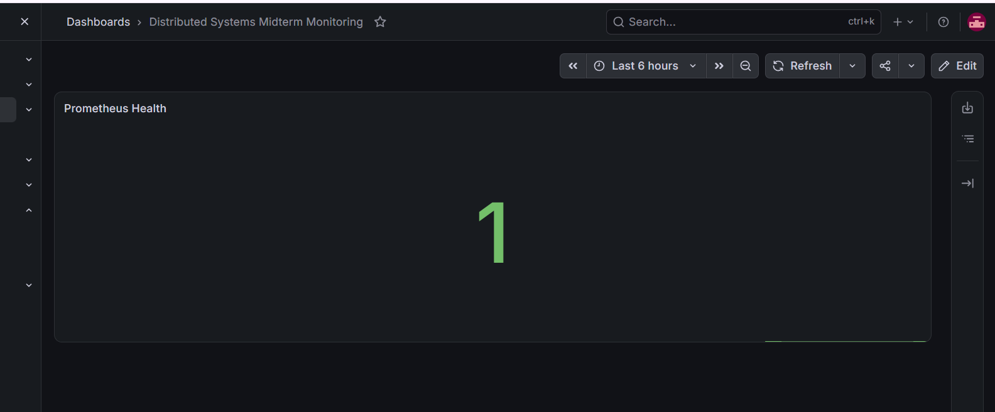

6. Testing and Verification
Testing is necessary to verify that the development environment and distributed components operate correctly.
The following checks are performed as applicable to the project:
- Verify that the required Docker containers are running.
- Confirm that the Kubernetes cluster is accessible.
- Test message publishing and consumption using Kafka.
- Verify RabbitMQ availability and messaging functionality.
- Check Prometheus query results and target status.
- Confirm that Grafana can query Prometheus and display monitoring data.
The results and screenshots for each test will be included after the corresponding operation has been completed.

7. Conclusion
This project provides practical experience with the tools and concepts used to develop and monitor distributed systems. Preparing the development environment establishes the foundation for implementing distributed communication, containerized services, orchestration, and monitoring.
The use of Kafka and RabbitMQ demonstrates different approaches to message-based communication, while Prometheus and Grafana provide tools for monitoring system health. The final implementation and conclusions will be documented according to the actual requirements and results of the midterm examination.

