DISTRIBUTED SYSTEMS

MIDTERM EXAM REPORT
Student Name: Myriam Rahal
Student ID: 202111991
Course: Distributed Systems
Academic Year: 2026–2027

1. Introduction
This report presents the development environment, configuration, implementation, and testing activities carried out for the Distributed Systems midterm examination.
The purpose of this project is to apply the fundamental concepts of distributed systems through practical implementation. These concepts include communication between services, message passing, event streaming, containerization, orchestration, and system monitoring.
The project uses modern development tools and technologies to support the deployment and observation of distributed applications. Each implementation phase is documented with explanations, relevant commands, test results, and screenshots demonstrating the progress and successful execution of the tasks.

2. Development Environment and Tools
The following tools and technologies are used to prepare the development environment and support the implementation of the distributed system:
- Python: Used as the primary programming language.
- PyCharm: Used to write, organize, and execute Python code.
- Python Virtual Environment: Used to isolate project dependencies.
- Git: Used for version control and tracking changes.
- GitHub: Used to host and manage the project repository.
- Docker Desktop: Used to run applications and supporting services in containers.
- Kubernetes: Used to manage and orchestrate containerized applications.
- Apache Kafka: Used for distributed event streaming and communication.
- RabbitMQ: Used for asynchronous messaging and message queues.
- Prometheus: Used to collect and query monitoring metrics.
- Grafana: Used to visualize metrics through dashboards.
The tools are configured according to the requirements of the project and are tested before being used in the implementation.

3. Development Environment Setup

3.1 Python and Virtual Environment
Python was prepared as the main programming environment. A virtual environment was configured to isolate the project's dependencies and avoid conflicts with packages installed globally.
Screenshot 1: Python and Virtual Environment Setup
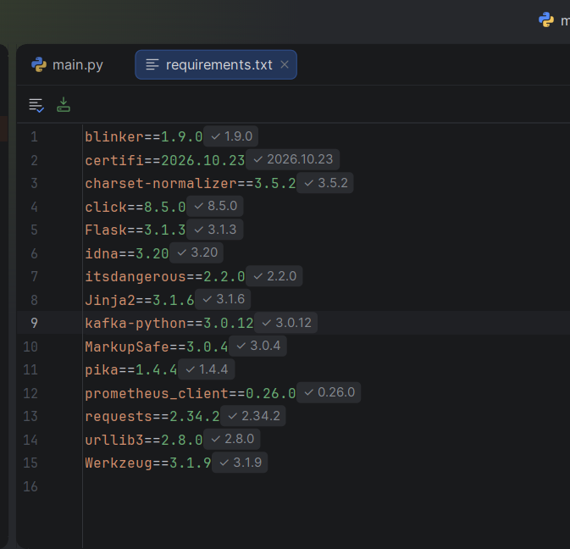

3.2 Git and GitHub Configuration
Git was initialized to track project files and manage version history. A remote GitHub repository was configured to store the project's source files and documentation.
Screenshot 2: Git Repository Configuration
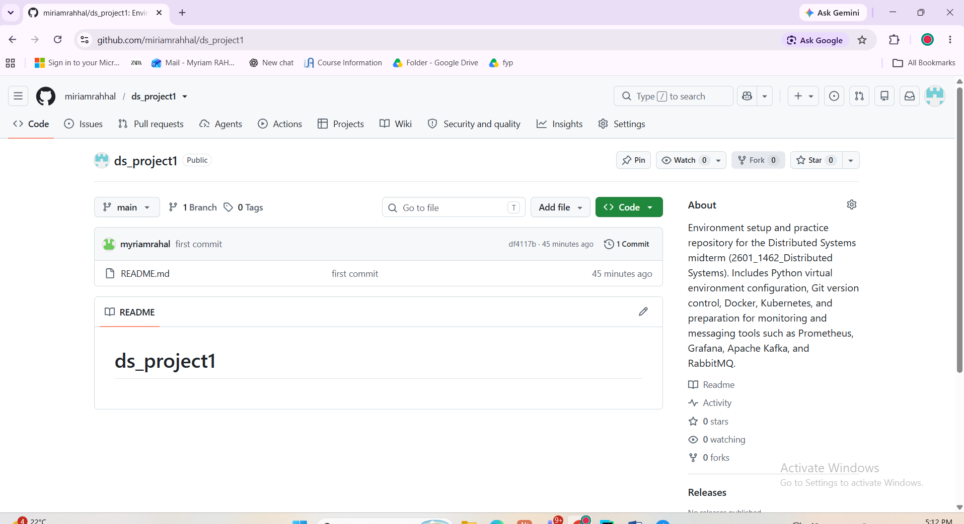

3.3 Docker Configuration
Docker Desktop was configured to run containerized services required for the distributed system. The container images and running containers were checked to verify the environment.
Screenshot 3: Docker Configuration and Running Containers
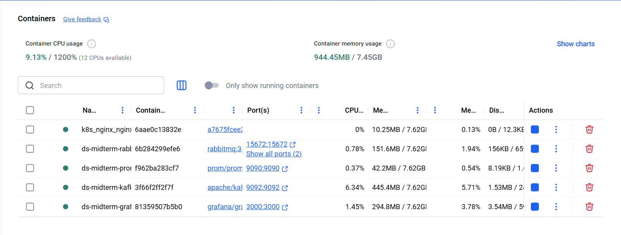

3.4 Kubernetes Configuration
Kubernetes was enabled through Docker Desktop. The Kubernetes context and cluster nodes were checked using kubectl to verify that the cluster was accessible.
Screenshot 4: Kubernetes Cluster Verification
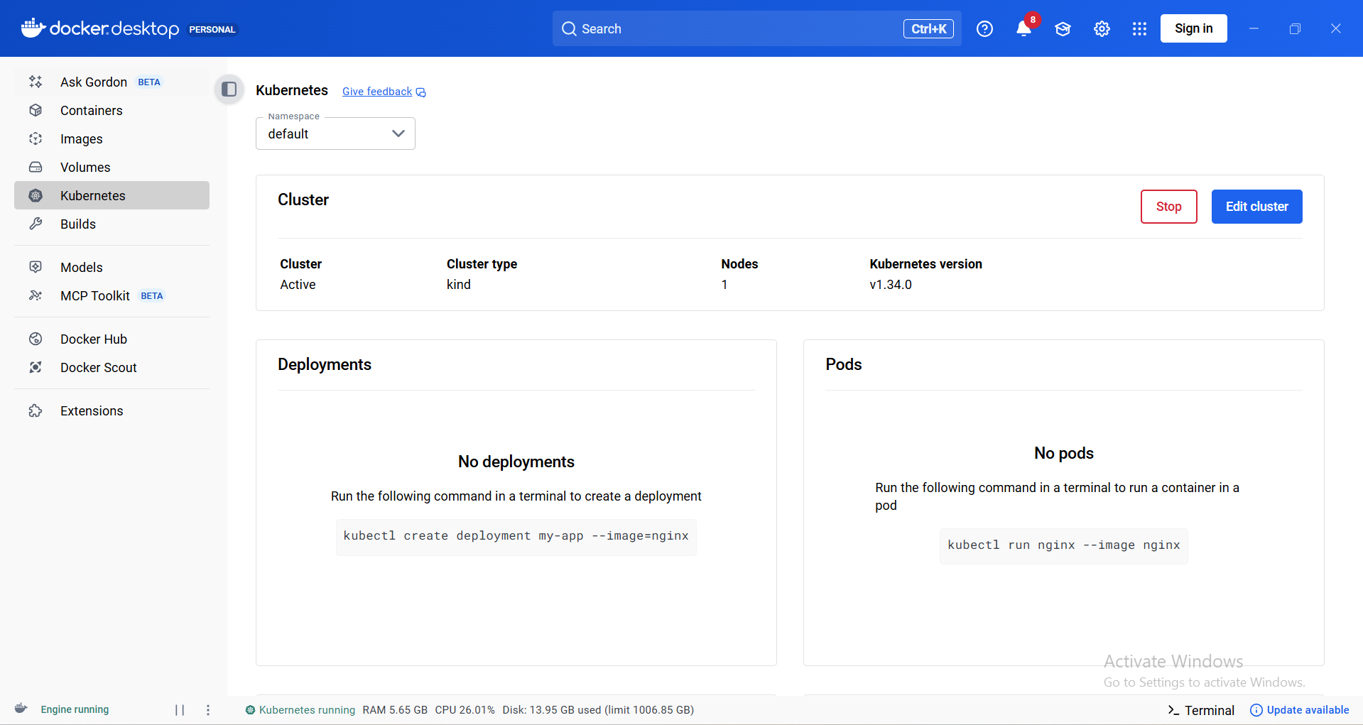

4. Messaging and Distributed Communication

4.1 RabbitMQ
RabbitMQ was prepared as a message broker to support asynchronous communication between distributed components. It allows producers to publish messages to queues and consumers to process those messages independently.
Screenshot 5: RabbitMQ Container and Management Interface
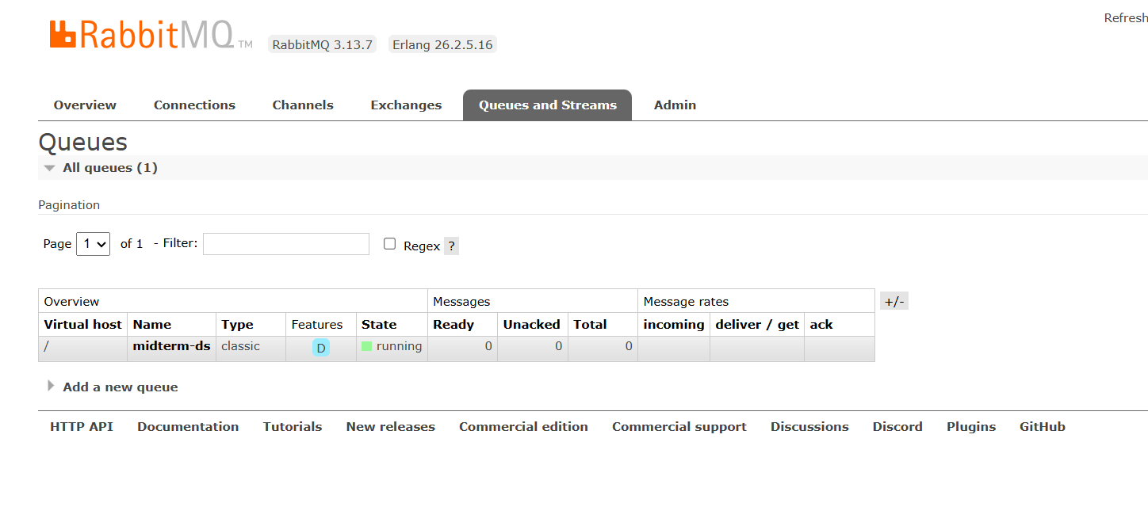

4.2 Apache Kafka
Apache Kafka was configured to support event streaming. A test topic was created, and a message was published and consumed to verify communication through the Kafka broker.

5. Monitoring and Visualization

5.1 Prometheus
Prometheus was configured as the monitoring component. It collects time-series metrics from monitored targets and provides a query interface for examining system health.
The up metric can be used to determine whether a monitored target is being successfully scraped. A value of 1 indicates success, while a value of 0 indicates that the target is not being successfully scraped.
Screenshot 7: Prometheus Interface and Query Results

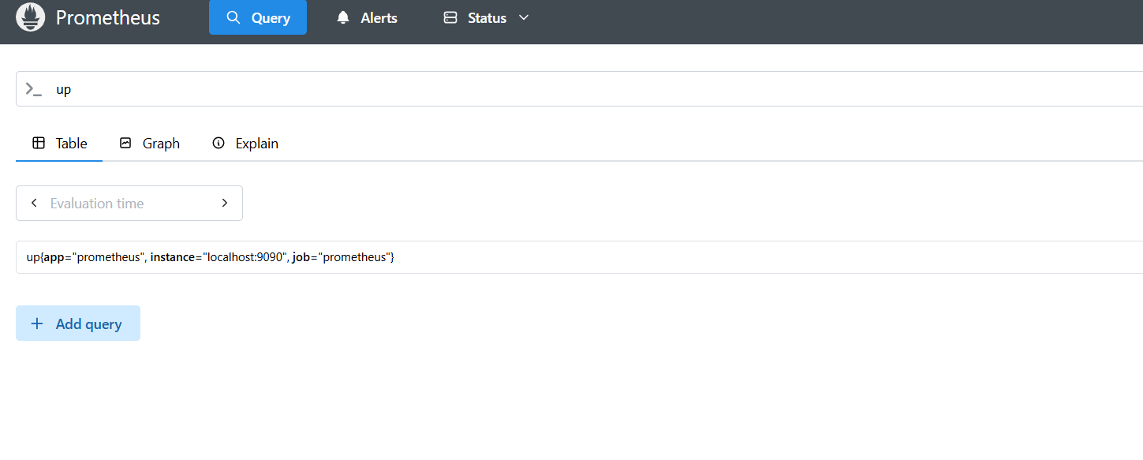5.2 Grafana Dashboard
Grafana was configured to use Prometheus as a data source. A dashboard was started to visualize monitoring metrics and provide an overview of system health.
A panel titled Prometheus Health was created using the up query to display the status of monitored targets.
Screenshot 8: Grafana Prometheus Health Panel
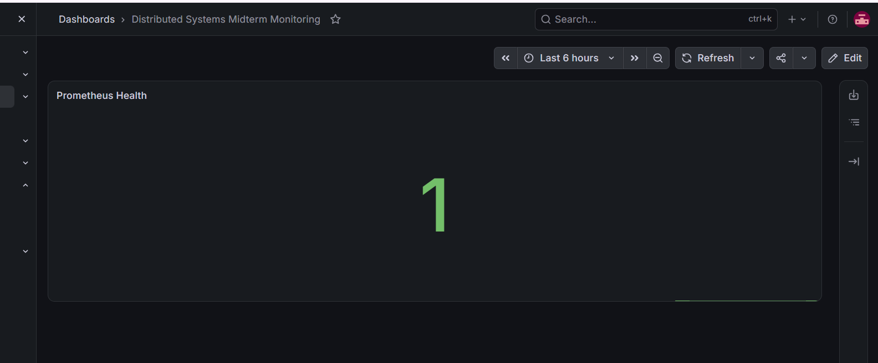

6. Testing and Verification
Testing is necessary to verify that the development environment and distributed components operate correctly.
The following checks are performed as applicable to the project:
- Verify that the required Docker containers are running.
- Confirm that the Kubernetes cluster is accessible.
- Test message publishing and consumption using Kafka.
- Verify RabbitMQ availability and messaging functionality.
- Check Prometheus query results and target status.
- Confirm that Grafana can query Prometheus and display monitoring data.
The results and screenshots for each test will be included after the corresponding operation has been completed.

7. Task 2: Storage Node Module

7.1 Objective
The objective of this task was to build the service that physically stores data in the framework. Each storage node keeps chunks on its own disk and exposes them over HTTP. Nodes do not decide where data goes or which object a chunk belongs to. Those decisions belong to the metadata and placement module in Task 3, so each node remains simple and more nodes can be added without changing this service.

7.2 What Was Implemented and Why
The service was written in storage_node/main.py. The main decisions were as follows.
FastAPI service: FastAPI was chosen from the options in the assignment because chunk operations map directly to HTTP methods. It also generates a documentation page automatically, which makes the endpoints easy to inspect and test.
PUT, GET, HEAD and DELETE: PUT stores a chunk, GET returns it, and DELETE removes it. HEAD reports whether a chunk exists and its size without transferring its content, which avoids unnecessary network traffic.
Content addressing with SHA-256: Every chunk is identified by the SHA-256 hash of its content. Identical data always receives the same address, which is the basis for deduplication in Task 3. The address also allows the content to be verified at any time.
Hash verification on upload: Before storing a chunk, the node recalculates its hash and compares it with the requested address. A mismatch returns HTTP 400, so damaged uploads and incorrect addresses are not stored.
Hash verification on read: The node recalculates the hash each time a chunk is read with GET. Data on a disk can become corrupted over time, so a corrupted chunk is rejected with HTTP 500 instead of being returned to the client. This allows a later version of the system to read a healthy copy from another node.
Validation of chunk identifiers: Only a 64-character lowercase hexadecimal hash is accepted. Because the identifier forms part of a file path, this check also prevents a request from reaching files outside the chunk directory.
Safe writing: A chunk is first written to a temporary file, flushed to disk and then moved to its final name. If the process stops during a write, a partial file is never treated as a valid chunk.
Repeated uploads: If a chunk already exists, the node returns HTTP 200 and does not write it again. Identical content has the same address, so a second copy on the same node would add nothing.
Directory structure: Chunks are grouped into subfolders using the first two characters of their hash. This prevents one folder from holding every chunk, which matters for the workload of many small files.
Heartbeats: A background task reports the node identifier, free space and chunk count to the metadata service every five seconds by default. The metadata service can use this information to detect failed nodes. If a heartbeat fails, the node logs a warning and continues serving chunks.
Configuration through environment variables: The node identifier, data directory and metadata service address are read from environment variables. The same code can therefore run in every container, with only its settings changing.
Current limitation: The node loads a whole chunk into memory when handling a request. This is acceptable because files are split into small chunks before they reach the node, but it would not suit very large chunks.

7.3 Starting the Service
The project dependencies were installed from requirements.txt, and the service was started with Uvicorn on port 8001. Heartbeats were temporarily disabled because the metadata service had not been created yet. The FastAPI documentation page was then opened to confirm that the health check and all four chunk endpoints were available. The documentation page shown below was captured from the containerized node1 on port 8201, because port 8001 was later used by another project on the same computer.
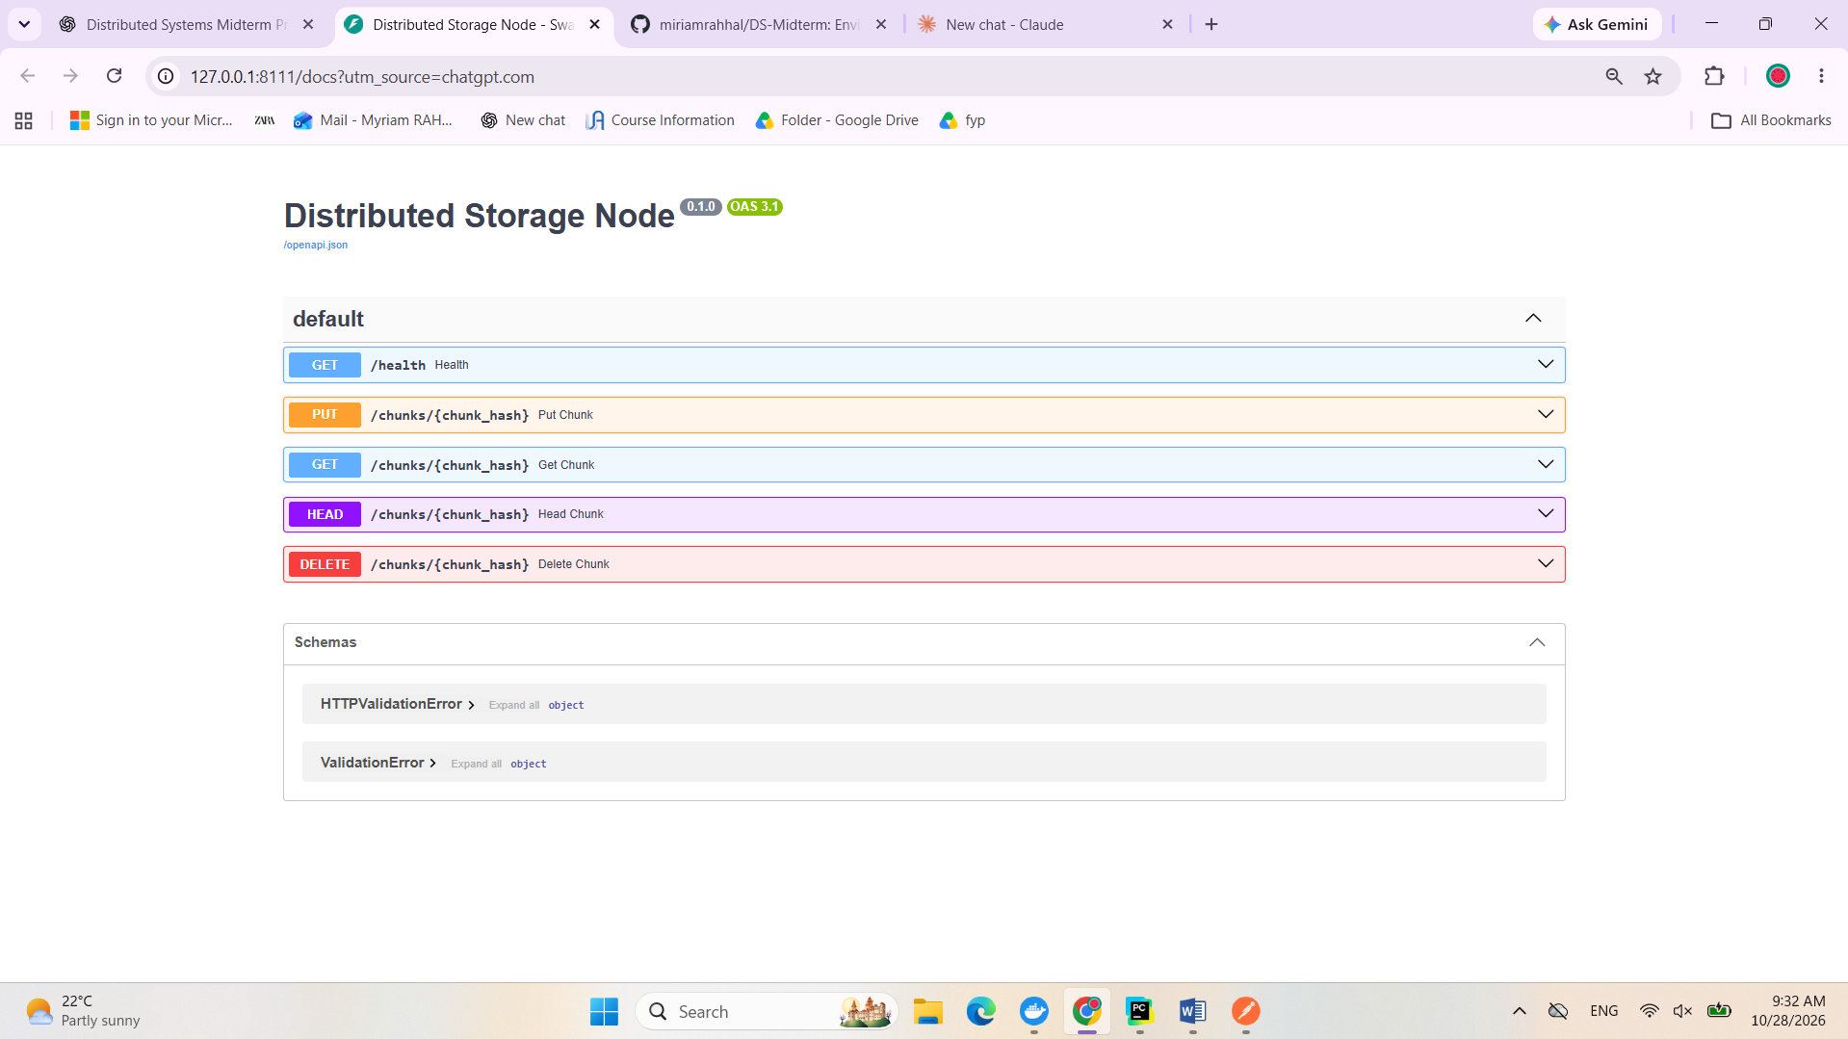
Screenshot: Storage Node API Endpoints

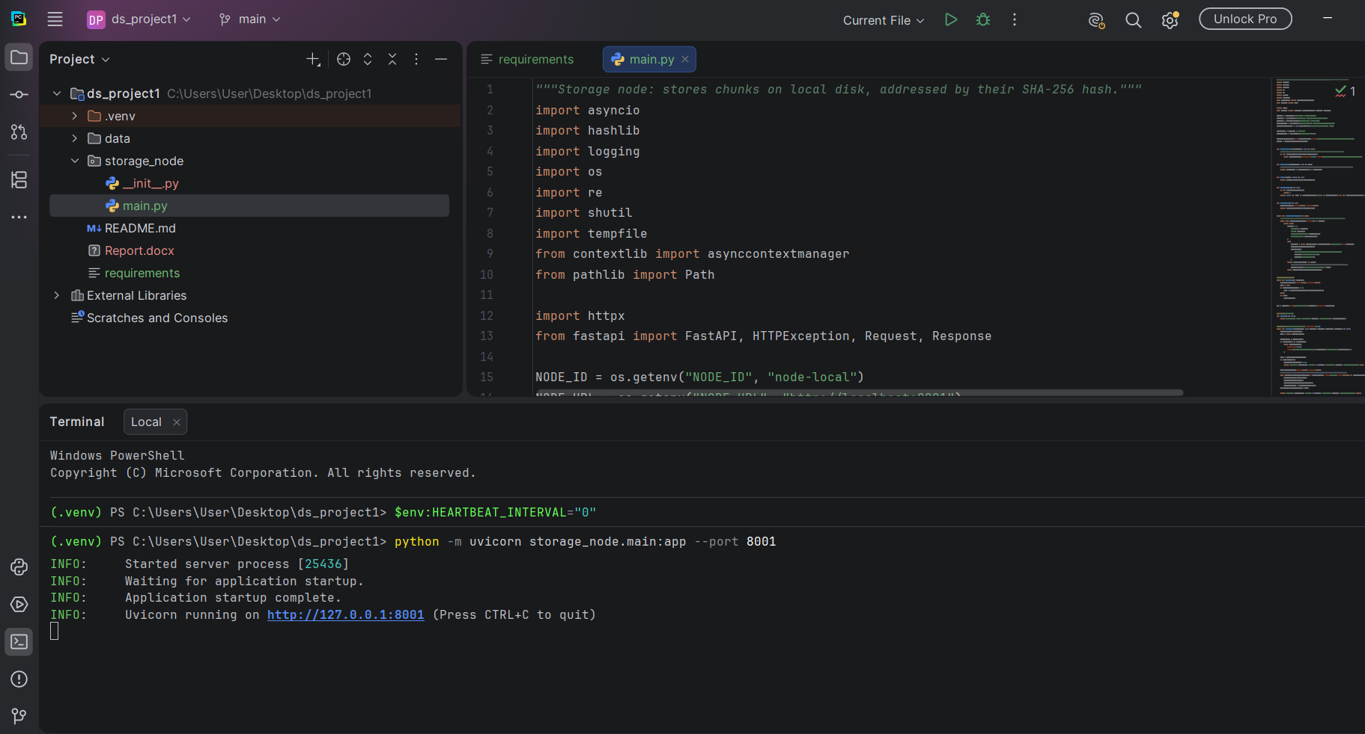

7.4 Uploading a Chunk (PUT)
A small test file was created and its SHA-256 hash was calculated. The file was then uploaded to the storage node using a PUT request addressed by that hash, and the node returned HTTP 201 with the hash, size and node identifier. A second request used an incorrect hash for the same content. The node rejected it with HTTP 400, which confirms that a chunk is stored only when its address matches its content.
Screenshot: Uploading a Chunk and Rejecting an Incorrect Hash
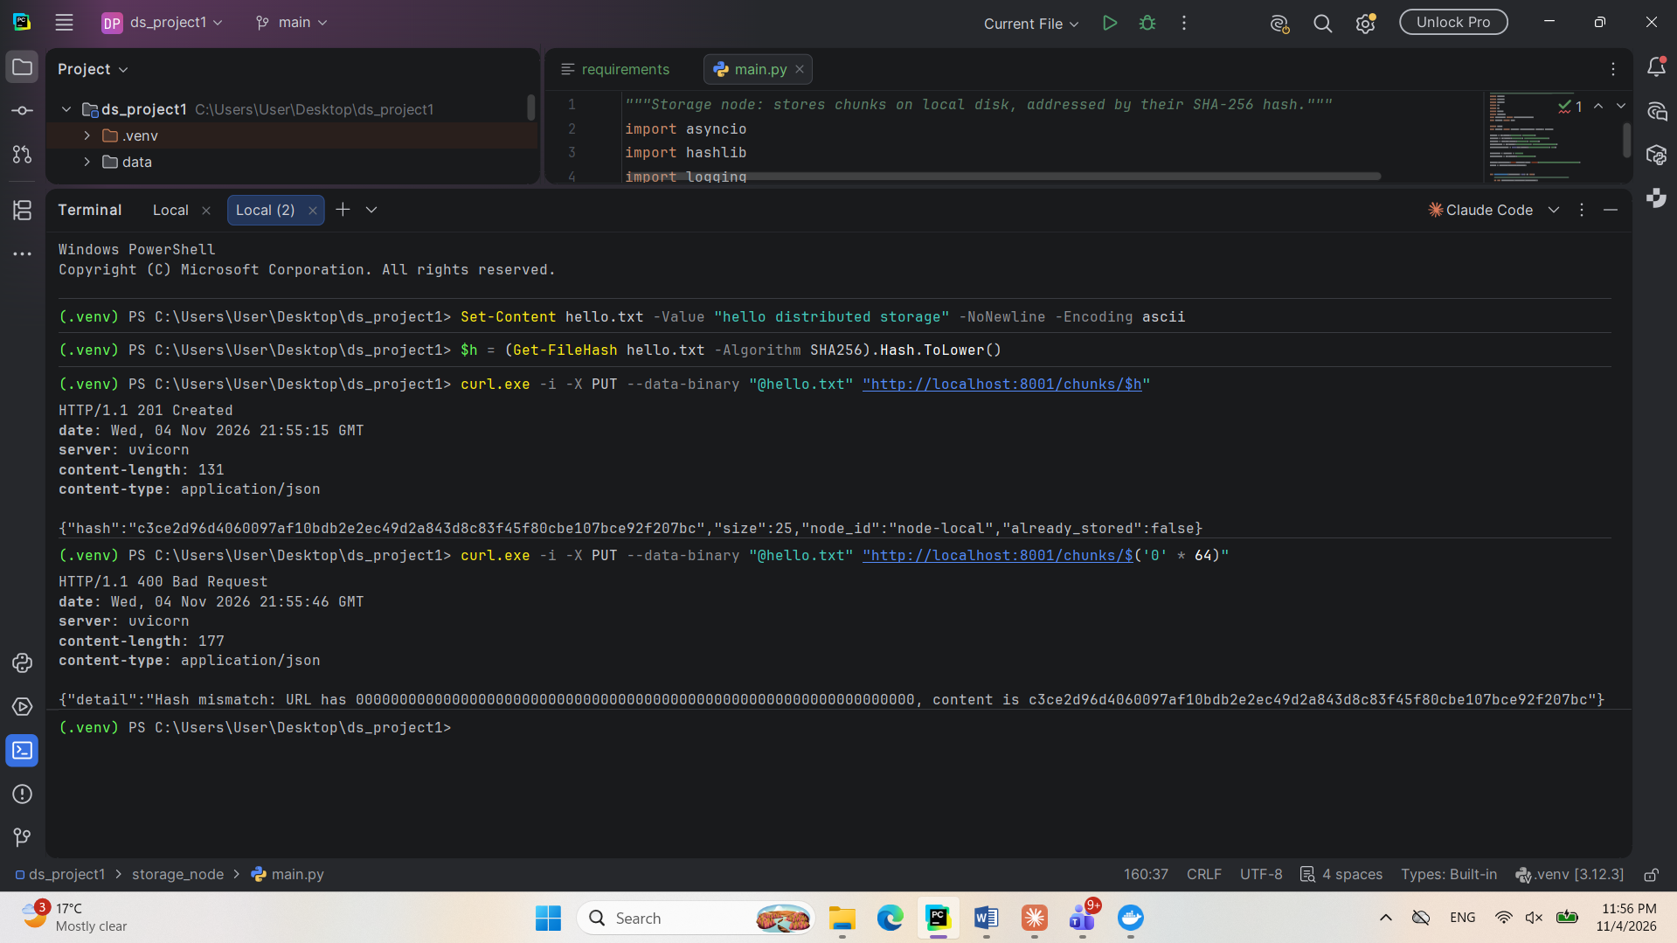

7.5 Checking and Downloading a Chunk (HEAD and GET)
A HEAD request was used to confirm that the chunk exists and to read its size without downloading its content, and the node returned HTTP 200. A GET request then returned the original content of the chunk. On each GET, the node recalculates the SHA-256 hash of the stored file before returning it.
Screenshot: HEAD and GET Requests on a Chunk
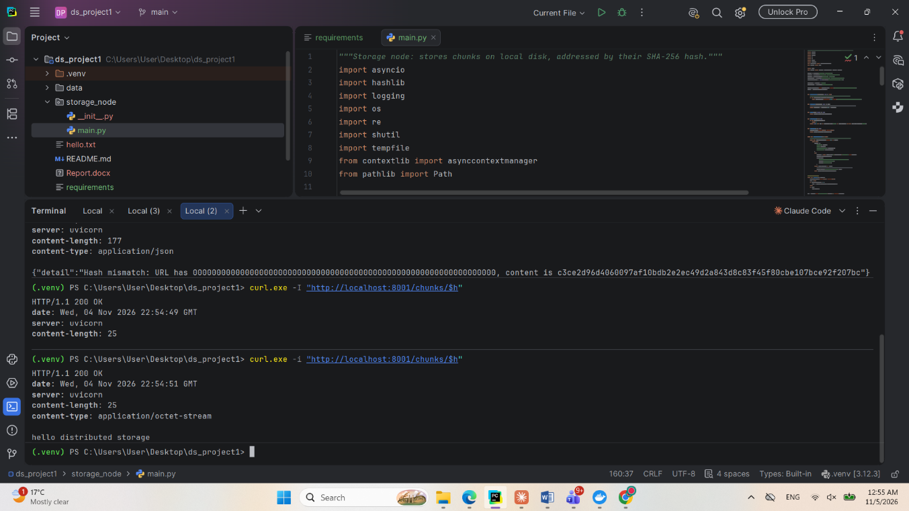

7.6 Detecting a Corrupted Chunk
To test integrity checking, the stored chunk was modified directly on the node's disk, which simulates data corruption. A new GET request returned HTTP 500 with a corrupted chunk message because the hash of the stored content no longer matched the chunk address. The corrupted data was not returned to the client.
Screenshot: Corrupted Chunk Rejected
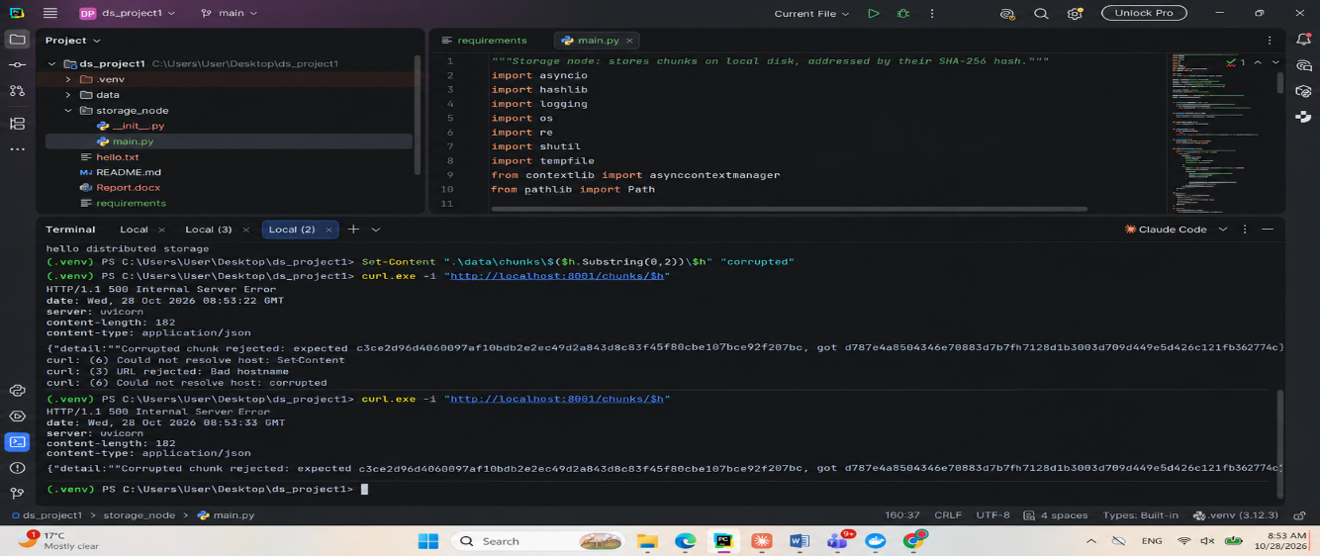

7.7 Deleting a Chunk (DELETE)
A DELETE request removed the chunk from the node and returned HTTP 204. A GET request for the same chunk then returned HTTP 404, which confirms that the chunk was no longer stored on the node.
Screenshot: Deleting a Chunk
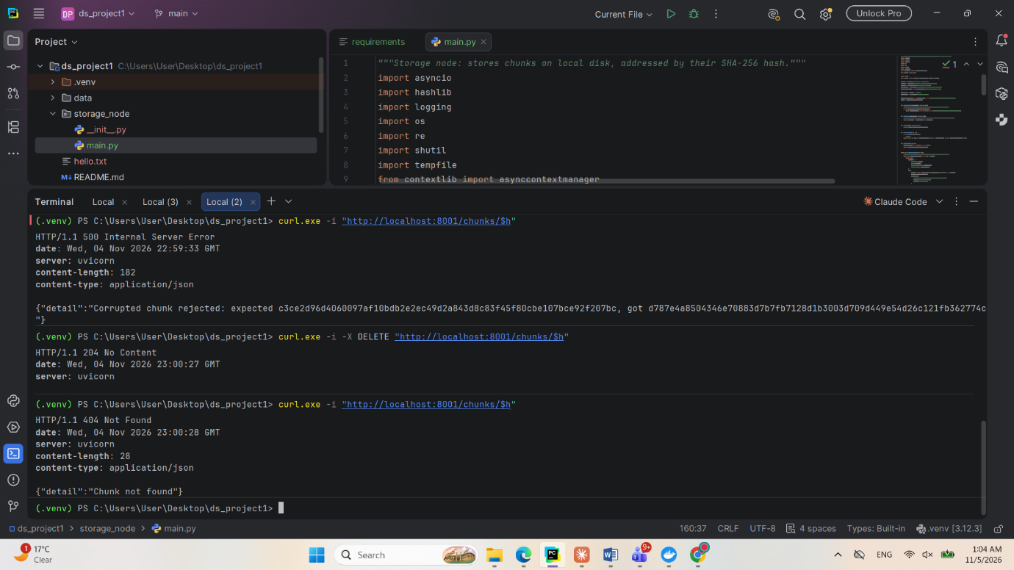

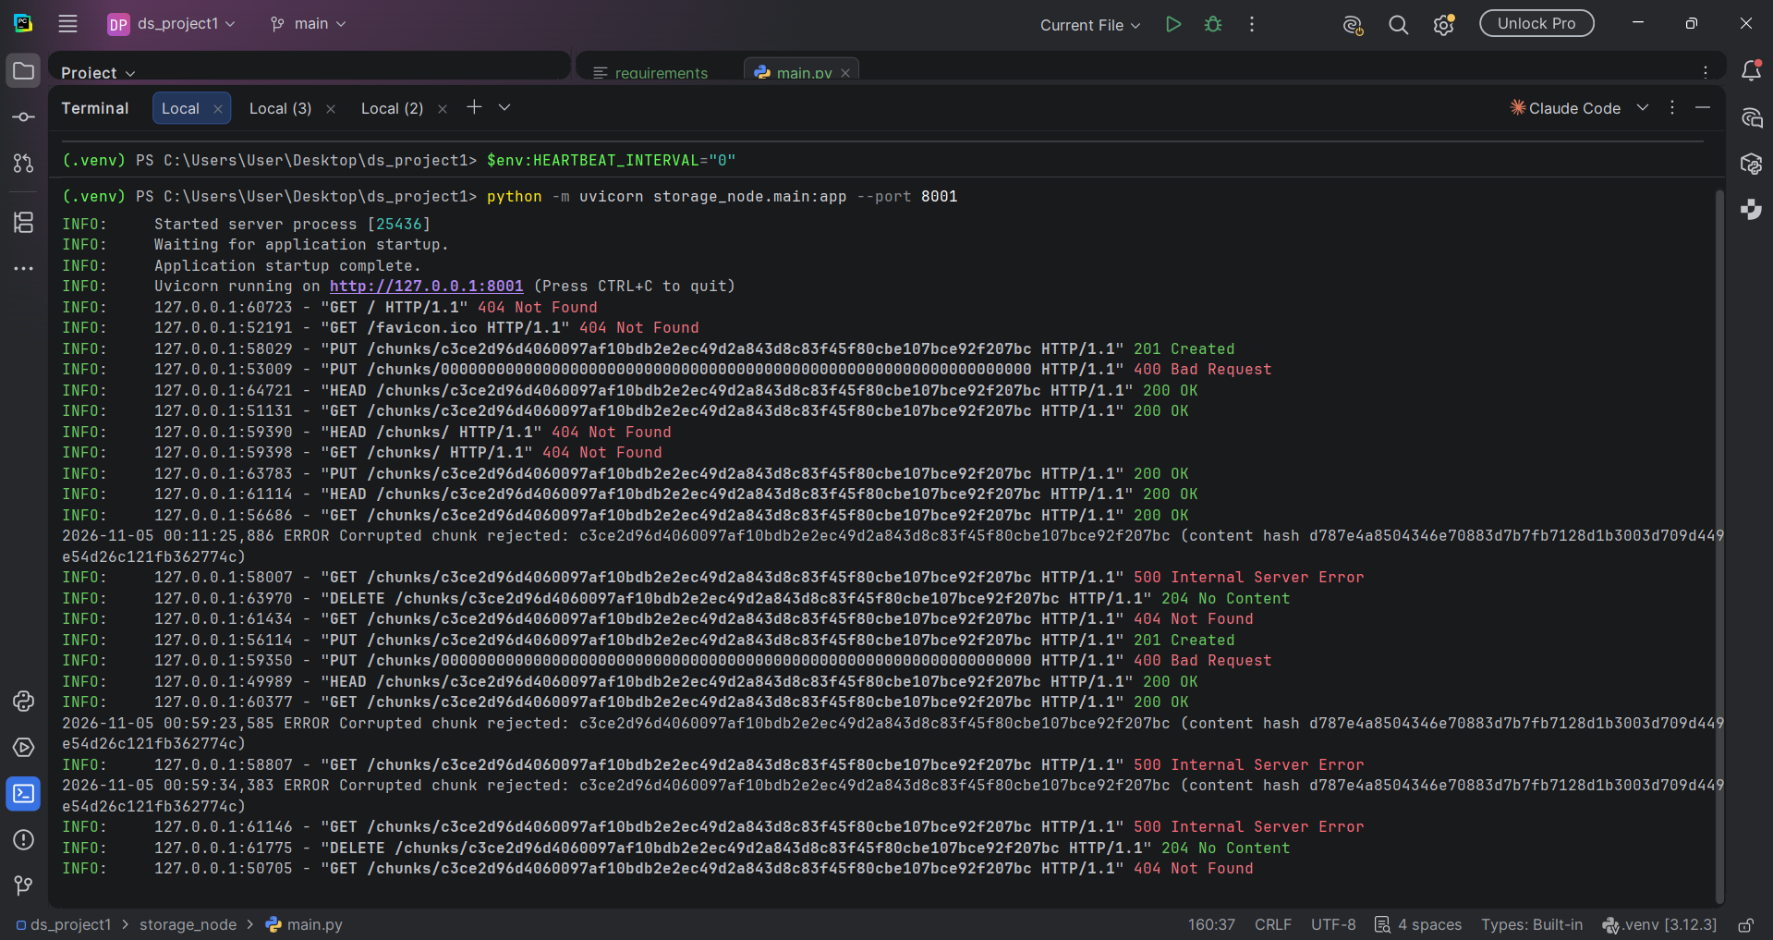
7.8 Metadata Service and Heartbeats
A metadata service was created using FastAPI so that the system has one place that knows the state of every storage node. Each node sends a heartbeat every five seconds containing its identifier, address, free space and chunk count. The service records the time of each heartbeat and reports the nodes through the GET /nodes endpoint. This approach was chosen because a stopped node cannot report its own failure, so its silence is used as the signal instead. In this module, node records are held in memory because they are rebuilt from the heartbeats that arrive every few seconds.
Screenshot: Node Reporting Heartbeats
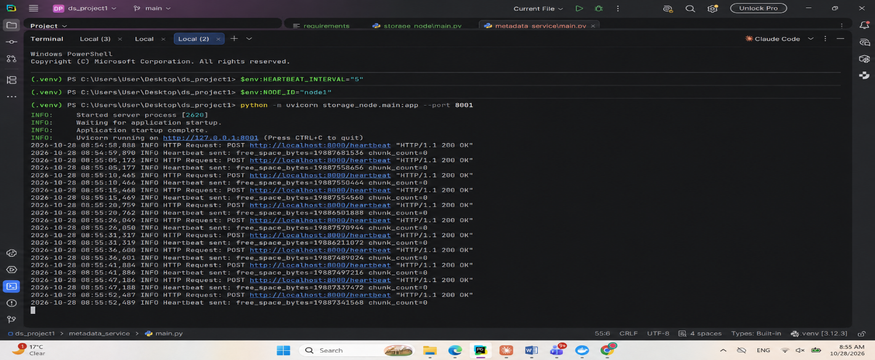
To test failure detection, the storage node was stopped. After 15 seconds without a heartbeat, the metadata service reported the node as failed. Automatic repair after a failure will be added in Task 4.
Screenshot: Stopped Node Marked as Failed
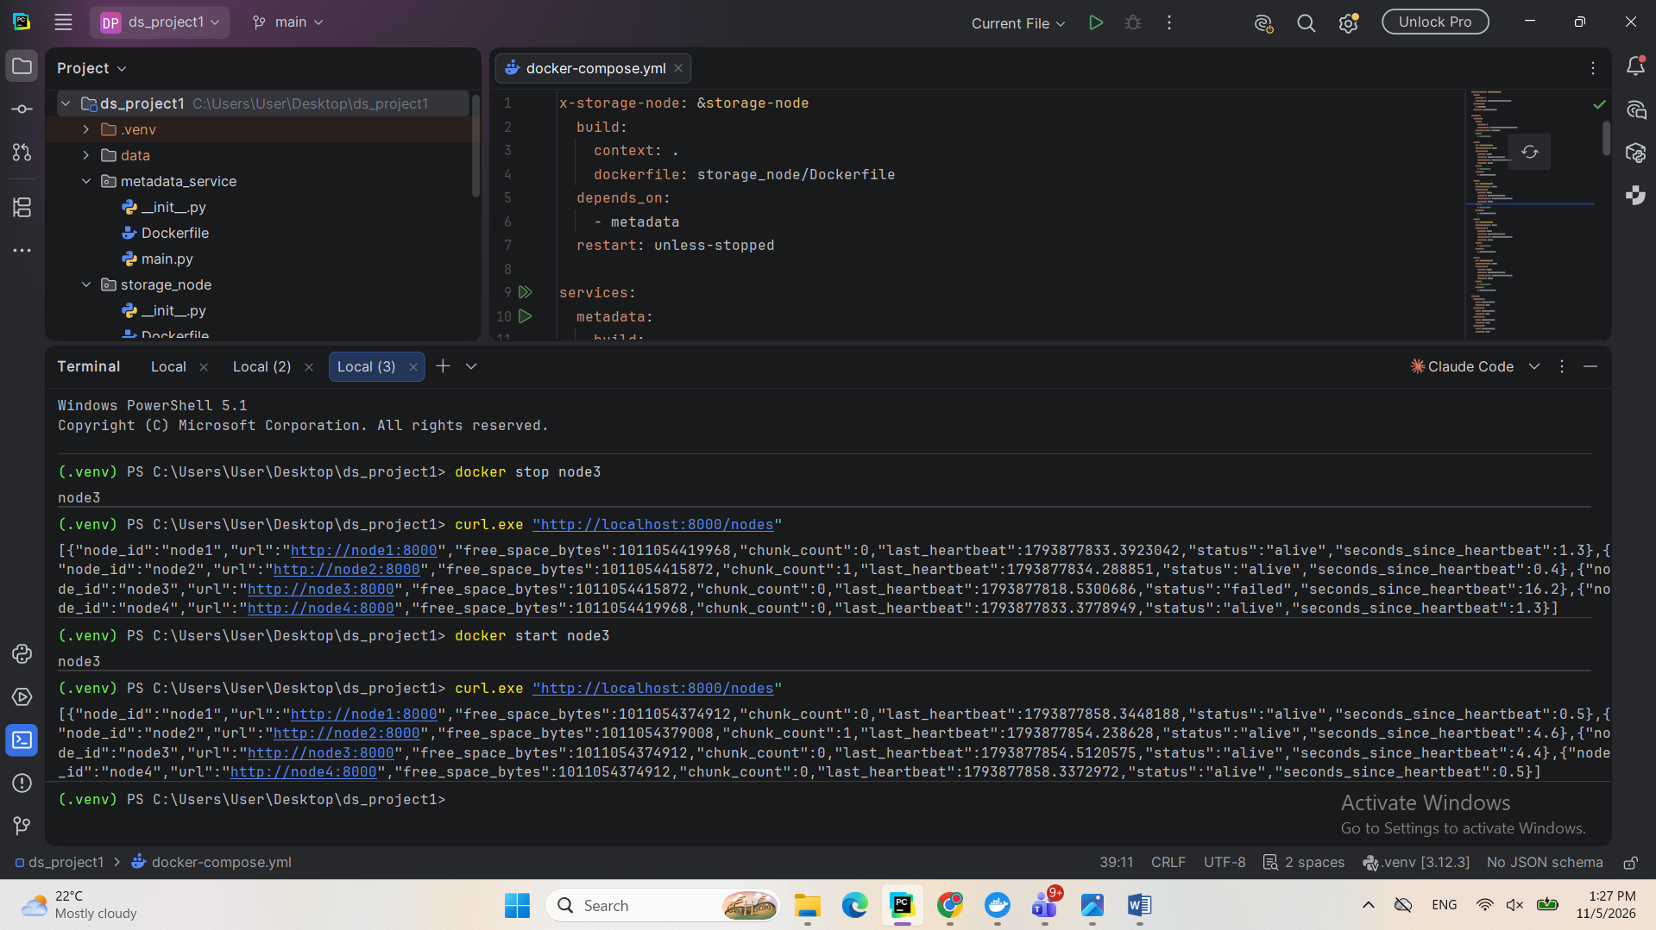

7.9 Running Four Storage Nodes in Docker
Dockerfiles were created for the storage node and metadata services, and Docker Compose was used to start one metadata container and four storage node containers. Running each node in its own container isolates it in the same way as a separate machine, and a single node can be stopped to test failures. Each node receives its own identifier through environment variables, which allows all four to run the same code. Each node also has its own Docker volume, so its chunks are stored separately and remain available if its container is recreated.
Screenshot: Metadata and Storage Node Containers Running
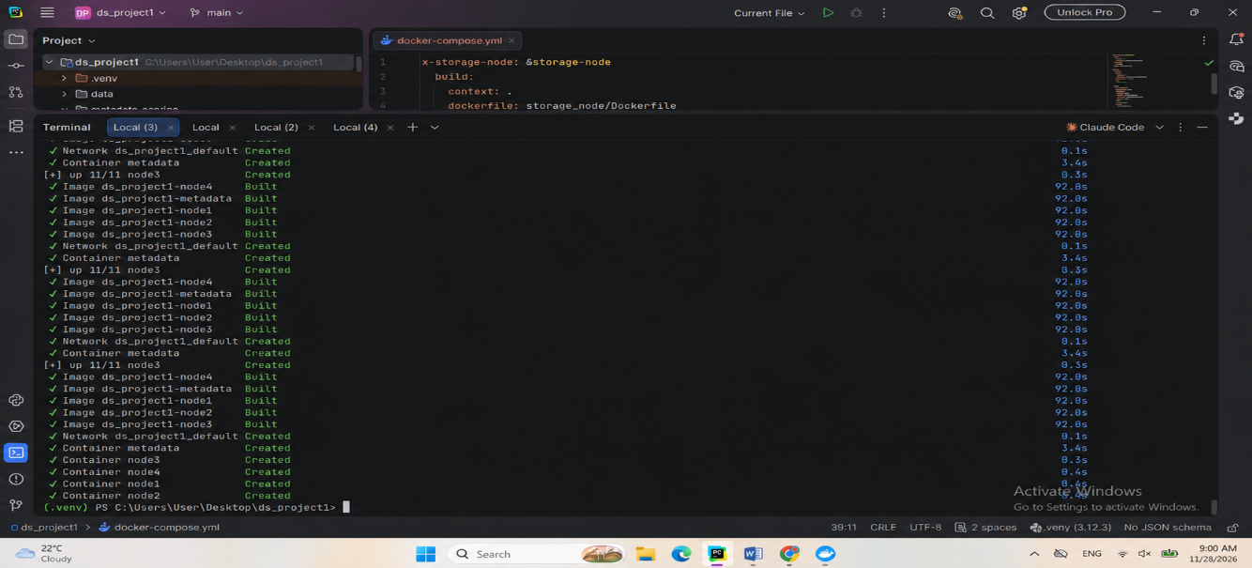
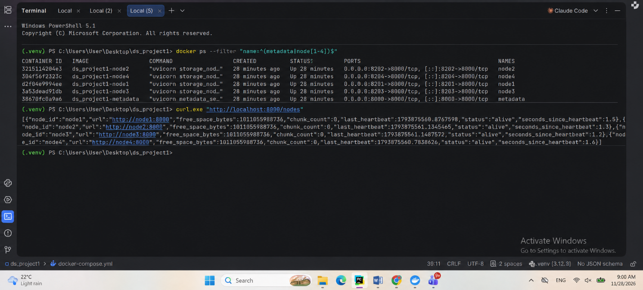
The GET /nodes endpoint was used to confirm that all four containers were sending heartbeats to the metadata service over the Docker network.
Screenshot: Heartbeats from All Four Nodes
To confirm that the containerized nodes work correctly, a chunk was uploaded to node2 and downloaded again, and its file was located inside the container’s data volume.

Screenshot: Chunk Stored on a Containerized Node
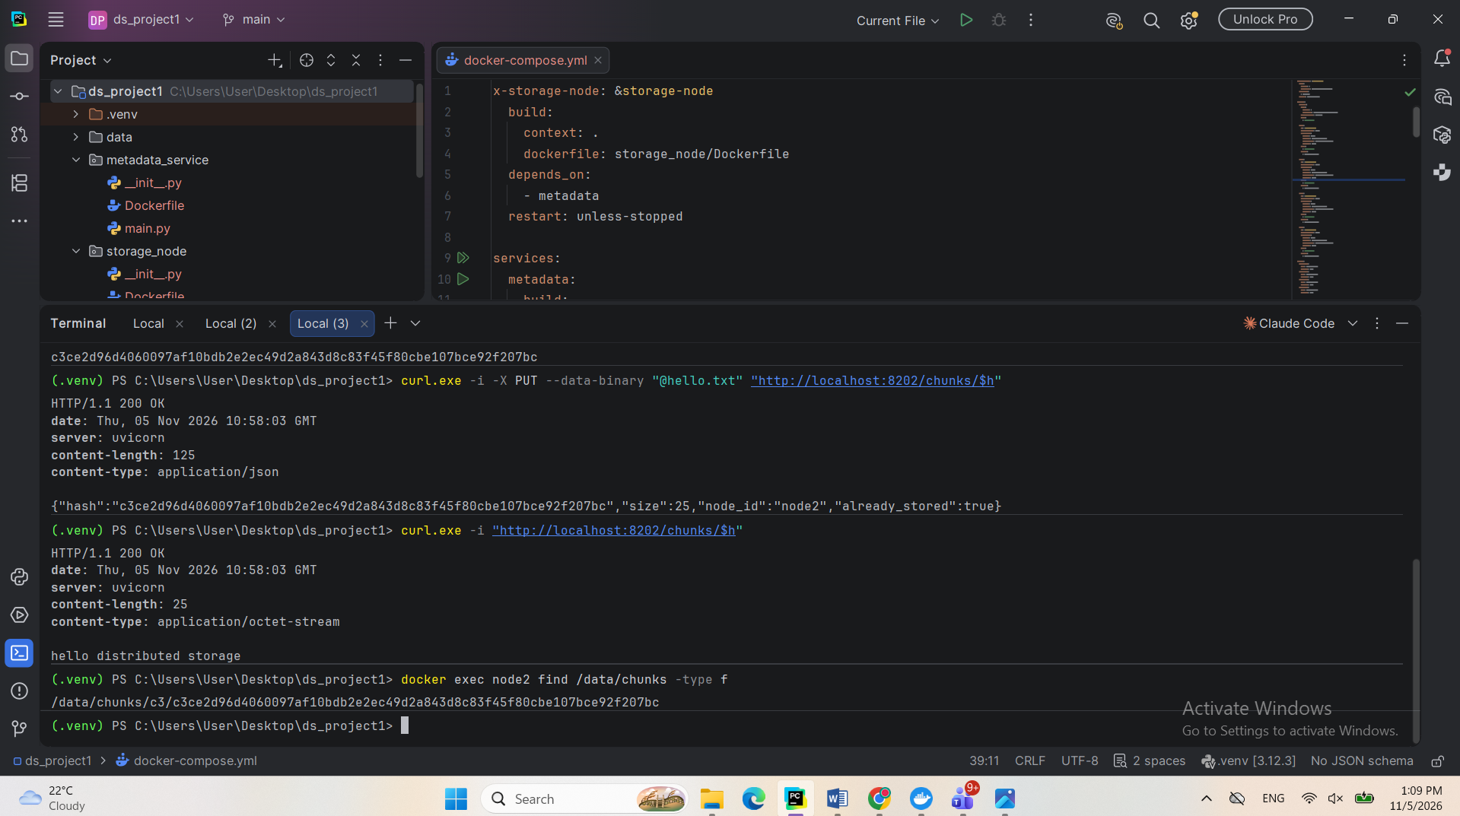
8. Task 3: Metadata and Placement Module
8.1 Objective
The objective of this task was to decide how files are divided into chunks, record which chunks make up each object, and determine which storage nodes hold each chunk. It also reduces storage cost by keeping identical chunks only once.
8.2 Fixed-Size and Content-Defined Chunking
Two chunking methods were implemented. Fixed-size chunking cuts a file every 4 MB. It is simple and fast, but inserting data near the start of a file shifts every later boundary, so the later chunks all change. FastCDC, a content-defined method, instead uses a rolling hash of the data to choose its boundaries, with minimum, average and maximum sizes of 1, 4 and 8 MB. Because the boundaries depend on the content, an insertion changes only the chunks around it, so more chunks can be deduplicated.
To compare them, 100 bytes were inserted near the start of a 4 MB synthetic file. Chunk sizes were scaled down to an average of 64 KB so that the test ran quickly in Python. After the edit, 0.0% of the fixed-size chunks were still shared with the original file, compared with 98.2% for FastCDC. The results show that FastCDC preserves far more deduplication when files are edited, while fixed-size chunking is faster and simpler.
Screenshot: Fixed-Size and FastCDC Chunking Comparison
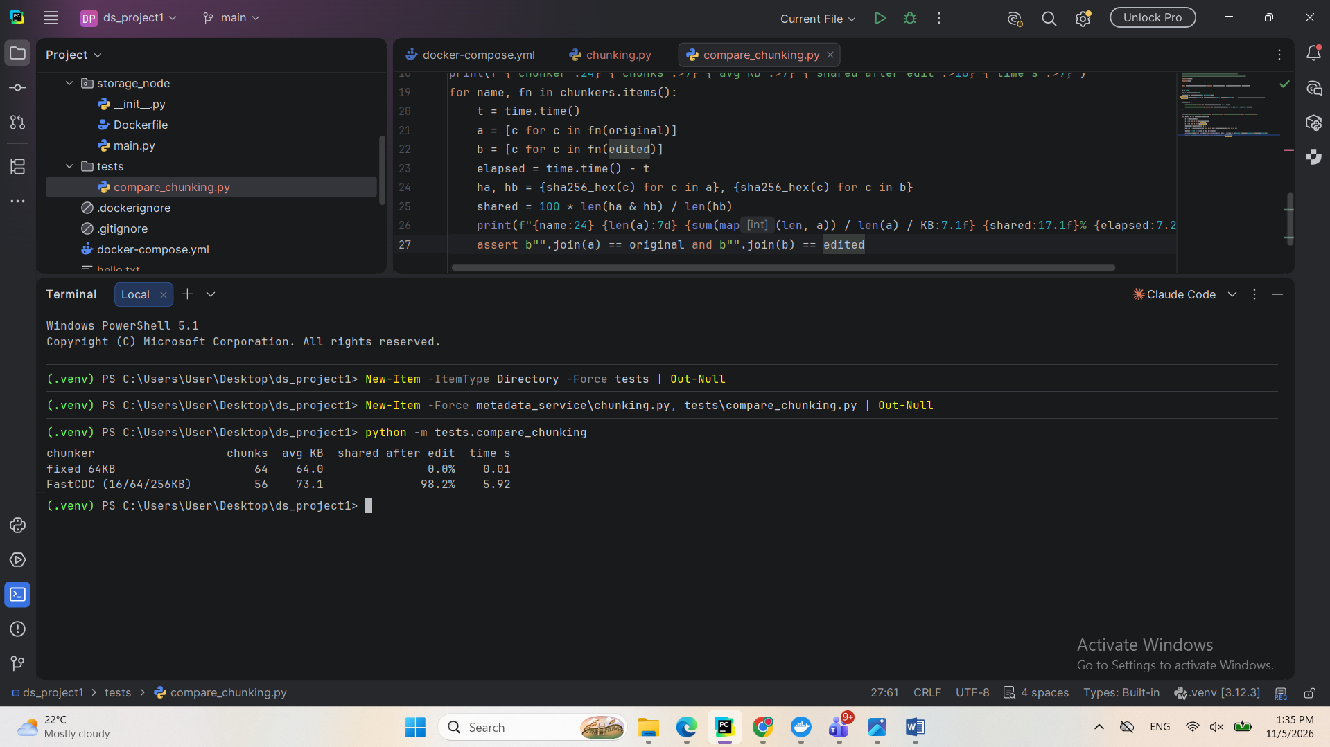
8.3 Storing Object Metadata in PostgreSQL
PostgreSQL was added as a container to store object metadata. It was chosen over etcd because its transactions can update an object and its chunk reference counts together, which keeps them consistent if an operation fails. Its data is kept in a Docker volume, so it survives container restarts. The objects table stores the bucket, key, size, version, ordered list of chunk hashes and creation date. The order of the hashes is essential because it is used to rebuild a file from its chunks. A new version number is created each time the same key is stored. A second table, chunks, stores the size and reference count of each unique chunk and will be used for deduplication.
Screenshot: Sample Object Stored and Read Back
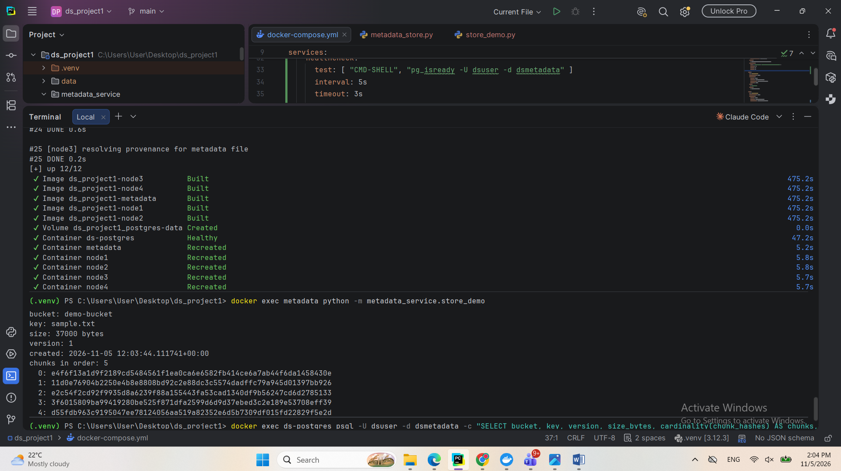The sample object was also confirmed directly in the database using a SQL query.
Screenshot: Object Metadata in PostgreSQL
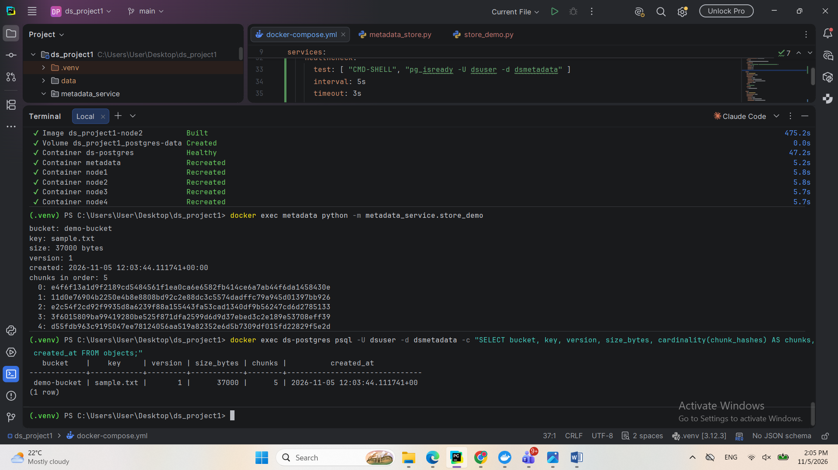
8.4 Consistent Hashing Ring
A consistent hashing ring was implemented to decide which nodes store each chunk. Nodes and chunks are mapped by hash onto the same ring, and a chunk is stored on the next three distinct nodes clockwise from its position. A simple hash modulo the number of nodes was not used because changing the number of nodes would relocate most chunks. With consistent hashing, a change affects only part of the ring. Each node also has 128 virtual nodes, meaning 128 positions on the ring, which spreads the chunks more evenly.
The placement was tested with 100,000 synthetic chunk hashes and four nodes, without transferring real data. Adding a fifth node moved 21.9% of replica copies, close to the ideal of 20%. Removing a node moved 23.5%, close to the ideal of 25%. This confirms that only a fraction of the data moves when the cluster changes. The test also compared different numbers of virtual nodes. With 1 virtual node, the most loaded node held 1.74 times the average, compared with 1.07 times with 128 virtual nodes, which shows the benefit of using virtual nodes.
Screenshot: Chunk Movement When Adding and Removing a Node
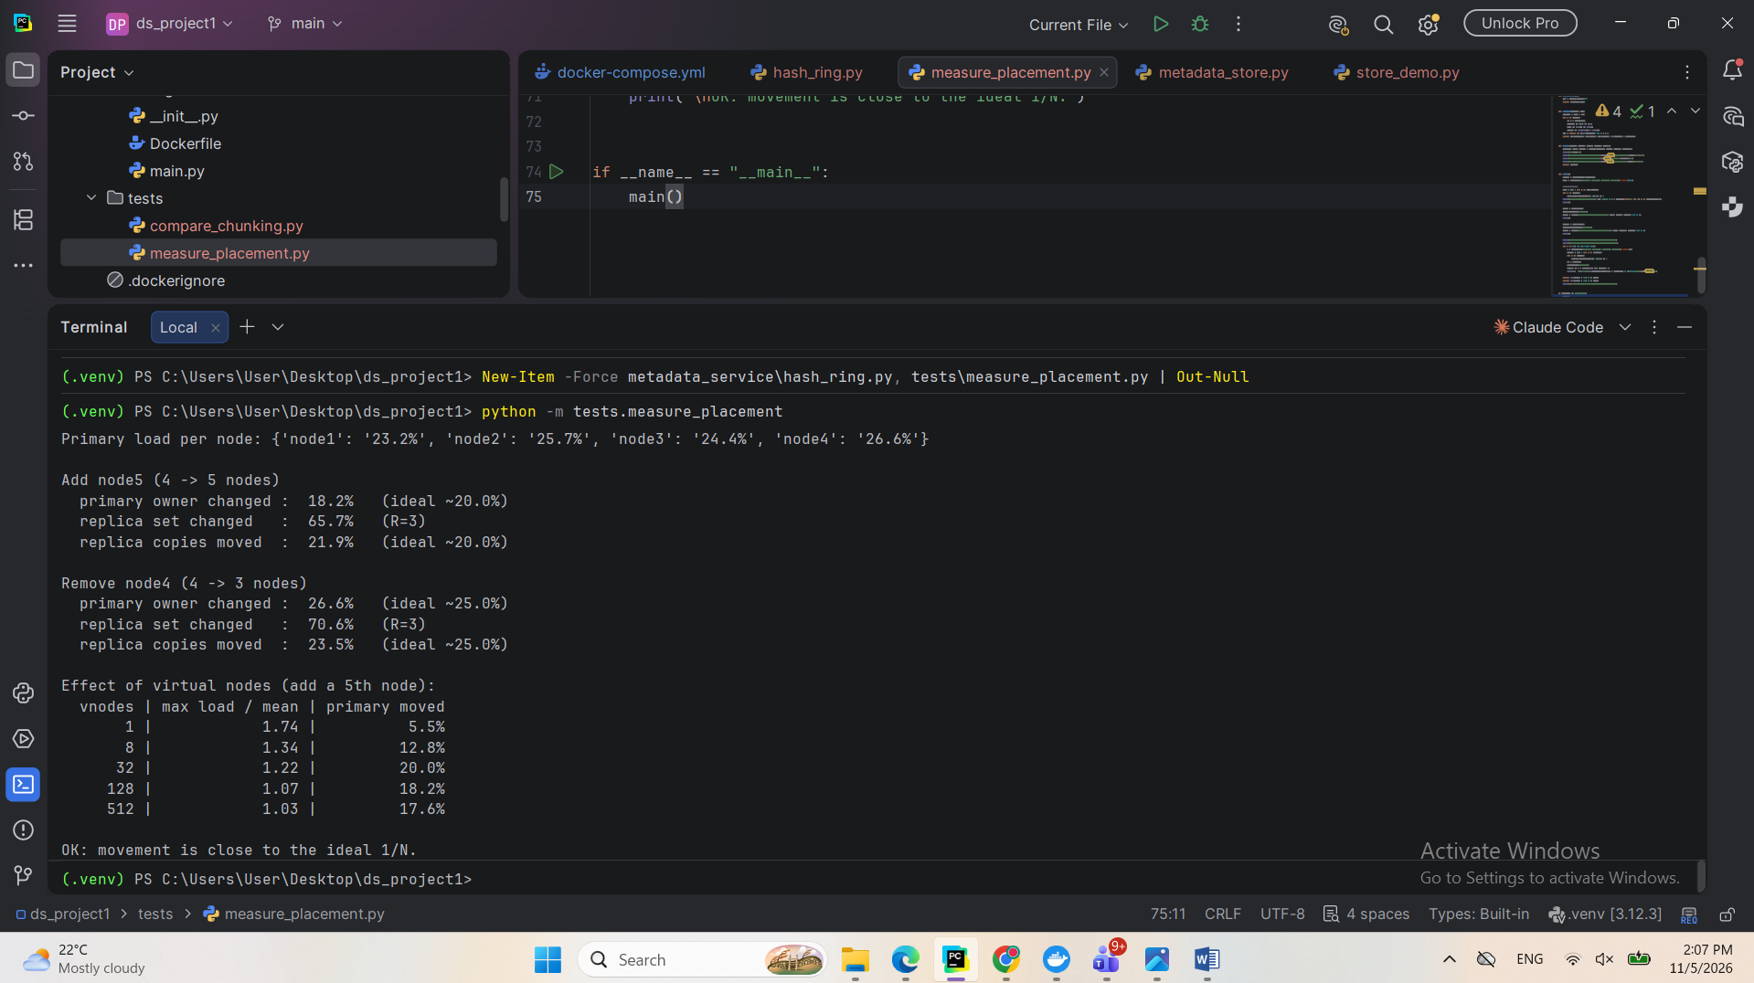
8.5 Deduplication and Reference Counting
The metadata service was extended to accept real files. Each file is split into chunks and hashed, and every new chunk is written to three nodes selected by the hash ring. Before uploading, the service records a reference to each chunk in the database. If the chunk already exists, its reference count increases and it is not uploaded again, which saves storage and network traffic.
To test this, the same 12 MB file was uploaded under two different names. The first upload stored 3 new chunks, which became 9 copies across the nodes. The second upload stored no new chunks and deduplicated all 3, which gave a deduplication ratio of 2.0.
Screenshot: Identical Upload Deduplicated

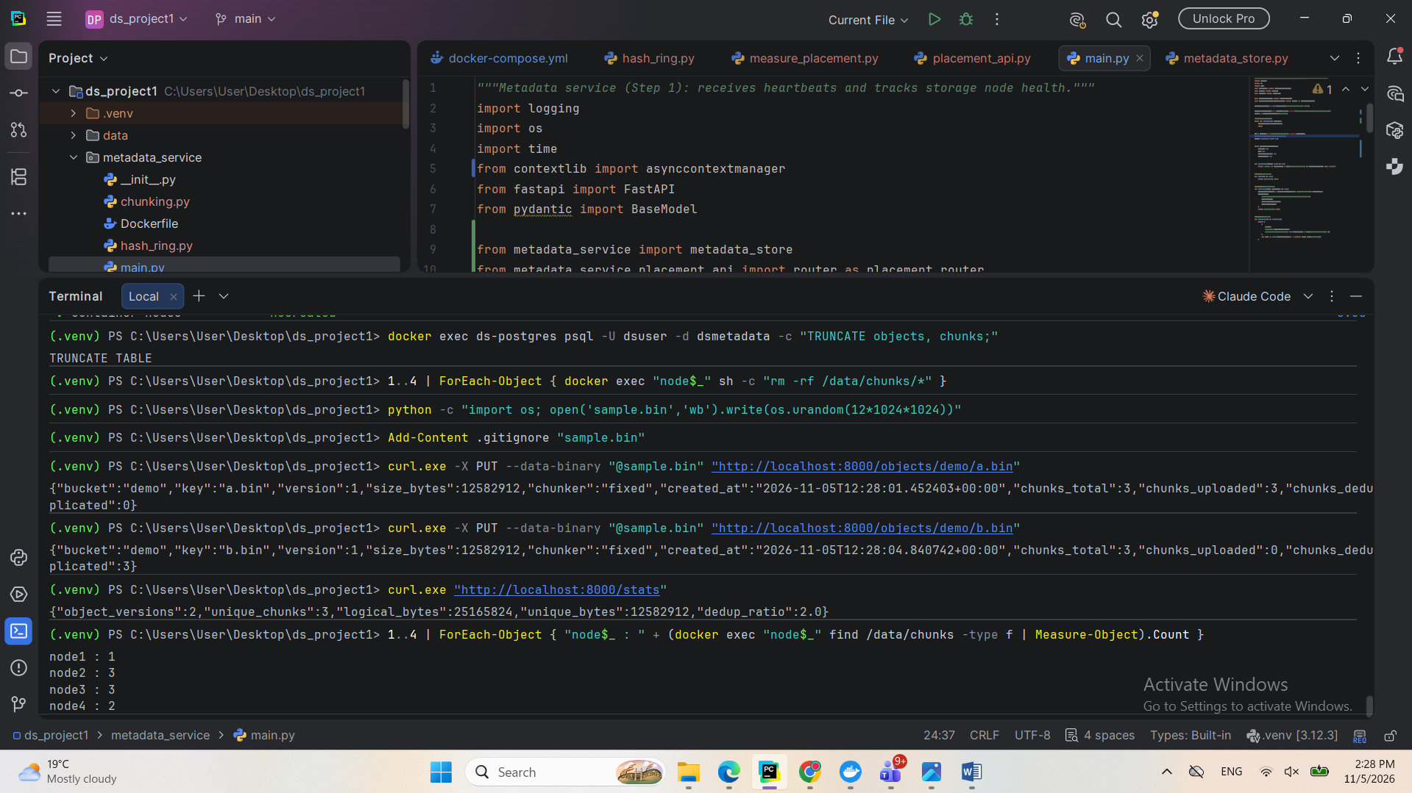
Reference counting ensures that a chunk is deleted only when no object uses it. Deleting the first name removed no chunks, and the other object could still be downloaded with an identical SHA-256 hash. Deleting the last name brought the reference counts to zero and removed the chunks from all nodes.

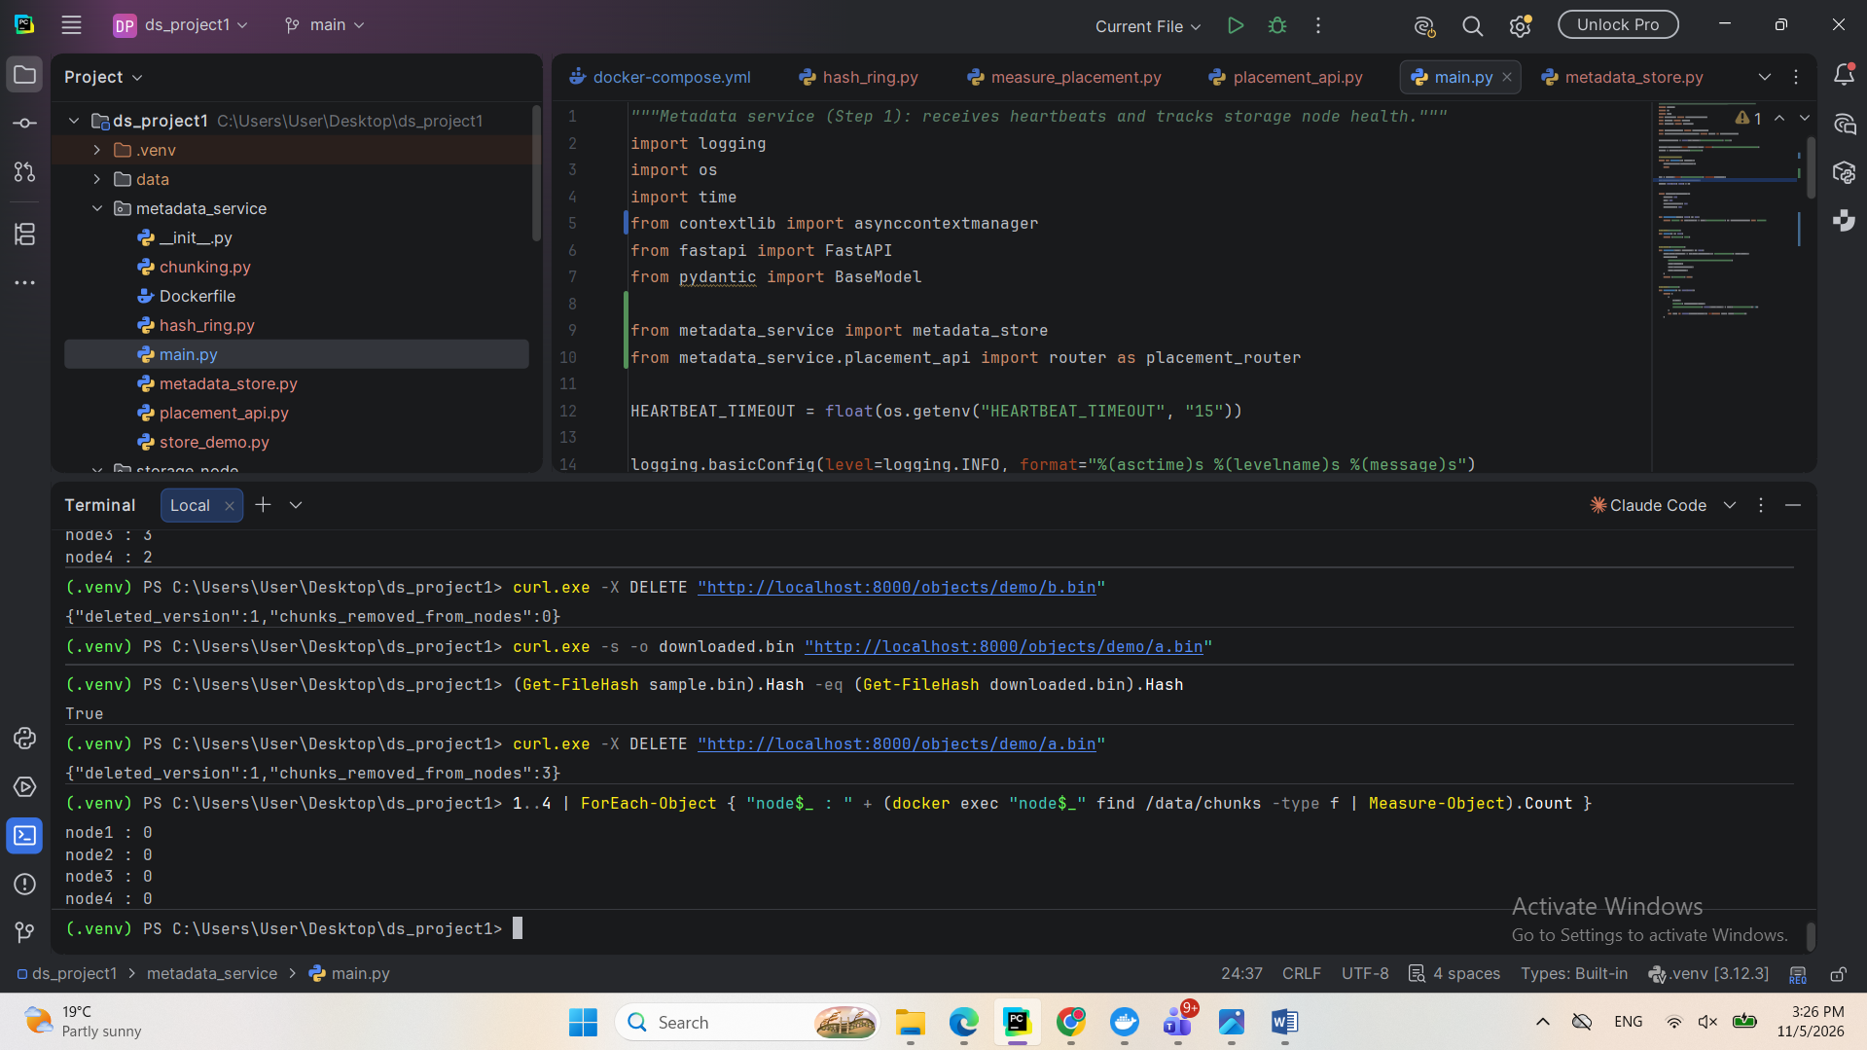
9. Task 4: Redundancy and Recovery
9.1 Objective
The objective of this task was to keep data available and correct when nodes fail or data becomes corrupted, and to compare the cost of replication with erasure coding.
9.2 Replication and Quorum
Each chunk is stored on N nodes, with a default of 3. A write succeeds only after W nodes confirm it, and a read succeeds only after R nodes return a valid copy. The default values are W = 2 and R = 2. The service refuses to start unless W + R is greater than N, because this guarantees that every read set overlaps with every successful write set. These values are configurable, so consistency and availability can be balanced as required.
With one node stopped, a new file was uploaded and an existing file was downloaded with an identical SHA-256 hash, which shows that the system continues to work during a single node failure.
Screenshot: Reads and Writes with One Node Down

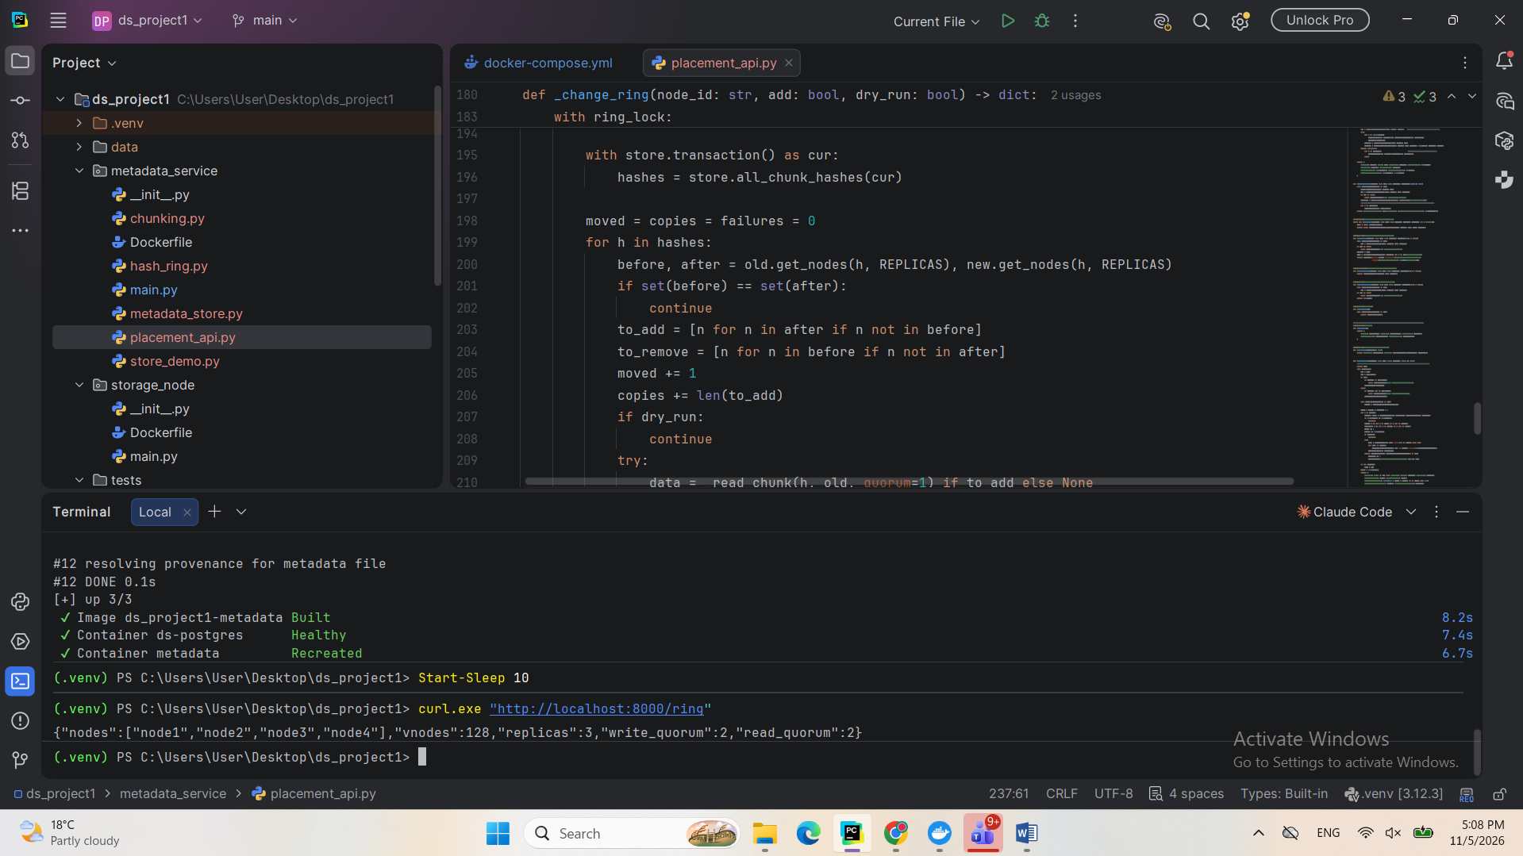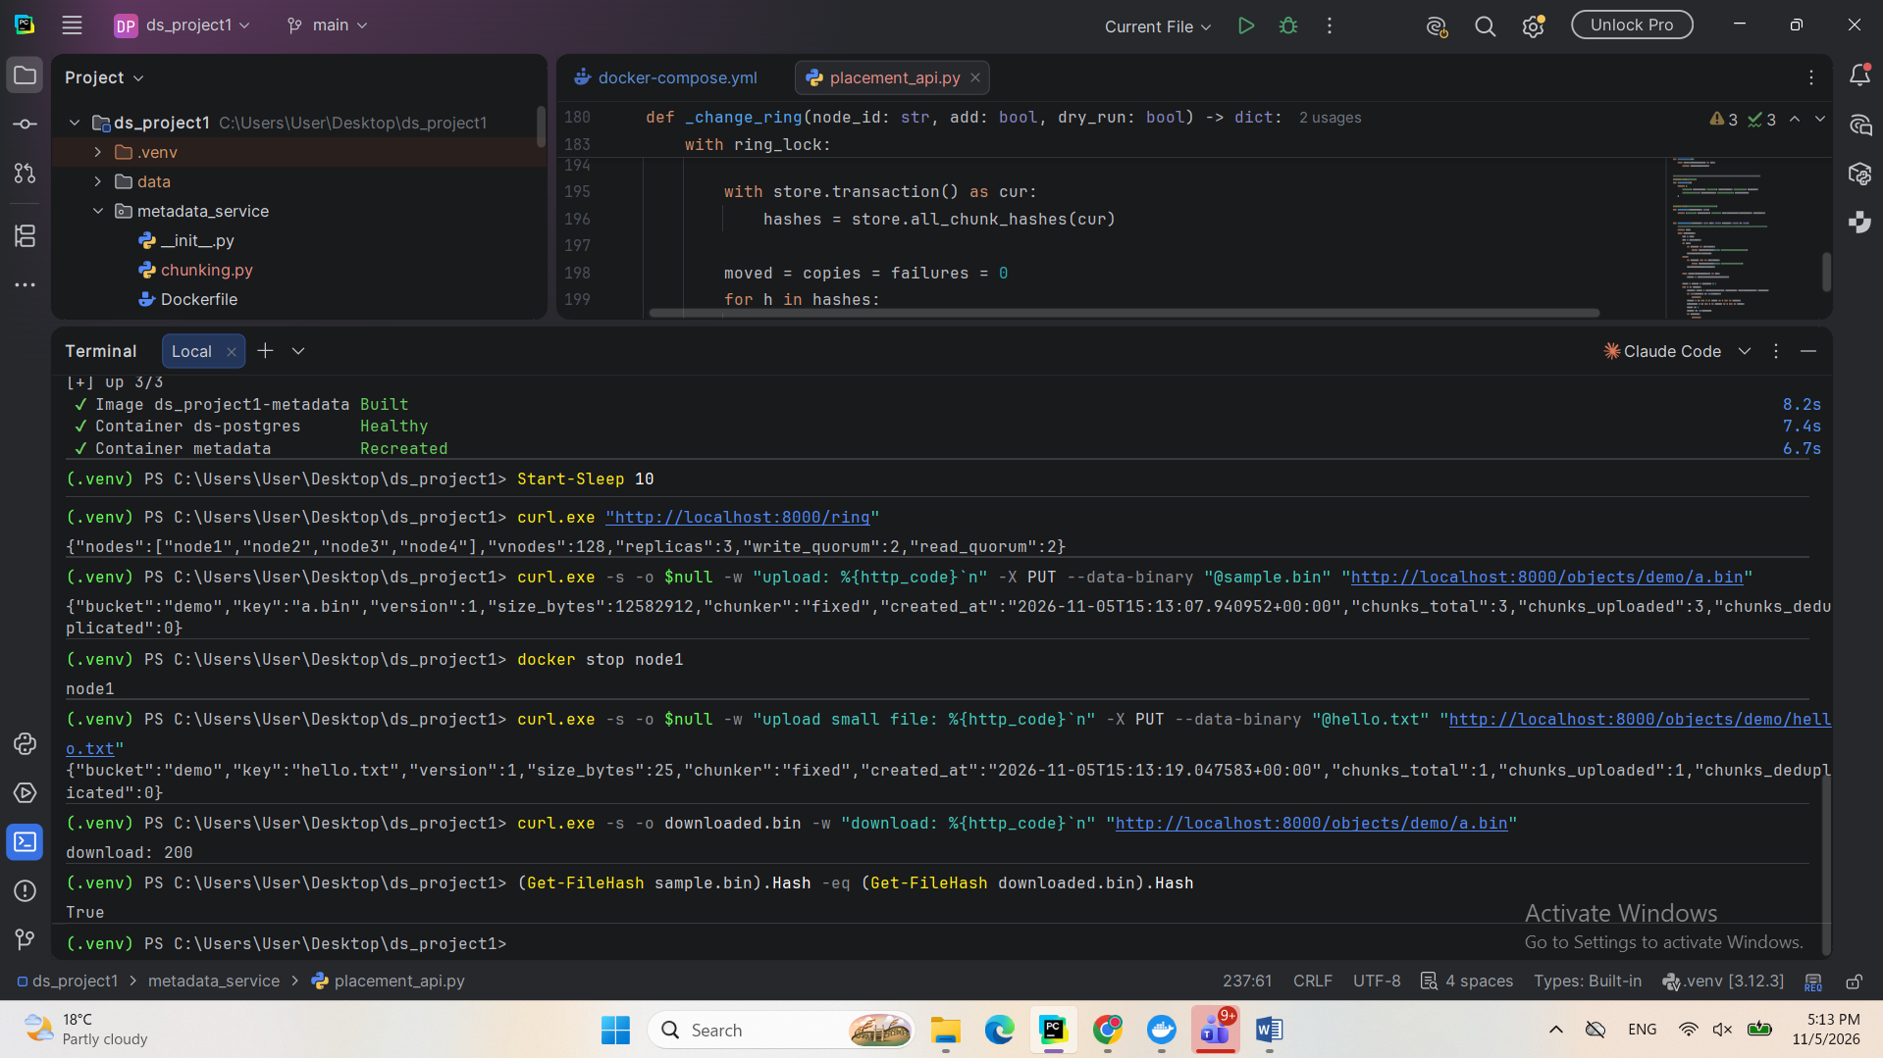
With three of the four nodes stopped, too few nodes remained to meet the quorum. Both the write and the read were rejected with HTTP 503. The system therefore reports an error instead of accepting a write without enough copies or returning data without enough confirmation.
Screenshot: Requests Rejected When Quorum Cannot Be Met

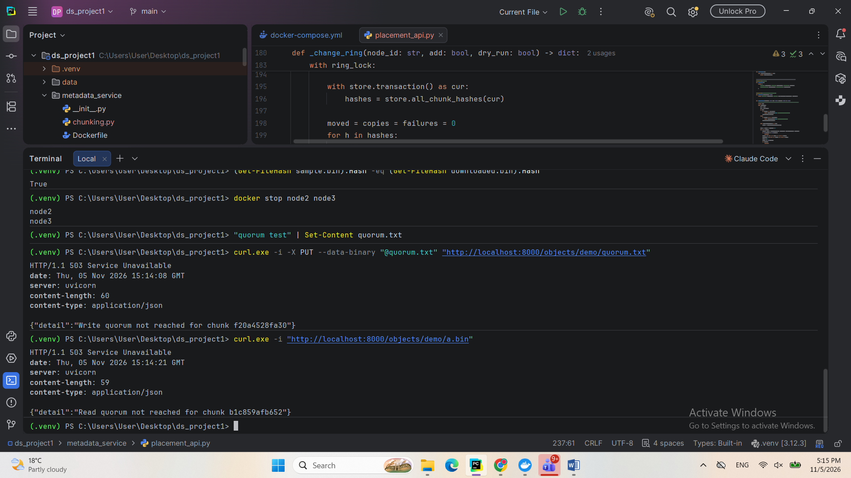
9.3 Erasure Coding
Reed-Solomon erasure coding was implemented with the zfec library and can be selected for each bucket. In the 4+2 configuration used here, each 4 MB chunk becomes 4 data fragments and 2 parity fragments of about 1 MB each, and any 4 of the 6 can rebuild the chunk. Each fragment is addressed by its own SHA-256 hash, and each is stored on a different node. For this reason, the cluster was expanded from four to six storage nodes, so that the loss of any two nodes removes no more than two fragments of a chunk. Replication remains the default mode for new buckets.
Erasure coding was chosen as an alternative to replication because it stores 1.5 times the original data instead of 3 times while also surviving two node failures. A 12 MB file stored 18 fragments of 1 MB each, or about 18 MB, compared with 36 MB under three-way replication. The cost is extra processing to encode and decode data. A write requires k + 1 fragments, so that a chunk is never stored with no spare fragment.
Screenshot: Erasure-Coded Bucket and Fragment Placement
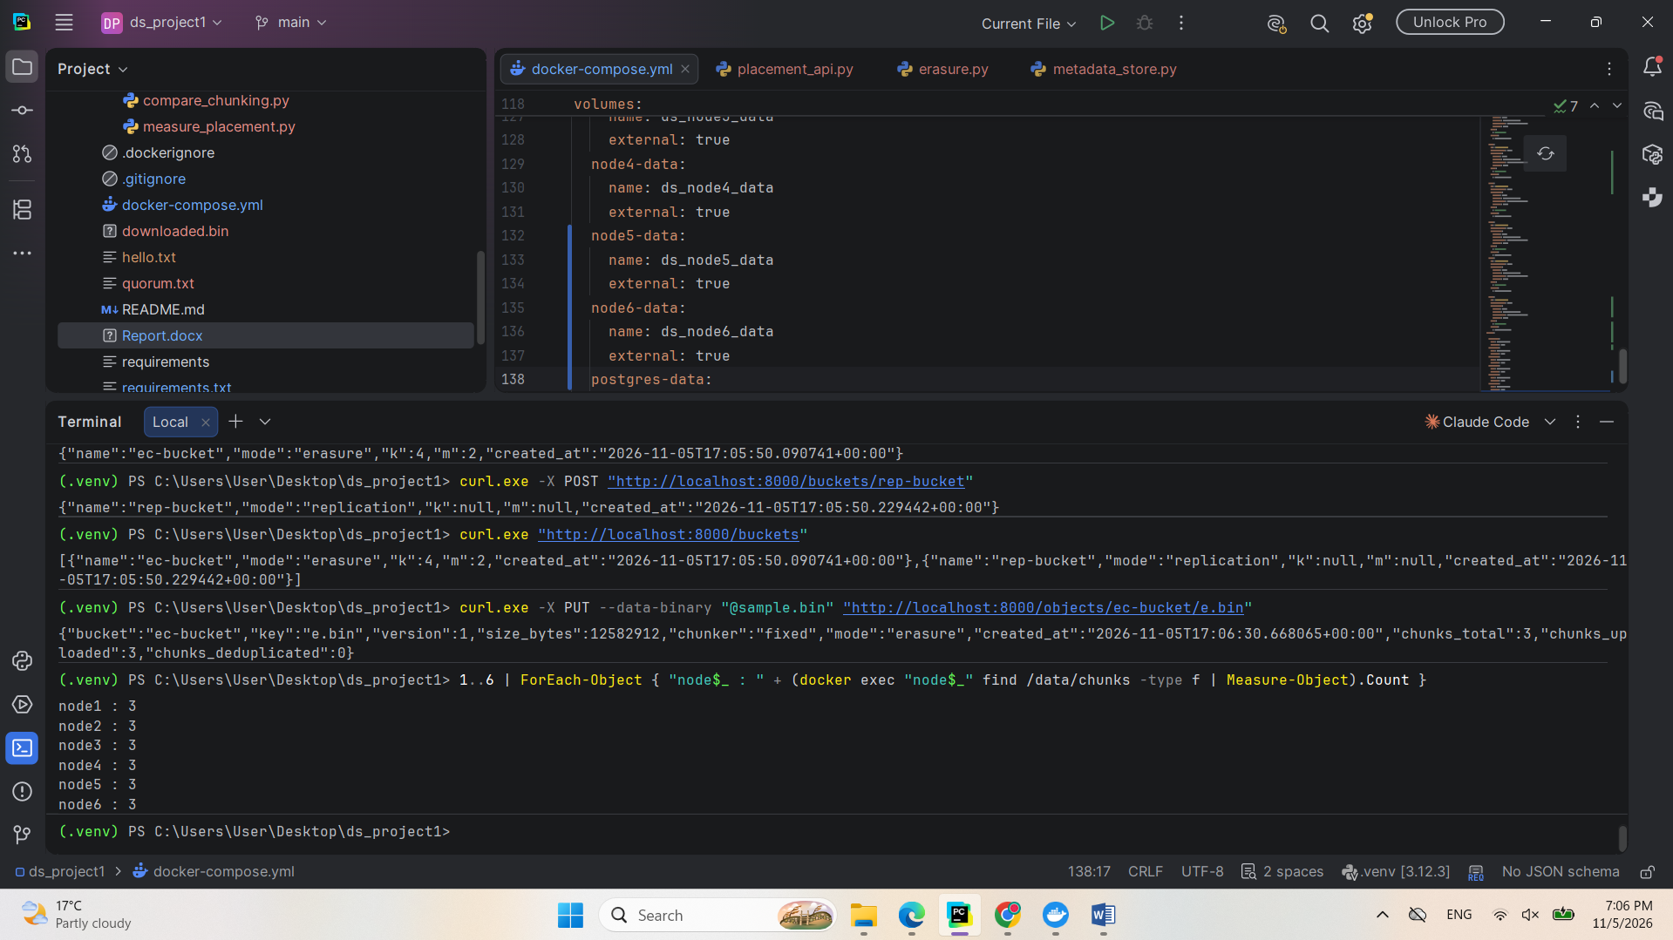With two nodes stopped, the file was still downloaded with an identical SHA-256 hash because at least 4 fragments of each chunk remained available.
Screenshot: File Rebuilt with Two Nodes Down
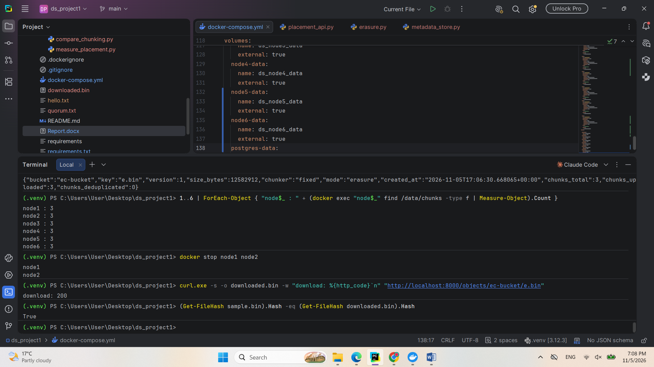
With three nodes stopped, fewer than 4 fragments remained, so the system correctly returned HTTP 503 instead of incomplete data.
Screenshot: Request Rejected with Three Nodes Down
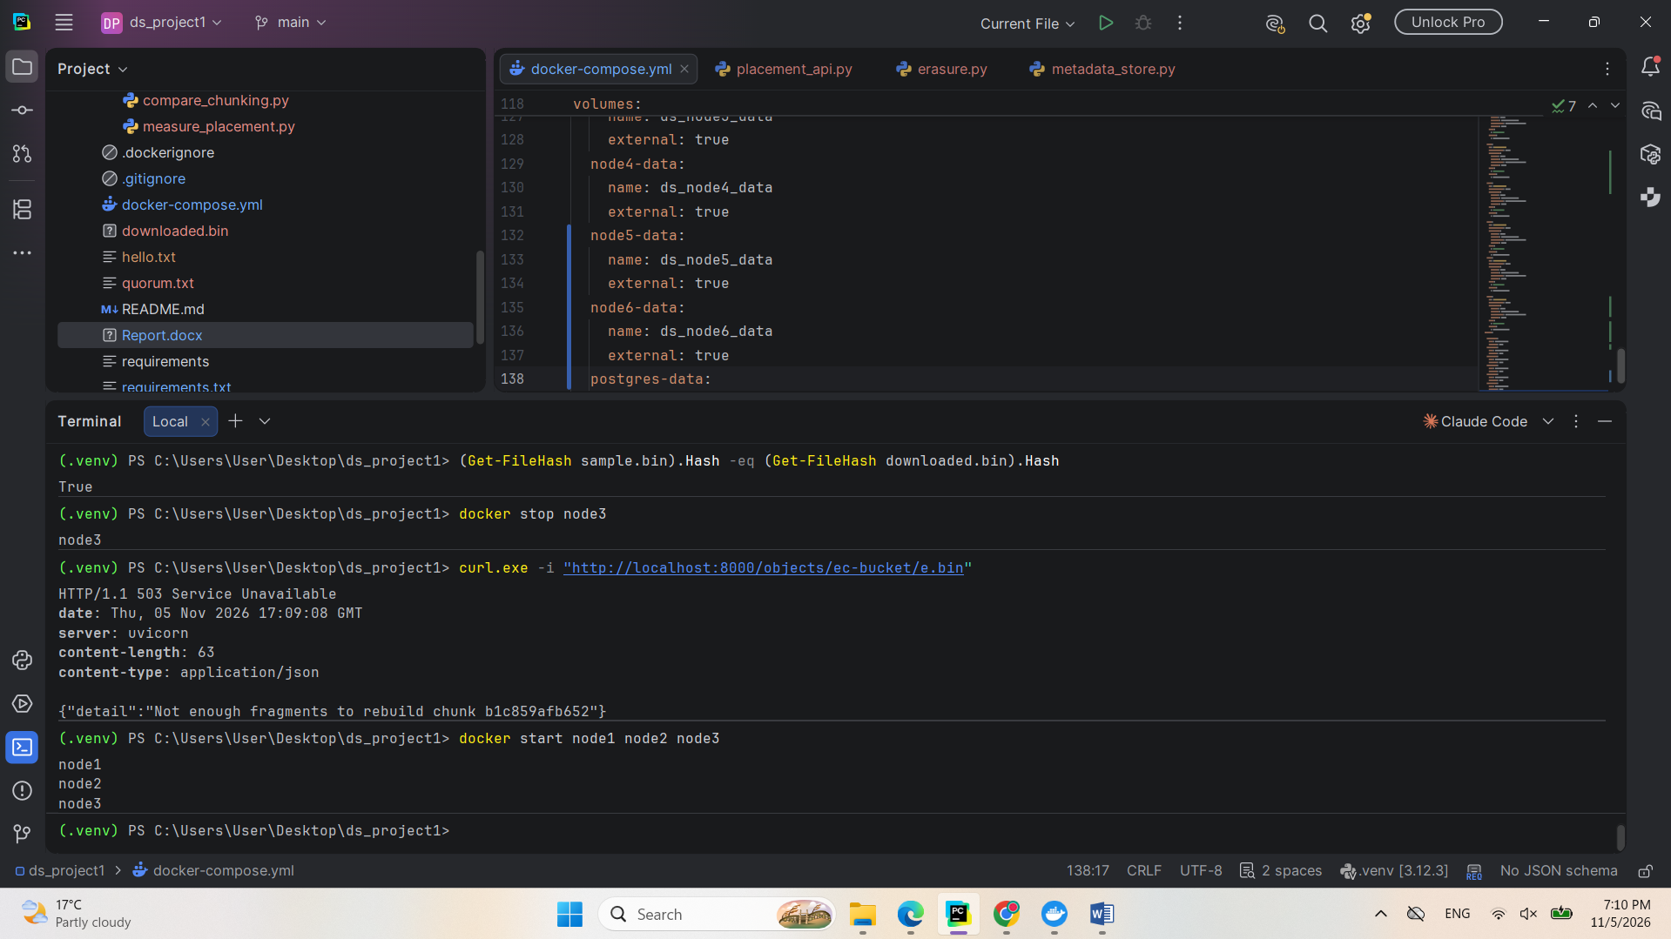
9.4 Failure Detection and Automatic Repair
The metadata service now checks node heartbeats every five seconds. A node is marked as failed after 15 seconds without a heartbeat, and it is then removed from the hash ring so that new data is not sent to it. A repair job then checks every chunk. For replicated chunks, a healthy copy is copied to another node until there are three copies again. For erasure-coded chunks, four surviving fragments are read, the chunk is rebuilt, and the missing fragment is written to another node. Progress and traffic are recorded for each job and reported through the GET /repair/jobs endpoint.
Screenshot: Objects Stored Before the Failure
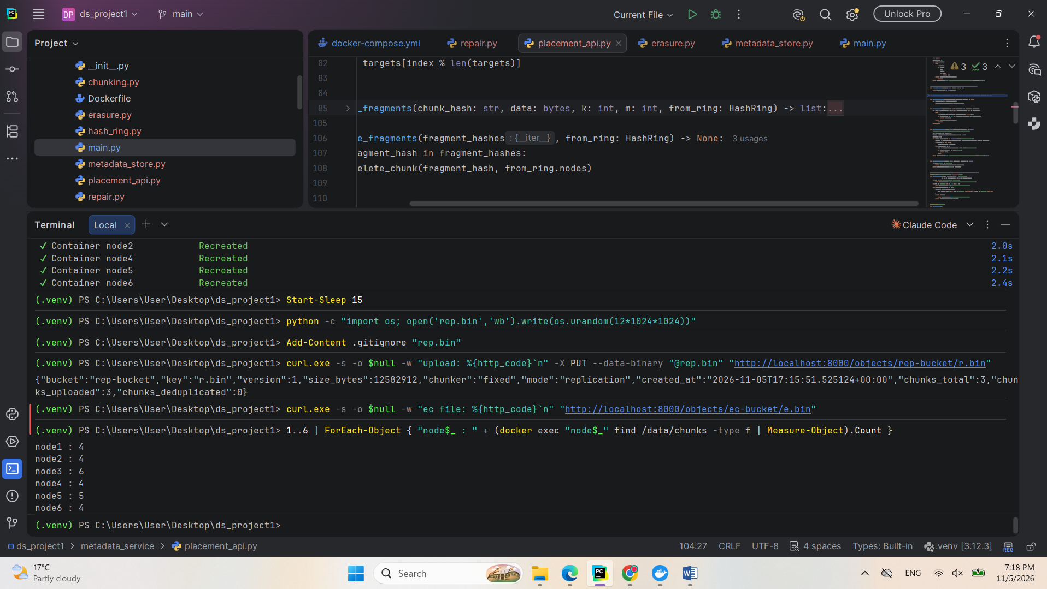To test this, node1 was stopped without any manual repair command. The service marked it as failed, removed it from the ring and completed a repair job automatically.
Screenshot: Failed Node Detected and Repair Completed
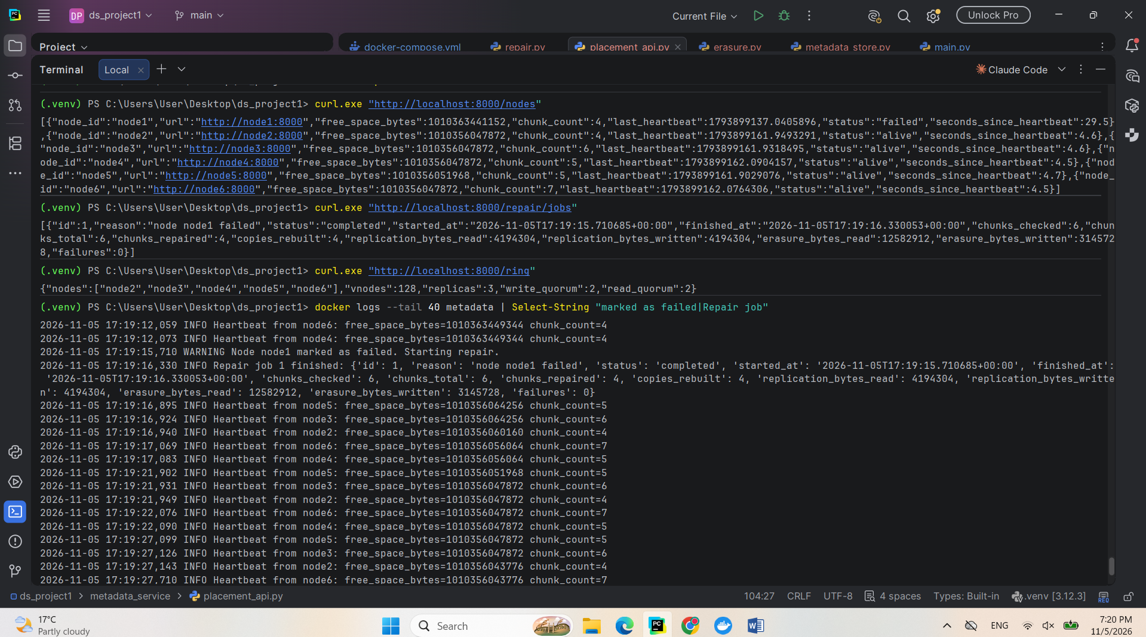After the repair, both files were downloaded with identical SHA-256 hashes. When node1 was restarted, its heartbeats resumed and it returned to the ring. One limitation is that a chunk deleted while a node is offline can remain on that node as an unused file until it is cleaned up.
Screenshot: Files Verified and Node Returned to the Ring
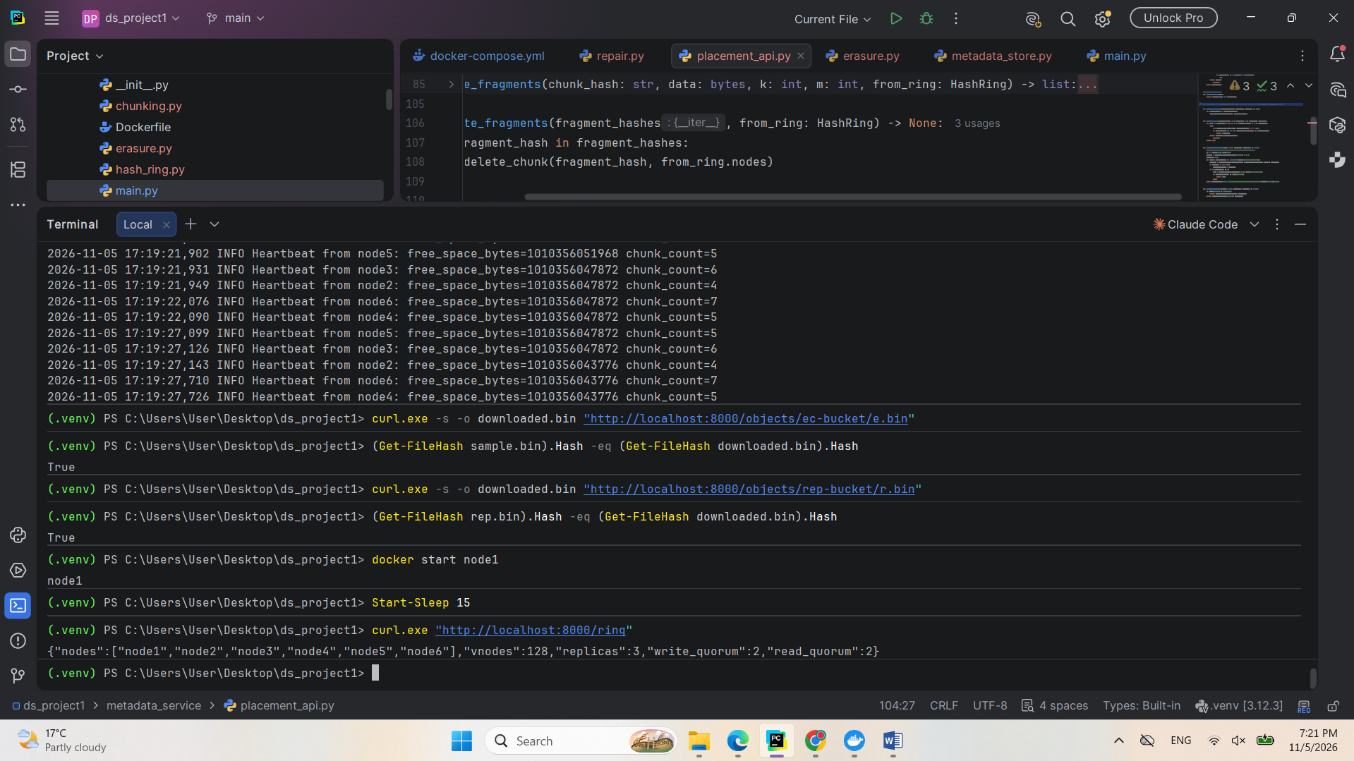
9.5 Background Scrubber
Reading a chunk verifies only the copy that is read, so a corrupted copy could stay unnoticed until it is needed. This is known as bit rot. To detect it early, a background scrubber was added to the metadata service. By default, every five minutes it reads every chunk and fragment on every node and verifies its SHA-256 hash. The scrubber can also be started on request through POST /scrub/run. When a copy is corrupted, it is deleted and restored from healthy data: a replicated chunk is copied from another replica, and an erasure-coded fragment is rebuilt from its surviving fragments.
To test this, one replicated chunk and one erasure-coded fragment were overwritten directly on disk.
Screenshot: Stored Data Corrupted on Disk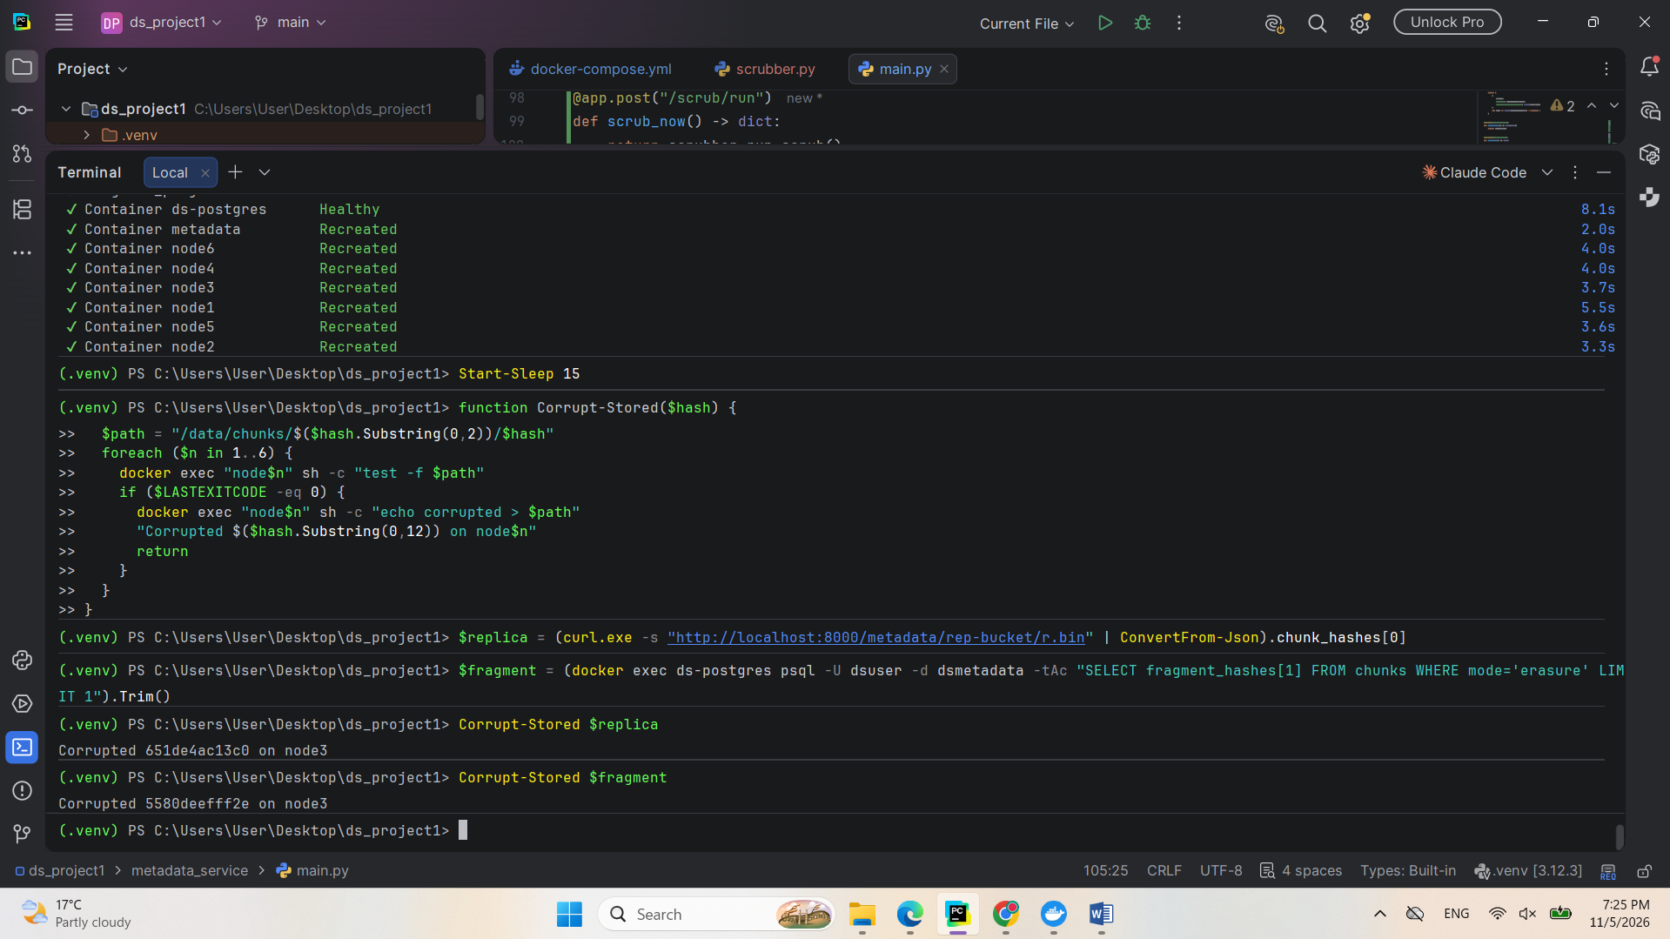
The scrubber found both corrupted copies and rebuilt them.
Screenshot: Scrubber Detecting and Repairing Corruption
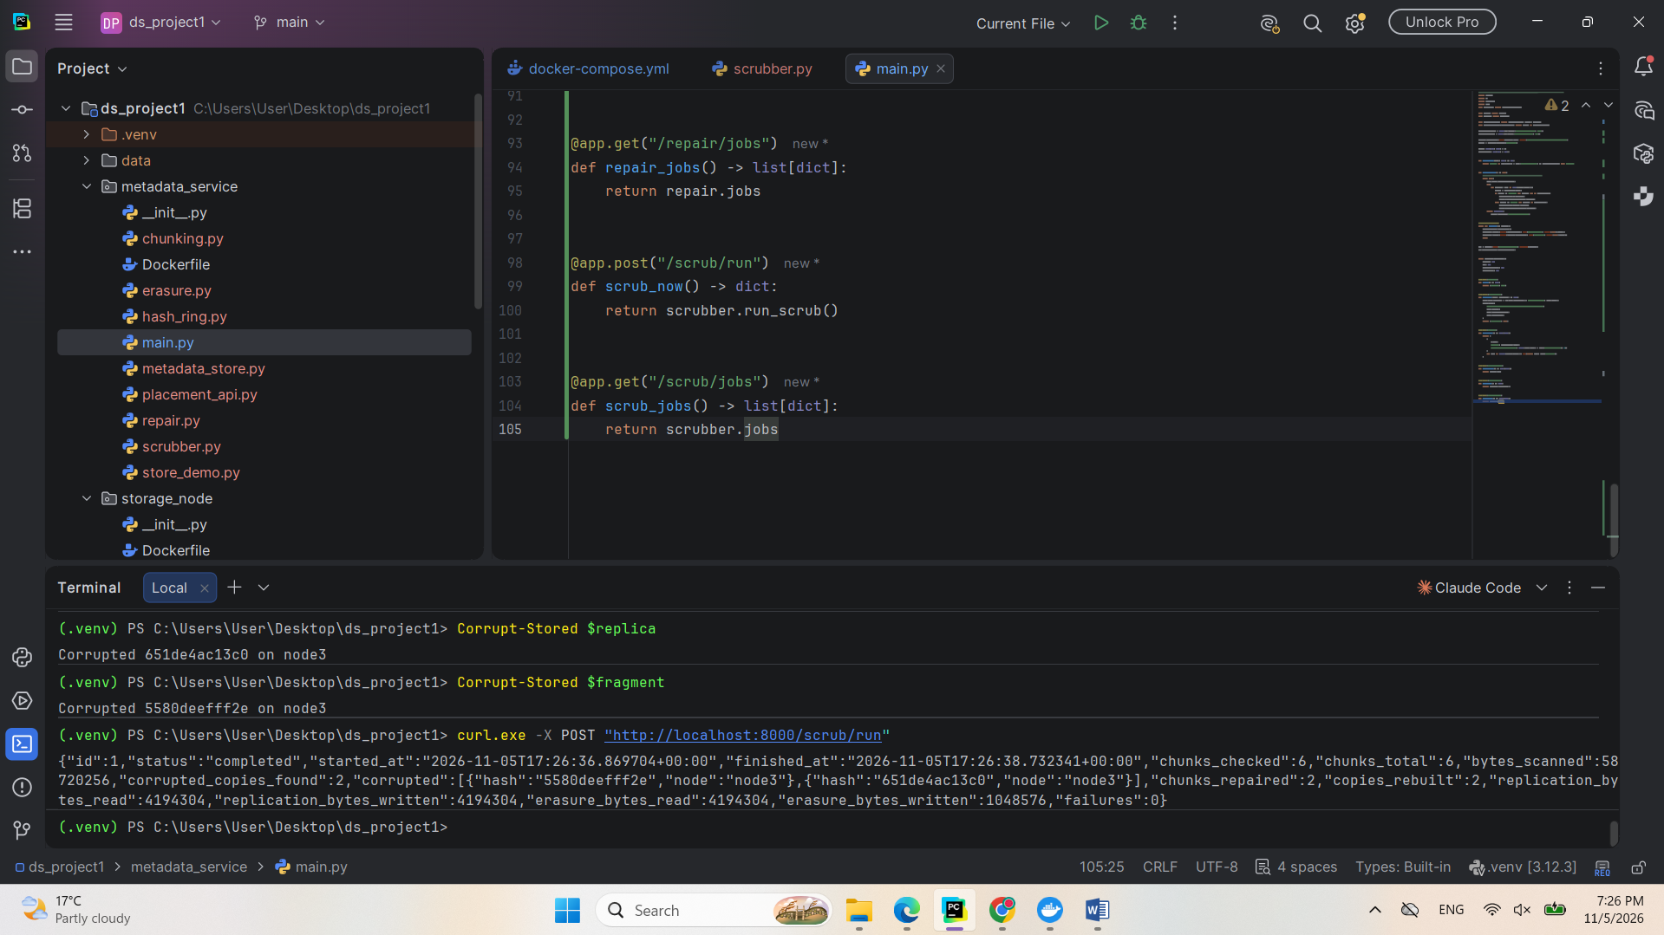Both files were then downloaded with identical SHA-256 hashes, and a second scrub found no corrupted copies, which confirms that the repair succeeded. Because every copy is read, scrubbing creates extra disk and network load, so it runs periodically rather than continuously.
Screenshot: Files Verified and Second Scrub Clean


