POLITECNICO DI MILANO

SOFTWARE ENGINEERING 2

Design Document

Mirjam Škarica

Milan, December 2014.

Table of Contents
1. Introduction 1
1.1 Purpose 1
1.2 Acronyms 1
2. System Architecture 3
2.1 JEE architecture overview 3
2.2 Identifying subsystems 5
3. Persistent data management 7
3.1 Conceptual design 7
3.3 Logical Design 10

1. Introduction

1.1 Purpose
The purpose of this document is to provide a comprehensive description of the structure of the MeteoCal system. It will state and analyze the design decisions made in order to satisfy all the requirements stated in the Requirements Analysis and Specification Document (RASD). This document is meant mainly as a guideline for developers of the software in question.

1.2 Acronyms
The following are some acronyms and their corresponding terms used throughout the document:
- CSS: Cascading Style Sheets
- DB: Database
- DBMS: Database Management System
- EIS: Enterprise Information System
- ER (model): Entity–Relationship (model)
- HTML: HyperText Markup Language
- HTTP: Hypertext Transfer Protocol
- JEE: Java Platform Enterprise Edition
- JMS: Java Message Service
- JSP: JavaServer Pages
- MCV: Model View Controller
- RASD: Requirements Analysis and Specification Document
- UML: The Unified Modeling Language

2. System Architecture

2.1 JEE architecture overview
Developing a system using Java Enterprise Edition (JEE) is one of the requirements imposed by the client. Having that in mind, an overview of JEE architectures given bellow (fig 2.1).
JEE follows the distributed multi-tiered application approach which means the entire application may not reside at a single location, but is distributed. JEE is divided into four tiers:
- Client tier: runs on the client machine and provides a dynamic interface to the middle tier, JEE server (fig 2.1) by interacting directly with users and communicating with the aforementioned server. The client tier distinguishes two types: application client and web client. The former being a standalone desktop application, and the latter usually a web browser. MeteoCal will be implemented as a web client.
- Web tier: runs on the JEE server and comprises of JavaSever Pages (JSP) and Java Servlets. Basic idea is the following. A servlet receives HTTP requests from the client tier and forwards the data to the business tier. After receiving a response from the business tier, dynamic web pages are generated using JSP and
- are sent back to the client.
- Business tier: runs on the JEE server and contains the application's logic. It processes data received from the client and data retrieved from the database (DB) in order to send a response back to the client. There are three types of business components in the JEE architecture:
  - Session Beans: represent a session with a client. Being a transient object, they lose their data when the session terminates
  - Java Persistence Entities: entity beans are persistent objects and retain data even after the session. (e.g. they represent a row of data in a database table).
  - Message-Driven Beans: used for receiving the receiving the Java Message Service (JMS) messages asynchronously.
- Enterprise Information System (EIS) tier: runs on the Database Server and is responsible for storing and retrieving all persistent data.
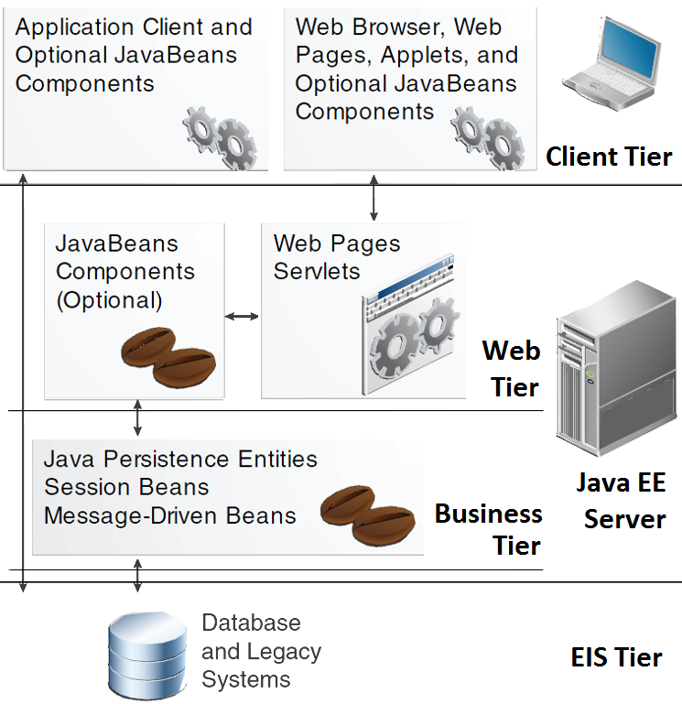

Fig 2.1

2.2 Identifying subsystems
MeteoCal system is broken-down into smaller subsystems by using a top-down approach. This is done in order to distinguish logically separate components so their role in the entire system is more understandable, making their functionality easier to identify and implement.
Subsystems (Fig 2.2) are derived from the functional requirements stated and described in the RASD document.
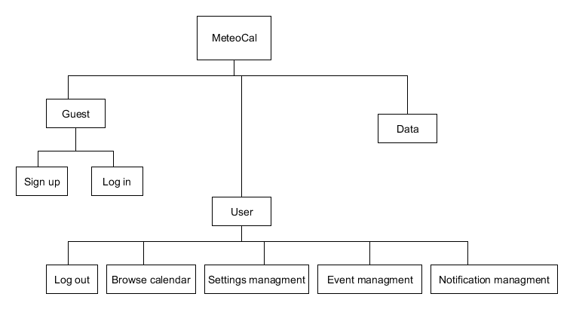Fig 2.2
Brief description of each subsystem's functionality is given below:
- Guest subsystem allows clients access to the application :
  - Log in: allows existing users to access the application
  - Sign up: allows new clients to register and log in
- User subsystem allows logged in clients (users) the full use of
- MeteoCal system's functionalities:
  - Log out
  - Browse calendar
  - Event management: allows users to create events, and the possibility to update and delete them
  - Notification management: depending on the type of notification received (weather or invitation), user can view it and in the case of an invitation notification, he can choose to accept or decline it
  - Setting management: allows users to change their settings, such as email or password.
- Data subsystem: is the subsystem where all the persistent data is stored (like the weather information)

3. Persistent data management
MeteoCal system's data will be stored into a relational database. Different diagrams of the DB schema are provided in order to identify and gain a deeper understanding of the system's underlying physical structure.

3.1 Conceptual design
Conceptual view of system's data communicates a clear picture regarding the entities we want to store and relationships between. The entity-relationship diagram, fig 3.2, is derived from Class diagram stated in the RASD document, Chapter 5.2. Some minor changes in the reference to the class diagram have been introduced for the sake of simplicity. They will be pointed out in the short explanation of the ER diagram bellow.
Event stores all information regarding an event. The class diagram suggests the inheritance relationship between Event, OutdoorEvent and IndoorEvent should be modeled using a disjoint constraint (fig 3.1). However, since the two classes differ minimally, instead of the constraint, a boolean attribute is_outdoor is added to the event entity to differentiate the two types of events.
Event
end_time
event_id
title
start_time
description
d
OutdoorEvent
IndoorEvent
Event
end_time
event_id
start_time
description
title
is_outdoor
Fig 3.1

Fig 3.2 Entity-Relationship diagram
Event
end_time
event_id
title
start_time
description
has
1
Location
address
long
lat
location_id
User
username
user_id
email
password
is_outdoor
1
has
1
Weather
updated_date
is_bad_weather
weather_id
info*
created
invitedTo
participatesIn
1
1
1:N
0:N
0:N
0:N
0:N
Notification
notification_id
timestamp
has
linksTo
1:N
1
0:N
1
0:N
description
is_invitation

User stores all information regarding a user.
Location stores all information about an event's location. With attributes lat and long representing location's latitude and longitude, respectively.
Weather stores available weather forecast information given the event's
time and location. Attribute info* is introduced to avoid unnecessary clutter in the ER diagram. Info* is a substitution for the following boolean attributes: sun, rain, thunderstorm, clouds, snow and one float attribute temperature.
Notification stores all notifications users receive. Two possible types are weather and event notification. Taking the class diagram into consideration, their relationship should be modeled using a disjoint constraint, but is instead differentiated much in the same way Event entity is, by introducing a boolean attribute is_invitation.

Relations:
Event has Location: each event has exactly one location, and each location is associated with exactly one event.
Event has Weather: each event has exactly one weather forecast information, and each weather forecast information is associated with exactly one event.
User created Event: a user can create zero or more events, but each event has to be created by exactly one user.
User invitedTo Event: a user can be invited to zero or more events, an event can have zero or more users invited
User participatesIn Event: a user can participate in zero or more events, but each event has to have at least one user participating (the user who created the event is automatically considered a participant)
User has Notification: each user can have zero ore more notifications, each
notification is associated with one or more users
Notification linksTo Event: each notification links to exactly one event, but each event can produce zero or more notifications

3.3 Logical Design
The logical view of system's data is the table schema of its database. It is derived by translating the ER diagram by applying the following transformations :
Entities:
- Each entity turns into a table
- Each attribute turns into a column in the table
- The primary key of each entity becomes the primary key of table
Relations:
- 1:N relation: take the primary key of the relation on the “1” side and set it as a foreign key for the table on the “N” side
- 1:1 relation: there is a choice which table will receive the primary key of the other as its foreign key. Usually, if the dependent entity can be determined, it receives the foreign key.
- N:N relation: each such relation turns into a separate table and the keys of the two entities are set as the primary key

The model obtained after this process is the following:
Table name | Attributes (*Primary keys are denoted by underlining the attribute name)
USER | user_id, email, username, password
EVENT | event_id, creator, title, end_time, start_time, description, is_outdoor
LOCATION | location_id, event_id, is_outdoor, address, latitude, longitude
WEATHER | weather_id, event_id, update_date, is_bad_weather, sun, rain, thunderstorm, clouds, snow, temperature
NOTIFICATION | notification_id, event_id,description, is_invitation, timestamp
PARTICIPATION | user_id, event_id
INVITATION | user_id, event_id
USER_  NOTIFICATION | user_id, notification_id

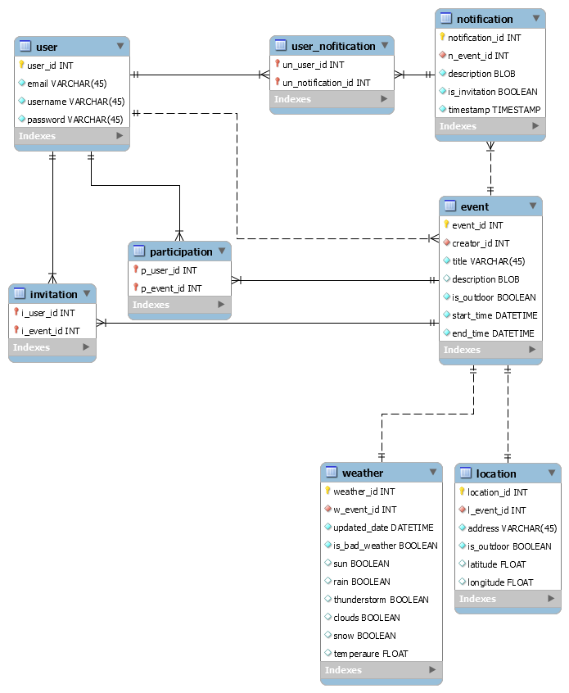Figure 3.3 Logical view

3.User experience

Reference material: T.Haigh, teaching material Connolly, Begg, Database Systems: A Practical Approach to Design, Implementation and Management

