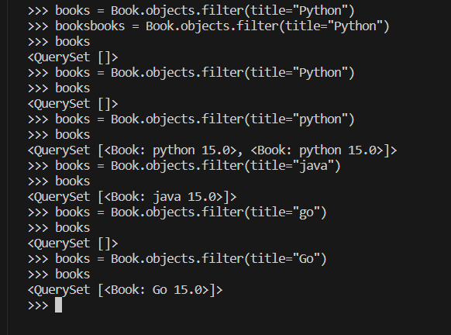 Filter

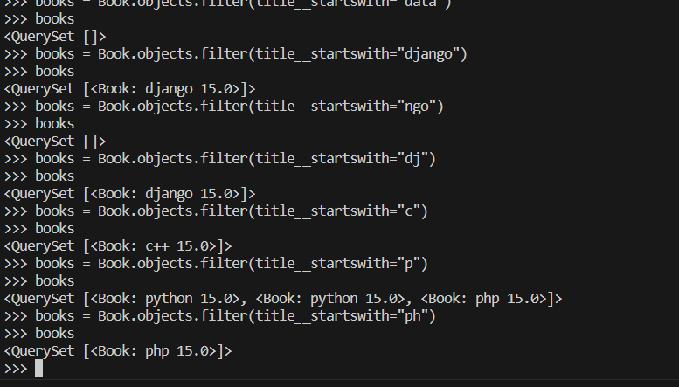 **Startswith**

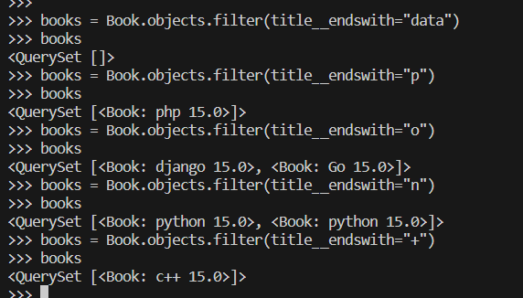**Endswith**

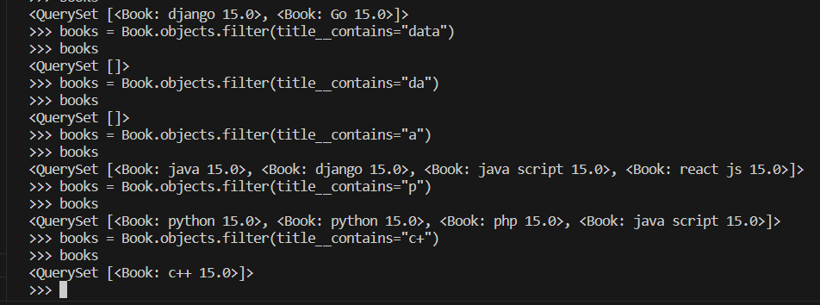**Contains**

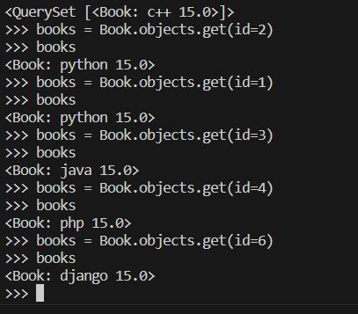**Get**

**Order_by ⇒ “data”**

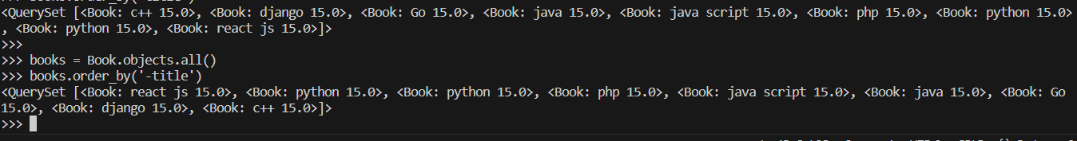**Order_by ⇒ “-data”**

**CREATE MODEL**

