UNIVERSITETI I PRISHTINËS

FAKULTETI I INXHINIERISË ELEKTRIKE DHE KOMPJUTERIKE



DOKUMENTACIONI I PROJEKTIT

**Lënda:**Mikroprocesorë dhe mikrokontrollerë

**Tema:**Gjeneratori i frekuencave 0-40MHz AD9850 (MODBUS RTU)

**Profesori:** Mr.Sc Lavdim Kurtaj **Studentët:** Ardi Rexhepi

Blerta Krasniqi

Elvisa Gashi

Mirjetë Hajdari

Mrika Govori

Perparim Dubova

Shpresarta Hamza

Prishtinë, 2019

Përmbajtja

1 Hyrje 3

2 Moduli AD9850 4

2.1 Tiparet dhe Perdorimi 5

2.1.1 Tiparet: 5

2.1.2 Aplikimet: 6

2.2 Definimi i pin-ave 6

3 Pllaka Easy8051A 7

4 Mikrokontrolleri dhe ndërfaqja 8

5 MODBUS 8

6 Ndërfaqja grafike në PC (GUI) 9

7 Nderfaqja njeri-makine 10

# Hyrje

Qëllimi i realizimit të këtij projekti është gjenerimi i sinjaleve 0-40MHz me AD9850 (MODBUS RTU). Do të shfrytëzohet moduli **AD9850**i cili përmes komunikimit paralel 8 bitësh do të komunikojë me mikrokontrollerin **AT89S8253** i cili i takon familjes të mikrokontrollerëve 8051.

# Moduli AD9850

AD9850 është një pajisje më e integruar që përdor Teknologjin DDS të avancurte shoqëruar me një shpejtësi të brendshme të lartë, konvertues me performancë të lartë D/A dhe krahasues për të formuar një sintetizues të frekuencave të programueshme digjitale dhe funksion të gjeneratorëve të clockut. Kur referohet në një burim të saktë të clockut, AD9850 gjeneron një spekter të paster, frekuencë/ faze të programueshme, output analog i vales sinusoidale. Kjo vale sinus mund te perdoret drejtpersedrejti si burim I frekuences , ose mund te konvertohet ne nje vale katrore per aplikacionet e gjeneratoreve te agile-clock.

Arkitektura e qarkut AD9850 lejon prodhimin e frekuencave të prodhimit deri në gjysmën e frekuencës së clockut referues (ose 62.5 MHz), dhe frekuenca e daljes mund të ndryshohet në mënyrë digjitale (asinkrone) me një normë deri në 23 milionë frekuenca të reja për sekondë.

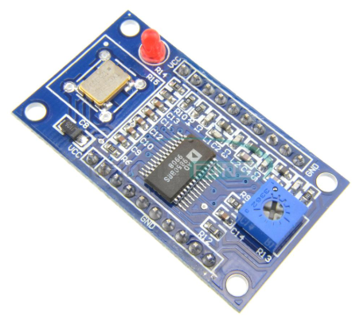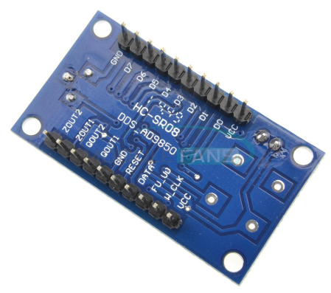

*Figura 1. Pamje e modulit AD9850*

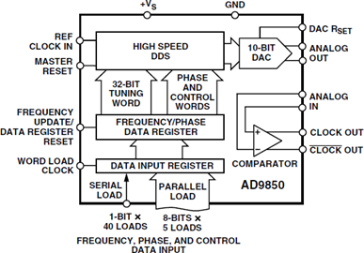

Figura 2.

## Tiparet dhe Perdorimi

### Tiparet:

* Shpejtësia e prodhimit të sinjalit me frekuencë: 0-40MHz
* 4 Signal outputs
* 2 dalje të valës sinusoidale dhe 2 dalje në valë katrore
* DAC SFDR > 50 dB @ 40 MHz AOUT
* 32-Bit Frekuenca Tuning Word
* Interface i thjeshtuar i kontrollit: Bajta paralel ose format i ngarkimit serial
* Faza e Modulimit të Aftësis (Phase Modulation Capability)
* +3.3 V ose +5 V Operim i Vetëm i Furnizimit
* Low Power: 380 mW @ 125 MHz (+5 V)
* Low Power: 155 mW @ 110 MHz (+3.3 V)
* Funksioni Power-Down
* Size: 42 x 30 x 1.6 mm

### Aplikimet:

* Frekuenca / Faza-agile Sintetizimi Sine-Wave
* Rigjenerim i clockut dhe Bllokimi i qarkut për Dixhital
* Komunikimi
* Digitally Controlled ADC Encode Generator
* Agile Local Oscillator Applications

## Definimi i pin-ave

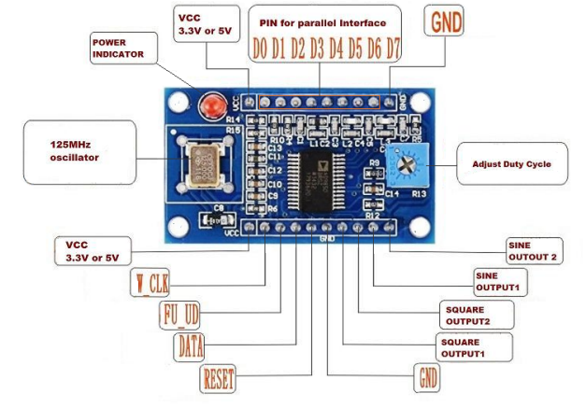  
*Figura 3. Permbajtja e modulit*

Sensori per perdorim ka ne dalje pinat ZOUT2, ZOUT1, QOUT2, QOUT1, GND, RESET, DATA, FU_UD, W_CLK, VCC dhe GND, D7, D6, D5, D4, D3, D2, D1, D0, VCC.

|  |  |  |
| --- | --- | --- |
| PIN-i | | Lidhja |
| ZOUT2 | | ... |
| ZOUT1 | | Osciloscope |
| QOUT2 | | Nuk lidhet |
| QOUT1 | | Nuk lidhet |
| GND | |  |
| RESET | | P1.6 |
| DATA | |  |
| FU_UD | P1.5 | |
| W_CLK | P.1.4 | |
| VCC |  | |
|  | | |
| Porti 0 | | |
| PIN-i | **Lidhja** | |
| GND | GND | |
| D7 | P0.7 | |
| D6 | P0.6 | |
| D5 | P0.5 | |
| D4 | P0.4 | |
| D3 | P0.3 | |
| D2 | P0.2 | |
| D1 | P0.1 | |
| D0 | P0.0 | |
| VCC | VCC | |

# Pllaka Easy8051A

Pllaka zhvillimore e mikrokontrollerit 8051 është përdorur për kontrollimin e sistemit, leximin e references dhe sensorit,leximin e nderprersave kufitar, kontrollin e AD9850 modulit dhe paraqitjen e nje interfejsi të thjeshtë me njeriun.

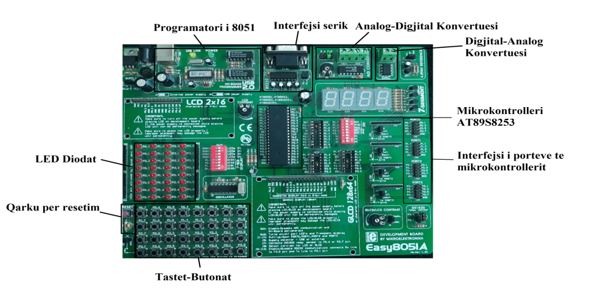

*Figura 4. Pllaka Easy8051A dhe pjeset e saj*

# Mikrokontrolleri dhe ndërfaqja

Mikrokontrolleri i cili do të përdoret për realizimin e projektit do të jetë AT89S8253 i cili i takon

familjes 8051.

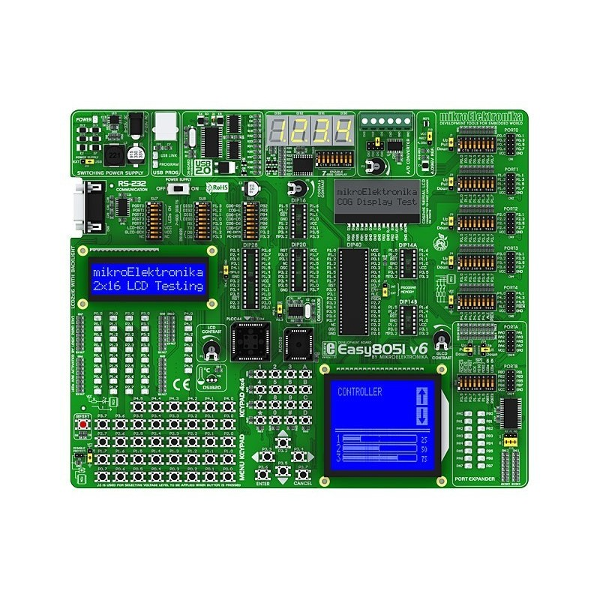

*Figura 5. Pinat e 8051 dhe pamje e pllakës Easy8051A*

Disa nga specifikat teknike të mikrokontrollerit AT89S8253 janë:

* Kompatibil me produktet e familjes MCS51
* Memorie të brendshme flash 12K Bytes (10,000 cikle lexim/shkrim)
* Memorie për të dhëna EEPROM 2K Bytes
* Memorie RAM 256 x 8 bit
* 32 Linja I/O të programueshme
* Tre kohorë/numërues 16 bit

Mikrokontrolleri do të jetë i instaluar në pllakën zhvillimore **Easy8051A** e cila përmbanë të instaluar edhe disa nga butonat dhe display 7 segmentësh të cilët do i përdorim për të “shfletuar” vlerat e lexuara nga sensori.

# MODBUS

Modbus është një protokoll i komunikimit që është zhvilluar nga Modicon systems. Përndryshe MODBUS është një metodë që përdoret për transmetim apo bartje të të informacioneve përgjatë linjave serike ndërmjet pajisjeve elektronike.

Pajisja e cila kërkon informacion quhet Modbus Master ndërsa pajisjet që jepin informacion quhen Modbus Slaves.

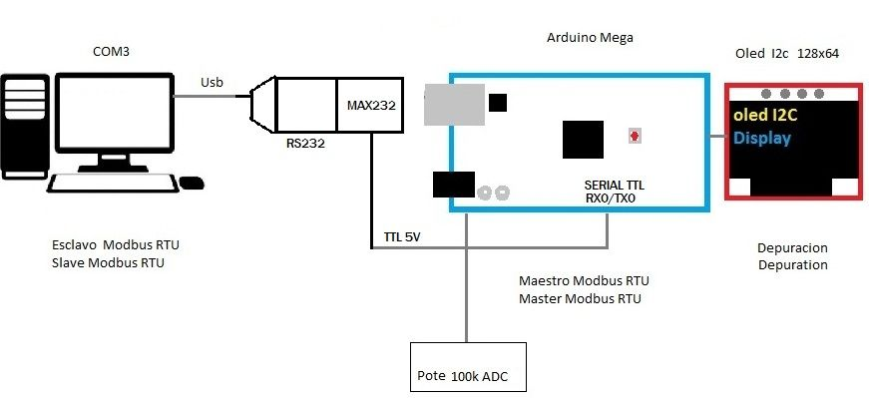

*Figure 6. Modbus RTU RS232*

# Ndërfaqja grafike në PC (GUI)

Të dhënat e lexuara nga sensori do të i dërgojmë edhe në PC për analizim. Për këtë arsye është zhvilluar një ndërfaqe grafike në gjuhën programuese C# së bashku me kornizën .NET (WinForms).

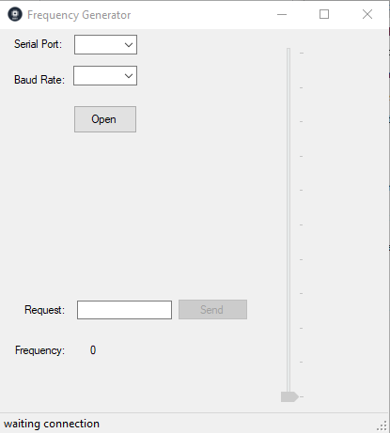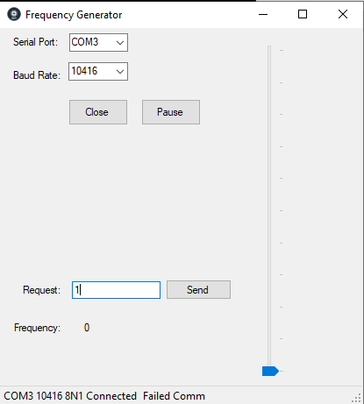

*Figura 7. Pamje e faqës së ndërfaqës në PC*

Nga këtu shihet se pasi të realizohet lidhja me mikrokontrollerin ,ne mund të zgjedhim portin dhe Baud Rate (10416) dhe pasi të dërgojmë kërkesën në HZ, KHZ ose MHZ rezultati do të shihet në osciloskop.

Baud Rate tregon numrin e bitave që porti serik mundet ti transmetojë brenda 1 sekondi.

Për të shfaqur pamjen në GUI duhet të përcjellni shtegun si në vijim:

11P_2018-2019/11P AD9850/11P AD9850/obj/Debug/CuurentMeter.

Kjo do t’ua mundësojë që të shihni aplikacionin edhe nëse nuk e keni Visual Studio-n të instaluar.

1 MHZ: 1 KHZ:

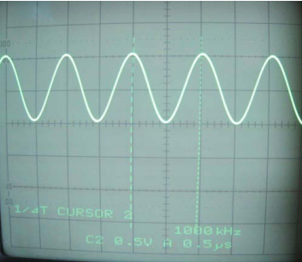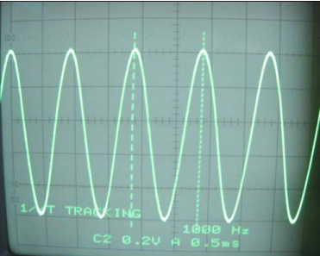

1MHZ: 1KHZ:

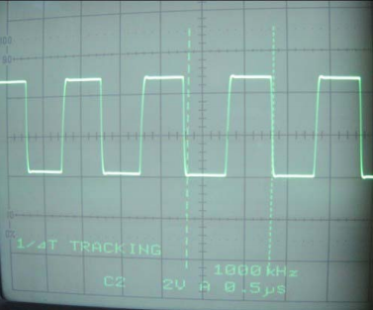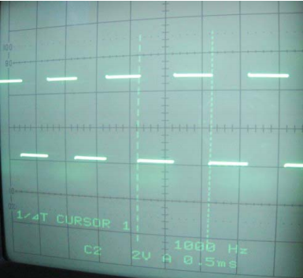

*Figura 8. Pamje ne osciloskop*

# Nderfaqja njeri-makine

Ndërfaqja ka 4 butona të cilin e lejon përdoruesin që të zgjedh modin e punës së sistemit, rregullimin e parametrave ose për kërkesë të shfaqjeve. Butonat janë të emëruara ESC, OK, UP dhe DOWN. Butoni OK e dergon Menyne në një hapë përpara, butoni ESC e kthen një hap mbrapa ndërsa UP dhe DOWN levizin poshtë dhe lartë.

|  |  |
| --- | --- |
| BUTONI | Funksioni |
| P2.0 | UP |
| P2.1 | ESCAPE |
| P2.2 | OK |
| P2.3 | DOWN |

# Referencat

I.Scott MacKenzie and Raphael C. -W. Phan.The 8051 Microcontroller, Fourth Edition.

<https://www.analog.com/media/en/technical-documentation/data-sheets/AD9850.pdf>

<https://www.schneider-electric.com/en/faqs/FA168406/>

# Kodi ne Assembler

;;;;;;;;;;;;;;;;;;;;;;;;;;;;;;;;;;;;;;;;;;;;;;;;;

;DESCRIPTION

;;;;;;;;;;;;;;;;;;;;;;;;;;;;;;;;;;;;;;;;;;;;;;;;;

;

;========DESCRIPTION END=========================

;;;;;;;;;;;;;;;;;;;;;;;;;;;;;;;;;;;;;;;;;;;;;;;;;

;initialization

;------------------------------------------------

;

;;;;;;;;;;;;;;;;;;;;;;;;;;;;;;;;;;;;;;;;;;;;;;;;;

display0 equ 030h; register for display 0

display1 equ 031h; register for display 1

display2 equ 032h; register for display 2

display3 equ 033h; register for display 3

nestedsample equ 034h; sample time divider

nestednum equ 5; sample time constant

nestedsamplee equ 035h; sample time divider

nestednumm equ 40; sample time constant

proc0_stat equ 036h; process state

proc1_stat equ 037h; process state

previousbuttonport equ 038h; saving previous scan of keyboards (for negative edge detection)

shownumH equ 039h; data HIGH for displaying

shownumL equ 3ah; data LOW for displaying

timer3p5 equ 03bh; waiting 3.5cahracter for modbus

start3p5 equ 000h; BIT start 3.5 calculating time

menudone equ 18h; bit set when user made all the erquests on meny

reqdown equ 19h;bit send a request to lower the frequency

requp equ 1ah;bit send a request to raise the freq

limup equ 1bh;bit limit raising frequency

limdown equ 1ch;bit limit lowering frequency

data3 equ 40h; data sent to device for setting frequency, MSB

data2 equ 41h; data sent to device for setting frequency, seond byte

data1 equ 42h; data sent to device for setting frequency, third byte

data0 equ 43h; data sent to device for setting frequency, LSB

calculateforreading equ 001h; MODBUS parameter to calculate CRC for reading or writing buffer

writingbuffercount equ 03ch; MODBUS save number of bytes to send (reply)

;Constants

SlaveID equ 1; MODBUS SlaveID

tim3p5 equ 40h; MODBUS 3.5character constant

CoilsNumber equ 64; MODBUS number of coils

CoilsStartAdd equ 40h; MODBUS address of first coil

HoldingRegStartAdd equ 30H; MODBUS start of first register

HoldingRegNumber equ 10H; MODBUS number of registers

StartofReadingBuffer equ 128; MODBUS start of readinf buffer

StartofWritingBuffer equ 192; MODBUS start of writing buffer

;for device

w_clk equ p1.4; DEVICE CLOCK used to load 8bit data

fq_ud equ p1.5; DEVICE FREQUENCY UPDATE loaded datas to output

resett equ p1.6; DEVICE RESET

;constants compatible with 7-segment for showing characters

Mhigh equ 00110011b

Mlow equ 00100111b

Ebig equ 01111001b

Nbig equ 00110111b

Xbig equ 01110110b

Ybig equ 01100110b

Zbig equ 01011011b

;================================================

Buttonport equ p2

;==============INITIALIZATION END================

;;;;;;;;;;;;;;;;;;;;;;;;;;;;;;;;;;;;;;;;;;;;;;;;;

; PROGRAM INTERRUPT ORGANIZATION

;------------------------------------------------

;

;;;;;;;;;;;;;;;;;;;;;;;;;;;;;;;;;;;;;;;;;;;;;;;;;

org 0000h ;reset interup

ljmp main

;;;;;;;;;;;;;;;;;;;;;;;;;;;;;;;;;;;;;;;;;;;;;;;;;

org 0bh ;timer 0 isr

ljmp t0isr

;;;;;;;;;;;;;;;;;;;;;;;;;;;;;;;;;;;;;;;;;;;;;;;;;

org 023h ;serial port isr

ljmp spisr

;=========INTERRUPT ORGANIZARION END============

;;;;;;;;;;;;;;;;;;;;;;;;;;;;;;;;;;;;;;;;;;;;;;;;;

;Main Code here

;;;;;;;;;;;;;;;;;;;;;;;;;;;;;;;;;;;;;;;;;;;;;;;;;

org 030h

main:

;;;;;;;;;;;;;;;;;;;;;;;;;;;;;;;;;;;;;;;;;;;;;;;;;

;CLEAN RAM

;------------------------------------------------

;Cleans all the registers on ram from

;$00 - $255 of general purpose ram

;leaving SFR un-changed

;calculation needed on proccesing time

;and program space

;;;;;;;;;;;;;;;;;;;;;;;;;;;;;;;;;;;;;;;;;;;;;;;;;

mov r0, #01h

cleanram:

mov @r0, #00

inc r0

cjne r0, #00b, cleanram

;============CLEAN RAM END=======================

;;;;;;;;;;;;;;;;;;;;;;;;;;;;;;;;;;;;;;;;;;;;;;;;;

;CODE INITIALIZATION

;------------------------------------------------

;This section initiates all the resources

;of MCu and selects their mode of

;operation

;;;;;;;;;;;;;;;;;;;;;;;;;;;;;;;;;;;;;;;;;;;;;;;;;

mov sp, #50h; move stack pointer

mov tmod,#22h; Timer 0, mode 2 (8-bit autoreload), Working as timer

; Timer 1, mode 2 (8-bit autoreload), Working as BaudRate Generator

mov th0, #-167; Sampling f ~ 4000Hz;

mov th1, #-2; 10416 bps Baud rate

mov nestedsample, #nestednum; nest f ~ 800Hz

mov nestedsamplee, #nestednumm;nest f ~ 20Hz

setb tr0; start timer 0

setb tr1; start timer 1

mov scon, #50h; Mode 8bitUART r-enable

mov ie, #10010010b; Enable interrupts Serial port + Timer 0

mov 08, #StartOfReadingBuffer;start of reading buffer;R0 bank1

mov 09, #StartOfWritingBuffer;start of writing buffer;R1 bank1

mov proc1_stat, #0 ; Process 1 state initialization

mov proc0_stat, #0 ; Process 0 state initialization

mov timer3p5, #tim3p5;

clr start3p5;

;=====CODE INITIALIZATION END====================

;DEVICE RESETING SEQUENCE

mov p0, #0

anl p1, #00001111b

;clr resett

setb resett

clr resett

;clr w_clk

setb w_clk

clr w_clk

;clr fq_ud

setb fq_ud

clr fq_ud

startitall:

jnb menudone, startitall; wait for user to select meny

mov r2, shownumL; pass parameter to show on 7seg display low

mov r1, shownumH; pass parameter to show on 7seg display high

Lcall HextoDisplay; do the math

jmp startitall; loop

HexToDisplay:

lcall HexToBcd; 16-bit (r2-LOW, r1-HIGHT) to r3-ones, r4-tenths, r5-hundreds, r6-thousands, r7-tenthousands,

mov a, r3; ones

lcall nto7seg; make ones 7-segment compatible number

mov display0,a; move data to show at display0

mov a, r4; tenths

lcall nto7seg; make tens 7-segment compatible number

mov display1,a; move data to show at display1

mov a, r5; hundreds

lcall nto7seg; make hundreds 7-segment compatible number

mov display2,a; move data to show at display2

mov a, r6; thousands

lcall nto7seg; make thousands 7-segment compatible number

mov display3,a; move data to show at display3

ret

;================MAIN CODE END===================

;;;;;;;;;;;;;;;;;;;;;;;;;;;;;;;;;;;;;;;;;;;;;;;;;

; timer 0 interrupt service routine

;------------------------------------------------

;

;

;

;

;

;

;

;

;;;;;;;;;;;;;;;;;;;;;;;;;;;;;;;;;;;;;;;;;;;;;;;;;

t0isr:

djnz nestedsample, fullfreq; divide sample time

mov nestedsample, #nestednum; refresh divider for next use

;routines called in 4000Hz/n; n=5 800Hz

lcall display; call display program that shows data in display

djnz nestedsamplee, fullfreq; redivide sample time

mov nestedsamplee, #nestednumm; refresh divider for next use

;routines called in 4000Hz/(n*m); n=5; m=40; 20=Hz

lcall buttons; call button scaning (meny navigation) routine, and requesting

lcall LoopP; display characters decoding

lcall request; raise/lower frequency registers

lcall writedevice; write registers to device

fullfreq:

;Routine called in 4000Hz

jnb start3p5, timerr3p5; MODBUS; if start of frame detected start modbus3.5character timer

djnz timer3p5, timerr3p5; after 3.5character time finnishes

lcall modbus; MODBUS

timerr3p5:

reti

;================TIMER 0 INTERRUPT END===========

;;;;;;;;;;;;;;;;;;;;;;;;;;;;;;;;;;;;;;;;;;;;;;;;;

; serial comm interrupt service routine

;------------------------------------------------

;

;

;

;

;

;

;

;

;;;;;;;;;;;;;;;;;;;;;;;;;;;;;;;;;;;;;;;;;;;;;;;;;

spisr: push psw; save psw

mov psw, #00001000b; activate Bank1

jnb ri, transmit;if interrupt wasnt made by rec, then transmit

clr ri;

mov @r0, sbuf; save data read at serial port buffer to reading buffer

inc r0; increment pointer

setb start3p5; start 3.5character timer

pop psw; replace Bank previously activated

reti

transmit:

clr ti;

djnz writingbuffercount, continue;count if not end of sending frame

jmp terminate

continue:

mov sbuf, @r1; write data at serial port buffer for transmission

inc r1; increment buffer for next time

terminate:

pop psw

reti

;==========SERIAL COMM INTERRUPT END=============

;;;;;;;;;;;;;;;;;;;;;;;;;;;;;;;;;;;;;;;;;;;;;;;;;

;DIAPLY

;------------------------------------------------

;source- WUS script-Prof. Lavdim Kurtaj

;Routine that displays on 4 7-segments

;the datas on ram meories 30h - 33h

;;;;;;;;;;;;;;;;;;;;;;;;;;;;;;;;;;;;;;;;;;;;;;;;;

display:

push acc; save accumulator

mov a,proc0_stat; check process state

rl a

rl a

mov dptr,#tabproc0 ; lookup table address

anl p1,#11000000b; turnoff all displays

jmp @a+dptr

tabproc0:

ljmp p0_s00

nop

ljmp p0_s01

nop

ljmp p0_s02

nop

ljmp p0_s03

nop

p0_s00:; display at 0 and set next time to process display 1

mov p0,display0

setb p1.0

mov proc0_stat,#1

ljmp p0_end

p0_s01:; display at 1 and set next time to process display 2

mov p0,display1

setb p1.1

mov proc0_stat,#2

ljmp p0_end

p0_s02:; display at 2 and set next time to process display 3

mov p0,display2

setb p1.2

mov proc0_stat,#3

ljmp p0_end

p0_s03:;; display at 3 and set next time to process display 0

mov p0,display3

setb p1.3

mov proc0_stat,#0

ljmp p0_end

p0_end:

pop acc; return accumulator

ret

;===== END======================

;;;;;;;;;;;;;;;;;;;;;;;;;;;;;;;;;;;;;;;;;;;;;;;;;

;WriteDevice

;routine that sends data3-0 to AD9850

;uses P0 as 8bit parallel data transmission mode

; and P1.4, P1.5 P1.6 as signalling pins

;------------------------------------------------

writedevice:

mov p1, #0; turn all displays off and device lines

mov p0, #0; send phase 0 and turnon sequence

setb w_clk; clock

clr w_clk

mov p0, data3; send LSB

setb w_clk; clock

clr w_clk

mov p0, data2; send second byte

setb w_clk; clock

clr w_clk

mov p0, data1; send third byte

setb w_clk; clock

clr w_clk

mov p0, data0; send MSB

setb w_clk; clock

clr w_clk

setb fq_ud; update frequency (output it)

clr fq_ud

ret

;;;;;;;;;;;;;;;;;;;;;;;;;;;;;;;;;;;;;;;;;;;;;;;;;

;HEXIMAL TO BCD

;------------------------------------------------

;source

;http://www.iuma.ulpgc.es/~nunez/clases-sed-mai-8051/programas/16bit-t0-bcd.asm

;value in registers R1 and R2 will be

;turned to binary-coded-decimal in

;register R3 througg R7

;;;;;;;;;;;;;;;;;;;;;;;;;;;;;;;;;;;;;;;;;;;;;;;;;

HextoBCD:

push acc

MOV R3,#00D

MOV R4,#00D

MOV R5,#00D

MOV R6,#00D

MOV R7,#00D

MOV B,#10D

MOV A,R2

DIV AB

MOV R3,B ;Resto en R3

MOV B,#10 ; R7,R6,R5,R4,R3

DIV AB

MOV R4,B ;Resto en R4

MOV R5,A

CJNE R1,#0H,HIGH_BYTE ; CHECK FOR HIGH BYTE

SJMP ENDD

HIGH_BYTE:

MOV A,#6

ADD A,R3

MOV B,#10

DIV AB

MOV R3,B

ADD A,#5

ADD A,R4

MOV B,#10

DIV AB

MOV R4,B

ADD A,#2

ADD A,R5

MOV B,#10

DIV AB

MOV R5,B

CJNE R6,#00D,ADD_IT

SJMP CONTINUEue

ADD_IT:

ADD A,R6

CONTINUEue:

MOV R6,A

DJNZ R1,HIGH_BYTE

MOV B,#10D

MOV A,R6

DIV AB

MOV R6,B

MOV R7,A

ENDD:

pop acc

ret

;===== END======================

;;;;;;;;;;;;;;;;;;;;;;;;;;;;;;;;;;;;;;;;;;;;;;;;;

;NORMAL 0-9 TO 7-SEGMENT

;------------------------------------------------

;Value in A from 0-9 returns to

;7-segment compatabile value in A

;;;;;;;;;;;;;;;;;;;;;;;;;;;;;;;;;;;;;;;;;;;;;;;;;

nto7seg:

inc a

movc a, @a+pc

ret

db 63,6,91,79,102,109,125,7,127,111; 63=0-for 7seg, 6=1-for seg, ...

;===== END======================

;;;;;;;;;;;;;;;;;;;;;;;;;;;;;;;;;;;;;;;;;;;;;;;;;;

;Button

;------------------------------------------------

;

;

;

;

;

;

;

;

;;;;;;;;;;;;;;;;;;;;;;;;;;;;;;;;;;;;;;;;;;;;;;;;;

buttons:

push acc

mov a, buttonport; save buttons state

cpl a; complement, easy8051a uses click to low

push acc; save data

;cpl a

anl a, #00001111b ; Assign only lower half for neg edg

xrl a, previousbuttonport;check which ones have changed

pop b; return buttons state

anl a, b; accept only the ones that have negative edge

mov previousbuttonport, b;save the data for next scan

jz ended

jnb acc.0, nochangein0

;change in pin 0 code UP

jb menudone, requpp

mov a , proc1_stat

inc a

cjne a, #4, gottogo

jmp ended

gottogo:

inc proc1_stat

jmp ended

requpp:

setb requp

jmp ended

nochangein0:

jnb acc.1, nochangein1

;change in pin 1 code ESC

jb menudone, justplain

mov proc1_stat, #0

justplain:

clr limup

clr menudone

mov data0, #0

mov data1, #0

mov data2, #0

mov data3, #0

mov shownumL, #0

mov shownumh, #0

jmp ended

nochangein1:

jnb acc.2, nochangein2

;change in pin 2 code OK

jb menudone, ended

mov a , proc1_stat

jz makeitone

setb menudone

jmp ended

makeitone:

mov proc1_stat, #1

jmp ended

nochangein2:

jnb acc.3, nochangein3

;change in pin 3 code DOWN

jb menudone, reqdownn

mov a , proc1_stat

dec a

jz ended

mov proc1_stat, a

jmp ended

reqdownn:

setb reqdown

jmp ended

nochangein3:

jnb acc.4, nochangein4

;change in pin 4 code

jmp ended

nochangein4:

jnb acc.5, nochangein5

;change in pin 5 code

jmp ended

nochangein5:

jnb acc.6, nochangein6

;change in pin 6 code

jmp ended

nochangein6:

jnb acc.7, ended

;change in pin 7 code

jmp ended

ended:

pop acc

ret

;===== END======================

;;;;;;;;;;;;;;;;;;;;;;;;;;;;;;;;;;;;;;;;;;;;;;;;;;

;MODBUS

;------------------------------------------------

;

;

;

;

;

;

;

;

;;;;;;;;;;;;;;;;;;;;;;;;;;;;;;;;;;;;;;;;;;;;;;;;;

MODBUS:

push acc

push psw

mov psw, #00001000b

mov timer3p5, #tim3p5

clr start3p5

mov r2, #startofreadingbuffer+2

mov r3, 08

setb calculateforreading

lcall crc16

mov a, @r0

cjne a, 14, failedCheckk; Check CRCHigh

inc r0

mov a, @r0

cjne a, 15, failedCheckk; Check CRCLow

HereModbusdoes:

mov r0, #StartOfReadingBuffer

MOV R1, #StartOfWritingBuffer

mov a, @r0

inc r0

cjne a, #slaveID, failedcheckk;Check slaveID

mov @r1, a

inc r1

;This device is addresed by modbus

mov a, @r0;GetFunctionCode

inc r0

cjne a, #15, noFC15WriteMultipleCoils

;;;;;;;;;;;;;;

ljmp Preparetransmit

noFC15WriteMultipleCoils:

cjne a, #16, noFC16WriteMultipleRegisters

;;;;;;;;;;;;;;;;

lcall AddressLavidation

jc AddressPassFC16

mov r1, #StartOfWritingBuffer+1

mov @r1, #90H

inc r1

mov @r1, #02

inc r1

ljmp Preparetransmit

AddressPassFC16:

mov r1, #STARTOFWRITINGBUFFER+ 1

mov a, #16

MOv @r1, a

inc r1

mov a, #0

mov @r1, a

inc r1

mov r0, #StartOfreadingBuffer+3

;mov r0, a

mov a, @r0

mov @r1, a

inc r1

rl a

add a, #HoldingRegStartAdd

;mov r0, a; Start of registers requested to WRITE

push acc

mov a, #0

mov @r1, a

inc r1

mov r0, #StartOfreadingBuffer+5

mov a, @r0

mov @r1, a

inc r1

mov r0, #startofreadingbuffer+6

mov a, @r0

mov r2, a

MOV R1, #STARTOFREADINGBUFFER+7

pop 08

LoopitFC16:

mov a, @r1

mov @r0, a

inc r0

inc r1

djnz 10, LoopitFC16

MOV R1, #STARTOFwritingBUFFER+6

ljmp Preparetransmit

noFC16WriteMultipleRegisters:

dec a

rl a

rl a

mov dptr,#tabFC

jmp @a+dptr

tabFC:

ljmp FC01_ReadCoils

nop

ljmp FC02_ReadDiscreteInputs

nop

ljmp FC03_ReadHoldingRegisters

nop

ljmp FC04_ReadInputRegisters

nop

ljmp FC05_WriteSingleCoil

nop

ljmp FC06_WriteSingleRegister

nop

failedcheckk:

ljmp failedcheck

FC01_ReadCoils:

cjne @r0, #0, sendexpectioncode

inc r0

inc r0

cjne @r0, #0, sendexpectioncode

dec r0

mov a, @r0

inc r0

inc r0

cjne a,#CoilsNumber, notCoilatend; Check address

cjne @r0, #1, sendExpectioncode; Reading Last Bit and only one

ljmp allrightnow

notcoilatend:

jc lessthanendcoil

sendexpectioncode:;Addres above allowed, and/or number of coils above allowed

mov @r1, #81h

inc r1

mov @r1, #2

inc r1

ljmp preparetransmit

lessthanendcoil:

dec r0

dec r0

mov a, @r0

inc r0

inc r0

add a, @r0

cjne a, #CoilsNumber, NotalltheCoils; make sure doent overflow the address

sjmp allrightnow

notAllthecoils:

jnc sendexpectioncode

allrightnow:

dec r0

dec r0

mov a, @r0

mov b, #8

div ab

add a, #CoilsStartAdd/8; we got the addres of first register to send

add a, #20

push acc;save the addres of first reg

mov r0, #StartOfReadingBuffer + 4; number of bits

mov a, @r0

mov b, #8

div ab

mov r2, a; Loop number of registers

inc b; mask; number of bits at the end

mov a, #0ffh

shiftloop:

djnz b, shiftit

sjmp endshifting

Shiftit:

clr c

rrc a

sjmp shiftloop

endshifting:

mov r3, a;save mask

mov r1, #StartofWritingBuffer + 1;response

mov @r1, #1;response fc code

inc r1

inc r2

mov a, r2

mov @r1, a

inc r1

pop 08

loopwriting:

mov a, @r0

inc r0

mov @r1, a

inc r1

djnz r2, loopwriting

dec r1

mov a, @r0

anl a, r3

mov @r1, a

inc r1

ljmp Preparetransmit

FC02_ReadDiscreteInputs:

ljmp Preparetransmit

FC03_ReadHoldingRegisters:

lcall AddressLavidation

jc AddressPass

mov r1, #StartOfWritingBuffer+1

mov @r1, #83h

inc r1

mov @r1, #02

inc r1

ljmp Preparetransmit

AddressPass:

mov r0, #StartOfreadingBuffer+3

;mov r0, a

mov a, @r0

rl a

add a, #HoldingRegStartAdd

;mov r0, a; Start of registers requested to read

push acc

mov r0, #StartOfreadingBuffer+5

mov a, @r0

rl a

mov r2, a

mov r1, #StartOfWritingBuffer+1

mov @r1, #03

inc r1

mov @r1, a

inc r1

pop 08

LoopitFC3:

mov a, @r0

mov @r1, a

inc r0

inc r1

djnz 10, LoopitFC3

ljmp Preparetransmit

FC04_ReadInputRegisters:

ljmp Preparetransmit

FC05_WriteSingleCoil:

mov r1, #StartOfWritingBuffer+1

mov @r1, #85h

inc r1

mov @r1, #01

inc r1

ljmp Preparetransmit

FC06_WriteSingleRegister:

mov r0, #StartOfReadingBuffer+2

cjne @r0, #0, sendexpectionFC6

sjmp addresspassFC6

sendexpectionFC6:

mov r1, #StartOfWritingBuffer+1

mov @r1, #86h

inc r1

mov @r1, #02

inc r1

ljmp Preparetransmit

addresspassFC6:

cjne @r0, #HoldingRegNumber, notthelastregFC6

notthelastregFC6:

jnc sendexpectionFC6

mov r1, #StartOfWritingBuffer+1

mov @r1, #06h

inc r1

mov @r1, #0

inc r1

mov r0, #StartOfreadingBuffer+3

;mov r0, a

mov a, @r0

mov @r1, a

inc r1

rl a

add a, #HoldingRegStartAdd

;mov r0, a; Start of registers requested to read

push acc

mov r0, #StartOfreadingBuffer+4

mov a, @r0

mov @r1, a

inc r1

pop 08

mov @r0, a

inc 08

push 08

mov r0, #StartOfreadingBuffer+5

mov a, @r0

mov @r1, a

inc r1

pop 08

mov @r0, a

ljmp Preparetransmit

Preparetransmit:

push 09

mov r2, #startofwritingbuffer

mov r3, 09

clr calculateforreading

lcall crc16

pop 09

mov a, r6

mov @ r1, a

inc r1

mov a, r7

mov @r1, a

inc r1

mov a, r1

inc a

clr c

subb a, #Startofwritingbuffer

mov writingbuffercount, a

setb ti

failedcheck:

mov r1, #startofwritingbuffer

mov r0, #startofreadingbuffer

pop psw

pop acc

ret

;===== END ======================

;;;;;;;;;;;;;;;;;;;;;;;;;;;;;;;;;;;;;;;;;;;;;;;;;;

;CRC16

;------------------------------------------------

;

;

;

;

;

;

;

;

;;;;;;;;;;;;;;;;;;;;;;;;;;;;;;;;;;;;;;;;;;;;;;;;;

CRC16:

mov a, r3;pass pointer

clr c

subb a, r2;pass end of pointer, calculate length

mov r5, a;

jnb calculateforreading, forwriting

mov r0, #startofreadingbuffer

sjmp calculateCRC

forwriting:

mov r0, #startofwritingbuffer

calculateCRC:

mov r7, #0ffh

mov r6, #0ffh

outterloop:

mov a, r6

xrl a, @r0

mov r6, a

mov a, r7

xrl a, #0

mov r7, a

mov r4, #8

inc r0

Innerloop:

clr c

mov a, r7

rrc a

mov r7, a

mov a, r6

rrc a

mov r6, a

jnc dontpol

mov a, r7

xrl a, #0a0h

mov r7, a

mov a, r6

xrl a, #01

mov r6, a

dontpol:

djnz r4, innerloop

djnz r5, outterloop

ret

;===== ======================

;;;;;;;;;;;;;;;;;;;;;;;;;;;;;;;;;;;;;;;;;;;;;;;;;;

;Adress Validation

;------------------------------------------------

;

;

;

;

;

;

;

;

;;;;;;;;;;;;;;;;;;;;;;;;;;;;;;;;;;;;;;;;;;;;;;;;;

AddressLavidation:

mov r0, #StartOfReadingBuffer+2

cjne @r0, #0 ,failedaddress

inc r0

inc r0

cjne @r0, #0 ,failedaddress

dec r0

cjne @r0, #HoldingREGNumber, notLastAddress

inc r0

inc r0

cjne @r0, #1, failedaddress

CheckGoodaddress:

setb c

ret

notlastaddress:

jnc failedaddress

mov r0, #StartOfReadingBuffer+3

mov a, @r0

inc r0

inc r0

add a, @r0

cjne a, #HoldingRegNumber, TestOverflow

sjmp CheckGoodAddress

TestOverflow:

jc CheckGoodAddress

failedaddress:

clr c

ret

;===== ======================

LoopP:

mov a, proc1_stat ; process state

rl a

rl a

mov dptr,#tabproc1s ; lookup table address

jmp @a+dptr

tabproc1s:

ljmp p1_s00s

nop

ljmp p1_s01s

nop

ljmp p1_s02s

nop

ljmp p1_s03s

nop

p1_s00s: ;move datas to 7seg to show MENU

mov display3, #MHigh

mov display2, #Mlow

mov display1, #Ebig

mov display0, #Nbig

ljmp p1_ends

p1_s01s: ;move datas to 7seg to show HZ

mov display3, #0

mov display2, #Xbig

mov display1, #Zbig

mov display0, #0

ljmp p1_ends

p1_s02s: ;move datas to 7seg to show KHZ

mov display3, #01110100b

mov display2, #00100000b

mov display1, #Xbig

mov display0, #Zbig

ljmp p1_ends

p1_s03s: ;move datas to 7seg to show MHZ

mov display3, #Mhigh

mov display2, #Mlow

mov display1, #Xbig

mov display0, #Zbig

ljmp p1_ends

p1_ends:

ret

;;;;;;;;;;;;;;;;;;;;;;;;;;;;;;;;;;;;;;;;;;;;;;;;;;;

request: ;process request to increase/decrease frequency

;UInt32.MAX=0xFFFFFFFF=4294967295

;4294967295->125.000.000Hz frequency;

;34359738=0x20C49BA ->1.000.000Hz; (1MHz constant)| 02h (MSB) |0Ch (third byte)| 49h (second byte)| BAh (LSB)

;34359=0x8637 ->1.000Hz; (1KHz constant)|86h (MSB)| 37h (LSB)

;34=0x22 ->1HZ; (1HZ constant)| 22h

jnb menudone, p1_s00

mov a, proc1_stat

rl a

rl a

mov dptr,#tabproc1

jmp @a+dptr

tabproc1:

ljmp p1_s00

nop

ljmp p1_s01

nop

ljmp p1_s02

nop

ljmp p1_s03

nop

p1_s00:

ljmp p1_end1; meny state doesnt use request

p1_s01: ; HZ state

jnb requp, notrequp; pass if theres no increase request, look for decrease request

clr requp; clear parameters for next use

inc shownuml; increase data to show at display

mov a, shownuml;

jnz contt; if overflow

inc shownumh; increase MSB too

contt:

clr c

mov a, data0;

add a, #022h; add to data0 constant for 1HZ

mov data0,a; save it

jnc notreqdown; if no overflow pass

inc data1; else increase second register

mov a, data1

jnz notreqdown; case overflow

inc data2; increase third register

mov a, data2

jnz notreqdown

notrequp:

jnb reqdown, notreqdown;check for request to decrease frequency

clr reqdown; clear parameter for next use

dec shownuml; hower the data to show at 7seg

mov a, shownuml

cjne a, #255, conttin; case of underflow

dec shownumh; lower the high part too

mov a, shownumH

cjne a, #255, conttin; case of 2 underflows (high and low) then set to 0

mov shownuml, #0

mov shownumh, #0

jmp notreqdown; and dont touch device data

conttin:

clr c

mov a, data0;

subb a, #022h; subbstract LSB the 1Hz constant

mov data0, a

jnc notreqdown; if no underflow, pass

dec data1; else subbstract form second register

mov a, data1

cjne a, #255, notreqdown;if underflow

dec data2; decrease third register too

mov a, data2

cjne a, #255, notreqdown; if 3 underflows then set frequency to 0

mov data0, #0

mov data1, #0

mov data2, #0

notreqdown:

ljmp p1_end1

p1_s02: ;REQUEST for KHZ

jnb requp, notrequp1; check increase request

clr requp

inc shownuml

mov a, shownuml

jnz contt1

inc shownumh

contt1:

clr c

mov a, data0

add a, #37h; increase 1KHz constant LOW

mov data0,a

mov a, data1

addc a, #086h; increase 1KHz constant HIGH

mov data1,a

mov a, data2

addc a, #00h

mov data2,a

jnc notreqdown1

inc data3

notrequp1:

jnb reqdown, notreqdown1;check for decrease request

clr reqdown

dec shownuml;decrease show number

mov a, shownuml

cjne a, #255, conttin1

dec shownumh

mov a, shownumH

cjne a, #255, conttin1

mov shownuml, #0

mov shownumh, #0

;jmp notreqdown1

conttin1:

clr c

mov a, data0

subb a, #37h; decrease 1KHz constant low

mov data0, a

mov a, data1

subb a, #086h; decrease 1KHz constant HIGH

mov data1, a

mov a, data2

subb a, #00h

mov data2, a

jnc notreqdown1

dec data3

mov a, data3

cjne a, #255, notreqdown1

mov data0, #0

mov data1, #0

mov data2, #0

mov data3, #0

notreqdown1:

ljmp p1_end1

p1_s03: ;REQUSTS for 1MHz

jnb requp, notrequp2

clr requp

jb limup, notrequp2

inc shownuml

mov a, shownuml

jnz contt2

inc shownumh

contt2:

clr c

mov a, data0

add a, #0bah; add 1KHz constant LOW byte

mov data0,a

mov a, data1

addc a, #049h; add 1KHz constant second byte

mov data1,a

mov a, data2

addc a, #0ch; add 1KHz constant third byte

mov data2,a

mov a, data3

addc a, #02h; add 1KHz constant MSB

mov data3,a

cjne a, #0ffh, notreqdown2

setb limup

mov data3, #0ffh

mov data2, #0ffh

mov data1, #0ffh

mov data0, #0ffh

notrequp2:

jnb reqdown, notreqdown2

clr reqdown

clr limup

dec shownuml

mov a, shownuml

cjne a, #255, conttin2

dec shownumh

mov a, shownumH

cjne a, #255, conttin2

mov shownuml, #0

mov shownumh, #0

;jmp notreqdown2

conttin2:

clr c

mov a, data0

subb a, #0bah; Subbstract 1MHz constant LSB

mov data0, a

mov a, data1

subb a, #049h; Subbstract 1MHz constant second byte

mov data1, a

mov a, data2

subb a, #0ch; Subbstract 1MHz constant third byte

mov data2, a

mov a, data3

subb a, #02h; Subbstract 1MHz constant MSB

mov data3, a

jnc notreqdown2

mov data0, #0

mov data1, #0

mov data2, #0

mov data3, #0

notreqdown2:

ljmp p1_end1

p1_end1:

clr requp

clr reqdown

ret

END