- Scope Introduction / Background

Project 2 operates a highly customized SAP ECC environment that supports critical global business operations and processes the majority of enterprise revenue. As part of the ERP modernization strategy, Project 2 intends to transition from SAP ECC to SAP S/4HANA. Project 2 is seeking proposals for the SAP ERP Migration program, particularly the SAP ECC to S/4 HANA upgrade.

The purpose of this engagement is to formulate a well-defined, business-aligned scope and implementation plan for the SAP ECC to S/4 HANA upgrade and execute the plan. The upgrade will follow a single enterprise go-live strategy under Brownfield mechanism where existing business processes will be preserved as much as possible, by migrating and modifying existing customizations except for where the business process and customization must be adjusted to operate with SAP S/4 HANA. The migration approach will include selective data transition with 2 years of historical data and all open transactions with select functional transformation scope items (detailed in Section 3). The program will also endeavor to minimize any changes to downstream reporting and transactional systems, meaning data structures and integrations will need to be transformed prior to sending data to reporting or transactional systems or when receiving data from transactional systems.

Project 2 is already in the process of implementing MDG and GTS E4H.

General Timing Considerations:
- Vendor proposal should include implementation plan indicating hosting preference (i.e. RISE vs. Hyperscaler IaaS)
- Timeline
  - JDE migration into ECC is expected to go live during Project 2 fiscal year 2028-Q3 (calendar Nov 2027-Jan 2028). The schedule will be firmed up when the system integrator is selected.
- The internal master schedule targets production cutover in Project 2 fiscal year 2029-Q1 (calendar May-July 2028). Proposed timeline to be finalized during scoping and planning phase is below.

- Scope Overview
The following sections provide an overview of the Organization, Overall S4 Migration program and the scope of this RFP:

2.1 Organization overview:



2.2 Migration scope (System-view):

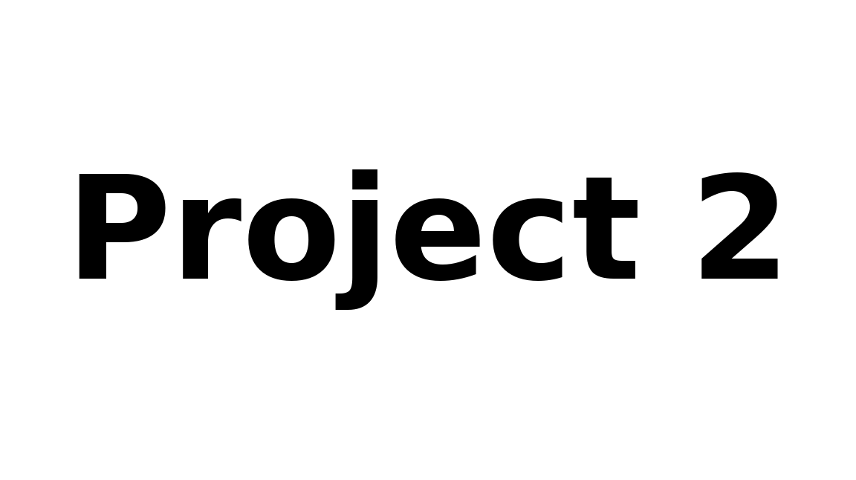

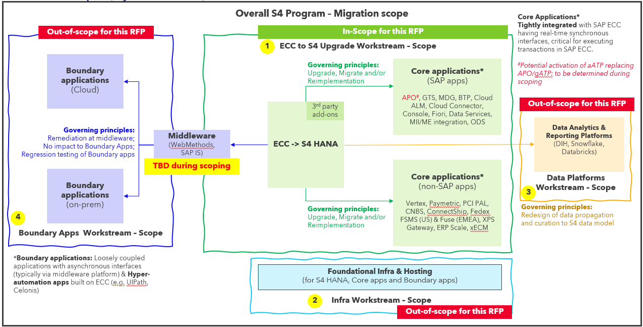

In-scope:
- Core ERP Platform, Application upgrade and Data Migration (SAP ECC to S/4 HANA)
- 3rd party add-ons remediation (list of add-ons provided in next section)
- Core applications remediation (list of core apps provided in next section):
  - Replacing APO/gATP with aATP – decision to be finalized during scoping phase
    - Suppliers should provide their perspective to shape Project 2 decision and price for both options (i.e. continue with APO/gATP with S/4 or implement aATP with S/4). Project 2 will determine the preferred option following scoping phase analysis.
  - SAP core apps (GTS, MDG, ODS, ME/MII, etc.) will require S/4 HANA interface remediation
  - Non-SAP core applications are planned to be migrated to be in proximity of S/4 HANA – Requires remediation of interfaces in S/4 (some applications may require upgrade to a S/4 compatible version)
  - Remediating data model changes in SAP ODS that provides data from ERP to Data Lake Platforms such as Databricks and SnowFlake (OR) Replacing SAP ODS application with Business Data Cloud – decision to be finalized during scoping phase. Data transformation will need to be included to ensure Databricks and SnowFlake keep their current table structures intact to limit downstream impact on reporting and integrations.
- Integration with Boundary applications:
  - Any modifications required to the integrations on the S/4 HANA side resulting directly from S/4 HANA changes shall be identified, documented, and addressed as part of the implementation scope.
  - Goal is to ensure continuity of existing data feeds, interfaces, integrations, and outputs to boundary applications to and from S/4 HANA.
- Functional testing in S4, orchestration of E2E testing and defects triaging, resolution of issues in S4, Performance and Stress testing.

Out-of-scope:
- Foundational Infrastructure & Hosting for the S/4 HANA, Core apps and Boundary apps landscape
  - Hosting, infrastructure setup and application migration
  - However, Suppliers should provide implementation services cost proposals for both hosting models (i.e. RISE and Hyperscaler IaaS). Project 2 will select the preferred option following scoping phase analysis.
- Data Analytics & Reporting platforms – Modernization, redesign, replacement of enterprise data platforms, data lakes, data warehouses, analytics platforms, reporting architectures, or master data management solutions (to accommodate changes due to S/4 HANA data model for downstream propagation & consumption)
- Remediation of changes in Boundary applications & Regression testing

2.3 Migration scope (High-level activity view*):
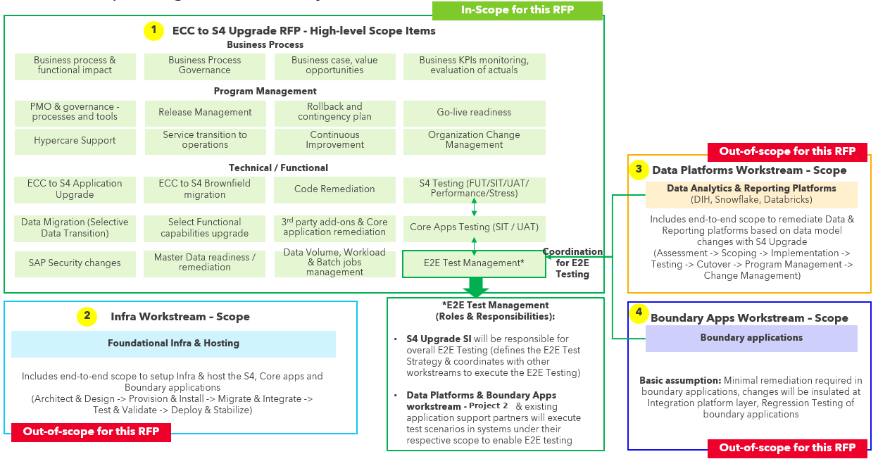

*Intent of the above illustration is to provide a high-level overview of the scope boundaries between the activities included in this RFP and what is considered in-scope for other workstreams. Detailed scope of work for this RFP is described in the next section.

2.4 Project 2 Value Streams, Functional Groups & Key Systems
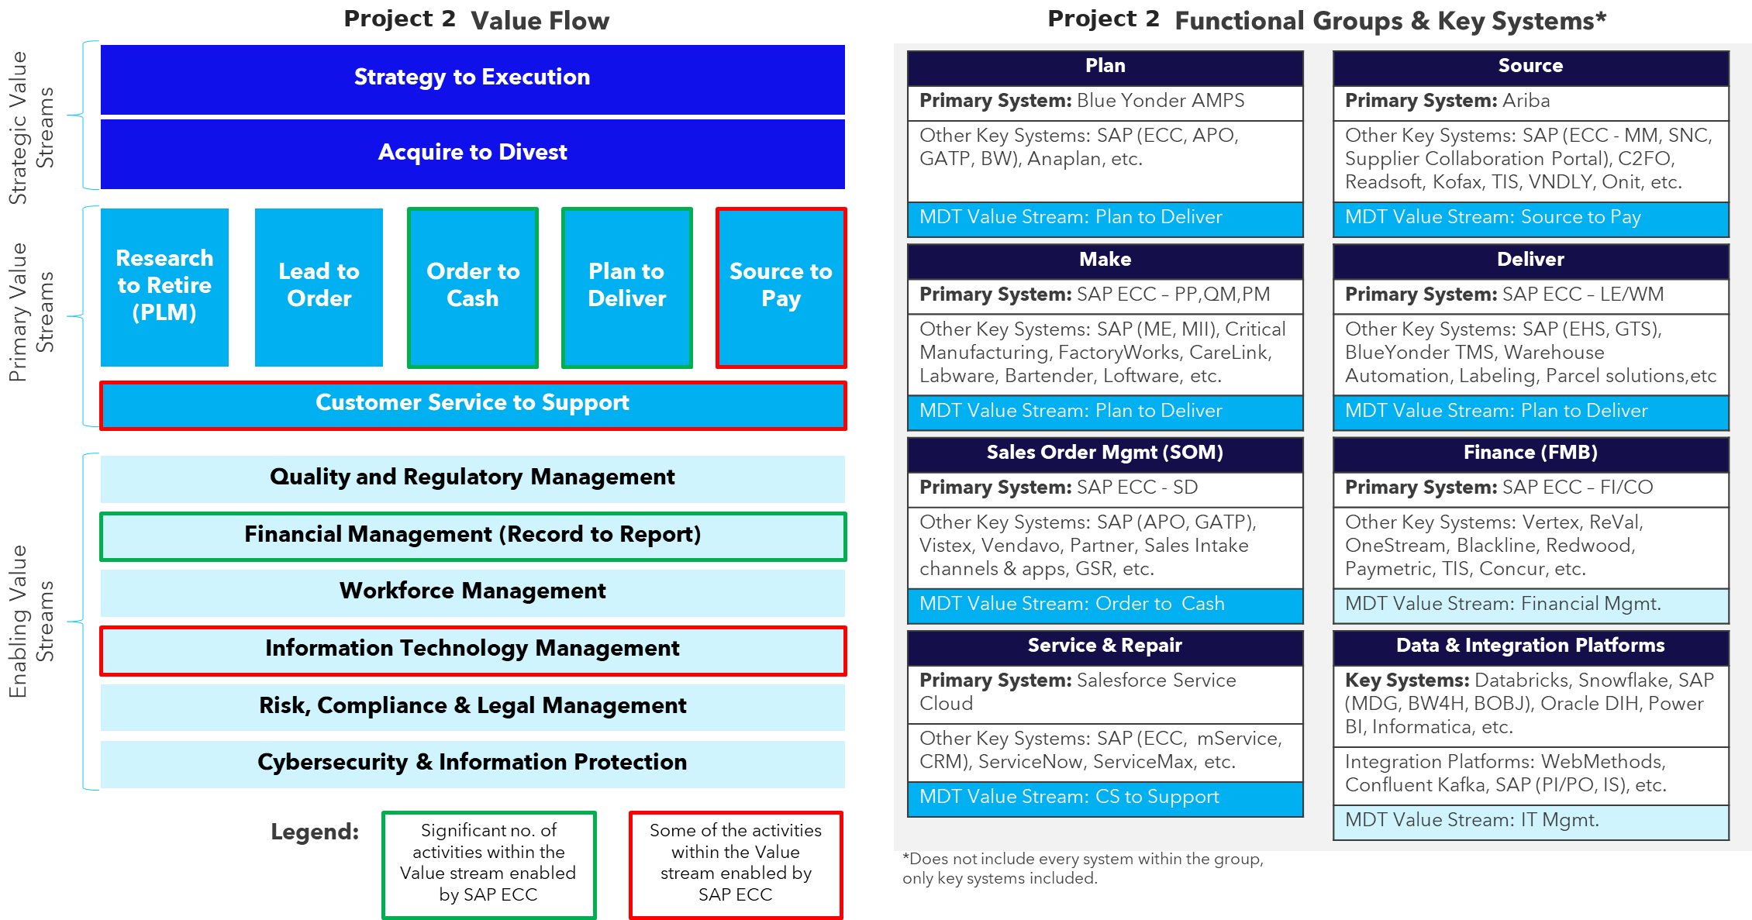

*Intent of the above illustration is to provide an overview of the Project 2 Value Streams and the functional grouping of IT systems. It also provides a high-level view of the various value streams that are enabled by current SAP ECC capabilities. Detailed process-level scope is provided in the next section.

2.5 Current SAP ECC Landscape
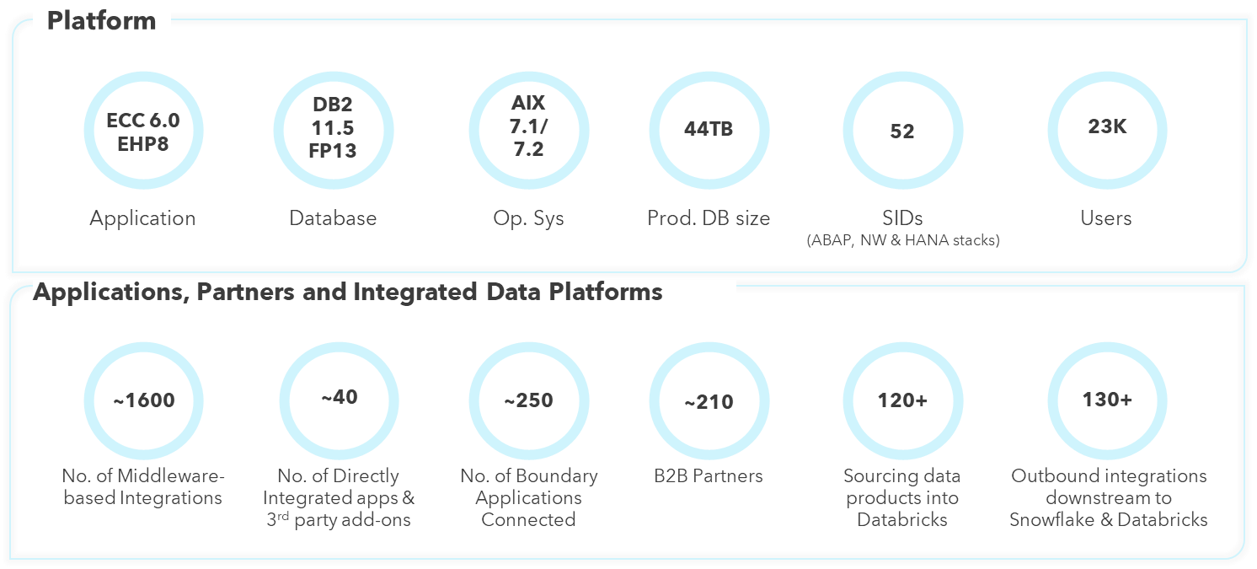

2.6 Current State Architecture and Integrations
Refer Appendix 1 – SAP ECC – Current State Architecture for detailed diagrams across functional and technical areas.

Refer Appendix 1a – SAP Environment Landscape Overview for current and future state environment strategy.

Refer Appendix 2 – SAP ECC - Current Interface Catalog for details regarding all interfaces (direct and via middleware). Further assessment and confirmation will be required during the scoping phase.

- Scope of Work

The following table provides details on anticipated scope of services, the work expected to be performed and provides references to additional details as needed:

Category | Scope details | Additional details / references
System conversion approach | - Brownfield with selective data transition (with select functional transformation and upgrades) with 2 years history and open transactions  - Data transformation includes multi-country statutory and regulatory variation. Country-level detail will be provided to the selected Supplier during the post-award discovery phase. | Refer Appendix 3 - Functional transformation scope for details.  Please populate the Addendum B – Staff Loading Chart - Project column with either Brownfield or Transformation in your RFP response.  Further assessment and alignment will be required during the scoping phase.
Deployment model | - Big-bang single release
Business impact assessment & alignment | - Conduct structured business capability workshops across impacted Value Streams (such as Order-to-Cash, Source-to-Pay, Plan-to-Deliver, Record-to-Report, Service to Support, etc.) and functional domains (such Finance, Treasury, Tax, Manufacturing, Supply Chain, Procurement, Planning, etc).  - Assess business impacts across Operating Units and global functions.  - Identify business processes and functions impacted by S/4HANA capabilities.  - Facilitate business discussions to determine future state functional decisions, including areas where multiple solution options exist, adoption of S/4HANA capabilities versus retention of existing solutions.  - Facilitate business decisions regarding functional configuration options and application landscape changes.  - Assess impacts on SAP add-ons & boundary applications and align remediation approaches and solution strategies.  - Document business stakeholder decisions (Key Design Decisions), obtain alignment from accountable business leaders and maintain an overall Business Decision Register. | Refer Appendix 4 – Process scope assessment conducted in Nov 2024 to determine L1-L4 process scope. This assessment is shared to provide directional guidance on the processes in-scope. Further assessment and alignment will be required during the scoping phase.
Data migration approach & business continuity | - Get business alignment on data migration approach and scope (e.g. duration of historical transactions to be migrated - 2 years, align on definition of open transactions to be migrated, etc.)  - Assess implications of enterprise structure changes and finalize data migration strategy.  - Facilitate data cleanup activities with the business, focusing on identification and remediation of inactive or obsolete data to ensure data quality and readiness for migration. | Current ECC DB size ~44TB  Preliminary assessment indicated ~9TB for 2 years’ data
Eco-system decisions | - Facilitate ecosystem decisions regarding core (tightly integrated) applications, integration platform and SAP add-ons.  - Confirm scope and compatibility of existing SAP add-ons and third-party extensions and implement remediations | Refer Appendix 5 – SAP 3rd party add-ons for details of high-level assessment conducted. Further assessment and alignment will be required during the scoping phase.
Readiness Check and Simplification Item analysis | - Assess the current SAP ECC system landscape and architecture.  - Identify technical prerequisites for S/4HANA conversion.  - Execute SAP Readiness Check and Simplification Item analysis.  - Identify mandatory technical changes, obsolete capabilities and remediation requirements.  - Produce a remediation register and prioritized remediation roadmap. | Refer Appendix 6 - SAP Readiness Check for SAP S4HANA Conversion (performed on 3/26/2026)
Environments strategy | - Define the environment and landscape strategy, including development, test, sandbox, training, pre-production, and production systems  - Align environment and landscape strategy with integrated Project 2 and vendor-hosted applications across all environments  - Ensure parallel production support rail expectations are defined, path to production aligned with Project 2 release management and platform teams
Stabilize ECC baseline | - Assess the baseline health of the ECC system including readiness checks, support pack levels, and add on compatibility. | Refer Appendix 7 – EarlyWatch Alert Report
Code Remediation | - Identify, assess, and remediate all custom code which are deprecated and incompatible with S/4 HANA (leverage accelerators or automation tools) | Detailed assessment and confirmation required during scoping phase:  • Total Custom Code: ~62000 Objects  • Unique object identified for Code Remediation: ~3900  • Individual changes required for all objects: ~21,000  ATC Check results summary:  43.5k findings (12.2k P1, 7.9k P2, 23.5 P3)  Top Categories: field length extensions (19.5k), simplified object usages (9.7k)
Master data | - Assess master data readiness including Customer Vendor Integration and Business Partner requirements.  - Validate and execute required Customer-Vendor Integration (CVI) through master data in MDG  - Assess master data change impacts due to S/4 upgrade to boundary applications
Business process & functional impact assessment | - Gain business alignment on functional impacts with S/4 HANA conversion (e.g. business process change, UX impact, etc.)
Business Process Governance | - Document and align E2E business processes that involves SAP and boundary applications  - Define and implement a governance process for review and approval of business process changes
S4 version / components selection | - Provide recommendations on target S/4 HANA release, Feature Pack Stack, Functional component scope based on current state landscape, business requirements and SAP’s Product roadmap  - Identify current ECC components/capabilities required to be enabled in compatibility mode for S/4 Upgrade and impact analysis of operating in compatibility mode  - Identify and implement remediation for current ECC components/capabilities (such as Screen Personas, Fiori apps, etc.) | RICEFW scope summary based on assessment conducted in Nov 2024. This assessment is shared to provide directional guidance only. Further assessment and alignment will be required during the scoping phase.  RICEFW Objects (New):  Reports = 28  Interfaces = 5  Conversions = 16  Enhancements = 106  Forms = 6  Workflow =16  Fiori = 11  RICEFW Objects (Modify):  Reports = 5  Interfaces = 38  Conversions = 30  Enhancements = 29  Forms = 98  Workflow = 36  Fiori = 33
Data volume management | - Define and implement data volume management solution for S4 solution, archiving/retrieval strategies for historical data not migrated to S4, solution options and recommendations.  - Align with business and IT stakeholders on data retrieval and access strategies for archived and historical data.
Workload / Batch jobs management | - Perform comprehensive batch workload analysis, identify and implement required remediations or rationalization
Platform security | - Evaluate platform security, cybersecurity, and privacy requirements.
SAP Security changes remediation | - Assess and align the impact of security role and authorization changes with business and IT stakeholders.  - Identify and implement security roles/profiles redesign and Segregation of Duties considerations. | 10.5k requestable roles in ECC today along with approximately 23k dialog users
Internal controls | - Define internal control requirements and compliance considerations.
Core applications remediation | - Identify and remediate core applications and associated integrations resulting from S/4 upgrade. | Refer to Appendix 8 – Core apps scope for details. Further assessment and alignment will be required during the scoping phase.
Integrated devices and resources remediation | - Identify and remediate impacts to integrated devices such as RF scanners, printers, and operational equipment.
S/4 Upgrade Testing | - Define the overall testing framework including test phases, scope, entry and exit criteria, governance processes, and quality metrics.  - Define and execute Functional Unit testing, System Integration testing, Regression, Performance / Stress and Security testing (including Vulnerability assessment) of the S/4 upgrade and core applications (and associated interfaces)  - Coordinate and manage defect triage, resolution tracking, and validation of fixes throughout the testing lifecycle.  - Define test automation strategy and tooling approach (Tricentis - preferred tool)  - Adopt an automation-first testing approach, prioritizing automated execution for repeatable scenarios and using manual testing only where automation is not feasible or exploratory validation is required. | Project 2 Preferred Testing tools:  Manual Test: Tricentis Qtest  Automated Testing: Tricentis Tosca  Performance Testing: NeoLoad
E2E Test Management including boundary applications | - Align with business stakeholders on testing approach, phases, scope, test scenarios & test cases inventory for end-to-end business process validation.  - Define and manage the End-to-End (E2E) Test Strategy covering S/4 modules, integrations and boundary applications (adopt an automation-first testing approach)  - Establish E2E test governance including test cycle planning, defect triage processes, and consolidated test reporting.  - Coordinate testing activities across S/4 upgrade workstream, Project 2 teams, and other SI partners responsible for boundary applications and data platforms.  - Ensure adequate test coverage of critical end-to-end business processes, integrations, interfaces, and batch processes spanning SAP and boundary applications.  - Manage integration validation and cross-system defect resolution during testing cycles.  - Ensure testing environments and representative test data are available and ready for all testing phases.  - Provide consolidated reporting on E2E test execution, system quality, and readiness for production deployment.  - Retain overall accountability for E2E test coordination, integration validation, and program-level testing readiness. | E2E Test Management  (Roles & Responsibilities):  The SI for S4 Upgrade under this RFP will be responsible for overall E2E Testing (i.e defines the E2E Test Strategy & coordinates with other workstreams to execute the E2E Testing)  Data Platforms SI & Boundary Apps workstream - Project 2 & other SI partners will execute test scenarios in systems under their respective scope to enable E2E testing
Program management & governance - processes and tools | - The System Integrator (SI) shall provide a dedicated Program Management Office (PMO) that operates within Project 2's established program governance framework and is accountable for the planning, coordination, monitoring, and management of all activities under the SI's scope of delivery.  - In addition, the SI shall serve as the program's "Master Conductor," as further described in Addendum B – Master Conductor Responsibilities, providing leadership and coordination across all participating parties, including Project 2, subcontractors, SAP, and third-party vendors.  - The SI will be expected to proactively drive integrated planning, maintain cross-vendor and cross-workstream alignment, develop and manage integrated roadmaps, resource plans, RACIs, testing and cutover plans, monitor third-party dependencies and performance, identify and escalate risks and issues, and recommend corrective actions to maintain overall program objectives.  - While Project 2 will retain responsibility for the Integrated PMO, executive-level reporting, program governance decisions, and formal escalation management, the SI shall provide the program management leadership support, analysis, coordination, reporting inputs, and cross-party orchestration necessary to enable effective governance and successful program execution.  - Utilize Project 2-approved program management tools, platforms, and dashboards for project planning, reporting, risk management, issue tracking, and program communications.  - Ensure that all program data, documentation, and reporting artifacts are owned by and stored within Project 2-managed systems and environments.  - Supplier may access project tools and data through secure access to Project 2 systems, but program data shall not be hosted or stored in Supplier-managed environments.  - Avoid the use of Supplier proprietary program management tools or platforms that would restrict Project 2 ownership, access, or portability of program data and artifacts.  - Ensure full transparency of program execution through standardized status reporting, risk and issue management, milestone tracking, and executive dashboards accessible to Project 2 stakeholders.  - Maintain clear governance structures including decision forums, escalation paths, and cross-workstream coordination mechanisms to support effective program delivery.
Mock conversion & Cutover | - Define and execute mock conversion cycles  - Develop & execute detailed cutover framework, plan, downtime model.
Rollback and contingency plan | - Define & execute rollback and contingency procedures.
Go-live readiness | - Define Go-Live readiness framework and decision criteria (covering process validation, controls, integrations, reporting, operational readiness, and compliance requirements).  - Support business sign-offs, readiness reviews, and executive Go/No-Go governance activities leading into production deployment.
Release Management | - Establish and manage release management framework governing the full lifecycle of transports, configuration changes, data refresh and custom code deployments across all landscape tiers during and post the conversion program.  - Define approach and governance to ensure parallel projects within legacy ECC environment are synched / migrated to S4 environment, are retrofitted, documented and tested within S4 environment for the duration of the project.
Defect Management | - Establish the defect management and triage process across all testing phases and deployment activities.
Hypercare Support | - Support Hypercare activities & governance, including command center operations, integrated support coordination, issue escalation, and stabilization reporting.
Service transition to operations | - Define, manage and execute a service transition plan (transfer of operational responsibility to internal IT operations or managed AMS partners)
Continuous Improvement | - Identify and document minor business process improvement opportunities arising from the S/4HANA conversion and AI/ML use cases (e.g., retirement of legacy workarounds, HANA enabled simplifications), assess effort, value, and risk, prioritize them into a post go-live quick win backlog.
Organizational Change Management | - Develop and execute an Organizational Change Management (OCM) strategy including stakeholder engagement, communications, training, and user adoption.
Business Value & benefits realization | - Align with business stakeholders on identified value opportunities and benefits  - Ensure upgrade approach and outcomes aligns to agreed value benefits  - Ensure traceability of value benefits to new capabilities, minor enhancements and process changes  - Track and report on benefits realization metrics

- RFP Timeline & Submission Requirements

4.1 Project 2 RFP Contact

All correspondence with Project 2 related to this RFP shall be conducted exclusively with the Project 2 Sourcing contact listed below. Any correspondence with any other employee at Project 2 shall only be conducted only after receiving explicit approval from the contact listed below, and any correspondence outside of this approved channel (related to this RFP) will be grounds for disqualification from this RFP process.

Project 2 contact information:
Name: [Contact Name]
Title: Sr. Sourcing Manager - IT Services
Email: [email]

4.2 RFP Timeline

Submit proposals no later than July 10th, 2026, electronically to [Contact Name] ([email]). Proposals received after this date are not considered.

The dates below reflect close-of-business hours (5 pm CST) unless otherwise noted, and the dates are subject to change at Project 2’s discretion.

RFP Process | Target Date | Responsible
RFP Submitted to Suppliers | 6/19/2026 (Fri) | MDT
Supplier RFP Questions Due to MDT (See Q&A file below) | 6/25/2026 (Thu) | Supplier
MDT Answers to Supplier Questions | 7/2/2026 (Thu) | MDT
Supplier RFP Proposals Due | 7/10/2026 (Fri);  EOD 5pm CT | Supplier
Supplier Virtual Presentations | Start week of 7/27/2026 | Supplier

Q&A File:

* NOTE: A draft SOW will be requested at some point during this RFP process. When requested, see the SOW template below.

4.3 Submission Guidelines and Assessment Schedule

Suppliers are required to submit the following in a written proposal.
EXECUTIVE SUMMARY
- Include an executive summary which briefly and concisely conveys what you see as the most important messages of the SAP Systems Integration proposal, the factors of differentiation, and the critical points that we should consider in our evaluation. Please explain how your strategic direction will benefit us from an immediate and long-term perspective.
IMPLEMENTATION METHODOLOGY, SCOPE, AND APPROACH
- Describe your service delivery methodology and approach for performing the services requested within this RFP.
- Include a description of each of your key phases for assuming responsibility of the services requested based upon the requirements of this RFP. This includes entry/exit criteria.
- Include a proposed project plan for the services requested in this RFP as an attached appendix to your response.
IN-SCOPE AND OUT-OF-SCOPE
- Based on the information we provided in this RFP, identify all of the elements you consider in-scope and out-of-scope for this initiative. Include a matrix of what you consider in-scope and out-of-scope as an appendix to your proposal.
PROPOSED TIMELINE, KEY MILESTONES AND DELIVERABLES
- Identify your proposed timeline, key milestones, technical upgrades, and major deliverables associated with providing the implementation services.
- Include a full description of the deliverables, as well as identify the party responsible for completion of each deliverable (i.e., primary responsible).
Resourcing
- Identify your specific capabilities with respect to leveraging low-cost offshore resources experienced in implementations. Indicate whether your recommended offshore solution would be based upon in-house capabilities or via a third-party alliance or partnership.
- Identify the specific phases, level of effort, and geographic reach where offshore resources can be utilized. Quantify the potential cost savings associated with your recommendation. Provide examples of specific offshore SAP implementation experience within our industry.
- Identify your attrition rates for the past 3 years for its various offshore locations and identify your project management approach to maintaining continuity of personnel.
- Complete the requested Addendum B file to reflect supplemental materials and resourcing details for all phases of the project
REUSE KNOWLEDGE
- Describe your ability to leverage and reuse knowledge capital from prior engagements of a similar nature.
PROJECT TOOLS AND TEMPLATES
- Identify all pre-existing tools and templates you propose to utilize for reporting, collaboration, performance dashboards, etc., and identify associated costs, if any.
KNOWLEDGE TRANSFER AND TRANSITION
- Describe your approach to knowledge transfer and transition management as well as the duration of these activities. Include the deliverables and artifacts as part of Knowledge transfer and transition.
CHANGE MANAGEMENT
- Describe your change management approach. Identify your change management philosophy, methodology, management framework, and deliverables necessary for organization change.
- Describe the measures we must take to enable your proposed change management approach to be successful.
DATA MIGRATION
- Describe your data migration approach. Include a description of your methodology and automated tools and techniques for migrating and maintaining date integrity.
- Describe your approach to data conversion, as well as the key deliverables that would be provided. Please elaborate on our role relative to data conversion.
WORKFLOWS, REPORTS, INTERFACES, CONVERSIONS, EXTENSIONS, FORMS – (WRICEF)
- Describe your methodology and approach for WRICEF related efforts within the Development Objects tab of the attached Addendum B. Please include the number of WRICEF objects included as part of the cost estimate as well as the associated level of effort per object per complexity. Justify any deviation from the WRICEF counts and complexities that we have provided.
FIORI ENABLEMENT USER INTERFACE CHANGES
- No User interface changes are expected unless any mandatory new Interfaces (e.g. Fiori) are required
- Describe the scope and approach for new interfaces activation, including security changes

TESTING SCOPE, METHODOLOGY AND APPROACH
- Describe your testing scope, methodology and approach, as well as your methodology and approach to performance and security testing. Provide a full list of testing cycles, indicating those in and out of scope of this RFP.
TRAINING SCOPE AND APPROACH
- Describe your training scope and approach for both project team and end-user training. Include a high-level training roadmap and identify the level of effort and associated cost. Post-Implementation Support.
HYERCARE AND TRANSITION SUPPORT
- Describe your post-implementation support and identify any associated cost. Indicate the duration of specific hyper care windows for each deployment, as applicable.
INCIDENT MANAGEMENT
- Provide a baseline definition of the various incident Levels (P1, P2, P3, P4) and SLAs for their resolution. Additionally, include your approach on how these resolutions are documented and transitioned to the support team following the closing out of hyper care activities.
- Acknowledge that incident level definitions as part of this RFP request are not meant to be finalized, but we are gathering baseline information at this stage.
INTERIM STATE PROCESSING
- Provide your expectations on any interim state processing where we may be required to leverage both legacy and the new system in parallel for entities that have been migrated based on the current project plan. Indicate how you will support us in minimizing business disruption.
PROJECT MANAGEMENT APPROACH
- Identify your willingness to assume a prime contractor role and assume responsibility for project management and performance of each subcontractor.
- Describe your approach to managing this initiative. Include insight into your capability to manage this initiative, respond to day-to-day problems, manage issues, staff, supervise and manage resources.
- Describe your process controls to be put in place to ensure the work required throughout this engagement is performed to the highest levels. Provide guidance on how we would be able to escalate persisting performance/quality issues with the program.
- Describe how your teams will interact with our internal teams.
- Identify an overall project executive sponsor, as well as the corresponding subcontractor executive sponsors, if applicable, and delineate anticipated roles, responsibilities, and level of involvement.
- Describe your plans to minimize disruption due to employee turnover.
PROPOSED PROJECT ORGANIZATION
- Separate from resource & staffing plan (included in Addendum B), we are requesting specific project organizational structure – including leadership roles, escalation points, etc.
- Detail to be provided by vendor in separate appendices attached to response
PROJECT ORGANIZATION CHART
- Provide a proposed project organization chart in the attached appendix.
ROLES AND RESPONSIBILITIES
- Describe the individual roles and responsibilities that our and your personnel (including subcontractors) will assume for this initiative as an attached appendix. Identify the roles, responsibilities, and party responsible, in the format of a detailed matrix.
- Identify our resource requirements for each phase of your methodology and include recommended qualifications and expertise.
STAFF LOADING CHARTS
- Provide a staff-loading chart (as an attached appendix, see “Appendices” below) identifying Client and vendor hours (not FTE’s or Person-Months), including subcontractors, according to role, month, and phase. For supplier proposed effort, the chart must include the hourly rate associated with each individual per the rate card you provide. Your proposal tied to Client effort will be used to assess internal resourcing required across Project 2 IT and our business.
- Map all Key resources for the program within the attached staff loading chart by name.
PROPOSED VENDOR TEAM FOR THIS PROJECT
- Identify your proposed team and describe the experience, skills, education, training, qualifications, and certifications for each position.
- Identify the location of your personnel who will be assigned to this initiative.
- Include resumes as an attached appendix.
- Level of commitment/confidence that the team you have presented would be the actual delivery team engaged
WORK HOURS
- Identify your standard business hours. We require you to provide adequate coverage throughout the workweek.
SAP SOFTWARE BILL OF MATERIALS
- Find the proposed SAP Bill of Materials for BYOL and RISE associated with the contemplated scope of this program. You are requested to review and validate the proposed SAP Bill of Material below, providing any feedback regarding the contents, quantities, and any potential omissions relative to the scope of the Implementation as you understand it.Volumes provided are directional at this time. We are looking for the SI partner to assist Project 2 in validating Project 2’s volume requirements.
SAP RISE Product / SKU | Volume | Notes
RISE with SAP S/4HANA Cloud, priv ed, tailored op (RISE FUEs) | 12,000
SAP S/4HANA Cloud, Digital Access, priv ed, tailored op | 10,000
SAP S/4HANA Cloud for Advanced Available-to-Promise, priv ed, tailored op | 75
SAP Document and Reporting Compliance for SAP S/4HANA Cloud Private Edition, tailored option | 15
SAP Secure Logon Service for SAP GUI | 70
SAP Information Lifecycle Management Cloud, priv ed, tailored op | 6
SAP Paybacks and Chargebacks by Vistex for SAP S/4HANA Cloud, priv ed, tailored op | 130
SAP Incentive Administration by Vistex for SAP S/4HANA Cloud, priv ed, tailored op | 122
SAP Business Data Cloud | 159,900 | Under consideration, not confirmed
SAP Build runtime | 18000 | Under consideration, not confirmed
SAP Build developer | 90 | Under consideration, not confirmed
SAP Build base user | 36,000 | Under consideration, not confirmed
SAP Build premium user | 12,000 | Under consideration, not confirmed
Advanced Finance close | TBD | Under consideration, not confirmed
InterCompany Matching & Reconciliation (ICMR) | TBD | Under consideration, not confirmed
Revenue Accounting & Reporting (RAR) | TBD | Under consideration, not confirmed
Financial Supply Chain Management (FSCM) | TBD | Under consideration, not confirmed
Data Obfuscation / Masking | TBD | Under consideration, not confirmed
GxP Compliance | TBD | Under consideration, not confirmed

SAP BYOL Product / SKU | Volume | Notes
SAP S/4HANA Enterprise Management for Professional use | 31,242
SAP S/4HANA Enterprise Management for Productivity use | 16,065
SAP S/4HANA Enterprise Management for Functional use | 2,707
SAP S/4HANA, Developer access | 102
SAP S/4HANA Digital Access | 10
SAP S/4HANA Advanced Available-to-Promise | 130
SAP Document and Reporting Compliance for S/4HANA | 15
SAP Secure Logon Service for SAP GUI | 70
SAP Paybacks and Chargebacks by Vistex for SAP S/4HANA | 130
SAP Incentive Administration by Vistex for SAP S/4HANA | 122
Business Data Cloud | 159,900 | Under consideration, not confirmed
SAP Build runtime | 18000 | Under consideration, not confirmed
SAP Build developer | 90 | Under consideration, not confirmed
SAP Build base user | 36000 | Under consideration, not confirmed
SAP Build premium user | 12000 | Under consideration, not confirmed
Advanced Finance close | TBD | Under consideration, not confirmed
InterCompany Matching & Reconciliation (ICMR) | TBD | Under consideration, not confirmed
Revenue Accounting & Reporting (RAR) | TBD | Under consideration, not confirmed
Financial Supply Chain Management (FSCM) | TBD | Under consideration, not confirmed
Data Obfuscation / Masking | TBD | Under consideration, not confirmed
GxP Compliance | TBD | Under consideration, not confirmed

APPENDICES EXPECTATIONS
Include, at a minimum, the following appendices with your proposal. Your appendices must provide the specific details of your proposal and afford the highest degree of transparency.
- In-Cost Summary & Commercial Requirements (See Addendum B: Cost Summary & Commercial Requirements)
  - Commercial Solicitation & Fee Summary
  - AI Assets and Tools & AI Questionnaire
  - RACI / Roles & Responsibilities
  - Staff Loading Chart / Key Resources
  - Development Object Inventory & Estimating Factors
  - Process Map
  - Assumptions
  - Rate Card
- Project Plan
- Organization Chart
- Resumes
Cost estimate:
- Pricing Model - Project cost estimate
Project 2 is looking for a fixed fee cost model with milestone / Deliverable-based services for all phases of the project. Supplier will be paid only after Project 2 approves the milestone/deliverable-based services.

Project 2 requires transparency in any cost proposal to understand the underlying roles, level of experience, rates, and hours that make up the total cost. Use the “Addendum B” Excel file below to provide this information back to Project 2. Failure to provide the resource file with this RFP will result in your elimination from the selection process. Missing fields (i.e., providing only hours but not rates, or providing only a high-level number of hours, etc.) will also be considered an incomplete submission, and you will be eliminated from the selection process. Underlying rates should remain flat during the engagement term until services are complete. A copy of the Excel template below is also attached to the RFP email. As part of the Addendum B exercise, you will be requested to provide rate detail related to your proposal in varying structures, however Project 2 wants to reiterate that the final SI agreement will be a under a fixed fee format.

Note: Please make sure your new Project 2 approved preferred partner (PP) rate card is used for baseline rates. You MUST map to the PP rate card roles, years of experience and rates. See the comment below about discounts/investments. Project 2 expects to see other discounts or partnership investments.

Discounts / Investments
Your proposal should highlight any proposed discounts or investments, including details on those investments (e.g., discounted rates, invested hours, etc.).

Project 2 SOW Template
The selected Supplier will be required to use the Project 2 Statement of Work (SOW) template for any contract. See the attached template. Key provisions from Addendum B included above will be incorporated into the SOW. Note: If Project 2 uses a Work Order template with your company, the terms should be comparable, or better, than the terms in the attached SOW template.

Licensing
Licensing fees and software support/maintenance are NOT in scope

Other
If your company can provide any tools or accelerators to support your services, please indicate what they are and how they should be used in Addendum B. Also, please indicate if there is a cost to Project 2 to use them. It is highly recommended to not charge Project 2 for these items.

- RFP Evaluation Criteria

Proposals will be evaluated based on the following criteria:
- Understanding of Project 2 project requirements.
- Experience and expertise in a regulated environment.
- Quality and feasibility of the proposed solution.
- Qualified and experienced resources.
- Project timeline and ability to meet deadlines.
- Cost-effectiveness of the proposed solution.
- References and past performance.
- Organization Change management
- Use of automation proposed in the delivery

- Supplier Qualifications

Suppliers should demonstrate:
- Proven Brownfield Conversion Expertise - Demonstrated success in large-scale ECC → S/4HANA Brownfield conversions
- Ability to handle complex landscapes (multi-instance, global footprint)
- Strong Technical Delivery Capability - Ownership of System conversion execution, Custom code remediation, Interface and integration remediation
- Data Migration & SDT Competence - Expertise in Selective Data Transition tools and methods
- End-to-End Testing Ownership - Structured testing strategy (Unit, SIT, UAT, regression), Automation where applicable, Defect management discipline, Business process validation across integrated landscape
- Business Continuity & Cutover Excellence - Detailed cutover planning and execution ownership, defined Downtime optimization strategy, Rollback and contingency plans, Command center support during go-live
- Performance & Scalability Assurance - Execution of Volume testing, Performance benchmarking
Optimization of batch jobs, critical transactions & Validation under peak loads
- Governance, PMO, and Transparency - Strong PMO discipline, Transparent reporting, Proactive risk identification and mitigation
- Resource Quality & Stability - Deployment of Senior, experienced consultants in key roles, Minimal resource churn, Clear accountability by workstream
- Integration & Ecosystem Alignment - Experience integrating with Non-SAP systems (MES, WMS, planning tools, banks, etc.), ownership of interface validation and remediation, coordination across vendors and internal teams
- Change Management & Business Readiness Support - Support for Impact assessment, Training content development, Alignment with business stakeholders, Enablement of super users and SMEs
- Compliance, Controls & Audit Readiness - Alignment with SOX and internal control requirements; Documentation of Migration logs, Reconciliation evidence; Support for internal and external audits
- Post-Go-Live Support & Stabilization - Structured hyper-care model, Dedicated support team, SLA-driven issue resolution; Knowledge transfer to internal teams; Clear exit and transition plan
- Value Focus (Beyond Technical Conversion) - Recommendations to reduce custom code, simplify processes where feasible, identification of quick wins (Automation, Reporting improvements)
- Contractual Accountability - Clearly defined deliverables and milestones, SLAs and KPIs, Commercial model aligned to outcomes, Incentives for on-time, quality delivery, penalties for missed commitments

7. Disclaimers and Confidentiality

All information contained in this RFP or provided separately relating to this request is considered confidential and proprietary to Project 2 and must be treated by Supplier as confidential. The privacy of all information surrounding the project is required until further notice. Discussions regarding the RFP with other parties within or associated with Project 2 are also subject to confidentiality restrictions. Any breach of this policy may result in, among other remedies available at law, the bidder’s disqualification from the bid process for this specific event and other bid requests by Project 2.

All information submitted by Supplier for this RFP shall become the property of Project 2 once submitted, unless otherwise requested by your Supplier at the time of submission. Any material that is to be considered confidential must be clearly marked as such.

This RFP is not an offer or a contract and does not bind Project 2 to any obligations. Costs incurred in the development of the response, attendance at meetings, presentations, and any other expenses are the responsibility of the Supplier and will not be reimbursed by Project 2.

To be awarded business outlined in this RFP, suppliers must meet the Project 2 Data Privacy and Security guidelines and have the applicable (updated) Master Agreement in place with Project 2.

Project 2 reserves the right to, and Project 2 may at any time, in its sole discretion:
- Accept, reject or not respond to any, and all proposals submitted in the response to this RFP.
- Change or discontinue the RFP process at any time.
- Add, modify, or delete any items in this RFP at any time.
- Negotiate additional items to be included in or deleted from the proposal
- Reject any or all proposals that it deems to be non-responsive, late in submission or unsatisfactory in any way.
- Extend or modify any date stated in the RFP (including any date in the MSA);
- Request new proposals to be submitted.
- Reissue this RFP, as updated by Project 2, to additional potential Suppliers at any time during the RFP process and subsequent negotiations.
- Terminate the RFP process and subsequent negotiations; and
- Negotiate with none, one or more than one Supplier.

Any decision by Project 2 to retain a Supplier to provide the Services will be subject to Project 2 legal and management approval and the negotiation and execution of a mutually agreed contract (e.g., SOW). The final contract will be based on the proposal and RFP, which may be altered by Project 2, as required, to adapt to the award circumstances.

8. No Publicity

Supplier may not make any public announcement relating to this RFP or otherwise publicize the existence or contents of this RFP without obtaining Project 2’s prior written consent. Any Supplier that discusses this RFP or initiative with anyone within or outside Project 2 other than as expressly permitted by this RFP will risk immediate disqualification from further consideration, in addition to enforcement by Project 2 of its remedies under the NDA (or CDA), at law or in equity.

9. Client References
Project 2 may wish to contact your client references. Please provide 2 client references for a similar size implementation, with special focus on execution support provided by you to your client by your proposed delivery team. Please note in the case studies if those clients are referenceable. Reference contact information should include: Company name, contact person name, email address, phone number.

Appendices

Appendix Document | Document Title | Embedded Document | RFP Section Reference
Appendix 1 | SAP ECC – Current State Architecture |  | 2.6 Current State Architecture and Integrations
Appendix 1a | SAP Environment Landscape Overview for current and future state environment strategy |  | 2.6 Current State Architecture and Integrations
Appendix 2 | SAP ECC - Current Interface Catalog |  | 2.6 Current State Architecture and Integrations
Appendix 3 | Functional transformation scope |  | 3 Scope of Work – System conversion approach
Appendix 4 | Process scope assessment |  | 3 Scope of Work – Business impact assessment & alignment
Appendix 5 | SAP ECC – 3rd party add-ons |  | 3 Scope of Work – Eco-system decisions
Appendix 6 | SAP Readiness Check for SAP S4HANA Conversion |  | 3 Scope of Work – Readiness Check and Simplification Item analysis
Appendix 7 | EarlyWatch Alert Report |  | 3 Scope of Work – Stabilize ECC baseline
Appendix 8 | Core apps scope |  | 3 Scope of Work – Core application remediation

