- 

the program Program — SAP PM Implementation
System Integrator RFP Response
Submitted to: Project 3
Submitted by: Deloitte
Date: July 17, 2026
Primary Contact: [Contact Name] | [email] | [phone]

PROPOSAL FOR

the program Program — SAP PM Implementation
System Integrator RFP Response
Submitted to: Project 3
Submitted by: Deloitte
Date: July 17, 2026
Primary Contact: [Contact Name] | [email] | [phone]

Table of Contents
1. Implementation Methodology & Delivery Framework 3
2. Tailored Methodology 6
3. Risk Management, Governance & Quality Management 8
4. Requirements Traceability 14
5. Solution Design 17
6. Development & Integration Methodology 29
7. Data Conversion Methodology 35
8. Testing Methodology & Quality Controls 40
9. Change Management Methodology 44
10. Deployment & Rollback Methodology 57
11. Hypercare & Transition-to-Support Methodology 60
12. Tools, Accelerators & Templates 63
13. Deliverables, Decision Points, Quality Gates & Acceptance Criteria 68
14. Risks & Assumptions 71
15. Previous Experience/Quals 72
16. Proposed Project Team 75
17. Integrated Project Plan 79
18. Pricing & Resourcing 80
19. Alternate Implementation Approach 81

Implementation Methodology & Delivery Framework
Deloitte will deliver the Project 3 the program SAP PM program using Deloitte Ascend Methodology, our digital delivery platform and hybrid implementation methodology that combines leading practices in project management, quality management, value realization, process and application design, information management, development, deployment, technology, and change management. Ascend uses GenAI-enabled capabilities, integrated tools, accelerators, and AI agents to improve efficiency, accuracy, productivity, and reusable asset creation across the delivery lifecycle. For Project 3, this approach is intended to increase delivery consistency, reduce execution risk, and accelerate value realization while supporting the full technology, process, data, integration, testing, and organizational change scope required by the program.
Leveraging the Ascend Intelligence Platform, Deloitte will orchestrate the digital transformation of Project 3 journey. This platform provides capabilities such as MoM (Minutes of Meeting), RAID (Risks, Actions, Issues, Decisions) Log Generation, and user story generation, ensuring comprehensive project oversight and streamlined execution.
The Spec Starter solution enhances delivery by enabling the search and reuse of Deloitte’s knowledge base, including code, strategy documents, functional specifications, and technical specifications. The Autonomous Configuration solution accelerates system configuration setup.
Autonomous Code and Autonomous Data solutions ensure efficient code generation and data management, reducing errors.
Ascend Test Solutions accelerate Test Scenarios and Test Case generation.
The methodology is made up of four phases—Prepare, Imagine, Deliver, and Run—and incorporates leading practices in project management, quality management, value realization, process and application, information management, development, deployment, technology, and change management.

The graphic below illustrates the key phases and calls out some of the key-impact deliverables that are produced during the Project.

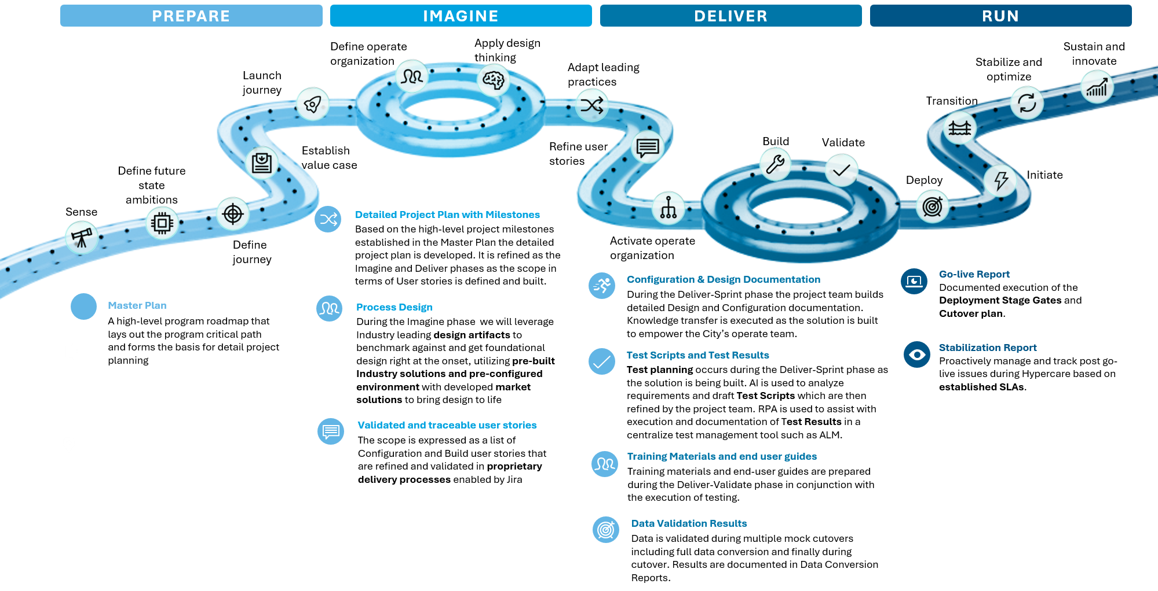

- Prepare Phase
In the Prepare phase, we establish the foundational program deliverables: project management, governance, cadence, and relationship management. These activities set up the structure needed to support end-to-end delivery across the organization. Key outputs include a readiness assessment and a master plan.
We will work with Project 3 leadership to define the future-state vision, confirm reporting lines, and align on the program rhythm. Key deliverables in this phase include the governance model, program operating structure, and initial change and transformation controls.
- Imagine Phase
In the Imagine phase, we will design the future solution and operating model using leading practices and design thinking. This stage refines user stories, defines the target organization, and creates detailed project plan, process design, and validated requirements.
We will collaborate with Project 3 business and technology teams to run design workshops, identify gaps, and define simplification opportunities.
- Deliver Phase
In the Deliver phase, we execute the build, configuration, testing, and deployment work. Key outputs include design/configuration documents, test scripts and results, training materials, user guides, data validation results, and go-live readiness artifacts.
Our teams will work iteratively through build, test, and deploy activities. This includes integration testing, user acceptance testing, performance and stress testing, cutover planning, end-user training, reconciliation, hypercare activation, and rollback planning.

- Run Phase
In the Run phase, we focus on stabilization, monitoring, and training after go-live. The key deliverables are business stabilization, post-production support, role-based training, and transition to steady-state support.
We will help Project 3 employees understand how their roles change and what actions they need to take differently. Over time, responsibilities transition to managed services, which will support ongoing optimization and future releases.

Tailored Methodology
For Project 3, Deloitte will tailor Ascend to fully conform to the the program 6-Phase-Gate framework described in the Project 3 Digital PMO playbook. The Project 3 stage-gate model remains the governing delivery and acceptance structure, including all required milestone deliverables, quality gates, approvals, and acceptance criteria. Deloitte’s approach will therefore align Ascend outputs to Project 3 gates and milestones.
Deloitte will map the Ascend phases to Project 3 as follows:
- Prepare: establish governance, align stakeholders, define digital ambitions, confirm scope, and baseline the integrated plan and RAIDD structure in support of SG0–SG1. This corresponds directly to Project 3’s required mobilization and plan approval deliverables, including the charter, PMP, IMS baseline, RASCI, stakeholder register, and communications plan.
- Imagine: conduct fit-to-standard and design workshops to validate the future-state operating model, business requirements, process design, integrations, data, controls, security, and change impacts, aligning to SG2 design baseline approval. Project 3 explicitly requires the refreshed RTM, RICEFW inventory, controls walkthrough, and approved design baseline at this point.
- Deliver: execute iterative build, configuration, development, mock conversions, unit testing, SIT, UAT support, training content development, and cutover preparation, with sprint-based validation embedded throughout. This aligns to Project 3’s SG3 and testing milestones, including master test plan approval, three SIT cycles, joint integration testing, controls testing, and readiness to enter go-live planning.
- Run: provide production cutover support, hypercare, stabilization, knowledge transfer, and transition to Project 3 support teams, aligned to SG4–SG5 and the hypercare exit / closeout milestones.
Below table showcases the mapping of Ascend phases to Milestones.
Ascend Phase | # | Milestone | Stage Gate Alignment
 | M0 | Award and Project Start  (Contract Effective Date) | Pre-SG0
Prepare | M1 | Project Preparation, Mobilization, Kickoff, and Plan Approved | SG0 → SG1
Imagine | M2 | Solution Design / Fit-Gap Complete + Controls Design Walkthrough + RTM Refresh | SG2 (Design Baseline Approved)
Deliver | M3 | Functional and Technical Specifications 50% Approved + Build Started + 1st End-State Demo + Mock Conversion Load #1 Reconciled | Mid-SG3
Deliver | M4 | Functional and Technical Specifications 100% Approved + 2nd End-State Demo + Mock Conversion Load #2 Reconciled | Late-SG3
Deliver | M5 | Build, Unit Test, and Configuration Baseline Complete + 3rd End-State Demo | SG3 (Build / Test Ready)
Deliver | M6 | SIT Three Cycles Complete + Joint Integration Testing Complete + Controls Test of Operating Effectiveness in SIT | Post-SG3
Run | M7 | UAT Sign-off + Mock Conversion Load #3 + Cutover Rehearsal #3 Pass + Controls Readiness Statement + Go-Live Readiness Approved | SG4 (Go-Live Readiness)
Run | M8, M10 | Go-Live (Project 3 Indiana + Project 3 Ohio + MVLt) — Successful Cutover and Day-14 Production Stability | SG4 Execution
Run | M9, M11 | Hypercare Exit (75 Days) + Transition-to-AMS + Hypercare Controls Readiness Statement + Project Closeout + Retainage Release | SG4 Stabilization  SG5 Closeout

Deloitte’s tailored delivery approach for Project 3 will emphasize:
- Stage-gate conformance to Project 3 Digital PMO governance and milestone acceptance requirements
- Integrated delivery across SAP PM, integrations, data conversion, controls, testing, and OCM
- Controls by design, with SOX, FERC, IURC, and PUCO requirements embedded throughout the lifecycle
- Hybrid agile execution, using sprint-based build and validation while preserving required governance discipline
- AI-enabled digital delivery, leveraging Ascend GenAI capabilities to increase efficiency, artifact reuse, and delivery quality
- Deployment and stabilization, with cutover, hypercare, and transition-to-support planned as formal controlled activities
In summary, Deloitte will use Ascend as the underlying delivery methodology and digital execution platform, while fully conforming to the Project 3 the program 6-Phase-Gate framework as the official program governance and acceptance model. This provides Project 3 with a disciplined, transparent, and controls-driven implementation approach that is both proven and tailored to the program’s stage-gate requirements.

Risk Management, Governance & Quality Management

Approach for Risk Identification, Assessment, Tracking, Mitigation, and Escalation
Deloitte's risk and issue management approach is embedded in our overall Project Management discipline and executed iteratively throughout the lifecycle of Project 3's SAP PM implementation under the the program Program for Project 3 Indiana, Project 3 Ohio, and Miami Valley Lighting (MVLt). The objective is to anticipate and reduce delivery disruption, protect quality and schedule, and ensure leadership has clear visibility into what is happening now, what is likely to happen next, and what decisions and interventions are required.
We will use Smartsheet as the system of record for RAIDD (Risks, Assumptions, Issues, Dependencies, Decisions) — consistent with the Project 3-mandated toolset — enabling consistent intake, scoring, ownership, mitigation tracking, escalation, and linkage to related deliverables (testing, data validation, cutover readiness, and status reporting). All RAIDD content will be integrated into the consolidated the program PMO supported by Deloitte and governed through Project 3-provided templates and repositories (SharePoint Teams site, Smartsheet, MS Project/Smartsheet for IMS, and Power BI for KPI roll-ups) as the single source of truth.

Risk Management Lifecycle
Risk Management Planning (Rules of Engagement)
During project preparation, Deloitte and Project 3 jointly define the Risk Management Plan, including:
- Risk categories tailored to the SAP PM implementation context (e.g., RICEFW custom object build and testing, integration impacts across DDS/GIS/OMS/PowerPlan/FSM, role and security conversion, SAP PM master data reconciliation, environment readiness governed by Project 3 Basis/Accenture AMS, testing capacity across three SIT cycles and UAT, cutover window constraints, and concurrent programme dependencies including the SAP S/4HANA 2021→2025 Upgrade, PowerPlan NXT, and DDS/GET)
- Project 3's risk tolerance, escalation thresholds, and reporting expectations as defined in the Project 3 Digital PMO Playbook and the program 6-Phase-Gate framework
- Required fields and documentation standards in Smartsheet (cause/trigger, impacted milestone, workstream, probability/impact, mitigation, contingency, owner, due dates aligned to Stage Gates SG0–SG5)
- Cadence for review: weekly at Tier 3 Workstream Delivery and Tier 2 Program-Level Governance; monthly at the Tier 1 Executive Steering Committee as needed
Outputs: Risk Management Plan, risk taxonomy aligned to the program workstreams, scoring matrix, escalation criteria, Smartsheet dashboard/reporting standards conforming to Project 3 Digital PMO Playbook.

Risk Identification (Continuous, Multi-Source)
Risk identification is performed continuously using structured prompts and project artefacts, including:
- Workstream execution and cross-workstream dependency reviews (including IMS reconciliation against DDS/GET, GIS/RAM, FSM, SAP S/4HANA Upgrade 2021→2025, and PowerPlan NXT timelines)
- Testing preparation and execution signals (readiness, defect trends, environment stability across DEV, QA, Pre-Prod, and PROD landscapes)
- SAP PM data migration and reconciliation planning across three mock load cycles and cutover-load operations
- Cutover planning and readiness activities for Project 3 Indiana, Project 3 Ohio and MVLt.
- Weekly status inputs from Deloitte and Project 3 workstream leads contributing to the 8-dimension Program Health RAG model (Schedule, Scope/Change, RAIDD Health, Budget, Quality, Testing/Progress, Data & Cutover Readiness, Adoption Readiness/OCM)
All risks are logged in Smartsheet with standardised metadata (category, impacted the program milestone/Stage Gate, workstream, probability/impact, triggers, and proposed response).

Risk Assessment and Prioritization (Qualitative Scoring)
We apply a qualitative scoring approach that multiplies likelihood (1–5) by impact (1–5) and plots the result on a baseline matrix to prioritise Project 3 leadership visibility and action. Risks are then tiered (Low/Medium/High) with defined response urgency, required approvers, and escalation rules.
What this enables for Project 3: A consistent way to separate "watch items" from "must-act-now" risks and focus mitigation effort on the items that could threaten Stage Gate approvals, go-live milestone commitments, or financial reporting and regulatory compliance obligations.

Below table is a sample of how the overall risk score will be calculated for a risk ID across different parameters.

Impact | Likelihood 1 – Low | Likelihood 2 | Likelihood 3 | Likelihood 4 – High
5 – High | Low (5) | Medium (10) | High (15) | High (20)
4 – Med/High | Low (4) | Medium (8) | Medium (12) | High (16)
3 – Medium | Low (3) | Medium (6) | Medium (9) | Medium (12)
2 – Low/Med | Low (2) | Low (4) | Medium (6) | Medium (8)
1 – Low | Low (1) | Low (2) | Low (3) | Low (4)

Risk Response Planning (Mitigation + Contingency + Ownership)
For each prioritised risk, Deloitte and Project 3 agree:
- Mitigation actions (reduce likelihood/impact)
- Contingency actions (what we do if the risk materialises)
- Trigger conditions (signals that activate contingency — e.g., defect velocity thresholds in SIT, mock load reconciliation failures, concurrent programme delays in S/4HANA Upgrade or DDS/GET that compress the the program delivery window)
- Owner (single accountable individual aligned to Tier 2 or Tier 3 governance layer) and contributing roles
- Due dates aligned to the program milestones and Stage Gates (SG0 Mobilisation through SG5 Project Closeout), including test readiness gates, mock cutover rehearsals, and go-live readiness approvals

Monitoring and Controlling Risks (Cadence + Dashboards + Escalation)
Risks are monitored continuously and formally reviewed across three governance tiers aligned to the Project 3 the program operating model:
- Tier 3 – Workstream Delivery (daily/weekly): RAIDD review, progress vs. plan, upcoming milestones, dependency asks, and decisions needed; the SI's primary operating layer
- Tier 2 – Program-Level Governance (weekly): integrated planning, dependency management, design authority review, and cross-workstream RAIDD triage within Steering Committee guardrails
- Tier 1 – Executive Steering Committee (monthly): top risks, trend themes, decisions required; mandatory escalation within one weekly cycle for any critical defect threatening a go-live milestone, budgetary change exceeding 10% of contingency (or cumulatively >50% of contingency), risk to financial reporting or regulatory compliance, or strategic design deviation from the the program target-state

Issue Intake, Triage, Resolution, and Escalation (Mechanisms + Service Levels)
Deloitte's issue management approach is designed to prevent issues from paralyzing productivity, increasing rework, or degrading deliverable quality. All issues are triaged through the Smartsheet RAIDD workflow, respect escalation triggers (cross-workstream impact, milestone or go-live threat, exceedance of workstream-lead authority, or high cost/timeline/benefits impact), and are resolved within service levels agreed with the Project 3 Digital PMO — ensuring that no issue ages unaddressed across a weekly governance cycle without a documented owner, resolution path, and
Quality Management Process
With respect to quality management, the PMO is charged with monitoring the program through a rigorous set of review and control procedures. Program goals, standards, and deliverables are carefully scrutinized on a continuous basis. Ongoing visibility is provided to scope and resource constraints.
Quality management is one of Deloitte’s core strengths and occurs throughout the project. Our methodology includes comprehensive quality assurance and quality control activities that help minimize project risk. These processes are based on industry-recognized PMBOK quality management themes and align with leading methodologies, including Prince2, PMI, and APM. Embedded throughout the project life cycle, these activities enable the regular review of project deliverables and drive adherence to the work plan.
Deloitte’s Project Management thread includes four processes for quality management, which are defined as follows:
Plan Quality Management | - Practice of defining the project’s quality objectives and expectations, and planning the tasks, procedures, tools, and participants that will perform the quality activities for the project.  - We plan the strategy, processes, and tools used to perform the three components of the project’s overall quality program: quality assurance, quality control, and quality support.
Execute Quality Assurance | - Practices to establish and manage project delivery standards, monitor adherence, and make process improvements.  - We verify that the project has the processes and tools it needs to deliver a high-quality solution and that the project team is using them effectively. These objectives are accomplished by performing the following tasks: managing the project methods and templates, managing the project standards and guidelines, and performing the quality assessment activities planned for the project.
Monitor and  Control Quality | - Practices that monitor project results and identify corrective, preventative, and improvement actions.  - We perform the deliverable reviews planned for the project, complete the deliverable sign-offs planned for the project, and manage the detailed project metrics plan for the project.
Execute  Quality Support | - Practices whereby non-project specialists are leveraged to assess, advise, and assist the project team, providing additional oversight and support to the project.  - We execute the quality support activities planned for the project, as defined in the quality management plan.

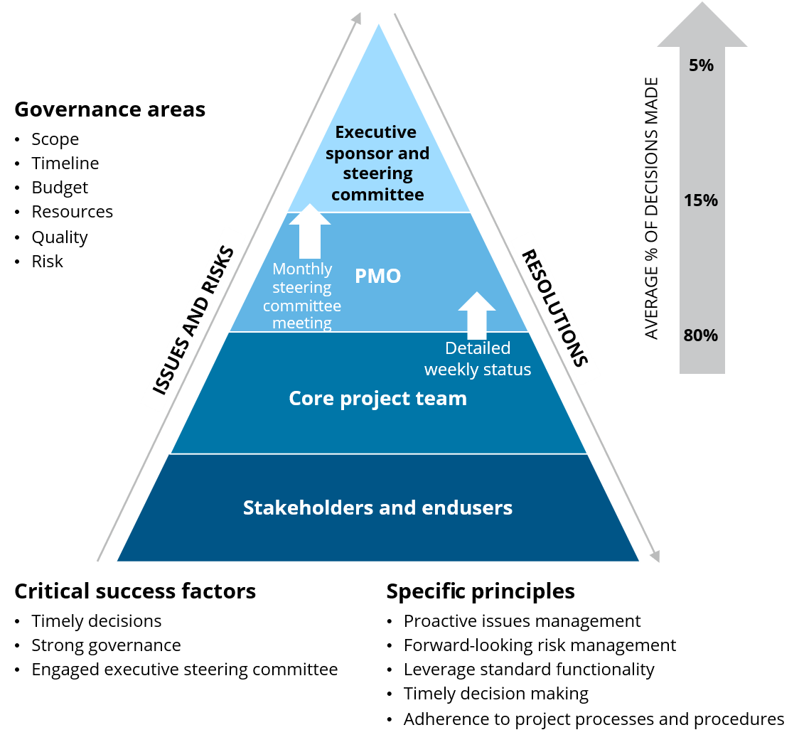
At the project management level, the objective of quality management is to facilitate the timely and cost-effective deliverable development that meets the requirements set forth in all agreements. The quality management approach for a specific project allows the quality of the deliverables to be assessed and upgraded as necessary. Project deliverables must meet certain predefined standards prior to official sign-off for completion.

Program Governance Overview
Our governance model is based on strong executive leadership, a clear org chart, roles and responsibilities, and maintaining consistency across geographies, processes, and disciplines. Our get it done mindset demands a governance structure that promotes a culture of rapid and effective decision-making by empowered stakeholders. Our high-level program governance structure establishes roles and responsibilities for both Deloitte and Project 3 resources to accelerate decision making and foster effective oversight of program delivery.
In order to maintain awareness and promote accountability, we encourage constant and consistent communication throughout the project at various levels to keep leadership well informed of progress, risks, and issues. For the implementation, we recommend the following touch points:
- Weekly status meetings with project management
- Visibility to all issues, risks, and progress to plan through our PMOne tool
- Monthly steering committee meetings and executive governance support.
Governance will also include
- Preparation of a Program level Integrated Master Schedule development as a single source of truth and its maintenance. Also creation of workstream Integrated Master Schedule at activity level
- Financial management and milestone tracking including weekly burn, monthly forecast versus plan, quarterly value-at-risk, and contingency reconciliation.
- Change control management defining the criteria for change categorization and the workflow with the relevant stakeholders to handle change requests and deviations.
- Coordination with parallel initiatives including SAP Upgrade, DDS implementation, PowerPlan modernization, OMS initiatives, and future FSM implementation. This will include schedule reconciliation with other program schedules and immediately surface critical-path or float changes.

Requirements Traceability
Requirements traceability approach
Requirement traceability is a core discipline of this program, ensuring that every business need captured at the outset of the project is systematically tracked through design, build, testing, and deployment — with full visibility into its status at any point in the lifecycle.
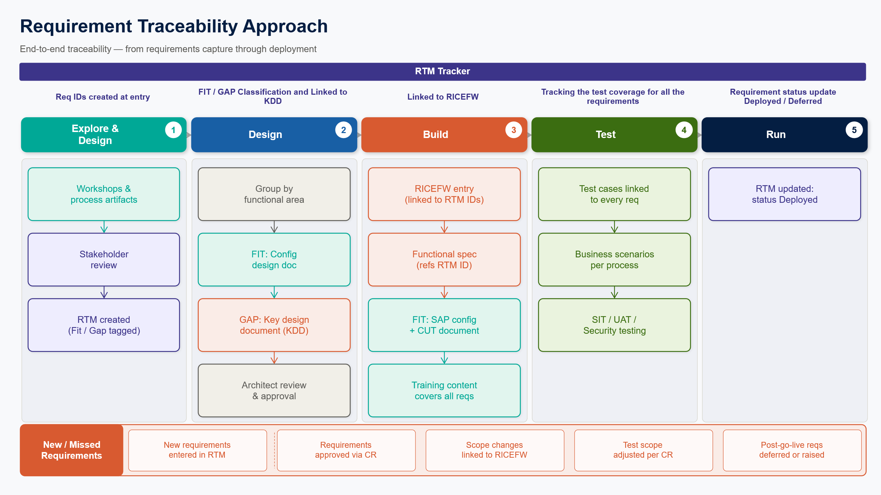
Requirements capture (Explore & Design)
Requirements will be elicited through structured workshops with business stakeholders and process owners, supported by a review of existing process documentation, system artifacts, and legacy configurations. Deloitte will leverage the Requirement Traceability Matrix (RTM) already developed, validate requirements against the RTM, and capture additional requirements only for processes or areas not yet completed. This approach enables the team to build on work already completed, avoid unnecessary duplication, and focus effort on outstanding requirements rather than re-establishing the baseline.
Each requirement will be documented in the RTM and assigned a unique requirement ID, description, functional area, source, and initial Fit/Gap classification.
- Fit requirements indicate that the standard SAP solution can address the need.
- Gap requirements indicate that additional design, custom development, or an enhancement is required.
Stakeholder review and prioritization
Product owners and business SMEs will review the RTM and confirm whether each requirement should proceed. Requirements will be categorized as Must Have, Should Have, or Nice to Have, and a release priority will be assigned to determine whether a requirement is in scope for the current release or deferred to a future wave based on business criticality and timeline constraints. Only approved requirements will advance to the design phase.
Design and solution documentation
Approved requirements will be grouped by functional area.
- For Fit requirements, a Configuration Design Document will be developed to document the standard SAP configuration decisions.
- For Gap requirements, a Key Design Document (KDD) will be prepared by the functional team to present solution options and associated trade-offs. The functional team will collaborate with technical architects to assess feasibility, and the KDD will be reviewed and approved by system architects before any build work begins.
RICEFW and build
Upon architect approval of a KDD, a RICEFW entry will be created in the RICEFW tracker, referencing the relevant requirement IDs from the RTM. Each RICEFW item may map to one or more requirements.
We will leverage existing RICEFW list, validate and add new/additional to the list that are found during process confirmation workshops.
- During the build phase, functional specifications will be written with explicit references to RTM requirement IDs, providing a traceable chain from requirement to deliverable. Unit test cases will be drafted against functional requirements.
- For Fit items, configuration will be maintained in the system and documented in a Configuration Unit Testing document.
Testing
Test cases are written at the requirement level, ensuring every requirement is covered by at least one test case. Test scenarios are constructed around end-to-end business processes, and every test case must be included in at least one business scenario. Integration and regression testing validates that both the functional requirements and the broader business processes work cohesively. Security requirements captured in the RTM are specifically addressed through dedicated security testing cycles. Upon successful testing, solution is deployed to production and requirements are marked as Deployed in the RTM.
Training and OCM
Training topics are identified primarily based on in-scope processes. The training content is reviewed against the RTM to confirm that every requirement has corresponding coverage in the training materials, closing the loop between documented requirements and end-user enablement.
Change management for new or missed requirements
If new requirements or missed functionalities surface at any point in the project lifecycle, they are entered into the RTM and submitted for PMO review. Requirements approved through the formal change management process then follow the same governance path — KDD preparation, architect approval, RICEFW creation, build, and testing — ensuring no requirement bypasses the traceability framework.

Solution Design
Solution design methodology

5.1 Functional Design
Our functional design approach will establish SAP S/4HANA Plant Maintenance as the authoritative system of record for work management, asset maintenance, construction execution, and capital project management across Project 3 Indiana, Project 3 Ohio, and MVLt. The design will support the full Identify–Plan–Schedule–Execute–Close–Analyze (IPSECA) lifecycle and align to Project 3’s objective of a unified, standardized, and controls-driven platform for distribution work management.
We will leverage the design and solution blueprint previously completed as part of the program work management and apply the five principles to enrich and refine the design.
Utility-operating-model first — design for real utility work types, not generic PM processes.
Controls by design — embed financial, operational, and regulatory controls directly in workflows, configuration, interfaces, and reporting.
Standardize where possible, localize only where necessary across Indiana, Ohio, and MVLt.
Integration-aware design — ensure process design reflects complex boundary system dependencies from day one.
Future-ready architecture — enable future adoption such as Joule, APM, and FSM adoption without rework.

- End-to-end process design across IPSECA
We will enrich future-state Level 3 and Level 4 business process designs for each in-scope work type across Identify, Plan, Schedule, Execute, Close, and Analyze.
This will cover following process scope items –
Work Types | Process Scope  (Refined Wording) | Implementation  Complexity
CORE MAINTENANCE | Preventive Maintenance | Very High
CORE MAINTENANCE | Predictive Maintenance (Condition-Based / SCADA-Triggered) | High
CORE MAINTENANCE | Corrective Maintenance (Reactive / Breakdown Work) | High
OMS-TRIGGERED WORK | OMS Like-for-Like Follow-Up (Direct Asset Replacement) | High
OMS-TRIGGERED WORK | OMS Storm Work (Storm-Driven Reactive Construction) | High
OMS-TRIGGERED WORK | OMS Unplanned Engineering Follow-Up (Engineering-Required Reactive Work) | Medium
OMS-TRIGGERED WORK | OMS Streetlighting Follow-Up (MVLt — Miami Valley Lighting) | Medium
CONSTRUCTION & CAPITAL | Long-Cycle Construction (Investment-Plan or Customer-Initiated Capital Projects) | Very High
CONSTRUCTION & CAPITAL | Minor Capital Work (Small Capital Projects / Simple Replacements) | Medium
CONSTRUCTION & CAPITAL | Joint Use / Make-Ready (Pole Attachment & Third-Party Coordination) | Medium
CUSTOMER SERVICE | Customer Service Connections (New Service / Residential & Commercial) | Medium
CUSTOMER SERVICE | New Streetlight Service Installation (MVLt Customer-Initiated Capital) | Medium
CUSTOMER SERVICE | IS-U New Connection / Disconnection (Meter Service Order Management) | Medium
CUSTOMER SERVICE | Meter Replacement (Asset Replacement via IS-U / OMS Trigger) | Medium
STREETLIGHTING — MVLt SPECIFIC | Streetlight Customer Service (MVLt — Streetlight Fault & Repair) | Medium
STREETLIGHTING — MVLt SPECIFIC | Streetlighting Billing / IS-U Billing Touch (formerly 'Joint-use billing') | Low
SCHEDULING & FIELD EXECUTION | Maintenance Scheduling (Work Order Sequencing & Dispatch Readiness) | High
SCHEDULING & FIELD EXECUTION | Maintenance Execution & Mobile Field Capture (Confirmations, As-Built, Materials, Attachments) | High

From a methodology perspective, we will work with Project 3 to understand the end-end business processes including the various SAP and non- SAP integration touchpoints ahead of the workshops. We will leverage our internal Deloitte accelerator ECON for process modelling. Using this tool allows Deloitte to leverage the experiential learning process by demonstrating the standard end-to-end processes in the pre-configured system and to focus on process adoption rather than investing in detailed as-is process analysis or beginning the design process from scratch. By approaching the project in this manner, the process definition and system design process naturally breaks down into two categories:
Process Confirmation Workshops: Processes and functional areas that adhere closely to industry standards and can be finalized via “Process confirmation workshops” (i.e., by validation against pre-built process flows that represent the industry leading practice, pre-configured SAP instance, and pre-defined list of requirements).
Deep Dive Workshops: Processes and functional areas that have a high level of variance from the standard due to valid business imperatives or regional nuances. Such topics go through a more traditional design process of current-state analysis, requirements gathering, process definition, and application configuration. These are still accelerated by a process and requirements baseline but require more in-depth analysis.
Detailed system requirements, as identified during the design phase, serve as the baseline to determine the differences (or “gaps”) between what the proposed solution can accomplish with standard functionality versus custom development. We will work with Project 3 to review standard requirements, augment your strategic priorities to enhance competitive advantage, and develop a list of differences between system capabilities and unique business requirements. Any key design decisions will be logged and appropriate approvals secured. After all the stakeholder alignment, Business Process Design documents are locked for the realization of the design.
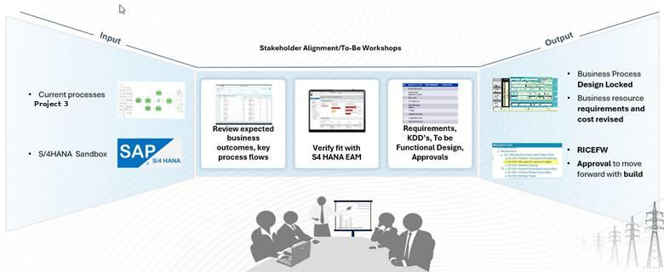

Need to add points as given below in the image above

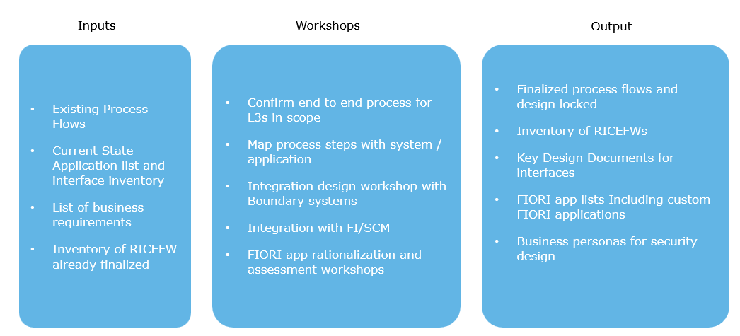
Inputs
- Finalized process flows and design locked
- Inventory of RICEFWs
- Key Design Documents for interfaces
- FIORI app lists Including custom FIORI applications
- Business personas for security design
Output

Work-type-specific utility design
Our design will differentiate process flows, approvals, routing, and order structures by work type rather than forcing all work into a single generic model. The Project 3 specification calls for distinct notification and order handling for OMS like-for-like follow-up, OMS storm, OMS unplanned engineering follow-up, OMS streetlighting, corrective maintenance, preventive maintenance, predictive maintenance, customer service connections, long-cycle construction, and joint-use / make-ready. We will design each of these with the right triggers, business rules, task content, settlement logic, and closeout requirements.
E.g., Typical Construction workflow would span from initial Project creation along with WBS in PS, the project plan sent for approval, after the approval, initial set of work orders and construction designs getting created which are linked to WBS. Planners create construction work orders which are planned and scheduled for the actual work to be done by getting the necessary permits and dispatching the appropriate resources. Once the work is completed, the work orders statuses under the construction of WBS are updated for work closure/settlements. Post completion of installation work As-Built design is created where the exact details about quantities and costs of various equipment/components installed are captured. As-builts will be transmitted to PowerPlan for unitization of mass assets and installation of specific plant. During this entire life cycle of work order, appropriate accounting settlements are triggered for FERC accounting.
Identify and Plan design
In the Identify phase, we will design harmonized notification types, mandatory data capture, asset/location validation, business-as-usual vs. storm/program routing logic, and automated notification creation from OMS and other upstream systems. In the Plan phase, we will design work-order structures, master/sub-order patterns, WBS assignment, task-list assignment, CU-based estimating and operation bundling, approval workflows, and maintenance-plan logic for preventive and predictive work. This design will ensure that work is correctly classified, costed, and routed before execution begins.
Schedule and Execute design
Project 3 has explicitly noted that it does not currently have a scheduling tool or mobile execution tool. Our functional design will therefore include a pragmatic scheduling and execution model using standard out of the box Fiori-based scheduling views, dispatch-support capabilities, crew-area filtering, mobile-compatible capture, as a foundation enabling future FSM-agnostic design. In execution, we will design confirmations, materials/time capture, damage/cause coding, attachments, as-built updates, and field-facing documents so the process works operationally from dispatch through completion.
Close and capitalization design
The functional design will place particular emphasis on Business Close, TECO, capitalization, and downstream financial synchronization, because Project 3’s requirements are explicitly controls-heavy. We will design automated close logic, settlement rule integrity, asset and financial summary handoffs, as-built completion, after-the-fact design approval for storm/unplanned work, and application of finance-critical custom fields such as estimated in-service date, financial asset class, and AFUDC indicator. This is critical to meeting Project 3’s capitalization, regulatory, and audit objectives.
Master data and asset model design
We will design SAP PM master data to support enterprise-scale utility asset management, including Functional Locations, Equipment, task lists, maintenance plans, catalogs, work centers, settlement structures, and related governance rules. The design will align to the finalized FLOC structures for Indiana Distribution, Ohio Distribution, MVLt, Indiana Vaults, and Indiana Manholes, while ensuring that conversion and downstream usability are addressed up front rather than deferred to cutover.
Controls-by-design
A major differentiator in our functional design is that controls will be embedded in the solution, not bolted on later. Project 3 requires controls spanning upstream data quality, work routing, CU governance, work-order hierarchy, scheduling readiness, as-built integrity, capital vs. expense classification, CWIP aging, AFUDC, settlement rule integrity, retirement/removal tracking, period-end reconciliation, integration monitoring, regional normalization, and persona/SoD design. We will map each control to its implementing mechanism — configuration, workflow, interface, report, or RICEFW object — and trace it through design, testing, and deployment evidence.
8. Role-based UX and AI-enabled design
We will design the end-user experience around role-based SAP Fiori navigation, including standard apps, Project 3-specific custom Fiori apps, and Spaces/Pages aligned to persona and security needs. We will also incorporate the required Joule enablement, including at minimum the Maintenance Planner Agent. This means the functional design will address not just process and configuration, but also how planners, dispatchers, field users, approvers, and finance teams interact with the solution day to day.
Integration-aware functional design
The functional design will explicitly account for the SAP-side ownership of integrations with DDS, GIS/ESRI Utility Network, OMS, SAP IS-U, PowerPlan/PowerPlan NXT, SPANS, document management, future FSM, SAP BTP, and SAP CPI. We will define business events, data ownership, validation rules, reconciliation needs, monitoring requirements, and exception-handling patterns as part of the functional design rather than leaving them to technical build alone. That will reduce downstream defects and improve end-to-end operational reliability.
Design deliverables and traceability
Our functional design will produce the full set of artifacts Project 3 expects for design approval: future-state BPDs, RTM updates, configuration workbook baseline, integration design document, data and conversion strategy, controls design document, persona and role catalog, SoD inputs, stakeholder-to-role mapping, security-level design, and approved FSDs for in-scope RICEFW. We will maintain traceability from requirement to design, configuration, RICEFW, test case, and deployment evidence to support Project 3 stage-gate acceptance and audit readiness.

In short, our functional design will emphasize a future-state, controls-driven, integration-aware solution that is built for operational readiness and long-term sustainability. We will bring a disciplined methodology for process design, detailed functional specification, testability, and readiness, supported by strong governance and change management so Project 3 can move from current-state complexity to a standardized, scalable work management platform with confidence.

5.2 Technology Design
Deloitte will provide end-to-end technology design services to enable a scalable, secure, and supportable SAP S/4HANA EAM solution across a dual landscape. For purposes of this response, we assume the dual landscape includes coexistence between the target SAP S/4HANA environment and legacy or adjacent enterprise platforms during transition and steady-state operations.
Our technology design approach translates business and functional requirements into a deployable architecture that supports asset management processes across maintenance, work management, planning, inventory, procurement, mobility, and reporting. We will define the target-state landscape, integration architecture, data architecture, security model, environment strategy, and operational support model needed to enable stable delivery and long-term maintainability.
Deloitte’s technology design services will include:
- Target-state application and technical architecture for SAP S/4HANA EAM within the broader enterprise landscape
- Dual-landscape design covering coexistence, synchronization, interface dependencies, and transition-state architecture
- Integration design across SAP and non-SAP systems, including middleware, APIs, events, batch interfaces, and file-based exchanges
- Data design for EAM master and transactional data, including migration architecture, data ownership, quality controls, and reconciliation
- Extensibility strategy defining standard functionality, side-by-side extensions, and approved custom development patterns
- Security and controls design, including role-based access, segregation of duties, authentication, and interface security
- Environment and release design covering development, test, training, cutover, and production landscapes, transport strategy, and deployment controls
- Operations design including monitoring, alerting, batch controls, error handling, support procedures, and production-readiness requirements
- Non-functional design covering performance, resiliency, availability, auditability, and scalability

Dual-Landscape Design Approach
Deloitte recommends a dual (N+1) landscape approach for the SAP S/4HANA 2025 EAM implementation to manage overlap with ASE’s parallel technical upgrade engagement from SAP S/4HANA 2021 to 2025. Under this model, the current 2021 production track remains dedicated for S/4 2021 to S/4 2025 technical upgrade, the maintenance path for business-as-usual changes and production defect fixes, while a separate 2025 project track is used to validate the upgrade and design, build, and test the new EAM capabilities. This approach helps preserve business continuity while reducing interference between the upgrade program and the EAM transformation, although it requires disciplined management of retrofit, integration synchronization, data consistency, release coordination, and cutover planning. Deloitte’s recommended sequencing is to first establish a stable “lift-and-shift” technical baseline on S/4HANA 2025, then activate EAM innovations in a controlled second phase, supported by automated retrofit tooling, early readiness and simplification checks, sandbox rehearsal upgrades, and a defined change freeze before cutover.
Our technology design methodology typically includes the following activities:
Assess and Align
Confirm business outcomes, functional scope, transition constraints, architecture standards, and non-functional requirements.
Design the Landscape
Define target and interim architecture, system interactions, hosting considerations, environment strategy, and technical dependencies.
Design Integrations and Data Flows
Document interface inventory, integration patterns, canonical mappings where appropriate, event and batch requirements, and data movement architecture.
Define Security and Controls
Design access model, security roles, interface controls, logging, auditability, and compliance requirements.
Prepare for Build and Operations
Produce technical specifications, design standards, monitoring requirements, support model inputs, and implementation roadmap.
Below, we present a reference integration architecture tailored to your enterprise landscape, illustrating how these components can work together to enable seamless, secure, and scalable integration across your organization – Include To-be integration architecture diagram

TO – BE - ARCHITECTURE DIAGRAM
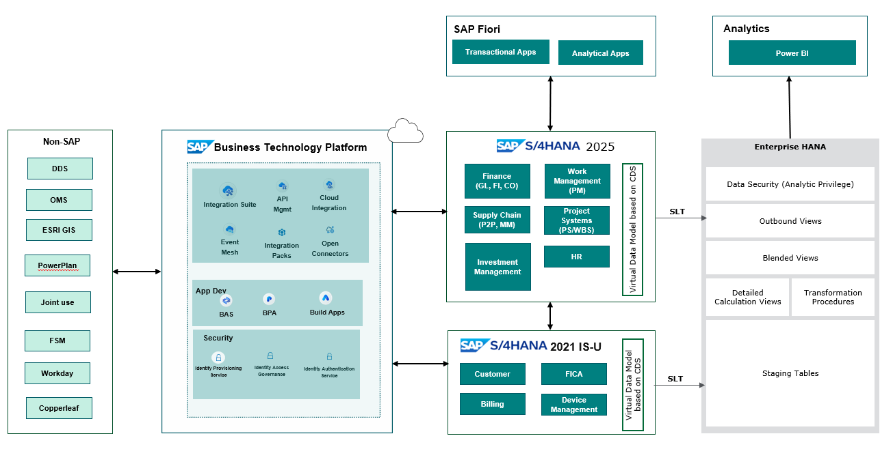
Enterprise HANA
Enterprise HANA
Data Security (Analytic Privilege)
Outbound Views
Blended Views
Detailed
Calculation Views
Staging Tables
Transformation Procedures
SLT
SLT
Virtual Data Model based on CDS
Virtual Data Model based on CDS
Power BI
Analytics
Deloitte’s Technology Design will enforce a clean core through BTP. Every line of code and every extension introduced into ASE’s S/4HANA is assessed against five clean core principles before deployment. All new interfaces and innovations will be built on BTP, not in the core.
Transport Management during and post S/4 2025 upgrade:
Below, we present a proposed transport management approach during and after the S/4 2025 upgrade. Keeping the N and N+1 SAP S/4 landscapes in sync is critical during parallel programs because it ensures that technical upgrades, configuration changes, and production fixes are consistently reflected across both environments. Without tight synchronization, the upgrade path and the EAM implementation can diverge, creating avoidable rework, test failures, and cutover risk.
In practical terms, disciplined synchronization reduces retrofit gaps, preserves interface and data consistency, and makes testing and release decisions more reliable. It also helps protect the April 2027 go-live by ensuring the target landscape reflects the latest approved business and technical changes.
Proposed Dual (N+1) Landscape for SAP EAM engagement during S/4 2025 upgrade:
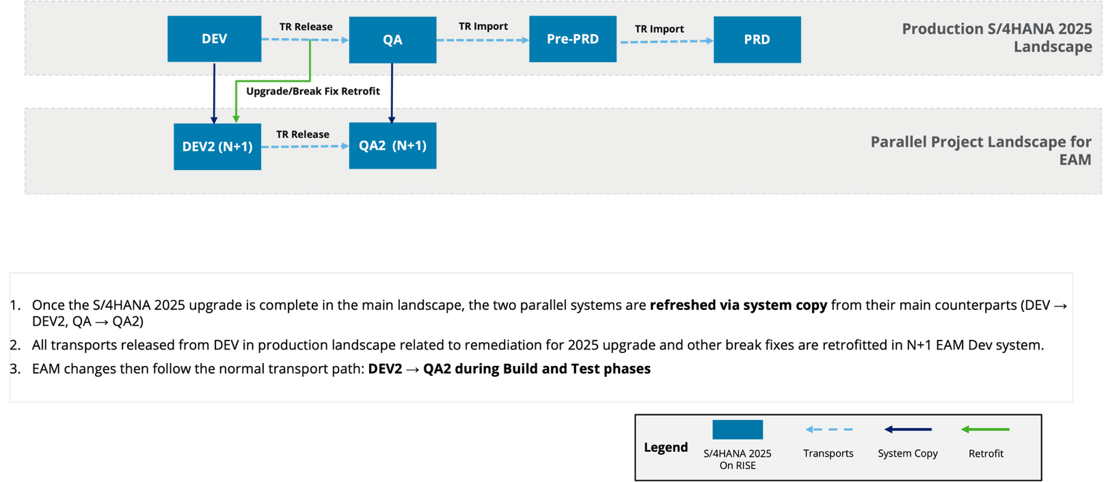

Proposed Dual (N+1) Landscape for SAP EAM engagement post S/4 2025 upgrade:

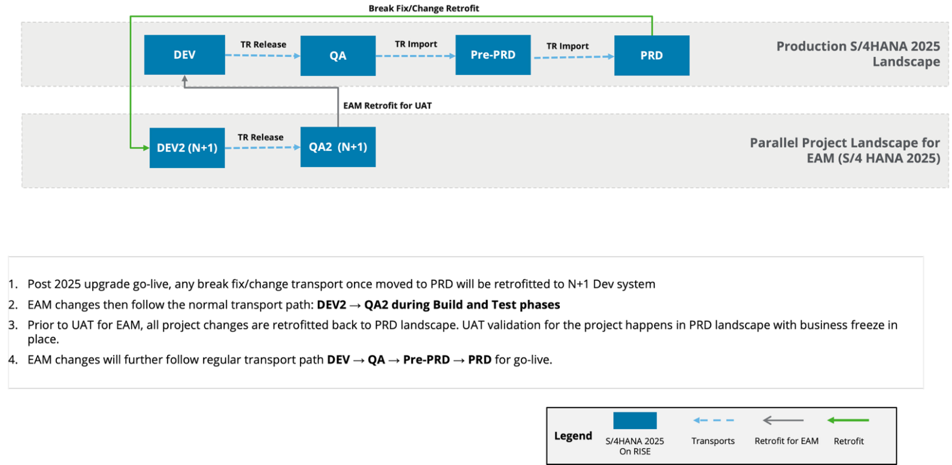

In a summary, Deloitte will bring a pragmatic, delivery-oriented approach to technology design for SAP S/4HANA EAM programs. Our teams combine SAP EAM process knowledge with enterprise architecture, integration, data, and environment design capabilities. We focus not only on the target-state solution, but also on the transition-state decisions required to operate effectively in a dual-landscape model. This helps clients reduce delivery risk, improve solution maintainability, and accelerate progress from design through build, testing, cutover, and production support.
Through this approach, Deloitte will help the ASE:
- Enable a stable and scalable SAP S/4HANA EAM technology foundation
- Reduce complexity from point-to-point integrations and fragmented interfaces
- Improve control over data, security, and cross-system processing
- Support phased deployment while maintaining business continuity
- Establish a production-ready architecture that is supportable and extensible over time

Security Design
A key component to both our process and technical design is to embed security and controls from Day 1. Our integrated security workstream will adopt a scalable risk-based approach, using our predefined, industry-specific roles and segregation of duties (SODs) rules for SAP S/4HANA and Fiori, and tailor them for Project 3’s Plant Maintenance business processes to design the comprehensive future state of SAP security and control environment, providing alignment with Sarbanes-Oxley (SOX), Federal Energy Regulatory Commission (FERC), Indiana Utility Regulatory Commission (IURC), Public Utilities Commission of Ohio (PUCO) and other compliance requirements identified within the imagine phase. Additionally, we will collaborate with you to implement essential security settings and configurations in S/4HANA such as audit logging, in alignment with your information security policies and existing IT General Control Framework.
Our security strategy for Project 3 focuses on implementing a least-privilege approach through clearly defined policies and procedures, a structured security roles framework, automation and workflows, and integrated compliance for risk and change management.

Below is a summary of our approach to Project 3 security services to establish a holistic, compliant security model early in the project complying with your access data restrictions by location:
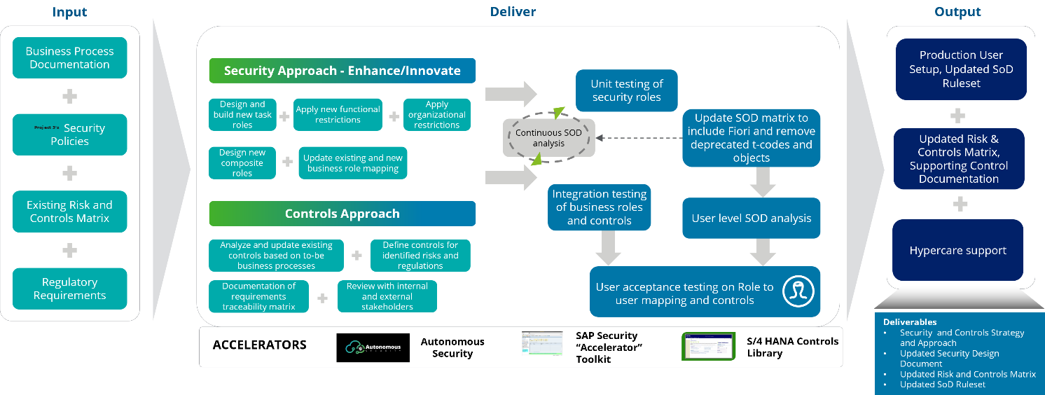
Our Controls strategy for Project 3 focuses on implementing a risk based, preventive control framework which is standardized cross locations with deviations only where required for compliance identified and validated through specific control workshops. The approach focuses on stakeholder identification early within the design phase, including internal controls and internal audit. The transparent communication with these stakeholders of the definition, refinement and alignment of the control activities and metadata allows for knowledge transfer early in the project, limits control gaps or expectations of activities, testing/process documentation or requirements. We maintain a clear audit interaction plan defining key activities and a timeline of when documentation will be available for review to collaboratively plan resources and address observations as identified.
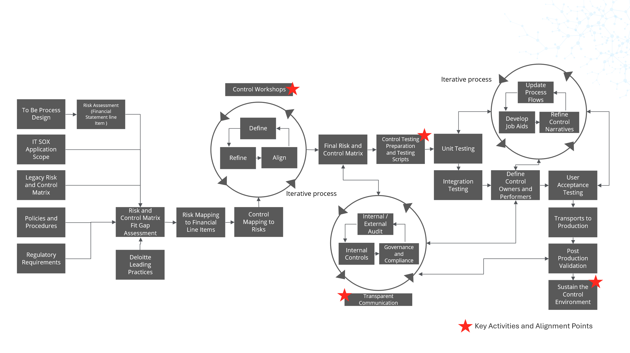
In addition to the security and controls workstreams, we embed Segregation of Duties (SOD) throughout the imagine and design phases based on Project 3’s risk appetite. Our process is based on your risk assessment and security design to manage and monitor the risks which maybe present in the landscape. We continuously run access risk reports throughout build and testing phases at various levels of granularity (task role, composite role and user) to prevent risks from entering the security design or risks which result from unanticipated changes. Risks deemed required to be present in the environment are mitigated at the user level for monitoring compliance.
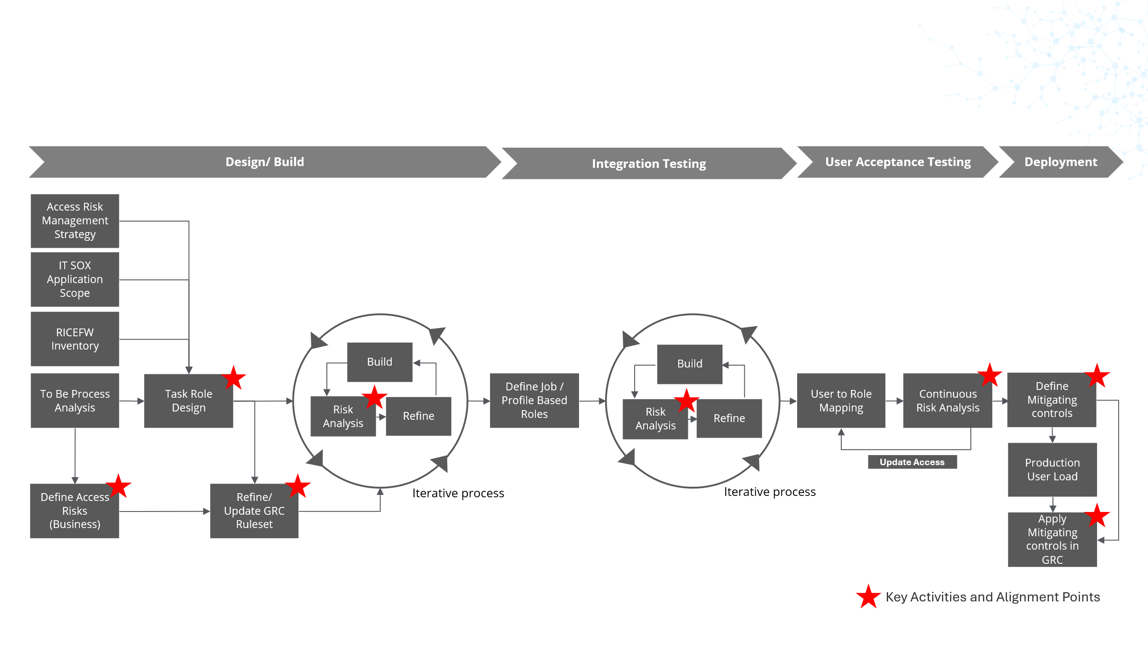

Development & Integration Methodology
Deloitte’s development and integration approach will enforce a clean core through SAP BTP. Every line of code and every extension introduced into ASE’s S/4HANA is assessed against five clean core principles before deployment.
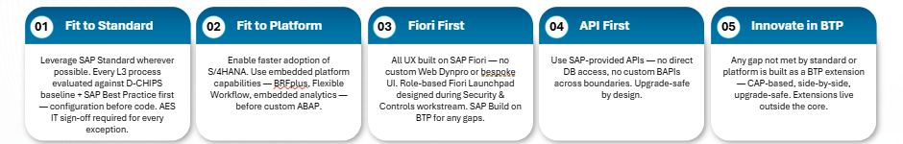
Clean Core Approach for Custom Development
At the end of Imagine/Design phase of the project, all requriements and process gaps will be identified and documented in the Requirements Traceability Matrix (RTM). FRICEW list identified for the gaps are rationalized, key design decisions are made, keeping in mind S/4 HANA clean core principles and long-term transformation goals. Deloitte’s strategy for custom development will be to adopt a ‘Clean Core’ approach that goes beyond merely moving extensions to cloud; it drives a scalable, flexible, and agile enterprise, bringing various value enablers that support long-term success. This will provide Project 3 with a solution which has substantially low technical debt, unique business requriements will be composed using APIs, extension and low-code approach enabling you to adopt incremental innovation adoption with signifiantly less burden than a heavily customized SAP solution.
Our approach includes:
- Foster cloud mindset through 'Fit to Standard' or 'Why not standard' approach
- We prioritize using out-of-the-box features and functionalities provided by SAP S/4HANA and other in-scope modules
- Our approach includes rigorous evaluation of standard functionalities to meet business requirements before considering customizations
- Fit-to-platform philosophy
- We adhere to the fit-to-platform philosophy, which emphasizes aligning business processes with the capabilities of the platform
- Review and refine the solution so that it remains aligned with business objectives and industry standards
- Implement a governance framework to manage and control customizations, validating that they are justified and add significant value
- Usage of modern Integration and Extension technologies
- Use API-based and event-based approach for integrations
- Use In-app or key user extensibility for S/4 HANA extensions
- Develop customer extensions in a side-by-side approach using SAP BTP as applicable.
- Use of patterns to drive standardization and reusability
- Collaboration with SAP Services and Product teams
- Establish a well-governed framework or an Architecture Governance Board, to scrutinize any needs for SAP enhancement except select case dictated by Project 3’s unique scenarios and to finalize the appropriate design decision using the detailed frameworks and decision matrix grounded clean core principles.
- Engage closely with SAP to address and resolve critical enhancements that may be currently absent in the product but considered essential
- Analyze results of volume testing with the SAP and other vendor teams so that products related performance, integration issues are addressed by Project 3 vendors and SAP product/ services teams including MaxAttention, CAS Package delivery teams.
- Utilize our strong relationships with the product innovation team to prioritize and expedite the release of features relevant to Project 3.
Fiori / UX Implementation Approach
As part of Fiori/UX approach, we will identify both the must-have and new Fiori apps based on assessment outcomes. Working closely with Project 3 business and IT teams, we will refine and finalize the inventory of required applications and activate Fiori apps using Deloitte’s D-FACT tool. We will then partner with change management to address end-user training requirements. The Fiori Launchpad will serve as the single point of access for SAP applications.
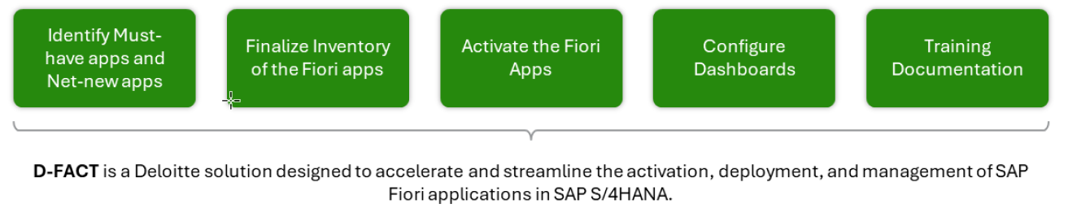

Integration Approach
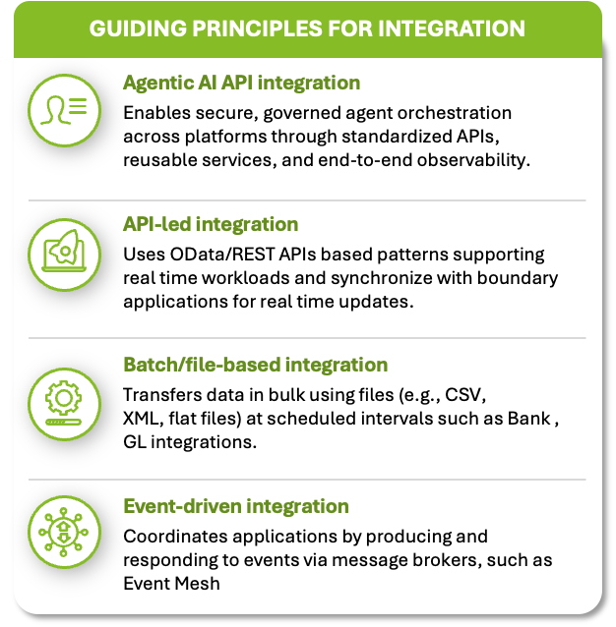
Deloitte brings extensive experience implementing SAP S/4HANA solutions for energy and utilities organizations across the United States and around the globe. Our integration methodology is customized for each client, ensuring alignment with their enterprise vision, innovation roadmap, existing technology landscape, available resources, and specific business requirements. We focus on delivering integration architectures that support critical operational objectives, including high system availability, the ability to process large transaction volumes, and adherence to leading security standards
Our approach is designed to create a robust, scalable, and future-ready integration environment that supports both current business needs and adoption of emerging SAP capabilities.
- Deloitte brings a modern, AI-enabled integration approach that applies the right patterns, tools, and delivery methods to accelerate scalable, consistent outcomes with Project 3. Our principle-led, platform-agnostic approach enables selection of the right patterns and technologies for each use case while maintaining flexibility and reuse.

Deloitte recommends a single, secure, and scalable integration layer to support end-to-end SAP S/4HANA EAM processes across ASE’s legacy and external applications. This approach avoids brittle point-to-point connections, enabling ASE to integrate consistently, accelerate connectivity, and govern integrations more effectively.
Our proposed integration backbone is SAP BTP Integration Suite, using SAP Cloud Integration to orchestrate and standardize integrations across S/4HANA EAM, ASE on-premises applications, and third parties through clear interface specifications and data mappings. We will leverage SAP-delivered standard integration content such as prepackaged iFlows, connectors, APIs, and patterns where available to reduce custom build and accelerate delivery. Our methodology will also enforce consistent API governance, including versioning, policies, and throttling, while enabling API-led integration where applicable for third-party and digital channels. In addition, we will implement production-grade monitoring and operations with alerting, retries, standardized error handling, and controlled reprocessing to improve reliability.
Deloitte brings deep, proven experience tailoring SAP BTP Integration Suite, including Cloud Integration, to address custom integration requirements across SAP and non-SAP utility ecosystems. Our delivery approach starts by aligning on business outcomes and non-functional requirements such as real-time versus batch processing, volumes, security and PII, and resiliency. We then select the right integration patterns and implement reusable CPI iFlows with standardized transformation, routing, error handling, and monitoring helping ensure the solution is scalable, supportable, and audit-ready in production.
Methodology
- Confirm outcomes and non-functional requirements: real-time vs. batch, volumes, security/PII, resiliency, and SLAs
- Design integration patterns: APIs, events, files, orchestration vs. point-to-point, and data standards
- Build reusable CPI iFlows: connectors/adapters, mappings and transformations, routing, and enrichment
- Harden for production: standardized error handling, retries, idempotency, reprocessing, and logging
- Monitor and operate alerts: dashboards, runbooks, and ongoing optimization

Deloittes integration design and development will adopt following integration methods, prioritized by best practice and future readiness.
Type | Description
Standard SAP Integration Content | Leverage SAP’s native, out-of-the-box integration content wherever possible. This includes pre-delivered content for SuccessFactors, Service cloud and several other solutions.  Benefits: Standard content accelerates implementation, ensures compatibility with SAP’s roadmap, and reduces maintenance overhead.
Application Programming Interface (API) | Prioritize the use of standard, whitelisted APIs published in the SAP API Hub for all integration requirements. Where necessary, extend these APIs using SAP’s “clean core” principles, leveraging both in-app and side-by-side extensibility options. In direct migration scenarios, we will try to reuse existing ABAP proxy code after code remediation.
SAP Events | Where real-time, event-driven integration is required, leverage SAP’s standard event framework (or leverage ASAPIO add-on for custom events) to enable asynchronous event-driven communication. This approach supports scalable, decoupled architectures and enhances responsiveness across business processes.
IDOCs | IDocs remain a preferred approach for certain scenarios, such as EDI integrations. SAP S/4HANA also provides a robust, out-of-the-box framework for IDoc monitoring and reprocessing.  Best Practice: We recommend using only future-ready, cloud-compatible IDocs and avoiding complex customizations. This ensures alignment with SAP’s strategic direction and simplifies ongoing support.
File based integration | File-based integration should be reserved and approved for exception cases, such as when standard SAP programs require or generate specific file formats (for e.g. XML and BAI formats for banks) when handling confidential files with sensitive PII data, or for high-volume, full-load data exchanges between on-premise systems.  These integrations should follow an asynchronous pattern, and comprehensive stress and performance testing must be conducted. Our team has extensive experience designing such solutions, often combining file-based methods with an API-first approach to maintain a clean core.

High volume and critical interfaces:
With our extensive experience in utility area, the most difficult challenge is designing the approach for High Volume Interfaces in SAP Cloud Integration:
Approach/Technique | Description / Best Practice
Parallel Processing | Enable parallelization in iFlows to process multiple messages simultaneously, improving throughput.
Message Splitting | Split large payloads into smaller chunks/messages for more efficient processing and reduced memory consumption.
Asynchronous Processing | Use asynchronous patterns (e.g., data store, JMS queues) to decouple sender and receiver, allowing for better scaling.
Batch Processing | Group multiple records/messages into batches to reduce the number of calls and optimize resource usage.
Data Store / JMS Queues | Leverage Data Store or JMS queues for buffering, retry, and decoupling high-volume message flows.
Resource Scaling | Monitor tenant resource usage and request scaling (CPU, memory) from SAP if sustained high volume is expected.
Exception Handling & Retry | Implement robust error handling and automated retry mechanisms to avoid data loss during spikes or failures.
Payload Compression | Compress large payloads to reduce network and processing overhead.
Archiving & Housekeeping | Regularly archive and clean up processed messages and logs to maintain performance.
Monitoring & Alerting | Set up monitoring, alerting, and KPIs for message throughput, failures, and latency to proactively manage performance.
Avoid Large Attachments | Minimize or avoid sending large attachments/files through CPI; use file-based integration or external storage if needed.
Optimize Mapping & Scripts | Use efficient mapping logic and lightweight scripts to reduce processing time per message.

Integration Security:
Deloitte delivers a comprehensive security framework for interfaces, ensuring confidentiality, integrity, and availability of data across cloud and on-premises systems. Our approach aligns with industry best practices and regulatory requirements, with deep expertise across SAP BTP-IS and other non-SAP leading platforms.
Authentication & Authorization
- SAML 2.0, OAuth 2.0, X.509, and RBAC for secure access and SOX compliance
- Principal propagation for end-to-end user identity, consistent authorization, and auditability
- Integration with enterprise identity providers (e.g., Azure AD, SAP IAS)
Data Protection
- End-to-End Encryption using TLS 1.2+ for data in transit and Project 3-256 for data at rest.
- Payload Masking for sensitive data fields or redacting in logs and monitoring tools.
- Secure credential storage and management using SAP’s secure store or external vaults.
Network Security
- IP Whitelisting: Access to Integration platform endpoints can be restricted to specific IP ranges.
- Private Link/Connectivity: Support for SAP Cloud Connector and Private Link to securely connect on-premises systems without exposing them to the public internet.
- Firewall and Security Groups: Network segmentation and firewall rules are enforced at the platform level.

Monitoring & Compliance
- Centralized logging and monitoring of integration activities, with real-time alerting for suspicious events.
- Audit trails for all integration transactions, supporting compliance
- Regular vulnerability assessments and SAP security note alignment

Error handling:

SAP BTP Integration Suite provides a dedicated dashboard to view all integration messages. Error handling in can be implemented at multiple levels to enhance reliability and minimize manual intervention.
Common approaches include:
- Alert notification: Leveraging SAP Alert Notification Services to automatically notify
stakeholders in case of errors, ensuring timely awareness and response
- Custom exception handling: Designing exception subprocesses within the iFlow trigger actions such as sending email alerts when errors occur, providing flexibility to address specific business requirements
- Incorporating retry mechanisms: To further improve resilience, a retry mechanism can be built into the iFlow. This involves automatically reattempting failed integration steps after a short delay, typically using loops or timer event

Data Conversion Methodology

Data conversion methodology
Deloitte recommends a phased data conversion approach designed to improve data readiness, reduce cutover risk, and build business confidence prior to production deployment. Our approach begins with data profiling to assess source-system readiness, confirm in-scope data objects, and identify quality issues early in the program. We then conduct detailed mapping and design sessions with business and technical stakeholders to define transformation rules, conversion logic, and object-level functional specifications.
During build, we would develop the extraction, transformation, and load processes required to convert legacy data into the target environment, supported by iterative unit testing and validation with business subject matter experts. This phase is complemented by a structured data cleansing effort, where identified quality issues are prioritized and remediated through coordinated business and program check-ins.
To reduce implementation risk, we would execute at least three mock conversion cycles to test conversion logic, validate dependencies, reconcile source-to-target results, and confirm data load timing. These rehearsals allow the team to refine execution procedures, resolve defects, and confirm readiness for final deployment. Prior to go-live, a dress rehearsal of the end-to-end migration process using cleansed and complete data to validate cutover sequencing and operational readiness. The approach culminates in production cutover and hyper-care support to stabilize the solution and address post-deployment data issues in a controlled manner.
A day in life for data migration journey
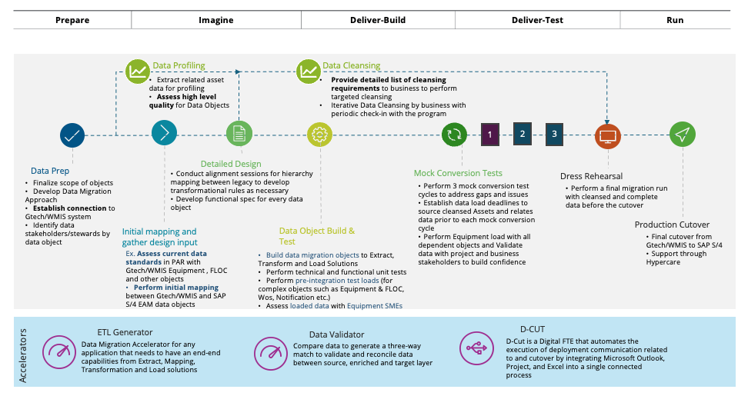

Data Profiling and Cleansing Approach
Deloitte will begin the conversion effort with structured data profiling to assess source-system readiness, identify data quality issues, and confirm the completeness and usability of in-scope data objects. Profiling will be performed to both understand the current state of source data and evaluate it against defined target-state standards, enabling early identification of cleansing needs and migration risks. Based on profiling results, Deloitte will support a targeted data cleansing process focused on data correction, standardization, and enrichment to improve data quality prior to conversion. This approach helps prevent poor-quality data from being carried into the future-state environment, while providing the visibility needed to plan remediation activities, align business stakeholders, and improve confidence in migration readiness.
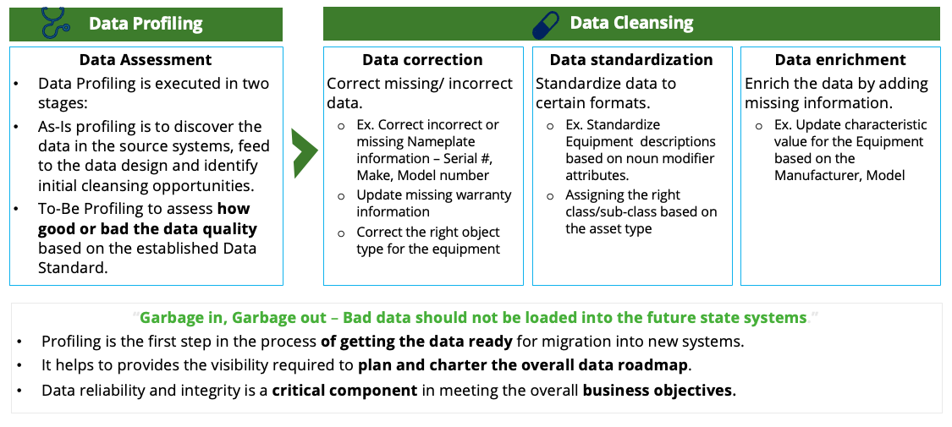

Asset 360 - AI-Enabled Data Enrichment and Cleansing
Deloitte will augment traditional profiling and cleansing activities using its Asset 360 accelerator, applying AI-enabled enrichment to identify missing attributes, recommend standardized values, and improve the completeness and usability of in-scope asset data. Rather than relying solely on manual cleansing, Deloitte’s approach uses automation to accelerate the review of large data volumes, surface exceptions, and support more consistent remediation outcomes. Human-in-the-loop review will be embedded throughout the process so that business and data SMEs can validate AI-generated recommendations, confirm enrichment logic, and approve changes before data is migrated to the target environment. This approach is intended to improve data quality, reduce manual effort, and increase confidence in migration readiness while maintaining appropriate business oversight.

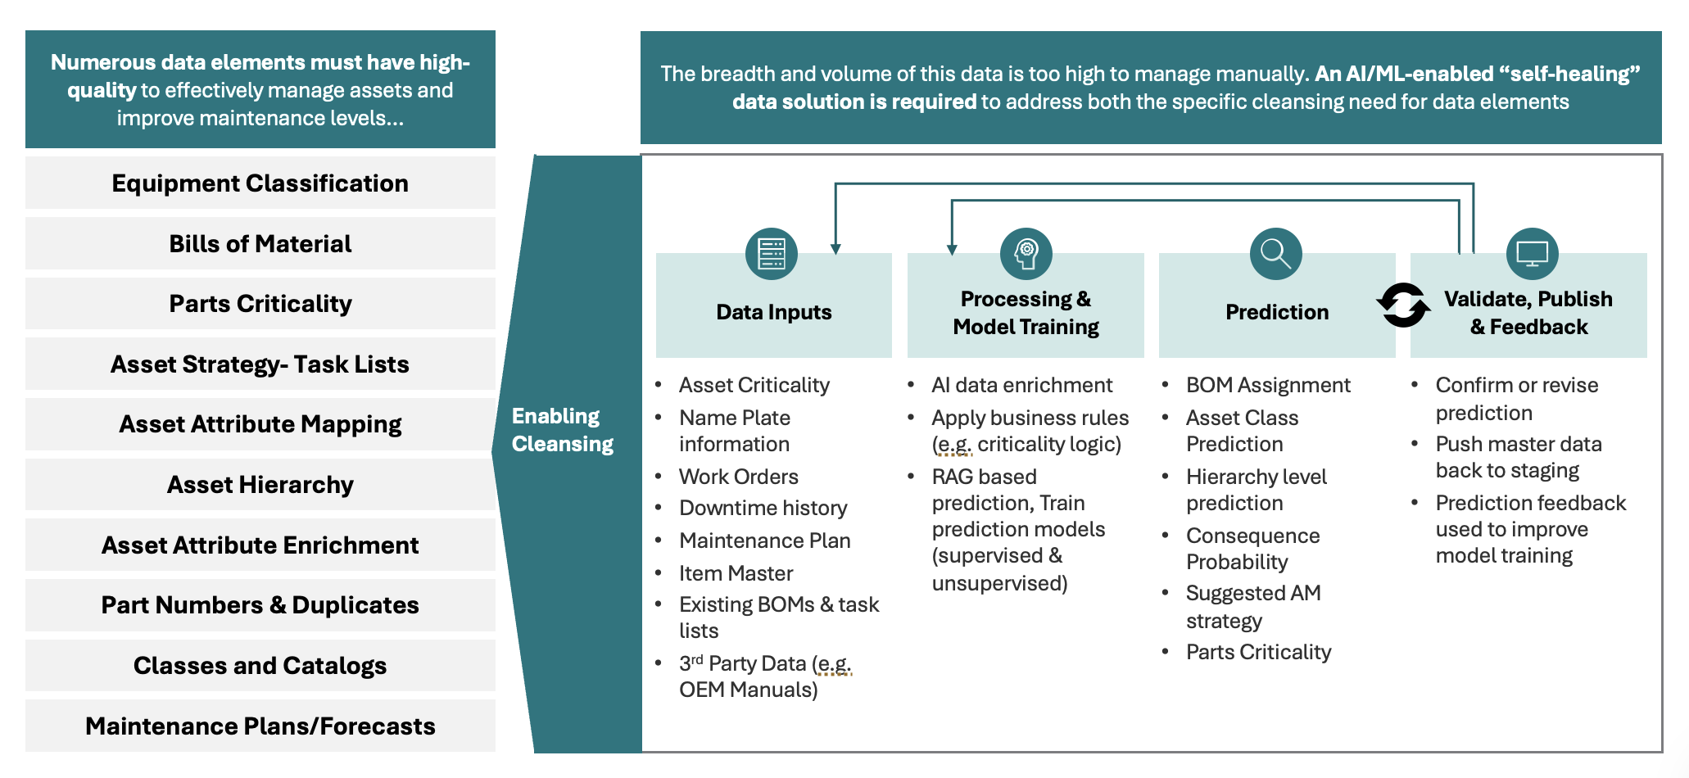

Tools Supporting Data Profiling, Transformation, Load, and Reconciliation

Deloitte will use Power BI to support data profiling and reconciliation reporting, SAP Data Services for ETL where licenses are available, or Asset 360 as an alternative transformation and enrichment solution provided we have necessary infrastructure to support deployment of Asset 360. SAP Data Migration Cockpit will be used for load execution into the target SAP environment. Together, these tools provide a controlled and scalable approach to assess data quality, transform and enrich in-scope data, load it into SAP, and validate migration outcomes through business-friendly reporting. We will assess what tool is best suited and available in the landscape and make a decision that is right for you.

Capability | Tool | Purpose
Data Profiling | Power BI, Inhouse visualization tool at Project 3 | Assess data quality, completeness, and exceptions; support profiling insights and cleansing prioritization
ETL / Transformation | SAP Data Services (if licensed) or Inhouse ETL tool available at Project 3 | Extract, transform, and prepare source data for migration
ETL / Transformation/ Cleansing Alternative | Asset 360 with Databricks backend | Perform scalable transformation, enrichment.
Data Load | SAP Data Migration Cockpit | Load transformed and approved data into SAP target environment
Reconciliation | Power BI, Inhouse visualization tool at Project 3 | Provide qualitative and quantitative summaries to validate source-to-target migration outcomes
Deloitte’s conversion approach is designed to provide a structured, scalable, and low-risk path to migration readiness by combining phased execution, early data profiling, targeted cleansing and enrichment, fit-for-purpose tooling, and iterative validation. Beginning with upfront profiling and design, the approach helps identify data issues early, define clear transformation requirements, and establish the foundation for effective remediation. Deloitte then applies a combination of business-led cleansing, AI-enabled enrichment through Asset 360, and controlled transformation and load processes to improve data quality and support efficient execution at scale. Through mock conversions, reconciliation reporting, dress rehearsal, and final cutover support, this approach is intended to improve confidence in data integrity, strengthen stakeholder readiness, and promote a more stable transition into the future-state SAP environment.

This approach helps ensure the conversion effort is executed as a business-led, quality-focused migration program rather than a one-time technical data load.

Testing Methodology & Quality Controls

8.1 Overview
The Deloitte testing approach for the program SAP PM is a risk-based, requirement-traceable, evidence-driven program designed to confirm functional fitness, technical integrity, controls operating effectiveness, and operational readiness across Project 3 Indiana, Project 3 Ohio, and MVLt. Testing operates across a phased cadence aligned to Project 3 Digital PMO Stage Gates 3 and 4, progressing from unit-level validation through production stability. All test execution is managed within Panaya as the Project 3-approved test management toolset, with full bi-directional traceability maintained between RTM requirements, RICEFW objects, Key controls, test cases, defects, and sign-off authorities. Controls Testing is not a standalone phase — it is embedded as a parallel discipline inside SIT and UAT cycles.
Mock Conversion Loads run in parallel with SIT cycles, synchronized so that each SIT cycle operates against progressively richer and more production-representative data. Every test phase has defined entry and exit criteria; no phase progresses without documented closure of the prior phase, and no Stage Gate closes without the designated acceptance authority's written sign-off.
8.2 Test Types
The following table defines each testing cycle in scope for the the program Program, including its definition, scope of what is being tested, and execution approach.
Testing Type | Definition | Data Source | Manual / Automation | Testing Tools
Functional Unit Testing | Validates that each RICEFW object is developed in accordance with its functional specification. Executed by the SI development team; mandatory exit gate before any object is promoted beyond the development environment. | Synthetic / unit data | Manual | Panaya (or Project 3-approved equivalent)
String Testing | Validates that a sequence of logically related transactions executes correctly as an end-to-end process thread within a single functional area, prior to full system testing. | Mock data | Manual | Panaya (or Project 3-approved equivalent)
System Testing | Validates the configured SAP PM solution as a complete system across all process areas and all three OpCos, exercising configuration, master data, and custom developments together. | Mock Load 1 | Automation and manual | Panaya (or Project 3-approved equivalent); test automation execution tooling subject to Project 3 confirmation
System Integration Testing (3 cycles) | Validates bidirectional data flow, message processing, error handling, and recovery behavior across all integration interfaces between SAP PM and connected upstream and downstream systems. | Mock Load (3 cycles) | Automation and manual | Panaya (or Project 3-approved equivalent); integration test automation tooling subject to Project 3 confirmation
User Acceptance Testing support | Validates that the solution meets Project 3 business requirements and is fit for operational use. Executed by Project 3 business users; the SI provides test coordination, environment management, defect triage, and issue resolution support. | Representative production-like data | Manual | Panaya (or Project 3-approved equivalent)
Regression Testing | Confirms that the program configuration changes and the S/4HANA upgrade do not introduce unintended defects into existing SAP functionality outside the direct program scope. Executed iteratively at each significant build release. | Production-representative | Automation and manual | Panaya (or Project 3-approved equivalent); regression automation execution tooling subject to Project 3 confirmation
Performance Testing support | Project 3-owned activity. The SI supports by developing the performance testing plan, configuring test scenarios, participating in execution, and owning timely resolution of SAP-PM-specific performance defects. | Production-like volumes | Automation and manual | Panaya (or Project 3-approved equivalent); performance testing execution tooling subject to Project 3 confirmation
Security Testing | Validates that the SAP PM authorization model enforces appropriate role-based access controls, segregation of duties, and data protection requirements across all user roles and OpCos. | Role-assigned test users | Manual and automated | Panaya (or Project 3-approved equivalent); SAP security tooling
Controls Testing | Validates that key application controls embedded in the the program solution are operating as designed and meet Project 3's internal control framework and audit requirements. | SIT / UAT / Production data | Manual | Panaya (or Project 3-approved equivalent)
Mock Conversion Testing | Validates that all data migration objects convert correctly, completely, and within the load time windows required by the cutover runbook. Executed in multiple iterations — each mock addresses defects and timing gaps from the prior run. | Actual source-system extracts | Automation and manual | Panaya (or Project 3-approved equivalent); SAP data migration tooling
Dress Rehearsal | Full dress rehearsal of the production cutover runbook in a production-equivalent environment, validating sequence, timing, team readiness, and decision escalation before the live cutover window. | Production clone | Manual | Panaya (or Project 3-approved equivalent); Cutover Runbook

8.6 Test Automation Strategy
We’ll introduce Deloitte’s GenAI-enabled Test Automation approach, a solution engineered to deliver greater test coverage, accelerated value realization, reduced manual effort, and minimal impact on business operations. Key features of our solution include:
- GenAI test case creation: Automated creation of test cases for manual and automated testing
- Manual-to-automated script conversion: Seamless conversion of manual test cases to automated scripts
- Accelerated execution: Rapid execution of test scripts to meet the overall testing timelines
- Defect logging and reporting: Integrated defect logging mechanisms and comprehensive reporting, including detailed test evidence
The diagram below illustrates the automated creation of test cases with GenAI and key benefits to Project 3.
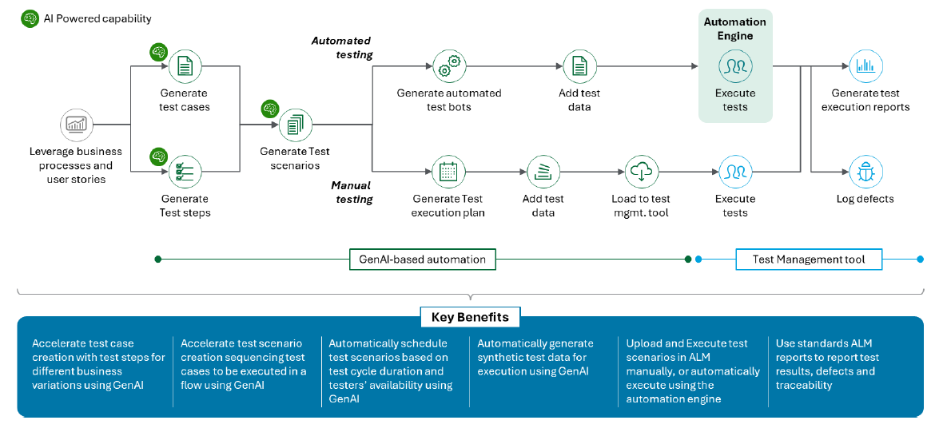

Change Management Methodology

Organizational change-management methodology
The the program program enters this engagement with meaningful OCM momentum already established. Deloitte's Project 3 OCM team has built foundational change strategies and validated artifacts from PwC's prior Work Management engagement that provide a tested baseline. Our role is not to replicate what exists — it is to operationalize that strategy, close execution gaps where capacity is constrained, and bring targeted SAP PM adoption expertise that reduces go-live risk across field crew, dispatch, engineering, and finance populations across Indiana, Ohio, and MVLt.

Three factors shape how we execute. Population risk: field technicians and dispatchers face the highest SAP PM adoption exposure and their resistance is often silent until go-live. Change saturation: Project 3 field roles are absorbing the S/4HANA upgrade and SAP PM go-live concurrently, requiring explicit sequencing. Synchronization: Indiana, Ohio, and MVLt go live on the same date with no sequenced rollout to absorb lessons between sites.

Our Approach: Four Integrated Capabilities
Deloitte's OCM delivery for this program will be organized around four integrated capabilities — each building on the existing the program program OCM foundation.
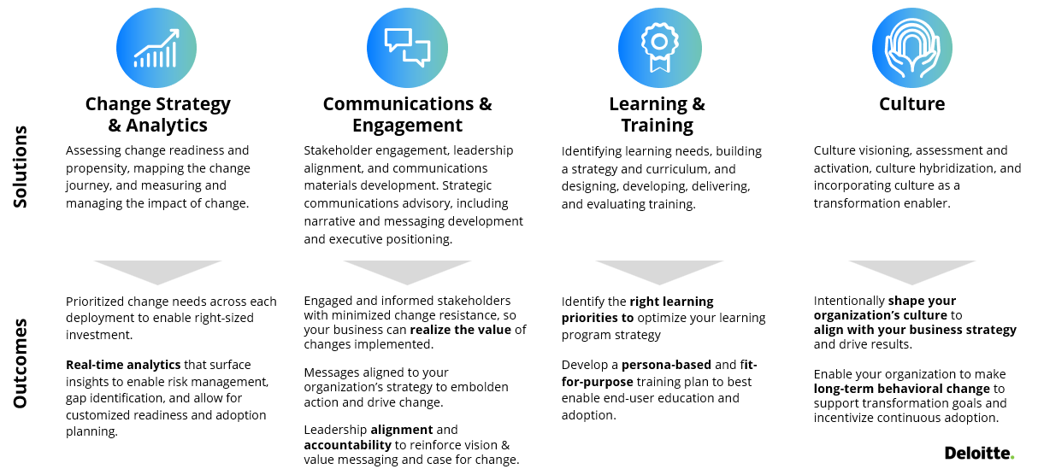

Pillar 1  Change Strategy & Analytics | Leveraging existing diagnostics to right-size SAP PM change interventions

Change Strategy & Analytics
Change Strategy We carry the existing Project 3 OCM change strategy and findings from the Ambition, Change, and Leadership Scans forward as the operational backbone for execution across all three OpCos. The work is not to redesign the program but to make it site-effective: calibrating engagement intensity, champion depth, and training prioritization to the distinct adoption profiles of Indiana, Ohio, and MVLt. One strategy, three coordinated delivery tracks.

Stakeholder Assessment
We validate and extend the stakeholder mapping already completed, tracking each group by impact level and degree of influence to determine the right engagement intensity and champion coverage. Project 3's affected population spans field technicians, dispatchers, schedulers, engineering, finance, fixed assets, supply chain, and operational leadership each with a different starting point for SAP PM readiness. External stakeholders contractors, vendors, regulators require proactive management to protect operational continuity, preserve trust, and mitigate risks through go-live.

Leadership & Alignment
Sustained SAP PM adoption requires visible, consistent sponsorship across three OpCos simultaneously. We work with the Project 3 OCM team to identify and align senior sponsors whose credibility with impacted communities will determine whether the change lands as a managed transition or a system imposition briefing them ahead of milestones, equipping them with OpCo-tailored talking points, coaching them on the resistance signals most likely to surface in their workforce, and holding them accountable through the governance cadence.

Change Champion Network
Champions are the program's most direct channel into the field populations carrying the highest adoption risk. We build on the champion model already designed, operating it across all three OpCos with sufficient depth to reach field technicians, dispatchers, and crew leaders at site level. Champions are selected on peer credibility — not availability. They receive role-specific materials, a direct feedback channel to the OCM team, and structured activation: regular network sessions, briefings, and go-live surge support.

Change Impacts Assessment
Structured change impact assessment across all three OpCos provides a role-level view of what SAP PM changes and by how much for each affected population. Impacts are captured through design workshops and Imagine Phase sessions, rated by degree of change to daily work and system dependency, and categorized across People, Process, and Technology with explicit mitigations mapped to each.

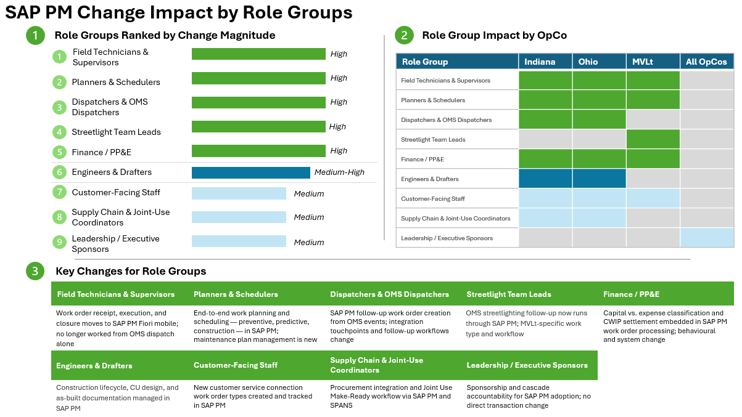

Change Readiness Assessments & Adoption
Deloitte will conduct three formal readiness assessments across the program lifecycle establishing baseline awareness and resistance signals, tracking whether OCM interventions are closing identified gaps, and delivering the pre-cutover go-live readiness recommendation: a site-by-site view of whether Indiana, Ohio, and MVLt have each reached the required thresholds, with any residual gaps explicitly named and mitigated before Day 1.

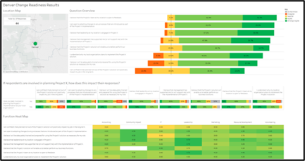

ChangeScout
ChangeScout is Deloitte’s proprietary digital change-delivery platform that creates a single source of truth to track impacts, stakeholders, risks, readiness, and adoption across all three OpCos using AI-led analytics and pre-configured interventions so teams spend less time on manual analysis and more time driving adoption. Proven across 300+ global deployments.

Communication & Engagement
Coordination Model
We build on the existing Communications Strategy, extending it across all three OpCos with sensitivity to the geographic and jurisdictional differences between Indiana, Ohio, and MVLt. A core set of ready-to-deploy assets, launch messaging, program updates, release readiness notices, cutover communications, hypercare guidance are packaged as templates the Project 3 OCM team can quickly tailor within the approval workflow already established.

With all three OpCos going live concurrently, sequencing is managed with explicit attention to change saturation field populations absorbing both the S/4HANA upgrade and SAP PM go-live do not receive conflicting messages at peak pressure points. Communications reach field-dominant audiences through channels that match how utility workers actually receive information: leader cascade messages delivered through People Leaders and Supervisors at site team meetings; Project 3 Hub and the program SharePoint as the single destination for updates and other information/training resources.

SAP PM communications are built around how people experience the change at their role level. Deloitte will develop and maintain five SAP PM-specific personas drawn directly from impacted role groups, used to test message relevance, guide content development, and validate that field workers receive information in terms that connect to their daily work in SAP PM.

Persona | SAP PM Change They Experience | OpCo
Field Technician | Receives, executes, and closes work orders in SAP PM Fiori mobile. Work no longer comes only from OMS dispatch — the biggest day-one change. | Indiana, Ohio, MVLt
Work Planner | Plans and schedules all SAP PM work types end-to-end — preventive, predictive, construction. Maintenance plan management is new. | Indiana, Ohio, MVLt
OMS Dispatcher | Creates SAP PM follow-up work orders from OMS events. Integration touchpoints change; dual-system coordination during cutover is a specific risk. | Indiana, Ohio
Streetlight Lead | OMS streetlighting follow-up now runs through SAP PM. MVLt-specific — Indiana and Ohio process content does not apply. | MVLt
PP&E Accountant | Capital vs. expense classification and CWIP settlement are embedded in SAP PM work order processing. Faces system and behavioural change — controls accountability changes alongside the tool. | Indiana, Ohio, MVLt

The communications plan below maps commitment levels from initial Awareness through sustained Ownership to program phases and communication themes. This structure governs how Deloitte moves each SAP PM persona from first program awareness through confident daily use of SAP PM after go-live.

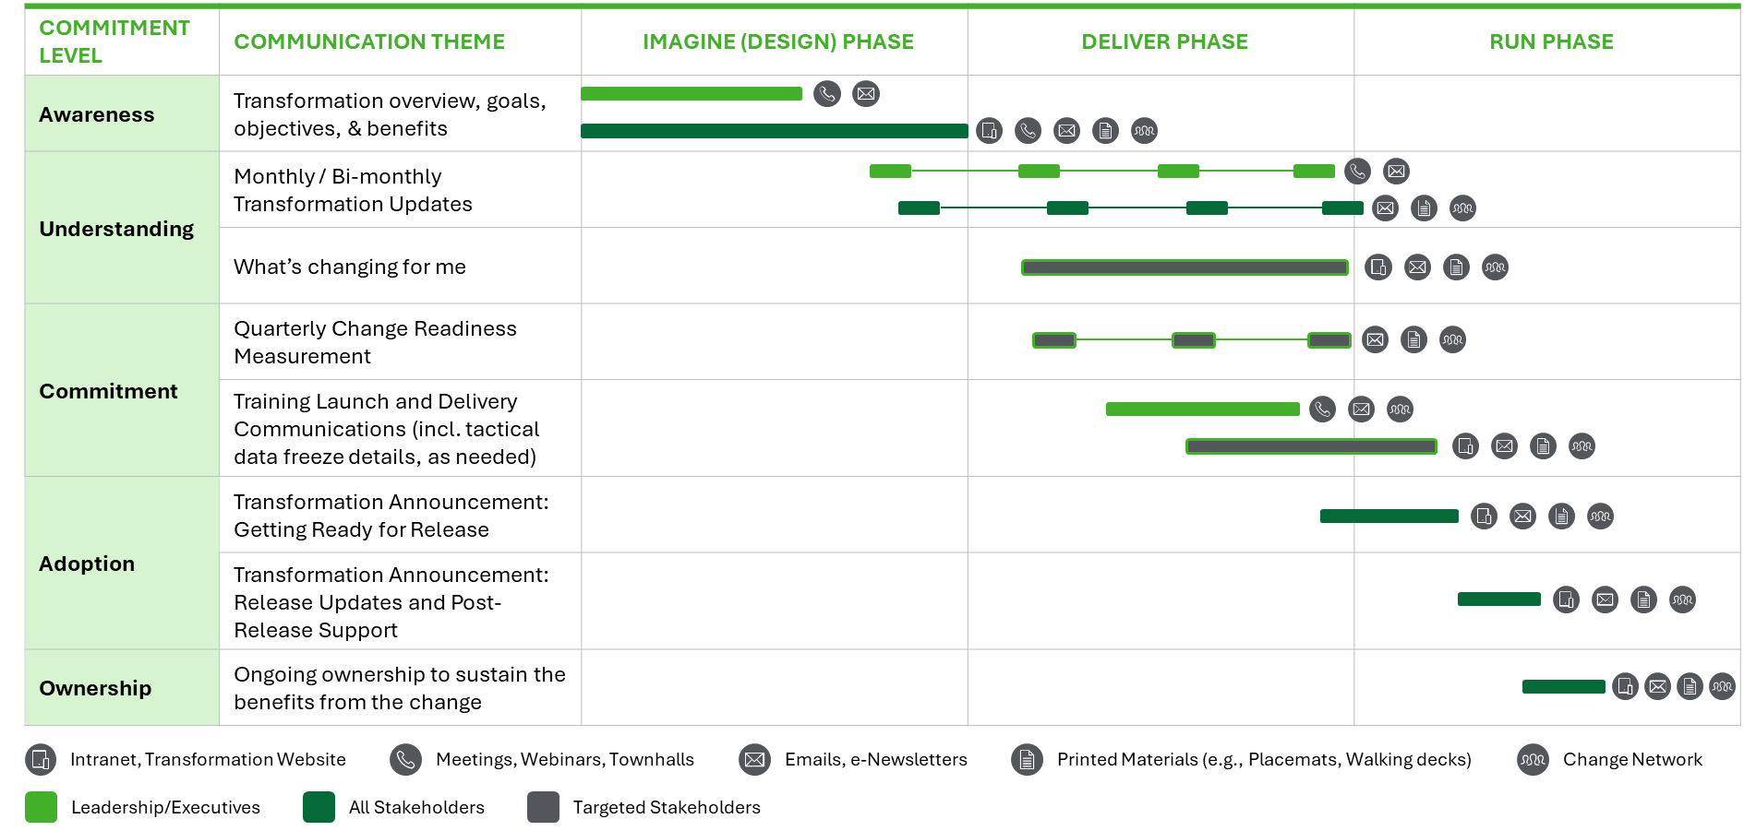

Culture
The greatest adoption risk is cultural: whether field technicians, dispatchers, and operational leaders change how they work — work order discipline, issue escalation, cross-functional coordination, and compliance rigor, not just how they use a new system. Deloitte positions the the program go-live as an enterprise operating change, not an IT implementation.

Adoption and cultural signals are monitored through formal readiness assessments and pulse surveys, distinguishing technical friction from cultural barriers and deploying interventions against root causes. The change champion network and governance rituals built during the program are designed to persist after go-live, leaving durable capability inside Project 3 rather than dependency on external support.

Training Philosophy — Field-First, Scenario-Driven
Training for the program is preparation for a field technician, dispatcher, or planner to arrive at work on go-live day and do their job confidently in a new environment not an introduction to SAP PM as a system. Three principles govern every training design decision:

- Role-based relevance: each role sees only the process scenarios and Fiori apps relevant to how they work. Field technicians learn the field technician's job in SAP PM — not the planner's, not the finance persona's.
- Scenario-driven learning: training is built around end-to-end business process scenarios — a corrective OMS follow-up from notification to close; a long-cycle construction order from investment plan to asset creation — not transaction-by-transaction walkthroughs.
- Sustained digital adoption: WalkMe guided tours and contextual help embedded in the Fiori UX ensure users find support at the point of need, on the day they need it, without leaving the system.

Let’s walk you through a sample learning journey of a user as a Field Technician. Transitioning from a legacy system to SAP S/4HANA Fiori for all planned maintenance work orders requires new ways of working.
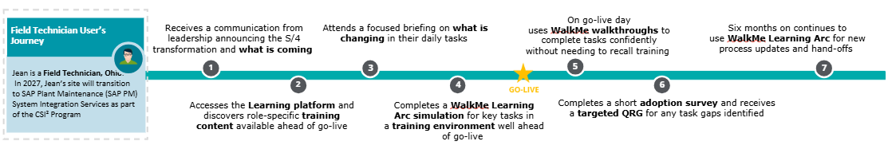

Training Needs Analysis
Training needs analysis will be driven by the change impact register and role mapping produced in Section 12.3. For each in-scope role across Indiana, Ohio, and MVLt, we will document: the SAP PM processes the role owns or participates in; the Fiori apps used; the change magnitude relative to current-state practice; and the learning modality best suited to the role's work context (field vs. office vs. hybrid). LearningScan results will validate these assumptions against actual learning tendencies and capabilities before curriculum development begins.

Minimum Work-Type Scenario Catalog
Training design will cover all work types specified in the Project 3 RFP and will be validated against SAP PM configuration in the development environment before delivery.

Scenario | Primary Roles | OpCo Applicability
OMS Like-for-Like Follow-Up | OMS Dispatcher, Field Technician, Planner | Indiana, Ohio
OMS Storm Work / Construction Work | OMS Dispatcher, Field Technician, Supervisor | Indiana, Ohio
OMS Unplanned Engineering Follow-Up | Engineer, Planner, Field Technician | Indiana, Ohio
OMS Streetlighting Follow-Up | Streetlight Team Lead, Dispatcher | MVLt
New Customer Service Connection — Engineered | Engineer, Planner, Field Technician | Indiana, Ohio, MVLt
New Customer Service Connection — Non-Engineered | Dispatcher, Field Technician | Indiana, Ohio, MVLt
Long-Cycle Construction — Company / Investment Plan Initiated | Planner, Engineer, Drafter, Finance/PP&E | Indiana, Ohio
Joint Use (Make-Ready) via SPANS | Joint-Use Coordinator, Planner | Indiana, Ohio
Preventive Maintenance Work Order from Maintenance Plan | Planner, Scheduler, Field Technician | Indiana, Ohio, MVLt
Predictive Notification to Work Order | Planner, Field Technician, Supervisor | Indiana, Ohio, MVLt

Digital Adoption — WalkMe Integration
Project 3's preferred digital adoption platform is WalkMe. We will design and build an embedded, role-aware learning experience within the SAP PM Fiori UX that extends training beyond the classroom and into the daily work environment. For each in-scope Fiori role and business process we will deliver:
- Fiori-guided tours — activated at first login and accessible on demand; oriented to the role's primary process scenarios
- Contextual on-screen help — triggered by Fiori screen, role assignment, and process step; surfaces relevant QRGs, FAQs, and Level 4 documentation without leaving the system
- Screen-level repository links — direct access to training recordings, QRGs, FAQs, and support materials from within each Fiori app
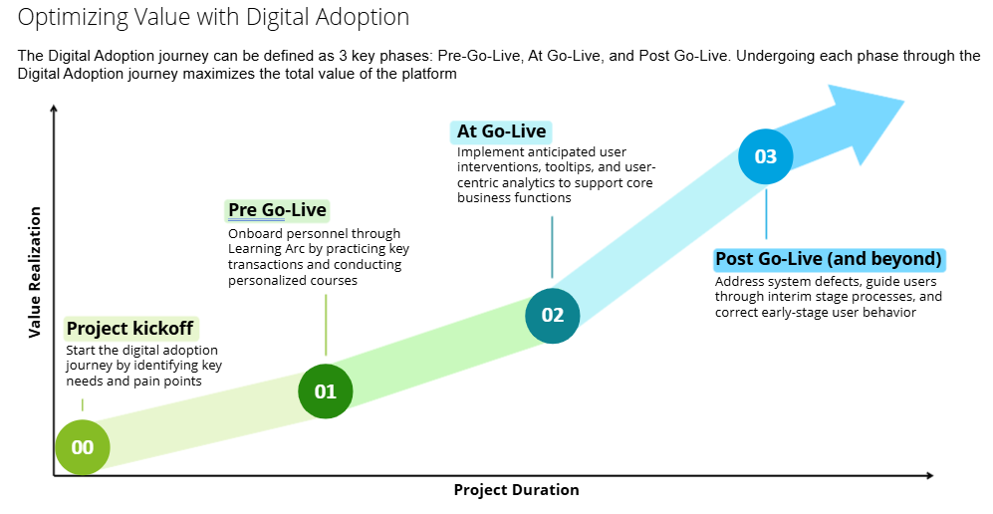
Training Delivery Model
Training delivery will be led by the SI and will be tailored to the operational realities of field-dominant workforces across three sites. Key delivery design decisions:
- Modality mix: instructor-led sessions (primary for field technicians and dispatchers), virtual instructor-led (for planners, engineers, and geographically dispersed populations), and self-paced eLearning modules for knowledge reinforcement and LMS recordkeeping
- Train the Trainer: designated super-users at each site will be trained in advance of the general population and will co-facilitate sessions with SI trainers, building internal capability for ongoing onboarding and support
- Pre-training readiness pulse: conducted before training execution begins to confirm scheduling completeness, logistics readiness, and audience access—corrective action taken before sessions begin, not after
- All logistics coordinated by Project 3: scheduling, room booking or virtual platform setup, equipment, and site-specific coordination (including shift worker scheduling at field sites)
- Workday LMS integration: attendance and completion records maintained in Workday LMS; completion data feeds the ≥95% training gate at M7
- Training recording library: all instructor-led sessions recorded and posted to the SharePoint training repository for new hire onboarding and role-change support

Pillar 5 — Post Go-Live Analytics and Support
Adoption risk peaks in the first two to four weeks after cutover, when field workers are navigating new processes under live operational pressure. We stand up a hypercare adoption cockpit combining ChangeScout dashboards with WalkMe in-app guidance updates to rapidly sense and respond to adoption barriers. The cockpit tracks: active user percentage by role and site; help-desk volume and theme trends; training completion for missed populations; and process adherence proxies from SAP PM transaction data.

Post go-live engagement forums — manager office hours, change agent feedback sessions, and targeted floor support at each OpCo site — keep channels open and surface ground-level issues before they become systemic. Where applicable, dual-system guidance, temporary workarounds, and 'who does what when' clarity documents are prepared and distributed before cutover begins.

Change Management Tools & Accelerators

Deployment & Rollback Methodology
Deloitte recommends a consolidated single-wave deployment in Nov 2027 because the alternative two-wave structure provides only a one-month separation, which is insufficient to generate meaningful risk burn-down while still requiring duplicate cutover, stabilization, and governance effort. A single wave better supports coordinated dependency management across DDS, PowerPlan, S/4HANA upgrade timing, and Project 3 operational constraints, while avoiding dual-state operations and simplifying enterprise conversion, interface activation, and transition to AMS.
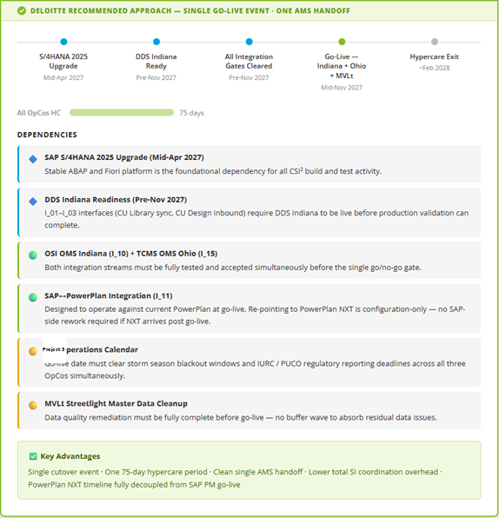

Deployment Approach
Our deployment strategy is designed to support a successful enterprise rollout by stabilizing critical business processes, applications, and operational capabilities. The approach prioritizes business continuity, risk mitigation, stakeholder readiness, and minimal disruption to Project 3 operations throughout the transition. The Deploy phase focuses on executing production go-live, supporting business adoption, and stabilizing the solution in the live environment.

Deloitte’s deployment approach recommends the program teams and the business unit align early on the overall deployment scope. This includes both the activities to be managed and the execution parties, which can range from project-specific teams to functional teams, or even the business. For example, the program cutover team should be responsible for defining and managing cutover plan activities, while business teams should be responsible for executing those activities. To navigate these complexities, we utilize a deployment wheel framework. This framework encompasses a comprehensive set of activities, enabling us to select, clearly define, and customize the deployment scope for each client.
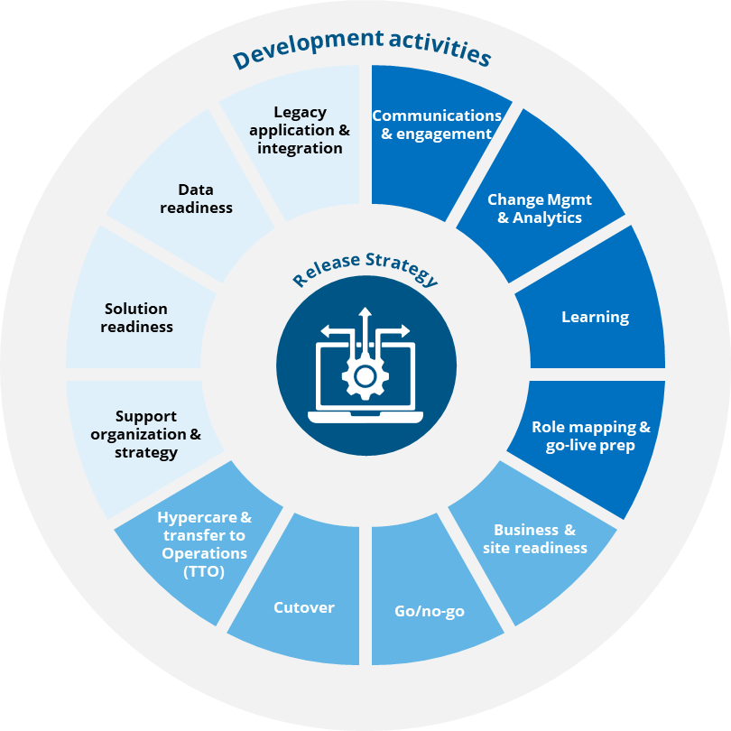

Deployment plan
The deployment plan is the cornerstone of our deployment strategy. It is a comprehensive plan outlining the steps for deploying the solution into the production environment, including rollback procedures and contingency plans. It lays out all the activities that take place within the scope areas of the deployment framework. It provides a detailed roadmap that outlines clear milestones and deadlines to enable timely delivery and helps to define, manage, and track deployment activities across the program teams and for external stakeholders.
We typically recommend Microsoft Project for planning purposes, as it is widely accessible and familiar to most clients. For clients requiring more advanced capabilities, we have also utilized tools such as Azure DevOps (ADO). However, MS Project remains our go-to solution and it can be integrated with Deloitte’s PMOne to facilitate client updates.
Cutover Plan
A more detailed cutover plan is used to define tasks with owners, durations, and dependencies required to execute the end-to-end conversion, including:
- System transition
- Data transition
- Business transition

We recommend using DCuT which streamlines the cutover communication process by automating task notifications to cutover task owners, organizing dependencies built into the plan, receiving completion notifications, and progressing execution automatically.
Technical Rollback Architecture
A go-live decision for a consolidated, multi-OpCo deployment carries significant operational consequence. Hence, rollback procedure is defined as a pre-engineered, rehearsed response that is ready to execute at any point across the cutover window. Key rollback components include:

SAP System Restore Points — Production client snapshots taken immediately prior to each major cutover phase (master data load, interface activation, business process enablement), enabling targeted restoration without full system reversion where feasible.
Data Conversion Reversal Procedures — For each converted data object, Deloitte will maintain a validated reversal script tested during Cutover Rehearsal 3. Legacy system re-activation steps will be documented in coordination with the Project 3 infrastructure team.
Legacy System Standby Protocol — Legacy operational systems will remain in a read-accessible, standby state through a defined post-go-live stabilization period, providing a fallback data reference and operational continuity path if rollback is invoked.

Hypercare & Transition-to-Support Methodology
Hypercare and transition-to-support methodology

The SI will provide 75 days of Hypercare support, with support activities designed to stabilize operations, drive user adoption, and enable a seamless transition to Project 3 Application Management Services (AMS).

Our approach recognizes that deployment success is determined not at cutover, but in the weeks that follow, when field personnel are executing new SAP PM processes in live operational environments. As a result, Hypercare combines operational support, adoption monitoring, targeted remediation, and knowledge transfer activities to sustain business readiness and accelerate value realization.

Weeks 1–2: High-Intensity Hypercare
During the first two weeks following go-live, the SI will deploy the full hypercare team on-site at the Project 3 Indiana Command Center, providing coverage aligned with field operations and shift schedules.
Key activities include:
- Real-time issue triage, escalation, and resolution management
- Resolution of critical incidents, defects, and production support issues covering configuration, RICEFW objects and integrations
- Maintenance of business continuity and operational stability
- Daily command center and war-room meetings
- Monitoring of critical business end-to-end processes and system performance
- Rapid deployment of corrective actions and user guidance
- Establishment of the Hypercare Adoption Cockpit leveraging ChangeScout analytics and WalkMe digital adoption capabilities
- Collection and analysis of help-desk trends, user feedback, and adoption barriers
- Targeted floor support, manager office hours, and change agent engagement sessions

Weeks 3–4: Medium-Intensity Hypercare
As the solution stabilizes, support transitions to a structured daily war-room cadence while maintaining active monitoring of business operations and adoption performance.
Key activities include:
- Daily operational and adoption review meetings
- Continued defect management and issue resolution
- Monitoring adoption metrics by role, site, and operating company
- Analysis of help-desk volumes and recurring issue themes
- Identification and remediation of process adherence challenges using SAP PM transaction data
- WalkMe guidance updates and targeted reinforcement communications
- Validation of training completion for missed or newly onboarded populations
- Day-14 adoption pulse assessment and reporting

Weeks 5–8: Monitoring and Stabilization
This phase focuses on proactive monitoring, trend analysis, and preparation for transition to steady-state support.
Key activities include:
- Monitoring system performance and operational stability
- Proactive identification of recurring issues and root causes
- Continued manage office hours and targeted end-user support
- Change agent feedback sessions and site engagement activities
- Knowledge transfer workshops and operational readiness activities
- Development and refinement of support procedures and operational documentation
- Support for interim-state processes, including dual-system guidance and temporary workarounds where required
- Day-45 adoption pulse assessment and reporting

Weeks 9–11: Transition to Project 3 AMS
The final phase focuses on transferring responsibility to the Project 3 AMS organization and confirming readiness for steady-state operations.
Key activities include:
- Formal transition of support responsibilities to Project 3 AMS
- Completion of knowledge transfer sessions and operational handoffs
- Delivery of support runbooks, documentation, and governance materials
- Final stabilization review and readiness assessment
- Validation of adoption KPIs and operational performance metrics
- Completion of Adoption KPI reporting requirements
- Confirmation that hypercare exit criteria have been achieved such as zero daily P1 incidents and fewer than five daily P2 incidents for five consecutive business days.

Sustaining Adoption and Business Readiness
Post-go-live engagement activities will continue throughout the 75-day hypercare period to reinforce desired behaviors and maintain open communication channels with field users. These activities include:
- Manage office hours
- Change champion and change agent feedback forums
- Site-based floor support
- Targeted communications and reinforcement campaigns
- Ongoing updates to digital adoption content and job aids
- Support for interim-state operating procedures where applicable
This phased approach balances intensive post-go-live support with a structured reduction in SI involvement, ensuring both successful operational stabilization and sustained adoption while enabling a seamless transition to Project 3 AMS for long-term support.

Hypercare (11-Week Support) – Tier-Based Support
Support Tier | Purpose | Primary Owner
Tier 1 – Users Self Help | - Self-troubleshoot  - Inquiry | N/A
Tier 1 – Super User Network | - "How-to" inquiries  - Initial troubleshooting | Super Users
Tier 2 – Application Maintenance | - Bug Fix / Break Fix  - Interface, Batch Job and Incident Management | Deloitte + IT/Support
Tier 3 – Vendor Support | - SAP/SaaS Ticket Management  - Planned Downtime & Release Management | SAP + Product Vendors

Tools, Accelerators & Templates

Tools, accelerators, templates, and reusable assets that will be utilized to improve delivery quality and reduce project risk

Our Tools and Accelerators:
Below are the key accelerators and automations Deloitte will bring support the transformation. We will asses and xxxxxx

Area | Tools / Accelerator | Details | Benefits to Project 3
Project Management & Governance | PMOne | PMOne, hosted on the Smartsheet platform, is a collaborative project management tool that allows robust customization, tailored alerting, and easy sharing with the entire project team. | Provides Project 3 the program program leadership and SI teams with a unified, real-time view of IMS milestones, RAIDD logs, wave readiness, and go/no-go criteria — replacing manual status tracking across Indiana, Ohio, and MVLt workstreams.
Business Process Design | Enterprise Consciousness (ECON) | Enterprise Consciousness™ (ECON) is a process modeling platform that enhances how organizations design and execute business transformation in support of their strategic priorities while enabling responsible decision-making. | Enables Project 3 to visually model and validate the IPSECA (Identify–Plan–Schedule–Execute–Close–Analyze) work management process, ensuring alignment between SAP PM configuration and Project 3 Indiana, Ohio, and MVLt operational requirements before build.
SAP PM Configuration | Autonomous Configuration | Autonomous Configuration Tool, powered by the latest OpenAI models, leverages Deloitte's comprehensive repository and Gen AI for Fit/Gap assessments, configuration path predictions, and automating configuration build. | Reduces manual configuration effort across PM Enterprise Structure nodes, master data, notification/order types, CU-based construction lifecycle, WBS/settlement patterns, and Fiori UX setup — accelerating delivery timelines for all three Project 3 utilities.
RICEFW / Functional Specs | Spec Starter | Spec Starter leverages Gen AI on Deloitte's existing knowledge repository to ensure consistent quality and increased efficiency for generating functional and technical specifications, with automated Document Analyzer review capability. | Accelerates authoring of Project 3's RICEFW functional and technical specifications (Reports, Interfaces, Conversions, Enhancements, Forms, Workflows), ensuring consistency and reducing review cycles within the controlled change management process.
Custom Development (ABAP / Fiori) | Autonomous Code | Autonomous Code, powered by OpenAI's latest models, leverages Deloitte's extensive code repository, enabling translation of requirements into functional code along with unit test cases to validate solution effectiveness in significantly shorter duration. | Speeds up delivery of Project 3-specific custom Fiori apps, ABAP enhancements, and RICEFW objects (e.g., CU governance forms, capitalization controls, Joule agent prerequisites) while embedding unit test proposals to reduce defect leakage into SIT cycles and UAT.
Data Migration & Conversion | Autonomous Data | Autonomous Data provides an innovative ETL (Extract Transform & Load) solution for data migration that combines Gen AI with Deloitte's industry expertise. The platform integrates all essential steps of data migration — Data Extraction, Profiling, Mapping, Load, and Reconciliation — enhanced with Gen AI, making the process faster with improved data quality. | Directly supports Project 3's 12 conversion objects (C_01–C_12), including FLOC migration, open WBS/CU Design/Construction Measure conversion, GIS equipment sync, and in-flight work order cutover from GTECH/WMIS and Stakeout — with built-in reconciliation to meet Project 3's mock load cadence requirements.
Testing | Test AI (Ascend Test) | Ascend Test solution is designed to accelerate the test design, test planning, and test execution phase, thereby reducing testing timeline, generating efficiencies, and minimizing scope of error during testing cycles. | Supports Project 3's multi-phase testing strategy (FUT, String, SIT ×3, UAT, Regression, Performance, Controls, Cutover Rehearsal, Mock Conversion) — reducing elapsed testing time and improving traceability across 75-day hypercare period.
Testing | ALM - Panaya | All defects are logged in Panaya (Project 3 preference testing tool) with P1–P4 severity classification, root cause, affected RTM requirement ID, affected RICEFW object, reproducibility steps, assignment owner, and resolution evidence.  Standard ALM reports cover test execution %, defect aging, defect inflow/outflow rate, test coverage %, re-test pass rate, and vendor-partner integration readiness — feeding Program Health KPIs and Stage Gate packs. | Enforces Project 3's binding defect severity framework (P1 Critical → P4 Low) with automatic escalation triggers: P1s escalate within 1 business day to Project 3 Test Sponsor; persistent P1s threatening Go-Live escalate to Steering Committee per RFP §9.9. Produces daily burn-down during SIT/UAT/Hypercare.  Produces the auditable SOX/FERC/IURC/PUCO evidence trail required by Project 3 Internal Audit, with bi-directional RTM traceability (Requirement → Design → Build → Test → Evidence) retained in the Project 3 Program Repository for the full regulatory retention period
Hypercare & Incident Resolution | Autonomous Incident Resolution | Autonomous Incident Management helps to automate incident management including self-help and providing shift-left opportunities. With Gen AI, it predicts incident category and group assignment, proposes solution to resolve the issue efficiently, and generates precise and easily understandable reports for Incident & Issue insights. | Enhances Project 3's 75-day hypercare period per wave by automating triage, category prediction, and resolution proposals for SAP PM incidents — reducing mean time to resolution and protecting operational stability at go-live for Indiana, Ohio, and MVLt.
SAP PM  Implementation | D-FACT (Deloitte Fiori Accelerator) | Automates SAP Fiori Catalog, Group, Space, and role-based navigation configuration from an Excel template. References the Fiori App Library for the target S/4HANA version, captures all changes in transport instantly, and highlights incorrectly requested mappings. Supports central hub and embedded architecture across Fiori apps per landscape. | Accelerates Fiori build phase — up to 70% time savings on Fiori configuration  - Eliminates manual mapping errors with built-in validation  - No additional software or hardware required — leverages existing SAP licenses  - Directly fulfils Fiori UX Configuration obligations (Spaces, Pages, Catalogs, Groups, security model)
SAP PM  Implementation | Automated Data Recon. Tool | Automated reconciliation of business data pre and post migration: Financial data, inventory etc. | Minimizes cutover window by automating business validation tasks
Overall | D-CUT (Deloitte Cutover Tool) | Automated cutover execution, tracking, and iterative optimization platform. Manages task sequencing, dependency tracking, real-time progress monitoring, go/no-go decision documentation, and rollback trigger logging across cutover cycles and rehearsals. | Minimizes risk and reduces downtime by automating cutover task execution  - Directly supports the three mandatory cutover rehearsal cycles  - Provides audit trail for go-live approval gate  - Directly fulfils Cutover & Hypercare Specification
 | ServiceNow | Ticket tool
Overall | Azure DevOps | User stories for tracking of Project delivery tasks such as workshops, readouts, playbacks and more
Change Management | AmbitionScan | AmbitionScan, our 28-question diagnostic accelerator, will allow us to quickly analyze Project 3’s change ambition across Indiana, Ohio, and MVLt, and automatically generate a report to prioritize the right areas and activities to invest change effort. | Helps Project 3 focus change resources on the areas with the greatest business impact, so the implementation is aligned to local readiness and adoption needs.
Change Management | ChangeScan | ChangeScan, our 24-question diagnostic accelerator, will help assess change propensity by evaluating the five indices and will provide recommendations and insights on how to shape the change activities based on Project 3’s requirements for the the program programme. | Surfaces where the organization can realistically absorb SAP PM process and role changes, so we can sequence interventions to protect operations, enabling more targeted interventions and reducing adoption risk.
Change Management | LeadershipScan | LeadershipScan is a 33-question diagnostic used to assess an individual’s capacity to succeed in complex, uncertain environments based on the dimensions of cognitive, behavioral, and emotional demands. | Helps identify where leaders may need additional support so they can actively sponsor the rollout, reinforce expectations, and model the desired behaviors.
Change Management | LearningScan | LearningScan is a 25-question diagnostic used at the onset of training to optimize the Learning Strategy development by confirming Project 3’s learning tools, capabilities, and organizational learning tendencies across Indiana, Ohio, and MVLt. | Enables tailoring of the training approach to how Project 3 employees learn best, improving readiness, retention, and field adoption of new processes.
Change Management | ChangeBlueprint | ChangeBlueprint is a strategy accelerator that combines the power of AmbitionScan and ChangeScan to accelerate your change strategy and provide baseline recommendations for how you should approach your critical change priorities. | Gives Project 3 an integrated view of ambition and readiness, helping prioritize the most important actions and accelerate a practical, implementable change plan.
Change Management | ChangeScout | ChangeScout captures and analyzes change data, automates deliverables, and surfaces powerful insights throughout the change management lifecycle leveraging an AI and insights-driven approach. | Improves decision-making during delivery by turning adoption/readiness signals into timely course-corrections, reducing manual effort and allowing the team to respond quickly to adoption issues.
Change Management | TrustID™ | TrustID™ is a Deloitte transformation intelligence accelerator that uses trust as a leading, measurable indicator, powered by the patented Four Factors of Trust, to predict customer behavior and pinpoint the actions, campaigns, and strategies that drive CX, workforce, sales, and analytics transformations. | Quantifies where trust may accelerate or hinder adoption, so the change plan can address resistance early and build confidence in the transformation.

Deliverables, Decision Points, Quality Gates & Acceptance Criteria
The proposal shall clearly identify deliverables, decision points, quality gates, approval requirements, and acceptance criteria associated with each phase of the methodology
Project 3 requires the SI to conform to the the program 6-Phase-Gate framework in the Project 3 Digital PMO playbook, with all stage gates approved by the Executive Steering Committee and with milestone deliverables posted to the Project 3 program repository at least five business days before the relevant gate review. Project 3 also requires formal acceptance by the named authority before invoicing, and it expects end-to-end traceability across requirements, design, build, test, and evidence artifacts
Deloitte will use Ascend as the delivery methodology and digital execution platform, with phases of Prepare, Imagine, Deliver, and Run, tailored to Project 3’s stage-gated governance and acceptance model.

Deloitte Ascend Phase-Crosswalk for Project 3

Deloitte Ascend Phase | Project 3 Stage Gate / Milestone | Deliverables | Decision Points | Quality Gates & Acceptance Criteria
Prepare | SG0–SG1 / M1: Project Preparation, Mobilization, Kickoff, Plan Approved | - Project Charter  - PMP  - IMS baseline  - RASCI  - Stakeholders register and approval matrix  - Communications plan  - RAIDD baseline  - Resource plan  - kickoff pack  - Design / fit-gap approach document | Approve mobilization, governance model, scope alignment, baseline schedule, and decision-rights structure. | G0 and SG1 signed by Project 3 Program Lead and Steering Committee; Performance Canvas, IMS, and RAIDD accepted into the consolidated the program PMO system of record
Imagine | SG2 / M2: Solution Design / Fit-Gap Complete + Controls Design Walkthrough + RTM Refresh | - Updated RTM with fit/gap disposition  - Refreshed RICEFW list  - Future-state process designs  - Controls design document  - Integration design  - Data and conversion strategy  - Draft test plan  - Updated PMP/IMS/RAIDD | Approve target-state design baseline, fit/gap disposition, and proceed-to-build decision. | Design baseline accepted; controls design walkthrough completed; RTM refreshed and aligned to design, RICEFW, and test evidence
Deliver | Pre-SG3 / M5: Build Complete + Test Ready + Master Test Plan Approved | - End-state demo  - Approved master test plan  - Authored/reviewed test scripts  - Cutover plan draft  - Training materials  - Updated RTM, RICEFW list, IMS, and RAIDD log. Project 3 requires the master test plan and supporting acceptance pack before testing gates can be closed | Decide solution is ready for formal SIT/UAT execution and integrated validation. | Master Test Plan approved; build sufficiently complete for formal testing; acceptance pack posted at least five business days before the review
Deliver | SG3 / M6: SIT Cycles Complete + Joint Integration Testing + Controls TOE in SIT | - SIT cycle evidence  - Integration testing results  - Defect register  - Controls test evidence  - RTM traceability snapshot  - Updated cutover and training materials | Approve exit from SIT and readiness to move toward UAT / deployment readiness. | SIT completed through all required cycles; acceptance by Project 3 Test Sponsor and Project 3 Business Lead; zero critical defects open at exit
Deliver | SG4 / M7: Go-Live Readiness Approved | - UAT sign-off;  - mock conversion #3  - Cutover Rehearsal 3  - Regression, performance, and security testing complete  - Controls Readiness Statement  - Final cutover runbook  - Training completion  - Go/no-go pack  - Steering Committee approval. Project 3 requires Executive Steering Committee approval for Stage Gate 4 | Formal go/no-go decision for production deployment. | Zero open critical defects; readiness assessment threshold met; integration pass rate ≥95%; Controls Readiness Statement complete; Steering Committee sign-off obtained
Run | SG4 Execution / M8: Go-Live + Day-14 Production Stability | - Production cutover execution  - Reconciliation evidence  - Issue log  - Stabilization tracking  - Command-center support  - Day-14 production stability assessment | Confirm successful cutover and operational stability after deployment. | Successful go-live; no rollback invoked; Day-14 production stability achieved; production support operating as expected
Run | SG4 Stabilization / M9: Hypercare Exit + Transition to AMS | - 75-day hypercare support  - Defect burn-down  - Knowledge transfer to Project 3 AMS  - Transition-to-operations document  - Hypercare controls readiness statement. Project 3 defines explicit hypercare exit criteria and signed transition documents | Approve exit from hypercare and transfer to steady-state support. | Zero daily P1 incidents for five consecutive business days; fewer than five daily P2 incidents for five consecutive business days; documented KT to Project 3 AMS; signed Transition-to-Operations Document; signed Hypercare Controls Readiness Statement
Run | SG4 Execution / M10: Wave 2 Go-Live + Day-14 Stability | - Same as Wave 1 go-live deliverables, adjusted for Wave 2 timing and scope.  - Project 3 supports single-wave or multi-wave deployment depending on approved plan | Decide to proceed with Wave 2 deployment and confirm stability. | Wave 2 cutover completed successfully; operational stability achieved; reconciliation and support criteria met
Run | SG5 / M11: Hypercare Exit + Project Closeout | - Final hypercare completion  - closeout report  - Final RTM snapshot  - Archived configuration and build documentation  - Final KT evidence  - Project closure package  - Project 3 requires final written approval of SG5 before retainage release and closeout | Approve formal closeout and release retainage. | Final project closeout approved; all artifacts archived; support transitioned; final acceptance obtained

Risks & Assumptions

Assump. ID | Category | Assumption Statement
1 | EAM Process Scope | We assume that all existing work order types and notification types configured for different work categories will be retained and managed through the new Fiori applications in SAP S/4HANA.
2 | EAM Process Scope | We assume that the custom report requiring inputs from designer workload, CU design status, and similar data will be built as part of DDS; therefore, it is considered out of scope for this project.
3 | Security and Controls Scope | We assume system activities within SAP Governance Risk and Compliance - Access Control (GRC-AC) will be executed by the client including configuring application, uploading of Segregation of Duties (SOD) rulesets, and mapping and application of mitigating controls to end users.
4 | Security and Controls Scope | We assume the client facilitates interactions with internal and external audit, we (Deloitte) support addressing observations and recommendations.
5 | Security and Controls Scope | We assume testing and documentation of control activities will occur once within the 3 SIT cycles and within UAT
6 | Security and Controls Scope | We assume GRC Ruleset refinement is limited to financial risk introduced within the environment as the result of SAP PM implementation and is limited to the tcodes and/or fiori apps contained within the production security design.
7 | Security and Controls Scope | We assume the client currently leverages a master and derived role construct and security approach that will continue to be leveraged
8 | Security and Controls Scope | Deloitte will create up to 50 new master security roles including the creation of up to 250 new derivations of the master security roles.
9 | Security and Controls Scope | We assume user lifecycle processes exists within the landscape and do not require modification or enhancements as part of this inciative including user access reviews, user provisioning and deprovisioning for movers or leavers.
10 | Security and Controls Scope | Deloitte will implement up to 50 key business process controls and 20 IT General Controls control requirements.
11 | Security and Controls Scope | Project 3 is responsible for the drafting and updating documentation of Control Process Narratives and/or Control Procedural documents
12 | Technology | We are assuming the Project 3 S/4 2021 to 2025 Dev environment upgrade will be completed before we begin the SAP EAM implementation.
13 | Technology | We assume that all transports released from the existing production path DEV in the production landscape, including those related to 2025 upgrade remediation and other break fixes, will be retrofitted into the proposed N+1 EAM Dev system.

Previous Experience/Quals

SI reference #1
Field | Content
Client Name / Description  Project Description / Scope | Peoples Gas (PSG), gas distribution utility owned by TECO Energy/Emera serving 425k customers throughout Florida.  Deloitte is leading an S/4 EAM greenfield implementation project to digitalize and enable future growth for PGS. Scope includes S/4 EAM, compatible units, Asset Manager, FSM for schedule/dispatch, Locana Lemur for integration to GIS and mobile mapping capabilities, Mirata Forms over 100 for mobile field completion and data collection, and sync between SAP and GIS for asset/equipment data.
Type of Engagement | Full scope implementation project with Deloitte as Lead SI
Roles and Responsibilities of SI Project Team | Deloitte owns full project management and delivery including PMO, functional, technical, change management, training, communications, security, and basis.
Legacy Platform Modernized or Replaced  Application Name / Version | Powerplan; infor; CartoPac; ArcGIS; SAP ERP  SAP Enterprise Asset Management  SAP Asset Manager  Mirata  SAP FSM
Solution Implementation Date  Total Project Duration | Release 1 planned for November 2022; Release 2 planned for February 2023  January 2021 to April 2023
Project Outcomes | Structured intake process through ISU, CRB, INFOR, FIORI, and SAM integration  Consistent master data across the landscape through GIS integration  Improved tracking of construction projects  Digitized forms that simplify field execution

SI reference #2
Field | Content
Client Name / Description  Project Description / Scope | Avangrid, global electric and gas utility company serving a customer base of 2.4 million.  Deloitte implemented SAP Enterprise Asset Management (EAM) for three U.S. subsidiaries of a global electric and gas utility company serving a customer base of 2.4 million. The solution was developed as a global template and later rolled out to additional subsidiaries with localization enhancements. Key highlight of solution was automation/integration of multiple systems using local SAP to Global FI/SCM, GIS. Mobility Solution and Joint pole systems
Type of Engagement | Full scope implementation project with Deloitte as Lead SI
Roles and Responsibilities of SI Project Team | Deloitte owns full project management and delivery including PMO, functional, technical, change management, training, communications, security, and basis.
Legacy Platform Modernized or Replaced  Application Name / Version | N/A  SAP CCS  SAP ERP  CIS Integrated System  GIS; Fleet Fuel; Mobility; BW; JUMS; DLI
Solution Implementation Date  Total Project Duration | Release 1 planned for November 2022; Release 2 planned for February 2023  January 2021 to April 2023
Project Outcomes | Asset Reliability and Uptime  Field Productivity and Work Execution  Capital and Construction Efficiency  Customer Service Responsiveness  GIS-Enabled Operational Visibility  Global Template Standardization

SI reference #3
Field | Content
Client Name / Description  Project Description / Scope | WaterOne, largest water utility, enhancing service delivery for 450,000 customers across a 274-square-mile service area.  Deloitte is implementing an integrated SAP solution for Kansas’s largest water utility, enhancing service delivery for 450,000 customers across a 274-square-mile service area. The solution will streamline 260+ daily service orders for 400+ employees through SAP FSM, SSAM, APM, and Dynamic Forms, improving scheduling, field execution, asset reliability, and workforce productivity
Type of Engagement | Full scope implementation project with Deloitte as Lead SI
Roles and Responsibilities of SI Project Team | Deloitte owns full project management and delivery including PMO, functional, technical, change management, training, communications, security, and basis.
Legacy Platform Modernized or Replaced  Application Name / Version | ArcGIS  SAP Enterprise Asset Management  SAP Asset Performance Management  SAP SAM  SAP FSM
Solution Implementation Date  Total Project Duration | Big bang planned for October 2026  August 2025 to October 2026
Project Outcomes | Improving maintenance execution and asset uptime  Reducing manual effort through workflow digitization  Increasing visibility into backlog, work status, and asset health

Proposed Project Team
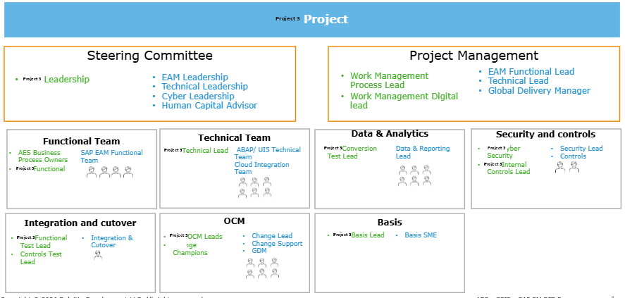
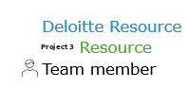
Roles and Responsibilities
Role | Responsibilities
Steering Committee | - Tier 1 governance / monthly decision authority for the program.  - Provide strategic direction.  - Approve charter changes, capitalization policy, and target-state design.  - Make cross-functional trade-off decisions.  - Issue go / no-go decisions for major releases and specifically approve SG4 Go-Live Readiness.  - Resolve high-severity risks and receive escalations for critical defects, major budget changes, regulatory/reporting risk, safety/operability risk, or strategic design deviations.  - Approve budgetary changes greater than 10% of contingency or more than 50% of cumulative contingency.  - Review the program monthly, including the 8-dimension Program Health RAG status.  - Serve as an acceptance authority for key milestones and stage gates, including SG0/SG1, SG2, SG3-related checkpoints, SG4, and go-live/cutover approvals in the payment schedule.
Project Management | - Build and maintain the Integrated Master Schedule (IMS) at activity level and contribute weekly to the consolidated program IMS.  - Manage dependencies across parallel initiatives such as DDS/GET, GIS/RAM, FSM, SAP S/4HANA Upgrade, PowerPlan NXT, and Project 3 operations calendars.  - Administer and participate in the RAIDD process for risks, assumptions, issues, dependencies, and decisions, using Smartsheet as the system of record.  - Provide weekly status reporting and inputs to the monthly Steering Committee for review, including the 8-dimension Program Health RAG view.  - Escalate critical issues within one weekly cycle when they threaten go-live, budget, regulatory/financial reporting, safety/operability, or target-state design.  - Perform financial tracking: weekly burn, monthly forecast vs. plan, quarterly value-at-risk, and contingency reconciliation.  - Support change control, documenting scope, schedule, cost, contingency, and risk impacts for formal changes.
Functional Team | - Authors for the Functional Specifications (FSDs) for each RICEFW object. Those FSDs must include RTM traceability, process flow, impacted data model, functional behavior, validation rules, security/authorization requirements, controls and audit needs, integration touchpoints, UAT acceptance criteria, and design assumptions.  - Lead Deloitte functional team members  - Plan functional team activities at a detailed level and coordinate with project management
Technical Team | - Author Technical Specifications (TSDs) for each RICEFW object, including object ID/type/complexity, full technical design, data dictionary, pseudo-code or detailed logic, integration patterns, error handling, security/authorization implementation, performance considerations, unit test scope, and dependencies  - Obtain design approval before build; each TSD must be reviewed and approved by the Project 3 Digital Lead before development starts  - Follow technical development standards, including SAPUI5 / Fiori Elements standards, CPI naming/package/folder standards, static code analysis, and clean ATC execution before transport  - Perform technical code reviews, with review by the SI Technical Lead, Project 3 Digital Lead, and Project 3 Architect Lead  - Unit test every RICEFW object and retain evidence in the Project 3 Program Repository; those objects also flow into SIT, UAT, regression, controls testing, and cutover rehearsal  - Own the SAP side of every interface in scope, including interface design, build, unit test, monitoring setup, error handling/retry logic, exception alerting, runbook creation, and operational handover to Project 3 AMS after hyper care  - Produce full interface technical documentation for the listed integrations and work within Project 3-approved middleware/patterns such as CPI, IDoc, RFC, OData, or event mesh  - Coordinate with technical counterparts such as GIS technical leads and other system owners where integrations cross program boundaries
Data Conversion | - The SI owns the conversion execution approach: Extract → Profile → Transform → Cleanse → Enrich → Load → Test → Validate & Reconcile  - The SI is responsible for extract specifications, mapping, transformation/load programs, validation routines, reconciliation, mock loads, and cutover loads  - Project 3 and SI jointly own data quality, cleansing decisions, legacy-side extracts, and business-data validation, with joint accountability for conversion timing, cleansing rule design, and reconciliation gates  - inal production cutover loads are executed per the approved cutover runbook, with go/no-go tied to reconciliation results and SAP Basis sign-off  - Conversion governance also requires an Project 3-approved conversion procedure for every object, including extract approval, transformation/cleansing rule approval, mock-load reconciliation, and cutover-load sign-off
Security & Controls | - supports controls design and governance; delivers design recommendations, control test plans, SoD ruleset configuration, deploys monitoring controls through GRC tooling, walks Project 3 teams through test of design, and signs the Controls Readiness Statement  - owns second-line controls design, governance, and testing; confirms SAP PM control design aligns to the Project 3 Global Control Framework and Internal Control Catalog; participates in operating-effectiveness and production validation; signs readiness statements  - participates in security testing sign-off, especially on the SoD ruleset before go-live readiness  - reviews and approves Functional Specifications where applicable before build starts
Integration and cutover | - Test Manager will participate in the consolidated the program Program weekly status meeting and the monthly Steering Committee Test Readiness review  - Contributing to the Program Health Testing / Progress dimension scored Green / Yellow / Red per Charter thresholds
OCM | - Deliver the Change Strategy across five focus areas — Change Preparation, Change Impacts, Communications, Education & Training, and Organizational Readiness  - Build and maintain a stakeholder map across Project 3 Indiana, Project 3 Ohio, and MVLt, covering impacted persona groups and refreshing it regularly  - Perform change impact analysis, documenting how future-state processes, roles, data, tools, skills, and behaviors change for each stakeholder group  - Define and operate the Change Champion Network, including selection criteria, operating rhythm, enablement approach, and rollout alignment  - Run readiness assessments, analyze adoption risks, and tie readiness to stage-gate go/no-go decisions; the document sets a Green threshold of Readiness ≥ 80% and Training ≥ 95% complete  - Provide training governance and quality oversight, including role-based training plans, end-to-end business process scenario training, Level 4 process documentation, FAQs, QRGs, recordings, and support resources  - OCM Leads: coordinate targeted engagement for high-impact and high-resistance groups  - Change Champions: act as SMEs / super-users who support localized adoption, reinforce key messages, validate readiness, and provide field feedback

Key Bios

Integrated Project Plan

Integrated project plan is placed in the folder xxx and is submitted via Ariba. Refer to the Microsoft Project file named ‘Integrated Project Plan_AES _ SAP PM

Pricing & Resourcing

Price breakdowna and Resource planning excel sheets are placed in the folder xxx and is submitted via Ariba. Refer to the following files – Pricing Breakdown.xlsx & Resource Plan_AES.xlsx

Alternate Implementation Approach
Deloitte’s close collaboration with the program program members across the Work Management, GET, and GIS workstreams for the the program Roadmap Recommendation initiative enabled us to identify and deconstruct key dependencies and pain points across the operating model. Based on this analysis, we recommend a phased transformation approach to reduce delivery risk and support a more stable transition. This approach introduces change in a controlled sequence, giving the Project 3 team additional time to prepare for each transformation milestone rather than moving through a single step changeover.

Why is Phased Transformation recommended?
- Introduction of changes in manageable waves
- Lowers risk from overlapping system and process changes
- Gives the Project 3 team time to prepare for each milestone
We suggest below phases for Work Management (SAP PM Implementation) transformation:
- Track 1 - Now: Streamlined Capital Construction Process
- Track 2 - Next: Road to an Effective Maintenance Process
- Track 3 - Future: A Transformed Field Service & Execution
Editable version in graphics deck
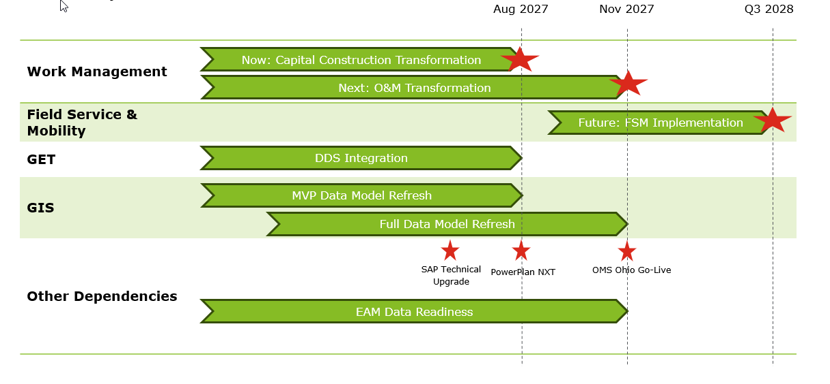
We are aligned with Project 3’s objective of retiring Lifecycle at the earliest possible date, and we also recognize the constraints associated with the unavailability of ready EAM master data and maintenance planning data required to enable a successful Work Management transformation. We believe this approach will support an effective transformation by initiating Capital Construction transformation immediately, while providing the Project 3 team additional time to collect, cleanse, and prepare the data required for Maintenance processes, including Proactive, Predictive, and Corrective maintenance.

Under this approach, we recommend beginning design for Track 1 and Track 2 in August 2026, while sequencing Track 2 build activities after completion of Track 1 build. This will allow Project 3 sufficient time to focus on data collection and EAM data readiness efforts. Go-Lives for Track 1 and Track 2 are Aug 2027 and Nov 2027 respectively. Track 3 can be kicked off as to overlap with Hypercare exit of Track 1.

High Level scope for the tracks is as below –
Editable version in graphics deck

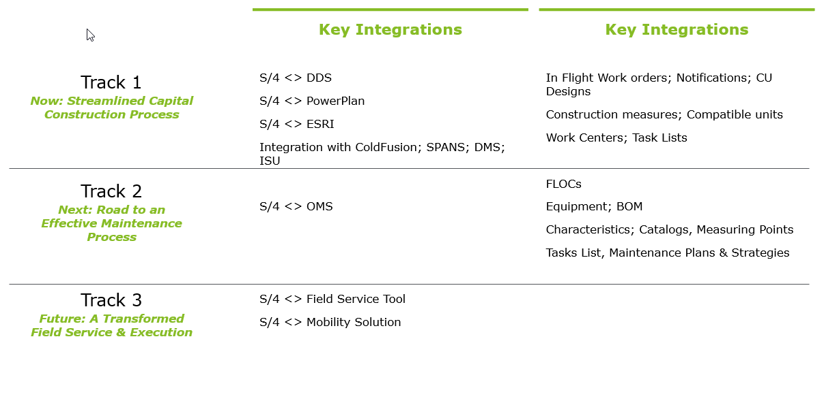

* - Please note that the table above is provided for high-level scoping purposes only and does not purport to reflect the complete scope of work.

Benefits
- Enables Project 3 to retire Lifecycle earlier, supporting a faster transition to the target operating model.
- Provides additional time to clean up the complete ESRI GIS data model, improving data quality and downstream usability.
- Allows additional time for EAM master data cleansing and preparation, which should strengthen readiness for Maintenance processes.
- Supports a concurrent go-live for DDS with SAP PM and Capital Construction in August, improving alignment across solution components.
- Extends the data preparation window for EAM master data, increasing the likelihood of a more stable and effective implementation.
- Reduces technical debt by accelerating the retirement of legacy dependencies such as Gtech and StakeOut systems.
- Lowers the risk of carrying legacy systems longer than necessary, while improving the overall transformation path.
Assumptions
- Project 3 intends to retire Lifecycle at the earliest feasible date.
- Project 3 acknowledges that the current availability of EAM master data and maintenance planning data may not be sufficient to support an immediate end-to-end Work Management transformation.
- The proposed approach assumes that Capital Construction transformation can commence immediately, while Project 3 continues data collection, cleansing, and readiness activities for Maintenance processes, including Proactive, Predictive, and Corrective maintenance.
- Design for Track 1 and Track 2 is assumed to begin in August 2026.
- Track 2 build activities are assumed to begin only after completion of Track 1 build.
- Project 3 is expected to use the intervening period to advance EAM data readiness efforts required to support downstream Maintenance processes.
- SAP upgrade remains on track in accordance with the current plan, April 2027.
- PowerPlan NXT implementation is assumed to be completed before, or concurrently with, Track 1 go-live.
- DDS implementation is assumed to be achievable for concurrent go-live with Track 1.
- MVP Data Model refresh is assumed to include the baseline FLOC and Asset Master cleanup required for the Capital Construction process, and design is assumed to be complete by Track 1 go-live.
- Project 3 will have the resources required to support activities across parallel tracks.
- OMS Ohio is assumed to remain on track for go-live in Q4 2027, before or concurrent with Track 2 go-live.

