Mir Kash — New Features Proposal
Coupons · Customer Accounts · Order History · Returns · Optional OTP
For BOTH the India and Global stores

1. Overview
This document proposes five customer-facing improvements for the Mir Kash website, covering both the India store (custom Cashfree checkout) and the Global store (Shopify checkout). Nothing here changes the products, the look of the storefront, or the existing payment flows — these are additions on top.
The thread connecting them is a new “My Account” area where customers log in with their phone number (OTP) to see their orders and request returns. The same login lets us make OTP optional at checkout — reducing purchase friction while keeping it useful.

How it all fits together
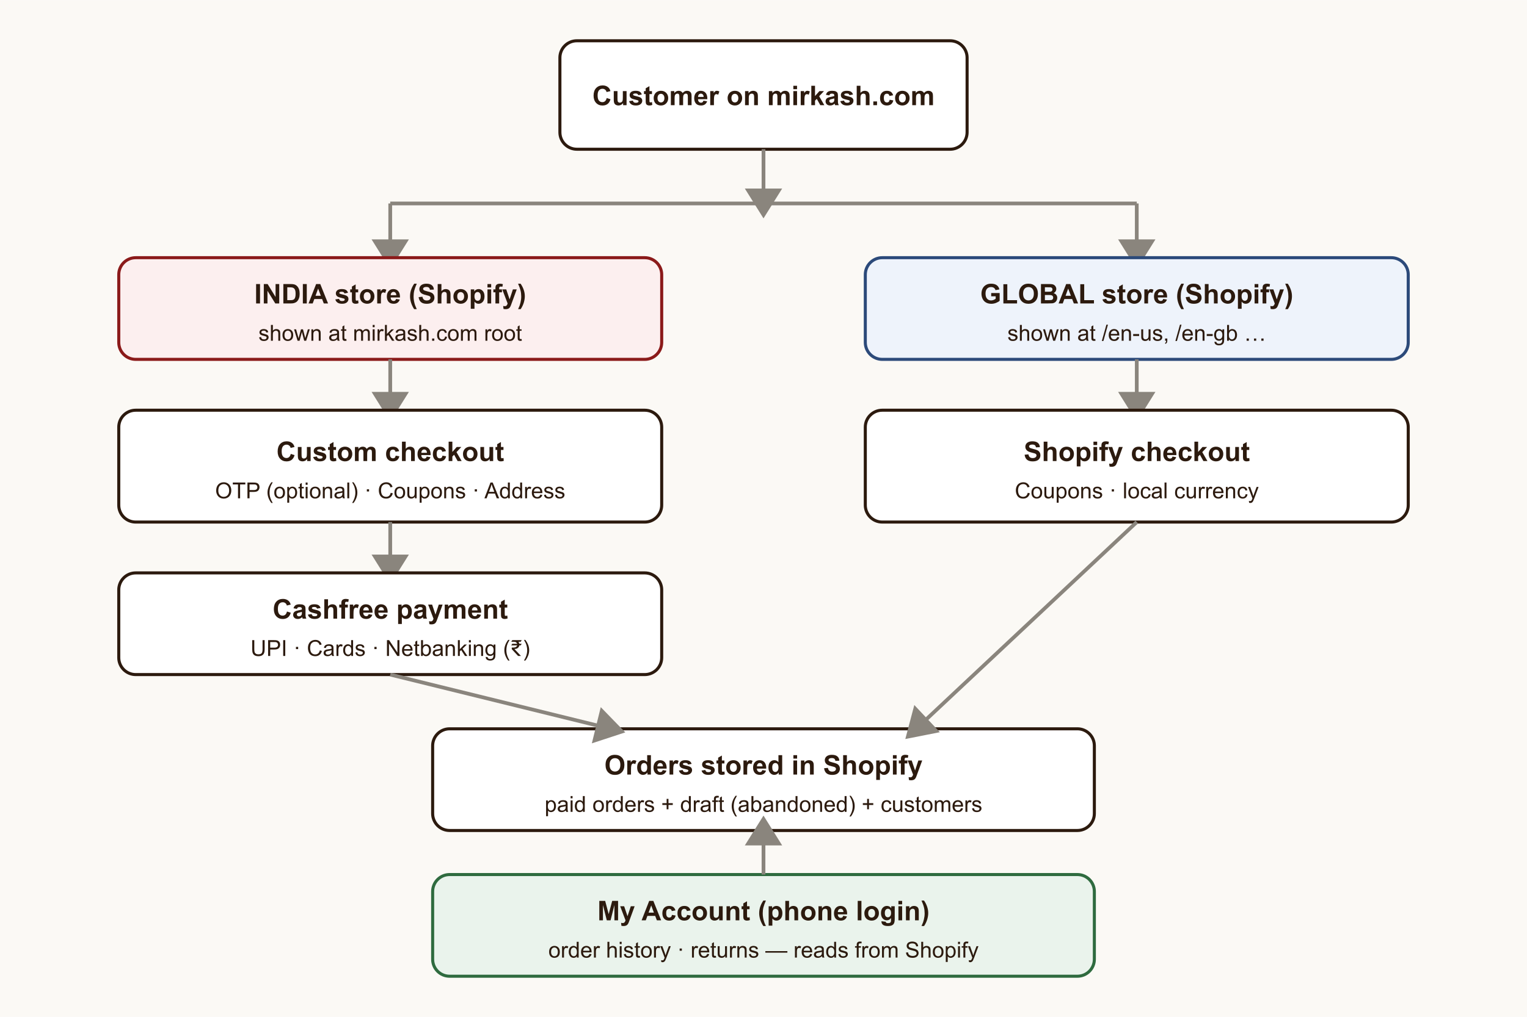
Both stores live under mirkash.com. Orders are stored in Shopify; the new Account area reads from there.

2. Coupons / Discount Codes
Today neither store lets a customer type a coupon code on our site. We will add a discount-code field on the cart/checkout for both stores.
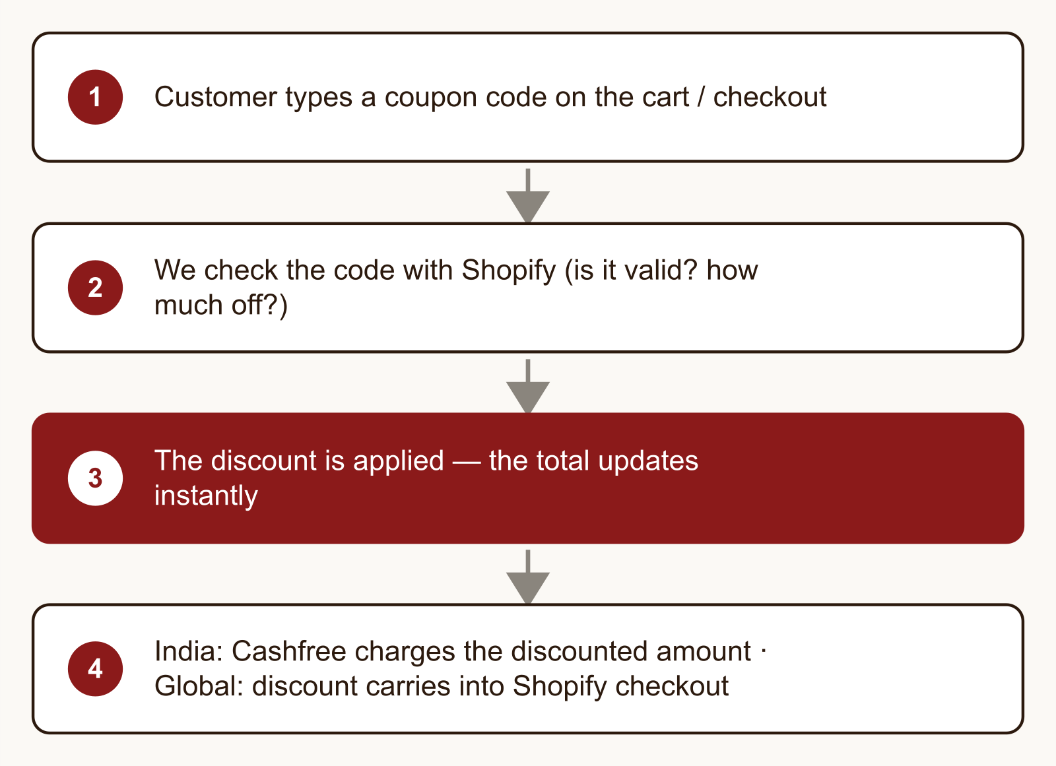
Coupon flow — works for both stores; codes are managed in Shopify (Discounts).
Area | Detail
Both stores | One coupon field on the cart/checkout; discounts are created and controlled in Shopify Admin → Discounts.
India | The custom checkout applies the discount to the order so Cashfree charges the correct, lower amount.
Global | The discounted cart flows into Shopify’s own checkout — Shopify handles the rest.

3. Customer Accounts & Login
A new “Account” link in the top menu opens a My Account page. Customers log in with their phone number and a one-time code (the same OTP technology already built). No passwords to remember, no separate sign-up.
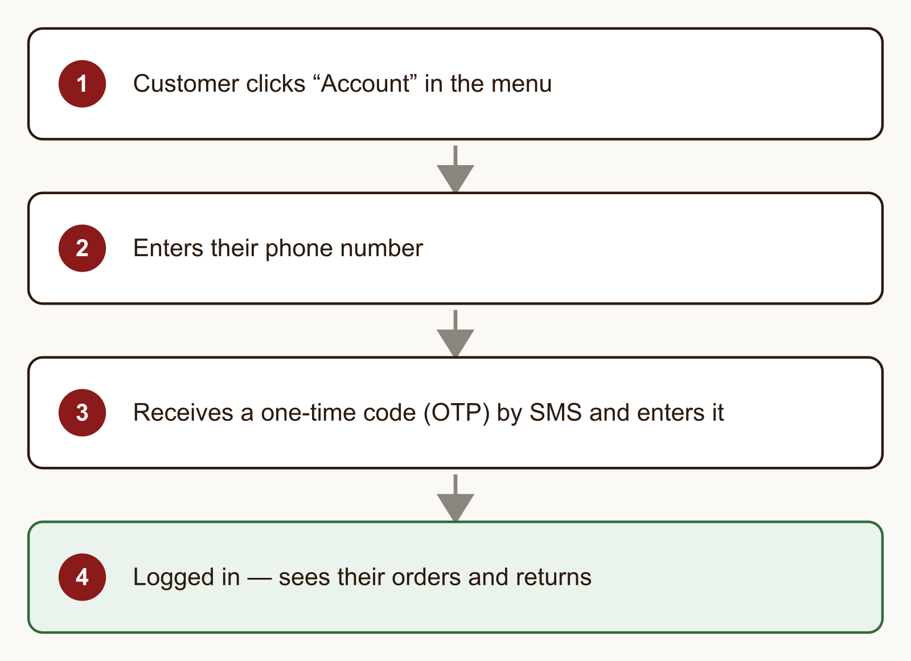
Login flow — phone + OTP, same for India and Global customers.

4. Order History
Once logged in, customers see every order they have placed — pulled live from Shopify, across both stores — with status, items, amount and delivery progress. A customer can only ever see orders that belong to their own verified phone number.
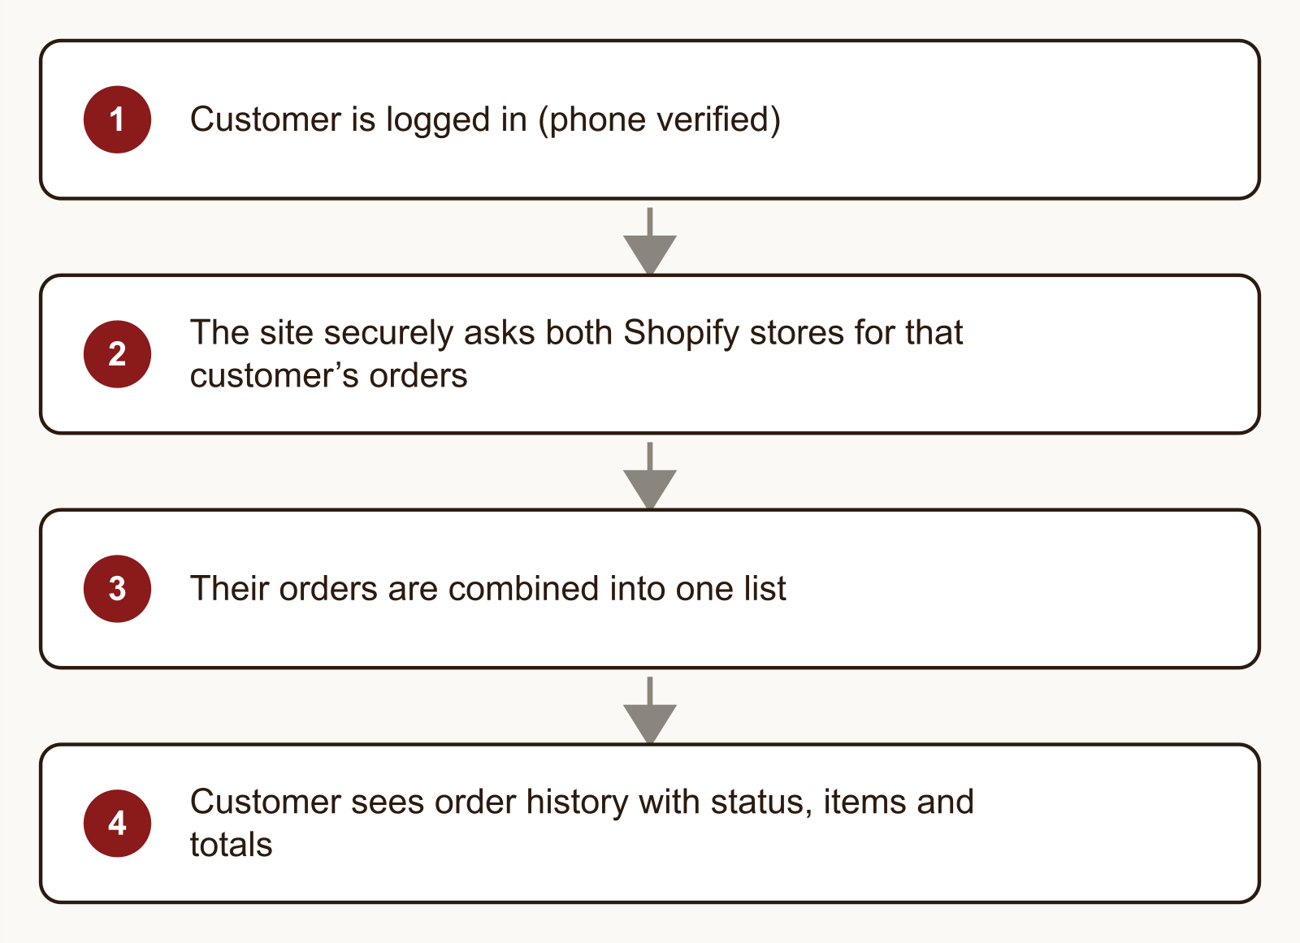
Order history — read directly from Shopify; no separate database to maintain.

5. Returns
On a delivered order, the customer can press “Request a return”, choose a reason, and submit. The order is flagged in Shopify so your team can review and process the refund. (Fully automatic refunds are a possible later upgrade.)
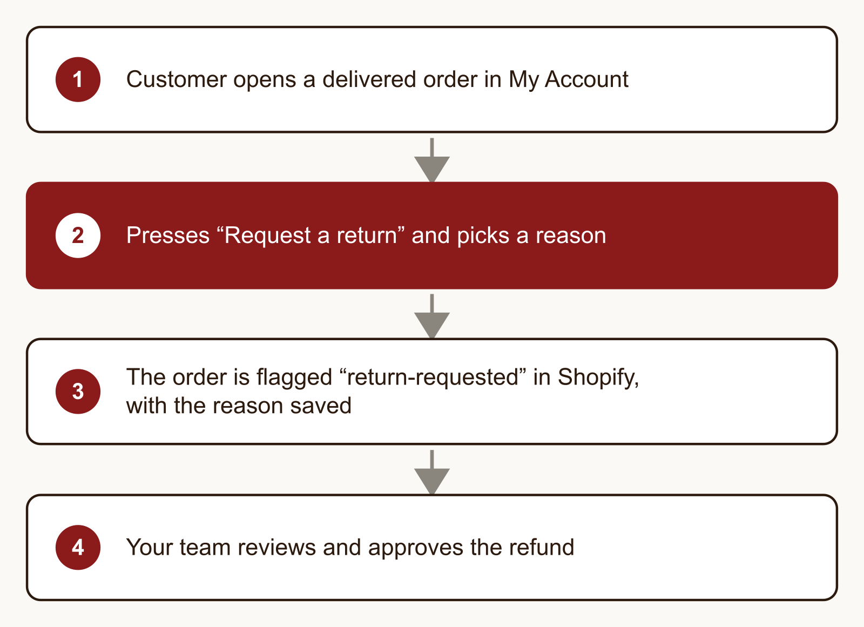
Returns (version 1) — a request + review flow; you stay in control of refunds.

6. Optional OTP at Checkout
You felt the mandatory OTP at checkout adds friction. Because OTP now powers account login, we can make it optional at checkout — a customer can buy without verifying, or verify if they want their order linked to their account. Their phone number is still collected on the order either way.

7. Rollout Plan
Each phase is useful on its own and can ship independently, lowest-risk first:
Phase | What ships
Phase 1 | Coupons on both stores.
Phase 2 | My Account + phone login + order history (both stores).
Phase 3 | Returns (request + review).
Phase 4 | Make OTP optional at checkout.

8. What We Need From You
Almost everything reuses what is already set up. The one new item:
- A Global Shopify Admin API app (Client ID + Secret) — set up exactly like the India one we already did. This lets the Account area read Global orders and flag Global returns.
Already decided: OTP at checkout → optional; account login → phone + OTP (no passwords); returns → request-and-review first. Customer data stays in Shopify (no new database).
Prepared for review — nothing is built yet. Approve the direction and we implement phase by phase.

