MIR KASH
Phase 2 — Product, Cart & Checkout
How it works — a business + technical guide

1. Overview
We added three things to the Mir Kash website so customers can actually shop and buy: a Product page (to view a bag and choose options), a Cart page (the bag/basket), and a Checkout step. The site is built with Astro and runs on Vercel. All product and cart information comes from Shopify through its official Storefront API. When a customer is ready to pay, we hand them over to Shopify's own secure checkout — so payments are handled entirely by Shopify, not by our website.
In one line: our site shows the products and manages the bag; Shopify stores the catalogue, runs the secure checkout, and records the order.

2. The three pages at a glance
Page | Address (URL) | What it does | Key file
Product | /products/<bag-name> | Photos, colour & size selection, price, Add to Bag | ProductPage.astro
Cart | /cart | Lists chosen items, change quantity, remove, see total, Checkout button | CartPage.astro
Checkout | Shopify-hosted (mirkash.in) | Address, shipping, payment, order creation | (Shopify) via checkoutUrl

3. How the pieces fit together
Our website never sees anyone's card details. We talk to Shopify behind the scenes to read products and build the bag; the moment money is involved, the customer is on Shopify's secure checkout.
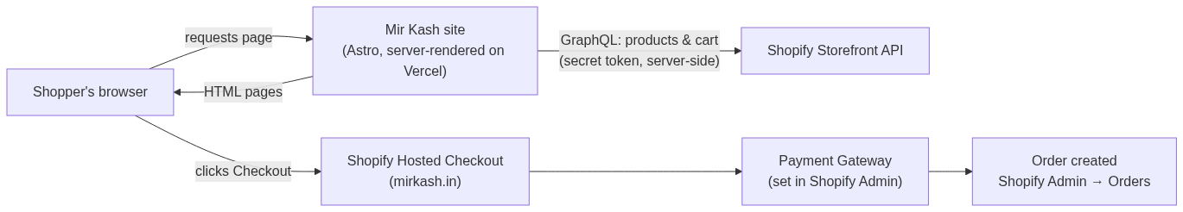
Figure 1 — System architecture
The customer's journey from browsing to a confirmed order:
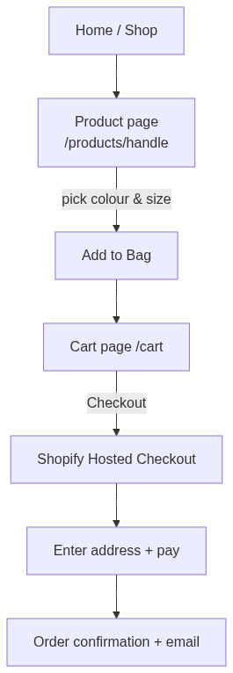
Figure 2 — Customer journey

4. The Product page
Business view: the shopper opens a bag, swipes/scrolls the photos, picks a colour and a size, sees the live price, and clicks “Add to Bag”. If a combination is out of stock the button shows “Sold Out”.
Technical view:
- When the page loads, our server asks Shopify for that product by its “handle” (the name in the URL) using getProductByHandle — pulling images, colours, sizes, variants and prices.
- Each colour+size combination is a Shopify “variant” with its own ID, price and stock. The page knows every combination and, as the shopper selects options, it resolves the exact variant, updates the price, and enables/disables the button.
- “Add to Bag” sends that variant ID to our server endpoint /api/cart/add, then takes the shopper to the Cart.

5. How the Cart works
Business view: the cart is the shopper's bag. They can change quantities, remove items, and see the subtotal and total. A bag-count badge in the header shows how many items are in the bag. Nothing is charged here — Checkout sends them to Shopify to pay.
Technical view — adding an item:
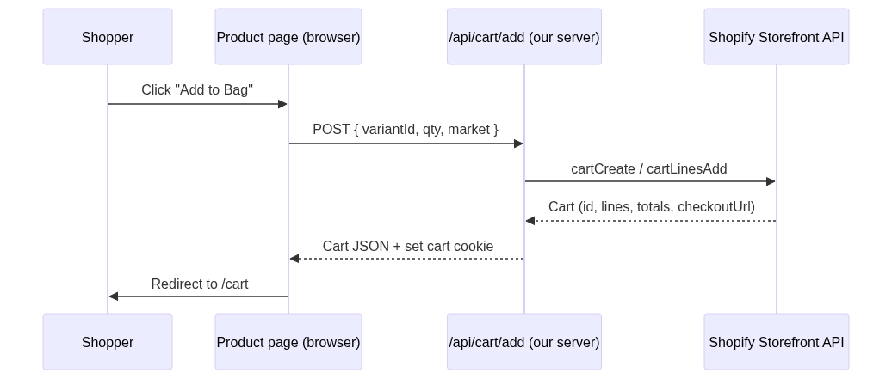
Figure 3 — Add to Bag
Technical view — changing quantity or removing:
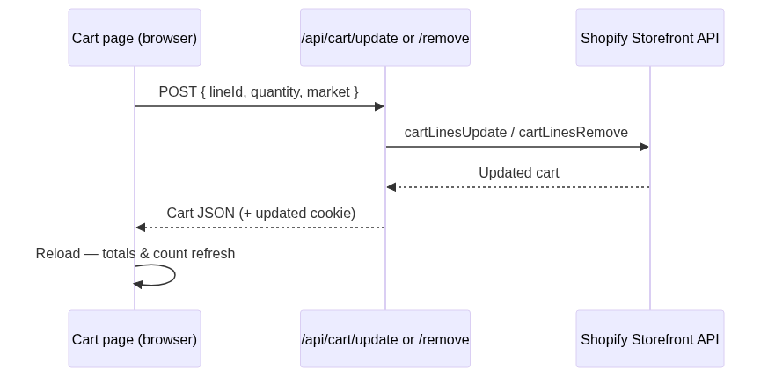
Figure 4 — Update / remove
Key points about how the bag is remembered:
- The real cart lives in Shopify. We create it via the Storefront API and Shopify gives us a cart ID plus a checkout link.
- We store only that cart ID in a secure browser cookie (mk_cart_<market>), so the bag persists if the shopper leaves and comes back. A small count cookie powers the header badge.
- All cart changes go through our own server endpoints (/api/cart/add, /update, /remove, and a read endpoint). This keeps the secret Shopify token on the server, never in the browser.

6. Checkout & Payments
When the shopper clicks Checkout, we send them to the cart's Shopify checkout link (checkoutUrl). From there Shopify handles address, shipping, taxes, payment, and creating the order.
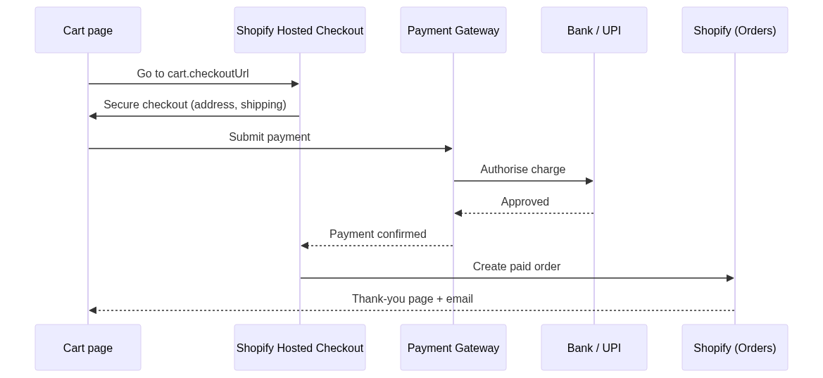
Figure 5 — Checkout & payment

Which payment gateway?
We do not build or choose the gateway in code — Shopify's hosted checkout uses whatever payment provider is enabled in your Shopify Admin (Settings → Payments). For the India store (mirkash.in, charging INR), Shopify Payments is not available in India, so it is typically a provider such as Razorpay, PayU, Cashfree, or similar (with cards, UPI, net-banking, wallets). The exact provider is whatever you have connected in Shopify Admin — please confirm there.

Is it a real order / real money?
- If the store is live with a real payment provider connected, a completed checkout is a REAL paid order: money is charged, the order appears in Shopify Admin → Orders, stock decreases, and confirmation emails are sent.
- To test safely without real charges: turn on test mode in Shopify Payments (or use the Bogus/test gateway), or place a real order and refund it, or use a 100%-off discount code.
- Card details never touch our website — Shopify is fully responsible for payment security (PCI compliance).

7. Two markets (India & International)
Market | URL | Currency | Checkout
India | mirkash.in (root) | INR ₹ | India Shopify store checkout
International / US | /en-us | USD $ | Global Shopify store checkout

Each market has its own Shopify store and its own checkout. The site detects the market and the cart/checkout automatically use the right store and currency.

8. Security & data
- The secret Shopify access token stays on our server only; the browser never sees it.
- The cart ID is kept in a secure, HTTP-only cookie (not readable by page scripts).
- Because payment happens on Shopify's hosted checkout, no card data ever passes through our site — Shopify carries the PCI responsibility.

9. Code reference (for developers)
File | Role
src/components/ProductPage.astro | Product page UI + add-to-bag logic
src/components/CartPage.astro | Cart page UI + qty/remove + checkout button
src/lib/shopify/queries.ts | getProductByHandle, product/collection queries
src/lib/shopify/cart.ts | Shopify cart mutations (create/add/update/remove/get)
src/lib/shopify/fragments.ts | GraphQL fragments (product, cart, money, image)
src/lib/cart-session.ts | Cart cookie helpers (id + count, per market)
src/pages/api/cart/*.ts | Server endpoints: add, update, remove, get cart
src/pages/products/[handle].astro | Product route (+ /en-us version)
src/pages/cart.astro | Cart route (+ /en-us version)

10. Quick FAQ
Where do orders show up?
In your Shopify Admin → Orders, exactly like any Shopify order.
Can we change the checkout look?
The hosted checkout is styled in Shopify (Settings → Checkout / branding). The custom “Checkout-Express” design was intentionally not built, since real payments require Shopify's secure checkout.
What if a cart link expires?
If Shopify no longer recognises a stored cart, the next “Add to Bag” simply starts a fresh cart automatically.

