OrchardSprays_Datset.R

Innova

Tue Jan 17 11:32:10 2017

#OrchardSprays Datset  
  
library(ggplot2)  
library(reshape2)  
library(plotly)

##   
## Attaching package: 'plotly'

## The following object is masked from 'package:ggplot2':  
##   
## last_plot

## The following object is masked from 'package:stats':  
##   
## filter

## The following object is masked from 'package:graphics':  
##   
## layout

library(MASS)

##   
## Attaching package: 'MASS'

## The following object is masked from 'package:plotly':  
##   
## select

library(caret)

## Loading required package: lattice

head(OrchardSprays)

## decrease rowpos colpos treatment  
## 1 57 1 1 D  
## 2 95 2 1 E  
## 3 8 3 1 B  
## 4 69 4 1 H  
## 5 92 5 1 G  
## 6 90 6 1 F

ls.str(OrchardSprays)

## colpos : num [1:64] 1 1 1 1 1 1 1 1 2 2 ...  
## decrease : num [1:64] 57 95 8 69 92 90 15 2 84 6 ...  
## rowpos : num [1:64] 1 2 3 4 5 6 7 8 1 2 ...  
## treatment : Factor w/ 8 levels "A","B","C","D",..: 4 5 2 8 7 6 3 1 3 2 ...

names(OrchardSprays)

## [1] "decrease" "rowpos" "colpos" "treatment"

library(Amelia)

## Loading required package: Rcpp

## ##   
## ## Amelia II: Multiple Imputation  
## ## (Version 1.7.4, built: 2015-12-05)  
## ## Copyright (C) 2005-2017 James Honaker, Gary King and Matthew Blackwell  
## ## Refer to http://gking.harvard.edu/amelia/ for more information  
## ##

library(mlbench)  
missmap(OrchardSprays, col=c("black", "grey"), legend=FALSE)

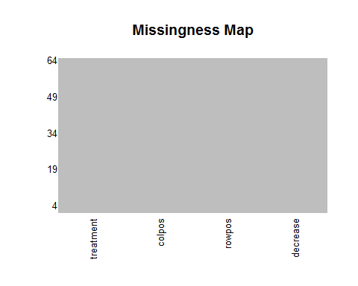

unique(OrchardSprays$rowpos)

## [1] 1 2 3 4 5 6 7 8

unique(OrchardSprays$colpos)

## [1] 1 2 3 4 5 6 7 8

unique(OrchardSprays$treatment)

## [1] D E B H G F C A  
## Levels: A B C D E F G H

mn <- tapply(OrchardSprays$decrease, OrchardSprays$treatment, mean)  
mn

## A B C D E F G H   
## 4.625 7.625 25.250 35.000 63.125 69.000 68.500 90.250

sd <- tapply(OrchardSprays$decrease, OrchardSprays$treatment, sd)  
sd

## A B C D E F G   
## 3.204350 3.292307 24.429198 13.437687 26.909571 29.189039 20.142351   
## H   
## 24.223660

pairs(OrchardSprays) ##Scatterplot Matrix

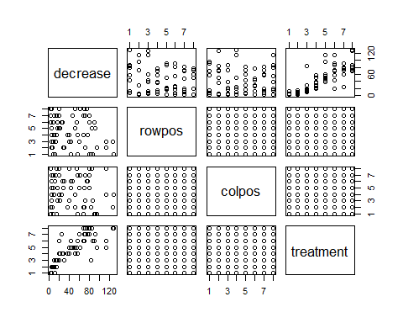

pairs(treatment~., data = OrchardSprays, col=OrchardSprays$treatment)#Scatterplot Matrix By Class

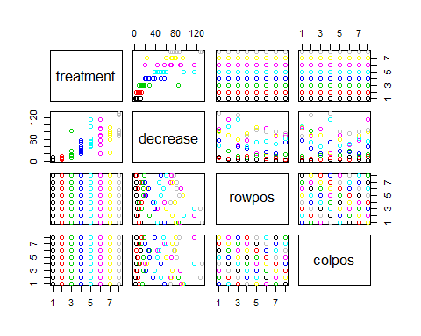

hist(OrchardSprays$decrease,col = "cyan")

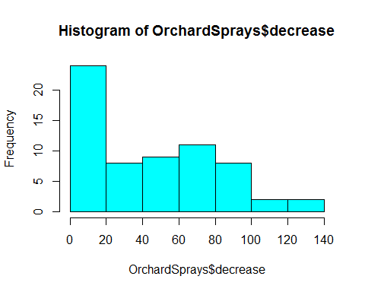

hist(OrchardSprays$rowpos, col = "blue")

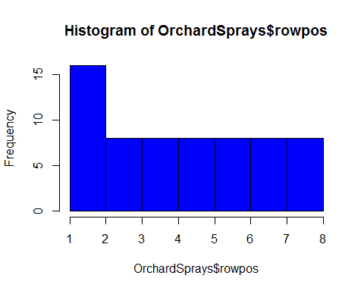

hist(OrchardSprays$colpos,col = "red")

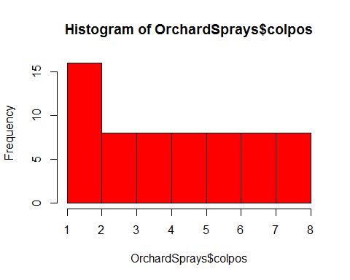

treatment = OrchardSprays$treatment  
treatment.freq = table(treatment)  
treatment.freq

## treatment  
## A B C D E F G H   
## 8 8 8 8 8 8 8 8

barplot(treatment.freq)

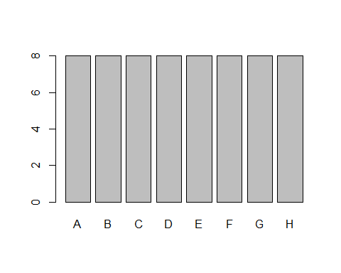

plot(decrease ~ rowpos + colpos + treatment, data=OrchardSprays)

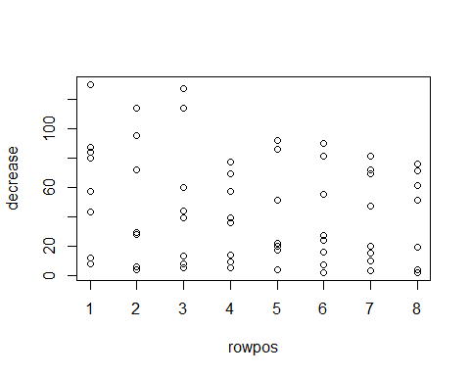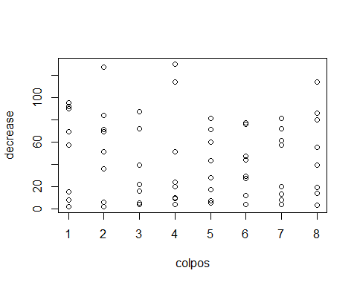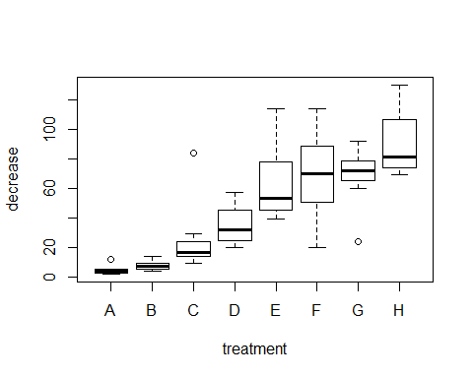

stripchart(OrchardSprays$decrease ~ OrchardSprays$treatment,  
 main = "stripchart(Orchardsprays)", ylab = "decrease",  
 vertical = TRUE)

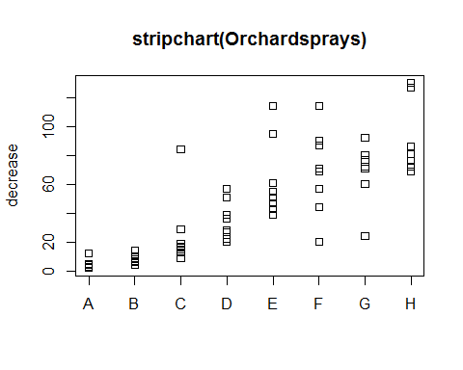

library(RColorBrewer)  
jBrewColors <- brewer.pal(n = 8, name = "Dark2")  
  
  
with(OrchardSprays, interaction.plot(treatment, colpos, decrease, col = jBrewColors))

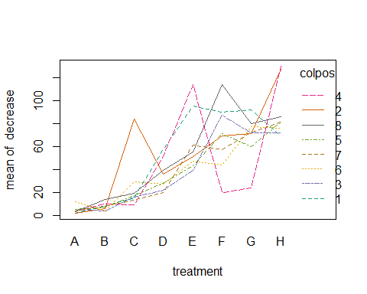

with(OrchardSprays, interaction.plot(treatment, rowpos, decrease, col = jBrewColors))

