Lecture 2c
From Words to Vision — Embeddings and CLIP
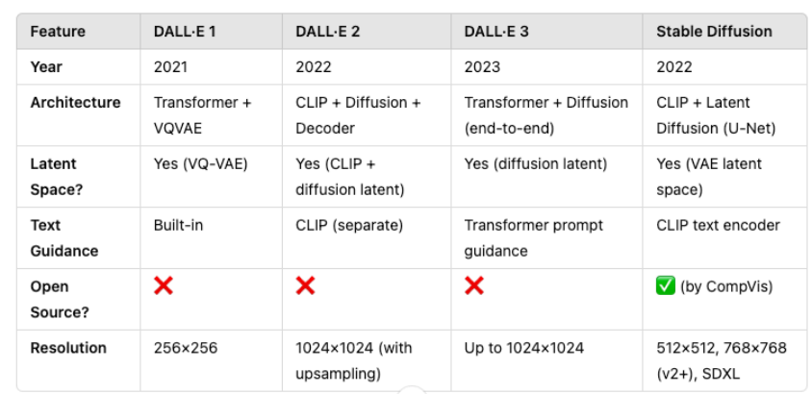
Why Multimodal Embeddings?
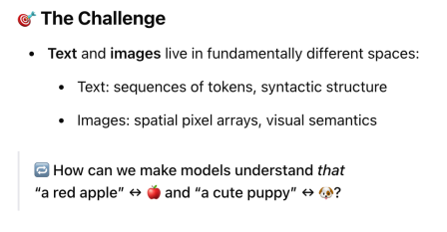
Why Multimodal Embeddings?
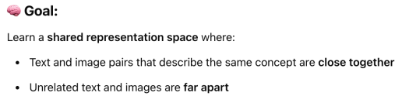
Why Multimodal Embeddings?
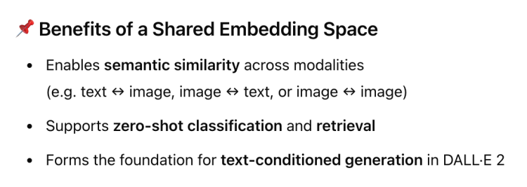
Why Multimodal Embeddings?
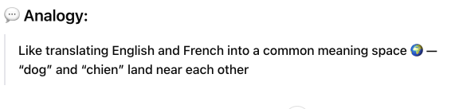
CLIP – Contrastive Language–Image Pretraining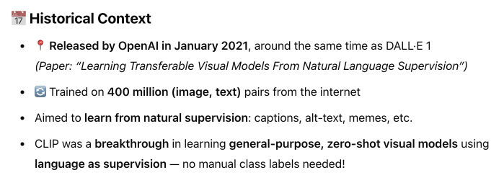
CLIP – Contrastive Language–Image Pretraining
CLIP – Contrastive Language–Image Pretraining
CLIP
CLIP
CLIP
CLIP
Now more on these…
ResNet-50: Deep CNN with Skip Connections
Now we can continue with the loss……….
CLIP
Just saw…
Skip now…just a very good text encoder…….
CLIP
More on this….
CLIP’s Contrastive Loss — Matching Images and Text
CLIP’s Contrastive Loss — Matching Images and Text
CLIP Capabilities — From Training to Downstream Tasks
CLIP Capabilities — From Training to Downstream Tasks
CLIP Capabilities — From Training to Downstream Tasks
Understanding the Shared Embedding Space
CLIP: A Foundation for Multimodal Intelligence

