ИНТЕРНЕТ ПРОГРАМИРАЊЕ
JAVA SERVER PAGES (MVC) M2
ПРЕДАВАЊА

САДРЖАЈ

MVC
MVC ИЗВЕДБА
JSP MODEL M2
USE BEAN
REQUEST BASED DATA SHARE
SESSION BASED DATA SHARE
SEND REDIRECT/SESSION BASED DATA SHARE
APPLICATION BASED DATA SHARE
FORWARD VS SEND REDIRECT
INCLUDE AND FORWARD
INCLUDE

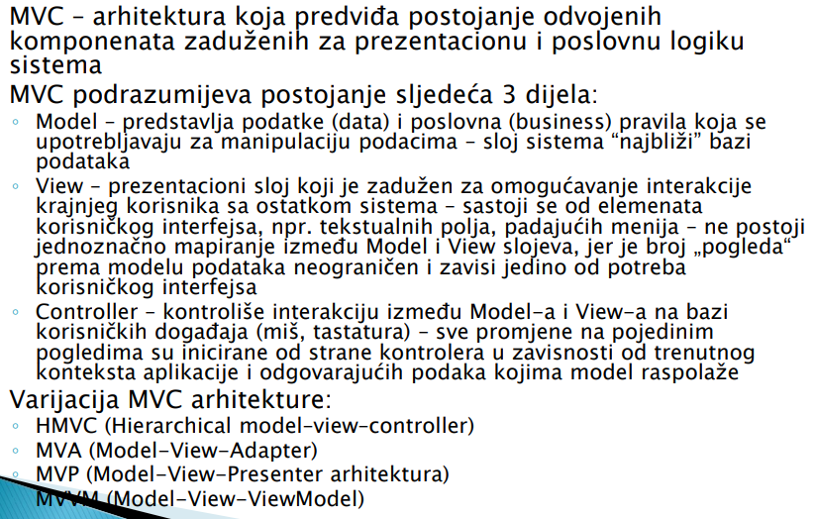
MVC – Model view controller

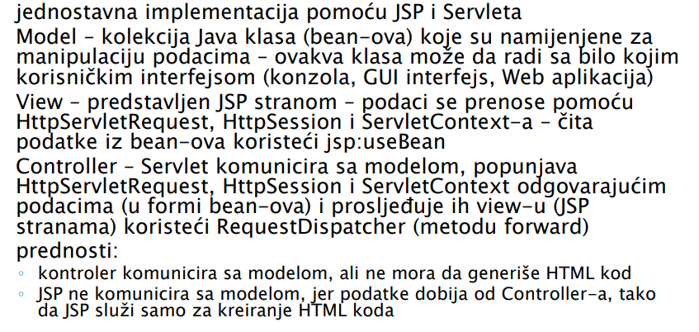

JSP M2

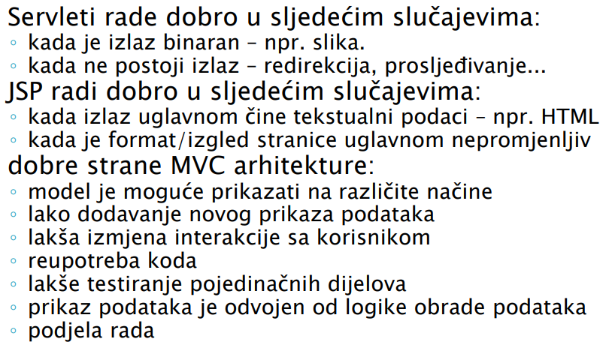
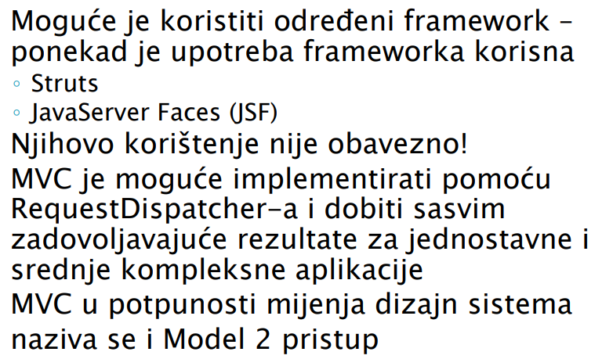

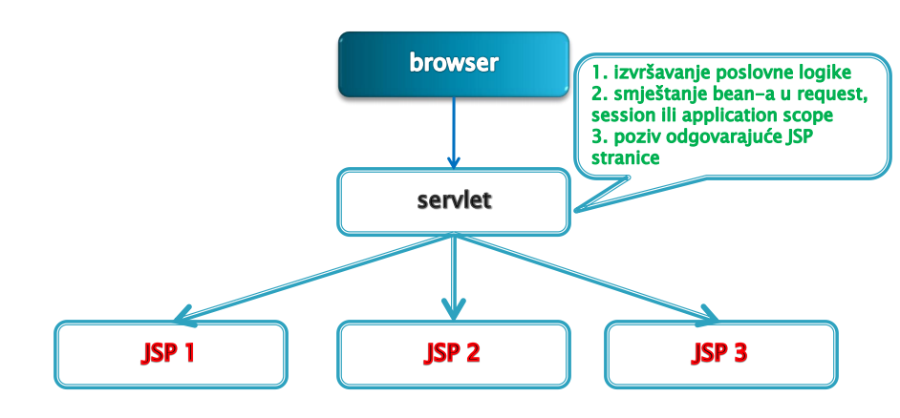
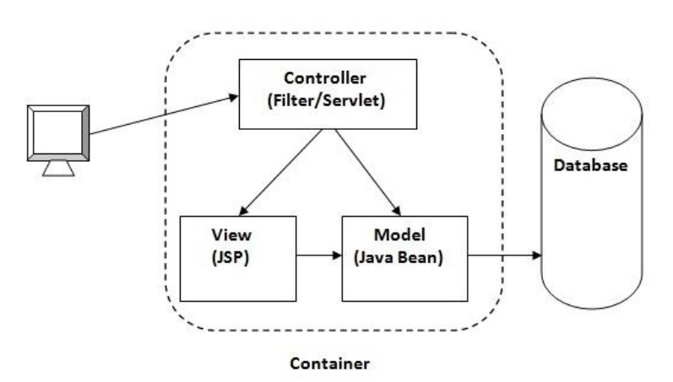

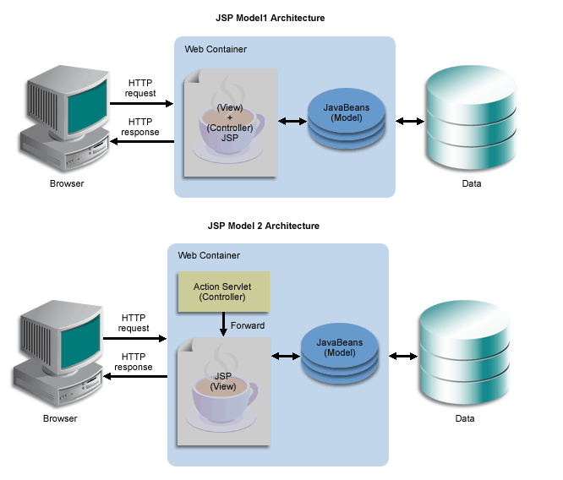

JSP M2 – КОРАЦИ

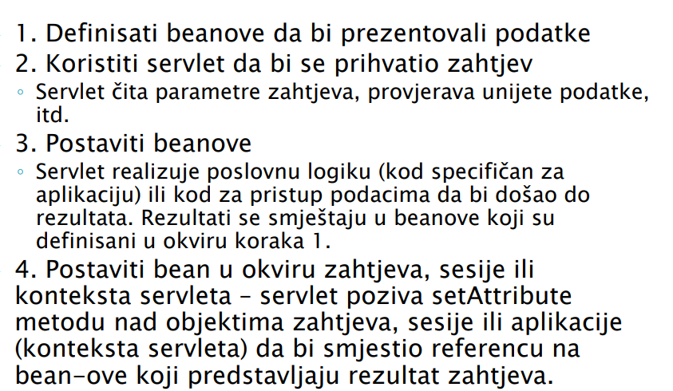
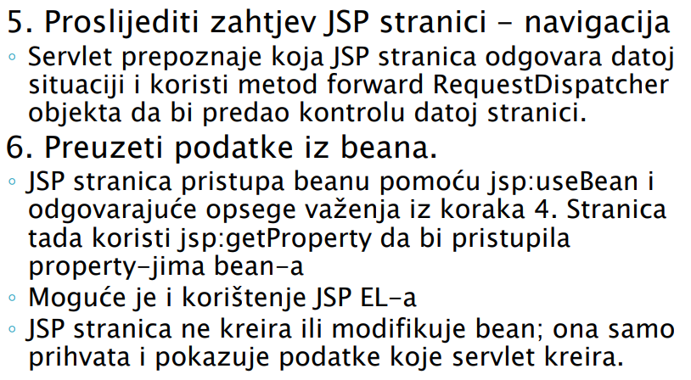

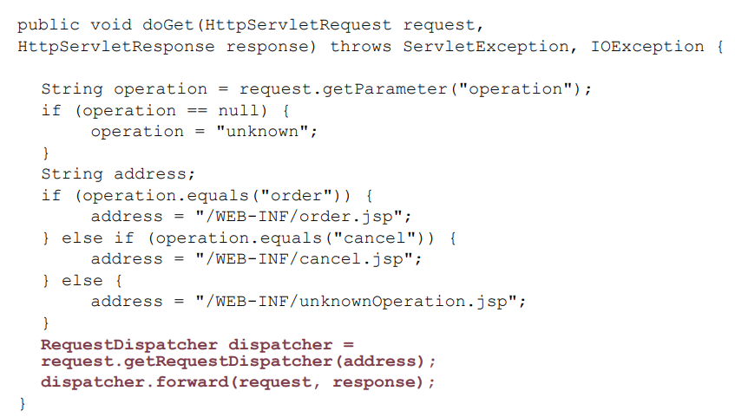
USE BEAN – MVC MODEL
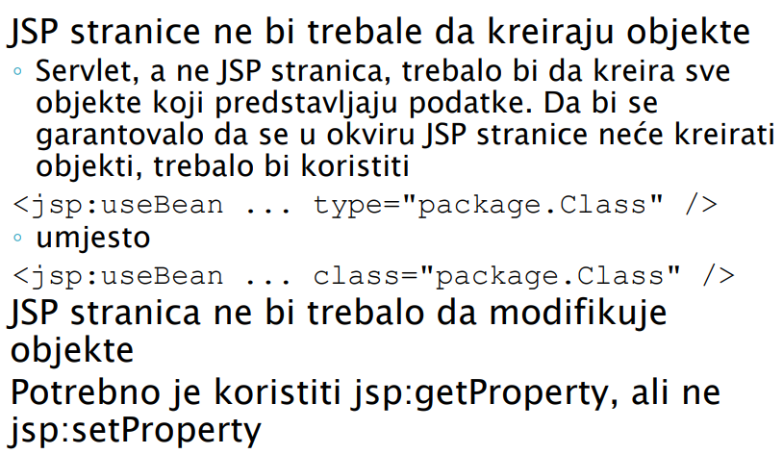

REQUEST BASED DATA SWAP
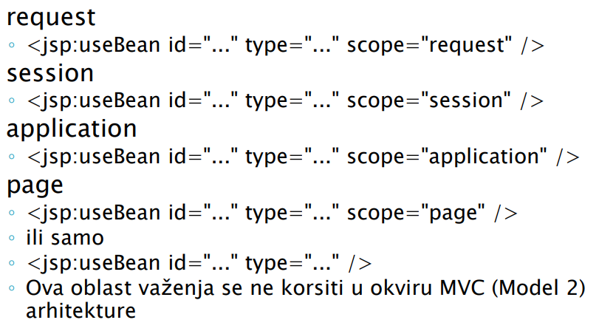

SESSION-BASED DATA DISTRIBUTION
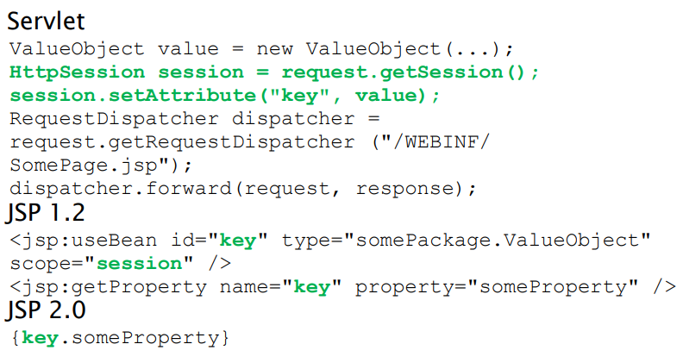

SEND REDIRECT

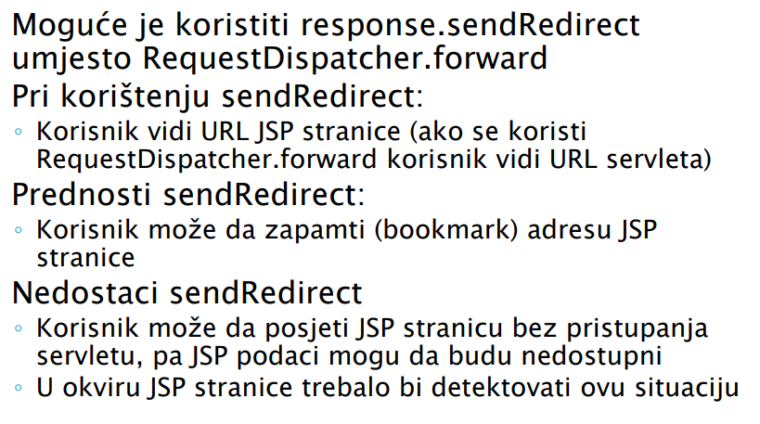
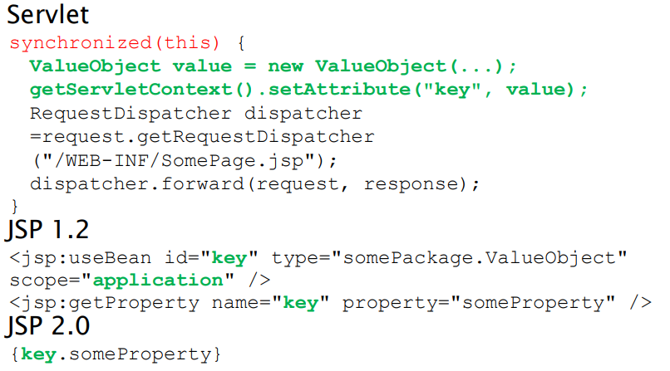
APLLICATION-BASED DATA SHARE

