JAVA SERVER FACES
NAVIGACIJA
PREDAVANJA

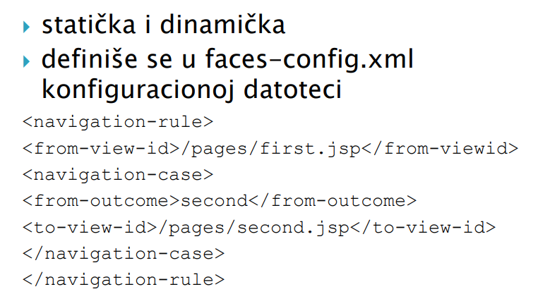
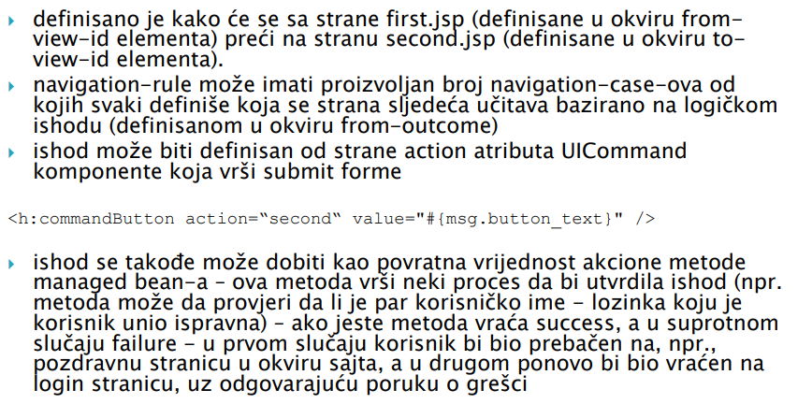
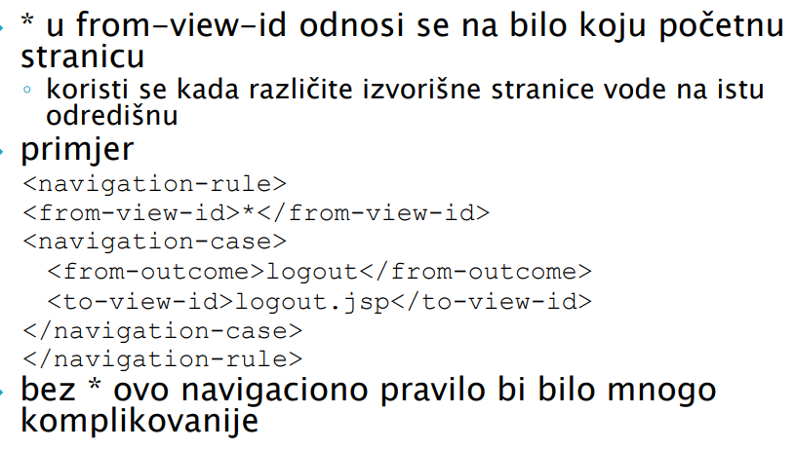
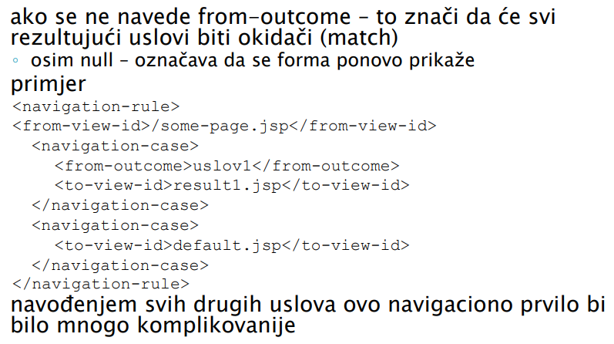

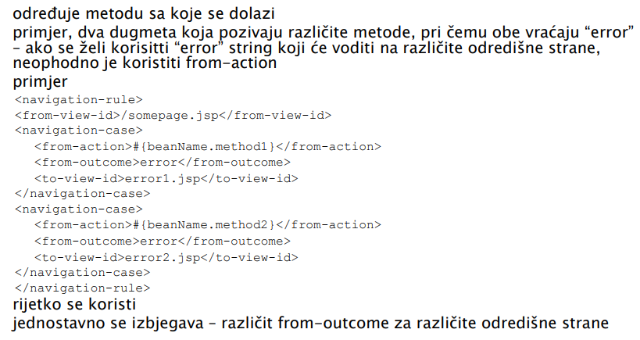
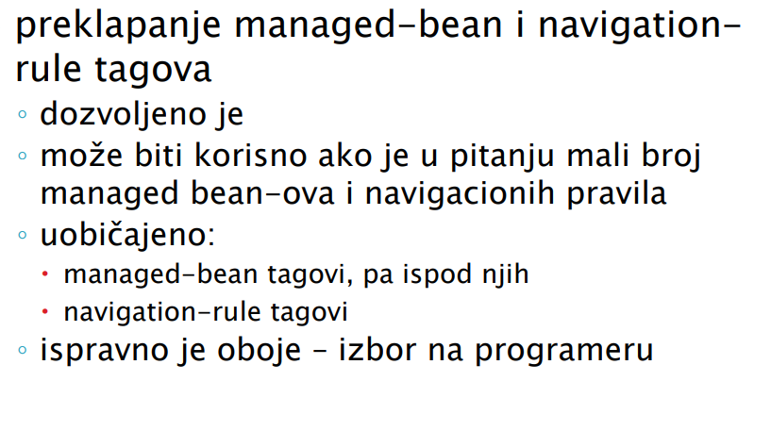
SADRZAJ 4

JSF Navigation Rules
JSF Navigation Wildcard
JSF Navigation Actions
JSF Navigation Managed Beans

