JAVA SERVER FACES
EVENT HANDLING
LESSONS

CONTENT-6

JSF Event Handling
JSF Action Listener
JSF Value Change Listener
JSF H Library
JSF H Form
JSF H Input Text
JSF H Input Secret
JSF H Command Button
JSF H Command Link
JSF Value Change Listener Atrribute
JSF Combo Boxes and List Boxes
JSF H Output Text and H Output Format

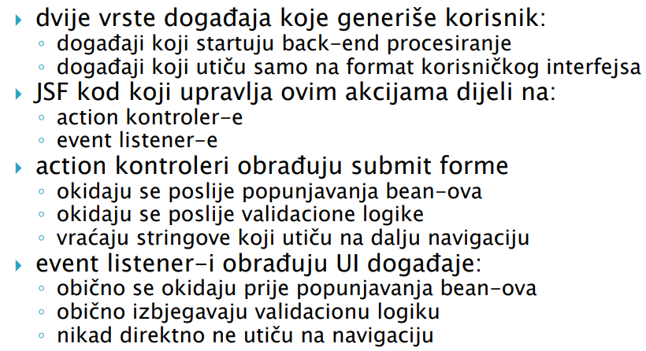
JSF Event Handling

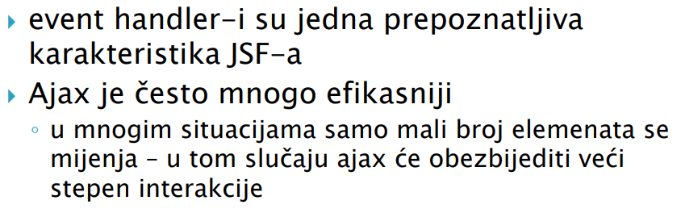
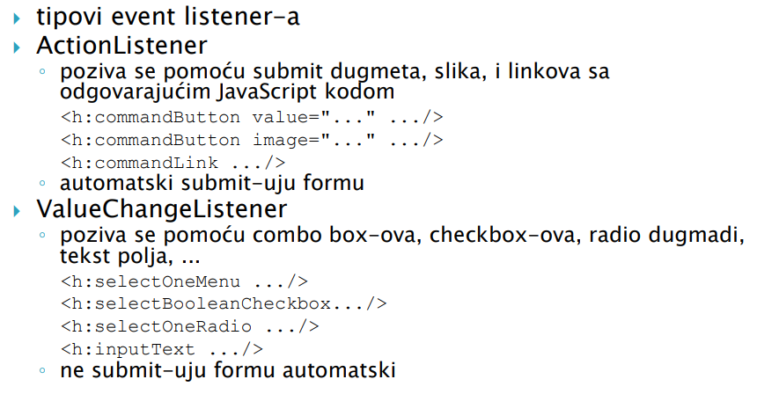
JSF Action Listener

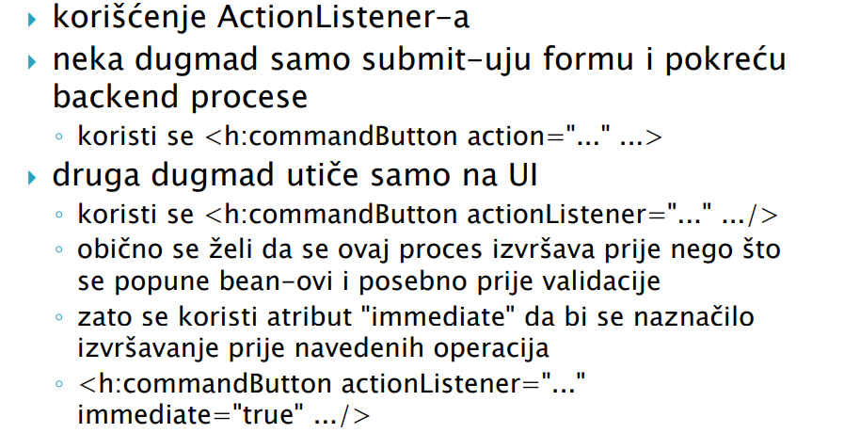
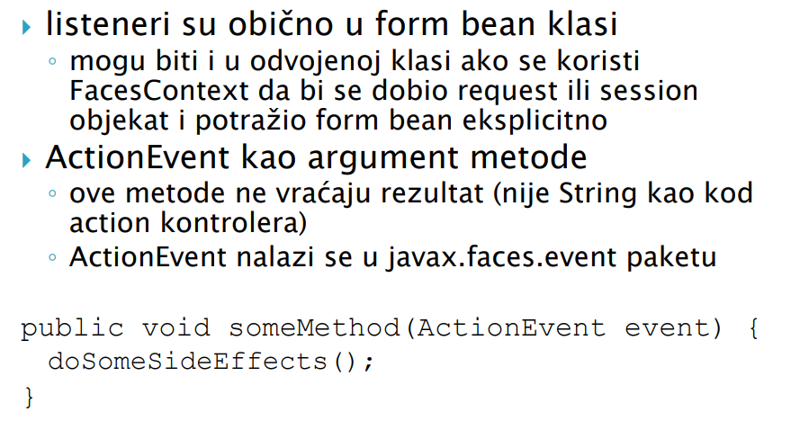

JSF Value Change Listener

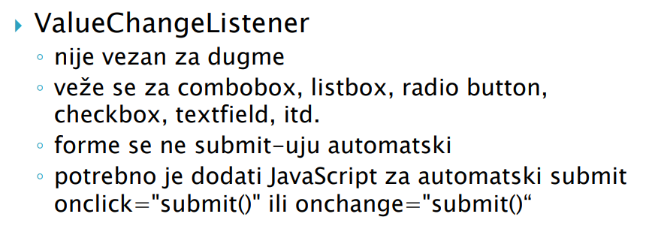
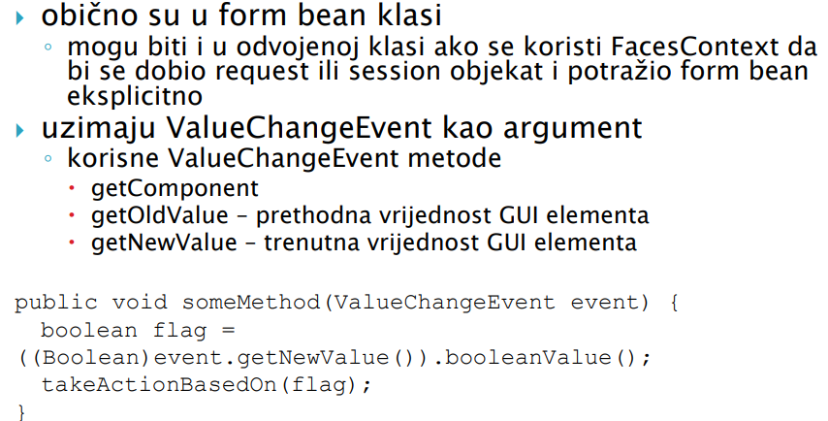

JSF H Library

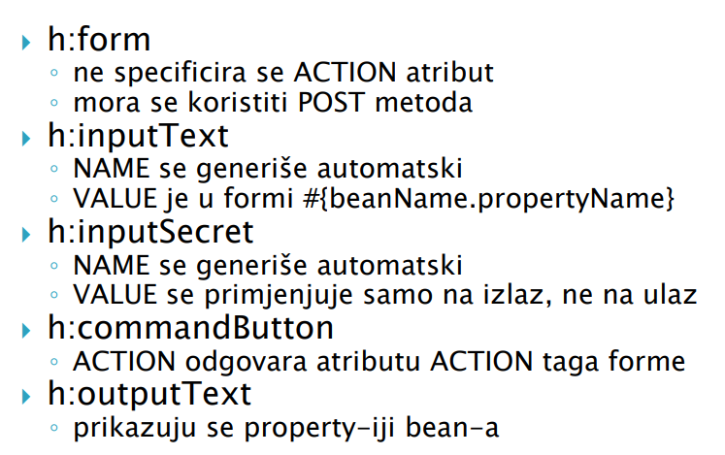

JSF H FORM

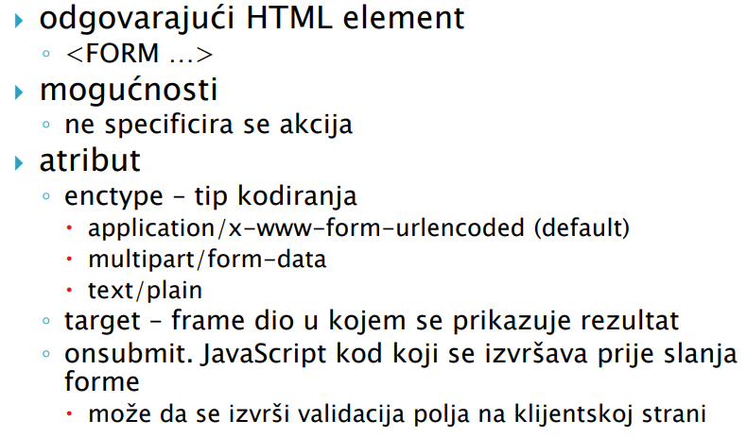

JSF H Elements

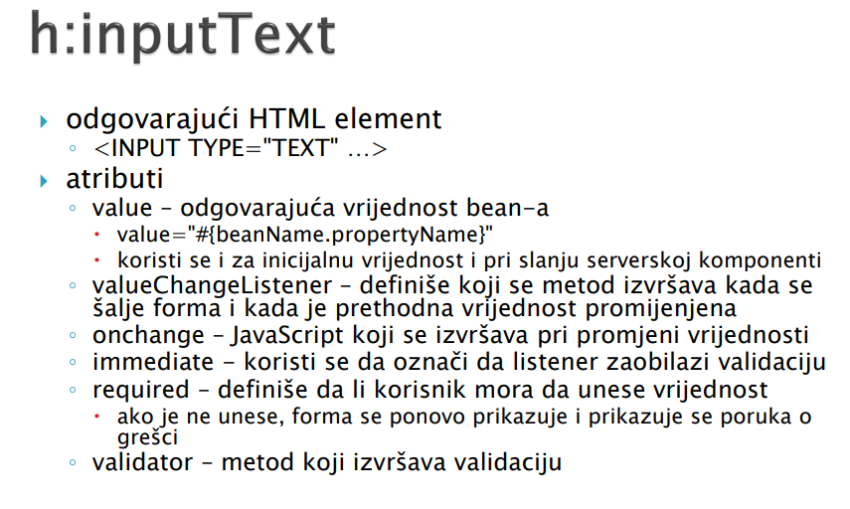
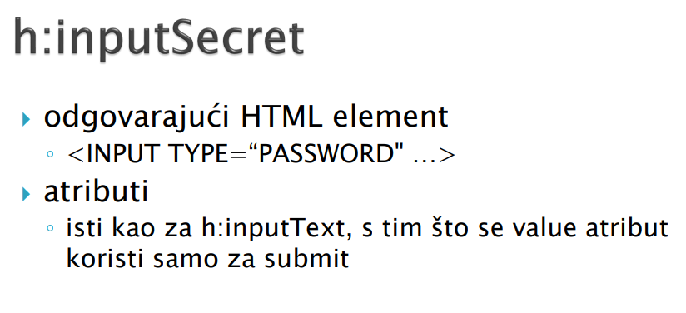

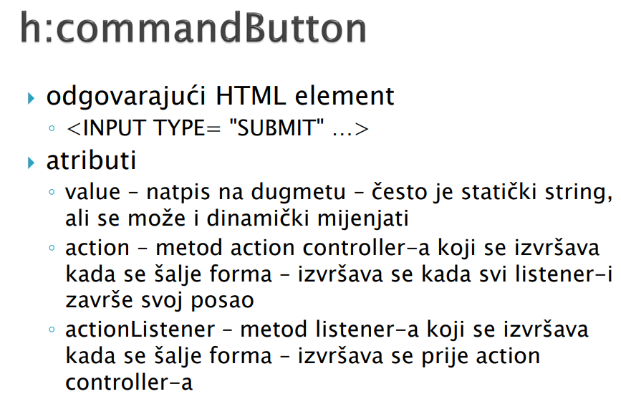

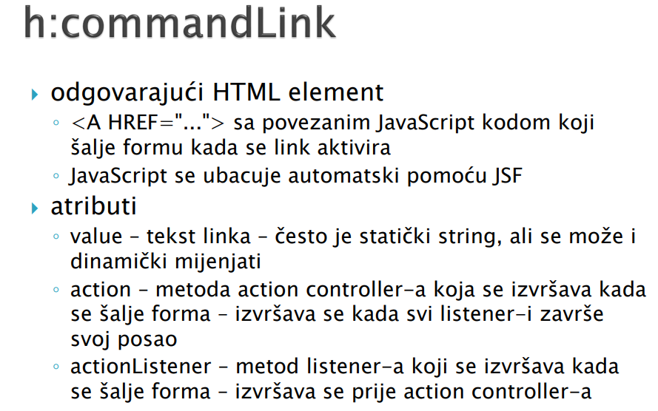

JSF Elementi sa Value Change Listener – ом / атрибутом

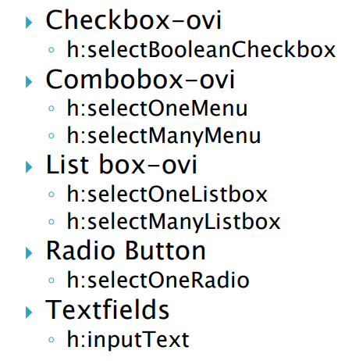

JSF COMBO BOX-OVI I LIST BOX-OVI

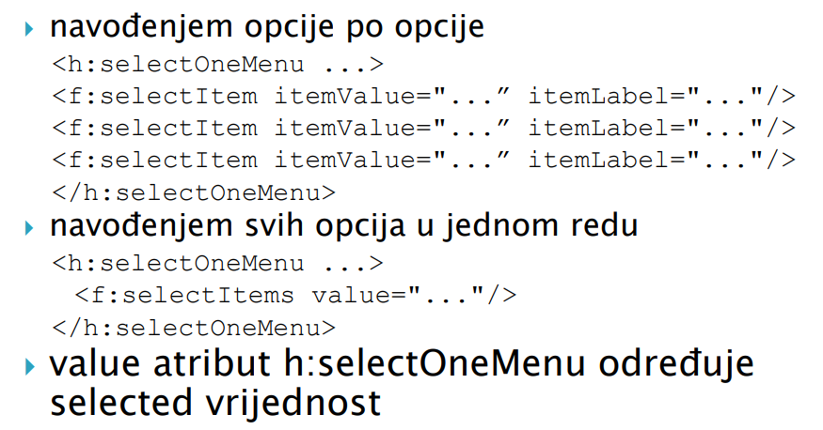
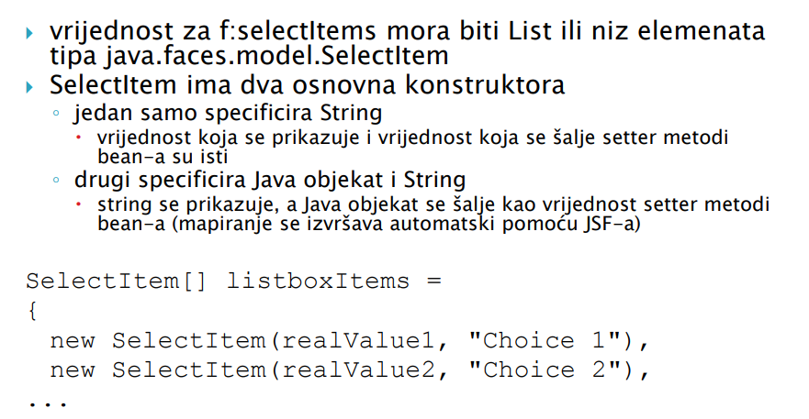

JSF H Output Text and Output Format

